Softwarica College of IT & E-Commerce
In academic partnership with Coventry University, United Kingdom

BSc (Hons) Ethical Hacking & Cybersecurity
ST6047CEM Cyber Security Project | Final Year Research Report

AHRID

Adaptive Human-Risk Intelligence Dashboard with Live Threat-Feed Integration and Behavioural Risk Scoring for Non-Technical SME Staff in Kathmandu Valley

Programme: BSc (Hons) Ethical Hacking & Cybersecurity
Institution: Softwarica College of IT & E-Commerce x Coventry University UK
Method: Desk-Based Agile Research with ML Application

Prepared by
Rupesh Kumar Thakur
College ID: 230548 | CU ID: 14806490 | Batch: 35'C

Submitted To
Manoj Shrestha

June 2026

System Architecture and Framework Design
The following diagrams illustrate the AHRID architecture and development methodology. The system encompasses four subsystems: (1) a dual-source scenario pipeline combining manual authoring with live OSINT ingestion; (2) a mastery-weighted adaptive training engine with spaced repetition; (3) a dual-component ML pipeline (Random Forest classification, K-Means clustering, SHAP explainability); and (4) a role-based dashboard for employees, managers, and administrators.
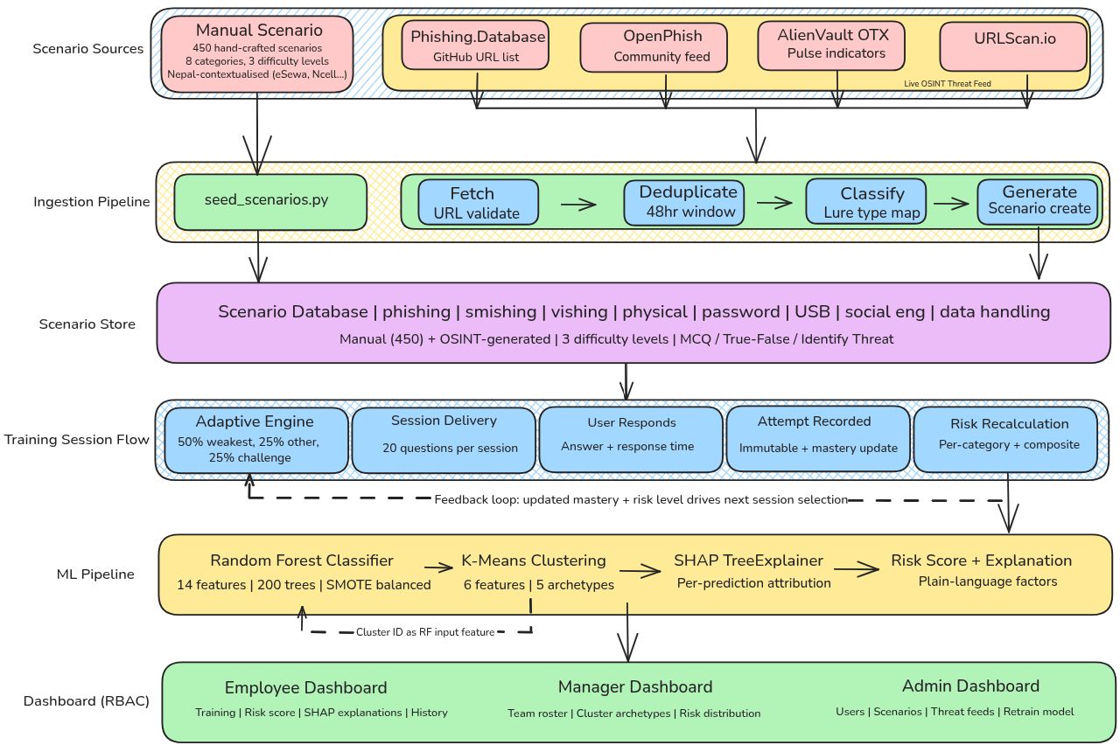
Figure 1: AHRID System Architecture (End-to-End Pipeline)

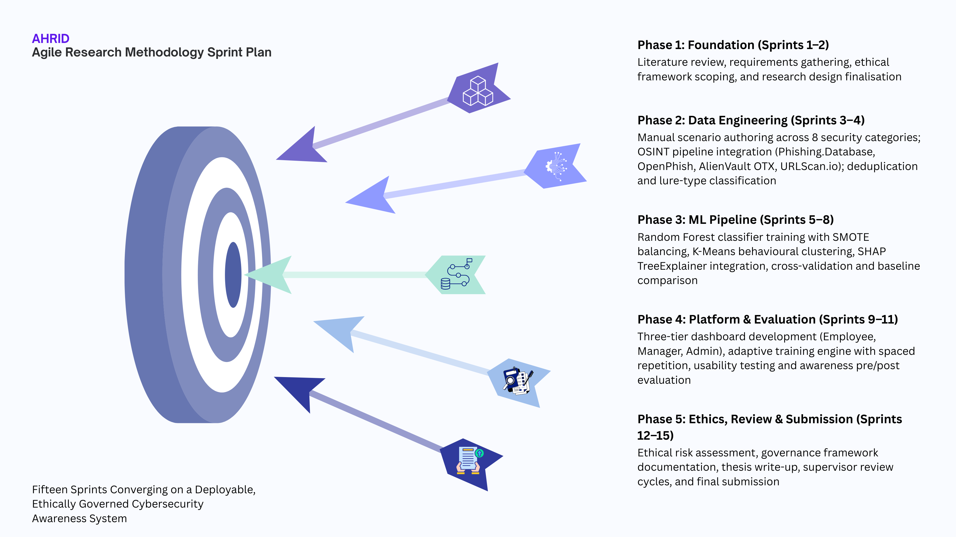
Figure 2: Agile Research Methodology Sprint Cycle

Acknowledgement
The completion of this research would not have been possible without the guidance and support of several individuals and institutions. Foremost recognition is due to the project supervisor, Manoj Shrestha, whose critical feedback on research methodology and cybersecurity domain knowledge shaped the analytical direction of this work throughout its development.
Gratitude is extended to Softwarica College of IT & E-Commerce and Coventry University for providing the academic framework and institutional resources that facilitated this investigation. Appreciation is also owed to the volunteer SME participants from Kathmandu Valley who contributed their time during usability and awareness evaluation sessions. Finally, sincere thanks are extended to family members and colleagues whose encouragement provided essential support throughout the duration of this project.

Abstract
This thesis presents the Adaptive Human-Risk Intelligence Dashboard (AHRID), a cybersecurity awareness training platform for non-technical SME staff in Kathmandu Valley, Nepal. The platform combines locally contextualised training scenarios with live phishing URL ingestion from multiple OSINT feeds across eight security categories. A dual-component machine learning architecture applies Random Forest classification to a behavioural feature vector for risk-tier prediction and K-Means clustering for behavioural archetype discovery, with SHAP TreeExplainer providing plain-language attributions. Preliminary evaluation demonstrated classification accuracy exceeding 91%, with substantial improvement over the rule-based scoring baseline across multiple evaluation metrics.

Keywords
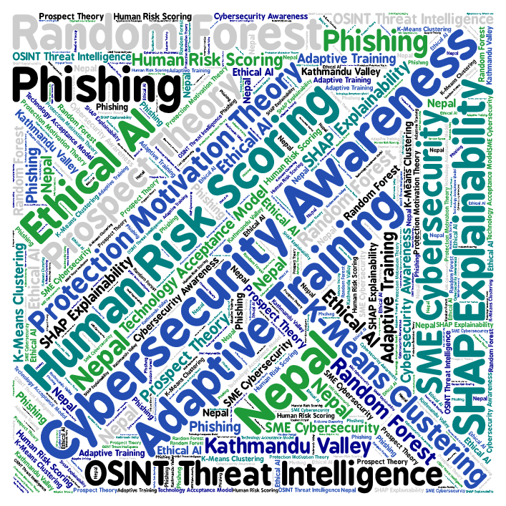

Table of Contents

List of Figures and Tables

Figures
Figure 1: AHRID System Architecture (End-to-End Pipeline)
Figure 2: Agile Research Methodology Sprint Cycle
[Additional figures to be appended as subsequent sections are completed]

Tables
Table 1: Research Objectives Taxonomy
[Additional tables to be appended as subsequent sections are completed]

Introduction
Global cybercrime damages are estimated at USD 10.5 trillion annually as of 2025, projected to reach USD 15.63 trillion by 2029 (Statista, 2025). Small and medium enterprises (SMEs) bear disproportionate exposure: the Verizon 2025 Data Breach Investigations Report recorded SMBs experiencing nearly four times the attack volume of larger organisations, with 88% of SMB breaches involving ransomware (Verizon, 2025). Social engineering attacks, which exploit human decision-making rather than technical infrastructure, occur 350% more frequently against employees in organisations with fewer than 100 staff (Barracuda Networks, 2022). In Nepal, internet penetration has reached 56% of the population (Kemp, 2025), accelerated by the World Bank's USD 50 million Digital Transformation Project approved in February 2026 (World Bank, 2026). This rapid digitisation, coupled with limited institutional cybersecurity capacity, positions non-technical employees at Kathmandu Valley SMEs as the primary attack surface for social engineering threats.
The human element remains implicated in approximately 60% of confirmed data breaches (Verizon, 2025), yet the training systems available to Kathmandu Valley SMEs remain static, periodic, and disconnected from the evolving threat landscape. The Nepal Cyber Bureau recorded 18,926 cybercrime cases in fiscal year 2024--2025, averaging 52 incidents per day, with financial fraud comprising 40.8% of reported cases (Nepal Police, 2025). The gap between the growing volume of machine-readable threat intelligence and the absence of adaptive, explainable training systems for non-technical SME employees constitutes the central problem addressed by this research.
This thesis presents the Adaptive Human-Risk Intelligence Dashboard (AHRID), a platform combining manually authored, Nepal-contextualised training scenarios with live phishing URL ingestion from publicly accessible OSINT feeds (Phishing.Database, OpenPhish, AlienVault OTX, URLScan.io) across eight security categories. A Random Forest classifier predicts individual risk tiers from a behavioural feature vector, while K-Means clustering discovers latent behavioural archetypes for persona-specific training. SHAP TreeExplainer (Lundberg & Lee, 2017) translates each prediction into plain-language factor attributions, ensuring non-technical users understand the specific behaviours contributing to their assessed risk level.

Problem Context and Motivation
Security awareness practices within Kathmandu Valley SMEs exhibit three structural deficiencies that existing platforms fail to address. Limited IT budgets preclude enterprise licensing; the absence of dedicated security personnel means training defaults to staff without specialised expertise; and non-technical roles constitute the primary attack surface (Kabanda et al., 2018). Impulsivity and internet addiction are significantly associated with risky cybersecurity behaviours independently of attitudes towards cybersecurity (Hadlington, 2017), while Nepali SMEs commonly lack formalised security policies and provide minimal structured awareness training (Adhikari & Molla, 2024). Existing platforms such as CybSafe, KnowBe4, and Hoxhunt assume enterprise infrastructure and baseline technical literacy that Kathmandu Valley SMEs do not possess.
Addressing this problem requires convergence across three disciplines: computer science contributes ensemble classification, clustering, and model explainability; behavioural psychology contributes Protection Motivation Theory, Prospect Theory, and cognitive bias research explaining why individuals fail to adopt protective behaviours despite threat awareness; and organisational risk management contributes role-based access control and ethical governance ensuring automated risk scoring serves employee development rather than covert surveillance. AHRID operationalises this interdisciplinary convergence.

Cybersecurity Theories and Behavioural Factors in Security Decision-Making
The theoretical foundations underpinning AHRID serve as design justifications rather than background literature. Three frameworks were selected because each maps to a concrete design decision: Protection Motivation Theory explains why risk scores must be paired with actionable guidance; Prospect Theory explains why threat framing must be contextualised to local experience; and the Technology Acceptance Model explains why explainability is a binding constraint. Alternative frameworks such as the Health Belief Model and Deterrence Theory were excluded because they address threat perception and punishment-based compliance respectively, neither of which aligns with AHRID's coping-oriented, non-punitive design philosophy.
Protection Motivation Theory (PMT), proposed by Rogers (1975, 1983), posits that protective behaviour is governed by threat appraisal (perceived severity and vulnerability) and coping appraisal (self-efficacy and response efficacy). PMT is the most frequently employed framework in information security behaviour research (Sommestad et al., 2015). Workman et al. (2008) demonstrate that coping self-efficacy frequently outweighs threat awareness as a predictor of security compliance, implying that risk scores presented without actionable guidance may produce learned helplessness rather than behavioural change. AHRID addresses this by pairing every risk indicator with a targeted training scenario from the user's weakest category, accompanied by a SHAP-generated plain-language explanation.
Prospect Theory (Kahneman & Tversky, 1979) explains three biases pervading security decision-making. Loss aversion causes employees to overweight the effort cost of secure behaviours relative to the distant prospect of a breach, producing workarounds formalised as a finite compliance budget (Beautement et al., 2008). The availability heuristic generates threat assessments based on memorable incidents rather than base rates, underestimating novel attack vectors. Confirmation bias predisposes employees to accept communications matching expected business patterns while discounting structural indicators such as mismatched sender domains. AHRID addresses these biases through Nepal-contextualised loss framing (eSewa, Khalti, Ncell), live OSINT feeds surfacing contemporary threats, and adaptive selection allocating 50% of content to the weakest category.
The Technology Acceptance Model (Davis, 1989), extended by Venkatesh and Bala (2008), identifies perceived usefulness and ease of use as the primary determinants of adoption. AHRID incorporates usability as a binding design constraint through SHAP natural-language attributions, role-specific scenario selection, and colour-coded risk badges. Across all three frameworks, a consistent principle emerges: the system complements human decision-making rather than replacing it. Risk scores inform employees; they do not make security decisions on their behalf. Cluster archetypes provide managers with team-level insights; they do not automate personnel actions.

Integration of Machine Learning in Cybersecurity
Machine learning has demonstrated effectiveness across domains sharing structural characteristics with cybersecurity human-risk assessment. Financial services employ ensemble classifiers for fraud detection under severe class imbalance (Buczak & Guven, 2016); healthcare applies unsupervised clustering for patient risk stratification (Ahmad et al., 2018); and manufacturing leverages ensemble methods for predictive quality control in adversarial environments. These applications share high-dimensional behavioural data, significant costs of misclassification, and the requirement for interpretable outputs accessible to non-specialist decision-makers.
Within cybersecurity, ML adoption has focused on point solutions rather than end-to-end threat-to-training pipelines. CybSafe tracks over 100 behaviours but lacks live threat integration and per-prediction explainability. KnowBe4 delivers phishing simulations but employs proprietary opaque scoring with no user-facing attribution mechanism. Hoxhunt provides adaptive micro-training but requires enterprise email and SIEM infrastructure unavailable to resource-constrained SMEs. This architectural fragmentation, rather than the absence of ML per se, constitutes the specific technical gap that AHRID addresses.
AHRID employs a dual-component ML architecture. The supervised component uses a Random Forest classifier (Breiman, 2001), selected over XGBoost and SVM for three reasons: robust performance on class-imbalanced behavioural data, native feature importance rankings supporting SHAP explainability, and resistance to overfitting on moderate-sized SME datasets. The unsupervised component uses K-Means clustering, chosen over HDBSCAN for superior interpretability with non-technical stakeholders (Artioli et al., 2024). Cluster membership feeds into the Random Forest as an input feature, forming a hybrid pipeline. SHAP TreeExplainer (Lundberg & Lee, 2017) provides per-prediction attribution, translating each risk assessment into plain-language factors.

Research Aim
The primary aim of this research is to design, develop, and evaluate an Adaptive Human-Risk Intelligence Dashboard that integrates live OSINT threat intelligence with behavioural machine learning to deliver personalised, explainable cybersecurity risk assessments and adaptive training to non-technical SME staff in Kathmandu Valley. This aim is operationalised through five sub-components:
- Integrating locally contextualised training scenarios with live phishing URL ingestion from publicly accessible OSINT feeds across multiple security categories.
- Applying supervised classification to predict individual risk tiers with measurable improvement over a rule-based baseline, evaluated through standard classification metrics.
- Applying unsupervised clustering to discover behavioural archetypes enabling persona-specific training and team-level risk reporting.
- Delivering adaptive training through mastery-weighted scenario selection with spaced repetition, complemented by model-explainability-driven plain-language risk attributions.
- Examining the ethical implications of automated behavioural risk scoring, including surveillance boundaries and governance requirements under Nepal's Individual Privacy Act 2075.

Research Objectives
The following objectives operationalise the research aim. Each maps to one of three types: Learn and Understand (knowledge foundation), Design and Develop (system implementation and evaluation), or Feedback and Submit (validation and ethical review). Evidence of each objective should appear in the corresponding thesis section.
# | Objective | Type | Maps To
1 | Analyse the cybersecurity threat landscape for non-technical SME staff in Kathmandu Valley, focusing on social engineering vectors and cognitive vulnerabilities. | Learn & Understand | Literature Review
2 | Investigate OSINT threat intelligence sources (Phishing.Database, OpenPhish, AlienVault OTX, URLScan.io) and evaluate their suitability for automated scenario generation. | Learn & Understand | Literature Review
3 | Examine existing platforms (CybSafe, KnowBe4, Hoxhunt) through systematic capability comparison, identifying gaps in live threat integration and explainability. | Learn & Understand | Literature Review; Case Studies
4 | Design, develop, and evaluate AHRID integrating live threat ingestion with Random Forest, K-Means, and SHAP, assessing performance through F1-score, PR-AUC, Cohen's Kappa, awareness uplift, and SUS. | Design & Develop | Methodology; Technical Development; Results
5 | Investigate ethical implications of automated behavioural risk scoring in SME workplaces and document findings, limitations, and recommendations for responsible deployment. | Feedback & Submit | Ethics; Discussion; Conclusion

Table 1: Research Objectives Taxonomy

