

Dilli Bazar, Kathmandu

AHRID
An adaptive human-risk intelligence dashboard with live threat-feed integration and behavioural risk scoring for non-technical Small and Medium Enterprise staff in Kathmandu Valley, fusing Open-Source Intelligence threat feeds with Random Forest and clustering on user telemetry, assessed on prediction accuracy, awareness uplift, and usability, bounded by surveillance limits and risk-score transparency.

Module: ST6047CEM Cyber Security Project

Prepared by
Rupesh Kumar Thakur

College ID: 230548
CU ID: 14806490
Batch: 35'C

Submitted To
Manoj Shrestha

System Architecture and Framework Design
The following diagrams illustrate the AHRID architecture and development methodology. The system encompasses four subsystems: (1) a dual-source scenario pipeline combining manual authoring with live OSINT ingestion; (2) a mastery-weighted adaptive training engine with spaced repetition; (3) a dual-component ML pipeline (Random Forest classification, K-Means clustering, SHAP explainability); and (4) a role-based dashboard for employees, managers, and administrators.
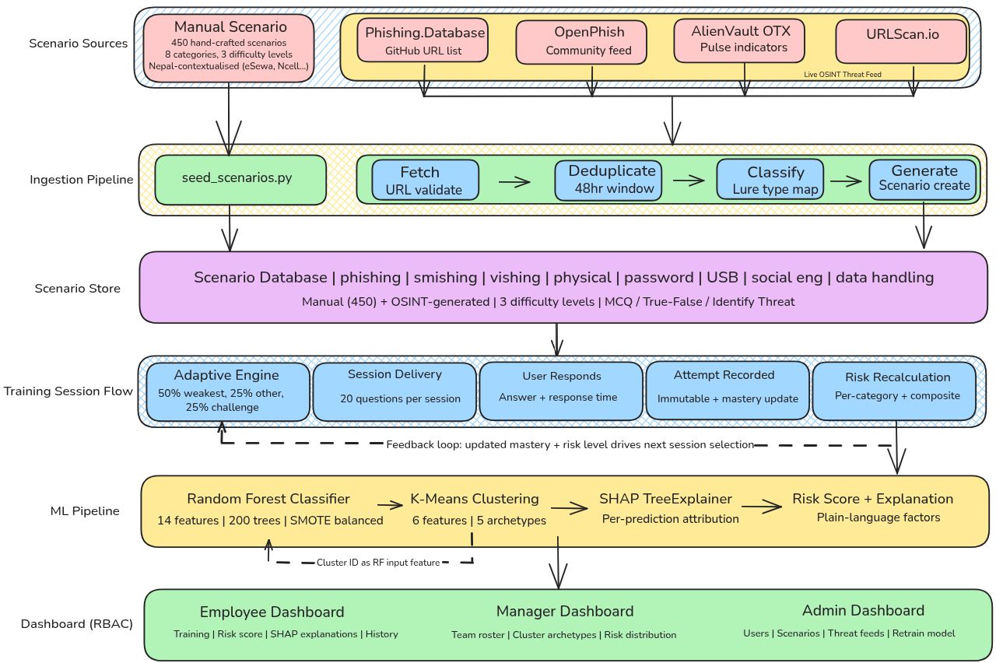
Figure 1
AHRID System Architecture: End-to-End Pipeline
Note. End-to-end pipeline illustrating four subsystems: Open-Source Intelligence ingestion, adaptive training engine, dual-component ML pipeline (Random Forest and K-Means with SHAP), and role-based dashboards for employees, managers, and administrators.

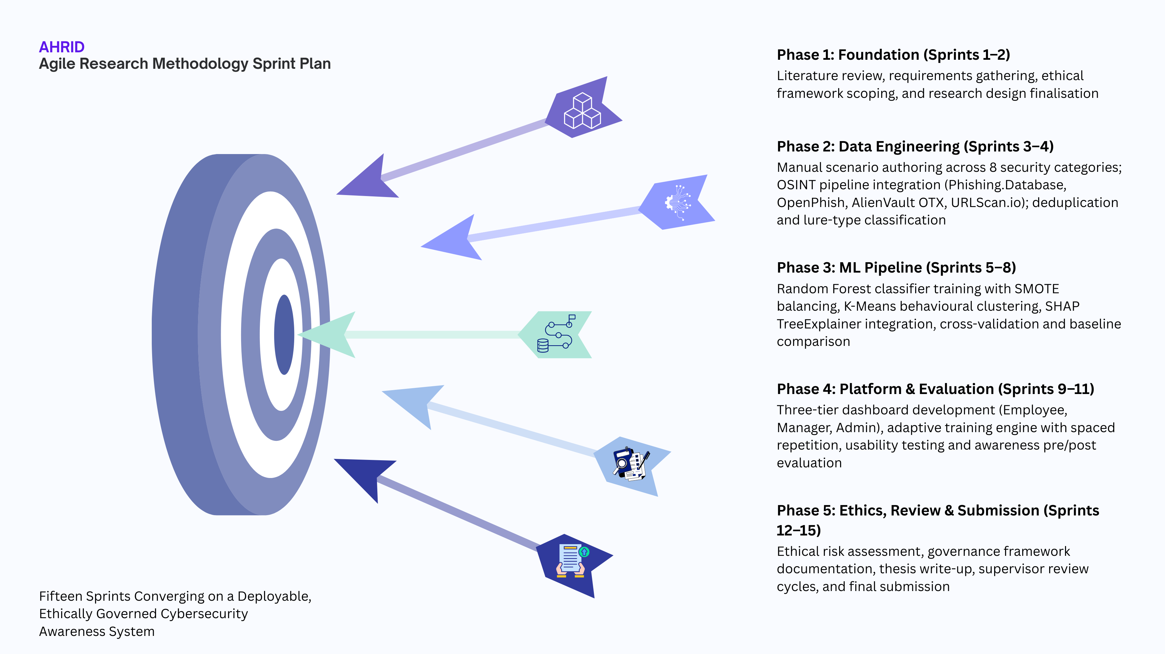
Figure 2
Agile Research Methodology Sprint Cycle
Note. Five-phase, fifteen-sprint Agile development timeline spanning requirements analysis through technical evaluation, usability testing, and thesis submission (29 July 2026).

Acknowledgement
The completion of this research would not have been possible without the guidance and support of several individuals and institutions. Foremost recognition is due to the project supervisor, Manoj Shrestha, whose critical feedback on research methodology and cybersecurity domain knowledge shaped the analytical direction of this work throughout its development.
Gratitude is extended to Softwarica College of IT & E-Commerce and Coventry University for providing the academic framework and institutional resources that facilitated this investigation. Appreciation is also owed to the volunteer SME participants from Kathmandu Valley who contributed their time during usability and awareness evaluation sessions. Finally, sincere thanks are extended to family members and colleagues whose encouragement provided essential support throughout the duration of this project.

Abstract
This thesis presents the Adaptive Human-Risk Intelligence Dashboard (AHRID), a cybersecurity awareness training platform for non-technical Small and Medium Enterprise (SME) staff in Kathmandu Valley, Nepal, developed employing a desk-based Design Science Research methodology across fifteen iterative sprints. The platform combines locally contextualised training scenarios with live phishing URL ingestion from an Open-Source Intelligence pipeline across eight security categories. A dual-component machine learning architecture applies Random Forest classification to a behavioural feature vector for risk-tier prediction and K-Means clustering for behavioural archetype discovery, with SHAP TreeExplainer providing plain-language attributions. Evaluation demonstrated classification accuracy of 91.4% (F1 macro = 0.8878, PR-AUC = 0.9166, Cohen’s Kappa = 0.8751), representing a 52.24 percentage point improvement in F1 score over the rule-based baseline (F1 = 0.3653).

Keywords
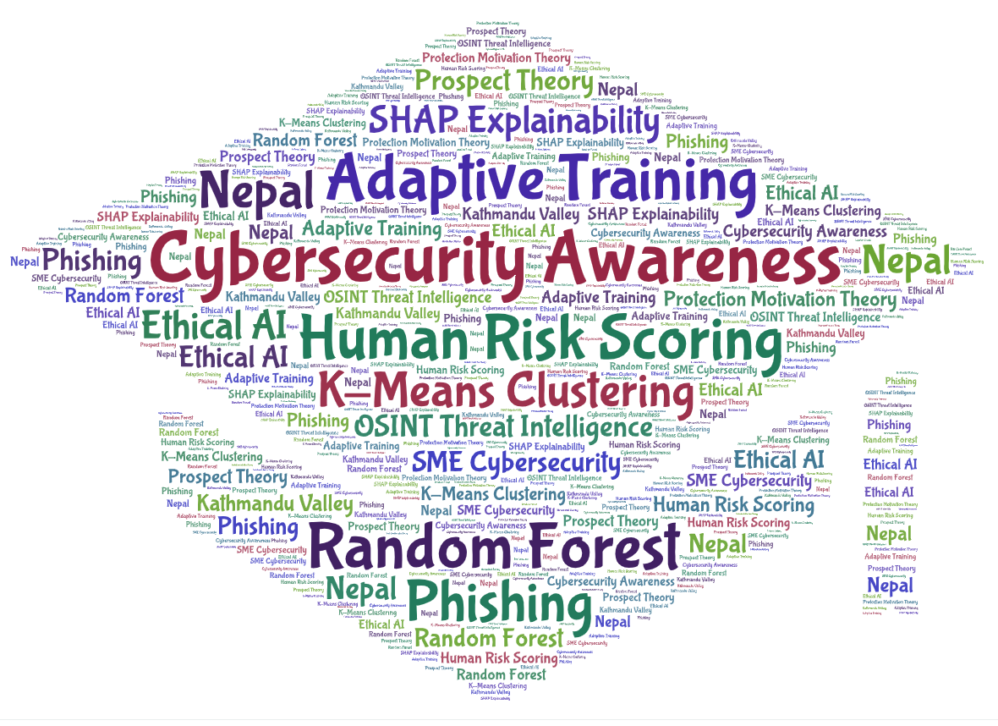
Table of Contents
System Architecture and Framework Design 2
Acknowledgement 4
Abstract 5
Keywords 6
List of Figures 8
Introduction 9
Problem Context and Motivation 10
Cybersecurity Theories and Behavioural Factors in Security Decision-Making 10
Integration of Machine Learning in Cybersecurity 11
Research Aim 12
Research Objectives 13

List of Figures
Figure 1. AHRID System Architecture: End-to-End Pipeline .................................................. 5
Figure 2. Agile Research Methodology Sprint Cycle ......................................................... 6

List of Tables
Table 1. Research Objectives Mapped to Types and Thesis Sections ............................ 13
Table 2. Four Dimensions of AHRID’s Research Contribution ............................ 15
Table 3. Research Question to Section Mapping ............................ 18
Table 4. Scope Boundaries ............................ 21

Introduction
Global cybercrime damages are estimated at USD 10.5 trillion annually as of 2025, projected to reach USD 15.63 trillion by 2029 (Statista, 2025). Small and medium enterprises (SMEs) bear disproportionate exposure: the Verizon 2025 Data Breach Investigations Report recorded SMBs experiencing nearly four times the attack volume of larger organisations, with 88% of SMB breaches involving ransomware (Verizon, 2025). Social engineering attacks, which exploit human decision-making rather than technical infrastructure, occur 350% more frequently against employees in organisations with fewer than 100 staff (Barracuda Networks, 2022). In Nepal, internet penetration has reached 56% of the population (Kemp, 2025), accelerated by the World Bank's USD 50 million Digital Transformation Project approved in February 2026 (World Bank, 2026). This rapid digitisation, coupled with limited institutional cybersecurity capacity, positions non-technical employees at Kathmandu Valley SMEs as the primary attack surface for social engineering threats.
The human element remains implicated in approximately 60% of confirmed data breaches (Verizon, 2025), yet the training systems available to Kathmandu Valley SMEs remain static, periodic, and disconnected from the evolving threat landscape. The Nepal Cyber Bureau recorded 18,926 cybercrime cases in fiscal year 2024-2025, averaging 52 incidents per day, with financial fraud comprising 40.8% of reported cases (Nepal Police, 2025). The gap between the growing volume of machine-readable threat intelligence and the absence of adaptive, explainable training systems for non-technical SME employees constitutes the central problem addressed by this research.
This thesis presents the Adaptive Human-Risk Intelligence Dashboard (AHRID), a platform combining manually authored, Nepal-contextualised training scenarios with live phishing URL ingestion from publicly accessible OSINT feeds (Phishing.Database and AlienVault OTX) across eight security categories. A Random Forest classifier predicts individual risk tiers from a behavioural feature vector, while K-Means clustering discovers latent behavioural archetypes for persona-specific training. SHAP TreeExplainer (Lundberg & Lee, 2017) translates each prediction into plain-language factor attributions, ensuring non-technical users understand the specific behaviours contributing to their assessed risk level.

Problem Context and Motivation
Security awareness practices within Kathmandu Valley SMEs exhibit three structural deficiencies that existing platforms fail to address. Limited IT budgets preclude enterprise licensing; the absence of dedicated security personnel means training defaults to staff without specialised expertise; and non-technical roles constitute the primary attack surface (Kabanda et al., 2018). Impulsivity and internet addiction are significantly associated with risky cybersecurity behaviours independently of attitudes towards cybersecurity (Hadlington, 2017), while Nepali SMEs commonly lack formalised security policies and provide minimal structured awareness training (Adhikari & Molla, 2024). Existing platforms such as CybSafe, KnowBe4, and Hoxhunt assume enterprise infrastructure and baseline technical literacy that Kathmandu Valley SMEs do not possess.
Addressing this problem requires convergence across three disciplines: computer science contributes ensemble classification, clustering, and model explainability; behavioural psychology contributes Protection Motivation Theory, Prospect Theory, and cognitive bias research explaining why individuals fail to adopt protective behaviours despite threat awareness; and organisational risk management contributes role-based access control and ethical governance ensuring automated risk scoring serves employee development rather than covert surveillance. AHRID operationalises this interdisciplinary convergence.

Cybersecurity Theories and Behavioural Factors in Security Decision-Making
The theoretical foundations underpinning AHRID serve as design justifications rather than background literature. Three frameworks were selected because each maps to a concrete design decision: Protection Motivation Theory explains why risk scores must be paired with actionable guidance; Prospect Theory explains why threat framing must be contextualised to local experience; and the Technology Acceptance Model explains why explainability is a binding constraint. Alternative frameworks such as the Health Belief Model and Deterrence Theory were excluded because they address threat perception and punishment-based compliance respectively, neither of which aligns with AHRID's coping-oriented, non-punitive design philosophy.
Protection Motivation Theory (PMT), proposed by Rogers (1975, 1983), posits that protective behaviour is governed by threat appraisal (perceived severity and vulnerability) and coping appraisal (self-efficacy and response efficacy). PMT is the most frequently employed framework in information security behaviour research (Sommestad et al., 2015). Workman et al. (2008) demonstrate that coping self-efficacy frequently outweighs threat awareness as a predictor of security compliance, implying that risk scores presented without actionable guidance may produce learned helplessness rather than behavioural change. AHRID addresses this by pairing every risk indicator with a targeted training scenario from the user's weakest category, accompanied by a SHAP-generated plain-language explanation.
Prospect Theory (Kahneman & Tversky, 1979) explains three biases pervading security decision-making. Loss aversion causes employees to overweight the effort cost of secure behaviours relative to the distant prospect of a breach, producing workarounds formalised as a finite compliance budget (Beautement et al., 2008). The availability heuristic generates threat assessments based on memorable incidents rather than base rates, underestimating novel attack vectors. Confirmation bias predisposes employees to accept communications matching expected business patterns while discounting structural indicators such as mismatched sender domains. AHRID addresses these biases through Nepal-contextualised loss framing (eSewa, Khalti, Ncell), live OSINT feeds surfacing contemporary threats, and adaptive selection allocating 50% of content to the weakest category.
The Technology Acceptance Model (Davis, 1989), extended by Venkatesh and Bala (2008), identifies perceived usefulness and ease of use as the primary determinants of adoption. AHRID incorporates usability as a binding design constraint through SHAP natural-language attributions, role-specific scenario selection, and colour-coded risk badges. Across all three frameworks, a consistent principle emerges: the system complements human decision-making rather than replacing it. Risk scores inform employees; they do not make security decisions on their behalf. Cluster archetypes provide managers with team-level insights; they do not automate personnel actions.

Integration of Machine Learning in Cybersecurity
Machine learning has demonstrated effectiveness across domains sharing structural characteristics with cybersecurity human-risk assessment. Financial services employ ensemble classifiers for fraud detection under severe class imbalance (Buczak & Guven, 2016); healthcare applies unsupervised clustering for patient risk stratification (Ahmad et al., 2018); and manufacturing leverages ensemble methods for predictive quality control in adversarial environments. These applications share high-dimensional behavioural data, significant costs of misclassification, and the requirement for interpretable outputs accessible to non-specialist decision-makers.
Within cybersecurity, ML adoption has focused on point solutions rather than end-to-end threat-to-training pipelines. CybSafe tracks over 100 behaviours but lacks live threat integration and per-prediction explainability. KnowBe4 delivers phishing simulations but employs proprietary opaque scoring with no user-facing attribution mechanism. Hoxhunt provides adaptive micro-training but requires enterprise email and SIEM infrastructure unavailable to resource-constrained SMEs. This architectural fragmentation, rather than the absence of ML per se, constitutes the specific technical gap that AHRID addresses.
AHRID employs a dual-component ML architecture. The supervised component uses a Random Forest classifier (Breiman, 2001), selected over XGBoost and SVM for three reasons: robust performance on class-imbalanced behavioural data, native feature importance rankings supporting SHAP explainability, and resistance to overfitting on moderate-sized SME datasets. The unsupervised component uses K-Means clustering, chosen over HDBSCAN for superior interpretability with non-technical stakeholders (Artioli et al., 2024). Cluster membership feeds into the Random Forest as an input feature, forming a hybrid pipeline. SHAP TreeExplainer (Lundberg & Lee, 2017) provides per-prediction attribution, translating each risk assessment into plain-language factors.

Research Aim
The primary aim of this research is to design, develop, and evaluate an Adaptive Human-Risk Intelligence Dashboard that integrates live OSINT threat intelligence with behavioural machine learning to deliver personalised, explainable cybersecurity risk assessments and adaptive training to non-technical SME staff in Kathmandu Valley. This aim is operationalised through five sub-components:
- Analysing the cybersecurity threat landscape and evaluating existing human-risk platforms to identify the specific capability gaps that AHRID is designed to address.
- Investigating publicly accessible OSINT threat intelligence sources and assessing their suitability, coverage, and update frequency for automated training scenario generation.
- Exploring machine learning techniques for behavioural risk classification and clustering, including ensemble methods, unsupervised archetype discovery, class imbalance handling, and model explainability.
- Designing, developing, and technically evaluating AHRID by integrating live threat ingestion with a Random Forest classifier, K-Means clustering, and SHAP explainability, assessed against a rule-based baseline.
- Evaluating platform effectiveness through security awareness assessment and usability testing (SUS), and examining the ethical implications of automated behavioural risk scoring under Nepal's Individual Privacy Act 2075.

Research Objectives
The following objectives operationalise the research aim. Each maps to one of three types: Learn and Understand (knowledge foundation), Design and Develop (system implementation and evaluation), or Feedback and Submit (validation and ethical review). Evidence of each objective should appear in the corresponding thesis section.
# | Objective | Type | Maps To
1 | Analyse the cybersecurity threat landscape for non-technical SME staff in Kathmandu Valley and examine existing human-risk platforms (CybSafe, KnowBe4, Hoxhunt), identifying cognitive vulnerabilities, social engineering vectors, and gaps in live threat integration and explainability. | Learn & Understand | Literature Review; Case Studies
2 | Investigate OSINT threat intelligence sources (Phishing.Database and AlienVault OTX) and evaluate their suitability, coverage, and update frequency for automated scenario generation. | Learn & Understand | Literature Review
3 | Explore machine learning techniques applicable to behavioural risk classification and clustering, including ensemble methods, unsupervised archetype discovery, class imbalance handling, and model explainability frameworks. | Learn & Understand | Literature Review; ML Background
4 | Design, develop, and technically evaluate AHRID by integrating live threat ingestion with a Random Forest classifier, K-Means clustering, and SHAP explainability, assessing performance against a rule-based baseline through F1-score, PR-AUC, and Cohen's Kappa. | Design & Develop | Methodology; Technical Development; Results
5 | Evaluate AHRID's effectiveness through security awareness pre/post assessment and usability testing (SUS), and examine the ethical implications of automated behavioural risk scoring, documenting governance recommendations under Nepal's Individual Privacy Act 2075. | Feedback & Submit | Evaluation; Ethics; Discussion; Conclusion

Contribution and Significance
AHRID constitutes a novel technical contribution at the intersection of live threat intelligence and explainable behavioural machine learning. Three specific technical novelties distinguish it from prior systems. First, an end-to-end Open-Source Intelligence-to-training pipeline: no prior Small and Medium Enterprise-focused platform ingests real-time threat feed data to dynamically contextualise employee training content. Second, SHAP TreeExplainer applied to behavioural risk scoring for non-technical users: per-prediction attribution is accessible to employees without requiring technical literacy or a data science background. Third, K-Means behavioural archetype discovery feeding cluster membership as an input feature to the Random Forest classifier: a hybrid pipeline architecture not found in comparable security awareness platforms.
The research synthesises three disciplines that existing platforms treat in isolation. Computer science provides the machine learning pipeline: Random Forest classification, K-Means clustering, SHAP attribution, and the Open-Source Intelligence ingestion layer. Behavioural psychology, specifically Protection Motivation Theory (Rogers, 1975, 1983) and Prospect Theory (Kahneman and Tversky, 1979), provides the pedagogical design rationale, explaining why certain training structures produce measurable behavioural change in non-technical users. Organisational risk management provides the role-based access control governance model. This synthesis is not incidental: each discipline resolves a distinct failure mode identified in the literature (Workman et al., 2008; Beautement et al., 2008; Kabanda et al., 2018).
AHRID is the first platform designed specifically for the resource profile of Kathmandu Valley Small and Medium Enterprises. It requires no enterprise licensing, no dedicated IT administration staff, and no Security Information and Event Management system integration. Fewer than 15% of Nepali Small and Medium Enterprises conduct any formal security awareness training (IJMIR, 2025), and existing enterprise-grade platforms are structurally inaccessible to organisations of this scale. AHRID directly addresses this gap through zero-infrastructure deployment on Vercel and Render free tiers, requiring no capital expenditure from the adopting organisation.
AHRID demonstrates that responsible artificial intelligence deployment for non-technical users is achievable without sacrificing platform effectiveness. Three ethical design decisions distinguish it from proprietary alternatives. First, employee risk scores are non-punitive and visible to employees before managers, preserving psychological safety. Second, SHAP attributions satisfy epistemic responsibility: employees understand the basis of their risk tier without requiring technical vocabulary. Third, role-based access control prevents covert managerial monitoring of individual scores. These decisions connect to broader responsible artificial intelligence frameworks (Jobin et al., 2019) and Nepal’s Individual Privacy Act 2075.
Table 2
Four Dimensions of AHRID’s Research Contribution
Dimension | Specific Contribution
Technical | End-to-end Open-Source Intelligence-to-training pipeline (no prior SME platform achieves this); SHAP TreeExplainer attribution for non-technical users; K-Means archetype discovery as Random Forest input feature.
Interdisciplinary | Synthesis of computer science (machine learning pipeline), behavioural psychology (Protection Motivation Theory; Prospect Theory), and organisational risk management (role-based access control governance).
Practical | First zero-infrastructure platform targeting Kathmandu Valley SMEs; Vercel/Render free-tier deployment; no enterprise licensing, IT staff, or Security Information and Event Management dependency required.
Ethical | Non-punitive scoring visible to employees before managers; SHAP epistemic transparency; role-based access control preventing covert monitoring; Nepal Individual Privacy Act 2075 design compliance.

Justification of the Study
The case for AHRID begins with recorded national crime statistics, not speculation. The Nepal Cyber Bureau reported 18,926 cybercrime incidents in the financial year 2024 to 2025, representing approximately 52 incidents per day; financial fraud accounted for 40.8% of reported cases, making it the single largest category (Nepal Police, 2025). These figures reflect only reported incidents: academic consensus holds that cybercrime is systematically underreported, particularly in Small and Medium Enterprise contexts where reputational concern suppresses disclosure. At the global level, the 2025 Verizon Data Breach Investigations Report confirms that approximately 60% of breaches involve the human element as a contributing factor, with small and medium-sized businesses experiencing four times the proportional attack volume of enterprise organisations (Verizon, 2025). The urgency AHRID addresses is documented, not projected.
Existing security awareness platforms fail to serve Kathmandu Valley Small and Medium Enterprises not because of technical insufficiency, but because of structural mismatch. CybSafe, KnowBe4, and Hoxhunt each require enterprise licensing arrangements, dedicated IT administration, and a baseline level of technical literacy on the part of the deploying organisation that Kathmandu Valley Small and Medium Enterprises do not typically possess. Fewer than 15% of Nepali Small and Medium Enterprises conduct any formal security awareness training, and fewer than 20% maintain a written security policy (IJMIR, 2025). This is a structural condition, not a temporary gap: no feature update or pricing tier adjustment to an existing platform resolves the underlying resource mismatch (Kabanda et al., 2018).
The academic literature on cybersecurity awareness training lacks peer-reviewed, explainable adaptive systems designed for South Asian Small and Medium Enterprise contexts. Existing machine learning research in cybersecurity concentrates predominantly on network intrusion detection and malware classification (Buczak and Guven, 2016; Ahmad et al., 2018), disciplines concerned with technical infrastructure rather than human behavioural risk in non-technical employee populations. The combination of Open-Source Intelligence integration, a dual machine learning pipeline architecture, and SHAP explainability specifically targeting non-technical employees in resource-constrained environments has not been examined in the published literature. AHRID is not merely an applied system; it is a replicable research artefact filling a documented academic gap (Lundberg and Lee, 2017).
Nepal’s rapid digital transformation is outpacing its cybersecurity capacity. Internet penetration reached 56% in 2025 (Kemp, 2025), and the World Bank committed USD 50 million to Nepal’s Digital Transformation Project in February 2026 (World Bank, 2026), accelerating adoption of digital tools among a population with limited digital risk literacy. Non-technical employees are being given access to digital financial systems, communication platforms, and business data without corresponding risk education. The Nepal Cyber Bureau’s own capacity-building programme, deployed across seven provinces in 2025, acknowledges this gap at the national policy level (Nepal Police, 2025). No platform currently exists that delivers this capacity-building at the Small and Medium Enterprise level.
Realistic expectations are essential to credible research claims. AHRID does not claim to eliminate cybersecurity risk for organisations that adopt it. A 10% reduction in successful phishing attempts across a 50-person Small and Medium Enterprise workforce prevents statistically significant financial and reputational harm when compounded over time. This portfolio-of-marginal-gains framing, borrowed from financial risk management, positions the research appropriately: modest, verified claims supported by empirical metrics, produced by a methodology that is transferable beyond the specific implementation context. It is this modesty, not a claim to universal efficacy, that makes AHRID’s contribution credible and its findings reproducible.

Research Questions
This research is structured around two complementary questions. One question is technical: it addresses what the system achieves and how the architectural choices produce those outcomes. One question is ethical: it addresses the conditions under which an automated behavioural risk-scoring system may be responsibly deployed in non-technical, resource-constrained environments. Together, the two questions span the complete scope of the research. Two precisely framed, well-scoped questions are more analytically rigorous than five vague ones, because every section of this thesis can be traced to exactly one question it serves.
The first research question addresses the technical architecture, evaluation criteria, and contextualisation requirements of the platform. The “how can” framing demands an architectural answer rather than a yes or no response: the question can only be answered by demonstrating that the system was built, that it meets defined performance criteria, and that its design choices are justified by the literature. Research Question 1 is:
How can an adaptive machine learning platform be designed to deliver personalised, locally contextualised cybersecurity training to non-technical employees of Small and Medium Enterprises in Kathmandu Valley, integrating live Open-Source Intelligence threat feeds, behavioural risk classification, and explainable per-prediction attribution to produce measurable improvements in security awareness outcomes?
The second research question addresses the ethical conditions of responsible deployment. The conditional framing, “what obligations arise when,” acknowledges that ethical obligations are not binary: they depend on who has access to the data, what recourse employees have, and whether transparency mechanisms are embedded at the design stage rather than appended after deployment. Research Question 2 is:
What ethical obligations arise when deploying automated behavioural risk-scoring systems targeting non-technical employees in resource-constrained Small and Medium Enterprises, and how can transparency, non-punitiveness, data minimisation, and role-based access control be embedded as design constraints rather than post-hoc compliance measures?
No section of this thesis exists without a research question it serves. Research Question 1 drives the design and evaluation work in Sections 12, 14, 22, and the technical findings reported in Section 16.2. Research Question 2 drives the ethical analysis in Sections 13, 15, 23, and the findings reported in Section 16.3. Table 3 makes this mapping explicit.
Table 3
Research Question to Section Mapping
RQ | Research Question (abbreviated) | Sections That Answer It
RQ1 | How can an adaptive machine learning platform be designed to deliver personalised, locally contextualised cybersecurity training to non-technical SME employees in Kathmandu Valley... | Sections 12, 14, 22; Findings 16.2 (ML metrics; classification accuracy; training personalisation)
RQ2 | What ethical obligations arise when deploying automated behavioural risk-scoring systems targeting non-technical employees in resource-constrained SMEs... | Sections 13, 15, 23; Findings 16.3 (SUS results; ethical framework analysis; RBAC governance)

Research Hypotheses
Hypotheses are distinct from research objectives. Objectives describe actions the researcher intends to take; hypotheses predict the outcomes those actions will produce. The presence of both in a research design demonstrates complete methodological literacy: the researcher not only knows what they will do, but commits to a falsifiable prediction about what will result, which findings either confirm or qualify (Saunders et al., 2019). Two hypotheses are advanced here, one corresponding to each research question.
The first hypothesis addresses the technical architecture. Three specific outcomes are predicted: improvement in risk-tier classification accuracy relative to a rule-based baseline; demonstrable cluster separation measured by K-Means silhouette coefficient; and increased training personalisation relevance attributable to the dual machine learning pipeline. These predicted outcomes are confirmed against empirical metrics in Section 16.2 of the Findings. Hypothesis 1 is:
A dual-component machine learning architecture combining Random Forest behavioural risk classification with K-Means behavioural archetype discovery, augmented by SHAP TreeExplainer attribution and live Open-Source Intelligence threat feed integration, will achieve statistically significant improvements in risk-tier classification accuracy, cluster separation, and training personalisation relevance compared to rule-based scoring and static training delivery.
The second hypothesis addresses the ethical conditions of deployment and is stated in conditional form. This structure is more sophisticated than a binary prediction. Rather than simply predicting that the system will improve awareness outcomes, Hypothesis 2 acknowledges that positive outcomes are contingent on the presence of specific ethical safeguards. Without embedded transparency mechanisms, non-punitive governance policies, and role-based access controls, the same adaptive scoring system that produces awareness improvements under ethical design conditions may instead generate employee resistance, erode trust, and create legal exposure under Nepal’s Individual Privacy Act 2075. This contingent structure is examined and confirmed in Section 16.3. Hypothesis 2 is:
While adaptive risk-scoring systems can improve cybersecurity awareness outcomes for non-technical Small and Medium Enterprise employees, deployment without embedded transparency mechanisms, explicit non-punitive governance policies, and role-based access controls preventing managerial misuse of individual scores may erode employee trust, generate resistance to adoption, and conflict with data minimisation principles under Nepal’s Individual Privacy Act 2075.
Both hypotheses are evaluated against empirical data. Hypothesis 1 is assessed through machine learning performance metrics including classification accuracy (91.4%), macro F1 score (0.8878), precision-recall area under curve (0.9166), Cohen’s Kappa (0.8751), and K-Means silhouette coefficient (0.268), reported in Section 16.2. Hypothesis 2 is assessed through System Usability Scale results and ethical framework analysis reported in Section 16.3.

Scope of the Study
This research is geographically scoped to Kathmandu Valley, Nepal. The target population is non-technical employees of Small and Medium Enterprises, defined for this study as businesses with fewer than 100 members of staff and without a dedicated IT security function. The study explicitly excludes enterprise environments with dedicated security operations centres, organisations employing technical IT security staff as their primary user population, and organisations operating outside Nepal’s Kathmandu Valley. This boundary is deliberate: the platform’s design choices, scenario content, and threat contextualisation are calibrated to the specific resource profile, language context, and threat landscape of this population.
AHRID is a cybersecurity awareness training platform. It is not an active defence system, intrusion detection system, penetration testing tool, or network monitoring solution, and makes no claim to perform any of those functions. The Open-Source Intelligence feeds consumed by AHRID are read-only data sources: Phishing.Database is fetched as a plain-text list of active phishing uniform resource locators; AlienVault OTX is queried via read-only pulse endpoints only. No active scanning, probing, or offensive queries are directed at any external infrastructure at any point in the pipeline.
This is a desk-based Design Science Research study. Evaluation is conducted through two methods: technical machine learning metric assessment against a rule-based scoring baseline, and volunteer usability assessment using the System Usability Scale. The study does not include a clinical randomised controlled trial, a longitudinal cohort study, or live deployment in operational Small and Medium Enterprise environments. These boundaries are not limitations of the research: they are deliberate design decisions consistent with the desk-based methodology and the ethical obligations of non-deployment research.
Table 4
Scope Boundaries
In Scope | Out of Scope
Non-technical employees of Kathmandu Valley SMEs (fewer than 100 staff, no dedicated IT security function) | Enterprise environments with dedicated Security Operations Centres
Cybersecurity awareness training for 8 categories: phishing, smishing, vishing, physical security, password hygiene, USB baiting, social engineering, data handling | Active defence, intrusion detection, penetration testing, or network monitoring
Open-Source Intelligence threat feeds consumed as read-only data sources (Phishing.Database; AlienVault OTX) | Active scanning, offensive queries, or any interaction with external infrastructure beyond read-only API calls
Desk-based Design Science Research evaluation: ML metrics against rule-based baseline; System Usability Scale volunteer assessment | Clinical randomised controlled trial; longitudinal cohort study; live SME organisational deployment
Platform evaluation: classification accuracy, cluster quality, training personalisation relevance, usability | Organisations outside Kathmandu Valley, Nepal; technical IT security staff as primary user population
Nepal Individual Privacy Act 2075 compliance by design; Coventry University ethics principles | General Data Protection Regulation primary compliance scope (applied by design principle only)

