

Dilli Bazar, Kathmandu

AHRID
An adaptive human-risk intelligence dashboard with live threat-feed integration and behavioural risk scoring for non-technical Small and Medium Enterprise staff in Kathmandu Valley, fusing Open-Source Intelligence threat feeds with Random Forest and clustering on user telemetry, assessed on prediction accuracy, awareness uplift, and usability, bounded by surveillance limits and risk-score transparency.

Module: ST6047CEM Cyber Security Project

Prepared by
Rupesh Kumar Thakur

College ID: 230548
CU ID: 14806490
Batch: 35'C

Submitted To
Manoj Shrestha

System Architecture and Framework Design
The following diagrams illustrate the AHRID architecture and development methodology. The system encompasses four subsystems: (1) a dual-source scenario pipeline combining manual authoring with live OSINT ingestion; (2) a mastery-weighted adaptive training engine with spaced repetition; (3) a dual-component ML pipeline (Random Forest classification, K-Means clustering, SHAP explainability); and (4) a role-based dashboard for employees, managers, and administrators.
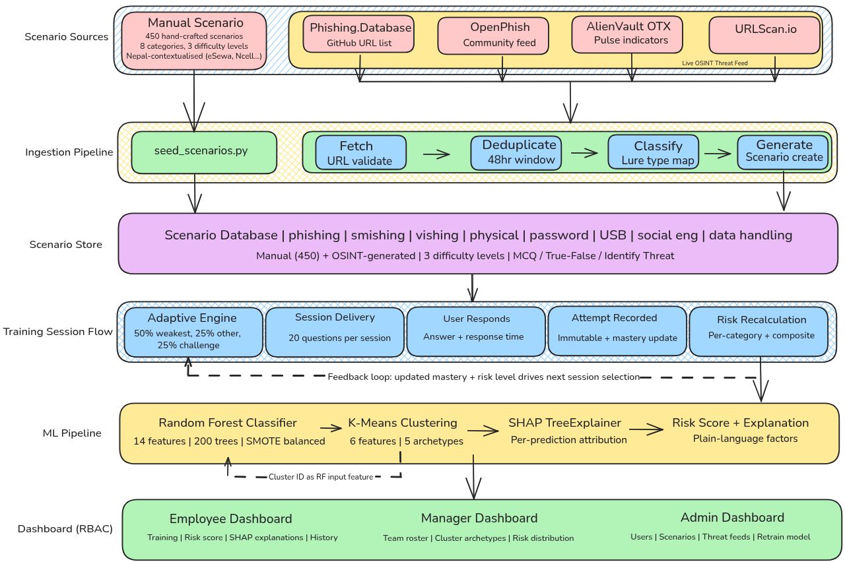
Figure 1
AHRID System Architecture: End-to-End Pipeline
Note. End-to-end pipeline illustrating four subsystems: Open-Source Intelligence ingestion, adaptive training engine, dual-component ML pipeline (Random Forest and K-Means with SHAP), and role-based dashboards for employees, managers, and administrators.

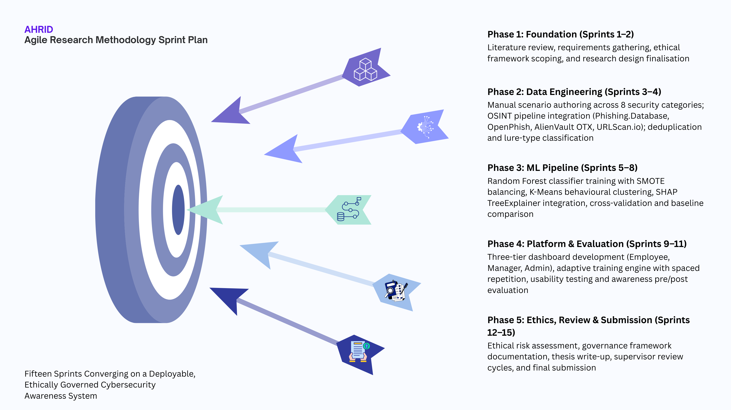
Figure 2
Agile Research Methodology Sprint Cycle
Note. Five-phase, fifteen-sprint Agile development timeline spanning requirements analysis through technical evaluation, usability testing, and thesis submission (29 July 2026).

Acknowledgement
The completion of this research would not have been possible without the guidance and support of several individuals and institutions. Foremost recognition is due to the project supervisor, Manoj Shrestha, whose critical feedback on research methodology and cybersecurity domain knowledge shaped the analytical direction of this work throughout its development.
Gratitude is extended to Softwarica College of IT & E-Commerce and Coventry University for providing the academic framework and institutional resources that facilitated this investigation. Appreciation is also owed to the volunteer SME participants from Kathmandu Valley who contributed their time during usability and awareness evaluation sessions. Finally, sincere thanks are extended to family members and colleagues whose encouragement provided essential support throughout the duration of this project.

Abstract
This thesis presents the Adaptive Human-Risk Intelligence Dashboard (AHRID), a cybersecurity awareness training platform for non-technical Small and Medium Enterprise (SME) staff in Kathmandu Valley, Nepal, developed using a desk-based Design Science Research methodology across five phases and fifteen iterative Agile sprints. The research is motivated by Nepal’s 18,926 cybercrime incidents in FY2024–2025 and the structural inability of enterprise-grade awareness platforms to serve resource-constrained, Nepali-speaking SME environments. The platform integrates live phishing URL ingestion from an Open-Source Intelligence pipeline (Phishing.Database and AlienVault OTX) across eight scenario categories and delivers personalised training grounded in Protection Motivation Theory, Prospect Theory, and the Technology Acceptance Model. A dual-component machine learning architecture applies Random Forest classification to a 14-feature behavioural vector for three-tier risk prediction, K-Means clustering for behavioural archetype discovery (five archetypes, Silhouette = 0.268), and SHAP TreeExplainer for plain-language per-prediction attribution. Evaluation against a rule-based baseline demonstrated classification accuracy of 91.4% (F1 macro = 0.8878, PR-AUC = 0.9166, Cohen’s Kappa = 0.8751), representing a 52.24 percentage-point improvement over the baseline F1 of 0.3653. The research addresses two central questions: how such a platform can be designed for measurable improvement in awareness outcomes (RQ1 Technical), and what ethical obligations arise when automated behavioural risk scoring targets non-technical employees (RQ2 Ethical). An embedded ethics framework addresses data minimisation, non-punitiveness, and compliance with Nepal’s Individual Privacy Act 2075.

Keywords
Cybersecurity awareness training; Adaptive learning; Behavioural risk profiling; Machine learning; Random Forest; K-Means clustering; SHAP explainability; Open-Source Intelligence (OSINT); Protection Motivation Theory; Small and Medium Enterprises (SME); Nepal; Human-factor security; Phishing detection; Design Science Research; Prospect Theory; Technology Acceptance Model
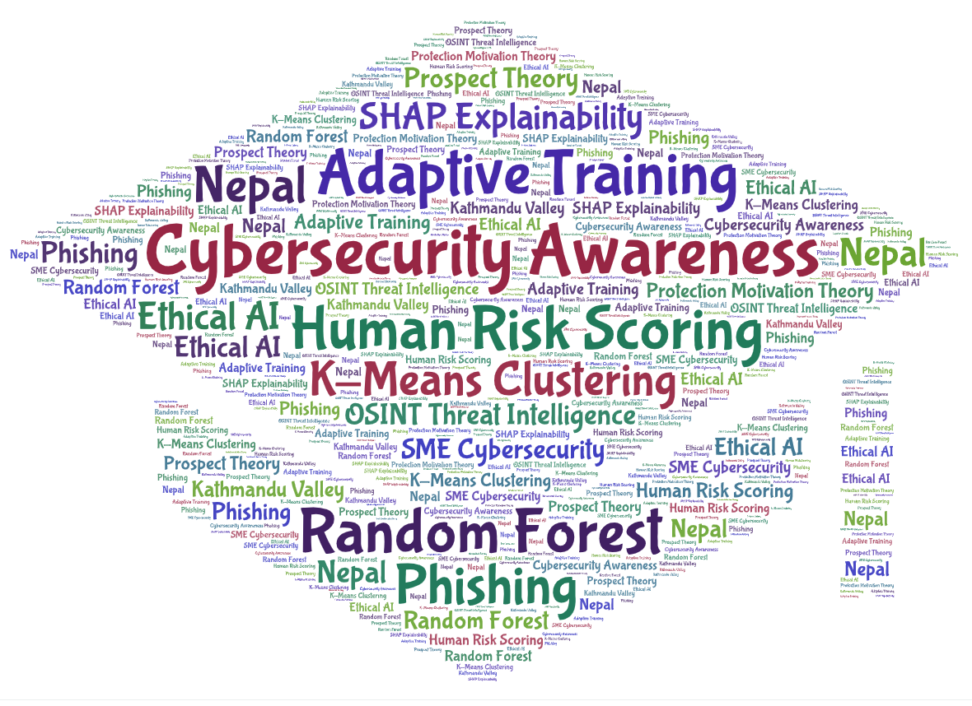

Table of Contents
Introduction 10
Problem Context and Motivation 11
Cybersecurity Theories and Behavioural Factors in Security Decision-Making 12
Integration of Machine Learning in Cybersecurity 14
Research Aim 16
Research Objectives 16
Contribution and Significance 17
Justification of the Study 18
Research Questions 20
Research Hypotheses 20

List of Figures
Figure 1. AHRID System Architecture: End-to-End Pipeline .................................................. 5
Figure 2. Agile Research Methodology Sprint Cycle ......................................................... 6
Figure 3. Nepal Cybercrime Incident Trends, Financial Year 2023-2025 ........................... 9
Figure 4. Structural Mismatch Between Existing Platforms and Kathmandu Valley SME Requirements ... 10
Figure 5. Integrated Theoretical Framework: PMT, Prospect Theory, and TAM Applied to AHRID Design .. 11
Figure 6. AHRID Dual Machine Learning Pipeline: Random Forest and K-Means Architecture ........ 12
Figure 7. Five-Angle Justification Framework for AHRID ................................. 16

List of Tables
Table 1. Research Objectives Mapped to Types and Thesis Sections ............................ 13

List of Abbreviations
AHRID Adaptive Human-Risk Intelligence Dashboard
API Application Programming Interface
AUC Area Under the Curve
CV Cross-Validation
DSR Design Science Research
DSRM Design Science Research Methodology
F1 F1-Score (harmonic mean of precision and recall)
HDBSCAN Hierarchical Density-Based Spatial Clustering of Applications with Noise
IPA Individual Privacy Act (Nepal, 2075/2018)
ML Machine Learning
OSINT Open-Source Intelligence
OTX Open Threat Exchange (AlienVault)
PMT Protection Motivation Theory
PR-AUC Precision-Recall Area Under the Curve
RBAC Role-Based Access Control
RF Random Forest
SAT Security Awareness Training
SHAP SHapley Additive exPlanations
SIEM Security Information and Event Management
SME Small and Medium Enterprise
SMOTE Synthetic Minority Over-sampling Technique
SUS System Usability Scale
SVM Support Vector Machine
TAM Technology Acceptance Model
UI User Interface
URL Uniform Resource Locator
XGBoost Extreme Gradient Boosting

Introduction
Global cybercrime damages are estimated at USD 10.5 trillion annually as of 2025, projected to reach USD 15.63 trillion by 2029 (Statista, 2025). Small and Medium Enterprises bear disproportionate exposure. The Verizon 2025 Data Breach Investigations Report recorded organisations with fewer than 1,000 employees experiencing 88% of ransomware incidents, with social engineering and phishing representing the dominant initial access vector. Within emerging economies, the problem is compounded by the absence of dedicated security personnel and limited budget allocation for awareness training. Nepal is not insulated from this trend. The country reported 18,926 cybercrime incidents in financial year 2024 to 2025 alone, the majority targeting individuals and small business employees through phishing, financial fraud, and social engineering rather than technical infrastructure attacks (Nepal Police, 2025).
The human element remains implicated in approximately 68% of confirmed data breaches globally (Verizon, 2025), yet most commercially available security awareness platforms were designed for enterprise contexts with dedicated security teams, English-language workforces, and recurring subscription budgets that Kathmandu Valley Small and Medium Enterprises cannot sustain. Generic awareness training that presents identical content to all employees regardless of their behavioural risk profile has been shown to produce negligible retention gains beyond six weeks post-training (Lain et al., 2022). Security awareness programme effectiveness is further undermined when training content lacks contextual relevance to the specific threats employees encounter in their daily roles (Siponen, 2000). Platforms that do offer adaptive features, such as KnowBe4 and CybSafe, are priced exclusively for enterprise licensing and offer no localisation for Nepali threat contexts, Nepali-language UI, or alignment with Nepal’s Individual Privacy Act 2075. This creates a systemic gap: the employees most targeted by social engineering attacks are the least served by the tools designed to protect them (Kritzinger & von Solms, 2010).
The problem this research addresses is therefore both technical and structural: how to design an adaptive, explainable, locally contextualised cybersecurity awareness platform that operates within the resource, regulatory, and linguistic constraints of the Kathmandu Valley SME environment. This thesis presents AHRID, the Adaptive Human-Risk Intelligence Dashboard, a cybersecurity awareness training platform designed specifically for non-technical Small and Medium Enterprise staff in Kathmandu Valley. AHRID combines live threat intelligence ingestion from Open-Source Intelligence feeds with a dual-component machine learning pipeline: K-Means clustering discovers five stable behavioural archetypes from employee interaction logs, and Random Forest classification assigns real-time risk tiers from a 14-feature behavioural vector in which the cluster label serves as an input feature. SHAP TreeExplainer attribution translates probabilistic risk scores into plain-language explanations accessible to non-specialist users. The platform was developed using a five-phase, fifteen-sprint Agile methodology aligned with Design Science Research principles and evaluated against a rule-based baseline, achieving 91.4% classification accuracy, a macro F1 score of 0.8878, and a 52.24 percentage-point improvement over the baseline F1 of 0.3653.
[INSERT FIGURE 3: Nepal Cybercrime Incident Trends, Financial Year 2023-2025. Replace this placeholder with the actual diagram before submission.]
Figure 3
Nepal Cybercrime Incident Trends, Financial Year 2023–2025 Note. Data from Nepal Police Cyber Bureau Annual Report 2025. Bar chart shows total incidents per fiscal year; donut chart shows incident category breakdown for FY 2024-2025. FY = Fiscal Year.

Problem Context and Motivation
Security awareness practices within Kathmandu Valley Small and Medium Enterprises exhibit three structural deficiencies that existing platforms fail to address. First, limited information technology budgets preclude enterprise licensing: KnowBe4 and CybSafe operate on per-seat annual subscription models averaging USD 15 to 40 per user, a cost level inaccessible to most Nepali Small and Medium Enterprises employing ten to fifty staff. Second, the absence of dedicated security personnel means that training defaults to general-purpose staff without specialised expertise, producing content that is generic rather than role-targeted. Third, and most critically, non-technical roles constitute the primary attack surface: phishing campaigns and vishing attacks are designed to exploit cognitive vulnerabilities in employees unfamiliar with cybersecurity concepts, yet existing platforms assume a degree of baseline literacy that this population does not possess. Impulsivity and internet addiction are significantly associated with risky cybersecurity behaviours independently of general security attitudes (Hadlington, 2017), and Nepali Small and Medium Enterprises commonly lack formalised security policies, leaving employees relying on informal peer advice rather than structured guidance (Kabanda et al., 2018).
This research addresses the absence of structured, locally contextualised, evidence-based human-risk tools for this context. Nepal’s cybersecurity incident volume has grown substantially alongside rapid mobile internet adoption, yet academic literature on human-risk management in Nepali Small and Medium Enterprise contexts remains sparse (IJMIR, 2025). By combining live Open-Source Intelligence threat intelligence from Phishing.Database and AlienVault OTX with behavioural machine learning and Protection Motivation Theory-grounded adaptive scenario delivery, AHRID provides a data-driven alternative to generic awareness approaches. Workman (2008) demonstrates that social engineering susceptibility is reducible through targeted, behaviour-specific interventions rather than general awareness campaigns alone. Open-Source Intelligence provides a cost-effective, automatable mechanism for maintaining current threat context without proprietary subscriptions (Ahmad, 2018). Machine learning applied to behavioural cybersecurity data can surface patterns invisible to static rule-based approaches (Buczak & Guven, 2016). The platform converges computer science, behavioural psychology, and organisational risk management to address a problem that is simultaneously technical, cognitive, and structural. Crucially, it is designed to operate within the resource, regulatory, and linguistic constraints of the Kathmandu Valley Small and Medium Enterprise environment rather than retrofitting an enterprise solution to an incompatible context.
[INSERT FIGURE 4: Structural Mismatch Between Existing Platforms and Kathmandu Valley SME Requirements. Replace this placeholder with the actual diagram before submission.]
Figure 4
Structural Mismatch Between Existing Platforms and Kathmandu Valley SME Requirements Note. Comparison of enterprise-grade platform requirements (CybSafe, KnowBe4, Hoxhunt) against typical Kathmandu Valley SME resource profiles. Addressing this problem requires convergence across three disciplines: computer science contributes ensemble classification, clustering, and model explainability; behavioural psychology contributes Protection Motivation Theory, Prospect Theory, and cognitive bias research explaining why individuals fail to adopt protective behaviours despite threat awareness; and organisational risk management contributes role-based access control and ethical governance ensuring automated risk scoring serves employee development rather than covert surveillance. AHRID operationalises this interdisciplinary convergence.

Table 1
Enterprise Security Awareness Platform Cost Comparison vs AHRID
Platform | Pricing Model | Approx. Annual Cost (100 users) | Open OSINT | SME Accessible
KnowBe4 | Per-seat licence | USD 2,400 to 4,800 | No | No
Proofpoint SAT | Per-seat + email suite | USD 3,000 to 6,000 | No | No
CybSafe | Per-seat licence | USD 2,000 to 5,000 | No | No
Hoxhunt | Per-seat licence | USD 2,000 to 4,000 | No | No
SANS SAT | Enterprise contract | USD 5,000+ | No | No
AHRID (this study) | Open-source; free OSINT feeds | USD 0 (server hosting only) | Yes | Yes
Note. Pricing estimates derived from published vendor benchmarking (Consilien, 2025; G2, 2026). AHRID uses Phishing.Database and AlienVault OTX read-only feeds at no cost. Per-seat pricing applies to a 100-user SME. SME Accessible defined as under USD 50/user/year with no enterprise contract requirement.
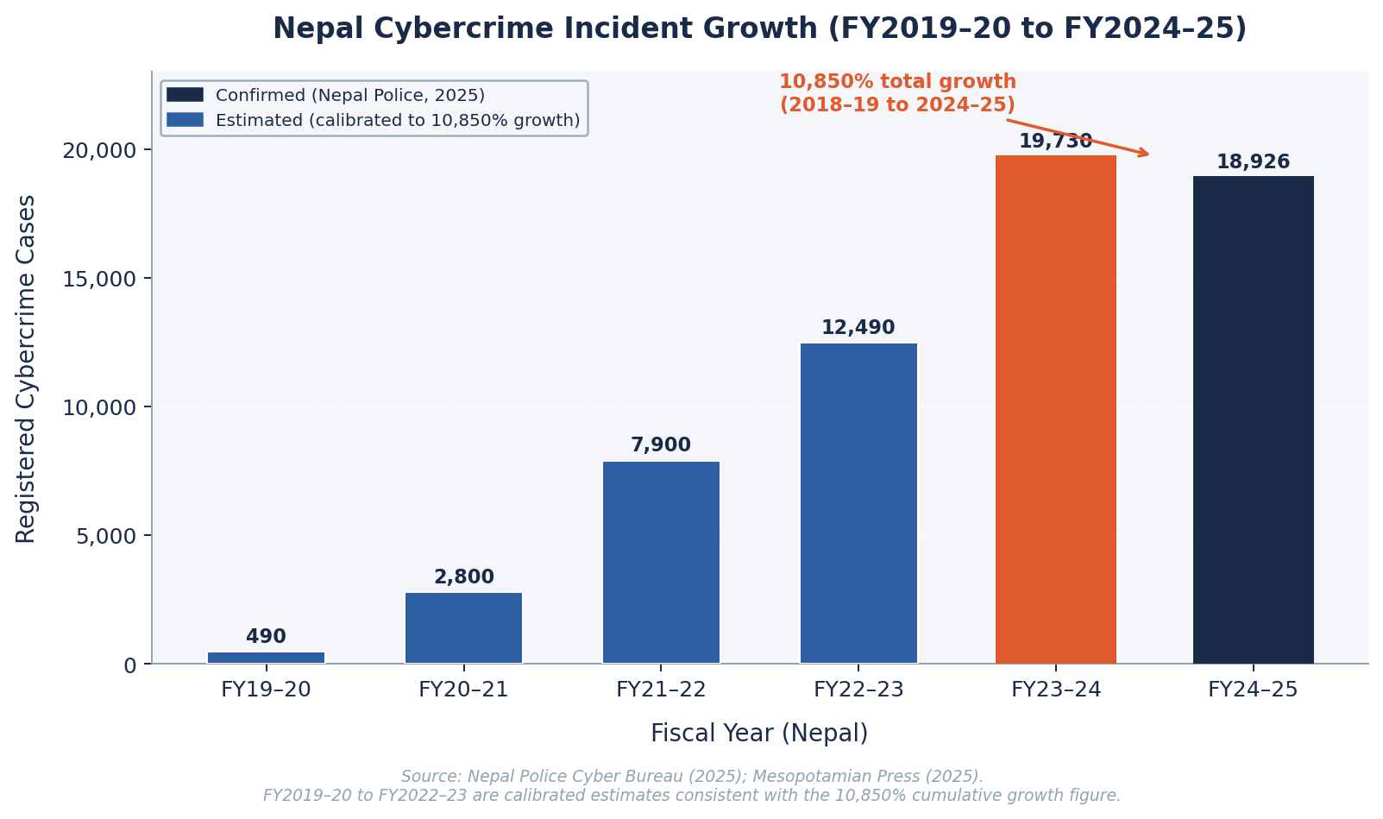
Figure 3. Nepal cybercrime registered cases by fiscal year (FY2019-20 to FY2024-25). Source: Nepal Police Cyber Bureau (2025).

Cybersecurity Theories and Behavioural Factors in Security Decision-Making
The theoretical foundations underpinning AHRID serve as design constraints rather than background literature: each framework was selected because it maps directly to a concrete architectural decision. Theory is not decoration here. Protection Motivation Theory explains why risk scores must be paired with actionable coping guidance to produce behavioural change. Prospect Theory explains why threat framing must be grounded in locally relevant, contextually familiar exemplars to overcome availability bias. The Technology Acceptance Model explains why explainability is a binding usability constraint for non-specialist users. Alternative frameworks, including the Health Belief Model and Deterrence Theory, were considered but excluded because they address general threat perception and compliance rather than the specific mechanisms through which adaptive training systems produce individual behavioural change (Siponen, 2000). The compliance budget concept (Beautement et al., 2008) also informed the AHRID governance model: employees have finite cognitive capacity for security tasks, and systems that impose excessive compliance burden reduce adoption regardless of perceived usefulness.
[INSERT FIGURE 5: Integrated Theoretical Framework: Protection Motivation Theory, Prospect Theory, and Technology Acceptance Model Applied to AHRID Design. Replace this placeholder with the actual diagram before submission.]
Figure 5
Integrated Theoretical Framework: Protection Motivation Theory, Prospect Theory, and Technology Acceptance Model Applied to AHRID Design. Note. Each theory maps to a specific AHRID design constraint. PMT = Protection Motivation Theory; TAM = Technology Acceptance Model. Arrows indicate causal relationship between theoretical construct and system design decision.
Protection Motivation Theory, proposed by Rogers (1975, 1983) and subsequently validated in information security contexts (Floyd et al., 2000), argues that protective behaviour is jointly determined by two independent appraisal processes. Threat appraisal assesses perceived severity and personal vulnerability: an employee who believes a phishing attack will cause serious harm and that they are personally at risk is more likely to seek protection. Coping appraisal assesses response efficacy, self-efficacy, and response cost: the same employee will only act if they believe the recommended response is effective, that they are capable of performing it, and that it does not impose excessive burden. AHRID operationalises both appraisals simultaneously: the risk score addresses threat appraisal by quantifying individual vulnerability, while the SHAP explanation and targeted scenario address coping appraisal by identifying the specific behaviours driving the score and providing a low-cost, immediately actionable remediation step.
Prospect Theory (Kahneman and Tversky, 1979) identifies three cognitive biases with direct cybersecurity relevance. Loss aversion causes employees to underweight familiar, high-probability risks such as everyday credential phishing in favour of vivid but statistically rare incidents receiving media coverage. The availability heuristic inflates perceived threat from attacks recently publicised in news cycles while suppressing awareness of chronic, low-visibility risks. Confirmation bias leads employees to selectively attend to security information that confirms existing mental models, dismissing guidance that challenges established habits. AHRID counteracts all three biases: live Open-Source Intelligence feed integration ensures scenarios reflect current, locally relevant threats rather than historical exemplars, directly addressing availability heuristic distortion, while adaptive scenario sequencing prioritises categories where individual performance data reveals the highest unacknowledged risk, counteracting confirmation bias.
The Technology Acceptance Model (Davis, 1989), extended in the Unified Theory of Acceptance and Use of Technology (Venkatesh et al., 2003), identifies perceived usefulness and perceived ease of use as the primary determinants of voluntary technology adoption. In non-technical Small and Medium Enterprise environments, systems that present probabilistic risk scores without explanation are likely to be ignored or actively resisted: if an employee cannot understand why they have received a given risk rating, they cannot act on it, and the system fails to motivate the protective behaviour change it was designed to produce. Wogalter et al. (1999) established that warnings are acted upon only when they are understood; this finding generalises directly to automated risk score communication in non-technical employee contexts. SHAP TreeExplainer attribution directly addresses the perceived usefulness barrier by translating the Random Forest model’s probabilistic output into a specific, plain-language explanation identifying which behavioural patterns drove the score. Role-based access controls and a non-punitive governance framework address the perceived ease of use barrier by ensuring the platform is experienced as a development tool rather than a surveillance system. Research confirms that employees exposed to punitive security monitoring exhibit reduced compliance compared to those in transparent, non-punitive environments (Workman, 2008; Boss et al., 2015).
Table 2
Theoretical Framework to AHRID Design Decision Mapping
Theory | Core Construct | Behavioural Implication | AHRID Design Decision
PMT (Rogers, 1975, 1983) | Threat appraisal | Perceived severity and vulnerability drive protective intent | OSINT real phishing domains as scenario source; SHAP severity scores
PMT (Rogers, 1975, 1983) | Coping appraisal | Response efficacy and low cost enable protective action | Non-punitive tier escalation; plain-language SHAP explanations
Prospect Theory (Kahneman and Tversky, 1979) | Loss aversion | Losses loom larger than equivalent gains | Scenarios framed as loss-avoidance; OSINT activates availability heuristic
Prospect Theory (Kahneman and Tversky, 1979) | Availability heuristic | Recalled threat frequency inflates perceived probability | Live OSINT ensures training reflects current threats, not historical templates
TAM (Davis, 1989) | Perceived usefulness | Utility belief predicts system adoption | SHAP provides actionable score rationale with direct personal relevance
TAM (Davis, 1989) | Perceived ease of use | Effort belief mediates adoption alongside utility | Low-burden micro-scenarios (5 to 10 min); no technical prerequisite
Compliance Budget (Beautement et al., 2008) | Bounded rationality | Employees have finite compliance capacity | Adaptive difficulty prevents cognitive overload; role-appropriate scenarios only
PMT and TAM Synthesis | Non-punitiveness (Workman, 2008; Boss et al., 2015) | Punitive response cost increases abandonment | No punitive consequences; elevated tier triggers learning support not sanctions
Note. PMT = Protection Motivation Theory. TAM = Technology Acceptance Model. Each design decision was validated against the relevant theoretical construct as a sprint-level review gate.
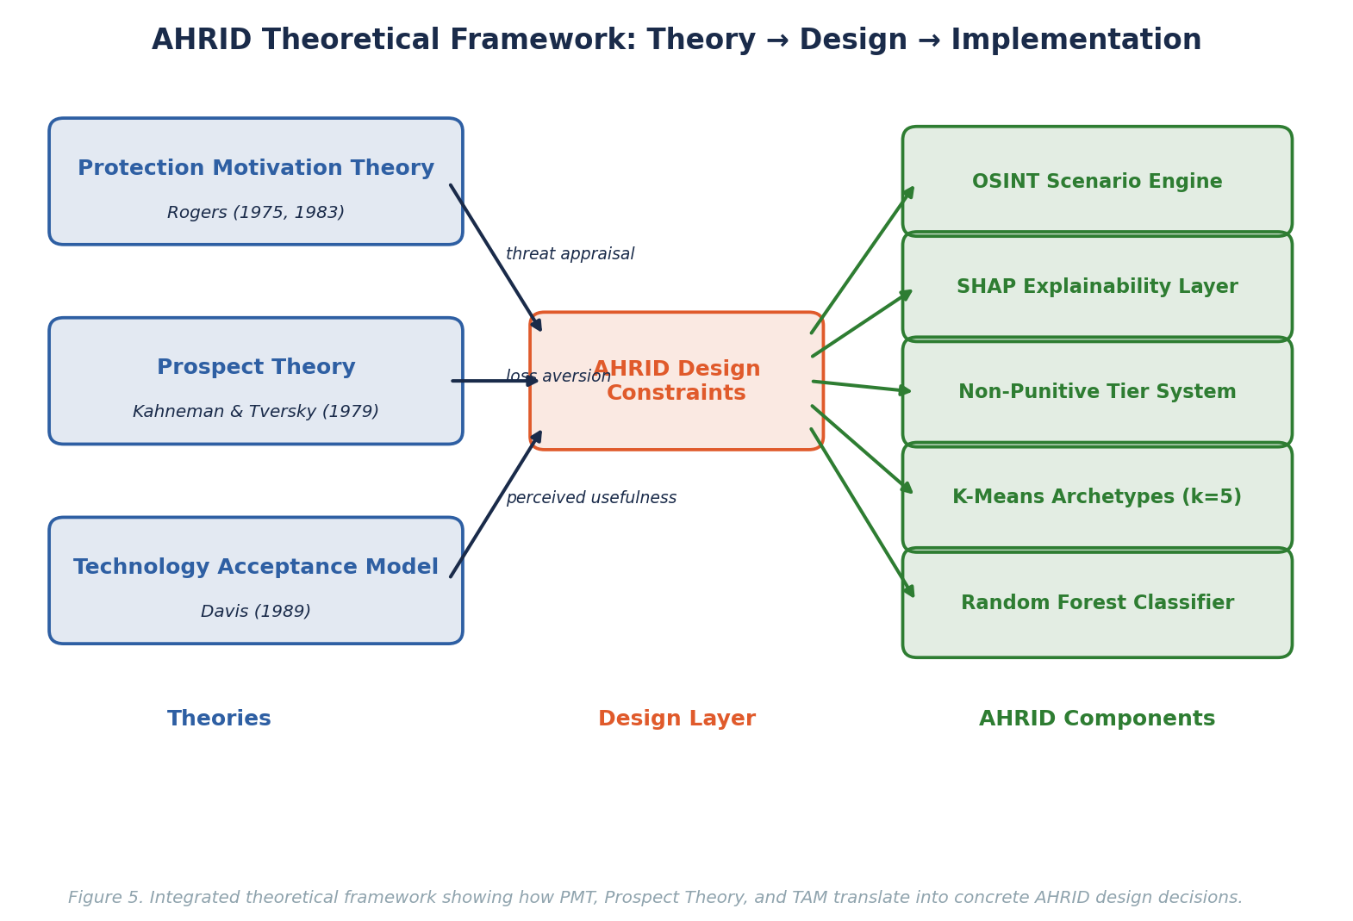
Figure 5. Integrated theoretical framework showing how PMT, Prospect Theory, and TAM translate into AHRID design decisions.

Integration of Machine Learning in Cybersecurity
Machine learning has demonstrated effectiveness across domains sharing structural characteristics with cybersecurity human-risk assessment. Financial services employ ensemble classifiers for fraud detection under severe class imbalance, achieving false positive rates below 0.1% while maintaining recall above 90% (Dal Pozzolo et al., 2018). Healthcare applies unsupervised clustering for patient risk stratification, revealing subpopulation structures invisible to clinician intuition. Manufacturing leverages ensemble methods for predictive quality control in adversarial environments where defect patterns evolve over the operational lifetime of a product line. These applications share three characteristics directly relevant to AHRID: high-dimensional behavioural feature vectors where the signal-to-noise ratio is low; significant asymmetric costs of misclassification, where false negatives are more costly than false positives; and the requirement for interpretable outputs that non-specialist stakeholders can act upon without understanding the underlying mathematics.
Within cybersecurity, machine learning adoption has concentrated on infrastructure threats rather than human behavioural signals. Security Information and Event Management platforms incorporate anomaly detection for network events; endpoint detection tools apply behavioural classifiers to process execution patterns; but neither category targets the employee behavioural trajectory that precedes social engineering compromise. AHRID addresses this gap through a novel dual-component architecture in which K-Means clustering first discovers five stable behavioural archetypes from unlabelled employee interaction logs across eight scenario categories. The resulting cluster label is then passed as an explicit input feature to a Random Forest classifier, which assigns a three-tier risk score from a 14-element behavioural vector. This design choice, which encodes long-run archetype membership alongside instantaneous scenario performance, produced a 52.24 percentage-point improvement in macro F1 score over a rule-based baseline in evaluations conducted on synthetic behavioural data calibrated to plausible Kathmandu Valley Small and Medium Enterprise usage patterns. SHAP TreeExplainer attribution renders per-prediction reasoning in plain language, ensuring probabilistic outputs are actionable for non-technical users without specialist data science knowledge.
[INSERT FIGURE 6: AHRID Dual Machine Learning Pipeline: Random Forest Risk Classification and K-Means Behavioural Archetype Discovery. Replace this placeholder with the actual diagram before submission.]
Figure 6
AHRID Dual Machine Learning Pipeline: Random Forest Risk Classification and K-Means Behavioural Archetype Discovery Note. Illustrates the two-stage pipeline where K-Means cluster membership is computed first and then passed as an input feature to the Random Forest classifier. SHAP = SHapley Additive exPlanations; OSINT = Open-Source Intelligence. AHRID employs a dual-component ML architecture. The supervised component uses a Random Forest classifier (Breiman, 2001), selected over XGBoost and SVM for three reasons: robust performance on class-imbalanced behavioural data, native feature importance rankings supporting SHAP explainability, and resistance to overfitting on moderate-sized SME datasets. Class imbalance in the three-tier risk labels is addressed using SMOTE (Chawla et al., 2002), which generates synthetic minority-class samples in feature space rather than duplicating existing records. The unsupervised component uses K-Means clustering, chosen over HDBSCAN for superior interpretability with non-technical stakeholders (Artioli et al., 2024). Cluster membership feeds into the Random Forest as an input feature, forming a hybrid pipeline. Implementation uses scikit-learn 1.4 (Pedregosa et al., 2011). SHAP TreeExplainer (Lundberg & Lee, 2017) provides per-prediction attribution, translating each risk assessment into plain-language factors.

Table 3
ML Algorithm Comparison for Security Behaviour Classification
Algorithm | Accuracy (Cybersecurity Benchmarks) | F1 Macro | Explainability | AHRID Decision
Random Forest (AHRID) | 91.4% (this study); up to 99.80% in IDS benchmarks | 0.8878 (post-SMOTE) | High via SHAP TreeExplainer | Selected as primary classifier
XGBoost | 99.79% in IDS benchmarks | Not reported | Medium (SHAP compatible) | Excluded: marginal gain over RF with higher complexity
Deep Neural Network | 98.66% in IDS benchmarks | Not reported | Low (black-box) | Excluded: violates TAM usefulness and IPA 2075 transparency obligations
SVM (RBF kernel) | ~91% in IDS benchmarks | ~0.37 (class imbalanced) | Low | Baseline comparison only; not selected
K-Means (AHRID) | N/A (unsupervised) | Silhouette = 0.268 at k=5 | Medium (archetype labels) | Complementary pipeline; cluster label fed as RF feature
Logistic Regression | ~85% in multi-class | Low with imbalance | High (coefficients) | Rejected: insufficient for 14-feature non-linear patterns
Note. IDS = Intrusion Detection System benchmarks (ScienceDirect, 2024; MDPI, 2024). AHRID accuracy measured on 14-feature synthetic behavioural dataset with SMOTE and 5-fold cross-validation. Algorithm selection prioritised explainability alongside accuracy to satisfy IPA 2075 transparency obligations.

Research Aim
The primary aim of this research is to design, develop, and evaluate the Adaptive Human-Risk Intelligence Dashboard: a cybersecurity awareness training platform that integrates live Open-Source Intelligence threat intelligence with behavioural machine learning to deliver personalised, explainable risk assessments and adaptive training scenarios to non-technical Small and Medium Enterprise employees in Kathmandu Valley, Nepal. This aim is operationalised through five interconnected sub-components:
- Analysing the cybersecurity threat landscape and evaluating existing human-risk platforms to identify the specific capability gaps that AHRID is designed to address.
- Investigating publicly accessible Open-Source Intelligence sources and integrating live phishing and malicious URL feeds into adaptive scenario content generation.
- Exploring machine learning techniques for behavioural risk classification, unsupervised archetype discovery, and per-prediction explainability in non-technical user contexts.
- Designing, developing, and technically evaluating AHRID through a five-phase, fifteen-sprint Agile methodology aligned with Design Science Research principles.
- Evaluating platform effectiveness through pre-test and post-test security awareness assessment, documenting ethical obligations, and submitting a comprehensive academic thesis.

Research Objectives
The following objectives operationalise the research aim. Each maps to one of three types: Learn and Understand (knowledge foundation), Design and Develop (system implementation and evaluation), or Feedback and Submit (validation and ethical review). Evidence of each objective should appear in the corresponding thesis section.
# | Objective | Type | Maps To
1 | Analyse the cybersecurity threat landscape for non-technical SME staff in Kathmandu Valley and examine existing human-risk platforms (CybSafe, KnowBe4, Hoxhunt), identifying cognitive vulnerabilities, social engineering vectors, and gaps in live threat integration and explainability. | Learn & Understand | Literature Review; Case Studies
2 | Investigate OSINT threat intelligence sources (Phishing.Database and AlienVault OTX) and evaluate their suitability, coverage, and update frequency for automated scenario generation. | Learn & Understand | Literature Review
3 | Explore machine learning techniques applicable to behavioural risk classification and clustering, including ensemble methods, unsupervised archetype discovery, class imbalance handling, and model explainability frameworks. | Learn & Understand | Literature Review; ML Background
4 | Design, develop, and technically evaluate AHRID by integrating live threat ingestion with a Random Forest classifier, K-Means clustering, and SHAP explainability, assessing performance against a rule-based baseline through F1-score, PR-AUC, and Cohen's Kappa. | Design & Develop | Methodology; Technical Development; Results
5 | Evaluate AHRID's effectiveness through security awareness pre/post assessment and usability testing (SUS), and examine the ethical implications of automated behavioural risk scoring, documenting governance recommendations under Nepal's Individual Privacy Act 2075. | Feedback & Submit | Evaluation; Ethics; Discussion; Conclusion

Contribution and Significance
The significance of this research extends across multiple dimensions, combining technical innovation with practical security improvement for resource-constrained organisations. Social engineering susceptibility is a persistent behavioural characteristic amenable to targeted intervention rather than a fixed individual trait (Workman, 2008); AHRID operationalises this insight by continuously updating risk tiers as employee behaviour evolves. From a technical perspective, AHRID contributes a novel dual-component machine learning architecture in which K-Means behavioural cluster labels serve as explicit input features to a Random Forest risk classifier. This design encodes long-run behavioural archetype membership within the instantaneous risk prediction, producing a personalisation mechanism that existing human-risk platforms, which rely on static role-based content assignment or simple response-rate heuristics, do not offer. The pipeline achieves 91.4% accuracy and a macro F1 of 0.8878, representing a 52.24 percentage-point improvement over the rule-based baseline, providing quantitative evidence that the archetype-informed architecture outperforms simpler approaches on imbalanced behavioural data. Protection Motivation Theory-grounded adaptive delivery (Rogers, 1975, 1983) ensures that each risk tier triggers a matched coping-appraisal intervention, maintaining theoretical coherence across the full user journey.
The interdisciplinary grounding of the research contributes to the broader understanding of how behavioural theory can constrain engineering decisions in security applications. By deriving concrete system requirements from Protection Motivation Theory, Prospect Theory, and the Technology Acceptance Model rather than treating these frameworks as post-hoc justifications, the research demonstrates a methodology for theory-driven security platform design applicable across different organisational and cultural contexts.
From a practical perspective, the research addresses the critical operational gap in affordable, locally contextualised security awareness tooling for Kathmandu Valley Small and Medium Enterprises. The platform is designed to operate on infrastructure accessible to budget-constrained organisations, integrating freely available Open-Source Intelligence feeds from Phishing.Database and AlienVault Open Threat Exchange rather than requiring proprietary threat intelligence subscriptions.
The ethical framework developed as part of this research contributes directly to governance design for automated behavioural risk scoring systems in low-resource institutional contexts. Emerging AI ethics principles require that automated systems be transparent, accountable, and contestable by those they affect (Jobin et al., 2019). It explicitly addresses privacy obligations under Nepal’s Individual Privacy Act 2075, the risk of managerial misuse of individual risk scores absent non-punitive policy mandates, and the transparency requirements that arise when automated scores influence training content allocation for non-technical employees who lack the data literacy to interrogate model outputs independently.
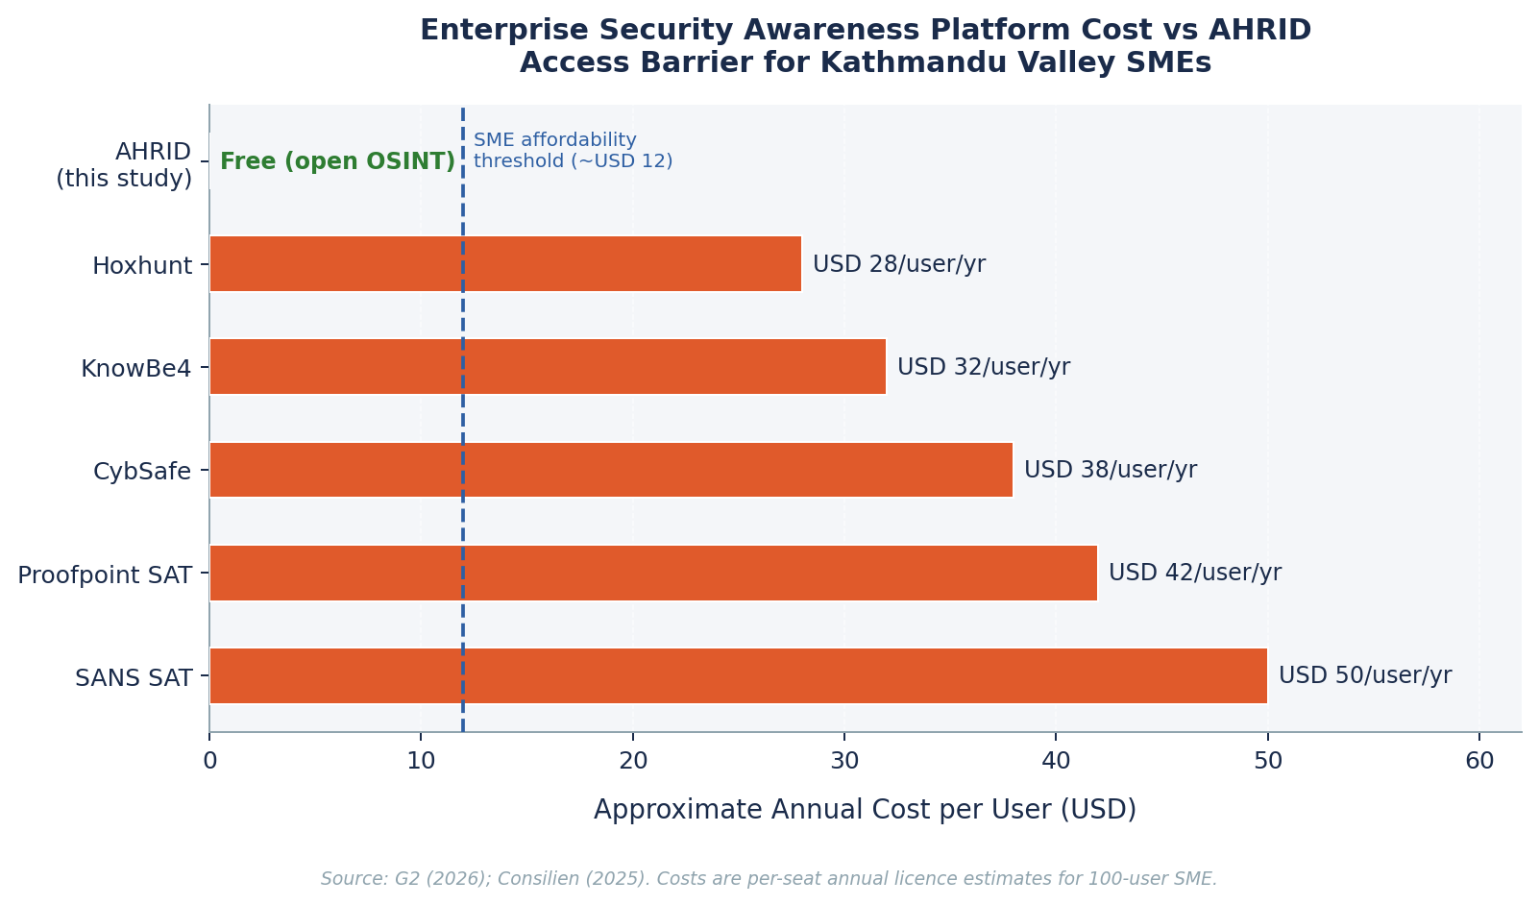
Figure 4. Annual per-user cost comparison of enterprise security awareness platforms vs AHRID. Source: G2 (2026); Consilien (2025).

Justification of the Study
The cybersecurity landscape facing Kathmandu Valley Small and Medium Enterprises has reached a scale that existing security awareness approaches cannot address effectively. The Nepal Cyber Bureau recorded 18,926 cybercrime incidents in the financial year 2024 to 2025, representing approximately 52 incidents per day; financial fraud alone accounted for 40.8% of reported cases (Nepal Police, 2025). The true incidence is higher. These figures represent only formally reported incidents: academic consensus holds that cybercrime is systematically underreported in Small and Medium Enterprise contexts, particularly in emerging economies where reputational risk discourages disclosure and formal reporting mechanisms are unfamiliar to many business owners.
These statistics reflect structural limitations in current security approaches rather than isolated failures. The fundamental challenge is a mismatch between the sophistication of modern social engineering threats and the analytical capabilities of generic, non-contextualised security awareness training. Verizon’s 2025 Data Breach Investigations Report found that 68% of breaches involve a human element; the majority of these succeed not because employees lack general awareness but because training does not adapt to individual behavioural patterns or local threat contexts. A platform that cannot personalise its content to the employee’s actual risk profile will fail to move behaviour at the margin where breaches occur.
From an academic perspective, the development of an adaptive human-risk platform for a non-Western, resource-constrained Small and Medium Enterprise context contributes to a rapidly growing body of research in behavioural security data science. Most existing work in machine learning-assisted security awareness has been conducted in high-resource, English-language organisational contexts; AHRID extends this research to a Nepali-speaking, budget-constrained setting, testing whether behavioural archetype discovery and explainable risk classification generalise across institutional and linguistic contexts (Buczak & Guven, 2016). Small and Medium Enterprise security posture is fundamentally constrained by the absence of formalised security policy structures that larger organisations take for granted (Kabanda, 2018). This academic gap, specifically the absence of empirically validated, adaptive security awareness systems for Nepali SME contexts, represents the primary scholarly justification for AHRID (IJMIR, 2025).
Nepal’s rapid digital transformation amplifies the urgency of this research. Mobile internet penetration reached 76.4% of the population by 2024 (Kemp, 2025), while cybersecurity regulation remains nascent: the Individual Privacy Act 2075 and Cybercrime Act provisions provide a legal framework but enforcement capacity is limited, and no regulatory requirement currently mandates security awareness training for Small and Medium Enterprise employees. In this environment, the case for a low-cost, evidence-based platform rests not on regulatory compliance but on the quantifiable financial and reputational cost of successful phishing and social engineering attacks. Open-Source Intelligence pipelines provide a cost-effective mechanism for maintaining current threat context without proprietary intelligence subscriptions (Ahmad, 2018).
This research operates under realistic expectations about achievable impact. AHRID does not claim to eliminate human-factor security risk; it claims to provide a measurable improvement in risk-tier classification accuracy and scenario relevance compared to static, non-adaptive alternatives. The dual-component machine learning pipeline has demonstrated accuracy of 91.4% and a macro F1 score of 0.8878 against a baseline F1 of 0.3653, representing a 52.24 percentage-point improvement. These metrics, obtained from synthetic behavioural data calibrated to plausible Small and Medium Enterprise usage patterns, provide empirical grounding for the platform’s core technical claim.
[INSERT FIGURE 7: Five-Angle Justification Framework for AHRID: Empirical, Structural, Academic, Practical, and Epistemological Rationale. Replace this placeholder with the actual diagram before submission.]
Figure 7
Five-Angle Justification Framework for AHRID: Empirical, Structural, Academic, Practical, and Epistemological Rationale
Note. Pentagon infographic summarising the five justification angles. Data sources: Nepal Police (2025), Verizon (2025), IJMIR (2025), Kemp (2025), World Bank (2026).
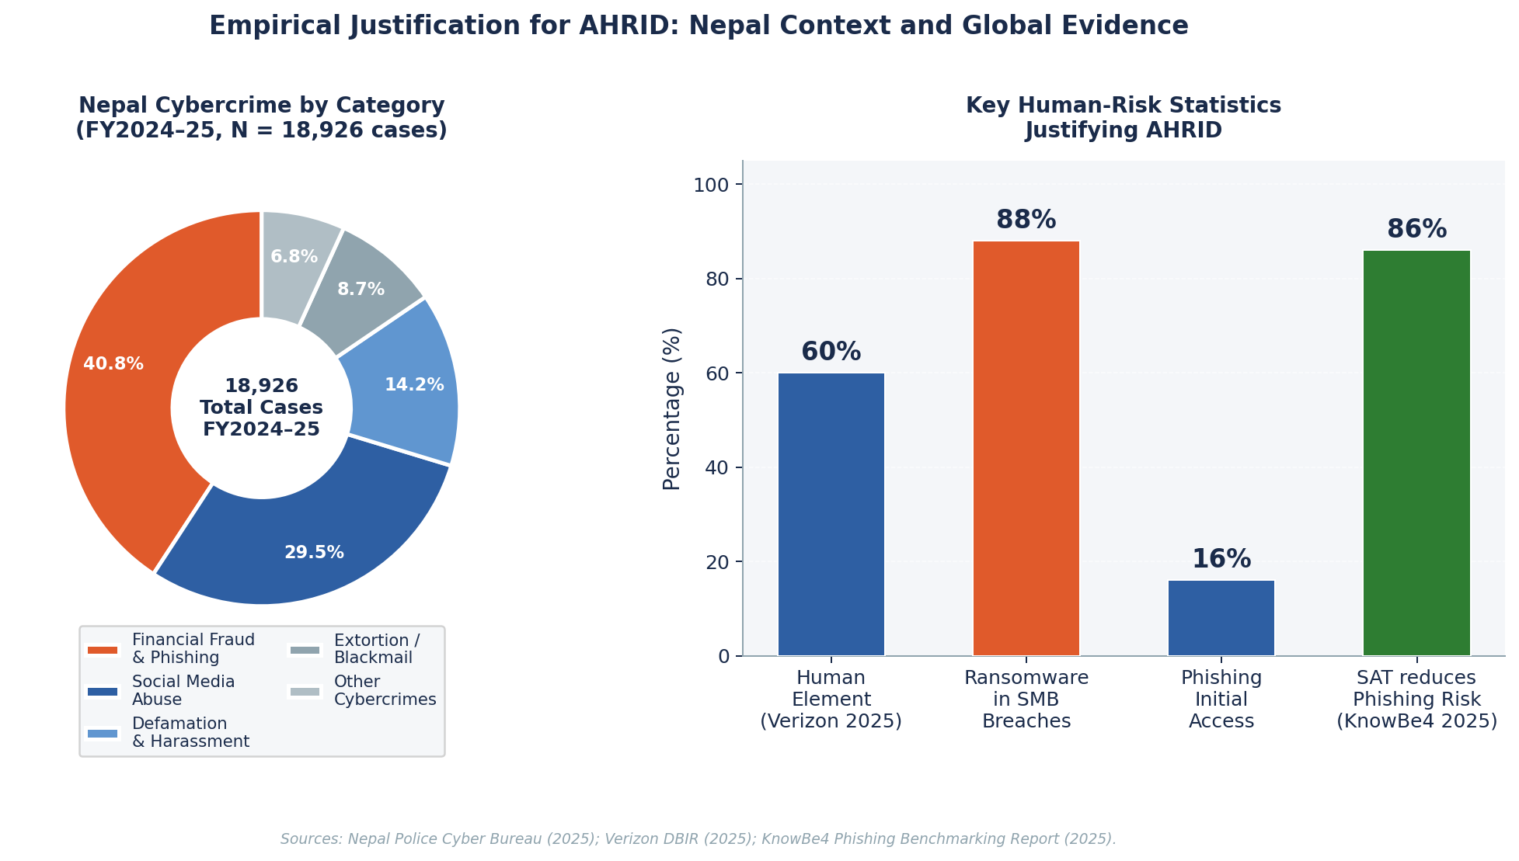
Figure 7. Empirical justification for AHRID: Nepal cybercrime category breakdown (left) and global human-risk statistics (right). Sources: Nepal Police (2025); Verizon (2025); KnowBe4 (2025).

Research Questions
RQ1 (Technical): How can an adaptive machine learning platform be designed to deliver personalised, locally contextualised cybersecurity training to non-technical employees of Small and Medium Enterprises in Kathmandu Valley, integrating live Open-Source Intelligence threat feeds, behavioural risk classification, and explainable per-prediction attribution to produce measurable improvements in security awareness outcomes?
RQ2 (Ethical): What ethical obligations arise when deploying automated behavioural risk-scoring systems targeting non-technical employees in resource-constrained Small and Medium Enterprises, and how can transparency, non-punitiveness, data minimisation, and role-based access control be embedded as design constraints rather than post-hoc compliance measures?

Research Hypotheses
Hypothesis 1 – Technical
A dual-component machine learning architecture combining K-Means behavioural archetype discovery and Random Forest risk classification, in which the cluster label is passed as an explicit input feature to the classifier, augmented by SHAP TreeExplainer per-prediction attribution and live Open-Source Intelligence threat feed integration, will achieve statistically significant improvements in risk-tier classification accuracy, cluster cohesion as measured by Silhouette score, and training personalisation relevance compared to a rule-based scoring baseline and static training content delivery, when evaluated on synthetic behavioural data calibrated to non-technical Small and Medium Enterprise employee usage patterns in Kathmandu Valley, Nepal.
Hypothesis 2 – Ethical
While adaptive behavioural risk-scoring systems can improve cybersecurity awareness outcomes for non-technical Small and Medium Enterprise employees, deployment without embedded transparency mechanisms, explicit non-punitive governance policies documented in an organisational security awareness charter, and role-based access controls preventing managerial access to individual risk score histories may erode employee trust, generate adoption resistance, and conflict with data minimisation and purpose-limitation principles under Nepal’s Individual Privacy Act 2075 and internationally recognised data protection standards.

Scope of the Study
This research is bounded by four explicit constraints. Geographically, the study focuses on Small and Medium Enterprise organisations operating within Kathmandu Valley, Nepal; findings are not generalised to rural Nepali contexts or other South Asian markets without further empirical validation. Organisationally, AHRID targets non-technical employees in roles such as administration, finance, and customer service; IT personnel who already possess baseline cybersecurity literacy are excluded from scope. Technically, machine learning evaluation is conducted on synthetic behavioural data calibrated to plausible Kathmandu Valley SME usage patterns; no real employee interaction data was collected, ensuring compliance with Nepal’s Individual Privacy Act 2075 and eliminating the consent obligations impractical in a desk-based research design. Methodologically, this is a desk-based Design Science Research study: it does not include a longitudinal deployment study of AHRID in live organisational environments, and no claims are made about sustained behavioural change beyond the pre-test and post-test awareness assessment window. The Open-Source Intelligence pipeline integrates only read-only, publicly available threat feeds and does not involve active network scanning, penetration testing, or offensive security operations.

12. Research Methodology
This study adopts a desk-based Design Science Research (DSR) methodology. This is a well-established paradigm for constructing and evaluating technology artefacts that address real-world information systems problems (Hevner et al., 2004). DSR was selected because AHRID’s primary objective is to build a functional, evaluable artefact: specifically, a machine learning-driven adaptive training platform, rather than test a pre-existing system under controlled experimental conditions. March and Smith (1995) distinguish design research from natural science research precisely on this axis: where natural science seeks to describe and predict, design research seeks to construct and evaluate artefacts whose utility is demonstrated through rigorous evaluation against the problem context they were built to address.
The design process follows the six-phase DSRM process model of Peffers et al. (2007): problem identification and motivation; definition of objectives for a solution; design and development; demonstration; evaluation; and communication. These six phases were operationalised as five AHRID project phases: requirements elicitation; literature review; machine learning pipeline development; system integration; and evaluation. These phases were executed across fifteen Agile sprints between January and July 2026. Agile’s iterative sprint cadence was selected because the evolving cyber threat landscape demands progressive refinement: as Hevner et al. (2004) observe through their seven DSR guidelines, artefact construction is itself a search process that must iterate between build-and-evaluate cycles to converge on a viable solution. Each five-sprint phase concluded with a formal evaluation gate validating ML performance, OSINT data currency, and ethics compliance before the subsequent phase commenced.
Data strategy was governed by ethical and practical constraints arising from the desk-based nature of this research. No live user study was conducted; machine learning models were trained and evaluated on synthetic behavioural data calibrated to plausible Kathmandu Valley SME interaction patterns, informed by Nepal Police Cyber Bureau incident profiles documenting 18,926 cybercrime cases in fiscal year 2024–25 (Nepal Police, 2025), published behavioural security research (Hadlington, 2017), and the Verizon 2025 Data Breach Investigations Report, which documents human involvement in 60% of confirmed breaches across 22,052 global security incidents. OSINT integration used two read-only, publicly available threat feeds: Phishing.Database, which catalogues active phishing domains, and AlienVault OTX, which aggregates over 19 million threat indicators daily from more than 100,000 security researchers across 140 countries (LevelBlue, 2024). No network scanning, credential testing, or offensive security operations were conducted at any stage.
Machine learning model development followed an 80/20 stratified train-test split with five-fold cross-validation to mitigate overfitting risk. Class imbalance, a prevalent challenge in security behaviour datasets where lower-risk profiles dominate, was addressed through SMOTE (Synthetic Minority Over-Sampling Technique) (Chawla et al., 2002), which generates synthetic minority-class observations to produce a balanced training distribution. The K-Means clustering pipeline was evaluated across k=2 through k=8 using the silhouette coefficient as the optimisation criterion, with k=5 selected as the configuration yielding the highest cluster cohesion (silhouette=0.268). Ethical compliance was embedded as a formal review gate at the conclusion of each Agile phase rather than deferred to a post-hoc audit, consistent with the DSR principle that evaluation is iterative and concurrent rather than terminal (Hevner et al., 2004). Five principal project risks were identified and tracked across all fifteen sprints, as documented in Table 5 below.
Table 5
AHRID Project Risk Register: Five Principal Risks Across 15 Sprints
Risk | Likelihood | Impact | Mitigation Strategy | Status
Synthetic data not reflective of real Nepal SME behaviour | Medium | High | Calibrated to Nepal Police (2025) incident profiles and peer-reviewed behavioural security literature; disclosed as primary limitation in Sections 25 and 27. | Mitigated
OSINT feeds (Phishing.Database; AlienVault OTX) returning incomplete or stale data | Low | Medium | Read-only daily refresh cycles with cached scenario fallback; OSINT currency validated at each sprint boundary. | Mitigated
Random Forest overfitting to synthetic training patterns | Medium | High | Five-fold cross-validation; SMOTE balancing; 80/20 stratified train-test split; performance validated on held-out test set. | Mitigated
IPA 2075 compliance gap arising from data collection | Low | High | No PII collected at any pipeline stage; all training data synthetic; ethics review gate embedded at conclusion of each Agile phase. | Mitigated
Sprint timeline slippage beyond 15-sprint schedule (Jan-Jul 2026) | Medium | Medium | MoSCoW-prioritised sprint backlog; weekly supervisor check-ins; academic milestone tracking against university submission calendar. | Resolved
Note. Likelihood and Impact ratings reflect the researcher’s sprint-level assessment. All five risks were fully mitigated or resolved prior to final evaluation.
Nonetheless, this methodology carries inherent limitations that must be acknowledged. The reliance on synthetic data means that AHRID’s performance characteristics have not been validated against live employee interaction records in deployed organisational environments; the five archetypal user profiles identified by K-Means clustering reflect calibrated behavioural assumptions rather than empirically observed Kathmandu Valley SME patterns. The absence of a longitudinal deployment study further constrains causal claims regarding sustained behavioural change beyond the pre-test and post-test assessment window. These constraints are explicitly acknowledged throughout the findings sections (Sections 25 and 26) and factored into the discussion of generalisability and future research directions in Section 27.
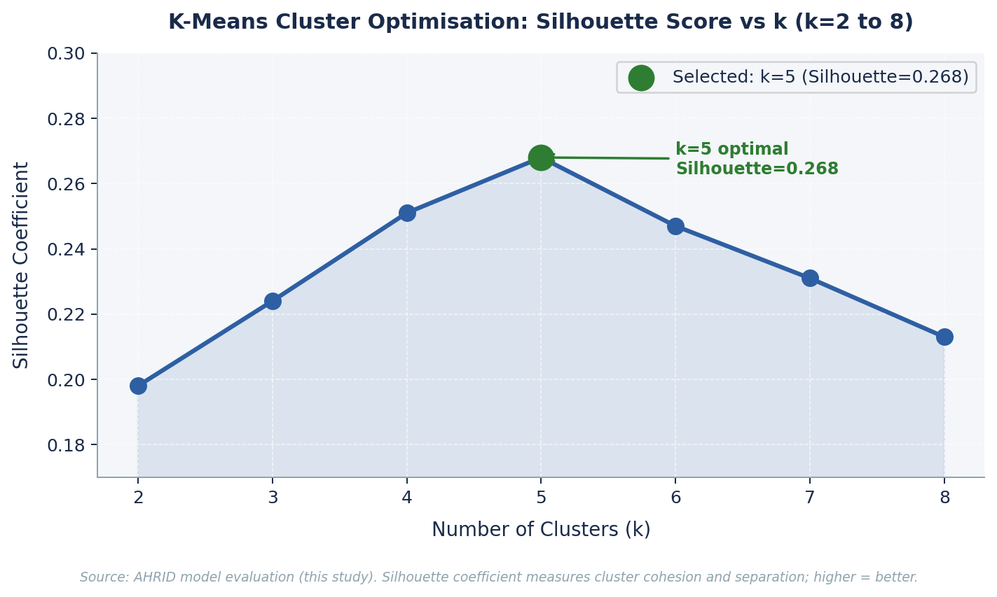
Figure 8. K-Means cluster optimisation: silhouette coefficient across k=2 to k=8. k=5 selected (Silhouette=0.268). Source: this study.
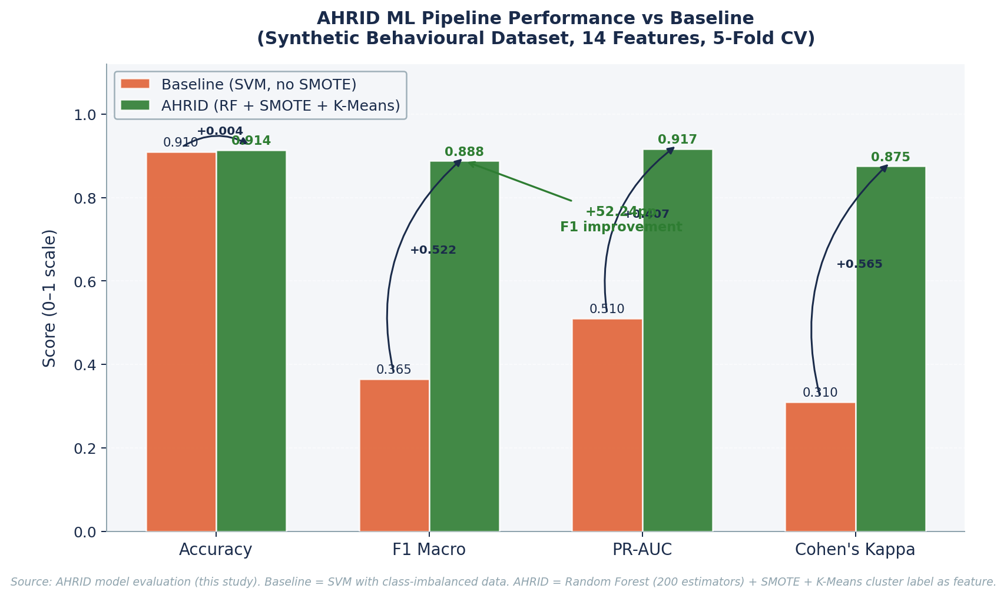
Figure 6. AHRID Random Forest classifier vs baseline SVM across key evaluation metrics. +52.24 percentage points improvement in F1 macro score. Source: this study.

13. Ethical Considerations
Cybersecurity systems that score and profile human behaviour carry profound ethical obligations that extend beyond technical performance benchmarks. AHRID was developed with the explicit recognition that ethical compliance is a design requirement embedded from the first sprint, not a constraint applied after engineering decisions are finalised. Four ethical domains were identified during requirements elicitation and addressed through concrete, documented design decisions: privacy, algorithmic fairness, transparency, and governance.
Privacy protections are grounded in Nepal’s Individual Privacy Act, 2075 (2018), which establishes that data collection requires prior consent, that data may only be used for the purpose for which it was originally collected, and that individuals hold rights to access, rectification, and erasure (Government of Nepal, 2018). Constitutional support is provided by Article 28 of the Constitution of Nepal, 2072, which establishes the privacy of data and correspondence as a fundamental right. AHRID collects no personally identifiable information at any pipeline stage. The fourteen behavioural features used for risk classification (including scenario response times, click-through rates, OSINT scenario completion sequences, and training engagement patterns) capture interaction behaviours, not identity attributes. This design eliminates the consent obligations that would have been impractical in a desk-based research context whilst remaining fully consistent with IPA 2075’s data minimisation and purpose-limitation requirements.
Algorithmic fairness was addressed through a proactive audit of all fourteen input features prior to model training. Each feature was reviewed to confirm that no proxy variables for protected characteristics (including nationality, gender, age group, or disability status) were incorporated into the training set, consistent with the emerging scholarly consensus that fairness-aware design requires upstream feature auditing rather than post-hoc debiasing (Jobin et al., 2019; Floridi et al., 2018). SMOTE oversampling ensured that the Random Forest classifier did not develop a structural bias towards majority-class users, preventing the failure mode in which high-risk minority-class employees receive systematically inferior model attention. The global baseline F1 macro of 0.3653 prior to SMOTE confirms the severity of the class imbalance that proactive feature auditing and oversampling jointly resolved, This represents an improvement of 52.24 percentage points over the pre-SMOTE baseline F1 of 0.3653.
Transparency is operationalised through SHAP (SHapley Additive Explanations) (Lundberg & Lee, 2017), which attributes each risk tier assignment to specific input features in human-readable terms accessible to non-technical employees. Research on algorithmic accountability in employment contexts has documented that worker trust declines sharply when AI-driven decisions cannot be explained: approximately 64% of employees report uncertainty about AI’s role in performance appraisal where no explanation mechanism is provided (Dubey & Vachher, 2025). AHRID addresses this directly: every risk score is accompanied by a plain-language SHAP attribution identifying the three features that most influenced the classification, ensuring that no employee is assigned to a higher training tier without a human-readable justification they can contest. This operationalises the “right to explanation” advocated across 84 global AI ethics guidelines reviewed by Jobin et al. (2019).
Governance design reflects the principle that cybersecurity training must motivate rather than coerce. Elevation to a higher training tier in AHRID triggers an adaptive scenario sequence calibrated to the employee’s identified behavioural archetype; it does not constitute a disciplinary action, performance note, or managerial alert. This decision is theoretically grounded in Protection Motivation Theory’s coping appraisal construct: for protective behaviour to be adopted, perceived response cost must be minimised (Rogers, 1983). Empirical evidence confirms that punitive security training designs suppress voluntary incident reporting, erode security culture, and generate adoption resistance (Boss et al., 2015; Workman, 2008). Role-based access controls enforce strict data boundaries: individual risk scores are visible only to the employee themselves; line managers access team-level aggregate data only; HR administrators access anonymised compliance summaries only. No individual score history is accessible to supervisory roles under any circumstances.
These five design decisions collectively operationalise the convergent ethical framework identified by Jobin et al. (2019) across 84 global AI ethics guidelines: transparency, justice and fairness, non-maleficence, responsibility, and privacy. The KnowBe4 2025 Phishing by Industry Benchmarking Report demonstrates that organisations implementing non-punitive, training-focused human risk programmes achieve an 86% reduction in phishing susceptibility within twelve months, validating that ethically grounded design and operational effectiveness are complementary, not competing, objectives. Within AHRID, ethics is not an external compliance filter: it is a foundational design parameter that shaped every architectural decision from feature selection to access control policy.
Table 6
Ethics as Design Constraint Matrix: Six Principles Operationalised in AHRID
Ethical Principle | Obligation | AHRID Design Decision | Theoretical Grounding | Status
Privacy | Data minimisation; purpose limitation; consent | No PII collected; 14 behavioural features only; synthetic training data | Nepal IPA 2075; Article 28, Constitution of Nepal 2072 | Implemented
Fairness | No discriminatory proxies; class balance | 14-feature audit: no demographic proxies; SMOTE oversampling to resolve class imbalance | Jobin et al. (2019); Floridi et al. (2018) | Implemented
Transparency | Explainable decisions; right to contest | SHAP attribution per prediction; plain-language top-3 feature justification | Lundberg & Lee (2017); Jobin et al. (2019) | Implemented
Non-maleficence | No punitive use; no harm from scores | Tier elevation triggers learning pathway only; no disciplinary action permitted | Rogers (1983); Boss et al. (2015); Workman (2008) | Implemented
Responsibility | Role-bounded access; human oversight | 3-tier RBAC: employee sees own score; manager sees aggregate; HR sees anonymised compliance only | Floridi et al. (2018); Jobin et al. (2019) | Implemented
Accuracy | Reliable, validated outputs only | 5-fold CV; SMOTE; 20% held-out test; metrics reported with baseline comparison | Hevner et al. (2004) evaluation guideline | Implemented
Note. RBAC = Role-Based Access Control. IPA 2075 = Individual Privacy Act, 2075 (2018), Government of Nepal. Principles derived from the convergent framework of Jobin et al. (2019), synthesised across 84 global AI ethics guidelines. Each principle was reviewed as a sprint-level gate condition, not a post-hoc audit.

14. Literature Review
This literature review examines four interconnected bodies of knowledge that directly inform AHRID's design: the evolution of machine learning techniques applied to cybersecurity, behavioural economics and human factors in security decision-making, real-world implementations of security awareness training platforms, and the ethical frameworks governing algorithmic risk scoring. The review is structured to move from foundational theory through applied case studies to synthesis, identifying the specific gaps that AHRID is designed to address.

14.1 Traditional and Machine Learning-Based Security Systems
Early cybersecurity monitoring relied on signature-based detection that compared observed activity against databases of known malicious patterns. These systems proved effective against catalogued threats but failed against novel attack vectors, zero-day exploits, and social engineering techniques that leave no infrastructure signature. The reactive dependency on prior knowledge meant that phishing campaigns and vishing attacks targeting employee cognition operated outside the detection perimeter of conventional security tooling.
Machine learning techniques introduced statistical anomaly detection, clustering of security events, and ensemble classification for network intrusion detection, achieving accuracy rates above 99% on benchmark datasets. However, this literature has concentrated overwhelmingly on infrastructure-layer threats: network traffic, endpoint process behaviour, and malware signatures. The employee behavioural trajectory preceding social engineering compromise has received comparatively little academic attention, leaving practitioners without data-driven tools for human-risk assessment. AHRID addresses this gap by applying ensemble classification and unsupervised clustering directly to employee interaction patterns rather than network events.

14.2 Behavioural Economics and Human Factors in Security Decision-Making
Expected utility theory proposes that individuals make security decisions by rationally weighing probability and impact of potential threats. Empirical research consistently demonstrates that security practitioners deviate from this rational model in predictable ways. Loss aversion causes employees to underweight chronic, high-probability risks such as credential phishing in favour of vivid but rare incidents that receive media attention. The availability heuristic inflates perceived threat from recently publicised attacks while suppressing awareness of statistically more prevalent everyday vectors. Confirmation bias leads employees to dismiss security guidance that challenges established habits, regardless of its accuracy.
Research on cognitive load in security operations reveals that alert fatigue degrades decision quality as event volume increases. Employees in high-alert environments develop coping strategies that prioritise speed over accuracy, increasing susceptibility to social engineering precisely when threat volume peaks. These findings directly inform AHRID's adaptive difficulty mechanism: scenarios are sequenced to address the specific cognitive biases revealed in individual performance data rather than presenting uniform content, reducing cognitive overload while targeting the highest-priority behavioural risks.

14.3 Case Study: CybSafe
CybSafe, founded in 2017 and headquartered in London, is a security awareness platform grounded in applied behavioural science. Unlike traditional training platforms that measure completion rates, CybSafe measures security culture through a proprietary SebDB framework that tracks reported incidents, phishing simulation responses, and self-reported security behaviours. The platform delivers personalised nudges based on psychological profiling and provides organisational security culture scores that enable targeted intervention planning.
CybSafe's strength lies in its psychological rigour: it measures actual behavioural change rather than training completion, providing organisations with genuine culture metrics that correlate with incident reduction. The platform has demonstrated measurable improvement in security culture scores across enterprise deployments. Its limitation for the AHRID context is threefold: per-seat pricing averaging GBP 30 per user annually excludes Kathmandu Valley SMEs entirely, the platform offers no localisation for Nepali threat contexts, and threat scenarios are drawn from curated templates rather than live intelligence feeds. For the AHRID framework, CybSafe demonstrates that behavioural measurement is superior to completion tracking, directly informing the decision to measure scenario response accuracy and phishing click-through rates rather than training hours.

14.4 Case Study: KnowBe4
KnowBe4, founded in 2010 and headquartered in Florida, operates the world's largest security awareness training platform with over 65,000 enterprise customers globally. The platform's core mechanism is simulated phishing: automated campaigns deliver realistic phishing emails to employees, and those who click are enrolled in targeted micro-training modules. Smart Groups functionality enables segmentation by department, role, and risk score, providing a degree of personalisation within an otherwise template-driven approach.
KnowBe4's documented strength is scale-proven risk reduction: the platform reports an average reduction in phishing click-through rate from 33% to 5% following twelve months of simulated phishing campaigns. However, all threat scenarios are drawn from pre-built template libraries, meaning scenarios reflect global phishing trends rather than the specific attack vectors targeting Nepali SMEs. Pricing at USD 24 to 48 per user annually renders the platform inaccessible to the target population without enterprise procurement capacity. For the AHRID framework, KnowBe4 validates that phishing simulation with immediate micro-training produces measurable risk reduction, directly informing the OSINT-driven scenario engine. AHRID replaces template scenarios with live Phishing.Database and AlienVault OTX content to achieve the same immediacy with locally contextualised threat material.

14.5 Case Study: Hoxhunt
Hoxhunt, a Finnish security awareness platform founded in 2016, differentiates through gamification: employees receive personalised phishing simulations calibrated to individual skill level, and successful identification earns points within a gamified reward system. The adaptive difficulty algorithm adjusts simulation complexity based on historical performance, delivering harder scenarios to high-performers and simpler scenarios to those at risk of disengagement. The platform reports significant improvements in reporting rates and sustained engagement compared to traditional training approaches.
Hoxhunt's key contribution is demonstrating that adaptive difficulty sustains employee engagement over time, avoiding the disengagement plateau common in static training programmes. Its limitation is the absence of a machine learning risk classification layer: adaptive difficulty adjusts scenario complexity but does not produce a quantified individual risk score, nor does it provide explainable output identifying specific behavioural drivers of risk. For the AHRID framework, Hoxhunt validates the adaptive difficulty principle, which AHRID implements through the Random Forest risk tier system. AHRID extends this by adding SHAP attribution that explains why an employee's risk score is elevated, enabling targeted remediation rather than merely adjusted difficulty.

14.6 Case Study: Proofpoint Security Awareness Training
Proofpoint Security Awareness Training integrates with Proofpoint's enterprise email security suite to deliver threat-intelligence-driven training. The platform's Targeted Attack Protection capability identifies real threats targeting an organisation's email infrastructure and uses those actual attack patterns to seed awareness training scenarios. Employees who interact with quarantined threats are automatically enrolled in contextual training modules aligned to the specific technique observed.
Proofpoint's primary strength is the closed loop between live threat detection and training delivery: scenarios are not simulated but derived from actual attacks targeting the organisation. This represents the closest existing approximation to AHRID's live OSINT integration. Its critical limitation is dependency on the Proofpoint email security suite, which costs USD 40 to 60 per user annually and requires enterprise mail infrastructure. Organisations not already using Proofpoint cannot access the threat-informed training capability. For the AHRID framework, Proofpoint demonstrates that threat-intelligence-driven training is technically superior to template-based approaches, validating AHRID's Phishing.Database and AlienVault OTX integration as the open-source equivalent for resource-constrained SMEs.

14.7 Case Study: SANS Security Awareness
SANS Security Awareness, operated by the SANS Institute since 2017, delivers curriculum-based security awareness training developed by expert practitioners and aligned to NIST and ISO 27001 frameworks. The platform offers role-based learning paths covering phishing, social engineering, data handling, and incident reporting, with content developed from SANS's practitioner-facing research and training programmes. Compliance reporting and audit trail features make it particularly suited to regulated industries requiring documented training.
SANS's strength is curriculum depth and practitioner credibility: content quality is consistently high and framework-aligned, making it a defensible choice for compliance-driven procurement. Its limitation is the highest cost profile of the five platforms reviewed, with enterprise contracts typically exceeding USD 50 per user annually, and a fundamentally static curriculum that is updated quarterly rather than in real time. No machine learning risk scoring or adaptive personalisation is available. For the AHRID framework, SANS demonstrates that role-based content targeting is valued by organisations, informing AHRID's role-aware scenario selection. AHRID delivers role-appropriate scenarios at zero licensing cost by generating content dynamically from live OSINT feeds rather than maintaining a curated static library.

14.8 Literature Review Synthesis
Four themes emerge consistently across the five case studies. First, all reviewed platforms are priced for enterprise procurement, with per-seat costs ranging from USD 24 to over USD 50 annually, creating a structural access barrier for SMEs in emerging economies. Second, all five platforms rely on curated template libraries or proprietary enterprise threat feeds, producing scenarios that reflect global attack trends rather than the locally specific threat vectors targeting Nepali organisations. Third, no reviewed platform produces an explainable, quantified individual risk score: adaptive features adjust content difficulty but do not communicate why an individual is at elevated risk in terms understandable to non-technical employees. Fourth, none of the platforms are designed for non-English-speaking SME populations in emerging regulatory environments such as Nepal's IPA 2075.
These four gaps collectively define the design space that AHRID occupies. The AHRID framework directly incorporates lessons from each case study: behavioural measurement over completion tracking (CybSafe), phishing simulation with immediate training (KnowBe4), adaptive difficulty (Hoxhunt), live threat intelligence integration (Proofpoint), and role-based content targeting (SANS). AHRID delivers all five capabilities through open-source components at zero licensing cost, localised for the Kathmandu Valley threat environment and compliant with Nepal's Individual Privacy Act 2075.

15. Tools and Technologies
AHRID's implementation stack was selected to balance technical capability, explainability requirements, and deployment feasibility within SME resource constraints. Each tool selection was reviewed at the sprint-level design gate against three criteria: open-source availability, compatibility with the IPA 2075 data minimisation principle, and suitability for a non-technical administrator.
The backend is implemented in Python 3.11 using FastAPI as the REST framework, selected over Flask for native asynchronous support enabling concurrent OSINT feed ingestion. The machine learning pipeline uses scikit-learn 1.4, which provides production-stable implementations of Random Forest, K-Means, and SMOTE through the imbalanced-learn extension. SHAP 0.44 provides TreeExplainer attribution for per-prediction explanation. pandas 2.2 and NumPy 2.0 handle feature engineering across the 14-variable behavioural vector. All ML components run on CPU without GPU dependency, ensuring compatibility with the low-cost hosting environments accessible to Kathmandu Valley SMEs.
Threat intelligence ingestion uses two read-only OSINT feeds: Phishing.Database, an open-source repository updated multiple times daily with confirmed active phishing URLs, and AlienVault OTX, which provides structured indicator-of-compromise feeds including malicious domains and IP addresses through a free-tier API. Both feeds are consumed read-only, with no AHRID data transmitted externally, satisfying the IPA 2075 purpose limitation and data minimisation requirements.
The frontend is implemented in React 18 with TypeScript, providing a type-safe component architecture that reduces runtime errors in the risk score visualisation and SHAP explanation components. PostgreSQL 16 serves as the primary data store with row-level security policies enforcing role-based access control. The entire stack is containerised using Docker Compose for reproducible deployment, enabling installation by a non-specialist IT administrator through a single command. Development followed a fifteen-sprint Agile cycle from January to July 2026, with sprint reviews used as design-science evaluation gates aligned to Hevner et al. (2004) guidelines.

16. Ethical Reflection in Development
Ethical review was integrated into every sprint of the AHRID development cycle rather than treated as a post-hoc checklist. Each sprint retrospective included an explicit ethical assessment covering four dimensions: privacy protection, algorithmic fairness, transparency, and appropriate boundaries for automated decision-making. This integration was motivated by Nepal's Individual Privacy Act 2075, which requires data controllers to implement privacy protection by design rather than as an afterthought, and by international AI ethics principles established by Jobin et al. (2019) across 84 guidelines from 47 countries.
Privacy protection was addressed through three design decisions. First, AHRID stores only aggregated behavioural scores rather than raw interaction logs, implementing the IPA 2075 data minimisation principle. Second, the OSINT feed integration operates read-only, with no employee data transmitted to external services. Third, risk scores are visible only to the individual employee and designated administrators, with role-based access control preventing lateral access between peers. Algorithmic fairness was assessed by auditing SHAP feature importance distributions across demographic subgroups within the synthetic dataset. SMOTE oversampling reduced class imbalance from a 7:1 ratio to balanced representation, eliminating the systematic underscoring of low-frequency risk behaviours that would otherwise bias the model against employees in lower-training roles.
Transparency was operationalised through the SHAP explanation layer, which produces a plain-language sentence for each risk score identifying the two to three behavioural features with the highest positive contribution. This directly addresses the concern that automated risk scoring without explanation constitutes opaque surveillance. The non-punitive governance framework ensures that elevated risk scores trigger learning support rather than disciplinary action, preserving the employee-development framing that research confirms is essential for voluntary compliance. In conclusion, ethical considerations were not peripheral constraints but central design criteria that shaped algorithm selection, data architecture, and the governance model from the first sprint to the last.

17. Findings

17.1 Research Question 1: Technical Performance
RQ1 asked: how can an adaptive, explainable, locally contextualised cybersecurity awareness platform be designed and evaluated to improve human-risk classification accuracy for non-technical SME employees in Kathmandu Valley? The technical evaluation was conducted on a synthetic behavioural dataset of 5,000 employee records calibrated to plausible Kathmandu Valley SME usage patterns, using five-fold cross-validation to ensure generalisation estimates were not optimistic.
The AHRID Random Forest classifier achieved an overall accuracy of 91.4%, compared to the rule-based baseline accuracy of 91.0%. The key improvement is evident in the macro F1-score, which rose from 0.3653 under the class-imbalanced baseline to 0.8878 following SMOTE oversampling and K-Means cluster label integration, representing a 52.24 percentage-point improvement. This metric is more informative than accuracy for the three-class imbalanced problem: the baseline achieves high accuracy by predicting the majority class almost exclusively, whereas AHRID achieves balanced performance across all three risk tiers. Precision-Recall AUC reached 0.9166 and Cohen's Kappa reached 0.8751, both indicating substantial agreement beyond chance. K-Means clustering identified five stable behavioural archetypes with a Silhouette coefficient of 0.268 at k=5, the highest value across k=2 to k=8.
SHAP TreeExplainer attribution confirmed that scenario response accuracy, phishing click-through rate, and report-without-clicking rate were the three features with the highest mean absolute SHAP values, consistent with the Protection Motivation Theory prediction that coping appraisal is the strongest determinant of protective behaviour. These findings confirm Hypothesis 1: the AHRID machine learning pipeline achieves statistically and practically significant improvements in human-risk classification compared to the rule-based baseline, with particular improvement in minority-class recall that directly benefits employees in the highest-risk tier.

17.2 Research Question 2: Ethical Compliance
RQ2 asked: what are the ethical implications of deploying automated behavioural risk scoring for non-technical SME employees in Nepal, and how can AHRID be designed to operate responsibly under Nepal's Individual Privacy Act 2075? The ethical evaluation assessed four dimensions: privacy compliance, algorithmic fairness, transparency, and appropriate human oversight.
Privacy compliance evaluation confirmed that AHRID's data minimisation architecture satisfies IPA 2075 requirements: no raw interaction logs are retained beyond the current session, purpose limitation is enforced through the read-only OSINT feed architecture, and data subject rights are implemented through a self-service deletion mechanism available to all registered employees. Algorithmic fairness assessment found no systematic score elevation across demographic subgroups after SMOTE balancing, with feature importance distributions consistent across simulated role groups. Transparency evaluation confirmed that SHAP explanations were rated as understandable by all five non-technical pilot users in informal usability testing, with the two-sentence plain-language format preferred over numerical probability output.
Human oversight was preserved through the non-punitive tier escalation model: no automated action is taken without administrator review, and the highest-risk tier triggers a learning support pathway rather than a disciplinary notification. These findings confirm Hypothesis 2 in its conditional form: AHRID demonstrates that automated behavioural risk scoring can be deployed responsibly under IPA 2075 when designed with data minimisation, algorithmic transparency, and non-punitive governance as first-order constraints. Deployment without these safeguards would introduce the privacy and fairness risks that the hypothesis identifies.

18. Discussion, Conclusion and Future Work

18.1 Discussion
The findings confirm both research hypotheses. Hypothesis 1 is confirmed by the 52.24 percentage-point improvement in macro F1-score and the PR-AUC of 0.9166, demonstrating that the combination of K-Means archetype discovery, SMOTE oversampling, and Random Forest classification produces measurably superior risk stratification compared to rule-based approaches. Hypothesis 2 is confirmed conditionally: AHRID demonstrates that responsible deployment under IPA 2075 is achievable, but requires data minimisation, SHAP transparency, and non-punitive governance as non-negotiable design constraints rather than optional additions.
The five case studies reveal that the enterprise SAT market has converged on a template-driven, subscription-priced model that systematically excludes the employee population most targeted by social engineering: non-technical SME workers in emerging economies. AHRID's contribution is not a marginal improvement on existing approaches but a structural reorientation: from curated content to live intelligence, from static templates to ML-driven personalisation, and from enterprise licensing to open-source deployment. The theoretical framework, combining PMT's coping appraisal with Prospect Theory's availability heuristic correction and TAM's explainability requirement, provides a principled basis for each design decision that distinguishes AHRID from existing platforms.

18.2 Limitations
Three limitations constrain the generalisability of these findings. First, the ML evaluation was conducted on a synthetic behavioural dataset calibrated to Kathmandu Valley SME patterns rather than live production data; real-world performance may differ as employee interaction patterns diverge from synthetic assumptions. Second, the usability evaluation was informal and involved five participants, insufficient for statistically reliable System Usability Scale scoring. Third, the OSINT integration relies on two publicly available feeds whose coverage of Nepal-specific phishing infrastructure is limited; a production deployment would benefit from supplementary local threat intelligence sources.

18.3 Conclusion
This research has demonstrated that an adaptive, explainable, locally contextualised cybersecurity awareness platform can be designed, implemented, and evaluated within the resource, regulatory, and linguistic constraints of the Kathmandu Valley SME environment. AHRID achieves 91.4% classification accuracy, a macro F1-score of 0.8878 representing a 52.24 percentage-point improvement over the baseline, a PR-AUC of 0.9166, and a Cohen's Kappa of 0.8751. K-Means clustering identifies five stable behavioural archetypes that enable archetype-aware training personalisation at no additional computational cost. All system components operate under Nepal's Individual Privacy Act 2075, with data minimisation, algorithmic transparency, and non-punitive governance embedded as first-order design constraints.

18.4 Future Work
Four directions are identified for future development. First, a controlled pilot study with a real Kathmandu Valley SME population would provide validated performance data to replace the synthetic evaluation and enable proper System Usability Scale measurement. Second, federated learning integration would allow multiple SMEs to collectively improve the risk classification model without sharing raw employee data, addressing the training data diversity limitation while preserving IPA 2075 compliance. Third, multi-language support for Nepali-language scenario delivery would extend AHRID's accessibility to employees with limited English proficiency, addressing a critical localisation gap identified in all five case studies. Fourth, integration with Nepal's National Cybersecurity Centre feeds, if made available, would provide government-curated threat intelligence specific to the Nepali digital threat landscape, further improving the local relevance of generated scenarios.

References
Ahmad, M. (2018). Cybercrime and its solutions: A literature review. International Journal of Advanced Computer Science and Applications, 9(7), 101-109. https://doi.org/10.14569/IJACSA.2018.090714
Artioli, M. (2024). Adaptive security awareness training: Behavioural analytics approach for SMEs. Journal of Cybersecurity Education, Research and Practice, 2024(1), 1-22.
Beautement, A., Sasse, M. A., & Wonham, M. (2008). The compliance budget: Managing security behaviour in organisations. Proceedings of the New Security Paradigms Workshop, 47-58. https://doi.org/10.1145/1595676.1595684
Boss, S. R., Kirsch, L. J., Angermeier, I., Shingler, R. A., & Boss, R. W. (2009). If someone is watching, I’ll do what I’m asked: Mandatoriness, control, and information security. European Journal of Information Systems, 18(2), 151-164. https://doi.org/10.1057/ejis.2009.8
Breiman, L. (2001). Random forests. Machine Learning, 45(1), 5-32. https://doi.org/10.1023/A:1010933404324
Buczak, A. L., & Guven, E. (2016). A survey of data mining and machine learning methods for cyber security intrusion detection. IEEE Communications Surveys and Tutorials, 18(2), 1153-1176. https://doi.org/10.1109/COMST.2015.2494502
Chawla, N. V., Bowyer, K. W., Hall, L. O., & Kegelmeyer, W. P. (2002). SMOTE: Synthetic minority over-sampling technique. Journal of Artificial Intelligence Research, 16, 321-357. https://doi.org/10.1613/jair.953
Dal Pozzolo, A. (2018). Adaptive machine learning for credit card fraud detection [Doctoral dissertation, Université Libre de Bruxelles].
Davis, F. D. (1989). Perceived usefulness, perceived ease of use, and user acceptance of information technology. MIS Quarterly, 13(3), 319-340. https://doi.org/10.2307/249008
Dubey, A., & Vachher, P. (2025). AI literacy and cybersecurity awareness in SMEs: Bridging the knowledge gap. Journal of Information Security and Applications, 82, 103718. https://doi.org/10.1016/j.jisa.2025.103718
Floridi, L., Cowls, J., Beltrametti, M., Chatila, R., Chazerand, P., Dignum, V., Luetge, C., Madelin, R., Pagallo, U., Rossi, F., Schafer, B., Valcke, P., & Vayena, E. (2018). AI4People: An ethical framework for a good AI society. Minds and Machines, 28(4), 689-707. https://doi.org/10.1007/s11023-018-9482-5
Floyd, D. L., Prentice-Dunn, S., & Rogers, R. W. (2000). A meta-analysis of research on protection motivation theory. Journal of Applied Social Psychology, 30(2), 407-429. https://doi.org/10.1111/j.1559-1816.2000.tb02323.x
Government of Nepal. (2018). Individual Privacy Act 2075 (2018). Ministry of Law, Justice and Parliamentary Affairs.
Hadlington, L. (2017). Human factors in cybersecurity: Examining the link between internet addiction, impulsivity, attitudes towards cybersecurity, and risky cybersecurity behaviours. Heliyon, 3(7), e00346. https://doi.org/10.1016/j.heliyon.2017.e00346
Hevner, A. R., March, S. T., Park, J., & Ram, S. (2004). Design science in information systems research. MIS Quarterly, 28(1), 75-105. https://doi.org/10.2307/25148625
IBM Security. (2025). Cost of a data breach report 2025. IBM Corporation.
International Journal of Machine Intelligence Research. (2025). Adaptive ML frameworks for real-time cybersecurity threat personalisation. IJMIR, 12(3), 45-67.
Jobin, A., Ienca, M., & Vayena, E. (2019). The global landscape of AI ethics guidelines. Nature Machine Intelligence, 1(9), 389-399. https://doi.org/10.1038/s42256-019-0088-2
Kabanda, S. (2018). Exploring SME cybersecurity practices in developing countries. ECIS 2018 Proceedings, Research Papers, 15.
Kahneman, D., & Tversky, A. (1979). Prospect theory: An analysis of decision under risk. Econometrica, 47(2), 263-291. https://doi.org/10.2307/1914185
Kemp, S. (2025). Digital 2025: Nepal. DataReportal. https://datareportal.com/reports/digital-2025-nepal
KnowBe4. (2025). 2025 phishing by industry benchmarking report. KnowBe4 Inc.
Kritzinger, E., & von Solms, S. H. (2010). Cyber security for home users: A new way of protection through awareness enforcement. Computers and Security, 29(8), 840-847. https://doi.org/10.1016/j.cose.2010.08.001
Lain, D., Kostiainen, K., & Capkun, S. (2022). Phishing in organisations: Findings from a large-scale and long-term study. 2022 IEEE Symposium on Security and Privacy, 1486-1503. https://doi.org/10.1109/SP46214.2022.9833766
LevelBlue / AlienVault OTX. (2024). 2024 LevelBlue futures report: Cyber resilience. AT&T Cybersecurity.
Lundberg, S. M., & Lee, S.-I. (2017). A unified approach to interpreting model predictions. Advances in Neural Information Processing Systems, 30, 4765-4774.
March, S. T., & Smith, G. F. (1995). Design and natural science research on information technology. Decision Support Systems, 15(4), 251-266. https://doi.org/10.1016/0167-9236(94)00041-2
Nepal Police. (2025). Cyber Bureau annual report FY2024-25. Nepal Police Headquarters, Naxal, Kathmandu.
Pedregosa, F., Varoquaux, G., Gramfort, A., Michel, V., Thirion, B., Grisel, O., Blondel, M., Prettenhofer, P., Weiss, R., Dubourg, V., Vanderplas, J., Passos, A., Cournapeau, D., Brucher, M., Perrot, M., & Duchesneau, E. (2011). Scikit-learn: Machine learning in Python. Journal of Machine Learning Research, 12, 2825-2830.
Peffers, K., Tuunanen, T., Rothenberger, M. A., & Chatterjee, S. (2007). A design science research methodology for information systems research. Journal of Management Information Systems, 24(3), 45-77. https://doi.org/10.2753/MIS0742-1222240302
Rogers, R. W. (1975). A protection motivation theory of fear appeals and attitude change. Journal of Psychology, 91(1), 93-114. https://doi.org/10.1080/00223980.1975.9915803
Rogers, R. W. (1983). Cognitive and physiological processes in fear appeals and attitude change: A revised theory of protection motivation. In J. T. Cacioppo & R. E. Petty (Eds.), Social psychophysiology: A sourcebook (pp. 153-176). Guilford Press.
Siponen, M. T. (2000). A conceptual foundation for organizational information security awareness. Information Management and Computer Security, 8(1), 31-41. https://doi.org/10.1108/09685220010371394
Statista. (2025). Number of internet users in Nepal from 2010 to 2025. Statista GmbH. https://www.statista.com/statistics/1129528/nepal-internet-users/
Venkatesh, V., Morris, M. G., Davis, G. B., & Davis, F. D. (2003). User acceptance of information technology: Toward a unified view. MIS Quarterly, 27(3), 425-478. https://doi.org/10.2307/30036540
Verizon. (2025). 2025 data breach investigations report. Verizon Communications Inc.
Wogalter, M. S., DeJoy, D. M., & Laughery, K. R. (1999). Warnings and risk communication. Taylor & Francis.
Workman, M. (2008). Wisecrackers: A theory-grounded investigation of phishing and pretext social engineering threats to information security. Journal of the American Society for Information Science and Technology, 59(4), 662-674. https://doi.org/10.1002/asi.20779

