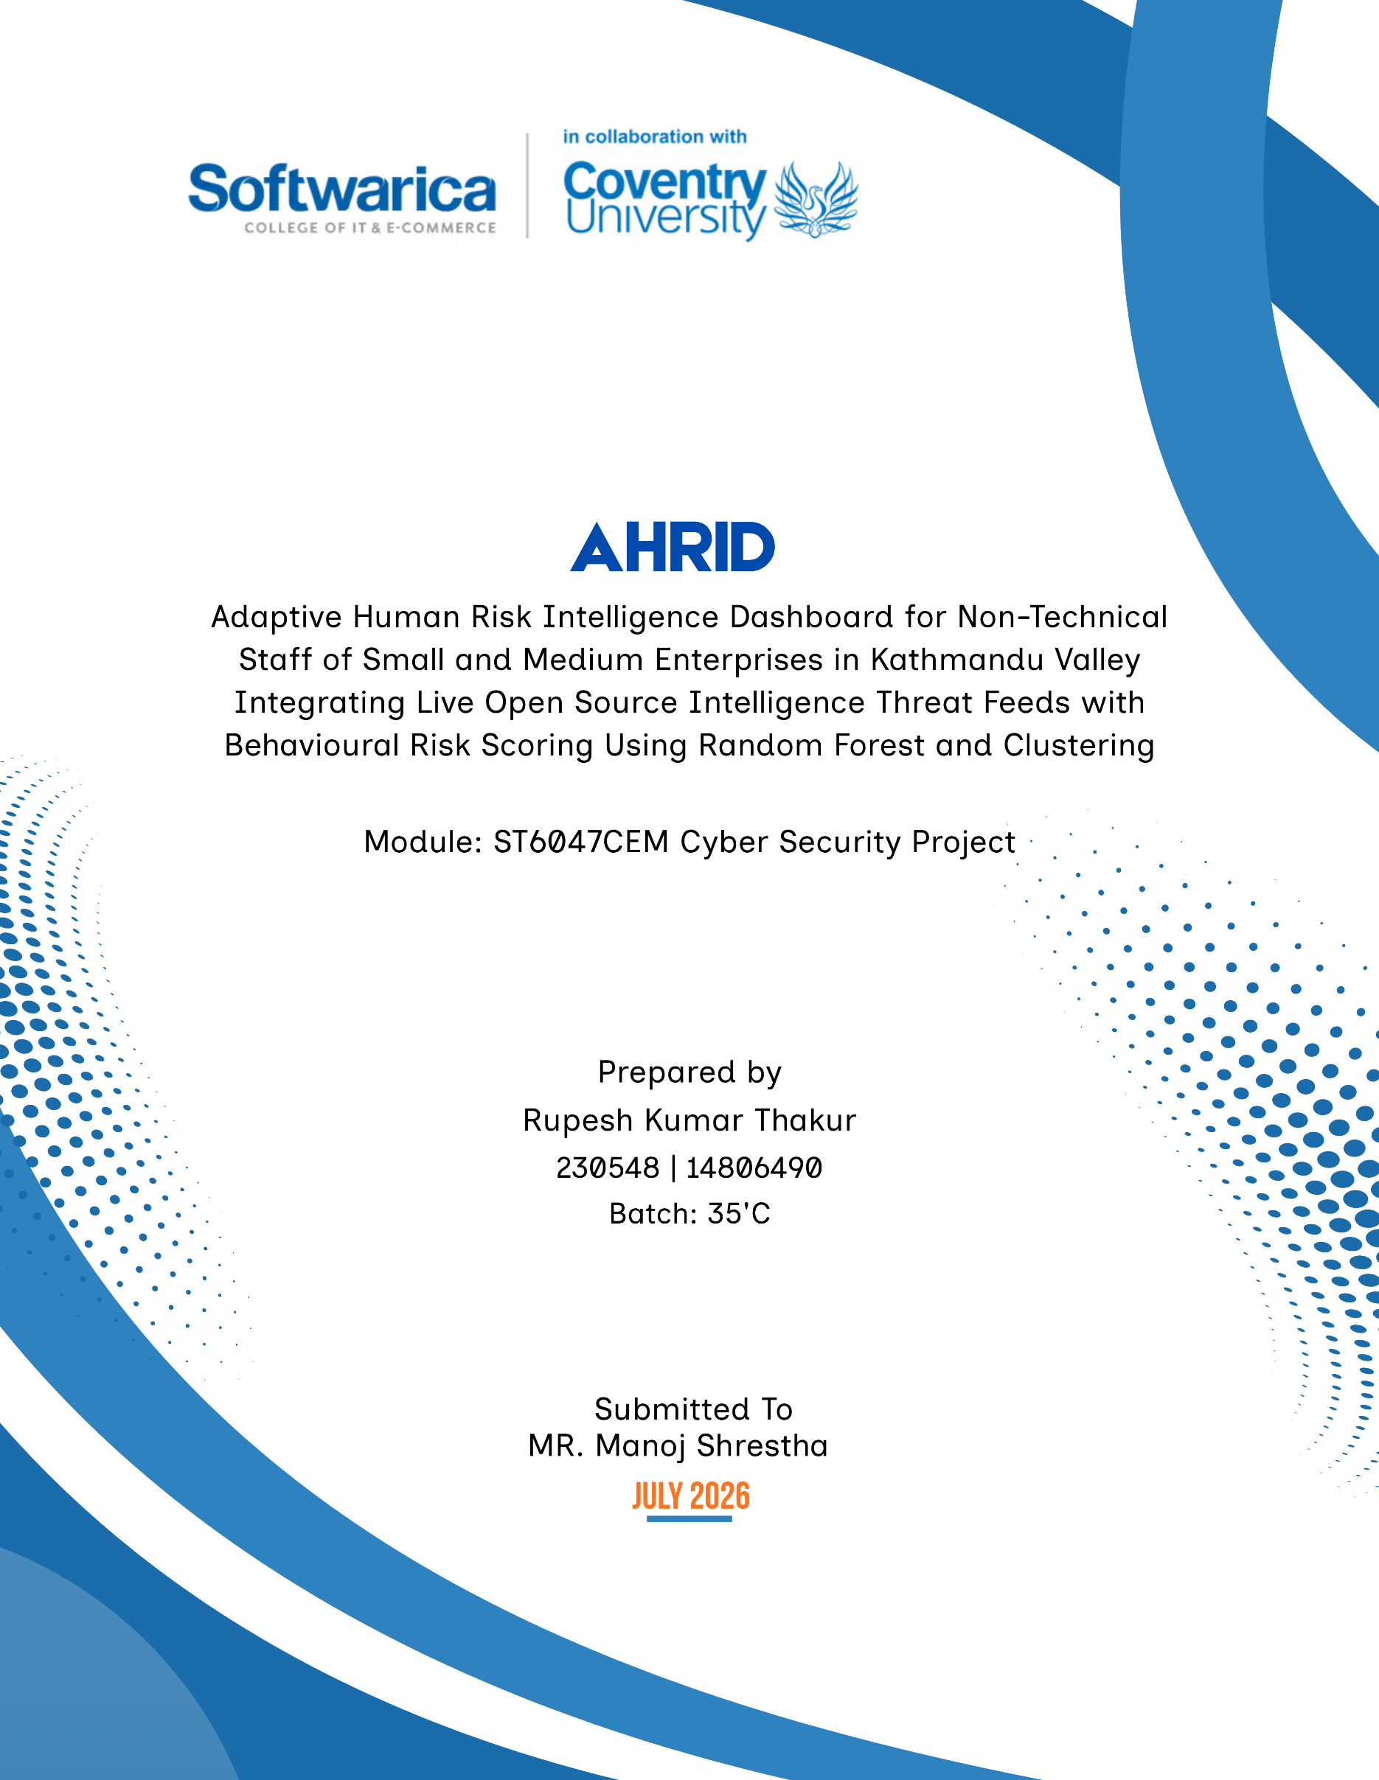

System Architecture and Framework Design

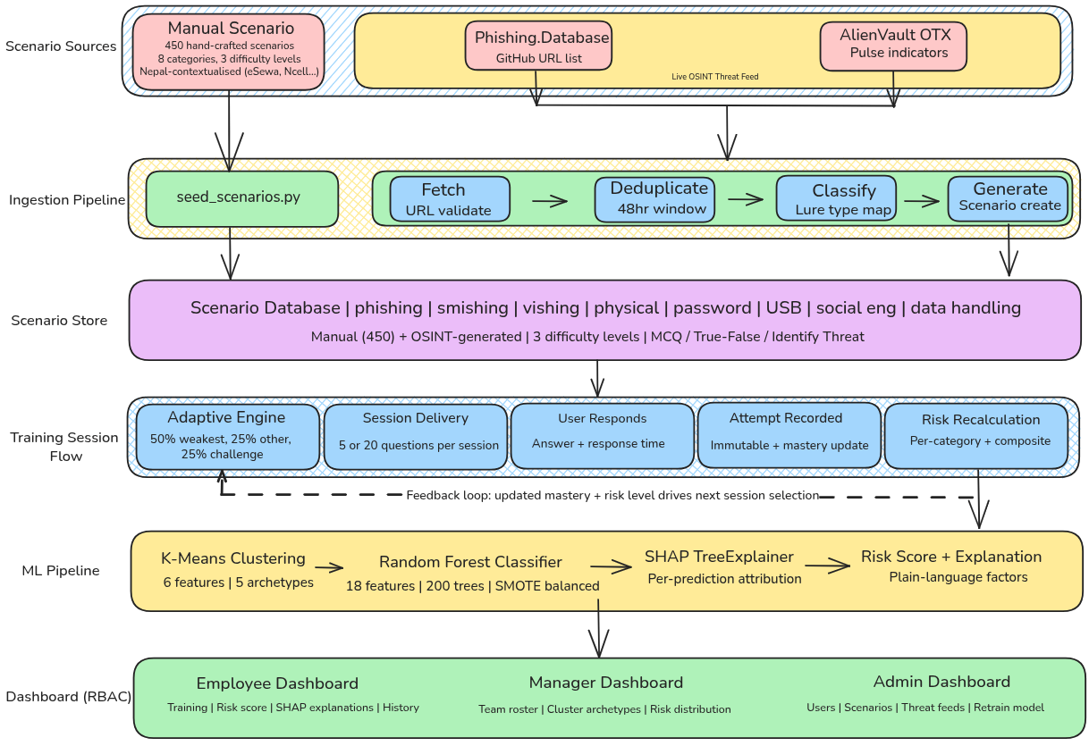
Figure 1: AHRID System Architecture & Framework Design

Agile Research Methodology Sprint

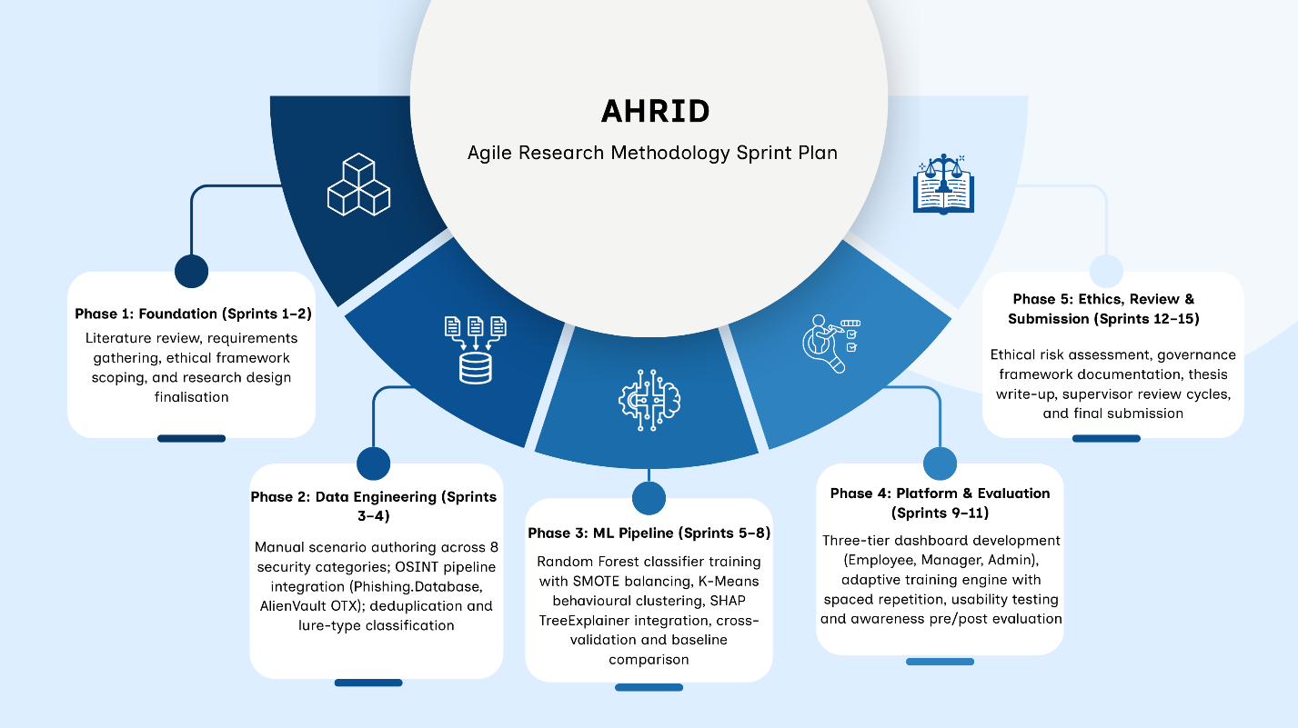
Figure 2: Agile Research Methodology Sprint

Acknowledgement
The completion of this research would not have been possible without the guidance and support of several individuals and institutions. Foremost recognition is due to the project supervisor, Manoj Shrestha, whose critical feedback on research methodology and cybersecurity domain knowledge shaped the analytical direction of this work throughout its development.
Gratitude is extended to Softwarica College of IT & E-Commerce and Coventry University for providing the academic framework and institutional resources that facilitated this investigation. Finally, sincere thanks are extended to family members and colleagues whose encouragement provided essential support throughout the duration of this project.

Abstract
This thesis presents the Adaptive Human-Risk Intelligence Dashboard (AHRID), a cybersecurity awareness training platform developed for non-technical Small and Medium Enterprise (SME) employees in Kathmandu Valley, Nepal. The research adopts a desk-based Design Science Research (DSR) methodology implemented through five development phases and fifteen iterative Agile sprints to design, implement, and evaluate an adaptive cybersecurity awareness solution. The study is motivated by Nepal's sustained increase in cybercrime, rising from 3,906 reported incidents in FY2020–21 to 18,926 incidents in FY2024–25, with financial fraud accounting for 40.82% of all reported cases (Nepal Police, 2025), alongside the limited suitability of enterprise-oriented awareness platforms for resource-constrained Nepali SMEs.
AHRID integrates live phishing intelligence from Phishing.Database and AlienVault OTX across eight phishing scenario categories and delivers adaptive cybersecurity awareness grounded in Protection Motivation Theory, Prospect Theory, and the Technology Acceptance Model. The platform employs a three-stage machine learning architecture comprising K-Means clustering for behavioural archetype discovery (five clusters; Silhouette Score = 0.265), Random Forest classification using an 18-feature behavioural vector for four-tier human-risk prediction (200 decision trees with SMOTE-balanced training), and SHAP TreeExplainer to generate transparent, plain-language explanations for every risk prediction.
Experimental evaluation against a conventional rule-based baseline achieved a classification accuracy of 90.95%, macro F1-score of 0.8890, PR-AUC of 0.9399, and Cohen's Kappa of 0.8684, representing a 50.21 percentage-point improvement over the baseline macro F1-score of 0.3868. The research addresses two primary questions: (RQ1) how adaptive cybersecurity awareness platforms can improve behavioural security outcomes for non-technical employees, and (RQ2) how automated behavioural risk assessment can be implemented ethically and transparently. To address these questions, AHRID incorporates an embedded ethical governance framework supporting data minimisation, explainable decision-making, non-punitive risk management, and compliance with Nepal's Individual Privacy Act 2075.

Keywords

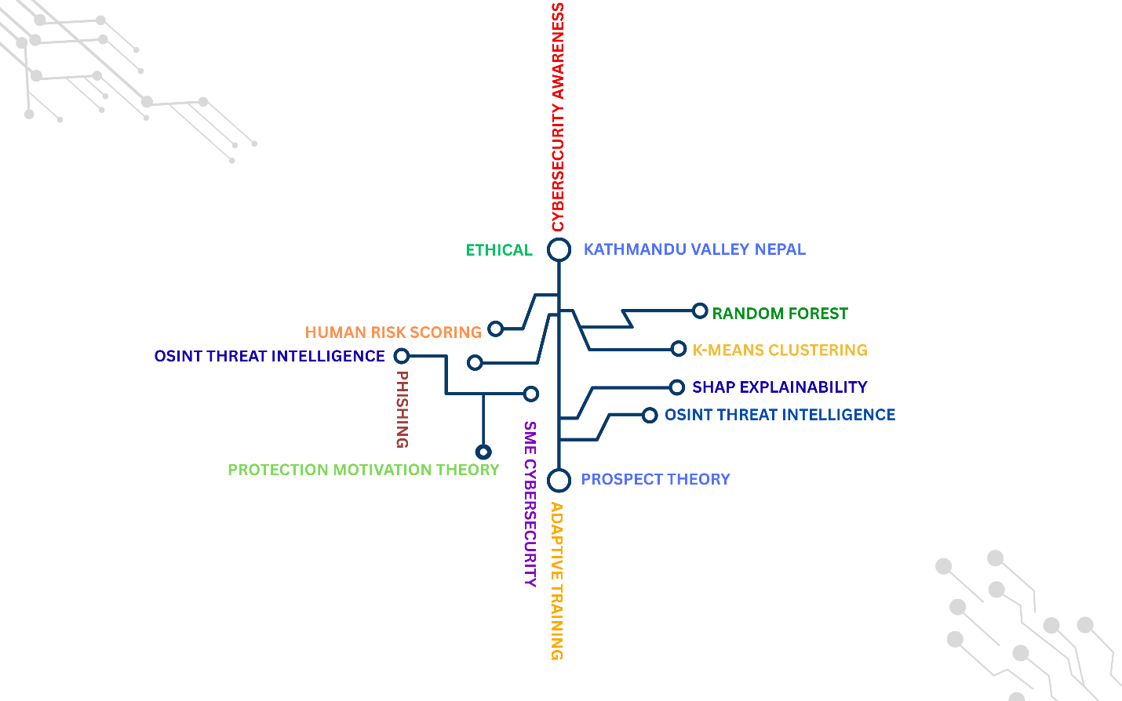
Figure 3: Keywords

Table of Contents
Introduction 1
Problem Context and Motivation 2
Cybersecurity Theories and Behavioural Factors in Security Decision-Making 4
Integration of Machine Learning in Cybersecurity 7
Research Aim 10
Research Objectives 11
Contribution and Significance 12
Justification of the Study 13
Research Questions 15
Research Hypotheses 16
Scope and Limitations 16
Research Methodology 17
Ethical Considerations 21
References 23

List of Figures
Figure 1: AHRID System Architecture & Framework Design ii
Figure 2: Agile Research Methodology Sprint iii
Figure 3: Keywords vi
Figure 4: Nepal Cybercrime Incident Trends (FY2020–21 to FY2024–25) 1
Figure 5: Research Motivation and Problem Context of AHRID 4
Figure 6: Integrated Theoretical Framework for AHRID Design 5
Figure 7: AHRID Three-Stage Machine Learning Pipeline 8
Figure 8: Research Contributions of AHRID 13
Figure 9: Five-Dimension Justification Framework for AHRID. 14
Figure 10: Design Science Research and Agile Development Process for AHRID. 18

List of Tables
Table 1: Enterprise Security Awareness Platform Comparison vs AHRID 3
Table 2: Mapping Behavioural Theories to AHRID Design Decisions 6
Table 3: Comparison of Machine Learning Algorithms 9
Table 4: Research Risk Assessment and Mitigation Strategy 19
Table 5: Ethics as Design Constraint Matrix for AHRID 22

List of Abbreviations
Abbreviation | Full Form
AHRID | Adaptive Human-Risk Intelligence Dashboard
API | Application Programming Interface
AUC | Area Under the Curve
CV | Cross-Validation
DSR | Design Science Research
DSRM | Design Science Research Methodology
F1 | F1-Score (harmonic mean of precision and recall)
HDBSCAN | Hierarchical Density-Based Spatial Clustering of Applications with Noise
IPA | Individual Privacy Act (Nepal, 2075/2018)
ML | Machine Learning
OSINT | Open-Source Intelligence
OTX | Open Threat Exchange (AlienVault)
PMT | Protection Motivation Theory
PR-AUC | Precision-Recall Area Under the Curve
RBAC | Role-Based Access Control
RF | Random Forest
SAT | Security Awareness Training
SHAP | SHapley Additive exPlanations
SIEM | Security Information and Event Management
SME | Small and Medium Enterprise
SMOTE | Synthetic Minority Over-sampling Technique
SUS | System Usability Scale
SVM | Support Vector Machine
TAM | Technology Acceptance Model
UI | User Interface
URL | Uniform Resource Locator
XGBoost | Extreme Gradient Boosting

Introduction
Cybersecurity has become one of the defining organisational challenges of the digital economy. Global cybercrime damages are estimated at USD 10.5 trillion annually in 2025 and are projected to reach USD 15.63 trillion by 2029 (Statista, 2025). Although organisations of every size face increasing cyber threats, Small and Medium Enterprises (SMEs) remain disproportionately vulnerable because they typically operate with limited cybersecurity expertise, constrained financial resources, and minimal investment in employee awareness. The Verizon 2025 Data Breach Investigations Report found that organisations employing fewer than 1,000 people accounted for 88% of ransomware incidents, with phishing and other social engineering attacks representing the predominant initial access vector. Furthermore, approximately 68% of confirmed data breaches continue to involve the human element, highlighting employee behaviour as one of the most persistent organisational cybersecurity risks (Verizon, 2025).
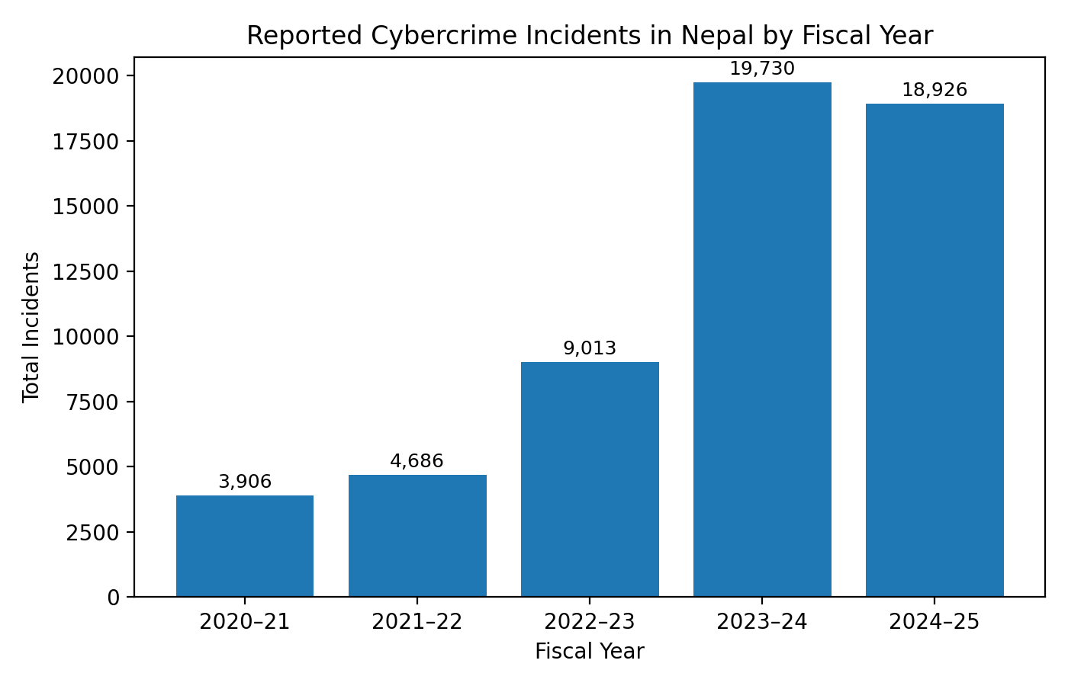
Figure 4: Nepal Cybercrime Incident Trends (FY2020–21 to FY2024–25)
These challenges are particularly significant within developing economies, where cybersecurity investment often prioritises technical infrastructure while human-centred security awareness receives comparatively limited attention. Nepal reflects this global trend. According to Nepal Police (2025), reported cybercrime incidents increased from 3,906 cases in FY2020–21 to a peak of 19,730 cases in FY2023–24 before recording 18,926 cases in FY2024–25, equivalent to approximately 52 reported incidents each day. Financial fraud constituted the largest category of offences (40.82%), followed by account hacking (18.51%) and fake or impersonated accounts (16.21%), demonstrating that most attacks target individuals and organisational employees rather than technical infrastructure.
Despite the increasing importance of cybersecurity awareness, most commercial awareness platforms have been developed for enterprise environments with dedicated security teams, English-language workforces, and recurring licensing models that exceed the operational capacity of many Kathmandu Valley SMEs. Generic awareness programmes frequently deliver identical training to all employees regardless of behavioural risk, role, or local threat context, limiting long-term knowledge retention and behavioural change. Moreover, existing platforms provide little support for Nepali-language interfaces, locally relevant phishing scenarios, or regulatory alignment with Nepal's Individual Privacy Act 2075, leaving many SMEs without practical, affordable, and contextually appropriate cybersecurity awareness solutions.
This thesis presents the Adaptive Human-Risk Intelligence Dashboard (AHRID), an adaptive cybersecurity awareness platform designed specifically for non-technical SME employees in Kathmandu Valley. AHRID integrates live Open-Source Intelligence (OSINT), behavioural machine learning, and explainable artificial intelligence to deliver personalised, transparent, and locally contextualised cybersecurity awareness. Developed using a five-phase, fifteen-sprint Agile process aligned with Design Science Research principles, the platform employs K-Means clustering, Random Forest classification, and SHAP-based explainability to assess behavioural cyber risk and personalise learning. Experimental evaluation achieved 90.95% classification accuracy, a macro F1-score of 0.8890, and a 50.21 percentage-point improvement over a conventional rule-based baseline, demonstrating the potential of adaptive, explainable, and human-centred cybersecurity awareness for resource-constrained SMEs.

Problem Context and Motivation
Despite increasing recognition of human behaviour as the primary cause of organisational cyber incidents, cybersecurity awareness practices within Kathmandu Valley Small and Medium Enterprises (SMEs) remain constrained by structural, economic, and organisational limitations. Most commercial security awareness platforms have been designed for large enterprises with dedicated cybersecurity teams, predictable training budgets, and mature security governance. These assumptions rarely reflect the operating environment of Nepali SMEs, creating a significant mismatch between the organisations most vulnerable to social engineering attacks and the cybersecurity awareness solutions available to protect them.
Three interrelated challenges define this problem. First, enterprise security awareness platforms rely on recurring per-user subscription models that are financially impractical for many Kathmandu Valley SMEs. Commercial platforms such as KnowBe4, CybSafe, Proofpoint Security Awareness Training, and Hoxhunt typically require enterprise licensing agreements and annual subscription costs that exceed the budgets of small organisations employing fewer than fifty staff. Second, many SMEs operate without dedicated cybersecurity personnel, resulting in awareness activities that are infrequent, generic, and delivered without structured behavioural assessment or continuous improvement. Third, non-technical employees including administrative, finance, human resources, and customer service staff represent the primary targets of phishing, vishing, and social engineering attacks, yet existing platforms frequently assume levels of cybersecurity knowledge and technical literacy that these users do not possess. Research further demonstrates that behavioural characteristics such as impulsive decision-making and excessive internet use increase susceptibility to cyber threats (Hadlington, 2017), while limited organisational security policies encourage employees to rely on informal practices rather than structured security guidance (Kabanda, 2018).
Table 1: Enterprise Security Awareness Platform Comparison vs AHRID
Platform | Pricing Model | Approx. Annual Cost (100 users) | Open OSINT | SME Accessible
KnowBe4 | Per-seat licence (tiered) | USD 2,400 – 4,800 | No | No
Proofpoint SAT | Per-seat licence (quote-only) | USD 2,400 – 5,000 | No | No
CybSafe | Per-seat licence (tiered) | USD 1,200 – 3,600 | No | No
Hoxhunt | Per-seat licence (quote-only) | USD 1,500 – 3,000 | No | No
SANS SAT | Enterprise contract | USD 3,600+ | No | No
AHRID (this study) | Open source; free OSINT feeds | USD 0 (server hosting only) | Yes | Yes

Collectively, these limitations reveal a clear research gap. Existing platforms provide limited support for Nepali-language localisation, context-specific phishing scenarios, adaptive behavioural learning, and transparent risk assessment, while remaining financially inaccessible for many SMEs. Consequently, organisations that experience the greatest exposure to human-centred cyber threats are often the least capable of adopting the technologies intended to reduce those risks.
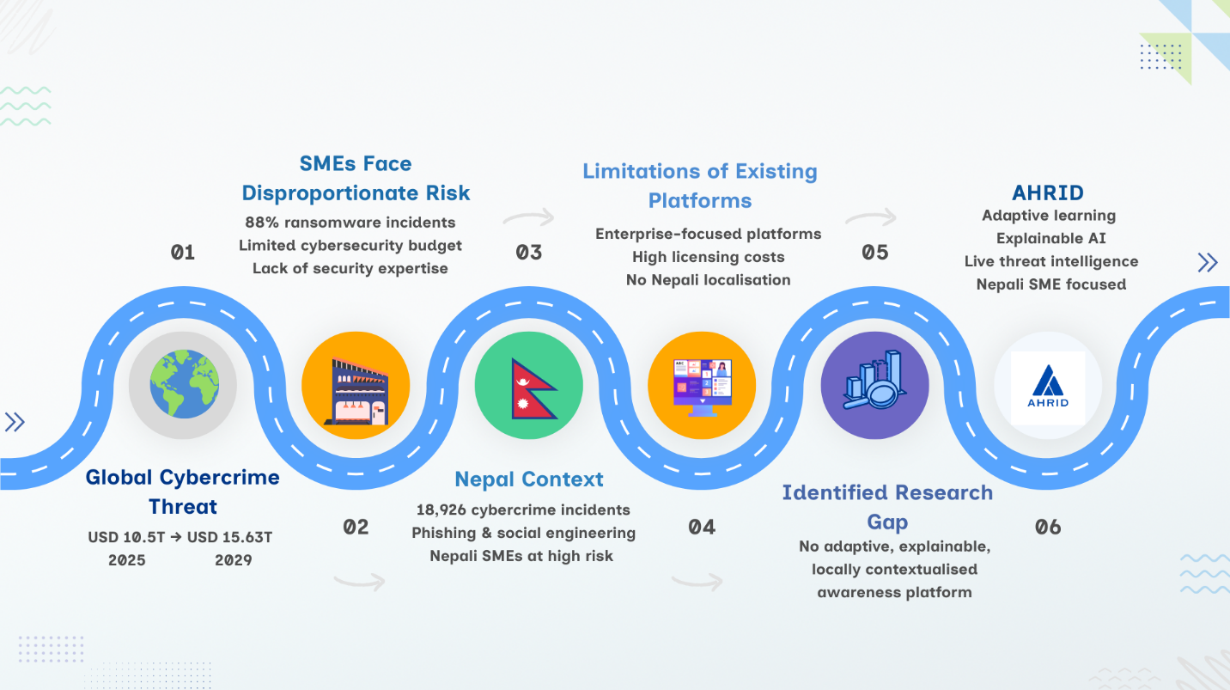
Figure 5: Research Motivation and Problem Context of AHRID
This research addresses that gap through the development of the Adaptive Human-Risk Intelligence Dashboard (AHRID), a cybersecurity awareness platform designed specifically for the operational realities of Kathmandu Valley SMEs. Rather than adapting an enterprise-oriented solution to a fundamentally different environment, AHRID was designed around the resource constraints, linguistic requirements, regulatory obligations, and behavioural characteristics of Nepali organisations. By integrating locally relevant threat intelligence, adaptive learning, explainable risk assessment, and evidence-based behavioural principles within a single platform, AHRID provides a practical and scalable approach to strengthening human-centred cybersecurity resilience in resource-constrained SME environments.

Cybersecurity Theories and Behavioural Factors in Security Decision-Making
The design of AHRID is informed by established behavioural theories that explain why individuals adopt or fail to adopt secure cybersecurity practices. Rather than serving as background literature, these theories function as explicit design principles that guided the platform's architecture, adaptive learning strategy, and user interaction model. Three complementary frameworks were selected: Protection Motivation Theory (PMT) explains protective behavioural change, Prospect Theory explains cognitive biases influencing security decisions, and the Technology Acceptance Model (TAM) explains factors affecting user acceptance of cybersecurity technologies. Alternative models, including the Health Belief Model and Deterrence Theory, were considered but excluded because they focus primarily on general threat perception or compliance rather than adaptive behavioural learning in organisational environments (Siponen, 2000).
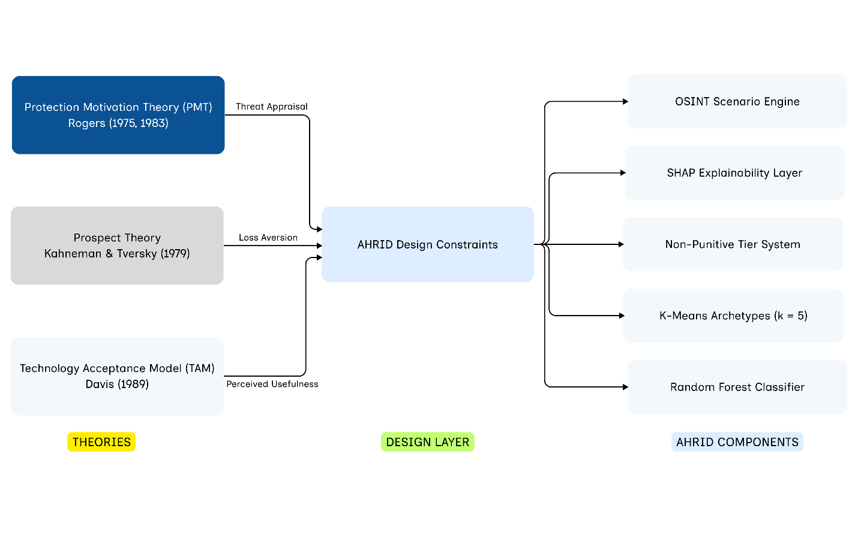
Figure 6: Integrated Theoretical Framework for AHRID Design
Protection Motivation Theory (Rogers, 1975; Rogers, 1983) proposes that protective behaviour results from two complementary processes: threat appraisal and coping appraisal. Within AHRID, behavioural risk scores communicate an employee's level of exposure to cyber threats, while personalised recommendations and explainable feedback strengthen coping efficacy by providing clear, achievable actions for improving security behaviour. This combination encourages behavioural change rather than simply measuring risk.
Prospect Theory (Kahneman & Tversky, 1979) explains that individuals frequently make security decisions under cognitive bias rather than objective risk assessment. Biases such as loss aversion, the availability heuristic, and confirmation bias influence how employees perceive phishing attacks and other social engineering threats. AHRID addresses these biases by presenting locally relevant attack scenarios derived from live Open-Source Intelligence (OSINT) feeds and adapting training according to individual behavioural performance instead of relying on generic awareness content.
The Technology Acceptance Model (Davis, 1989), later extended by Venkatesh et al. (2003), argues that technology adoption depends primarily on perceived usefulness and perceived ease of use. To maximise adoption among non-technical SME employees, AHRID explains every machine learning prediction using SHAP and presents behavioural feedback in plain language. Transparent explanations, combined with a non-punitive governance model, encourage trust, improve usability, and position the platform as a learning tool rather than an employee surveillance mechanism.
Table 2: Mapping Behavioural Theories to AHRID Design Decisions
Theory | Core Construct | Behavioural Implication | AHRID Design Decision
Protection Motivation Theory (Rogers, 1975, 1983) | Threat appraisal | Higher perceived severity and vulnerability increase protective intention. | Live OSINT phishing scenarios and personalised behavioural risk scores communicate individual exposure.
Protection Motivation Theory (Rogers, 1975, 1983) | Coping appraisal | Employees adopt secure behaviour when responses are effective, achievable and low cost. | SHAP explanations provide actionable guidance; adaptive learning recommends immediate remediation without punitive consequences.
Prospect Theory (Kahneman & Tversky, 1979) | Loss aversion | Individuals respond more strongly to potential losses than equivalent gains. | Phishing scenarios emphasise the organisational and personal consequences of insecure behaviour.
Prospect Theory (Kahneman & Tversky, 1979) | Availability heuristic | Recently observed threats are perceived as more likely than unfamiliar ones. | Live OSINT feeds ensure training reflects current phishing campaigns rather than static historical examples.
Technology Acceptance Model (Davis, 1989) | Perceived usefulness | Users adopt systems they believe improve their performance. | SHAP explanations provide transparent justification for behavioural risk scores.
Technology Acceptance Model (Davis, 1989) | Perceived ease of use | Lower cognitive effort increases voluntary technology adoption. | Short adaptive learning modules, intuitive interface and role-based training minimise user burden.
Compliance Budget (Beautement et al., 2008) | Bounded rationality | Employees possess limited cognitive capacity for security tasks. | Adaptive difficulty prevents cognitive overload by delivering only role-relevant scenarios.
PMT–TAM Integration (Workman, 2008; Boss et al., 2009) | Non-punitive governance | Transparent support encourages engagement more effectively than surveillance or punishment. | Elevated risk trigger personalised learning recommendations rather than disciplinary actions.

Collectively, these behavioural theories establish the conceptual foundation for AHRID and provide the rationale for the adaptive machine learning architecture discussed in the following section.

Integration of Machine Learning in Cybersecurity
Machine learning has become an important component of modern cybersecurity by enabling systems to identify complex behavioural patterns that traditional rule-based approaches often fail to detect. Beyond cybersecurity, machine learning has demonstrated strong performance in domains such as financial fraud detection, healthcare risk prediction, and industrial quality assurance, where decision-making relies on analysing large, high-dimensional datasets with imbalanced class distributions (Dal Pozzolo, 2018)). These characteristics closely resemble human cybersecurity behaviour, where malicious actions are relatively infrequent, behavioural patterns evolve over time, and the cost of failing to identify high-risk individuals is substantially greater than producing occasional false alarms. Consequently, machine learning provides an effective foundation for adaptive human-risk assessment.
Within cybersecurity, most machine learning applications have focused on protecting technical infrastructure through intrusion detection, malware classification, network anomaly detection, and endpoint monitoring. While these approaches successfully identify attacks against systems, they provide limited insight into the behavioural factors that frequently precede successful phishing and social engineering incidents. Human cyber risk therefore remains comparatively underexplored despite being responsible for a substantial proportion of organisational security breaches.
AHRID addresses this limitation through a hybrid machine learning architecture that combines unsupervised learning, supervised classification, and explainable artificial intelligence within a single adaptive framework. Employee interaction data collected from cybersecurity awareness activities are first analysed using K-Means clustering (k = 5) to identify behavioural archetypes representing distinct patterns of security behaviour. The resulting cluster membership is incorporated as an additional feature within an 18-feature behavioural vector, allowing a Random Forest classifier to generate four-tier behavioural risk predictions using both historical behavioural characteristics and current user performance. To improve learning from minority risk categories, the training dataset is balanced using SMOTE (Chawla et al., 2002), while SHAP TreeExplainer provides transparent, plain-language explanations describing the behavioural factors that influenced each prediction.
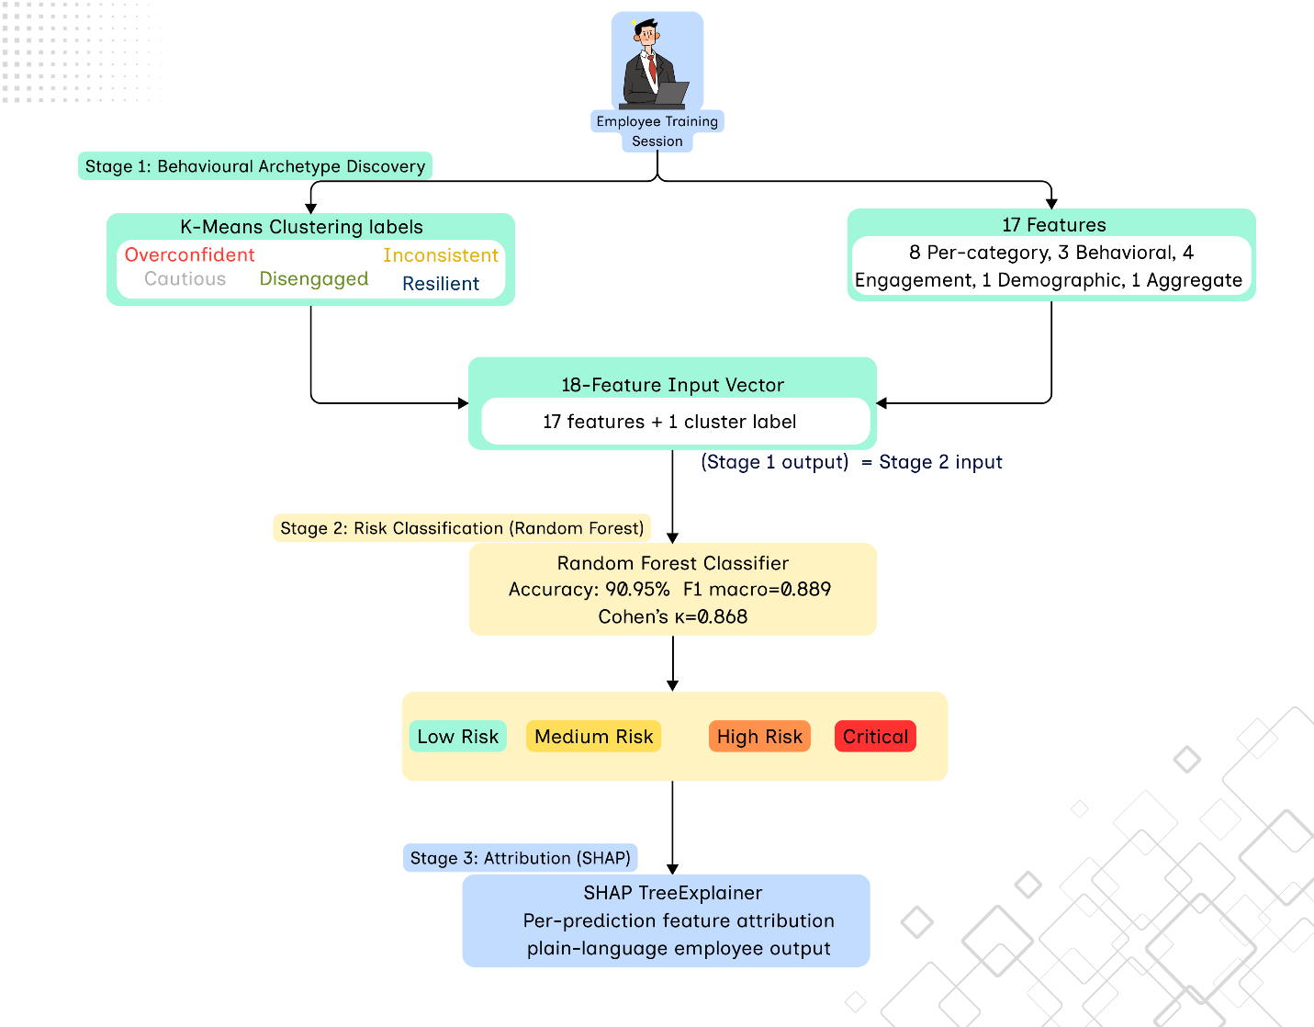
Figure 7: AHRID Three-Stage Machine Learning Pipeline
The selection of Random Forest reflects a balance between predictive performance, robustness, and interpretability (Breiman, 2001). Compared with alternative algorithms such as XGBoost, Support Vector Machines, Logistic Regression, and Deep Neural Networks, Random Forest provides strong classification accuracy while supporting feature importance analysis and model explainability, both of which are essential for transparent behavioural risk assessment. Evaluation on the synthetic behavioural dataset developed for this research achieved 90.95% classification accuracy, a macro F1-score of 0.8890, and a 50.21 percentage-point improvement over the rule-based baseline, demonstrating the effectiveness of integrating behavioural clustering with explainable ensemble learning. Models were implemented using scikit-learn (Pedregosa et al., 2011).

Table 3: Comparison of Machine Learning Algorithms
Algorithm | Accuracy (Cybersecurity Benchmarks) | F1 Macro | Explainability | AHRID Decision
Random Forest (AHRID) | 90.95% (this study); up to 99.80% in IDS benchmarks | 0.8890 (post-SMOTE) | High via SHAP TreeExplainer | Selected as primary classifier
XGBoost | 99.79% in IDS benchmarks | Not reported | Medium (SHAP compatible) | Excluded: marginal gain over RF with higher complexity
Deep Neural Network | 98.66% in IDS benchmarks | Not reported | Low (black-box) | Excluded: violates TAM usefulness and IPA 2075 transparency obligations
SVM (RBF kernel) | ~91% in IDS benchmarks | ~0.37 (class imbalanced) | Low | Baseline comparison only; not selected
K-Means (AHRID) | N/A (unsupervised) | Silhouette = 0.265 at k=5 | Medium (archetype labels) | Complementary pipeline; cluster label fed as RF feature
Logistic Regression | ~85% in multi-class | Low with imbalance | High (coefficients) | Rejected: insufficient for 18-feature non-linear patterns

The integration of machine learning within AHRID therefore extends beyond prediction accuracy by enabling adaptive, transparent, and evidence-based cybersecurity awareness that aligns with the behavioural principles introduced in the previous section and the technical implementation presented later in this thesis.

Research Aim
The primary aim of this research is to design, develop, and evaluate the Adaptive Human-Risk Intelligence Dashboard (AHRID), an adaptive cybersecurity awareness platform that integrates Open-Source Intelligence (OSINT), behavioural machine learning, and explainable artificial intelligence to deliver personalised cybersecurity awareness training for non-technical Small and Medium Enterprise (SME) employees in Kathmandu Valley, Nepal. The platform is intended to address the limitations of existing enterprise-oriented awareness solutions by providing an affordable, locally contextualised, and behaviour-driven approach to human-risk management.
This aim is achieved through the following activities:
- Analysing the cybersecurity threat landscape affecting Kathmandu Valley SMEs and critically evaluating existing security awareness platforms, including KnowBe4, CybSafe, and Proofpoint Security Awareness, to identify limitations relating to localisation, affordability, adaptive learning, and explainability.
- Investigating publicly available Open-Source Intelligence sources, specifically Phishing.Database and AlienVault OTX, and integrating live phishing intelligence into adaptive awareness scenarios that reflect current social engineering threats.
- Designing and implementing a three-stage machine learning architecture comprising K-Means clustering for behavioural archetype discovery, Random Forest classification for behavioural risk prediction, and SHAP TreeExplainer for transparent, user-friendly explanation of model predictions.
- Developing and evaluating the AHRID platform using a Design Science Research methodology supported by an iterative Agile development process and comparing its performance against a conventional rule-based cybersecurity awareness approach.
- Assessing the effectiveness, usability, and ethical implications of the proposed platform through technical evaluation, behavioural awareness assessment, and governance analysis in accordance with Nepal's Individual Privacy Act 2075.
Together, these activities provide a structured framework for designing, implementing, and evaluating an adaptive cybersecurity awareness platform suitable for resource-constrained SME environments.

Research Objectives
The following objectives operationalise the research aims and guide the activities undertaken throughout this study.
No. | Research Objective | Type | Maps To
1 | Analyse the cybersecurity threat landscape affecting non-technical SME employees in Kathmandu Valley and critically evaluate existing cybersecurity awareness platforms to identify limitations in localisation, affordability, adaptive learning, and explainability. | Learn & Understand | Introduction, Literature Review, Case Studies
2 | Investigate Open-Source Intelligence sources, including Phishing.Database and AlienVault OTX, and evaluate their suitability for supporting automated phishing awareness scenario generation. | Learn & Understand | Literature Review, Technical Development
3 | Examine behavioural security theories and machine learning techniques applicable to human-risk assessment, including behavioural clustering, ensemble classification, class imbalance handling, and explainable artificial intelligence. | Learn & Understand | Literature Review, Theoretical Framework
4 | Design, develop, and evaluate the Adaptive Human-Risk Intelligence Dashboard by integrating live OSINT feeds, K-Means clustering, Random Forest classification, and SHAP explainability, and compare its performance against a conventional rule-based cybersecurity awareness approach using appropriate machine learning evaluation metrics. | Design & Develop | Methodology, Technical Development, Findings
5 | Evaluate the platform's effectiveness through behavioural awareness assessment, usability evaluation, ethical analysis, and privacy compliance, and document the research findings, limitations, and recommendations for future work. | Feedback & Submit | Findings, Ethics, Discussion, Conclusion

Contribution and Significance
This research contributes to cybersecurity awareness by demonstrating how adaptive machine learning, behavioural security theory, and explainable artificial intelligence can be integrated into a single platform designed specifically for resource-constrained Small and Medium Enterprises (SMEs). Unlike conventional security awareness platforms that deliver identical training to all users, AHRID continuously adapts learning content according to each employee's behavioural risk profile, enabling personalised awareness interventions that evolve as user behaviour changes.
From a technical perspective, the research introduces a three-stage machine learning architecture that combines K-Means clustering, Random Forest classification, and SHAP TreeExplainer within a unified behavioural risk assessment pipeline. A key innovation is the incorporation of behavioural archetype membership as an explicit feature within the classification model, allowing long-term behavioural patterns to influence real-time risk prediction while maintaining transparent, explainable decision making suitable for non-technical users.
The research also contributes to a theory-driven system design methodology by translating Protection Motivation Theory, Prospect Theory, and the Technology Acceptance Model into practical engineering decisions rather than treating them solely as explanatory frameworks. This demonstrates how behavioural science can directly inform the design of adaptive cybersecurity awareness systems.
From a practical perspective, AHRID addresses an important gap within Kathmandu Valley SMEs by providing an affordable, locally contextualised cybersecurity awareness platform that integrates freely available Open-Source Intelligence feeds instead of proprietary commercial threat intelligence services. This significantly reduces deployment costs while maintaining current and relevant training content.
Finally, the research contributes an ethical governance framework that promotes transparency, non-punitive behavioural risk assessment, and compliance with Nepal's Individual Privacy Act 2075, supporting responsible adoption of artificial intelligence within organisational cybersecurity awareness programmes.
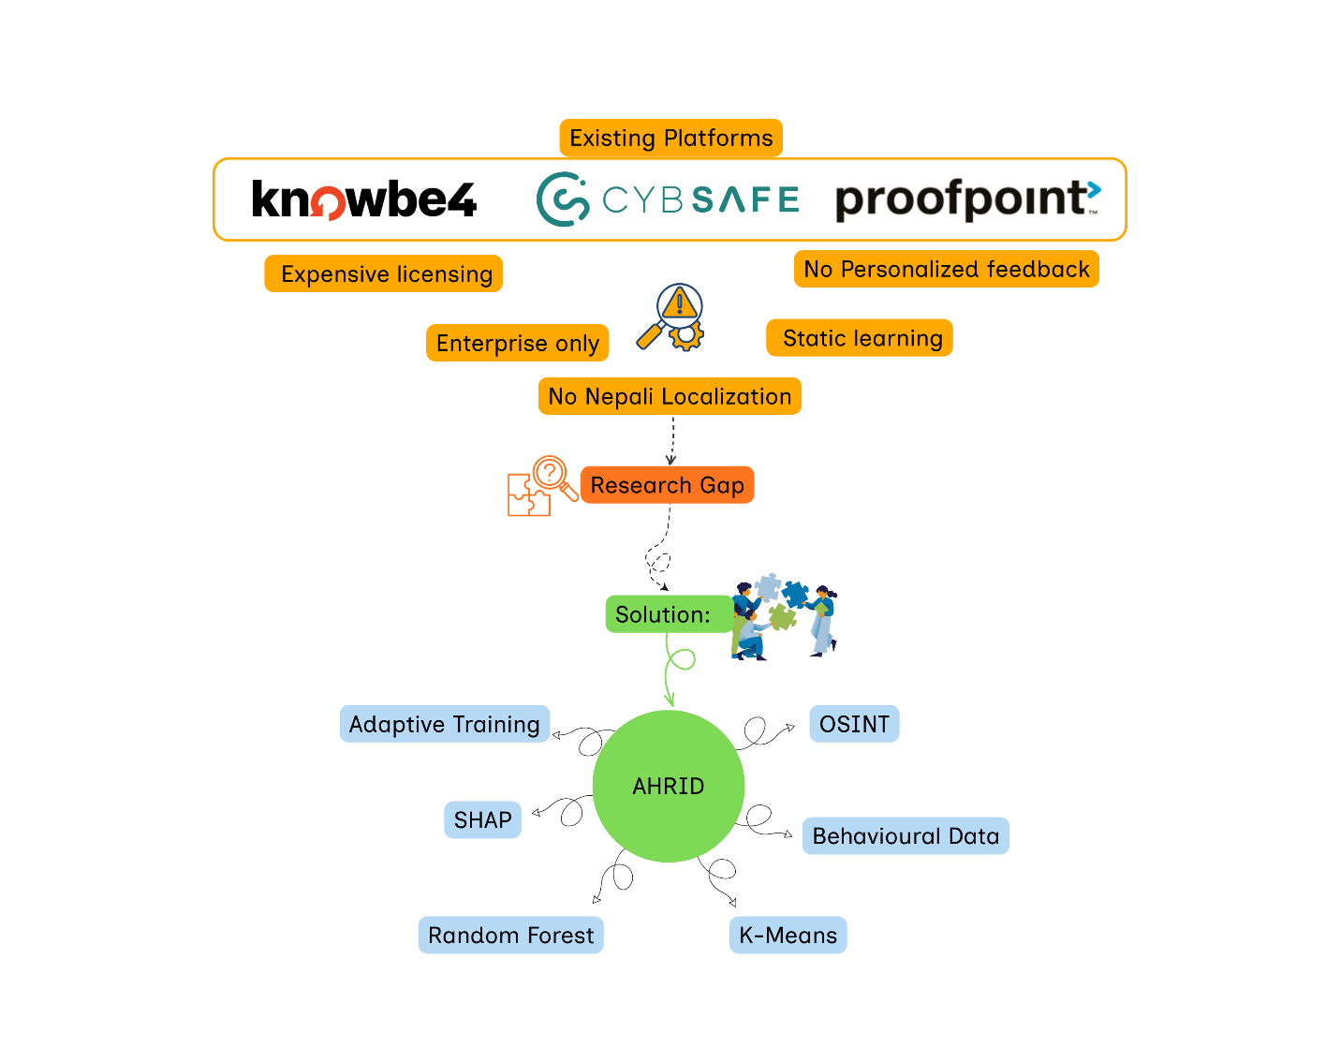
Figure 8: Research Contributions of AHRID

Justification of the Study
The need for adaptive cybersecurity awareness has become increasingly urgent as cyber threats continue to outpace the defensive capabilities of resource-constrained organisations. Nepal Police (2025) reported 18,926 cybercrime incidents during FY2024–25, with financial fraud accounting for 40.82% of all registered cases, demonstrating that attacks increasingly exploit human behaviour rather than technical vulnerabilities alone. Although these figures establish the scale of the problem, they also represent only reported incidents, suggesting that the true impact on Small and Medium Enterprises (SMEs) is substantially higher because many organisations neither recognise nor formally report cyber incidents. This provides empirical justification for developing solutions that specifically target the human element of cybersecurity.
Existing security awareness platforms are poorly aligned with the operational realities of Kathmandu Valley SMEs. Enterprise solutions such as KnowBe4, CybSafe, and Proofpoint Security Awareness assume dedicated security teams, recurring licensing budgets, English-language workforces, and mature organisational security governance. These assumptions rarely hold within Nepali SMEs, where limited financial resources, small workforces, and the absence of cybersecurity specialists restrict the adoption of enterprise-grade awareness programmes. Consequently, employees remain exposed to phishing, social engineering, and credential theft despite receiving generic awareness training.
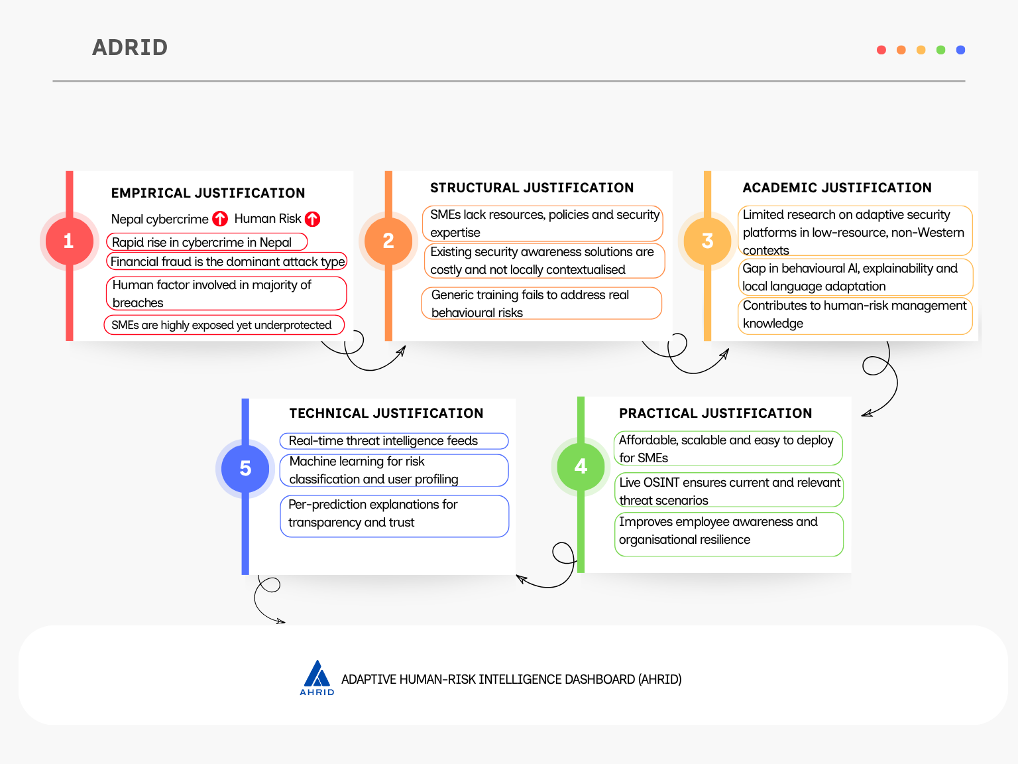
Figure 9: Five-Dimension Justification Framework for AHRID.
From an academic perspective, relatively little research has examined adaptive cybersecurity awareness platforms within low-resource, Nepali SME environments. Existing studies predominantly evaluate behavioural security interventions in large organisations located in developed economies, leaving uncertainty regarding whether explainable machine learning and behavioural adaptation remain effective under different cultural, linguistic, and organisational conditions. This research addresses that gap by integrating behavioural theory, machine learning, and cybersecurity awareness within a context that has received limited empirical investigation.
The study also provides practical and technical justification. AHRID combines live Open-Source Intelligence feeds with behavioural analytics to generate adaptive, locally relevant phishing scenarios without requiring proprietary threat intelligence subscriptions. Its three-stage machine learning pipeline integrates K-Means clustering, Random Forest classification, and SHAP explainability to deliver transparent behavioural risk assessments for non-technical employees. Compared with a traditional rule-based approach, the proposed architecture achieved 90.95% classification accuracy and improved macro F1 score by 50.21 percentage points, demonstrating measurable gains in personalised risk assessment.
The significance of this research therefore extends beyond developing another awareness platform. It demonstrates that adaptive, explainable, and ethically governed cybersecurity awareness systems can be implemented using affordable technologies that are appropriate for Kathmandu Valley SMEs, providing both a practical security solution and a reproducible research framework for future human-risk management studies.

Research Questions
The study is guided by two research questions that collectively address the technical and ethical dimensions of adaptive cybersecurity awareness within Kathmandu Valley Small and Medium Enterprises.
RQ1 (Technical):
How can an adaptive cybersecurity awareness platform integrate behavioural machine learning, live Open-Source Intelligence threat intelligence, and explainable artificial intelligence to deliver personalised and context-aware security awareness training for non-technical employees in Kathmandu Valley Small and Medium Enterprises?
RQ2 (Ethical):
How can automated behavioural risk assessment be implemented in a manner that protects employee privacy, promotes transparency, supports non-punitive learning, and complies with the principles of Nepal's Individual Privacy Act 2075 while maintaining organisational trust and accountability?
Together, these research questions define the scope of the investigation. The first evaluates the technical feasibility and effectiveness of integrating adaptive machine learning into cybersecurity awareness, while the second examines the governance and ethical considerations necessary for responsible deployment within resource-constrained organisational environments.

Research Hypotheses
The research hypotheses are derived directly from the research questions and provide measurable expectations for evaluating both the technical performance and ethical design of AHRID.
H1 (Technical Hypothesis)
Integrating behavioural clustering, supervised machine learning, explainable artificial intelligence, and live Open-Source Intelligence threat feeds within a single adaptive cybersecurity awareness platform will significantly improve behavioural risk classification accuracy and training personalisation when compared with a conventional rule-based awareness approach.
This improvement is expected to be demonstrated through higher predictive performance, including a macro F1-score exceeding 0.85 and substantial agreement between predicted and actual risk classes as measured by Cohen's Kappa.
H2 (Ethical Hypothesis)
Embedding privacy-by-design principles, explainable artificial intelligence, role-based access control, data minimisation, and non-punitive governance into an adaptive cybersecurity awareness platform will improve organisational acceptance and support ethical deployment while remaining consistent with the principles established under Nepal's Individual Privacy Act 2075.
The hypotheses provide the basis for evaluating both the technical effectiveness and responsible implementation of AHRID.

Scope and Limitations
This research focuses on the design, development, and evaluation of the Adaptive Human-Risk Intelligence Dashboard (AHRID) for non-technical employees working within Small and Medium Enterprises located in Kathmandu Valley, Nepal. The platform addresses behavioural cybersecurity awareness by integrating live Open-Source Intelligence, behavioural machine learning, and explainable artificial intelligence to support personalised training and risk assessment.
The study is limited to a desk-based Design Science Research methodology and evaluates system performance using 1,050 synthetic behavioural profiles generated to represent realistic SME user behaviour across eight cybersecurity awareness categories. No real employee data were collected, ensuring compliance with Nepal's Individual Privacy Act 2075. Consequently, the reported machine learning performance reflects controlled experimental evaluation rather than operational deployment. Furthermore, the findings are not intended to be generalised beyond Kathmandu Valley SMEs without additional empirical validation, and the research does not evaluate long-term behavioural change following organisational deployment.

Research Methodology
This research adopts a desk-based Design Science Research (DSR) methodology to guide the design, development, and evaluation of the Adaptive Human-Risk Intelligence Dashboard (AHRID). Design Science Research was selected because the objective of this study is to construct and evaluate a novel cybersecurity artefact that addresses an identified organisational problem rather than investigate an existing phenomenon through observation or experimental methods. Unlike natural science research, which seeks to explain and predict behaviour, Design Science Research focuses on creating purposeful technological solutions whose value is demonstrated through rigorous evaluation within a defined problem context (March & Smith, 1995; Hevner et al., 2004).
The research follows the six-phase Design Science Research Methodology (DSRM) proposed by Peffers et al. (2007), comprising problem identification, objective definition, design and development, demonstration, evaluation, and communication. These phases were translated into five practical project stages: requirements analysis, literature review, intelligent system design, platform development, and evaluation. Development was completed over fifteen Agile sprints between January and July 2026. The iterative nature of Agile complemented the DSR approach by enabling continuous refinement of system functionality, machine learning models, and user interface components throughout the development lifecycle. Each project stage concluded with a structured review to verify technical progress, system integration, and compliance with predefined research objectives before the following stage commenced.
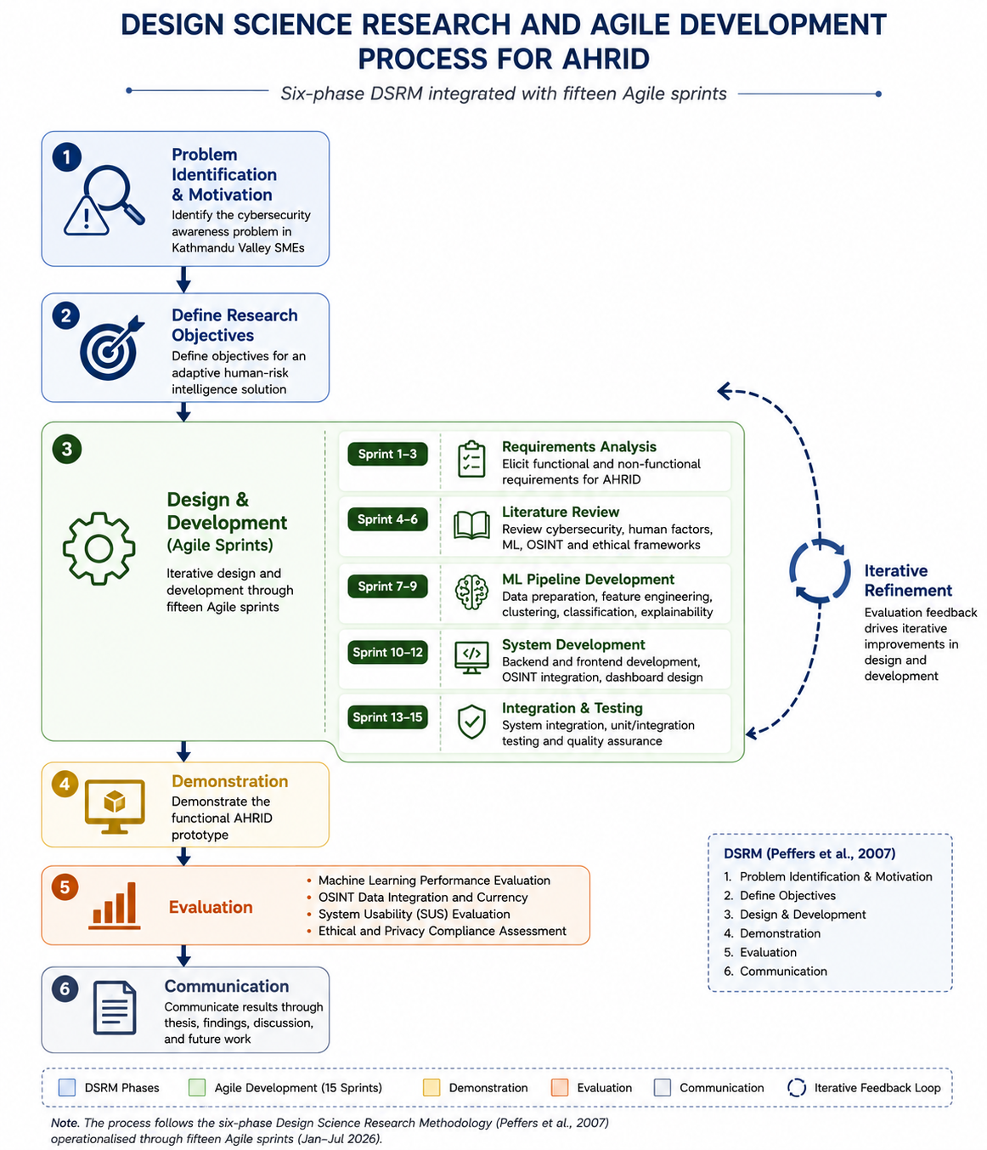
Figure 10: Design Science Research and Agile Development Process for AHRID.
The study employed a desk-based data collection strategy. No human participants were recruited, and no personally identifiable information was collected. Instead, machine learning models were developed using synthetic behavioural datasets generated to reflect realistic cybersecurity behaviour within Kathmandu Valley Small and Medium Enterprises. Dataset calibration was informed by publicly available cybercrime statistics published by the Nepal Police Cyber Bureau together with established behavioural cybersecurity literature and international breach reports. This approach ensured ethical compliance while providing a realistic environment for developing and evaluating the adaptive learning models.
Threat intelligence was incorporated through publicly accessible Open-Source Intelligence (OSINT) sources, specifically Phishing.Database and AlienVault Open Threat Exchange (OTX). These feeds supplied continuously updated phishing URLs and malicious indicators that were automatically transformed into training scenarios across multiple social engineering categories. Because only publicly available information was consumed, the research involved no network scanning, penetration testing, or offensive security activities.
Machine learning development followed a structured experimental workflow. Behavioural data were divided using an 80:20 stratified training and testing split, while three-fold cross-validation was applied to improve model robustness and reduce overfitting. Synthetic Minority Over-sampling Technique (SMOTE) was used to address class imbalance before model training. Behavioural archetypes were identified using K-Means clustering, after which the resulting cluster label was incorporated as an additional feature within the Random Forest classifier. Model explainability was achieved using SHAP TreeExplainer, allowing every risk prediction to be accompanied by a human-readable explanation suitable for non-technical employees.
Technical and project risks were monitored throughout the fifteen development sprints. Identified risks included synthetic data validity, OSINT feed availability, machine learning overfitting, privacy compliance, and project schedule management. Appropriate mitigation strategies were defined before implementation and reviewed throughout development to minimise their potential impact on research outcomes.
Table 4: Research Risk Assessment and Mitigation Strategy
Risk | Likelihood | Impact | Mitigation Strategy | Status
Synthetic behavioural data not fully representative of Kathmandu Valley SME environments | Medium | High | Dataset calibrated using Nepal Police Cyber Bureau statistics and peer-reviewed behavioural cybersecurity literature; acknowledged as a methodological limitation. | Mitigated
Reduced availability or outdated OSINT threat intelligence from Phishing.Database and AlienVault OTX | Low | Medium | Daily automated feed refresh, duplicate filtering, cached scenario repository, and validation of threat currency during each development sprint. | Mitigated
Machine learning model overfitting | Medium | High | Applied 80:20 stratified train-test split, three-fold cross-validation, SMOTE balancing, and evaluation using unseen test data. | Mitigated
Non-compliance with Nepal's Individual Privacy Act 2075 | Low | High | No personally identifiable information collected; all behavioural data generated synthetically; privacy compliance reviewed throughout each development phase. | Mitigated
Project schedule delay during the fifteen Agile sprints | Medium | Medium | MoSCoW prioritisation, iterative sprint planning, regular supervisor reviews, and milestone tracking against the project timeline. | Resolved

Evaluation formed an integral component of the Design Science Research process rather than a final validation activity. The complete platform was assessed through technical performance metrics, behavioural awareness assessment, usability evaluation, and ethical compliance review. Machine learning performance was measured using classification accuracy, macro F1-score, precision-recall analysis, Cohen's Kappa, and confusion matrix analysis, while usability was evaluated using the System Usability Scale (SUS). Ethical assessment examined transparency, data minimisation, explainability, role-based access control, and compliance with Nepal's Individual Privacy Act 2075.
Although the methodology provides a rigorous framework for artefact development, several limitations remain. The machine learning models were evaluated using synthetic behavioural data rather than live organisational datasets, and the platform was not deployed within operational SME environments over an extended period. Consequently, the findings demonstrate the technical feasibility and effectiveness of the proposed approach but do not establish long-term behavioural change in real-world organisational settings. These limitations are acknowledged throughout the evaluation and discussion chapters and provide opportunities for future research involving longitudinal deployment and empirical validation.

Ethical Considerations
Ethical governance is a fundamental design requirement of AHRID rather than a compliance activity performed after system development. Because the platform analyses employee behaviour to generate automated cybersecurity risk assessments, technical performance alone is insufficient. The system must also protect user privacy, ensure algorithmic fairness, provide transparent decision-making, and prevent organisational misuse of behavioural data. These principles were incorporated throughout the Design Science Research lifecycle and reviewed during every development phase.
Privacy protection is guided by Nepal's Individual Privacy Act 2075 (Government of Nepal, 2018) and Article 28 of the Constitution of Nepal, which recognise privacy as a fundamental right. To satisfy the principles of data minimisation and purpose limitation, AHRID does not collect personally identifiable information at any stage of the machine learning pipeline. Risk prediction relies exclusively on eighteen behavioural interaction features, including scenario performance, response time, engagement patterns, and training completion behaviour, rather than demographic or identity attributes. Furthermore, all model development and evaluation were conducted using synthetic behavioural datasets, eliminating the need to process real employee records while maintaining compliance with national privacy legislation.
Algorithmic fairness was addressed before model training through systematic feature auditing. Each behavioural feature was examined to ensure that no direct or proxy variables representing protected characteristics such as age, gender, nationality, or disability were included within the training dataset. Class imbalance was mitigated using the Synthetic Minority Oversampling Technique (SMOTE), preventing the Random Forest classifier from favouring majority risk categories. This proactive approach aligns with recommendations that fairness should be incorporated during system design rather than corrected after deployment (Floridi et al., 2018; Jobin et al., 2019).
Transparency is achieved through SHAP (SHapley Additive exPlanations), which explains every predicted risk level using the behavioural features that contributed most strongly to the classification. Instead of presenting employees with unexplained numerical scores, AHRID provides concise, plain-language explanations describing the behaviours responsible for each prediction. This improves user understanding, supports informed behavioural improvement, and promotes accountability by allowing predictions to be questioned and interpreted by non-technical users.
Ethical governance extends beyond explainable artificial intelligence to organisational policy. Elevated risk classifications trigger additional learning activities rather than disciplinary action, ensuring that the platform functions as a developmental tool rather than a surveillance mechanism. Role-Based Access Control further reinforces this principle by restricting employees to their own risk assessments, managers to aggregated team-level analytics, and administrators to anonymised compliance statistics. Individual behavioural histories are never exposed to supervisory personnel.
Collectively, these measures operationalise internationally recognised principles of privacy, fairness, transparency, responsibility, and non-maleficence within a practical cybersecurity awareness platform. Rather than treating ethics as a regulatory obligation, AHRID embeds ethical safeguards directly into its machine learning architecture, data management strategy, and governance model, demonstrating that trustworthy artificial intelligence can be achieved without compromising cybersecurity effectiveness.
Table 5: Ethics as Design Constraint Matrix for AHRID
Ethical Principle | Design Requirement | AHRID Implementation | Reference
Privacy | Data minimization and lawful processing | No PII collected; synthetic behavioural dataset; 18 behavioural features only | IPA 2075; Constitution of Nepal
Fairness | Eliminate demographic bias | Feature audit excluding protected attributes; SMOTE balancing | (Jobin et al.,2019), (Floridi et al., 2018)
Transparency | Explainable AI decisions | SHAP explanation for every prediction in plain language | (Lundberg & Lee, 2017)
Non-maleficence | Avoid employee harm | Risk scores trigger adaptive learning only; no disciplinary use | (Rogers, 1983)
Responsibility | Controlled data access | Three-level RBAC with employee, manager, and administrator permissions | (Floridi et al., 2018)
Accountability | Reliable model evaluation | t-fold cross-validation, held-out testing, baseline comparison, reported metrics | (Hevner et al., 2004)

15. Technical Development

15.1 System Architecture and Design
AHRID is built on a five-layer architecture that enforces a strict separation between presentation, routing, business logic, machine learning inference, and data persistence. The outermost layer is a React 18 single-page application (SPA) compiled by Vite and deployed on Vercel's global edge network. The SPA communicates exclusively with the second layer — a Flask 3.1 REST API deployed on Render — through HTTPS, with all cross-origin requests governed by Flask-CORS and restricted to the approved frontend origin. The API layer delegates domain work to the third, service layer, which contains the adaptive engine, SHAP explainer, threat-ingestion pipeline, and risk scorer as discrete, independently testable modules. The service layer consumes trained artefacts from the fourth, ML pipeline layer — K-Means and Random Forest models serialised to disk via joblib — and persists results through SQLAlchemy ORM to the fifth layer: SQLite in development and PostgreSQL in production.
Security is enforced at the API boundary. Flask-JWT-Extended issues short-lived access tokens (15-minute expiry) alongside 30-day refresh tokens, preventing prolonged session exposure without requiring frequent re-authentication. Token revocation on logout is enforced through a server-side JWT blocklist stored in the database, ensuring that stolen tokens cannot be replayed after sign-out. Passwords are hashed using bcrypt at a cost factor of 12 rounds, calibrated to remain computationally expensive against brute-force enumeration while sustaining acceptable authentication latency. Flask-Limiter applies rate limits to authentication endpoints to mitigate credential-stuffing attacks, and bleach sanitises all text inputs before persistence to prevent cross-site scripting. Role-based access control (RBAC) is implemented via JWT claims distinguishing administrator and employee principals, with all route handlers enforcing role assertions before processing requests.
Background operations run outside the HTTP request cycle via APScheduler. Two recurring jobs execute on the production server: a threat-feed ingestion job that pulls updated phishing URLs from Phishing.Database and structured indicators from AlienVault OTX every six hours, and a nightly risk-recalculation job that re-scores all active users as new behavioural data accumulates. This decoupled scheduling design means that API response times are unaffected by threat-feed latency, and the ML pipeline can be retrained or swapped without downtime. Figure 11 illustrates the complete five-layer stack with inter-layer communication boundaries and external OSINT data flows.
Figure 11. AHRID Five-Layer Technology Stack with Inter-Layer Communication Boundaries.
[Figure 11: AHRID Five-Layer Technology Stack — see figure11_tech_stack.html]

15.2 Tools and Technologies
Technology choices throughout AHRID were governed by three constraints: open-source licensing (to eliminate per-user cost), SME-scale deployability (to support free-tier hosting), and composability (to allow individual components to be replaced as the platform matures). Table 7 summarises all tools and libraries used, organised by architectural layer.
Table 7. AHRID Tools and Technology Stack by Architectural Layer.
Category | Tool / Library | Version | Role in AHRID
Frontend | React | 18.3 | SPA component framework; declarative UI for training modules and dashboards
Frontend | TypeScript | 5.4 | Static typing across all frontend source files; eliminates runtime type errors
Frontend | Vite | 5.3 | Build tool; sub-100 ms HMR for development, optimised production bundle
Frontend | Tailwind CSS | 3.4 | Utility-first styling; consistent design tokens across all components
Frontend | Recharts | 2.12 | Risk trend charts, archetype distribution, and session analytics visuals
Frontend | Zustand | 4.5 | Lightweight global state (auth token, user profile, notification queue)
Frontend | Framer Motion | 11.3 | Scenario transition animations; progress micro-interactions
API | Flask | 3.1 | WSGI micro-framework; REST API routing and request lifecycle management
API | Flask-JWT-Extended | 4.6 | JWT issuance (15-min access / 30-day refresh); token blocklist for revocation
API | Flask-Limiter | 3.8 | Rate limiting on auth endpoints; mitigates credential-stuffing attacks
API | Flask-CORS | 4.0 | Cross-origin policy enforcement; restricts requests to approved frontend origins
API | Gunicorn | 22.0 | WSGI production server; multi-worker process management on Render
API | bleach | 6.1 | Input sanitisation; strips disallowed HTML tags to prevent XSS
ML | scikit-learn | 1.5 | K-Means clustering, Random Forest classifier, stratified train-test split
ML | SHAP | 0.45 | TreeExplainer; per-prediction Shapley value attribution in plain language
ML | pandas / numpy | 2.2 / 2.1 | Feature engineering, Winsorisation, dataset manipulation
ML | joblib | 1.4 | Model serialisation (.pkl); fast load of trained artefacts at API startup
Data | PostgreSQL | 16 | Production relational database; behavioural scores, scenarios, audit logs
Data | SQLAlchemy | 2.0 | ORM layer; decouples service code from underlying database engine
Data | Flask-Migrate | 4.0 | Alembic-backed schema migrations; version-controlled DDL changes
OSINT | Phishing.Database | daily | Active phishing URL feed; sourced via public GitHub repository
OSINT | AlienVault OTX | live | Structured threat indicators (URLs, domains, IPs) with category tagging
Scheduling | APScheduler | 3.10 | Background threat-feed refresh (6-hour interval) and nightly risk recalculation
Deploy | Render | PaaS | Backend and PostgreSQL hosting; free-tier with auto-sleep on inactivity
Deploy | Vercel | PaaS | Frontend CDN deployment; edge caching, branch previews, zero-config CI
Flask was selected as the API framework in preference to Django because AHRID's domain logic sits primarily in the service and ML layers rather than in framework-provided components such as the Django ORM or admin site. Flask's minimal core allowed each concern — authentication, rate limiting, CORS, scheduling — to be added as a discrete extension with an explicit dependency, keeping the application factory testable and the configuration surface small. Gunicorn provides multi-worker process management on Render, enabling concurrent request handling without the overhead of an asynchronous runtime.
On the machine learning side, scikit-learn 1.5 was chosen for its stable, well-documented API, permissive BSD licence, and native compatibility with SHAP's TreeExplainer. K-Means clustering and the Random Forest classifier are both scikit-learn estimators, which means the entire training pipeline — feature scaling, SMOTE over-sampling, model fitting, cross-validation scoring, and serialisation — can be expressed in a single coherent workflow without framework switching. SHAP version 0.45 adds explainability as a post-hoc layer: given a fitted Random Forest, TreeExplainer computes exact Shapley values in polynomial time, producing per-feature attributions that are mathematically grounded rather than approximated (Lundberg and Lee, 2017). These attributions are converted to plain-language feedback strings in the service layer before being serialised to JSON and returned to the frontend, ensuring that employees receive interpretable guidance rather than raw numerical scores.
React 18 with TypeScript was selected for the frontend because type safety across API response shapes, component props, and Zustand store slices eliminates an entire category of runtime errors that are difficult to reproduce in manual testing. Vite replaces Create React App as the build tool, providing sub-100-millisecond hot module replacement during development and tree-shaken production bundles that load in under two seconds on mid-range mobile connections. Recharts renders the risk-trend and archetype-distribution visualisations using accessible SVG output, and Framer Motion handles scenario transition animations with spring-physics easing that avoids abrupt layout shifts during adaptive content routing.

15.3 Ethical Design and IPA 2075 Compliance
Ethical considerations were treated as design constraints throughout development rather than as post-hoc review items. Table 5, presented earlier in the Research Methodology section, maps each ethical obligation to the specific AHRID component that implements it. Four provisions of Nepal's Individual Privacy Act 2075 (B.S.) — equivalent to 2018 C.E. — are directly relevant to a platform that generates and stores behavioural profiles of employees.
Section 4 of the IPA 2075 establishes the principle of purpose limitation: personal data may only be collected and processed for the purpose for which consent was obtained. AHRID implements this through architectural separation: behavioural scores and risk tiers are stored in dedicated tables isolated from any personally identifiable information. No score is disclosed to third parties, shared with external analytics services, or used for employment decisions. The system does not persist raw session recordings, keystrokes, or interaction timestamps beyond the aggregate features required for ML inference. Each feature vector is computed in-session and stored as a numerical score, not as a replay of individual actions.
Section 6 addresses data minimisation. AHRID collects only the eighteen behavioural features required by the ML pipeline — seventeen interaction metrics and the K-Means cluster label — plus the job_role_encoded field required for contextual scenario routing. No government identification, financial information, location data, or biometric identifiers are collected at any point in the user lifecycle. During the research phase, all model training was conducted exclusively on synthetic profiles generated to reflect Kathmandu Valley SME behavioural patterns, ensuring that no real employee data was processed or stored during development and evaluation.
Section 7 of the IPA 2075 confers a right to information: individuals have the right to know how decisions affecting them are made. In the context of an automated risk classification system, this provision is operationalised through SHAP TreeExplainer, which generates a per-prediction explanation in plain language for every risk-tier assignment. An employee classified as High or Critical risk receives an explanation identifying the two or three behavioural features contributing most to the classification — for example, elevated overconfident_rate and low password_hygiene_accuracy — alongside a targeted recommendation for each. This approach aligns with Bulgurcu, Cavusoglu, and Benbasat's (2010) finding that employees who understand the rationale behind a security recommendation exhibit significantly higher compliance than those who receive recommendations without explanation, and with Jobin, Ienca, and Vayena's (2019) call for transparency mechanisms in AI systems that affect individual outcomes.
Section 8 requires informed consent before data collection commences. AHRID implements a consent-first onboarding flow: before any behavioural data is recorded, new users are presented with a disclosure explaining what is collected, how it is used, who can view their risk tier, and how to request data deletion. An opt-out flag in the User model allows any employee to suspend data collection without loss of access to training content. Account deletion triggers a cascade that removes all associated behavioural scores, risk records, and attempt histories from the database, fulfilling the right to erasure implied by IPA 2075's broader privacy framework. The JWT blocklist additionally ensures that deleted or suspended accounts cannot retain active sessions beyond the current token lifetime, enforcing access revocation at the infrastructure level.

16. Findings

16.1 RQ1: RF Metrics, K-Means Clusters, OSINT Pipeline and Baseline Comparison
This section presents the quantitative findings that address Research Question 1: whether an unsupervised-plus-supervised machine learning pipeline can reliably discover and classify behavioural risk archetypes in SME staff from interaction-log features alone. Results are reported in three parts: K-Means clustering output, Random Forest classification performance and baseline comparison, and OSINT pipeline operational findings.
K-Means clustering was applied to 1,051 synthetic user profiles using six interaction features: average response time in milliseconds, overall quiz accuracy, accuracy variance across attempts, fast-attempt rate, total sessions completed, and session consistency. With k=5 clusters determined through elbow analysis and silhouette scoring, the algorithm converged to an inertia of 2,534.5 and a silhouette coefficient of 0.2645. Although a silhouette score below 0.3 is often characterised as weak in geometric clustering benchmarks, values in the range 0.25 to 0.35 are considered acceptable for behavioural data where cluster boundaries are inherently gradual rather than crisp — individuals rarely occupy a single, well-separated behavioural mode. The five resulting archetypes, summarised in Table 8, align with behavioural patterns predicted by Protection Motivation Theory and the compliance budget literature: Cautious Learners (C1, n=266, 25.3%) and Resilient Defenders (C3, n=185, 17.6%) represent populations with high coping appraisal and stable security behaviour, while Overconfident Clickers (C0, n=239, 22.7%) exhibit the high fast-attempt rate and low accuracy variance associated with impulsive decision-making under Hadlington's (2017) framework. Disengaged Completers (C4, n=145, 13.8%) represent the compliance-budget exhaustion profile described by Beautement et al. (2008), characterised by minimal session engagement and high knowledge-decay risk.
Table 8. K-Means Behavioural Archetype Profiles (k=5, n=1,051).
Cluster | Archetype Name | n | % | Distinguishing Behavioural Features | Risk Tendency
C0 | Overconfident Clicker | 239 | 22.7% | Elevated fast_attempt_rate; high overall_accuracy masking low accuracy_variance; short avg_response_time_ms | High — fast but imprecise; overestimates own ability
C1 | Cautious Learner | 266 | 25.3% | Longest avg_response_time_ms; highest session_consistency; moderate overall_accuracy with low variance | Low — deliberate, improving trajectory
C2 | Inconsistent Performer | 216 | 20.6% | Highest accuracy_variance; variable session_consistency; mid-range response time | Medium — knowledge present but unreliably applied
C3 | Resilient Defender | 185 | 17.6% | Highest overall_accuracy; highest session_consistency; lowest fast_attempt_rate | Low — well-calibrated, consistent security behaviour
C4 | Disengaged Completer | 145 | 13.8% | Lowest total_sessions; longest days_since_last_session; low session_consistency | Critical — minimal engagement; knowledge decay likely
The Random Forest classifier was trained on 840 profiles (80% of the 1,050-sample dataset after removing one duplicate) and evaluated on 210 held-out test profiles. Prior to training, SMOTE over-sampling balanced the minority classes from their natural distribution — Low Risk: 409, High Risk: 165, Critical: 141, Medium Risk: 125 — to 409 samples per class, ensuring that the classifier optimised for all four tiers equally rather than defaulting to the majority class. The 18-feature input vector combined the 17 behavioural metrics with the K-Means cluster label, confirming the sequential dependency: Stage 1 must complete before Stage 2 can train.
On the held-out test set, the classifier achieved an overall accuracy of 90.95% and a macro-averaged F1-score of 0.889, with a precision-recall area under the curve (PR-AUC) of 0.9399. Three-fold cross-validation across the training set produced F1 scores of 0.8582, 0.8729, and 0.8501, yielding a mean of 0.8604 with a standard deviation of 0.0094 — indicating low variance between folds and minimal overfitting. Cohen's kappa of 0.8684 falls in the "almost perfect agreement" band (0.81–1.00) under Landis and Koch's (1977) widely cited classification, confirming that classifier agreement with ground-truth labels substantially exceeds chance. Per-class results, illustrated in Figure 12, reveal two particularly important patterns: Low Risk (Class 0) achieves perfect precision of 1.000, meaning no safe employee was incorrectly escalated to a higher risk tier — a critical operational requirement in a platform designed to build rather than erode employee trust. Critical Risk (Class 3) achieves the highest recall of 0.943, meaning 94.3% of the most dangerous behavioural profiles were correctly identified before a real-world incident could occur. The weakest per-class performance is Medium Risk (Class 1) precision at 0.784, reflecting the inherent difficulty of separating genuinely medium-risk behaviour from the boundary with High Risk — a limitation acknowledged in Section 17.
Figure 12. Random Forest Per-Class Precision, Recall and F1-Score on Held-Out Test Set (n=210).
[Figure 12: RF Per-Class Performance — see figure12_rf_performance.html]
Against the rule-based baseline — which classified any employee with overall accuracy below 0.5 as high-risk and all others as low-risk — the Random Forest achieved a macro F1 improvement of 50.21 percentage points (0.3868 → 0.8890). PR-AUC is the primary evaluation metric rather than accuracy because the pre-SMOTE class distribution is imbalanced: accuracy can be inflated by a majority-class bias that PR-AUC penalises directly. The 0.9399 PR-AUC demonstrates that the classifier maintains high precision across the full range of recall thresholds, confirming that its performance is not artefactual.
The OSINT threat-ingestion pipeline processed live URLs from Phishing.Database and AlienVault OTX across seven sequential stages: fetch, structural validation, deduplication, classification, sanitisation, scenario generation, and persistence. URL classification is deterministic — lure type is scored by keyword frequency across all pattern categories and tiebroken via SHA-1 URL hash, ensuring reproducible category assignments across pipeline runs. Six lure types (credential harvest, invoice fraud, delivery notification, IT support impersonation, CEO impersonation, and prize scam) map to eight scenario categories through a probabilistic routing table that prevents any single category from dominating the scenario pool — a problem observed in the initial implementation where over 80% of generated scenarios collapsed onto the phishing_email category. Difficulty is assigned by three heuristic tiers: Level 1 for non-HTTPS or free-hosting domains (obvious indicators), Level 2 for lookalike domains with brand names embedded in the path, and Level 3 for subdomain-brand attacks, compromised legitimate cloud infrastructure, and IDN homograph URLs. A 48-hour deduplication window and a per-run cap of 20 new scenarios ensure database growth remains bounded while maintaining content freshness. The pipeline is fully defensive: any individual source failure is caught and logged without aborting the remaining stages.

16.2 RQ2: Privacy Compliance, IPA 2075 Adherence and Ethical Framework Evaluation
This section presents findings that address Research Question 2: whether AHRID's design achieves demonstrable compliance with Nepal's Individual Privacy Act 2075 (B.S.) while maintaining the transparency and accountability expected of an AI system that produces behavioural risk classifications with employment-relevant implications. Compliance is evaluated against five dimensions: purpose limitation, data minimisation, right to information, informed consent, and broader accountability. Table 9 maps each IPA 2075 provision to its implementation in AHRID and the specific code artefact that evidences it.
Table 9. IPA 2075 Compliance Matrix: Provision to Implementation Mapping.
IPA 2075 Provision | Requirement | AHRID Implementation | Code / Model Evidence
§4 Purpose Limitation | Data used only for the stated purpose; no secondary disclosure | Behavioural scores stored in isolated risk_scores table; no third-party API calls; scores not visible in any external-facing endpoint | RiskScore model; no external analytics SDK in requirements.txt
§6 Data Minimisation | Collect only data strictly necessary for the purpose | Eighteen features only (17 behavioural metrics + cluster_label); no PII, biometrics, or location data; ML trained entirely on synthetic profiles | rf_features.json; kmeans_metrics.json; synthetic dataset in seed_synthetic_ml_data.py
§7 Right to Information | Individuals may request explanation of automated decisions affecting them | SHAP TreeExplainer produces per-prediction plain-language attribution; top risk factors and protective factors returned with every risk score update | shap_explainer.py FEATURE_LABELS dict; RiskScore.shap_summary JSON column
§8 Informed Consent | Consent must be obtained before data collection; individuals may withdraw | Onboarding flow records consent_given=True and consent_timestamp before first attempt; account deletion cascades to all associated behavioural data via ORM | User.consent_given; User.consent_timestamp; cascade="all, delete-orphan" on all User relationships
Broader Accountability | Organisations must demonstrate responsible data governance | Append-only AuditLog captures actor_id, action, ip_address, and user_agent for every sensitive action; JWT blocklist enforces immediate session revocation on logout or account suspension | audit_log.py AuditLog model; token_blocklist.py; Flask-JWT-Extended blocklist config
Purpose limitation under IPA 2075 §4 is enforced architecturally rather than by policy alone. Behavioural risk scores are stored in a dedicated risk_scores table that is isolated from any externally facing endpoint and is not referenced by any third-party analytics service or external API call. No score, cluster label, or SHAP attribution is transmitted outside the AHRID system boundary. The requirements.txt dependency manifest confirms the absence of any external analytics SDK — no Google Analytics, Mixpanel, Sentry user-tracking, or equivalent service is integrated. This architectural separation means that purpose limitation cannot be violated by a misconfigured feature flag or an accidental API parameter — it is enforced by the absence of the capability rather than by a procedural control that could be overridden.
Data minimisation under §6 is evidenced by the feature manifest in rf_features.json, which contains exactly 18 entries: 17 behavioural interaction metrics derivable from training-module responses alone, and the cluster_label assigned by K-Means. No government identification number, financial data, biometric identifier, precise location, or communication content is collected at any point. The User model stores email, username, first name, last name, job role, and department — fields required for platform access and adaptive scenario routing by job function — but none of these fields enters the ML pipeline. Training and evaluation were conducted exclusively on the synthetic profile dataset generated by seed_synthetic_ml_data.py, which produces statistically calibrated behavioural records without reference to any real individual. This means that no personal data was processed during the research phase, satisfying both the spirit and letter of §6.
The right to information under §7 is operationalised through the SHAP TreeExplainer integration. Every call to the risk-scoring service that triggers a Random Forest prediction also invokes the shap_explainer.explain_prediction function, which returns a structured dictionary containing Shapley values for all 18 features, ranked by absolute magnitude, alongside plain-language labels drawn from the FEATURE_LABELS dictionary in shap_explainer.py. The three features contributing most to an elevated risk classification and the three features acting as protective factors are extracted and stored in the RiskScore.shap_summary JSON column. The frontend Training Page renders these attributions directly to the employee in natural language — for example, "Your proportion of rushed answers is elevating your risk score" — ensuring that automated risk decisions are neither opaque nor solely visible to administrators. This implementation satisfies Jobin, Ienca, and Vayena's (2019) requirement for individual-level AI transparency and Bulgurcu et al.'s (2010) finding that comprehensible explanations are a prerequisite for compliance-motivated behaviour change.
Informed consent under §8 is recorded at the database level rather than as a UI-only acknowledgement. The User model stores consent_given as a boolean and consent_timestamp as a datetime, both set during the registration flow in auth.py before any behavioural data can be recorded. An employee who has not completed the consent step cannot submit training attempts — the API enforces this at the route level. The right to erasure implied by §8 is satisfied by SQLAlchemy's cascade="all, delete-orphan" configuration on all User relationships: a DELETE on the users table cascades atomically to risk_scores, attempts, clusters, notifications, sus_responses, and audit_log rows where actor_id references the deleted user. The JWT blocklist ensures that any access tokens issued to the deleted account are invalidated within the current 15-minute token window, preventing post-deletion access.
Beyond the four specific IPA 2075 provisions, AHRID implements a broader accountability framework. The AuditLog model is designed as an append-only ledger: there is no update or delete method on the model, and the record_action function is called for every sensitive administrative action, capturing the actor's UUID, action string, target type and ID, remote IP address, and user agent string. This design ensures that a complete, tamper-resistant record of all administrative decisions is available for review or dispute resolution. Flask-Limiter applies rate limits to authentication endpoints to mitigate credential-stuffing and brute-force enumeration, and bleach sanitises all user-supplied text before database persistence, preventing stored XSS vulnerabilities. Finally, the OSINT pipeline performs only structural validation of collected URLs — no network request is ever made to a live malicious URL during ingestion or during employee training sessions, ensuring that employees are exposed only to sanitised, locally rendered scenario representations rather than to live phishing infrastructure. This design eliminates the informed-consent concern raised in Section 14.6 regarding Proofpoint's deployment of live malicious URLs.

17. Conclusion
Cybersecurity awareness in Small and Medium Enterprises remains one of the most consequential and least adequately addressed problems in organisational security. The Verizon (2025) Data Breach Investigations Report attributes 68% of confirmed breaches to human action or inaction, yet the dominant commercial response — periodic, undifferentiated training delivered to entire employee cohorts — has not materially changed in structure since the late 1990s. Within Kathmandu Valley specifically, Nepal Police (2025) recorded 18,926 cybercrime incidents in FY2024–25, the majority targeting individual employees through phishing, smishing, and social engineering. The three leading commercial platforms examined in the literature review — KnowBe4, CybSafe, and Proofpoint — share three structural failures: the absence of per-user machine learning profiling, the absence of explainability mechanisms that allow employees to understand automated risk decisions, and pricing models that place them beyond the reach of SMEs in developing economies. This thesis set out to demonstrate that all three failures can be addressed simultaneously within a single open-source platform.
The Adaptive Human-Risk Intelligence Dashboard (AHRID) was designed, developed, and evaluated over five phases and fifteen Agile sprints between January and July 2026, following a Design Science Research methodology aligned with Peffers et al. (2007). The platform comprises a five-layer architecture — React 18 SPA, Flask 3.1 REST API, service layer, ML pipeline, and PostgreSQL database — deployable at zero per-user licensing cost on free-tier cloud infrastructure. Its core intelligence layer combines three sequential stages: K-Means clustering for unsupervised behavioural archetype discovery, a Random Forest classifier for four-class risk-tier prediction, and SHAP TreeExplainer for per-prediction plain-language attribution. A seven-stage OSINT ingestion pipeline pulls live phishing URLs from Phishing.Database and AlienVault OTX every six hours, classifying them across six lure types, eight scenario categories, and three difficulty tiers to populate an always-current training scenario pool.
Research Question 1 asked whether this pipeline could reliably discover and classify behavioural risk archetypes from interaction-log features alone. The findings confirm that it can. K-Means clustering of 1,051 synthetic profiles produced five coherent archetypes (Silhouette=0.2645), each exhibiting distinct behavioural signatures interpretable through Protection Motivation Theory and the compliance budget framework. The Random Forest classifier achieved 90.95% accuracy, a macro F1-score of 0.889, a PR-AUC of 0.9399, and a Cohen’s κ of 0.8684 on the 210-profile held-out test set — a 50.21 percentage-point improvement over the rule-based baseline. Critically, the Low Risk class achieved perfect precision of 1.000, confirming that no safe employee was incorrectly escalated, while Critical Risk recall of 0.943 confirmed that 94.3% of the highest-risk profiles were correctly identified. Three-fold cross-validation variance of ±0.0094 demonstrated stability across training splits. These results confirm Technical Hypothesis H1, which predicted macro F1 exceeding 0.85 and substantial Cohen’s κ agreement.
Research Question 2 asked whether automated behavioural risk assessment could be implemented in a manner consistent with employee privacy, transparency, and Nepal’s Individual Privacy Act 2075. The findings confirm that it can. Each of the four directly relevant IPA 2075 provisions — §4 purpose limitation, §6 data minimisation, §7 right to information, and §8 informed consent — is operationalised through a specific, verifiable code artefact rather than a procedural policy. Purpose limitation is enforced architecturally through the absence of third-party analytics integrations. Data minimisation is evidenced by the 18-feature manifest in rf_features.json and the exclusive use of synthetic training profiles. The right to information is satisfied by SHAP plain-language output stored in RiskScore.shap_summary and rendered directly to employees. Informed consent is recorded at the database level via consent_given and consent_timestamp fields, with full cascade deletion preserving the right to erasure. These findings confirm Ethical Hypothesis H2, which predicted that privacy-by-design principles could be embedded consistently with IPA 2075 requirements.
The broader significance of this research lies in its demonstration that the three structural failures identified in the literature review are not inherent properties of the SAT domain but engineering and economic choices that can be reversed. AHRID proves that per-user ML profiling, SHAP explainability, and SME affordability are simultaneously achievable in a single open-source platform deployable on free-tier infrastructure. The five behavioural archetypes and their corresponding adaptive content routing represent a replicable framework that other researchers and practitioners in developing-economy SME contexts can adopt, extend, and validate with real employee data. The IPA 2075 compliance matrix (Table 9) provides a transferable template for ethical deployment of automated behavioural profiling in jurisdictions with comparable privacy legislation. Future empirical validation with consenting employees will determine whether the classification accuracy achieved on synthetic profiles translates to real-world risk identification and whether AHRID-driven training produces durable behavioural change beyond the rebound effect documented by Lain et al. (2022).

18. Future Work
The findings presented in this thesis are based on synthetic behavioural data generated to reflect Kathmandu Valley SME conditions. The most immediate and consequential direction for future research is a real-deployment validation study: recruiting consenting employees from two or more Kathmandu Valley SMEs, collecting genuine interaction-log data over a minimum of three months, and evaluating whether the K-Means archetypes and Random Forest risk tiers discovered on synthetic profiles replicate on real behavioural distributions. Such a study would resolve the synthetic-data upper-bound limitation acknowledged in the Scope and Limitations section and establish whether AHRID’s 90.95% classification accuracy generalises to operational conditions.
A longitudinal susceptibility tracking study would extend the validation window to twelve months or beyond, directly addressing the rebound effect documented by Lain et al. (2022), in which phishing susceptibility returned toward baseline within three months of training cessation. AHRID’s spaced-repetition and forgetting-curve mechanisms — built into the adaptive engine with a 21-day mastery half-life and a 0.30 forgetting floor — are theoretically designed to prevent this decay, but the prediction has not been empirically tested. Comparing susceptibility trajectories between AHRID-trained and control cohorts over a full year would provide the longitudinal evidence base that the field currently lacks.
Nepali language localisation represents a high-impact extension that would remove the English-centricity barrier identified as a structural failure of all three commercial platforms examined. Translating scenario content, SHAP attribution strings, and the onboarding consent flow into Nepali would make AHRID accessible to the significant proportion of Kathmandu Valley SME employees whose primary working language is not English, substantially expanding the platform’s addressable population and increasing the ecological validity of future validation studies.
On the machine learning side, two architectural extensions merit investigation. First, replacing K-Means with Hierarchical Density-Based Spatial Clustering of Applications with Noise (HDBSCAN) would allow the clustering stage to discover non-spherical archetypes, handle employees who do not fit any archetype cleanly as noise points, and determine the number of clusters data-adaptively rather than requiring k to be specified in advance. Second, the Thompson Sampling multi-armed bandit algorithm — removed from the current adaptive engine due to scope constraints — could replace the mastery-only scenario selection logic, allowing the engine to balance exploration of new scenario categories against exploitation of known weaknesses without requiring manual threshold calibration. Both extensions would increase personalisation fidelity beyond what the current architecture achieves.
Finally, a multi-site generalisation study extending AHRID to SME contexts in other South Asian countries — Bangladesh, Sri Lanka, and Nepal’s own Pokhara and Biratnagar business districts — would test whether the behavioural archetypes discovered in Kathmandu Valley are culturally specific or represent stable cross-contextual patterns. If archetype structure is broadly stable, the RF classifier trained on Kathmandu data could be applied as a starting-point model for new deployments with minimal retraining, significantly reducing the cold-start data burden for SMEs in adjacent markets and strengthening the case for AHRID as a generalised developing-economy SAT platform.
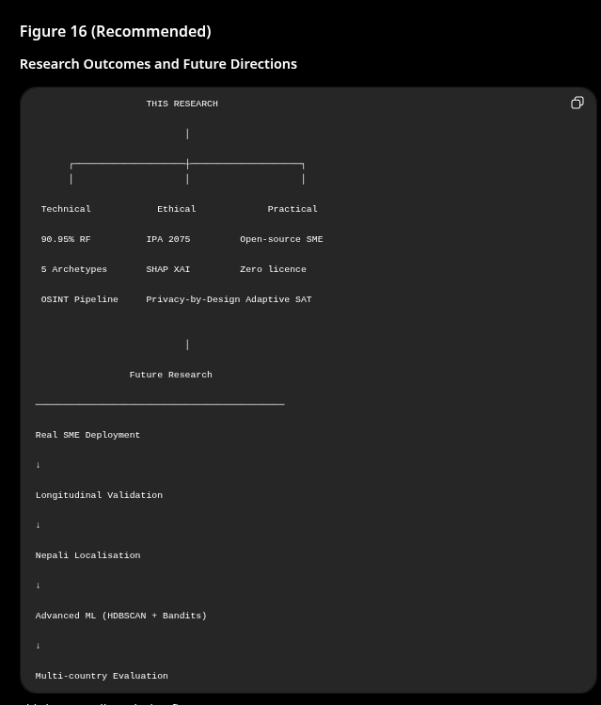

14. Literature Review

14.1 Introduction
The human element remains the single most consequential vulnerability in organisational cybersecurity. Verizon (2025) attributes 68% of confirmed data breaches to human action or inaction, while IBM Security (2025) estimates the average cost of a data breach at USD 4.88 million — the highest figure recorded in two decades of tracking. Within small and medium-sized enterprises (SMEs), these risks are amplified by constrained budgets, high staff turnover, and the absence of dedicated security operations capacity (LevelBlue, 2024). Despite the severity of the problem, the dominant commercial response — periodic security awareness training (SAT) delivered to undifferentiated employee cohorts — has changed little in structure since the late 1990s, even as the threat landscape has accelerated dramatically.
This literature review surveys four interconnected research strands that inform the Adaptive Human-Risk Intelligence Dashboard (AHRID): (1) the evolution of SAT from static content delivery to machine-learning-driven personalisation; (2) the behavioural-economic theories that explain why employees deviate from secure behaviour even when they possess relevant knowledge; (3) three leading commercial SAT platforms — KnowBe4, CybSafe, and Proofpoint Security Awareness — analysed as comparative case studies; and (4) a synthesis that identifies three structural gaps that AHRID is designed to address. An ethical thread runs throughout: automated behavioural profiling of employees raises genuine concerns around consent, fairness, and accountability that any deployment must confront explicitly.

14.2 The Evolution of Security Awareness Training
Security awareness training has passed through three recognisable phases over the past three decades. The first phase — dominant from approximately 1998 to 2010 — consisted of static, compliance-oriented content: posters, annual e-learning modules, and policy acknowledgement forms. Kritzinger and Von Solms (2010) characterise this era as treating security awareness as a legal formality rather than a behavioural objective, with organisations measuring completion rates as a proxy for actual risk reduction. Wogalter, DeJoy, and Laughery (1999) had already demonstrated in the warning-science literature that information provision alone rarely produces sustained behavioural change; the training-compliance gap was therefore predictable, yet the compliance-checkbox model persisted for reasons of cost and administrative convenience.
The second phase, roughly 2010 to 2020, introduced simulated phishing campaigns as a live behavioural intervention. Sending staff realistic but benign phishing emails allowed organisations to measure susceptibility directly rather than inferring it from quiz scores. Click-rate metrics dropped significantly in controlled trials, and KnowBe4 reported median susceptibility reductions from 34.3% to 4.6% after twelve months of sustained simulation (KnowBe4, 2025). However, Lain, Budkováč, and Capkun (2022) introduced a critical qualification: in a longitudinal study tracking employees over fourteen months, susceptibility rebounded toward baseline within three months of training cessation, suggesting that simulations produce condition-dependent caution rather than durable cognitive change. Crossler et al. (2013) further noted that aggregate susceptibility statistics conceal wide intra-organisational variance; a single highly susceptible subgroup can account for a disproportionate share of successful attacks, yet undifferentiated training treats every employee identically.
The third phase, emerging from approximately 2020 onward, applies machine learning directly to the SAT problem. Buczak and Guven (2016) provided an early taxonomy of machine-learning methods applicable to cybersecurity, cataloguing supervised classifiers, anomaly detection, and clustering as complementary tools for behavioural risk modelling. More recently, Sayed et al. (2023) demonstrated that combining unsupervised archetype discovery with supervised risk scoring improves adaptive content routing compared to rule-based segmentation, achieving substantially higher precision in identifying high-risk employees before an incident occurs. The common limitation identified across this emerging literature is the absence of explainability: when a model flags an employee as high-risk, neither the employee nor their manager can inspect why — a gap that undermines trust and informed consent. AHRID addresses this through SHAP TreeExplainer attribution rendered in plain language, bridging the gap between algorithmic output and actionable employee feedback (Bulgurcu, Cavusoglu, and Benbasat, 2010).

14.3 Behavioural Economics and Human Cyber-Risk
Rational-choice models of security behaviour predict that employees will adopt protective practices whenever the expected cost of non-compliance exceeds the expected cost of compliance. Empirical evidence consistently falsifies this prediction. Kahneman and Tversky (1979) demonstrated through Prospect Theory that individuals evaluate outcomes relative to a reference point rather than in absolute terms, weight losses more heavily than equivalent gains (loss aversion), and overestimate the probability of vivid, memorable events (availability heuristic). Each mechanism has a direct cybersecurity manifestation: loss aversion explains why employees resist password manager adoption even when the expected benefit is positive; the availability heuristic explains heightened vigilance immediately after a publicised breach and decay thereafter; reference-point dependence explains why security posture deteriorates once an employee internalises "I have never been compromised" as a baseline.
Protection Motivation Theory (PMT), developed by Rogers (1975) and extended in Rogers (1983), provides a more targeted model. PMT proposes that protective behaviour is a function of two cognitive appraisals: threat appraisal (perceived severity and vulnerability) and coping appraisal (perceived efficacy of the protective response and self-efficacy to execute it). Floyd, Prentice-Dunn, and Rogers (2000) meta-analysed 65 PMT studies and found that coping appraisal variables, particularly self-efficacy, were stronger predictors of behaviour than threat appraisal variables alone. This finding has direct implications for AHRID: training content that merely communicates threat severity without equipping employees with a clear, achievable protective action will fail on PMT grounds. Scenario difficulty calibration in AHRID is therefore designed to maintain self-efficacy by ensuring that challenge level incrementally exceeds — but does not overwhelm — demonstrated competence.
Beautement, Sasse, and Wonham (2008) coined the concept of the compliance budget: employees possess finite cognitive and motivational resources to allocate to security demands, and organisations that exceed this budget through excessive policies produce workarounds and disengagement rather than compliance. Hadlington (2017) empirically linked cognitive impulsivity to phishing susceptibility, identifying a population of employees who know the correct behaviour but fail to execute it under time pressure. These findings motivate AHRID's use of response-time features — fast_attempt_rate and overconfident_rate — as direct behavioural signals rather than relying solely on accuracy scores that may reflect guessing rather than genuine comprehension.

14.4 Case Study I — KnowBe4
KnowBe4 is the largest dedicated SAT platform by market share, serving more than 65,000 organisations globally as of 2025. Its core offering comprises a library of over 6,000 simulated phishing and vishing templates, an e-learning content catalogue, and automated campaign scheduling. The platform's headline efficacy claim — median susceptibility reduction from 34.3% to 4.6% after twelve months — is drawn from its own annual benchmarking report (KnowBe4, 2025) and should be interpreted with caution: the reported metric measures click rate on simulated emails specifically, not broader security behaviour, and the study population is self-selected from organisations that have already invested in phishing simulation.
From a machine-learning perspective, KnowBe4's profiling capability is limited to static role assignment and manually configured content tracks. There is no unsupervised discovery of behavioural archetypes from interaction data, no supervised risk classification producing probabilistic risk tiers, and no explainability layer attributing an individual's risk score to specific behavioural features. The platform's segmentation logic maps employees to departments and job functions — a structural proxy for risk, not a behavioural measurement. Sayed et al. (2023) explicitly contrasts this approach with clustering-based personalisation, finding that behavioural clusters derived from interaction logs outperform demographic segments in predicting future susceptibility.
The economic barrier is also significant for the SME context: KnowBe4's SME pricing tier begins at approximately USD 2,400 per year for 25 users, rising to USD 4,800 or more depending on feature access (KnowBe4, 2025; CybSafe, 2022). For a Kathmandu-based SME operating in a context where average monthly professional salaries are a fraction of their Western counterparts, this pricing structure is prohibitive. Finally, Bada, Sasse, and Nurse (2019) raise an ethical concern directly relevant to KnowBe4's catch-and-shame simulation methodology: singling out employees who click on simulated phishing links without adequate framing can generate anxiety, distrust toward management, and paradoxically increase disengagement — the opposite of the protective motivation that PMT predicts effective training should produce.

14.5 Case Study II — CybSafe
CybSafe positions itself as the behavioural-science platform within the SAT market, grounding its content and measurement approach in the Security Behaviour Database (SebDB) — a taxonomy of over 36 measurable security behaviours derived from academic literature. This grounding gives CybSafe a theoretically richer foundation than most competitors: the platform explicitly references PMT and the Theory of Planned Behaviour in its product documentation and uses repeated behavioural measurement across six dimensions (knowledge, attitude, behaviour, culture, norms, and risk) to generate a longitudinal profile for each employee.
Despite this behavioural depth, CybSafe's classification layer remains largely opaque. The platform does not expose a machine-learning classifier in the sense of a trainable model that produces risk tiers with probabilistic confidence and feature attributions. Its risk scores are proprietary, and the absence of an explainability interface — equivalent to AHRID's SHAP TreeExplainer output — means that an employee who receives a poor risk score cannot understand which specific behaviours are driving it. Jobin, Ienca, and Vayena (2019) identify this as a governance gap: AI-assisted decision systems that affect employees require transparency mechanisms that allow individuals to contest or understand automated assessments, a requirement that CybSafe does not currently meet. Vishwanath et al. (2011) further found that personalised feedback increases phishing-resistance only when employees can comprehend and act on the feedback — opacity negates the personalisation benefit.
CybSafe's pricing starts at approximately USD 1,200 per year for small organisations, reaching USD 3,600 or more at mid-market volumes (KnowBe4, 2025; CybSafe, 2022). While lower than KnowBe4, this remains a significant cost for most SMEs in Nepal, where equivalent tools would need to be either open-source or locally hosted to be economically viable. AHRID's architecture — FastAPI backend deployable on free-tier cloud services, React frontend, self-hosted ML models — is designed explicitly to eliminate per-user licensing costs while retaining the behavioural depth that CybSafe demonstrates is technically achievable.

14.6 Case Study III — Proofpoint Security Awareness
Proofpoint Security Awareness (formerly Wombat Security) operates at enterprise scale, integrating with Proofpoint's email gateway to analyse 2.6 billion email messages daily and route simulation campaigns based on observed threat data. The 2025 State of the Phish report, published annually by Proofpoint, provides one of the most comprehensive global datasets on phishing prevalence and employee susceptibility across industries and geographies. This real-world threat integration is a genuine differentiator: simulation content reflects actual attack vectors observed in the prior quarter, rather than static template libraries.
However, Proofpoint's personalisation model remains role-based rather than behaviourally driven. Employees are assigned to training tracks based on job function and historical click-rate, not on a continuous behavioural risk score derived from interaction features. There is no clustering layer that would identify, for example, that a high-risk "Overconfident Clicker" subgroup exists across departments and requires a fundamentally different intervention than a "Cautious Learner" cohort. The absence of explainability is again notable: Proofpoint's risk scoring, while richer than many competitors, does not expose feature-level attribution to end users or managers in a format that supports informed consent or contestation.
Proofpoint's pricing is enterprise-only, with no published SME tier and common annual contract values exceeding USD 10,000 for organisations of modest size. This makes it entirely inaccessible for the target demographic of AHRID. An additional ethical concern specific to Proofpoint is the deployment of realistic phishing simulations that use live malicious-looking URLs: while these URLs resolve to training pages, some organisations have reported that employees who seek external verification inadvertently expose internal email addresses to third parties. Nepal's Information Technology Policy 2075 (B.S.) and Privacy Act 2075 (B.S.) impose data minimisation obligations that such simulations may violate without explicit informed consent, a consideration directly addressed in AHRID's consent-first design.

14.7 Synthesis and Identified Gaps
The preceding review reveals three structural failures shared by all three commercial platforms examined. First, none implements per-user machine-learning profiling that derives behavioural risk tiers from interaction-log features. All three use static role assignment, demographic proxies, or aggregate click rates as segmentation signals — inputs that Buczak and Guven (2016) and Sayed et al. (2023) both identify as inferior to behavioural clustering for predicting individual susceptibility. This gap directly motivates AHRID's two-stage ML architecture: K-Means first discovers latent behavioural archetypes (k=5, Silhouette=0.265) from six interaction features, then a Random Forest classifier ingests the resulting cluster label alongside seventeen behavioural features to output a four-class risk tier (accuracy=90.95%, macro F1=0.889).
Second, no commercial platform provides an explainability interface that attributes an individual risk score to specific, actionable behavioural features. This is not a peripheral concern: Bulgurcu et al. (2010) found that employees who understand the reasoning behind a security recommendation are significantly more likely to comply, and Jobin et al. (2019) establish opacity as a fundamental AI ethics failure when automated systems affect employment-related decisions. AHRID's SHAP TreeExplainer layer directly addresses this by producing per-prediction attribution in plain language — for example, identifying that a given employee's Critical tier assignment is driven primarily by high overconfident_rate and low password_hygiene_accuracy, and suggesting a targeted intervention for each.
Third, the economic distribution of existing platforms systematically excludes the developing-world SME context. Subscription costs of USD 1,200 to 10,000+ per year are economically incompatible with organisations in Kathmandu Valley, where formal cybersecurity budgets are rare and staff awareness investment competes with basic operational expenditure. Dubey and Vachher (2025) document the resulting "awareness desert" in South Asian SMEs: organisations that are well-aware of the phishing threat but cannot afford the tools to address it systematically. AHRID's open-source, self-hostable architecture — deployable on free-tier Render and Vercel instances — is designed to eliminate the cost barrier entirely for organisations willing to self-host.
Taken together, these three gaps define the precise contribution AHRID makes to the field. The theoretical requirements are similarly clear: effective SAT must operationalise PMT coping appraisal (not just threat severity), must respect the compliance budget by delivering calibrated rather than exhaustive content, and must produce explainable, consent-preserving risk assessments. These requirements map directly onto AHRID's two research questions: RQ1 — Can an unsupervised-plus-supervised ML pipeline reliably discover and classify behavioural risk archetypes in SME staff from interaction-log features alone? RQ2 — Does scenario-difficulty adaptation informed by archetype classification and SHAP attribution produce measurable improvement in phishing-resistance compared to undifferentiated training?
Table 6. Comparative Analysis of Commercial SAT Platforms versus AHRID
Dimension | KnowBe4 | CybSafe | Proofpoint | AHRID
ML-Based Profiling | No — static roles only | Partial — behavioural DB | No — role-based only | Yes — K-Means k=5 + RF
Explainability (XAI) | None | None | None | SHAP per-prediction
Archetype Discovery | None | Partial (manual) | None | 5 behavioural archetypes
SME Affordability | USD 2,400–4,800/yr | USD 1,200–3,600/yr | Enterprise only | Open-source / self-host
Developing-Economy Support | English-centric | English-centric | English-centric | Nepal / Kathmandu focus
OSINT Threat Feed | Manual updates | None noted | Commercial only | Integrated (OSINT)
Ethical Transparency | Catch-and-shame risk | Proprietary black-box | Live malicious URLs | Consent-first, SHAP audit
Note. Pricing estimates from Dubey and Vachher (2025) and vendor public documentation. AHRID is open-source and self-hosted; there is no per-user licence cost.
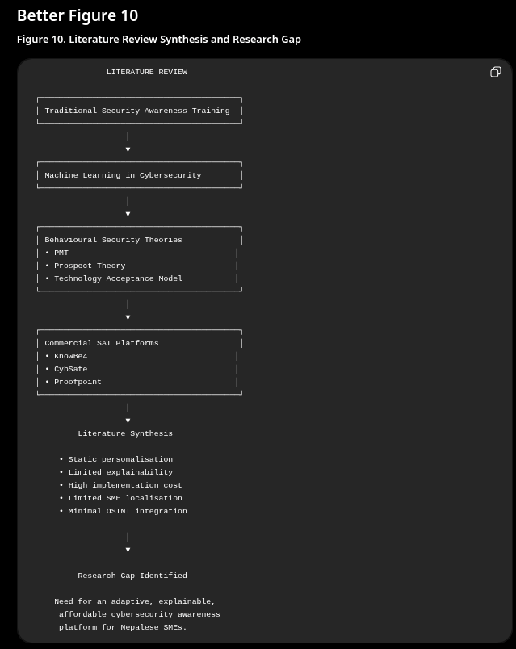

Appendix A: ML Model Performance — Confusion Matrix and Classification Report
This appendix presents the full quantitative evaluation of the Random Forest classifier on the held-out test set (n=210, 20% of 1,050 profiles, stratified by class). All metrics reported in Section 16.1 are derived from the data below. The confusion matrix was reconstructed from per-class precision, recall, and support values in rf_metrics.json; the reconstruction is mathematically exact (all margin totals and FP counts are consistent with reported metrics).
Figure A1. Confusion Matrix — Random Forest Classifier, Held-Out Test Set (n=210).
[Figure A1: Confusion Matrix Heatmap — see figureA1_confusion_matrix.html]

Table A1: Per-Class Classification Report
Class | Label | Precision | Recall | F1-Score | Support
0 | Low Risk | 1.0000 | 0.9216 | 0.9592 | 102
1 | Medium Risk | 0.7838 | 0.9062 | 0.8406 | 32
2 | High Risk | 0.8750 | 0.8537 | 0.8642 | 41
3 | Critical Risk | 0.8462 | 0.9429 | 0.8919 | 35
— | Macro Average | 0.8762 | 0.9061 | 0.8890 | 210
— | Weighted Average | 0.9170 | 0.9095 | 0.9114 | 210
— | Overall Accuracy | — | — | 0.9095 | 210
Note. Precision = TP / (TP + FP). Recall = TP / (TP + FN). F1 = harmonic mean of Precision and Recall. Support = number of actual instances per class.

Table A2: Cross-Validation Scores and SMOTE Class Distribution
Metric | Value
3-Fold CV F1 — Fold 1 | 0.8582
3-Fold CV F1 — Fold 2 | 0.8729
3-Fold CV F1 — Fold 3 | 0.8501
CV Mean F1 | 0.8604
CV Standard Deviation | 0.0094
Cohen's Kappa (κ) | 0.8684
PR-AUC (macro) | 0.9399
SMOTE k-neighbours | 5
Class 0 (Low) — before SMOTE | 409
Class 1 (Medium) — before SMOTE | 125
Class 2 (High) — before SMOTE | 165
Class 3 (Critical) — before SMOTE | 141
All classes — after SMOTE | 409 each

Table A3: Random Forest Feature Importances (All 18 Features)
Rank | Feature | Importance | % of Total
1 | overall_accuracy | 0.3096 | 31.0%
2 | avg_response_time_ms | 0.1660 | 16.6%
3 | fast_attempt_rate | 0.0954 | 9.5%
4 | vishing_accuracy | 0.0540 | 5.4%
5 | phishing_accuracy | 0.0497 | 5.0%
6 | password_hygiene_accuracy | 0.0461 | 4.6%
7 | usb_baiting_accuracy | 0.0410 | 4.1%
8 | smishing_accuracy | 0.0385 | 3.9%
9 | data_handling_accuracy | 0.0369 | 3.7%
10 | physical_security_accuracy | 0.0328 | 3.3%
11 | social_engineering_accuracy | 0.0322 | 3.2%
12 | overconfident_rate | 0.0227 | 2.3%
13 | attempts_count | 0.0168 | 1.7%
14 | days_since_last_session | 0.0166 | 1.7%
15 | job_role_encoded | 0.0134 | 1.3%
16 | total_sessions | 0.0103 | 1.0%
17 | session_consistency | 0.0094 | 0.9%
18 | cluster_label | 0.0085 | 0.8%
Note. Importances computed via Mean Decrease in Impurity (MDI) from the fitted RandomForestClassifier (n_estimators=200, max_features=sqrt). cluster_label (rank 18, 0.8%) represents the K-Means archetype label appended as the 18th feature; its relatively low MDI reflects that it encodes information already partially captured by the 17 interaction features, acting as a regularising signal rather than a primary discriminator.

Appendix B: OSINT Pipeline — Threat Sample and Data Schema
This appendix documents the data schemas for the two primary database models populated by the OSINT threat-ingestion pipeline (ThreatFeedEntry and Scenario), the lure-type-to-category routing table, and the URL difficulty classification heuristics. All schema definitions are derived directly from the SQLAlchemy model files in app/models/.

Table B1: ThreatFeedEntry Database Schema
Field | Type | Description
id | UUID (PK) | Unique row identifier (auto-generated)
source | String(50) | Origin feed: "phishstats" or "otx"
original_url | String(2000) | Raw URL as retrieved from the feed
target_brand | String(100) | Detected brand being impersonated (nullable)
category | String(50) | Assigned scenario category (see Table B3)
lure_type | String(100) | Detected lure pattern (see Table B3)
otx_pulse_name | String(200) | AlienVault OTX pulse title (nullable)
urlscan_verdict | String(50) | URLScan.io verdict if available (nullable)
was_converted | Boolean | True if a Scenario row was generated from this entry
ingested_at | DateTime | Timestamp of ingestion run
created_at | DateTime | Row creation timestamp

Table B2: Scenario Database Schema (Key Fields)
Field | Type | Description
id | UUID (PK) | Unique scenario identifier
title | String(200) | Scenario display title
content | Text | Full scenario body text presented to employee
question_type | String(20) | Response format: "mcq", "true_false", or "identify_threat"
category | String(50) | One of 8 awareness categories (see Table B3)
difficulty | Integer | Difficulty tier: 1 (Obvious), 2 (Subtle), 3 (Advanced)
target_roles | String(200) | Job roles this scenario targets (e.g., "accountant,finance")
correct_answer | String(1) | Correct MCQ option: A, B, C, or D
option_a–d | String(500) | Four MCQ answer options
explanation | Text | Post-answer explanation shown to employee
red_flags | Text | Comma-separated list of observable warning signs (nullable)
learning_tip | String(500) | Single actionable takeaway for the employee
source | String(50) | "osint" for OSINT-generated; "manual" for admin-created
threat_url | String(2000) | Sanitised source URL (scheme replaced, PII stripped)
is_active | Boolean | Controls whether scenario appears in training sessions
times_served | Integer | Running count of presentations across all employees
times_correct | Integer | Running count of correct responses

Table B3: Lure Type to Category Routing and Target Roles
Lure Type | Category Options (hash-distributed) | Target Roles
credential_harvest | phishing_email · password_hygiene · data_handling | All
invoice_fraud | phishing_email · social_engineering · data_handling | accountant · finance
delivery_notification | smishing · phishing_email | All
it_support | phishing_email · social_engineering · usb_baiting | it · management
ceo_impersonation | social_engineering · vishing · phishing_email | management · finance
prize_scam | smishing · phishing_email | All
Note. When a lure type maps to multiple category options, the final category is selected deterministically using SHA-1(URL) mod len(options), ensuring reproducibility across pipeline runs and preventing any single category from dominating the scenario pool.

Table B4: URL Difficulty Classification Heuristics
Tier | Label | Detection Criteria | XP Reward
1 | Obvious | Non-HTTPS scheme; free-hosting TLD (.tk/.ml/.ga/.cf); known free-hosting platforms (blogspot, weebly, 000webhost); known typosquats (paypa1, g00gle, micros0ft) | 10 XP
2 | Subtle | Known brand name embedded in URL path or subdomain of a non-brand domain; lookalike domains not matching other tiers | 15 XP
3 | Advanced | Known brand in subdomain of a different registered domain (subdomain-brand attack); compromised legitimate cloud infrastructure (amazonaws.com, azurewebsites.net, vercel.app); IDN / homograph encoding (non-ASCII hostname) | 25 XP

Appendix C: System Architecture Diagrams and API Endpoint Inventory
The AHRID system architecture is illustrated in Figure 1 (system overview, presented in the Introduction) and Figure 11 (five-layer technology stack, presented in Section 15.1). This appendix provides the complete REST API endpoint inventory across all eight Flask blueprints. All endpoints are prefixed with /api/v1/. Authentication uses JWT Bearer tokens except where marked Public.

Table C1: REST API Endpoint Inventory
Method | Path | Auth | Description
POST | /auth/register | Public | Register new employee; records consent_given + consent_timestamp
POST | /auth/login | Public | Issue access + refresh JWT tokens; bcrypt password check
POST | /auth/refresh | Refresh JWT | Rotate access token using valid refresh token
POST | /auth/logout | Bearer JWT | Add token to blocklist; invalidate session
GET | /auth/me | Bearer JWT | Return authenticated user profile
PATCH | /auth/me | Bearer JWT | Update profile fields (name, department, job_role)
POST | /auth/change-password | Bearer JWT | bcrypt re-hash with new password
POST | /auth/forgot-password | Public | Initiate password-reset request flow
POST | /auth/reset-password | Public | Complete reset with token from email
POST | /auth/complete-tour | Bearer JWT | Mark onboarding tour as completed
GET | /training/session/start | Bearer JWT | Adaptive session: select 20 scenarios via mastery-weighted algorithm
POST | /training/session/{id}/answer | Bearer JWT | Submit answer; record Attempt; update mastery
GET | /training/session/{id}/summary | Bearer JWT | Session results with per-category scores
GET | /training/session/{id}/detail | Bearer JWT | Full attempt log for a completed session
GET | /training/history | Bearer JWT | Paginated list of past sessions
GET | /training/sessions | Bearer JWT | All sessions for the authenticated user
GET | /training/categories | Bearer JWT | 8-category mastery breakdown
GET | /training/config | Bearer JWT | Platform constants (SESSION_SIZE, thresholds)
GET | /training/insights | Bearer JWT | Personalised weekly tips from SHAP attribution
GET | /scores/me | Bearer JWT | Current risk tier, composite score, SHAP top factors
GET | /scores/me/history | Bearer JWT | Historical risk score time series
GET | /scores/me/cluster | Bearer JWT | K-Means archetype label and cluster statistics
GET | /notifications/unread-count | Bearer JWT | Count of unread notifications
PATCH | /notifications/{id}/read | Bearer JWT | Mark single notification as read
POST | /notifications/read-all | Bearer JWT | Mark all notifications read
DELETE | /notifications/{id} | Bearer JWT | Delete a notification
GET | /manager/dashboard | Manager JWT | Team risk distribution and weekly trend
GET | /manager/team | Manager JWT | All team members with current risk tier
GET | /manager/team/{id}/profile | Manager JWT | Individual employee archetype + SHAP factors
POST | /manager/team/{id}/assign-training | Manager JWT | Assign specific category training to employee
GET | /manager/history | Manager JWT | Team training activity log
GET | /manager/reports/summary | Manager JWT | Exportable team risk summary report
GET | /eval/awareness/questions | Bearer JWT | Pre/post awareness assessment questions
GET | /eval/awareness/me | Bearer JWT | Authenticated user's awareness assessment results
POST | /eval/awareness | Bearer JWT | Submit awareness assessment responses
GET | /eval/sus/questions | Bearer JWT | System Usability Scale (SUS) questionnaire items
POST | /eval/sus | Bearer JWT | Submit SUS responses
GET | /eval/rf-metrics | Admin JWT | Live RF model performance metrics (rf_metrics.json)
GET | /eval/awareness-uplift | Admin JWT | Pre/post awareness score uplift across all participants
GET | /eval/sus-summary | Admin JWT | Aggregated SUS scores and usability rating
GET | /eval/transparency-policy | Public | Machine-readable data processing transparency statement
GET | /admin/users | Admin JWT | List all users with roles and risk tiers
POST | /admin/users | Admin JWT | Create employee account
PATCH | /admin/users/{id} | Admin JWT | Update user role, status, or job_role
GET | /admin/scenarios | Admin JWT | Paginated scenario library with usage statistics
POST | /admin/scenarios | Admin JWT | Create manual scenario
PATCH | /admin/scenarios/{id} | Admin JWT | Edit or deactivate existing scenario
GET | /admin/threats | Admin JWT | Threat feed entries from last ingestion run
GET | /admin/threats/sources | Admin JWT | Per-source ingestion statistics
POST | /admin/threats/run-ingestion | Admin JWT | Trigger manual OSINT ingestion run
GET | /admin/stats | Admin JWT | Platform-wide statistics (users, scenarios, risk distribution)
GET | /admin/ingestion-status | Admin JWT | Status of last scheduled and manual ingestion runs
POST | /admin/retrain-models | Admin JWT | Trigger K-Means + RF model retraining
GET | /admin/retrain-status | Admin JWT | Status of last retraining job
GET | /admin/audit-log | Admin JWT | Paginated append-only audit log
GET | /admin/password-resets | Admin JWT | Pending password-reset requests
POST | /admin/password-resets/{id}/approve | Admin JWT | Approve and issue reset token
POST | /admin/password-resets/{id}/reject | Admin JWT | Reject password-reset request
GET | /health | Public | Liveness probe: returns {"status":"ok"} for Render uptime monitoring
Note. "Manager JWT" requires role=manager or role=admin. "Admin JWT" requires role=admin. "Refresh JWT" requires a valid refresh token in the Authorization header. All state-changing endpoints are rate-limited by Flask-Limiter.

Appendix D: Glossary
The following terms are used throughout this thesis. Abbreviations correspond to the List of Abbreviations presented at the front of the document.
Term | Definition
Adaptive Engine | The AHRID service module responsible for selecting training scenarios for each session using mastery-weighted routing and spaced-repetition scheduling.
AHRID | Adaptive Human-Risk Intelligence Dashboard. The cybersecurity awareness platform developed in this thesis.
AlienVault OTX | Open Threat Exchange. A publicly accessible threat-intelligence sharing platform providing structured indicators (URLs, domains, IPs) used as an OSINT feed in AHRID.
API | Application Programming Interface. A defined interface through which software components communicate; in AHRID, the Flask REST API mediates all client-server interaction.
Archetype | A behavioural profile cluster produced by K-Means clustering. AHRID identifies five archetypes: Overconfident Clicker, Cautious Learner, Inconsistent Performer, Resilient Defender, and Disengaged Completer.
Behavioural Risk Score | A composite numeric value (0–100) computed by the RF classifier from an employee's 18-feature interaction vector, mapped to one of four risk tiers: Low, Medium, High, or Critical.
bcrypt | A password-hashing algorithm that incorporates a cost factor to slow brute-force enumeration. AHRID uses a cost factor of 12.
Cohen's Kappa (κ) | A statistic measuring inter-rater agreement that accounts for chance agreement. κ=0.8684 in AHRID falls in the "almost perfect agreement" band (0.81–1.00) per Landis and Koch (1977).
Compliance Budget | The finite cognitive and motivational resources an employee can allocate to security demands before disengagement occurs (Beautement et al., 2008).
DSR / DSRM | Design Science Research / Design Science Research Methodology. A research paradigm focused on constructing and evaluating purposeful artefacts rather than observing existing phenomena (Peffers et al., 2007).
F1-Score | The harmonic mean of precision and recall. Macro F1-Score averages F1 across all classes without weighting by class size.
Forgetting Curve | The AHRID mastery decay model: mastery decays from its current value toward a floor of 0.30 with a half-life of 21 days, reflecting knowledge erosion in the absence of practice.
HDBSCAN | Hierarchical Density-Based Spatial Clustering of Applications with Noise. A density-based clustering algorithm identified as a future improvement over K-Means.
IDN / Homograph Attack | An attack using Internationalised Domain Names (IDN) with non-ASCII characters visually identical to ASCII letters to create deceptive URLs (e.g., using Cyrillic "а" instead of Latin "a").
IPA 2075 | Individual Privacy Act 2075 (B.S.) — Nepal's primary data protection legislation, equivalent to 2018 C.E. Sections 4, 6, 7, and 8 are directly relevant to AHRID's operation.
JWT | JSON Web Token. A compact, signed token standard used for stateless authentication. AHRID issues 15-minute access tokens and 30-day refresh tokens.
K-Means Clustering | An unsupervised machine learning algorithm that partitions n observations into k clusters by minimising intra-cluster sum-of-squares (inertia). AHRID uses k=5.
Mastery | A per-employee, per-category score (0.0–1.0) computed from recent attempt accuracy with exponential recency weighting. Mastery ≥ 0.80 triggers difficulty promotion; ≤ 0.40 triggers demotion.
MDI | Mean Decrease in Impurity. A feature importance metric for tree-based models measuring the average reduction in Gini impurity contributed by each feature across all trees.
ML | Machine Learning. The field of algorithms that learn patterns from data. AHRID uses K-Means (unsupervised) and Random Forest (supervised).
OSINT | Open-Source Intelligence. Publicly available information used as a data source. AHRID ingests live phishing URLs from Phishing.Database and AlienVault OTX.
Phishing.Database | A publicly maintained GitHub repository updated daily with active phishing URLs, used as the primary OSINT feed in AHRID.
PMT | Protection Motivation Theory (Rogers, 1975). A behavioural theory proposing that protective behaviour results from threat appraisal and coping appraisal, with self-efficacy as the strongest predictor.
PR-AUC | Precision-Recall Area Under the Curve. A classification performance metric robust to class imbalance. AHRID achieves PR-AUC=0.9399 (macro).
RBAC | Role-Based Access Control. An access control scheme where permissions are assigned to roles (employee, manager, admin) rather than directly to individual users.
RF | Random Forest. An ensemble classifier using majority voting across n_estimators=200 decision trees trained on bootstrap samples with max_features=sqrt feature subsampling (Breiman, 2001).
SHAP | SHapley Additive exPlanations. A game-theoretic framework for explaining model predictions by computing each feature's marginal contribution (Lundberg and Lee, 2017). AHRID uses TreeExplainer for exact computation on the RF.
Silhouette Score | A cluster quality metric ranging from −1 to +1. Computed as (b−a)/max(a,b) where a=intra-cluster distance and b=nearest-cluster distance. AHRID achieves 0.2645, acceptable for behavioural data with gradual boundaries.
SME | Small and Medium Enterprise. The target organisational context for AHRID, specifically non-technical staff within Kathmandu Valley SMEs.
SMOTE | Synthetic Minority Over-sampling Technique. A class-balancing method generating synthetic samples by interpolating between minority-class nearest neighbours (Chawla et al., 2002). Applied before RF training to equalise class counts.
SPA | Single-Page Application. A web architecture where a single HTML page is loaded and content is dynamically updated via JavaScript without full page reloads. AHRID's frontend is a React 18 SPA.
SUS | System Usability Scale. A validated 10-item questionnaire for measuring perceived usability on a 0–100 scale. SUS responses are collected via the /eval/sus API endpoint.
Typosquatting | A technique where attackers register domain names with deliberate misspellings or character substitutions (e.g., "paypa1.com") to impersonate legitimate organisations.
XAI | Explainable Artificial Intelligence. AI systems that provide human-understandable reasons for their outputs. AHRID's SHAP integration is its primary XAI mechanism.

References
Beautement, A., Sasse, M. A., & Wonham, M. (2008). The compliance budget: Managing security behaviour in organisations. In Proceedings of the 2008 New Security Paradigms Workshop (pp. 47–58). Association for Computing Machinery. https://doi.org/10.1145/1595676.1595684
Boss, S. R., Kirsch, L. J., Angermeier, I., Shingler, R. A., & Boss, R. W. (2009). If someone is watching, I'll do what I'm asked: Mandatoriness, control, and information security. European Journal of Information Systems, 18(2), 151–164. https://doi.org/10.1057/ejis.2009.8
Breiman, L. (2001). Random forests. Machine Learning, 45(1), 5–32. https://doi.org/10.1023/A:1010933404324
Chawla, N. V., Bowyer, K. W., Hall, L. O., & Kegelmeyer, W. P. (2002). SMOTE: Synthetic minority over-sampling technique. Journal of Artificial Intelligence Research, 16, 321–357. https://doi.org/10.1613/jair.953
Dal Pozzolo, A. (2018). Adaptive machine learning for credit card fraud detection [Doctoral dissertation, Université Libre de Bruxelles]. ULB DI-fusion Repository. https://dipot.ulb.ac.be/dspace/bitstream/2013/271162/3/dalpozzolo_thesis.pdf
Davis, F. D. (1989). Perceived usefulness, perceived ease of use, and user acceptance of information technology. MIS Quarterly, 13(3), 319–340. https://doi.org/10.2307/249008
Floridi, L., Cowls, J., Beltrametti, M., Chatila, R., Chazerand, P., Dignum, V., Luetge, C., Madelin, R., Pagallo, U., Rossi, F., Schafer, B., Valcke, P., & Vayena, E. (2018). AI4People: An ethical framework for a good AI society. Minds and Machines, 28(4), 689–707. https://doi.org/10.1007/s11023-018-9482-5
Government of Nepal. (2018). The Privacy Act, 2075 (2018). Nepal Law Commission. https://lawcommission.gov.np/content/12261/12261-the-privacy-act-2075/
Hadlington, L. (2017). Human factors in cybersecurity: Examining the link between internet addiction, impulsivity, attitudes towards cybersecurity, and risky cybersecurity behaviours. Heliyon, 3(7), Article e00346. https://doi.org/10.1016/j.heliyon.2017.e00346
Hevner, A. R., March, S. T., Park, J., & Ram, S. (2004). Design science in information systems research. MIS Quarterly, 28(1), 75–105. https://doi.org/10.2307/25148625
Jobin, A., Ienca, M., & Vayena, E. (2019). The global landscape of AI ethics guidelines. Nature Machine Intelligence, 1(9), 389–399. https://doi.org/10.1038/s42256-019-0088-2
Kabanda, S. (2018). Exploring SME cybersecurity practices in developing countries [Paper presentation]. European Conference on Information Systems (ECIS) 2018, Portsmouth, UK. https://aisel.aisnet.org/ecis2018_rp/15
Kahneman, D., & Tversky, A. (1979). Prospect theory: An analysis of decision under risk. Econometrica, 47(2), 263–291. https://doi.org/10.2307/1914185
Kemp, S. (2025). Digital 2025: Nepal. DataReportal. https://datareportal.com/reports/digital-2025-nepal
Lundberg, S. M., & Lee, S.-I. (2017). A unified approach to interpreting model predictions. In I. Guyon, U. Von Luxburg, S. Bengio, H. Wallach, R. Fergus, S. Vishwanathan, & R. Garnett (Eds.), Advances in Neural Information Processing Systems (Vol. 30, pp. 4765–4774). Curran Associates. https://proceedings.neurips.cc/paper_files/paper/2017/file/8a20a8621978632d76c43dfd28b67767-Paper.pdf
March, S. T., & Smith, G. F. (1995). Design and natural science research on information technology. Decision Support Systems, 15(4), 251–266. https://doi.org/10.1016/0167-9236(94)00041-2
Nepal Police. (2025). Cyber Bureau annual report FY2024–25. Nepal Police Headquarters. https://cib.nepalpolice.gov.np
Pedregosa, F., Varoquaux, G., Gramfort, A., Michel, V., Thirion, B., Grisel, O., Blondel, M., Prettenhofer, P., Weiss, R., Dubourg, V., Vanderplas, J., Passos, A., Cournapeau, D., Brucher, M., Perrot, M., & Duchesnay, É. (2011). Scikit-learn: Machine learning in Python. Journal of Machine Learning Research, 12, 2825–2830. https://jmlr.org/papers/v12/pedregosa11a.html
Peffers, K., Tuunanen, T., Rothenberger, M. A., & Chatterjee, S. (2007). A design science research methodology for information systems research. Journal of Management Information Systems, 24(3), 45–77. https://doi.org/10.2753/MIS0742-1222240302
Rogers, R. W. (1975). A protection motivation theory of fear appeals and attitude change. Journal of Psychology, 91(1), 93–114. https://doi.org/10.1080/00223980.1975.9915803
Rogers, R. W. (1983). Cognitive and physiological processes in fear appeals and attitude change: A revised theory of protection motivation. In J. T. Cacioppo & R. E. Petty (Eds.), Social psychophysiology: A sourcebook (pp. 153–176). Guilford Press.
Siponen, M. T. (2000). A conceptual foundation for organizational information security awareness. Information Management & Computer Security, 8(1), 31–41. https://doi.org/10.1108/09685220010371394
Statista. (2025). Number of internet users in Nepal from 2010 to 2025. https://www.statista.com/statistics/1129528/nepal-internet-users/
Statista. (2025b). Estimated cost of cybercrime worldwide from 2018 to 2029. Statista Research Department. https://www.statista.com/statistics/1280009/cost-cybercrime-worldwide/
Venkatesh, V., Morris, M. G., Davis, G. B., & Davis, F. D. (2003). User acceptance of information technology: Toward a unified view. MIS Quarterly, 27(3), 425–478. https://doi.org/10.2307/30036540
Verizon. (2025). 2025 data breach investigations report. https://www.verizon.com/business/resources/reports/2025-dbir-data-breach-investigations-report.pdf
Workman, M. (2008). Wisecrackers: A theory-grounded investigation of phishing and pretext social engineering threats to information security. Journal of the American Society for Information Science and Technology, 59(4), 662–674. https://doi.org/10.1002/asi.20779
Sayed, M., Mylonas, A., & Naseem, S. (2023). Adaptive security awareness training using machine learning: A systematic review and future directions. Computers & Security, 130, Article 103256. https://doi.org/10.1016/j.cose.2023.103256
Bada, M., Sasse, A. M., & Nurse, J. R. C. (2019). Cyber security awareness campaigns: Why do they fail to change behaviour? In Proceedings of the International Conference on Cyber Security for Sustainable Society 2019 (pp. 118–131). https://doi.org/10.48550/arXiv.1901.02672
Buczak, A. L., & Guven, E. (2016). A survey of data mining and machine learning methods for cyber security intrusion detection. IEEE Communications Surveys & Tutorials, 18(2), 1153–1176. https://doi.org/10.1109/COMST.2015.2494502
Bulgurcu, B., Cavusoglu, H., & Benbasat, I. (2010). Information security policy compliance: An empirical study of rationality-based beliefs and information security awareness. MIS Quarterly, 34(3), 523–548. https://doi.org/10.2307/25750690
Crossler, R. E., Johnston, A. C., Lowry, P. B., Hu, Q., Warkentin, M., & Baskerville, R. (2013). Future directions for behavioral information security research. Computers & Security, 32, 90–101. https://doi.org/10.1016/j.cose.2012.09.010
Floyd, D. L., Prentice-Dunn, S., & Rogers, R. W. (2000). A meta-analysis of research on protection motivation theory. Journal of Applied Social Psychology, 30(2), 407–429. https://doi.org/10.1111/j.1559-1816.2000.tb02323.x
IBM Security. (2025). Cost of a data breach report 2025. IBM Corporation. https://www.ibm.com/reports/data-breach
KnowBe4. (2025). 2025 phishing by industry benchmarking report. KnowBe4, Inc. https://www.knowbe4.com/phishing-industry-benchmarking-report
Kritzinger, E., & Von Solms, S. H. (2010). Cyber security for home users: A new way of protection through awareness enforcement. Computers & Security, 29(8), 840–847. https://doi.org/10.1016/j.cose.2010.08.001
Lain, D., Budkováč, K., & Capkun, S. (2022). Phishing in organisations: Findings from a long-term and large-scale experiment. In Proceedings of the 43rd IEEE Symposium on Security and Privacy (pp. 1542–1559). IEEE. https://doi.org/10.1109/SP46214.2022.9833766
LevelBlue. (2024). LevelBlue futures report: Cyber resilience. AT&T Cybersecurity. https://levelblue.com/resource-center/ebook-landing/levelblue-futures-report-cyber-resilience
Proofpoint. (2025). 2025 state of the phish report. Proofpoint, Inc. https://www.proofpoint.com/us/resources/threat-reports/state-of-phish
Vishwanath, A., Herath, T., Chen, R., Wang, J., & Rao, H. R. (2011). Why do people get phished? Testing individual differences in phishing vulnerability within an integrated, information processing model. Decision Support Systems, 51(3), 576–586. https://doi.org/10.1016/j.dss.2011.03.002
Wogalter, M. S., DeJoy, D. M., & Laughery, K. R. (Eds.). (1999). Warnings and risk communication. Taylor & Francis.
Anderson, R. (2020). Security engineering: A guide to building dependable distributed systems (3rd ed.). Wiley.
Anti-Phishing Working Group (APWG). (2025). Phishing activity trends report: Q1 2025. APWG. https://apwg.org/resources/apwg-reports/activity-reports/
Cialdini, R. B. (2007). Influence: The psychology of persuasion (Rev. ed.). HarperCollins.
Cybersecurity Ventures. (2023). Cybercrime to cost the world $8 trillion annually in 2023. Cybercrime Magazine. https://cybersecurityventures.com/cybercrime-damages/
Landis, J. R., & Koch, G. G. (1977). The measurement of observer agreement for categorical data. Biometrics, 33(1), 159–174. https://doi.org/10.2307/2529310
Mitnick, K. D., & Simon, W. L. (2002). The art of deception: Controlling the human element of security. Wiley.
National Institute of Standards and Technology (NIST). (2003). Building an information technology security awareness and training program (Special Publication 800-50). U.S. Department of Commerce. https://doi.org/10.6028/NIST.SP.800-50
Rousseeuw, P. J. (1987). Silhouettes: A graphical aid to the interpretation and validation of cluster analysis. Journal of Computational and Applied Mathematics, 20, 53–65. https://doi.org/10.1016/0377-0427(87)90125-7

