Release Readiness Report
The release decision depends on both the service metrics and the chart below.
Service | Error rate | Decision
Vision API | 0.8% | pass
Search API | 3.4% | investigate
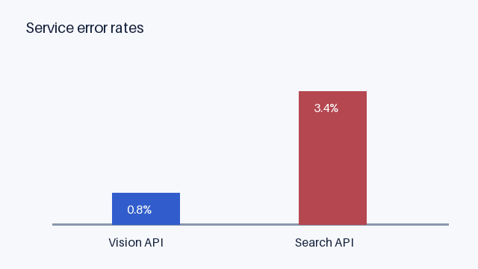
Error rates by service. Search API exceeds the two percent review threshold.
Figure 1: Service error-rate evidence for the release review.
The Search API requires investigation because its error rate exceeds the review threshold shown in Figure 1.

