Table of Contents
Architecture Description 1
Checkout and Payment System with General Ledger 1
Table of Contents 1
1. System of Interest 1
2. Stakeholders and Concerns 1
3. Architecture Viewpoints 1
4. Views 1
5. Correspondences and Correspondence Rules 1
6. Architecture Decisions and Rationale 1

Architecture Description

Checkout and Payment System with General Ledger
Field | Value
Standard | ISO/IEC/IEEE 42010:2022
AD Identifier | AD-CHECKOUT-001
Version | 1.1.0
Date | 2026-05-10
Status | Baseline
System of Interest | Checkout and Payment Platform — Code Quest #77
Author | Ibrahim Alamro
Classification | Internal / Hiring Quest Submission

Table of Contents
- System of Interest
- Stakeholders and Concerns
- Architecture Viewpoints
- Views
  - 4.1 Context View
  - 4.2 Functional Decomposition View
  - 4.3 Component and Connector View
  - 4.4 Information View — Domain Models
  - 4.5 Information View — State Machines
  - 4.6 Process View — Key Flows
  - 4.7 Data View — Persistence Schema
  - 4.8 Deployment View
  - 4.9 Development View — Module Dependencies
- Correspondences and Correspondence Rules
- Architecture Decisions and Rationale

1. System of Interest

1.1 Purpose
This system is a single-service backend for a simplified e-commerce platform. I designed it to cover the full purchase lifecycle from shopping to ledger reconciliation. In practice, that means four areas of responsibility:
- Shopping cart — customers create carts, add items, and eventually lock them at checkout
- Order management — the cart-to-order conversion, tracking order state through payment outcomes
- Payment processing — initiating charges, ingesting webhook callbacks from the payment provider, and handling retries when a payment fails
- General ledger — double-entry bookkeeping that records every financial event so the books always balance
A fifth piece, the mock payment provider, lives in-process and lets you test the webhook flow without wiring up an external service.

1.2 Scope
Everything runs in a single Spring Boot 3.x deployable backed by H2. All four bounded contexts share the same JVM, but the design treats them as if they were separate services: they communicate through integration events rather than direct calls, their domain models are not shared, and the module boundaries are statically enforced by ArchUnit tests. The goal is that extracting any one context into its own service would require infrastructure changes only — no domain code changes.

1.3 Key Quality Attributes
Attribute | Priority | Rationale
Financial Correctness | Critical | No double charges; balanced ledger entries; idempotent payment operations at every layer
Concurrency Safety | Critical | Race conditions on payment initiation corrupt financial state and must be prevented at the database level
Auditability | High | Event sourcing gives a full, immutable history of every state change — nothing is ever overwritten
Modularity | High | Bounded contexts with hard boundaries make the system extraction-ready and straightforward to reason about
Testability | High | Domain logic has zero framework dependencies so invariants can be tested without a Spring context
Extensibility | Medium | The payment provider and the message transport are both behind adapters; swapping either requires no domain changes

2. Stakeholders and Concerns

2.1 Stakeholder Register
ID | Stakeholder | Role
SH-01 | Customer | Initiates cart, checkout, and payment operations via HTTP
SH-02 | Platform Engineer (author) | Designs, builds, and is responsible for the correctness of the system
SH-03 | Tech Evaluator (ExeQut) | Reviews architecture quality, code structure, and functional correctness
SH-04 | Finance / Accounting | Reads ledger accounts and journal entries for revenue reconciliation
SH-05 | Payment Provider | Sends webhook callbacks when a payment is authorized, confirmed, or failed
SH-06 | Future Maintainer | Anyone who picks this up after initial delivery — needs to understand and extend it safely

2.2 Concern Register
ID | Concern | Stakeholders | Addressed In
CN-01 | A customer must never be charged twice for the same order | SH-01, SH-03, SH-04 | §4.3, §4.6, ADR-005
CN-02 | Duplicate webhook delivery must not corrupt payment or order state | SH-03, SH-05 | §4.6 Flow-3, ADR-006
CN-03 | Two concurrent payment initiation requests for the same order must not both succeed | SH-03 | §4.6 Flow-4, ADR-007
CN-04 | Order state transitions must follow the defined business rules | SH-01, SH-03 | §4.5, §4.4
CN-05 | Every ledger posting must balance — debits must equal credits | SH-04, SH-03 | §4.4 Ledger, ADR-008
CN-06 | Module boundaries must be structurally enforced, not just by convention | SH-03, SH-06 | §4.9, ADR-001
CN-07 | Cross-module integration events must survive a process crash between write and publish | SH-03, SH-06 | §4.3, §4.6, ADR-004
CN-08 | A complete audit trail of every state change must be available | SH-04, SH-03 | §4.3, ADR-002
CN-09 | Client retries on POST /payments must be safe — no second charge on retry | SH-01, SH-03 | §4.6 Flow-2, ADR-005
CN-10 | The system must be runnable with no external dependencies | SH-02, SH-03 | §4.8, ADR-003

3. Architecture Viewpoints
Each viewpoint below defines a lens through which a specific set of stakeholder concerns can be examined. I chose these viewpoints to cover every concern in §2.2 at least once.
VP-ID | Viewpoint Name | Concerns Addressed | Model Kind | Notation
VP-01 | Context | CN-06, CN-10 | Context diagram | Mermaid graph
VP-02 | Functional Decomposition | CN-06, CN-08 | Module decomposition | Mermaid graph
VP-03 | Component and Connector | CN-01, CN-07, CN-08 | Component diagram | Mermaid graph
VP-04 | Information — Domain | CN-04, CN-05, CN-08 | Class diagram | Mermaid classDiagram
VP-05 | Information — State Machines | CN-01, CN-04 | State machine diagram | Mermaid stateDiagram
VP-06 | Process | CN-01, CN-02, CN-03, CN-07, CN-09 | Sequence diagrams | Mermaid sequenceDiagram
VP-07 | Data | CN-01, CN-05, CN-08 | ER diagram | Mermaid erDiagram
VP-08 | Deployment | CN-10 | Deployment diagram | Mermaid graph
VP-09 | Development | CN-06 | Module dependency | Mermaid graph

4. Views

4.1 Context View
Viewpoint: VP-01
The system is a single Spring Boot service behind a REST API. There are three external actors: the customer who drives the purchase flow, the mock payment provider that fires webhook callbacks, and the finance team who reads ledger data. Nothing leaves the process boundary except HTTP.

4.2 Functional Decomposition View
Viewpoint: VP-02
The system breaks into four bounded contexts and a shared kernel. Each context is fully self-contained: it owns its domain model, its application use cases, and its persistence projections. The shared kernel holds only the infrastructure primitives that every context needs — event sourcing, the outbox, idempotency, and the Money value object.
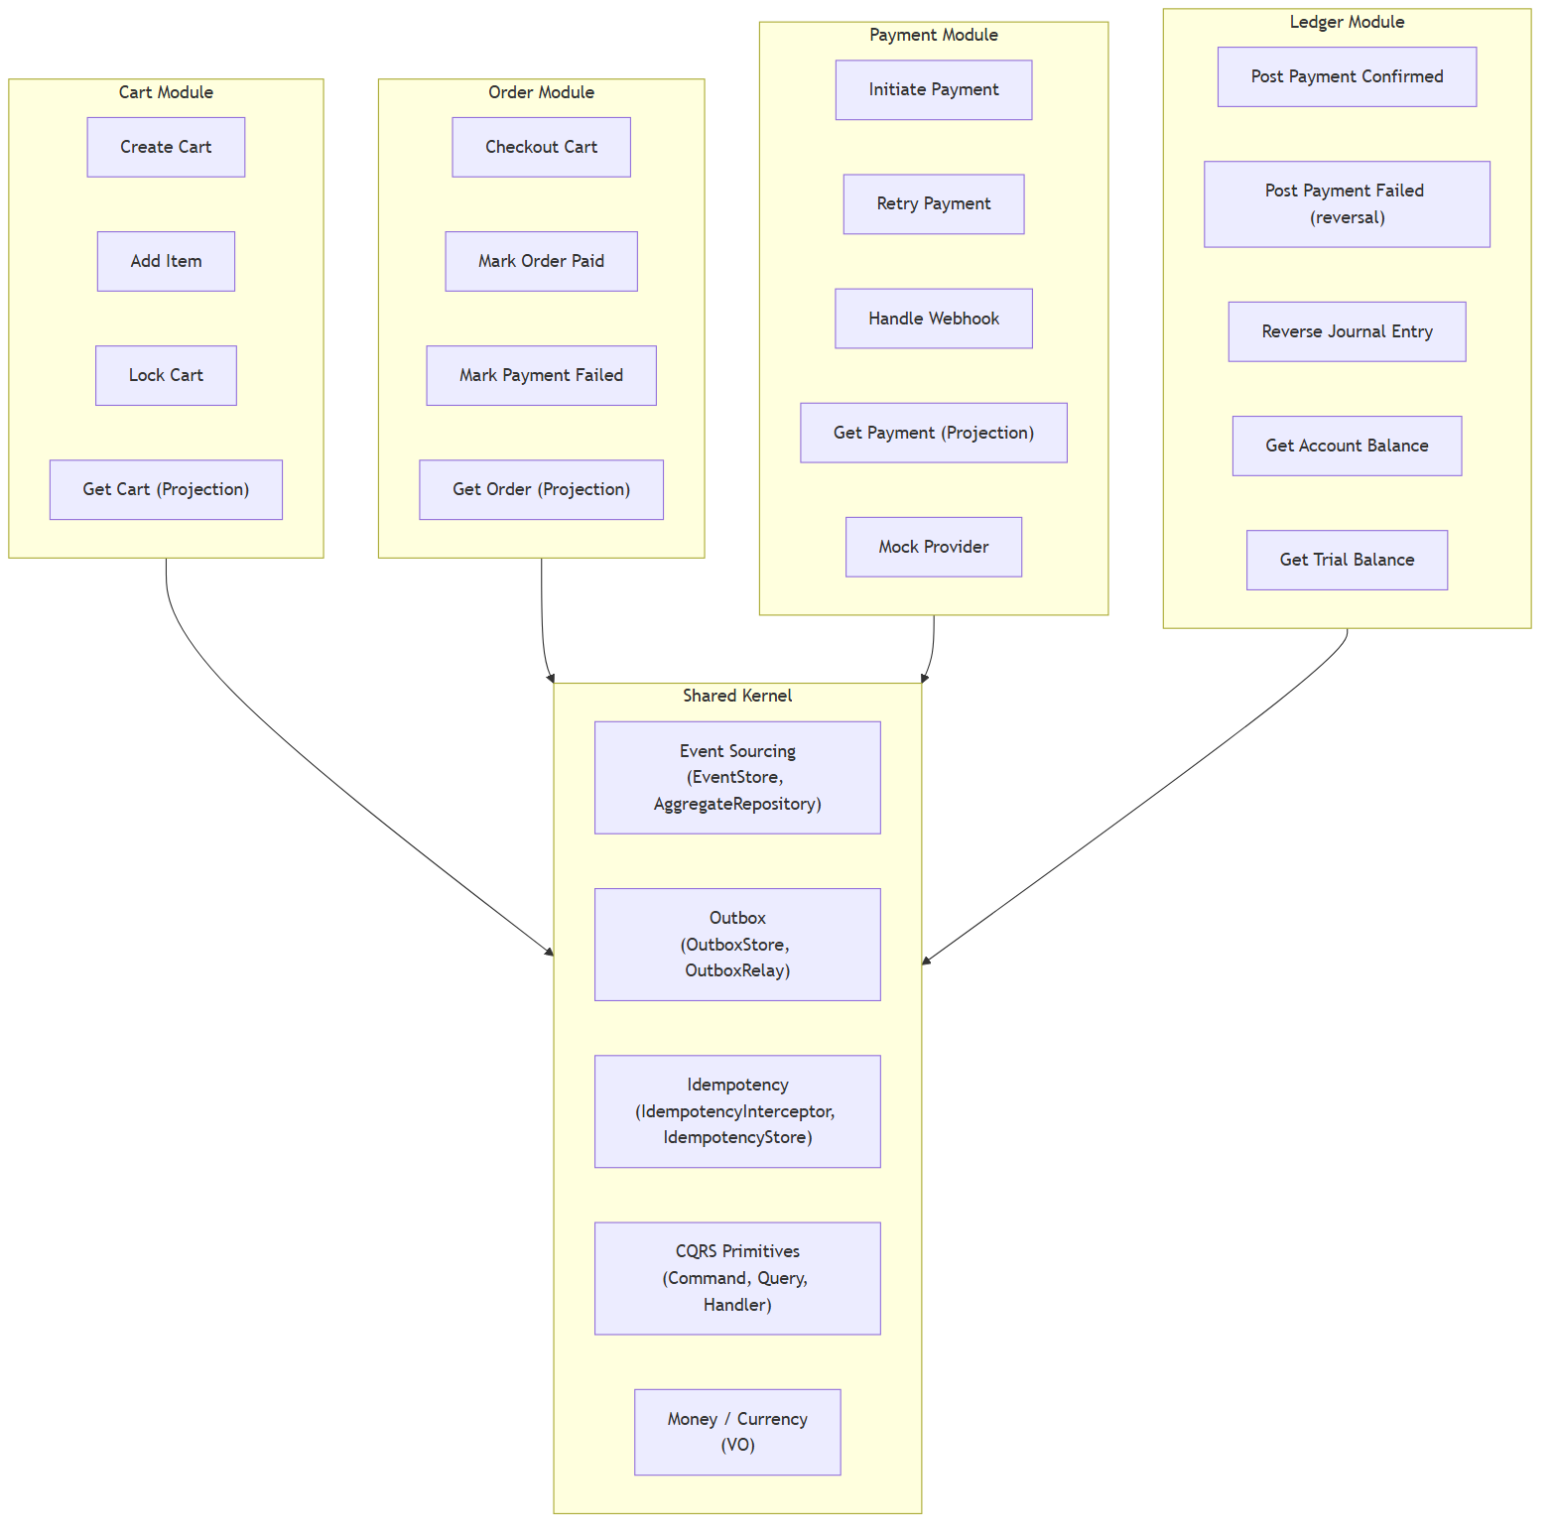

4.3 Component and Connector View
Viewpoint: VP-03
There are two kinds of connectors in this system. Synchronous facade calls happen in the same transaction — the Order module calls CartFacade to get a snapshot and lock the cart before creating the order. Asynchronous outbox-relay-to-listener calls happen in a separate transaction with REQUIRES_NEW semantics — this is how integration events cross module boundaries without direct coupling.
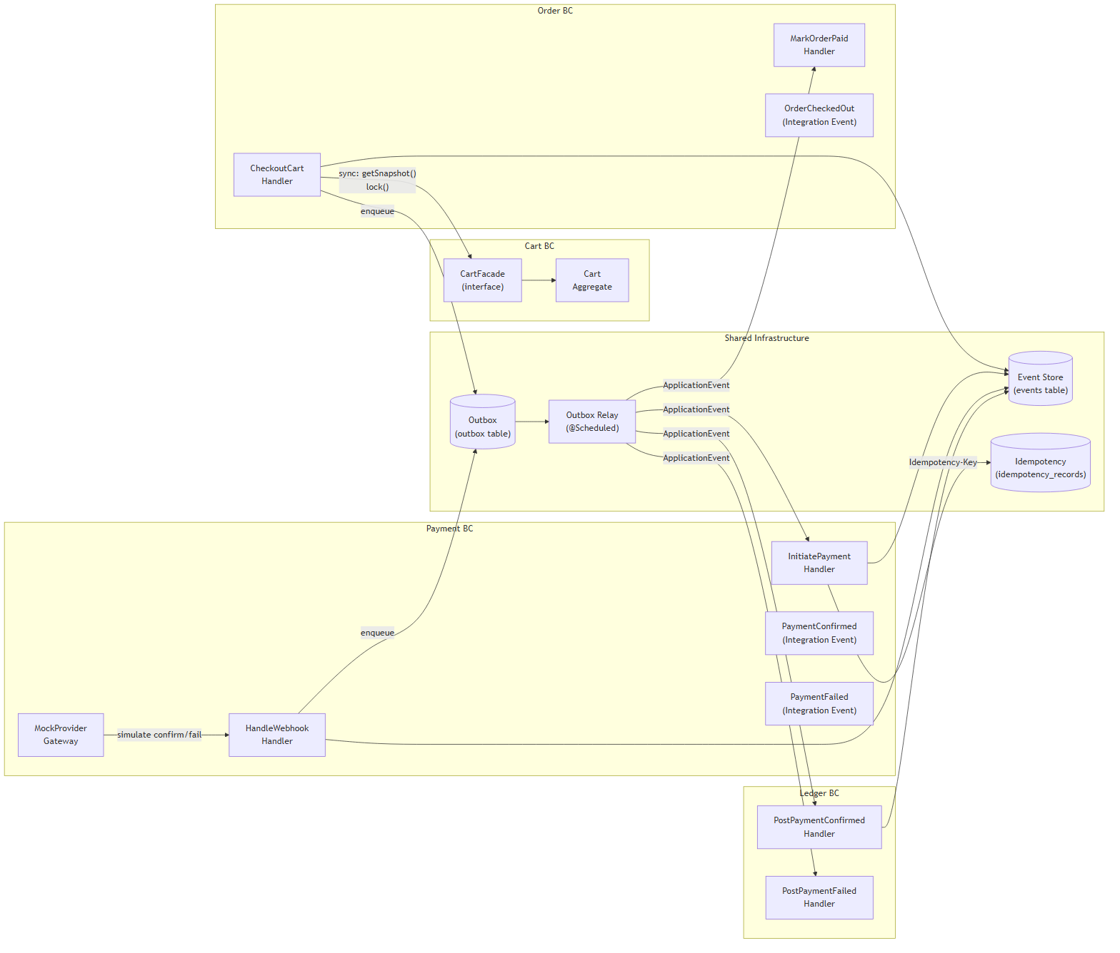
Connector semantics: - Solid arrows within a TX boundary = same ACID transaction - Outbox -> Relay -> Listener = at-least-once, separate transaction (REQUIRES_NEW)

4.4 Information View — Domain Models
Viewpoint: VP-04

4.4.1 Cart Domain
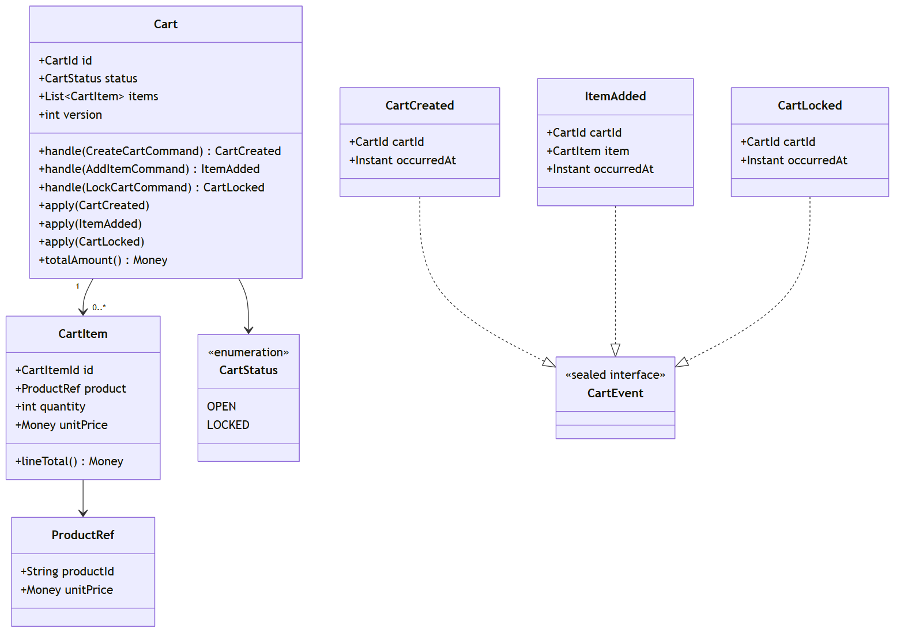

4.4.2 Order Domain
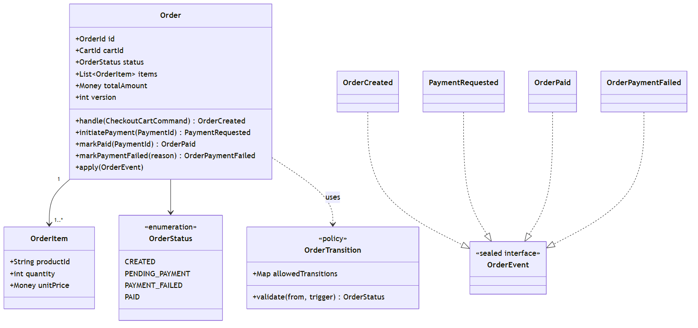

4.4.3 Payment Domain
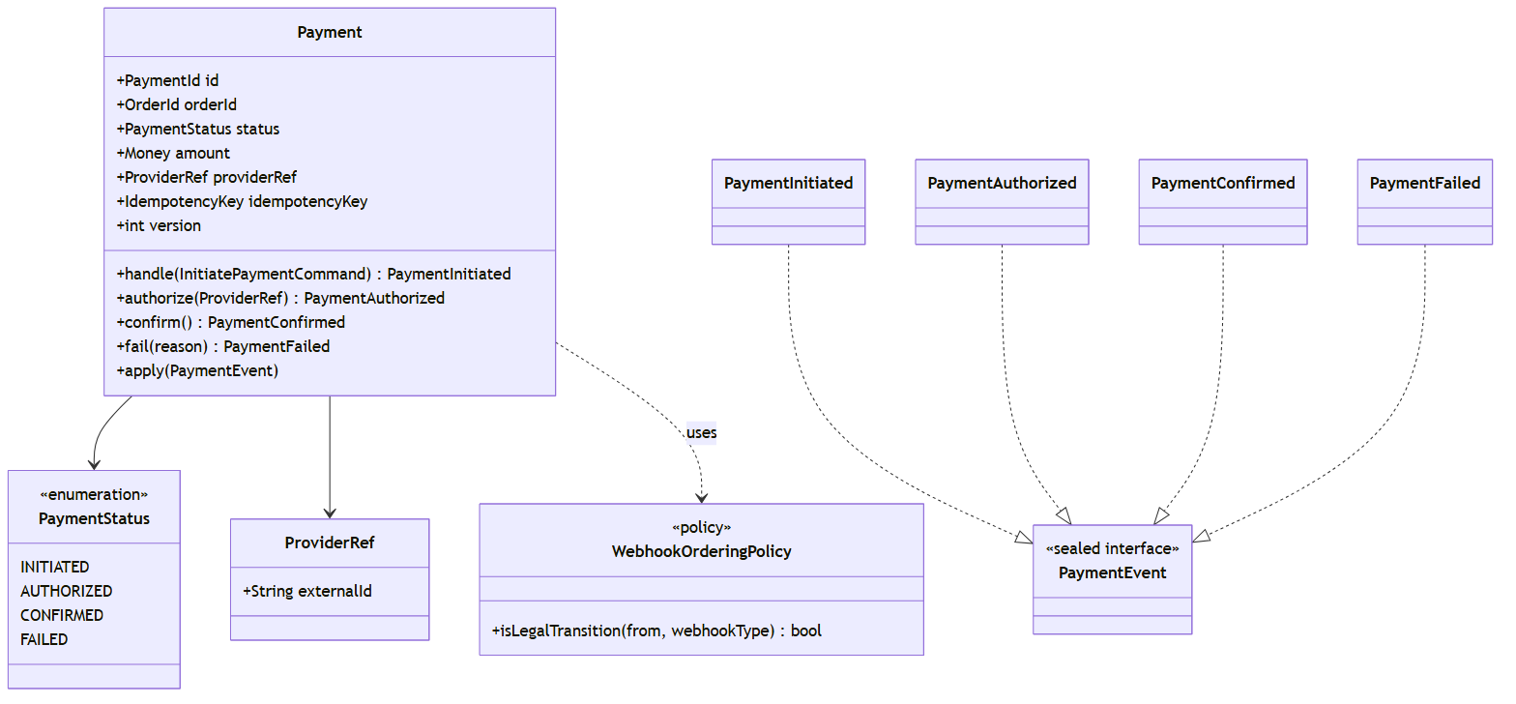

4.4.4 Ledger Domain
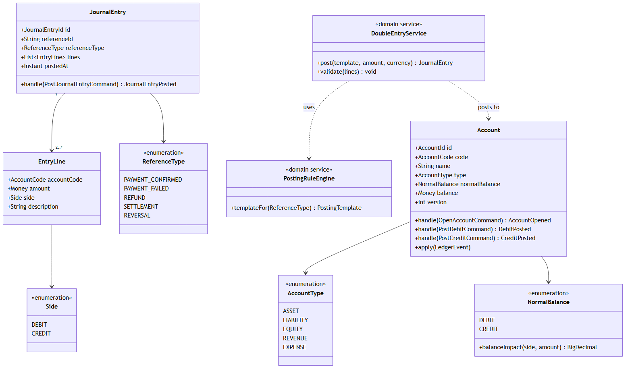

4.5 Information View — State Machines
Viewpoint: VP-05

4.5.1 Order State Machine
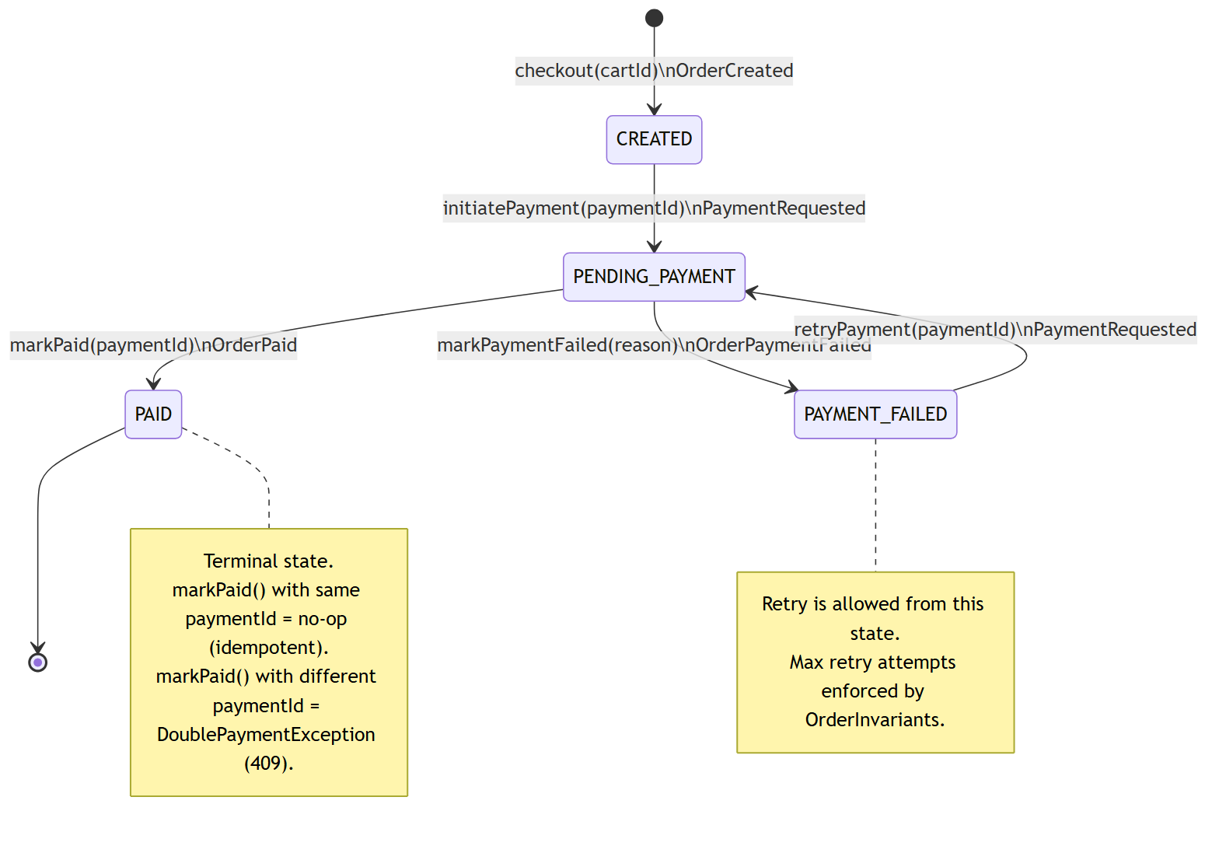

4.5.2 Payment State Machine
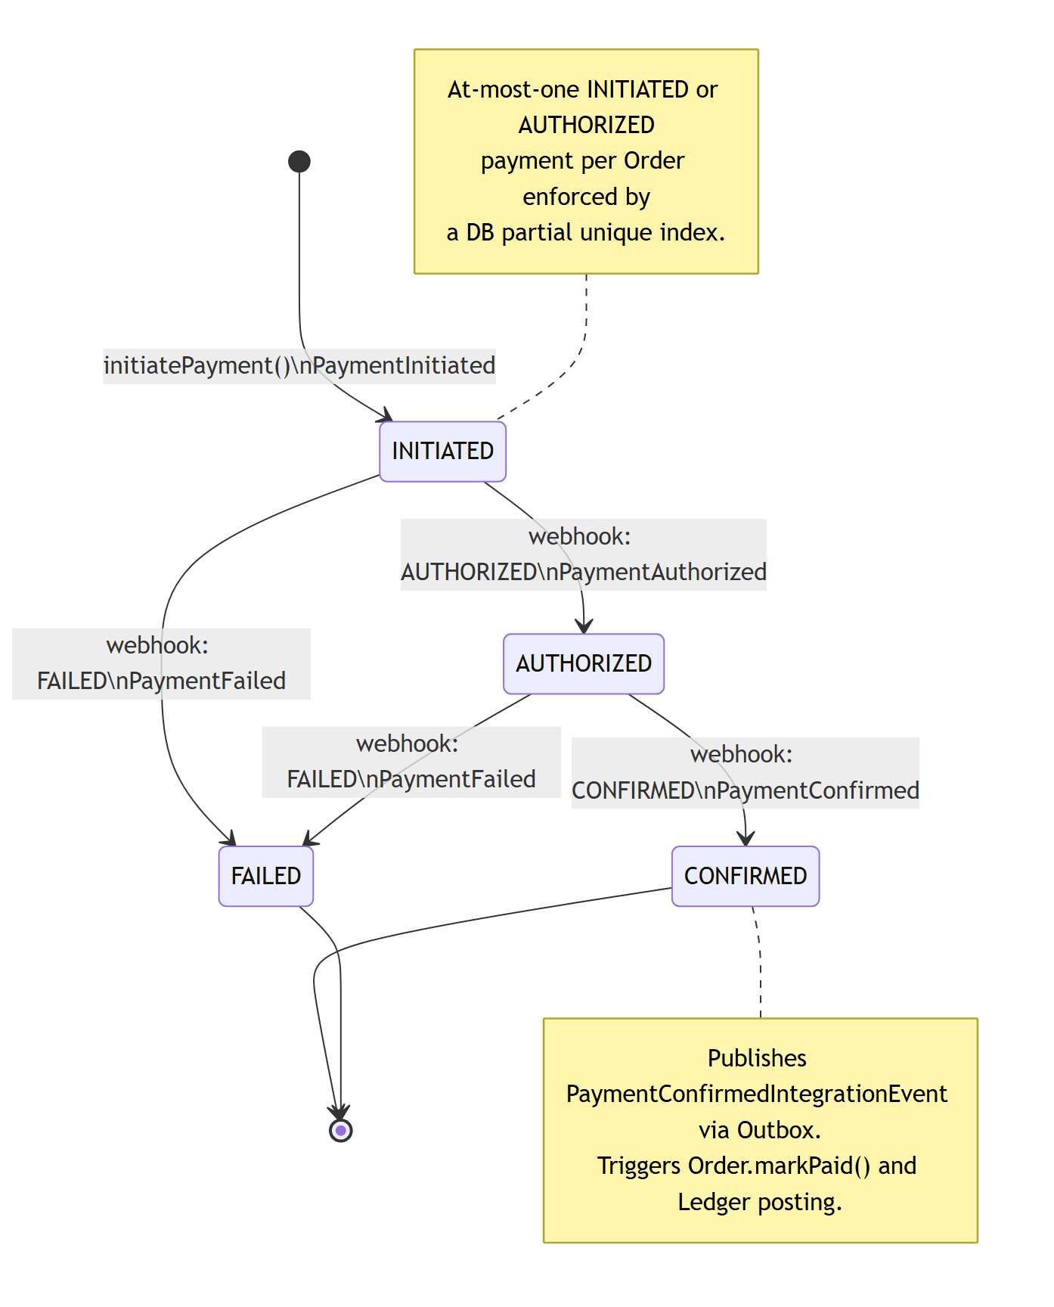

4.5.3 Cart State Machine
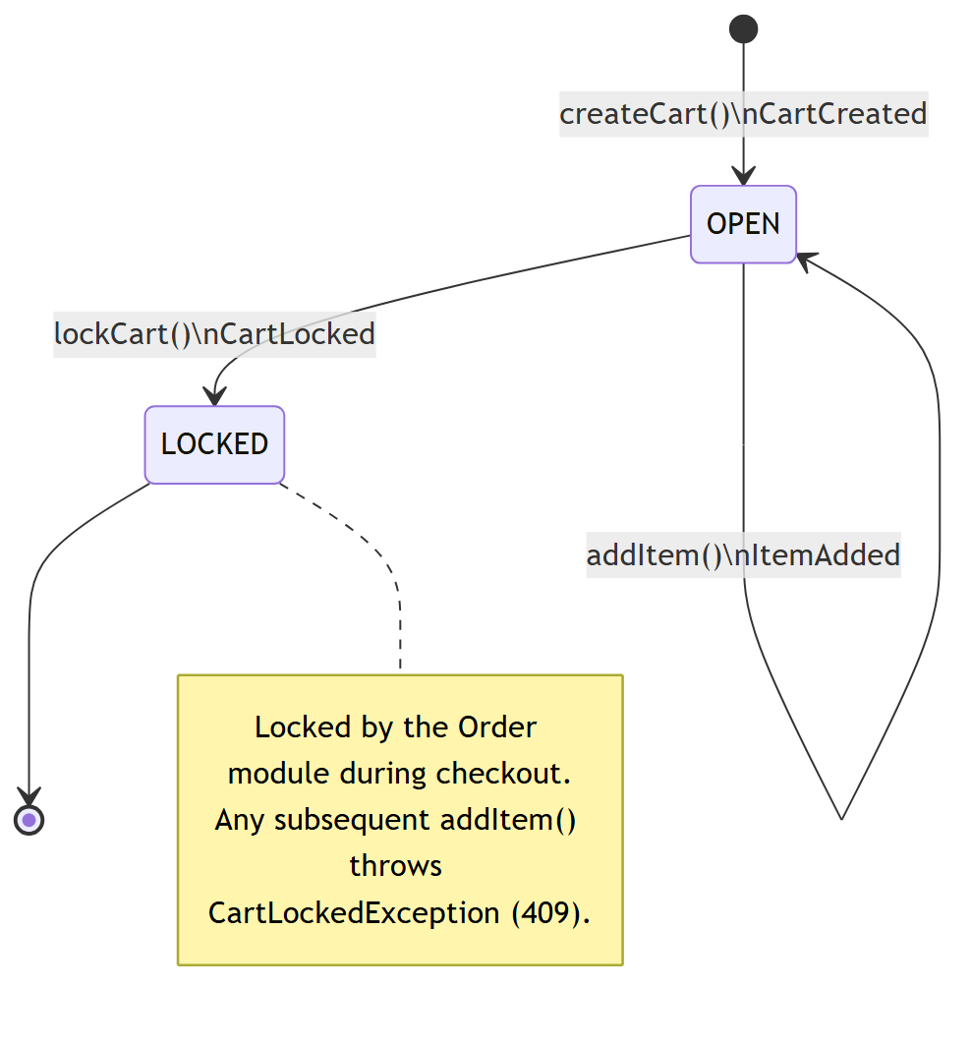

4.6 Process View — Key Flows
Viewpoint: VP-06

Flow 1 — Cart Checkout (Happy Path)
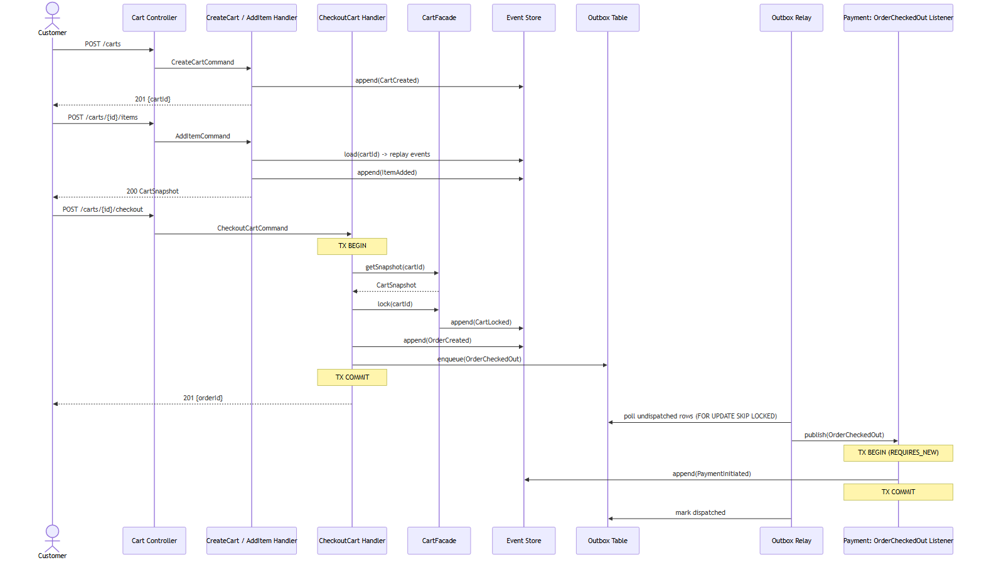

Flow 2 — Payment Initiation with Idempotency
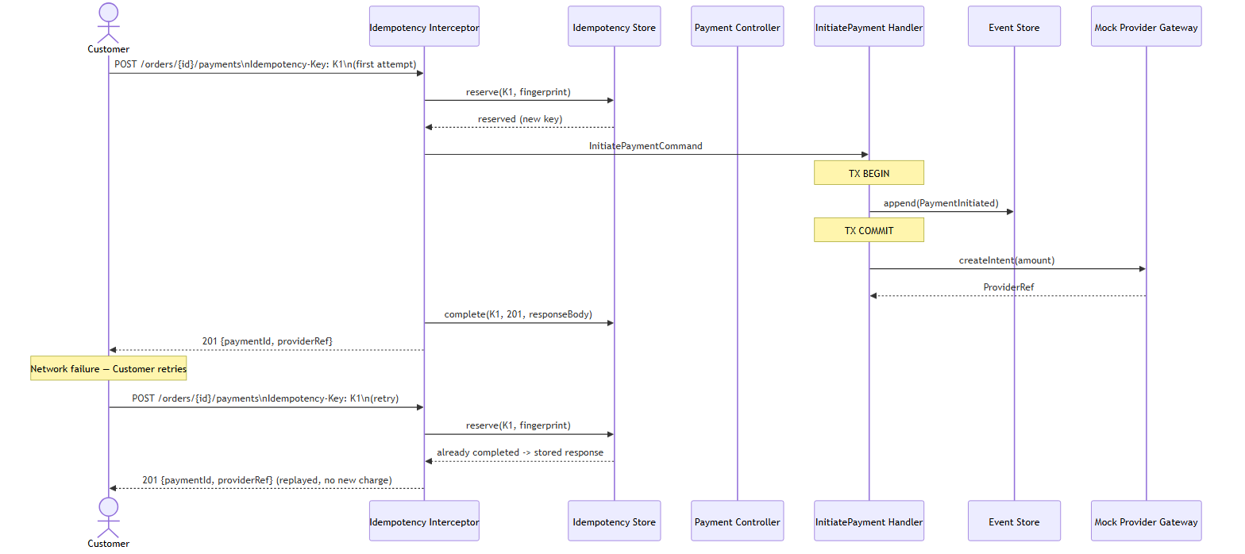

Flow 3 — Webhook Handling with Deduplication
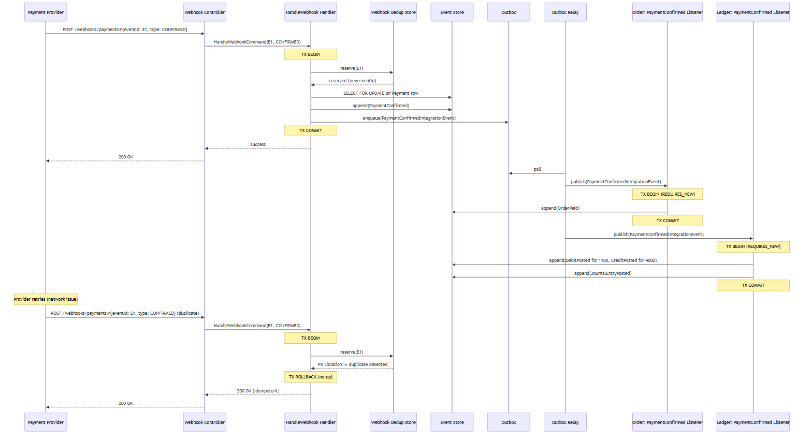

Flow 4 — Concurrent Payment Initiation Guard
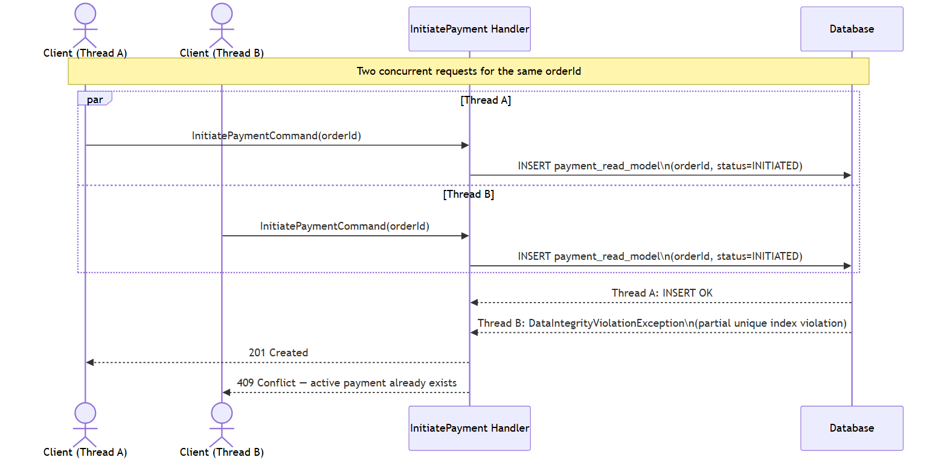

Flow 5 — Payment Retry after Failure
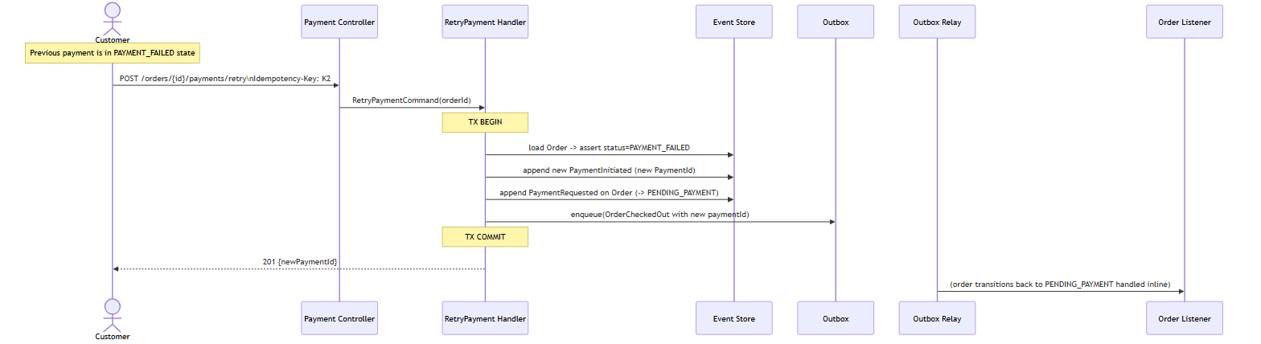

Flow 6 — Event Sourcing Write Path (Generic)
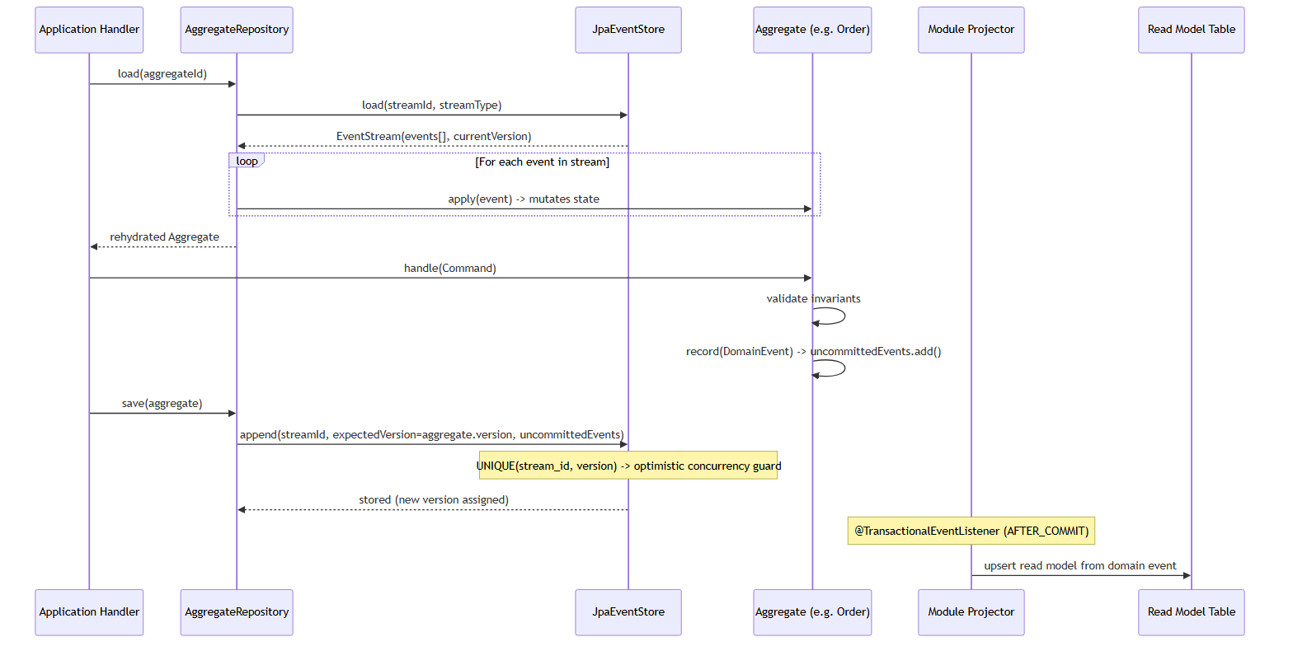

4.7 Data View — Persistence Schema
Viewpoint: VP-07
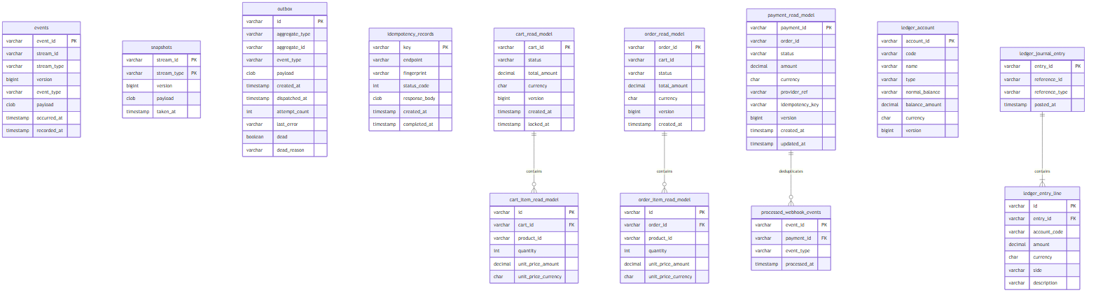
Key constraints (enforced at DB level): - UNIQUE(stream_id, stream_type, version) on events — optimistic concurrency - UNIQUE INDEX ux_payment_active ON payment_read_model(order_id) WHERE status IN ('INITIATED','AUTHORIZED') — concurrent payment guard - UNIQUE(reference_id, reference_type) on ledger_journal_entry — no duplicate ledger postings - PRIMARY KEY(event_id) on processed_webhook_events — webhook dedup

4.8 Deployment View
Viewpoint: VP-08
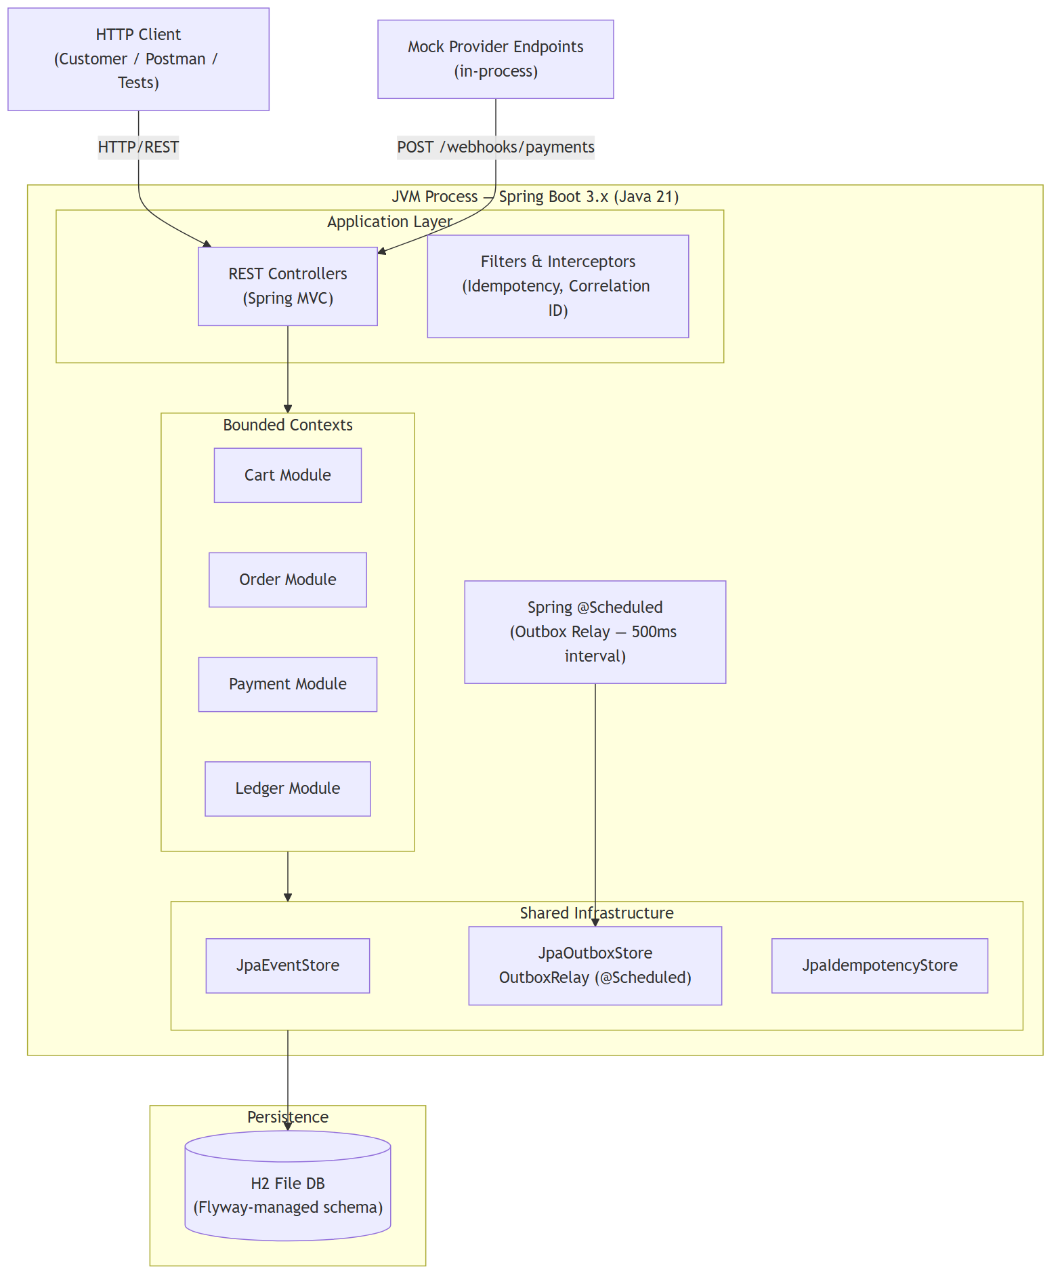
Profiles: - default — H2 file-mode (data persists across restarts during development) - test — H2 in-memory (reset between test runs, outbox relay disabled) - Future prod profile — swap application-prod.yml for a PostgreSQL datasource; no code changes required

4.9 Development View — Module Dependencies
Viewpoint: VP-09
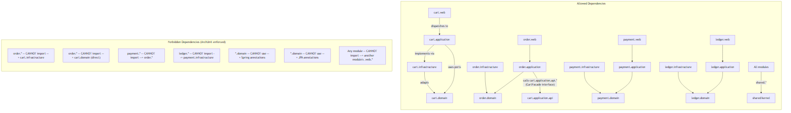
Integration event boundaries:
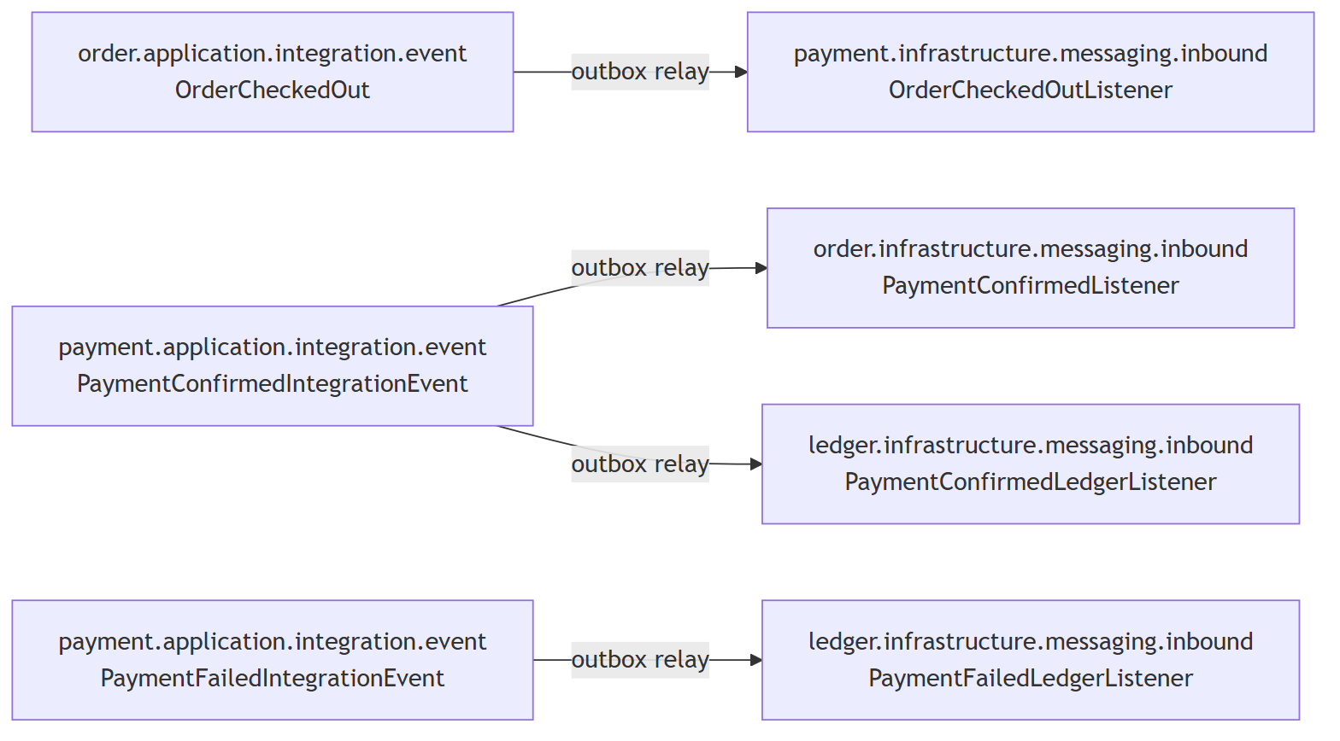
Only *.application.integration.event.* and *.application.api.* packages are permitted as cross-module import targets. Everything else is private to the owning module.

5. Correspondences and Correspondence Rules

5.1 Correspondences
ID | From Element | Relation | To Element
CO-01 | Order aggregate | persisted as event stream in | events table (stream_type=‘order’)
CO-02 | Order aggregate | projected into | order_read_model table via OrderProjector
CO-03 | DomainEvent (internal) | sourced into aggregate via | AggregateRepository.load() replay
CO-04 | IntegrationEvent | transported via | outbox table -> OutboxRelay -> ApplicationEventPublisher
CO-05 | Idempotency-Key HTTP header | stored in | idempotency_records table keyed by header value
CO-06 | PaymentConfirmedIntegrationEvent | triggers | PostPaymentConfirmedHandler in Ledger module
CO-07 | JournalEntry aggregate | persisted as event stream in | events table (stream_type=‘ledger-journal’)
CO-08 | Account balance | projected into | ledger_account.balance_amount via LedgerProjector
CO-09 | CartFacade interface | implemented by | CartFacadeImpl in cart.infrastructure
CO-10 | Vertical Slice (e.g. checkout-cart) | maps 1:1 to | single HTTP endpoint + single Handler class

5.2 Correspondence Rules
ID | Rule | Enforcement
CR-01 | Every state-changing command on an aggregate must result in at least one domain event appended to the event store | ArchUnit: all AggregateRepository.save() calls must be preceded by handle()
CR-02 | No domain event may cross module boundaries; only integration events may | ArchUnit: forbid import of *.domain.event.* outside the owning module
CR-03 | Every integration event must be published via the outbox table, never via direct ApplicationEventPublisher call in application handlers | Code review + ArchUnit: handlers may not inject ApplicationEventPublisher
CR-04 | Every POST endpoint that creates a financial resource must carry the idempotency filter | ArchUnit: all @PostMapping in payment.web must be covered
CR-05 | *.domain.* packages must not contain Spring or JPA annotations | ArchUnit: no @Entity, @Service, @Component, @Autowired in domain
CR-06 | Module A must not import module-B.infrastructure.* or module-B.web.* | ArchUnit: package dependency rules per module
CR-07 | Every JournalEntry must satisfy: sum of DEBIT amounts = sum of CREDIT amounts | DoubleEntryService.validate() — throws UnbalancedEntryException before any persistence
CR-08 | A payment aggregate in CONFIRMED or FAILED state is terminal — no further events may be appended | PaymentTransition policy — throws InvalidPaymentStateException
CR-09 | The events table version column must be monotonically increasing per stream; gaps are forbidden | JpaEventStore.append() — unique constraint + sequential version assignment
CR-10 | Outbox rows must be dispatched at-least-once; exactly-once delivery is the responsibility of downstream idempotency. Rows that violate a business invariant are dead-lettered immediately; rows that fail transiently are retried up to scheduling.outbox-max-retries times before dead-lettering. Dead rows (dead=TRUE) are never polled again. | OutboxRelay — NonRetryableException → immediate dead-letter; other exceptions → retry cap then dead-letter; each listener is idempotent by design

6. Architecture Decisions and Rationale

ADR-001 — Modular Monolith over Microservices
Field | Detail
Status | Accepted
Context | This is a solo quest submission targeting a single deployable artifact. Running multiple services would require service discovery, inter-service networking, distributed tracing, and container orchestration — none of which add value at this scale.
Decision | Build as a modular monolith. Bounded contexts live in separate Java packages and their boundaries are enforced at compile-time by ArchUnit, not at runtime by network calls.
Rationale | Microservices solve deployment and team scaling problems. Neither problem exists here. The modular structure gives the same domain isolation as microservices without the operational tax. If requirements change, each bounded context can be extracted into its own service — the domain code stays the same, only the wiring changes.
Trade-offs | All contexts deploy together and share a JVM heap. This is acceptable because the enforced module boundaries mean a bad deploy in one context cannot silently corrupt another at the domain level.
Consequences | Module boundary violations are caught as test failures, not runtime errors. The ArchUnit suite is the enforcement mechanism.

ADR-002 — Event Sourcing for Order, Payment, and Ledger Aggregates
Field | Detail
Status | Accepted
Context | Financial operations need an immutable audit trail. A state-stored aggregate only tells you what the current state is — it loses the sequence of decisions that led there.
Decision | Order, Payment, and Ledger aggregates are event-sourced. Cart uses the same pattern for codebase consistency, even though its history is less critical.
Rationale | The event stream is the source of truth. Read models are projections — derived views that can be rebuilt at any time by replaying events. This directly addresses CN-08. It also means schema migrations only touch read model tables; the event payloads are immutable records of history.
Trade-offs | Write path is more complex than a simple UPDATE statement — events must be serialized, versioned, and replayed on load. For long-lived aggregates, snapshots may be needed to keep load times reasonable.
Consequences | Every state transition is recoverable from first principles. You can replay events against a new projection at any time to answer questions the original schema did not anticipate.

ADR-003 — H2 In-Memory Database for Persistence
Field | Detail
Status | Accepted
Context | The quest requires a zero-dependency setup. The evaluator needs to be able to run the project with a single mvn spring-boot:run command, no Docker, no external database.
Decision | H2 with file-mode for the default profile, in-memory for test. Flyway manages all schema migrations so the schema is always reproducible.
Rationale | H2 supports the features this system actually needs: partial unique indexes (required for the concurrent payment guard in CN-03), SELECT FOR UPDATE, and proper transaction semantics. Spring Boot autoconfigures everything — there is nothing to install.
Trade-offs | H2 is not a production database. However, the only change needed to switch to PostgreSQL is a datasource URL in application-prod.yml. The application code is completely database-agnostic.
Consequences | The test suite runs against a real database (not mocks), which means the partial unique index and constraint-based idempotency guards are tested the same way they run in production.

ADR-004 — Transactional Outbox for Cross-Module Integration Events
Field | Detail
Status | Accepted
Context | When a payment is confirmed, both the Order module and the Ledger module need to react. If we published events directly to ApplicationEventPublisher after the database commit, a process crash in between would silently lose those events.
Decision | All cross-module integration events are written to an outbox table in the same transaction as the aggregate event store write. A @Scheduled relay polls the outbox and publishes pending events using ApplicationEventPublisher.
Rationale | Writing the event and the outbox row in the same transaction guarantees they are either both committed or both rolled back. There is no window where the domain state changed but the downstream reaction was lost. This is the standard solution to the dual-write problem and directly addresses CN-07.
Trade-offs | The relay introduces up to 500ms of latency between a domain event and its downstream reaction. The relay is single-threaded — adequate for this scope, but a partitioned relay with SKIP LOCKED would handle higher throughput.
Consequences | Swapping ApplicationEventPublisher for Kafka or RabbitMQ requires only an adapter change in the relay. The domain code and the outbox contract do not change. Failed delivery is handled by the dead-letter mechanism described in ADR-011.

ADR-005 — Three-Layer Idempotency Strategy
Field | Detail
Status | Accepted
Context | Three genuinely different failure modes affect payment correctness: clients retrying after a network timeout, two threads racing to initiate payment for the same order, and the payment provider resending a webhook that was already processed. A single mechanism cannot cover all three.
Decision | Layer 1 — Idempotency-Key header stored in idempotency_records: if the key is seen again after completion, the stored response is replayed with no side effects. Layer 2 — partial unique index on payment_read_model(order_id) where status is INITIATED or AUTHORIZED: the database rejects a second active payment before any application logic runs. Layer 3 — processed_webhook_events(event_id PK): inserting a duplicate event_id throws a primary key violation, which the handler catches and converts to a no-op.
Rationale | Application-level checks alone are vulnerable to TOCTOU races under concurrent load. Each layer targets a distinct attack surface. Removing any one of them leaves a real vulnerability open. This addresses CN-01, CN-02, CN-03, and CN-09.
Trade-offs | Three mechanisms to understand and maintain. The complexity is load-bearing — it is not accidental.
Consequences | The payment flow is safe under client retry, concurrent initiation, and unreliable webhook delivery from the provider.

ADR-006 — Vertical Slice Architecture within Bounded Contexts
Field | Detail
Status | Accepted
Context | A traditional layered architecture (Controller -> Service -> Repository) scatters the implementation of a single use case across three directories. Every feature change becomes a cross-cutting edit.
Decision | Each use case is a self-contained vertical slice: one package containing the Command or Query, the Handler, and any supporting types. Controllers dispatch to handlers and do nothing else.
Rationale | Cohesion lives at the use case level, not the layer level. Adding a new feature means adding a new package. Deleting a feature means deleting a package. The blast radius of any change is bounded to a single folder. The aggregate and domain model remain shared within a bounded context — they are not duplicated per slice.
Trade-offs | Slices that share common loading patterns will have some duplication. I prefer this over a premature abstraction that couples independent slices to a shared base class.
Consequences | Code reviews are scoped to feature folders. Feature branches rarely produce merge conflicts because different features touch different directories.

ADR-007 — UUIDv7 for All Entity Identifiers
Field | Detail
Status | Accepted
Context | UUIDv4 identifiers are random — good for uniqueness but terrible for B-tree index performance because they scatter writes across the entire index. Auto-increment integers are sequential but leak row counts and create a coordination point when scaling across services.
Decision | All entity identifiers use UUIDv7, generated in the application layer through a small UuidV7 utility class.
Rationale | UUIDv7 encodes a millisecond-precision timestamp in the high bits, so identifiers are monotonically increasing within the same millisecond. This gives index locality similar to auto-increment while remaining globally unique without any database sequence or coordination. It also makes the IDs themselves informative — you can extract the creation time directly from the ID.
Trade-offs | Java’s standard library does not include a UUIDv7 generator, so a small utility class is needed. It is straightforward to implement and has no external dependencies.
Consequences | All event_id, stream_id, and aggregate primary keys are naturally time-sorted and index-friendly.

ADR-008 — Double-Entry General Ledger as a Bounded Context
Field | Detail
Status | Accepted
Context | The quest requires financial correctness. A payment record by itself says an amount moved from one place to another — it does not prove the books balance. Double-entry bookkeeping is the industry standard precisely because it makes imbalance structurally impossible.
Decision | A dedicated Ledger bounded context implements double-entry bookkeeping. It is purely downstream: it listens to integration events from Payment and never publishes to other modules.
Rationale | The invariant that sum of debits equals sum of credits is enforced by DoubleEntryService.validate() before any ledger entry reaches the database. This is a domain-level guarantee, not a reporting afterthought. The PostingRuleEngine maps each event type to a balanced posting template so no handler has to remember which accounts to debit and credit. The trial balance endpoint provides a machine-verifiable proof that the ledger is correct at any moment. This directly addresses CN-05.
Trade-offs | Adding a full bounded context with aggregates, projections, and seeded accounts is non-trivial scope. It is justified by the financial correctness quality attribute, which is listed as Critical.
Consequences | A GET /ledger/trial-balance call returns a balance sheet that proves no money was created or destroyed by the system.

ADR-009 — Hand-Rolled State Machine over Spring State Machine
Field | Detail
Status | Accepted
Context | Order and Payment both have explicit state machines with transition guards. Spring State Machine exists as a framework option.
Decision | State machines are implemented as table-driven policy classes inside each aggregate — OrderTransition and WebhookOrderingPolicy — using plain Java Maps. No external framework.
Rationale | State machine logic belongs to the domain. It enforces business invariants. Coupling it to a framework would put framework annotations or configuration inside the domain layer, which violates the dependency rule from Clean Architecture. A Map<State, Set> is self-documenting, trivially unit-testable without a Spring context, and has zero configuration overhead. Spring State Machine is a powerful tool for complex statecharts — it is significant overkill for a four-state machine.
Trade-offs | More explicit code than an annotation-driven framework. The explicitness is the point — every allowed transition is visible in one place and has no hidden framework magic.
Consequences | State machine tests are pure JUnit with no Spring context. They run in sub-millisecond time and produce clear failure messages that name the exact invalid transition.

ADR-011 — Dead-Letter Strategy for the Outbox Relay
Field | Detail
Status | Accepted
Context | The outbox relay must dispatch every message at-least-once, but an unbounded retry loop is dangerous. Two structurally different failure modes exist. First, a message whose listener throws a domain business rule violation — for example, InvalidOrderTransitionException when PaymentInitiatedIntegrationEvent arrives for an order that is already PAID. Retrying this message will always throw the same exception; the aggregate state is the invariant, not a transient condition. Second, a message that fails due to a transient infrastructure error — serialization failure, database timeout, dependency unavailability. These failures may resolve on their own if the message is retried after a short interval. Treating both failure modes identically forces an impossible choice: either retry business violations forever (wasted work, log noise, obscured failures) or dead-letter on first failure (losing recoverable messages).
Decision | Two-branch dead-letter strategy based on exception type. Domain business rule violations — identified by NonRetryableException, an abstract base class in the shared kernel that all domain invariant exceptions extend — are dead-lettered on the first failure without any retry. Transient failures are retried up to scheduling.outbox-max-retries (default 5) attempts. If all attempts are exhausted the row is also dead-lettered. Dead-lettering sets dead=TRUE and records the dead_reason on the outbox row. The findUndispatched query filters dead=FALSE, so dead rows are never polled again.
Rationale | The distinction is structural: a NonRetryableException represents a business invariant violation whose root cause is in the current system state, not in a transient external condition. InvalidOrderTransitionException, Order.DoublePaymentException, and Payment.InvalidPaymentStateException all extend NonRetryableException. Retrying any of these is equivalent to retrying a validation error — the aggregate state does not change between relay ticks. Marking the outbox row dead instead of logging and moving on makes the failure visible and queryable: SELECT * FROM outbox WHERE dead = TRUE is a complete dead-letter queue that retains the full message payload, error chain, and attempt count for replay or investigation.
Trade-offs | Domain exception classes must remember to extend NonRetryableException. A business rule violation that extends RuntimeException directly would be retried up to max-retries times before dead-lettering, which is harmless but wastes cycles and log lines. This is mitigated by the fact that all current domain exception classes are in the shared module structure, reviewed as part of adding each bounded context.
Consequences | The outbox relay loop is bounded — no message retries indefinitely. Dead-lettered rows are observable at the database level and carry enough context to replay manually by setting dead=FALSE, attempt_count=0. The dead_reason column contains a human-readable string prefixed with either NON_RETRYABLE: or RETRY_EXHAUSTED after N attempts:, making triage immediate.

ADR-010 — Optimistic Locking for Aggregates, Pessimistic Locking for Webhooks
Field | Detail
Status | Accepted
Context | Concurrent writes to the same aggregate need to be detected and rejected. Webhook processing presents a different concurrency pattern — multiple deliveries of the same event arriving in rapid succession.
Decision | Aggregate saves use optimistic locking via the UNIQUE(stream_id, version) constraint on the events table. Any concurrent write that tries to append to the same stream position gets a DataIntegrityViolationException, which the repository translates into a ConcurrencyException and returns a 409 to the caller. Webhook processing uses SELECT FOR UPDATE on the Payment row before applying the transition, serializing concurrent webhook delivery for the same payment.
Rationale | Optimistic locking is the right default for user-facing commands because collisions are rare and the failure is clean — the caller gets a 409 and can retry with fresh state. Webhooks from a provider can arrive in fast bursts for the same payment, and the ordering matters. Pessimistic locking serializes that processing at the cost of a lock wait, which is acceptable because webhook latency is not user-facing.
Trade-offs | SELECT FOR UPDATE on the webhook path serializes concurrent webhook delivery for the same payment. This is intentional and documented. Under very high webhook throughput it could become a bottleneck, but that is out of scope for this system.
Consequences | No two webhook handlers can concurrently mutate the same Payment aggregate. Combined with Layer 3 webhook dedup from ADR-005, payment state is always consistent regardless of how many times the provider delivers the same event.

