Table of Contents

Checkout Quest - Developer Guide
This is a production-grade modular monolith that walks through the complete lifecycle of a purchase, from adding items to a cart all the way through to a confirmed payment and a balanced set of accounting books. Every bounded context lives inside the same JVM process and the same database, but each one owns its schema, its domain model, and its event log. There are no direct package imports across context boundaries, and ArchUnit tests will fail the build if you try.
The point is to show that you do not need microservices to get the benefits of loose coupling. You get fast local tests, simple deployment, and a clean upgrade path to services if you ever need it.

Table of Contents
- What Is This Project?
- Architecture at a Glance
- Bounded Contexts
- Getting Started
- Running the Mock Payment Provider
- API Reference
- State Machines
- Error Responses
- Postman Collection
- Happy Path Walkthrough
- Failure Path Walkthrough
- Inspecting the Database
- Key Design Decisions

1. What Is This Project?
Checkout Quest models a real e-commerce purchase flow. You build a cart, check it out into an order, pay for it through an external payment provider, and watch the accounting books balance themselves automatically when the payment confirms. Nothing is faked or stubbed in the main application - every piece of state lives in a real H2 database backed by Flyway migrations.
The tech stack is intentionally boring in the best way:
Concern | Choice
Language | Java 21
Framework | Spring Boot 3.3.4
Persistence | Spring Data JPA with H2 file-based storage
Migrations | Flyway, V1 through V9
HTTP Client | OpenFeign
Mapping | MapStruct with Lombok
Tests | JUnit 5, Spring Boot Test, ArchUnit
Build | Maven

2. Architecture at a Glance
Each bounded context follows a hexagonal structure. The shared module provides the scaffolding that everything builds on - the event store, the outbox relay, and the idempotency filter.
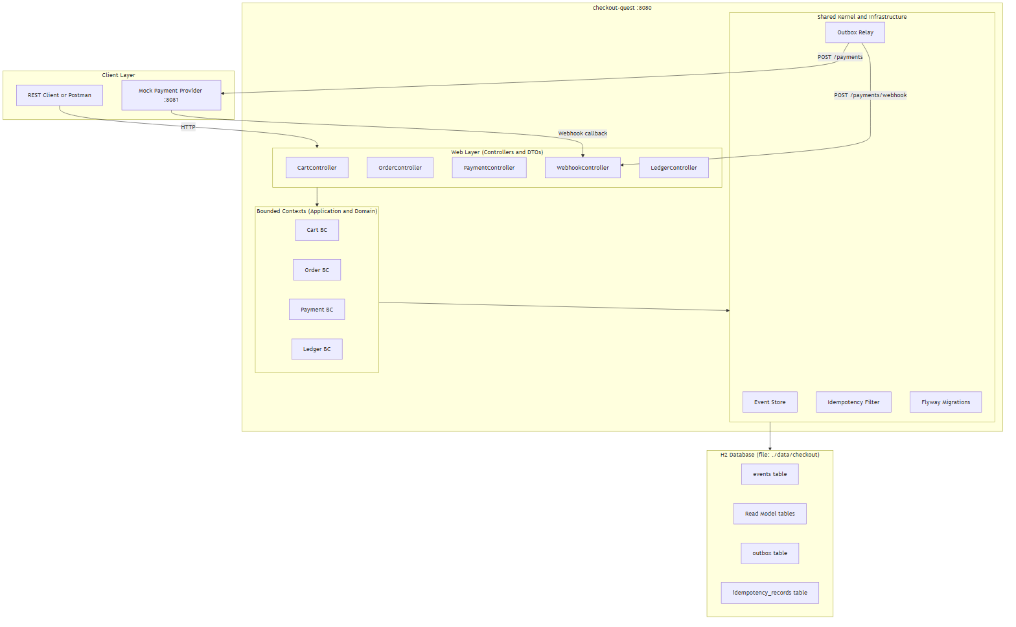
Every write command follows the same path through the system:
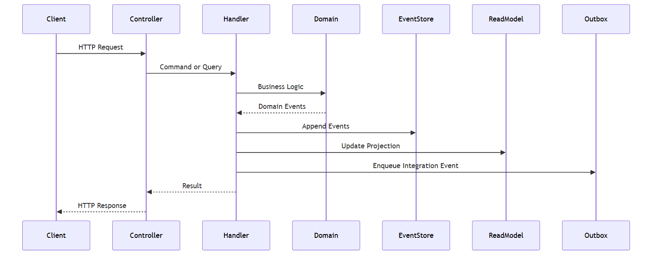

3. Bounded Contexts
Cart manages the shopping cart. A cart starts open, accepts items, and gets locked the moment you check it out. Once locked, it does not accept new items. Every ItemAdded and CartLocked event is stored in the event log and replayed to rebuild state.
Order is created from a checked-out cart. It starts in CREATED and follows payment-driven transitions through to PAID or PAYMENT_FAILED. The Order context learns about payment outcomes through integration events published via the outbox - it never imports from the Payment package directly.
Payment handles the intent creation with an external provider and processes the provider’s webhooks. Authorization happens synchronously when the provider responds to the intent. The terminal state (CONFIRMED or FAILED) arrives asynchronously via webhook.
Ledger does the bookkeeping. Every confirmed payment results in a balanced journal entry - debit Accounts Receivable, credit Revenue. The trial balance endpoint lets you verify at any point that the books are in balance.

4. Getting Started
Prerequisites
- Java 21 or later
- Maven 3.9 or later
- The mock payment provider running on port 8081 (covered in the next section)
Clone and Build
git clone <repo-url>
cd checkout-quest
mvn clean install
All 33 tests should pass: 8 ArchUnit, 12 domain state-machine, 9 payment domain, and 4 integration tests.
Run the Application
mvn spring-boot:run
Or build the jar and run it directly:
mvn package -DskipTests
java -jar target/checkout-quest-1.0.0-SNAPSHOT.jar
The application starts on http://localhost:8080. The H2 database is persisted to ./data/checkout in the working directory, so your data survives restarts.
Configuration
Everything lives in src/main/resources/application.yml. The values you are most likely to touch:
Property | Default | Description
server.port | 8080 | HTTP port
mock.provider.url | http://localhost:8081 | Mock payment provider base URL
scheduling.outbox-relay-interval-ms | 500 | How often the outbox relay fires, in milliseconds
scheduling.outbox-max-retries | 5 | Max delivery attempts before a message is dead-lettered
spring.datasource.url | jdbc:h2:file:./data/checkout | H2 file path

5. Running the Mock Payment Provider
The mock payment provider simulates an external payment gateway. It runs on port 8081 and handles three things:
- Accepting a payment intent (POST /payments) and returning a providerRef
- Exposing manual control endpoints so you can trigger confirm or fail outcomes
- Sending webhook callbacks to the application whenever you trigger a state change
Start it before running the main application. Once it is up, you can check it is responding:
curl http://localhost:8081/payments
You should get a JSON object listing any pending payments.

6. API Reference
All endpoints are served from http://localhost:8080. Request bodies are JSON. Timestamps in responses are ISO-8601 UTC strings.

6.1 Cart API

Create Cart
Opens a new empty shopping cart.
POST /carts
No request body needed.
Response - 201 Created
{
"cartId": "019e12e0-15b8-750d-bf23-cdaa9de90864"
}

Add Item to Cart
Adds a product to an open cart. If you try this on a locked cart, you get a 409.
POST /carts/{cartId}/items
Path parameters
Parameter | Type | Description
cartId | string | The cart identifier from Create Cart
Request body
{
"productId": "prod-laptop-001",
"quantity": 1,
"unitPrice": 1299.99,
"currency": "USD"
}
Field | Type | Rules | Description
productId | string | required, not blank | Your product SKU or any identifier
quantity | integer | required, minimum 1 | Number of units
unitPrice | decimal | required, minimum 0.01 | Price per unit
currency | string | required, not blank | ISO 4217 currency code, e.g. USD
Response - 200 OK
{
"cartId": "019e12e0-15b8-750d-bf23-cdaa9de90864",
"status": "OPEN",
"totalAmount": 1299.99,
"currency": "USD",
"createdAt": "2026-05-10T17:00:00.000Z",
"lockedAt": null,
"items": [
{
"productId": "prod-laptop-001",
"quantity": 1,
"unitPriceAmount": 1299.99,
"unitPriceCurrency": "USD"
}
]
}

Get Cart
Fetches the current cart state along with all items and the running total.
GET /carts/{cartId}
Path parameters
Parameter | Type | Description
cartId | string | The cart identifier
The response structure is identical to the Add Item response above.

Checkout Cart
Locks the cart and creates an Order. After this call, the cart will not accept new items.
POST /carts/{cartId}/checkout
No request body needed.
Response - 201 Created
{
"orderId": "019e12e0-15b8-750d-bf23-cdaa9de90999"
}

6.2 Order API

Get Order
Returns the current order state. The status field will update as payment events arrive.
GET /orders/{orderId}
Path parameters
Parameter | Type | Description
orderId | string | The order identifier from Checkout Cart
Response - 200 OK
{
"orderId": "019e12e0-15b8-750d-bf23-cdaa9de90999",
"cartId": "019e12e0-15b8-750d-bf23-cdaa9de90864",
"status": "CREATED",
"totalAmount": 1399.97,
"currency": "USD",
"createdAt": "2026-05-10T17:01:00.000Z",
"items": [
{
"productId": "prod-laptop-001",
"quantity": 1,
"unitPriceAmount": 1299.99,
"unitPriceCurrency": "USD"
},
{
"productId": "prod-mouse-007",
"quantity": 2,
"unitPriceAmount": 49.99,
"unitPriceCurrency": "USD"
}
]
}
What the status values mean
Status | What it means
CREATED | Order exists, no payment has been started yet
PENDING_PAYMENT | Payment initiated, waiting on the provider
PAID | Payment confirmed by the provider
PAYMENT_FAILED | Payment failed, a retry is possible

6.3 Payment API

Initiate Payment
Creates a payment intent with the external provider and moves the order to PENDING_PAYMENT. The providerRef in the response is the external provider’s identifier for this transaction. You will need it to trigger confirmation or failure through the mock provider.
POST /orders/{orderId}/payment/start
Headers
Header | Required | Description
Content-Type | yes | application/json
Idempotency-Key | no | Any unique string. Replaying the same key returns the cached response without creating a second payment.
Path parameters
Parameter | Type | Description
orderId | string | The order to pay for
Request body
{
"amount": 1399.97,
"currency": "USD"
}
Field | Type | Rules | Description
amount | decimal | required, minimum 0.01 | Payment amount
currency | string | required, not blank | ISO 4217 currency code
Response - 201 Created
{
"paymentId": "019e12e0-15b8-750d-bf23-cdaa9de90aaa",
"providerRef": "prov-ref-abc123"
}
Save the providerRef. You will use it to confirm or fail the payment through the mock provider.

Retry Payment
Creates a fresh payment attempt for an order whose previous payment failed. The amount and currency are carried over from the failed payment automatically.
POST /orders/{orderId}/payments/retry
Headers
Header | Required | Description
Idempotency-Key | no | Unique string for safe retries
The response structure is the same as Initiate Payment.

Get Payment
Returns the latest payment record associated with an order.
GET /orders/{orderId}/payments
Response - 200 OK
{
"paymentId": "019e12e0-15b8-750d-bf23-cdaa9de90aaa",
"orderId": "019e12e0-15b8-750d-bf23-cdaa9de90999",
"status": "AUTHORIZED",
"amount": 1399.97,
"currency": "USD",
"providerRef": "prov-ref-abc123",
"idempotencyKey": "pay-idem-xyz",
"createdAt": "2026-05-10T17:02:00.000Z",
"updatedAt": "2026-05-10T17:02:01.500Z"
}
What the status values mean
Status | What it means
INITIATED | Intent created, waiting for the provider to authorize
AUTHORIZED | Provider has reserved the funds
CONFIRMED | Funds captured, payment is complete
FAILED | Provider declined or something went wrong

6.4 Webhook API
The webhook endpoint is called by the payment provider - or by you through Postman - to push state transitions back into the application.

Handle Webhook
POST /payments/webhook
Request body
{
"eventId": "evt-conf-unique-id-001",
"providerRef": "prov-ref-abc123",
"type": "CONFIRMED",
"reason": null
}
Field | Type | Rules | Description
eventId | string | required, not blank | Globally unique event identifier from the provider. Replaying the same eventId is a safe no-op.
providerRef | string | required, not blank | The provider’s payment reference
type | string | required | One of AUTHORIZED, CONFIRMED, or FAILED
reason | string | optional | Human-readable reason, mainly useful for FAILED webhooks
Response - 200 OK with an empty body. Any 200 means the webhook was accepted, including idempotent replays.

6.5 Ledger API

Get Chart of Accounts
Returns all ledger accounts and their current balances.
GET /ledger/accounts
Response - 200 OK
[
{
"accountId": "acc-001",
"code": "1100",
"name": "Accounts Receivable",
"type": "ASSET",
"normalBalance": "DEBIT",
"balanceAmount": 1399.97,
"currency": "USD"
},
{
"accountId": "acc-002",
"code": "4000",
"name": "Revenue",
"type": "REVENUE",
"normalBalance": "CREDIT",
"balanceAmount": 1399.97,
"currency": "USD"
}
]

Get Journal Entries
Returns all posted journal entries. Each entry is balanced - debits and credits always match within a single entry.
GET /ledger/journal-entries
Response - 200 OK
[
{
"entryId": "je-001",
"referenceId": "019e12e0-15b8-750d-bf23-cdaa9de90aaa",
"referenceType": "payment",
"postedAt": "2026-05-10T17:03:00.000Z",
"lines": [
{
"accountCode": "1100",
"amount": 1399.97,
"currency": "USD",
"side": "DEBIT",
"description": "Payment confirmed"
},
{
"accountCode": "4000",
"amount": 1399.97,
"currency": "USD",
"side": "CREDIT",
"description": "Payment confirmed"
}
]
}
]

Get Trial Balance
Returns aggregated balances across all accounts and a simple boolean telling you whether the books are in balance. After any confirmed payment, balanced should always be true.
GET /ledger/trial-balance
Response - 200 OK
{
"accounts": [ "..." ],
"totalDebitBalances": 1399.97,
"totalCreditBalances": 1399.97,
"balanced": true
}

7. State Machines

Cart
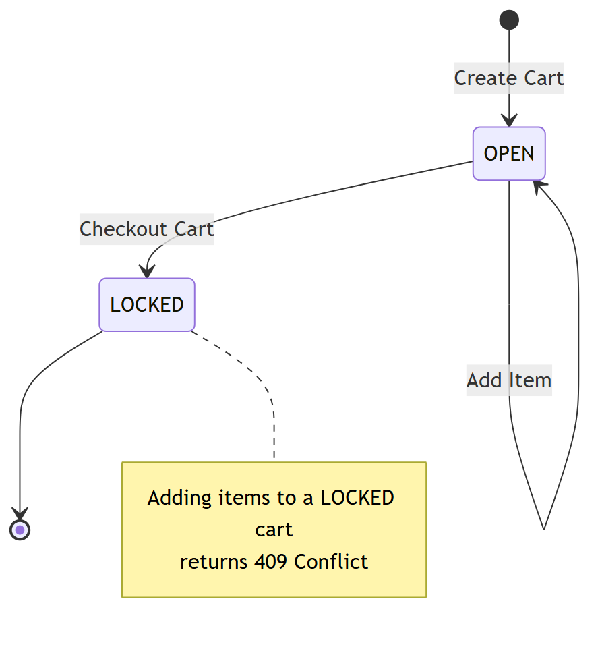

Order
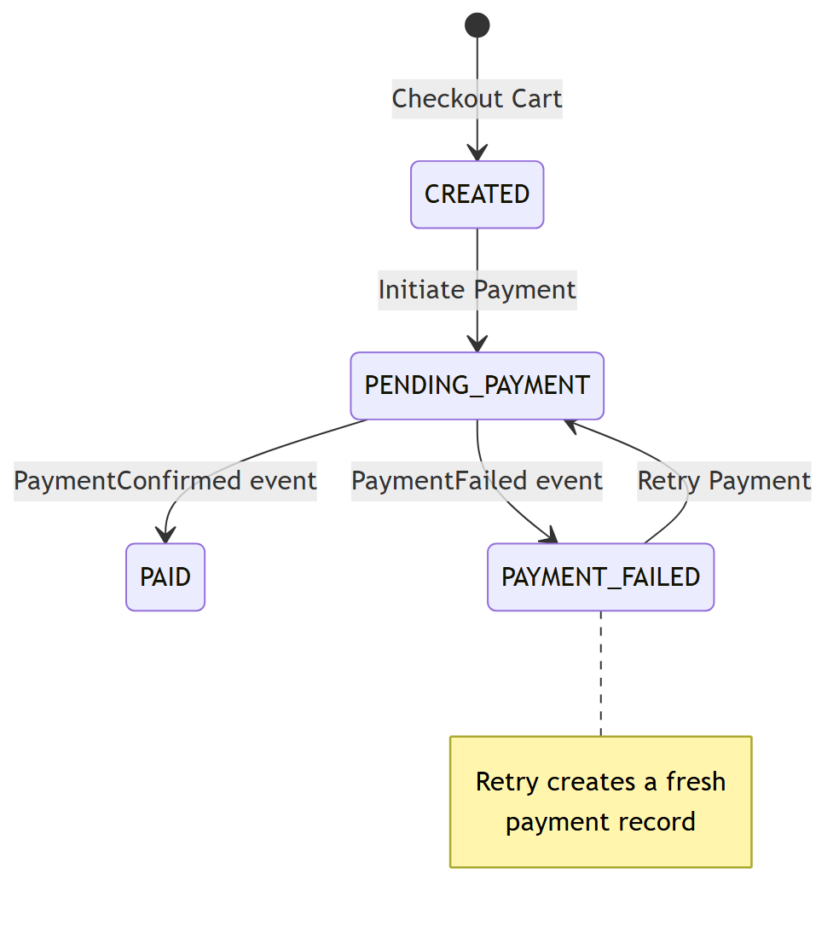

Payment
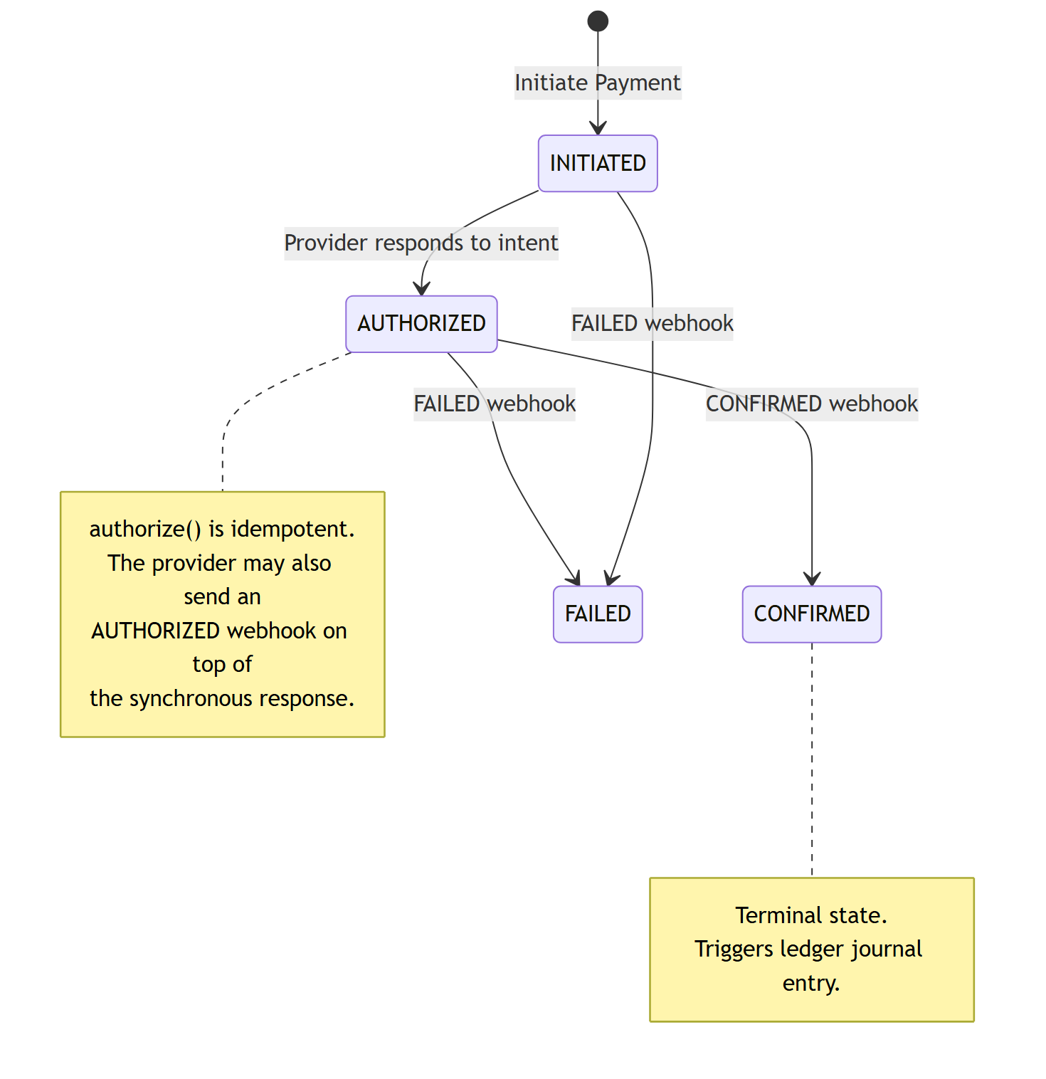

8. Error Responses
Every error comes back in the same shape:
{
"status": 409,
"error": "Conflict",
"message": "An active payment already exists for order abc-123",
"timestamp": "2026-05-10T17:05:00.000Z"
}
HTTP Status | When you will see it
400 Bad Request | A required field is missing or fails validation
404 Not Found | The cart, order, or payment does not exist
409 Conflict | Cart is locked, a payment is already active for the order, or an optimistic concurrency failure occurred
422 Unprocessable Entity | An invalid state transition, like trying to confirm an already-failed payment
500 Internal Server Error | Something unexpected happened - check the application logs

9. Postman Collection
The collection file is checkout-quest.postman_collection.json in the root of the repository.
Importing the Collection
- Open Postman.
- Click Import in the top-left.
- Drag and drop checkout-quest.postman_collection.json onto the dialog, or click Upload Files and select it.
- The collection shows up as “Checkout Quest” in your sidebar.
Collection Variables
The collection uses variables to wire outputs from one request into the next. The test scripts populate them automatically as you run each step, so you do not need to copy and paste IDs manually.
Variable | Where it comes from | Where it is used
baseUrl | Pre-set to http://localhost:8080 | All main application requests
mockUrl | Pre-set to http://localhost:8081 | Mock provider requests
cartId | Step 1 - Create Cart | Steps 2a, 2b, 3, 4
orderId | Step 4 - Checkout Cart | Steps 5, 6, 7
paymentId | Step 6 - Initiate Payment | Reference only
providerRef | Step 7 - Get Payment | Steps 8 and Webhooks
One thing worth noting: always let Step 7 (Get Payment) capture the providerRef, not Step 6. Step 7 reads from the read model which is guaranteed to have the value once the payment reaches AUTHORIZED. Step 6 captures it from the synchronous response which is reliable in practice, but Step 7 is the safe source of truth.
Running the Full Collection
Right-click the Checkout Quest collection in the sidebar and choose “Run collection”. Make sure the requests are in step order, then click “Run Checkout Quest”. The runner will go through each request, populate variables, and check the expected status codes for you.

10. Happy Path Walkthrough
This is the end-to-end flow for a purchase that goes through successfully.
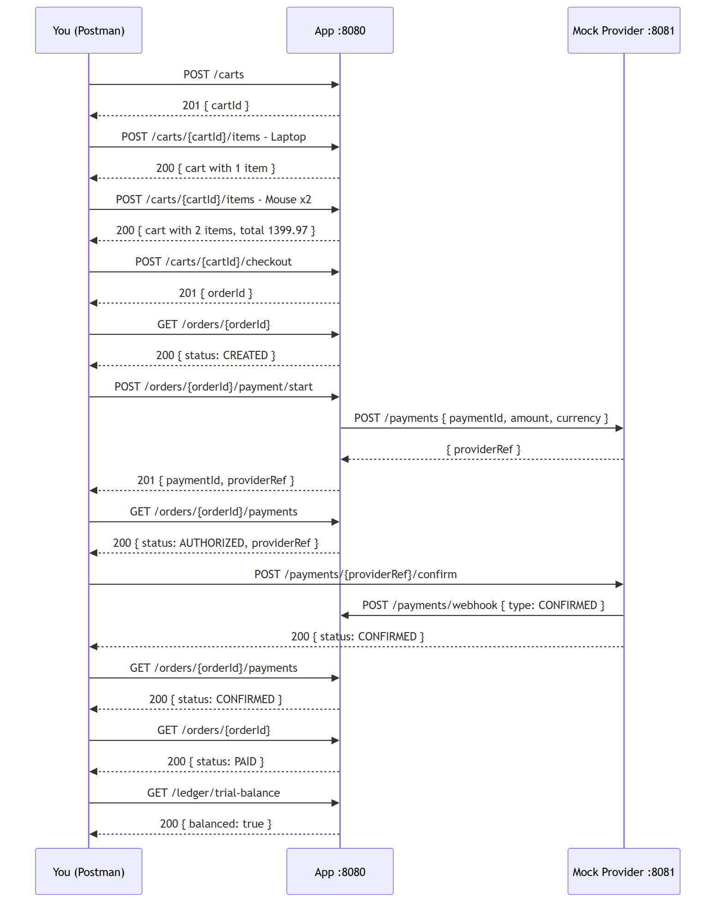
Step 1 - Create a Cart
Send POST /carts. You get back a cartId. Postman saves it automatically.

Step 2a - Add the First Item
Send POST /carts/{{cartId}}/items with:
{
"productId": "prod-laptop-001",
"quantity": 1,
"unitPrice": 1299.99,
"currency": "USD"
}
The response shows status: "OPEN" and one item in the list.

Step 2b - Add a Second Item
Send POST /carts/{{cartId}}/items with:
{
"productId": "prod-mouse-007",
"quantity": 2,
"unitPrice": 49.99,
"currency": "USD"
}
The totalAmount should now be 1399.97, which is 1 laptop at 1299.99 plus 2 mice at 49.99 each.

Step 3 - Check the Cart
Send GET /carts/{{cartId}}. You should see two items and the correct total.

Step 4 - Checkout
Send POST /carts/{{cartId}}/checkout. You get back an orderId. The cart is now locked - any further add-item requests will return a 409. Postman saves the orderId.

Step 5 - Look at the Order
Send GET /orders/{{orderId}}. Status should be CREATED.

Step 6 - Initiate Payment
Send POST /orders/{{orderId}}/payment/start with an Idempotency-Key header and this body:
{
"amount": 1399.97,
"currency": "USD"
}
The application calls the mock provider, gets a providerRef back, and returns both paymentId and providerRef to you. The order moves to PENDING_PAYMENT.

Step 7 - Confirm the Payment Is Authorized
Send GET /orders/{{orderId}}/payments. Status should be AUTHORIZED. This step is important because Postman’s test script captures the providerRef from the read model here, which is what you will need in the next step.

Step 8 - Confirm Through the Mock Provider
Send POST {{mockUrl}}/payments/{{providerRef}}/confirm. The mock provider updates its internal state and fires a CONFIRMED webhook back to the application. You should get a 200 response with status: CONFIRMED.

Step 9 - Verify the Payment
Send GET /orders/{{orderId}}/payments. Status should now be CONFIRMED.

Step 10 - Verify the Order
Send GET /orders/{{orderId}}. Status should now be PAID.

Step 11 - Check the Books
Send GET /ledger/trial-balance. The response should show balanced: true with equal debit and credit totals.
If you want to see the actual journal entry, hit GET /ledger/journal-entries as well.

11. Failure Path Walkthrough
This covers what happens when a payment fails and you need to retry - a normal scenario in any payment system.
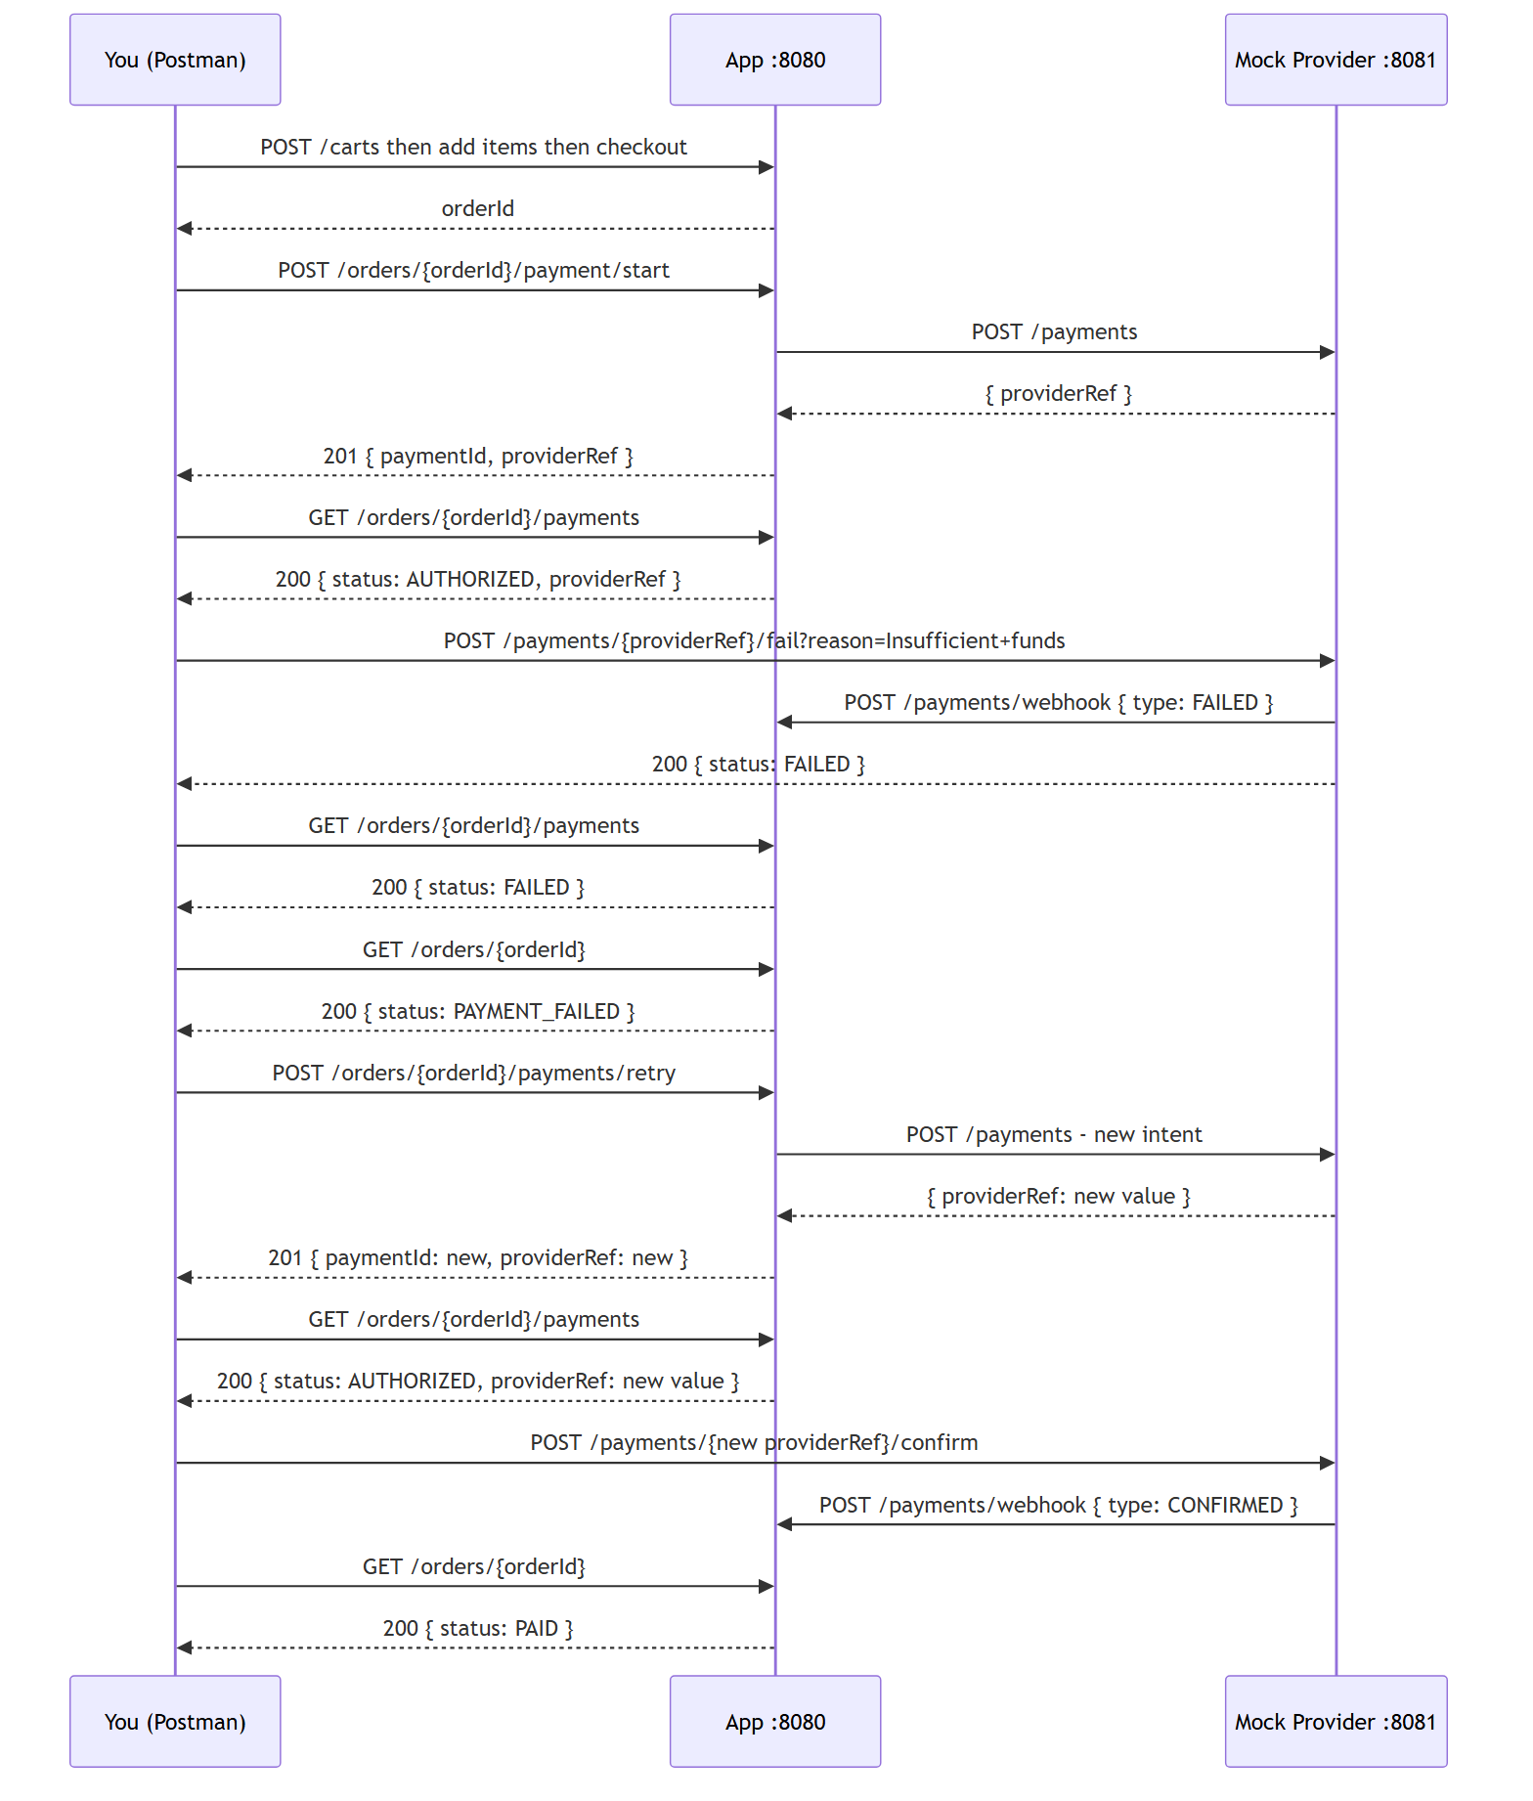
Steps 1 through 7 are the same as the happy path. Create the cart, add items, check out, initiate payment, and make sure you have the providerRef from Step 7.

Step 8 - Fail the Payment
Instead of confirming, send:
POST {{mockUrl}}/payments/{{providerRef}}/fail?reason=Insufficient+funds
The mock provider fires a FAILED webhook. The payment moves to FAILED and the order moves to PAYMENT_FAILED.

Step 9 - Check the Failure
GET /orders/{{orderId}}/payments shows status: FAILED.
GET /orders/{{orderId}} shows status: PAYMENT_FAILED.
The ledger will have no entries yet because no payment has been confirmed.

Step 10 - Retry the Payment
Send POST /orders/{{orderId}}/payments/retry with no body. The system creates a new payment record using the same amount and currency from the failed one, then issues a fresh intent to the mock provider. You get back a new paymentId and a new providerRef.

Step 11 - Capture the New providerRef
Send GET /orders/{{orderId}}/payments. Status should be AUTHORIZED. Postman captures the new providerRef from this response.

Step 12 - Confirm the Retry
Send POST {{mockUrl}}/payments/{{providerRef}}/confirm using the new providerRef.

Step 13 - Everything Should Be Green
GET /orders/{{orderId}} shows status: PAID.
GET /ledger/trial-balance shows balanced: true.

Other Scenarios Worth Trying
Duplicate Payment Attempt
After Step 6 (Initiate Payment), try initiating payment again for the same order:
POST /orders/{{orderId}}/payment/start
You should get 409 Conflict with a message like “An active payment already exists for order xyz”.

Checkout a Cart That Does Not Exist
POST /carts/this-cart-does-not-exist/checkout
Returns 404 Not Found.

Add an Item to a Locked Cart
After Step 4 (Checkout Cart), try adding another item to the same cart:
POST /carts/{{cartId}}/items
Returns 409 Conflict.

Replay a Webhook
After the mock provider confirms the payment, send the exact same webhook again using the same eventId:
{
"eventId": "evt-conf-duplicate-fixed-id",
"providerRef": "{{providerRef}}",
"type": "CONFIRMED",
"reason": null
}
The system deduplicates by eventId and returns 200 without reprocessing. The ledger does not double-post.

Idempotency Key Replay
Use the same Idempotency-Key header value on two separate calls to POST /orders/{orderId}/payment/start. The second call returns the cached 201 response from the first. No second payment is created.

12. Inspecting the Database
The H2 web console is available at http://localhost:8080/h2-console.
Connection settings
Field | Value
Driver Class | org.h2.Driver
JDBC URL | jdbc:h2:file:./data/checkout
User Name | sa
Password | leave blank
Useful Queries
See all domain events for a specific payment in version order:
SELECT event_id, stream_id, version, event_type, occurred_at, payload
FROM events
WHERE stream_id = '<your-payment-id>'
ORDER BY version;
Check outbox messages, including any that have been dead-lettered:
SELECT id, event_type, aggregate_id, dispatched_at, attempt_count, dead, dead_reason
FROM outbox
ORDER BY created_at DESC;
See which webhook events have already been processed:
SELECT * FROM processed_webhook_events ORDER BY processed_at DESC;
Browse idempotency records to see cached responses:
SELECT idempotency_key, endpoint, status, status_code, created_at, completed_at
FROM idempotency_records
ORDER BY created_at DESC;

13. Key Design Decisions
Why a Modular Monolith?
Microservices introduce distributed systems problems before a team has validated that the service boundary is even correct. Network partitions, distributed tracing, cross-service transactions - none of that is free. A modular monolith lets you enforce the same architectural boundaries through code: no cross-context package imports, context-owned read models, integration only through the outbox. Local development stays simple, tests run fast, and if a context genuinely needs to become its own service later, that becomes an extraction rather than a redesign.
Why Event Sourcing?
The event log is the source of truth. Every state change is an immutable, ordered fact. You get a full audit trail without extra effort, temporal queries become possible (what was the state of this payment at exactly 17:03?), and the read models are just projections that can be rebuilt at any time by replaying the event stream.
Why the Outbox Pattern?
Writing to an external service inside a database transaction is risky. If the external call succeeds but the transaction rolls back, you have created a phantom event in the world with no record of it on your side. The outbox pattern solves this by writing the event to an outbox table in the same transaction as the domain changes. A background relay handles delivery. The relay retries on transient failures and dead-letters messages that fail due to non-retryable business exceptions, giving you at-least-once delivery with a clear story for what to do when things go wrong.
Why Double-Entry Bookkeeping?
Every financial system eventually needs an audit trail that cannot lie. Double-entry bookkeeping enforces that every credit has a matching debit. If the trial balance is unbalanced, you know immediately that something went wrong. It is far cheaper to build it in from the start than to retrofit it after money has already moved.
Idempotency at Three Layers
Payment operations are protected at three distinct points. The HTTP idempotency filter stores the first response and replays it verbatim on duplicate requests with the same key. A database uniqueness constraint ensures that even if two requests race past the filter simultaneously, only one active payment per order can exist. Webhook deduplication using processed_webhook_events ensures that a provider redelivering the same event is a no-op at the domain level.

