**Frenzy (a compilation of 3 games)**

**Project by:**

Vishal K

Grade XI

January 2022

**Project Details:**

**Programming Language:** Python (Pygame)

**Code editor:** Visual Studio Code

**Project Statement:**‘Frenzy’ is an exciting compilation of three different games that offer unique challenges and gameplay experiences. The first game is a classical snake game that requires the player to control a snake and eat fruits to increase its size and score. However, the game's difficulty increases as the snake grows larger, making it harder to avoid hitting a wall or its own body.

The second game in ‘Frenzy’ is the classic tic-tac-toe, a two-player turn-based game that is easy to learn but challenging to master. The game requires players to place their symbol on a three-by-three grid, and the first player to occupy a row, column or diagonal wins. The game offers endless possibilities and strategies, making it a great way to pass the time and test one's skills against friends and family.

The third game in ‘Frenzy’ is a 2D platformer game similar to Super Mario, but with the added element of grenades ammunition and intelligent enemies. The game allows players to run, jump, and shoot their way through various levels filled with traps, enemies, and obstacles. The inclusion of grenades ammunition adds a new dimension to the gameplay, allowing players to take down multiple enemies at once or destroy obstacles that are blocking their path. The game also comes with a level designer, which allows players to create their own levels using csv files, making it a great way to express their creativity and challenge others.

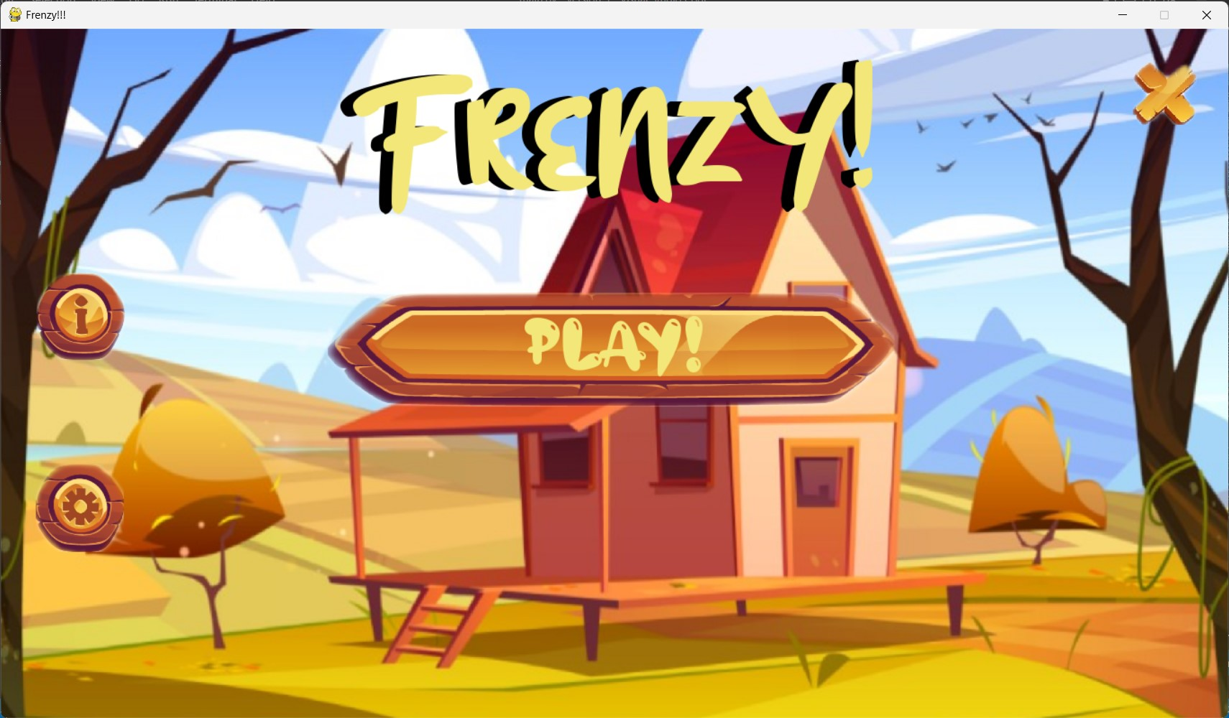

**Main menu**

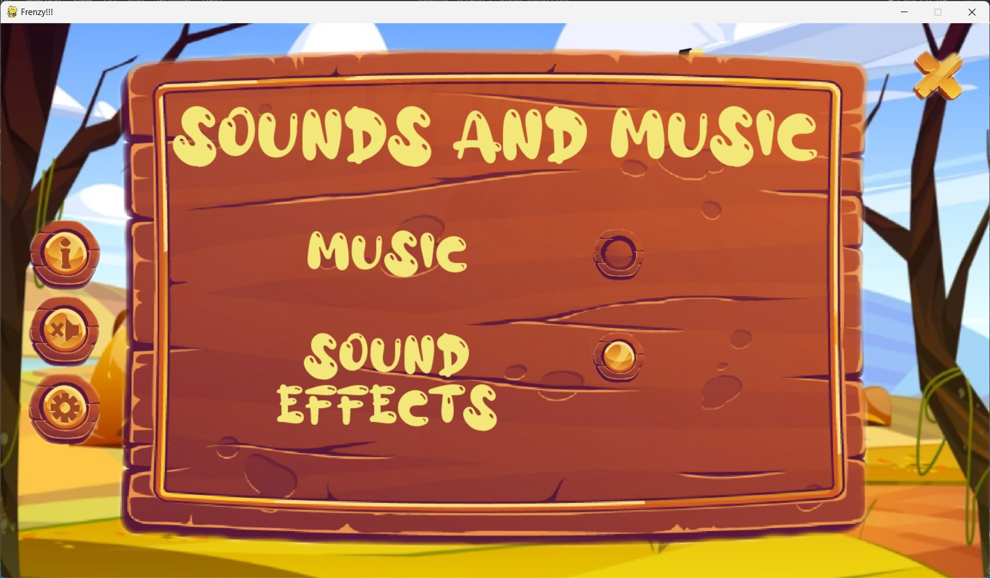

**Settings menu**

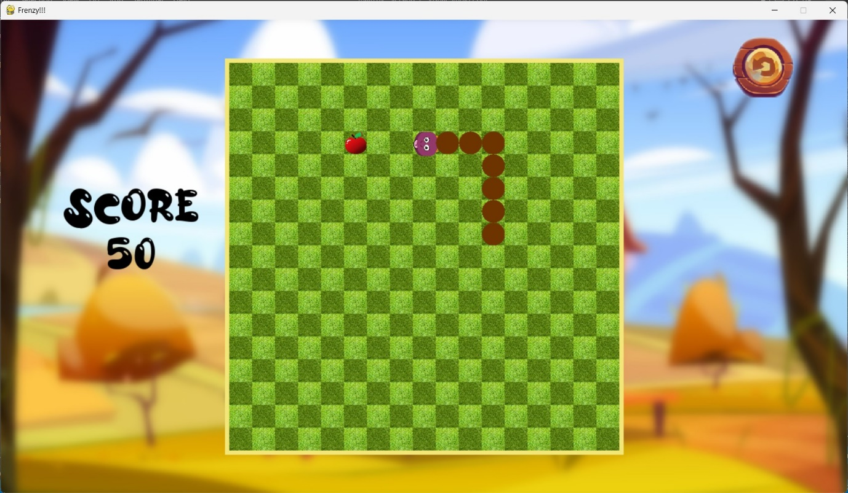

**Snake Game**

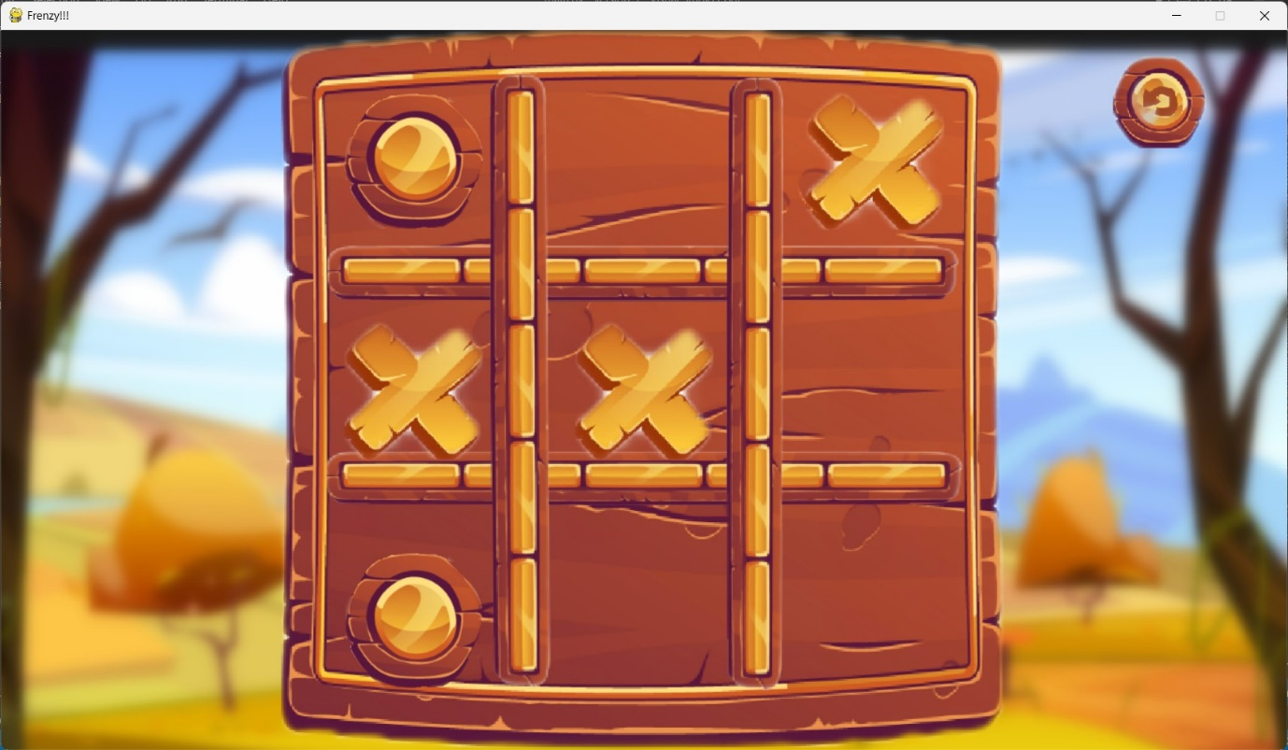

**Tic Tac Toe**

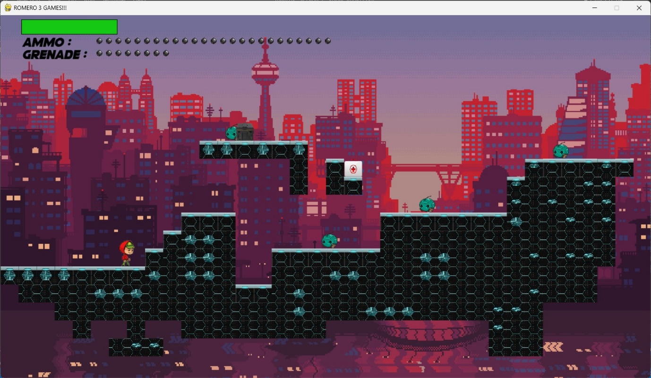

**2D-Platformer**

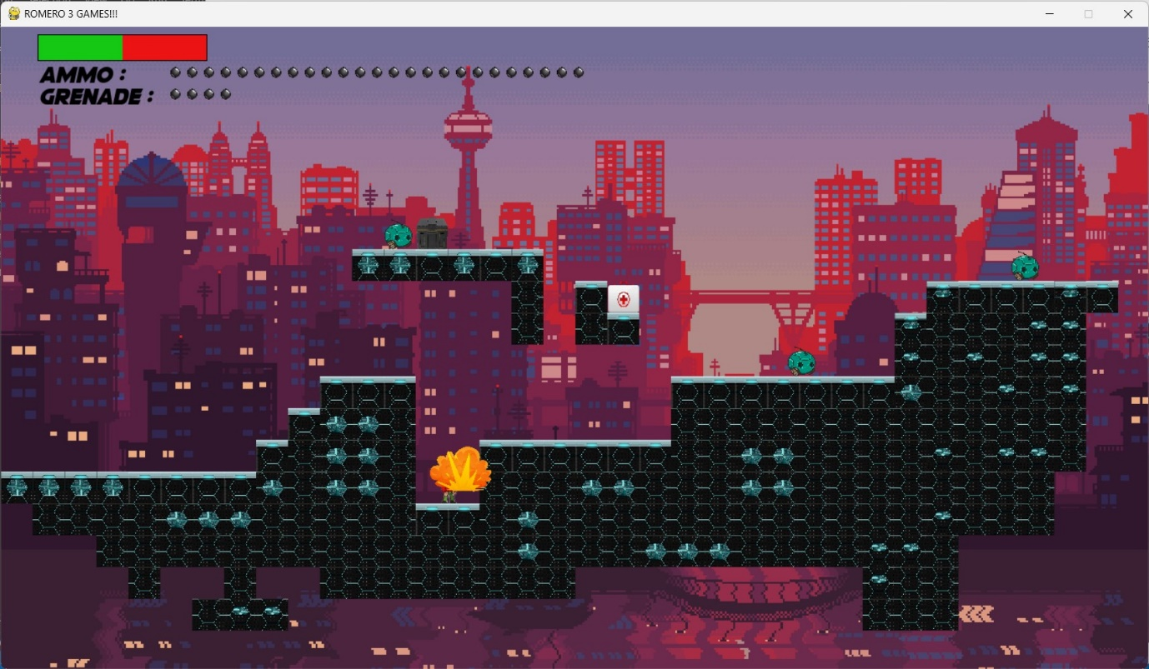

**Explosives**

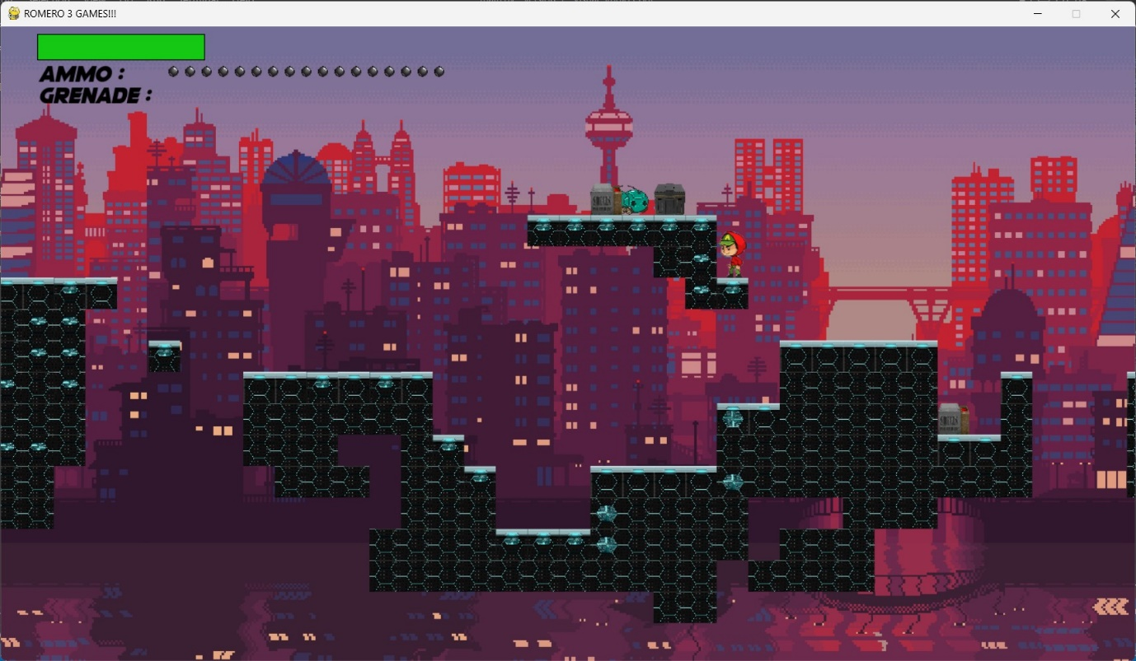

**Collect Ammo and Kill Enemies**

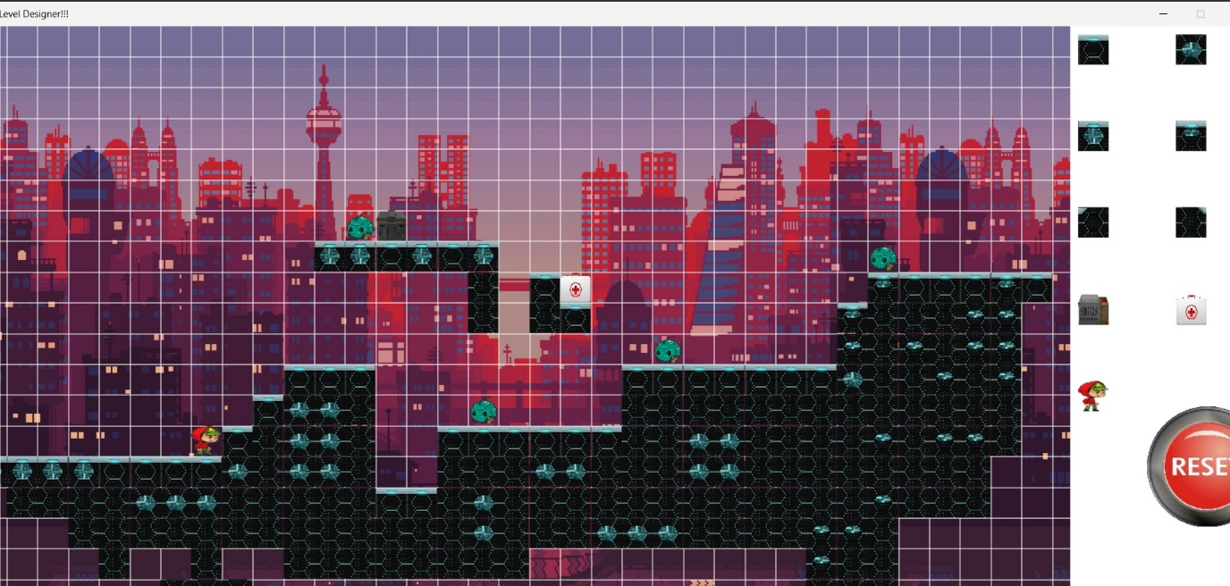

**Level Designer**

**My GitHub Repository:** <https://github.com/IAmACodeGeek/Frenzy-Pygame-Python>