**Name: Shubhan Singh**

**SE comps B/Batch C**

**2022300118**

CCN Exp 1

**Basic commands:**

1. **Ifconfig**

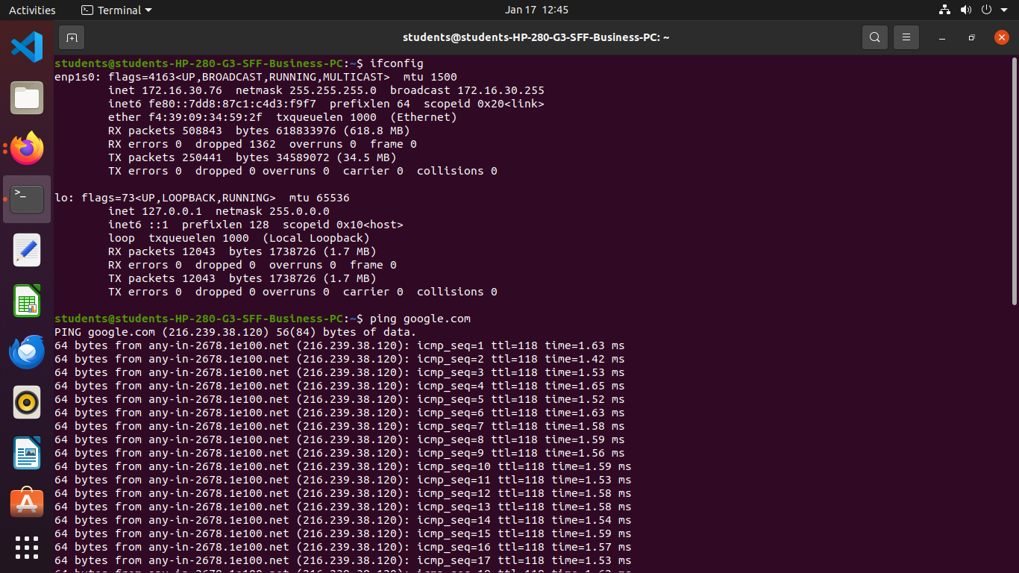

* The **ifconfig** function displays the current configuration for a network interface when no optional parameters are supplied.
* You can use the **ifconfig** command to assign an address to a network interface and to configure or display the current network interface configuration information. The **ifconfig** command must be used at system startup to define the network address of each interface present on a system. After system startup, it can also be used to redefine an interface’s address and its other operating parameters.
* The windows counterpart of this command is **ipconfig**

1. **Ping**

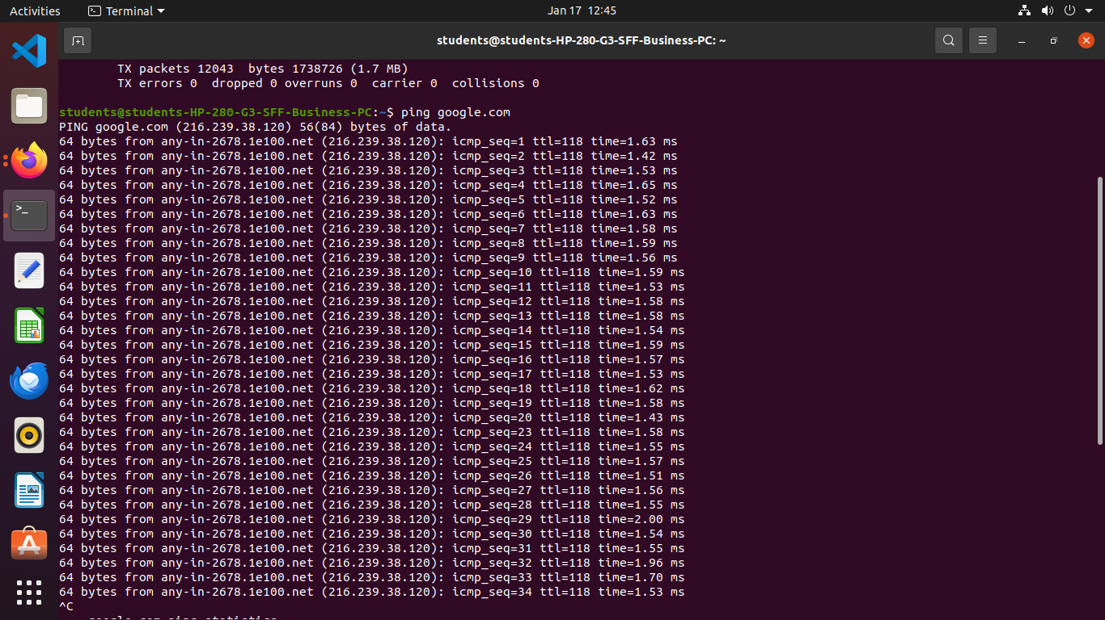

* **Ping** is short for **Packet Internet Groper**. This command is mainly used for checking the network connectivity among host/server and host. The ping command takes the URL or IP address as input and transfers the data packet to a specified address along with a **"PING"** message. Then, it will get a reply from the host/server.
* The time specified in the output is the time between the system sending the packet and receiving another in response. This time is called latency. Lower latency means a more responsive connection.
* This command is mainly used in troubleshooting as it helps us to:

- Test our Internet connection.

- Check if the remote machine is active.

- Analyse when there are network problems such as high latency or dropped packages.

1. **traceroute**

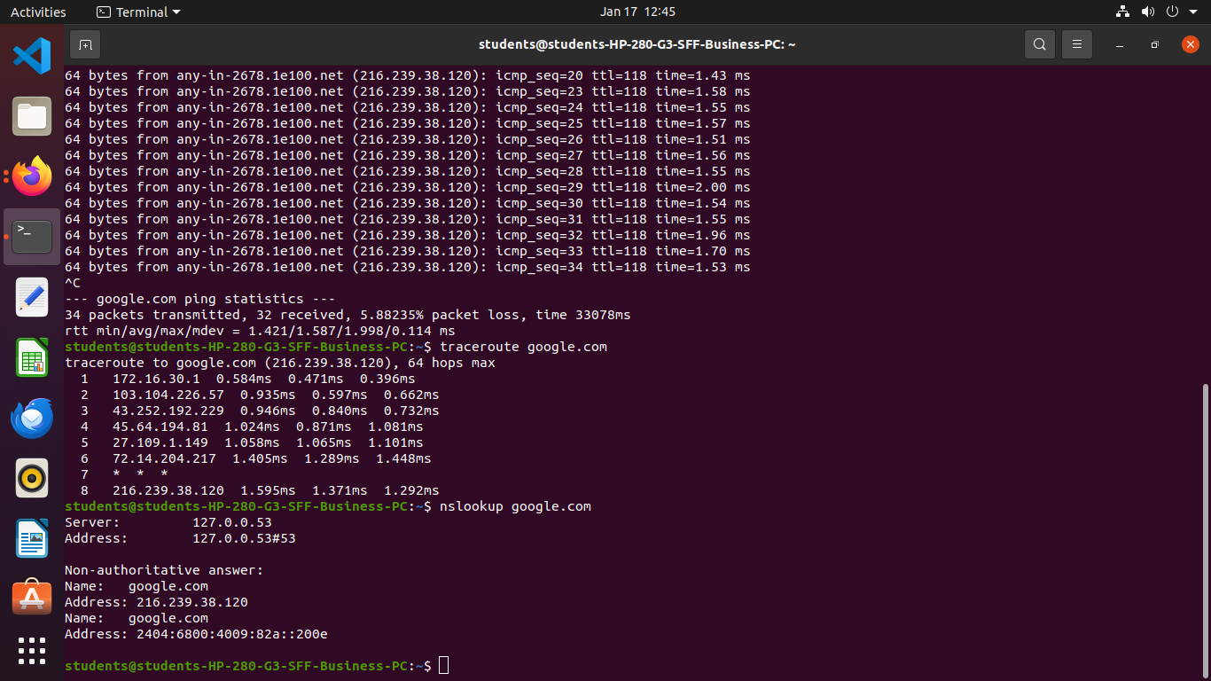

* Linux traceroute command is a network troubleshooting utility that helps us determine the number of hops and packets traveling path required to reach a destination. It is used to display how the data is transmitted from a local machine to a remote machine.
* traceroute and tracert(windows) are the commands for computer network diagnostics to display possible routes and measure packet transit delays across the IP network. The route history is recorded as the packet round-trip time from all successive hosts in the route. The mean time sum in every hop is the total time measure spent to create the connection.
* The traceroute command continues unless every sent package is lost more than twice, the connection is lost, or the path can't be evaluated.
* The command **sends the packets to each server 3 times**, and the latency for each of those transmissions is displayed in the output.

1. **nslookup**

* **Nslookup**(stands for “Name Server Lookup”) is a useful command for getting information from the DNS server. It is a network administration tool for querying the Domain Name System (DNS) to obtain domain name or IP address mapping or any other specific DNS record. It is also used to troubleshoot DNS-related problems.
* nslookup followed by the domain name will display the “A Record” (IP Address) of the domain. A reverse lookup can also be done by providing the ip address of a domain.
* This command also supports an interactive mode, this can be accessed by providing no command line arguments with the command(as shown above).

Interactive mode allows you to query name servers for information about various hosts and domains, or to print a list of the hosts in a domain.