Name: Shubhan Singh

Class: SE Comps B

Roll no.:2022300118

**CCN Experiment 5**

SMTP

1. Change domain name to custom username using hostname command.

1. Step 3: Run sudo nano /etc/hostname Command And Enter Domain And Save The File.

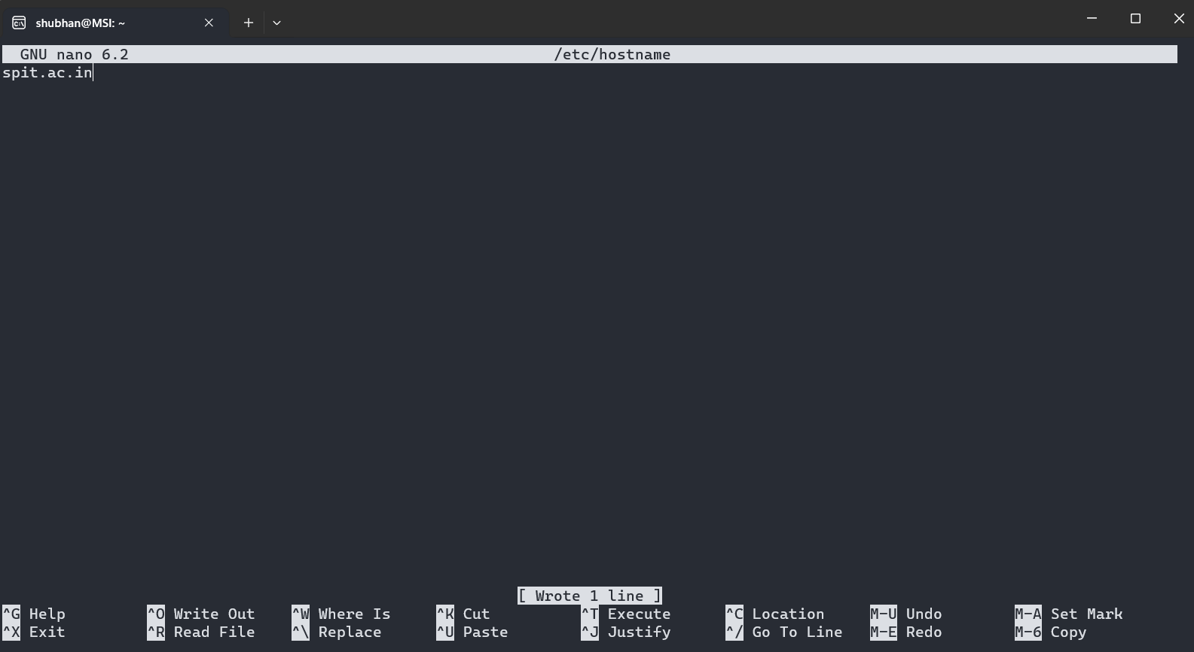

1. Run sudo nano /etc/hosts Command And Enter Domain Next To 127.0.1.1 And Save The File.

1. Run sudo apt-get update to install all updates, sudo apt-get mailutils , and sudo apt install postfix.

1. During installation And Configuration Of Postfix Select Internet Site Because We Need SMTP.

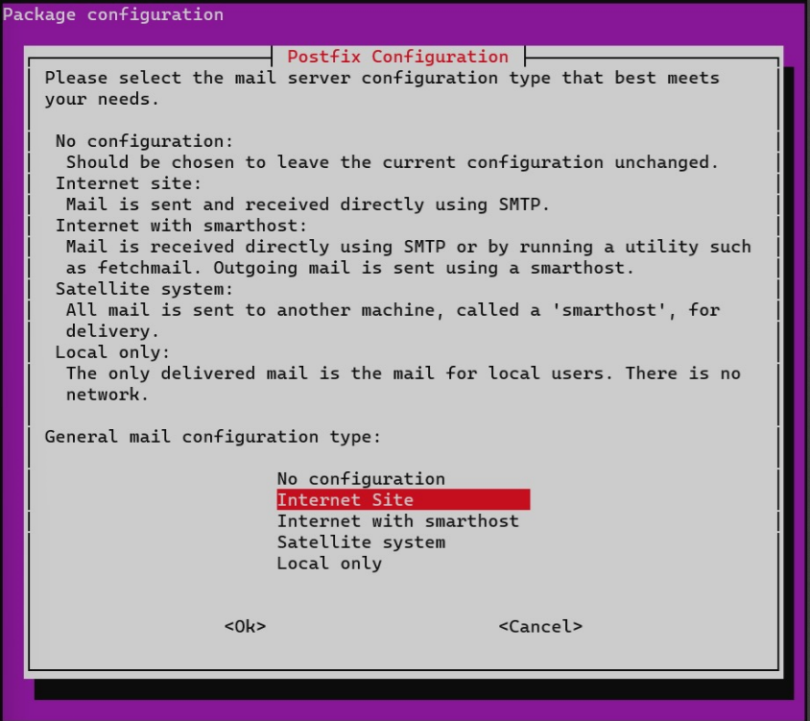

1. Check If Domain Name Is Correct And Press Ok.

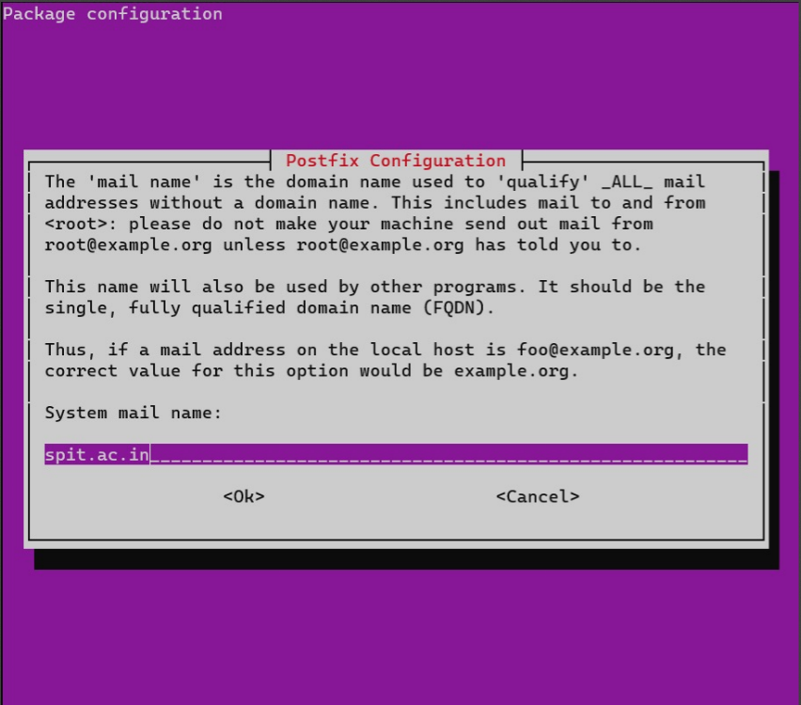

1. Write the required lines into the main.cf file in the /etc/postfix/ folder

1. Write the following into the sasl_passwd file:

(Here app password generated by google was used instead of password, the ability to allow less secure apps was removed from gmail in 2022, so we have to use app passwords generated by google to allow specific apps to access our account.)

1. Convert The sasl_passwd File Into A Database File Using sudo postmap /etc/postfix/sasl/sasl_passwd Command

1. After reloading postfix, run the following command to send a mail:

echo “<Message>” | 