Name: Shubhan Singh

Class: SE Comps B

Roll no.:2022300118

**CCN Experiment 6**

FTP

**Aim:** To configure file transfer protocol server using Filezilla

1. Installing vsftpd

1. Making the required changes in the /etc/vsftpd.conf file

1. Configuring the firewall to allow incoming connections from certain ports over TCP

1. Creating a public user account “ftpuser”

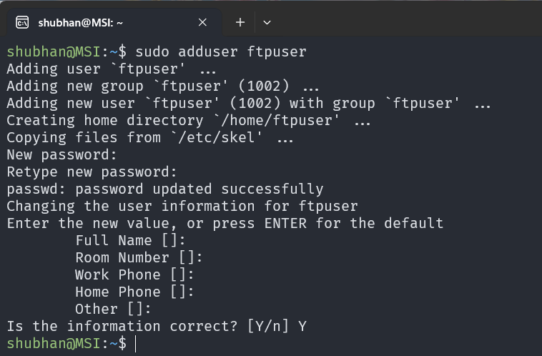

1. Creating folder named ftp in root directory which will act as the root directory for the ftp server.

1. Configuring vsftpd for secure operation, and setting the local_root directory for the ftp server.

1. Restarting vsftpd to apply changes

1. Securing vsftpd with SSL. Generating self-signed certificate to use with FTPS (FTP over SSL)

1. Connecting to ftp server using filezilla.

(Used my ip address and ftpuser and its password as username and password)

(As can be seen, this is my ip address)

(The files available on the server match the ones placed in the /ftp directory we created earlier)

