Name: Shubhan Singh

Class: SE Comps B

Roll no.: 2022300118

**CCN Experiment 9**

Cisco Packet Tracer

**Aim:** To use Cisco Packet Tracer

Topology diagram:

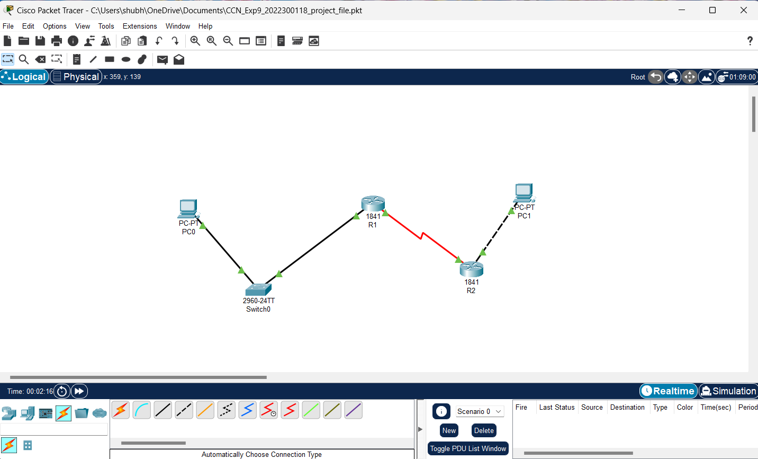

**Task 1: Subnet the address space**

Step 1: Examine the network requirements.

Address space : 192.168.1.0/24

The network consists of the following segments:

• The network connected to router R1 will require enough IP addresses to support 15 hosts. • The network connected to router R2 will require enough IP addresses to support 30 hosts. • The link between router R1 and router R2 will require IP addresses at each end of the link.

Step 2:

1. How many subnets are needed for this network?

• 3 Subnets are required for this network

1. What is the subnet mask for this network in dotted decimal format?

• 255.255.255.224 is the subnet mask

1. What is the subnet mask for the network in slash format?

• /27 is the subnet mask in slash format for this address.

1. How many usable hosts are there per subnet?

• 30 usable hosts are there per subnet

Step 3: Assign subnetwork addresses to the Topology Diagram.

• Assign subnet 1 to the network attached to R1 − 192.168.1.32/27

• Assign subnet 2 to the link between R1 and R2 − 192.168.1.64/27

• Assign subnet 3 to the network attached to R2 − 192.168.1.96/27

**Task 2-3: Determine Interface Addresses and configure serial and FastEthernet interfaces of routers and PCs.**

Step 1: Assign appropriate addresses to the device interfaces.

1. Assign the first valid host address in subnet 1 to the LAN interface on R1 i.e., 192.168.1.33

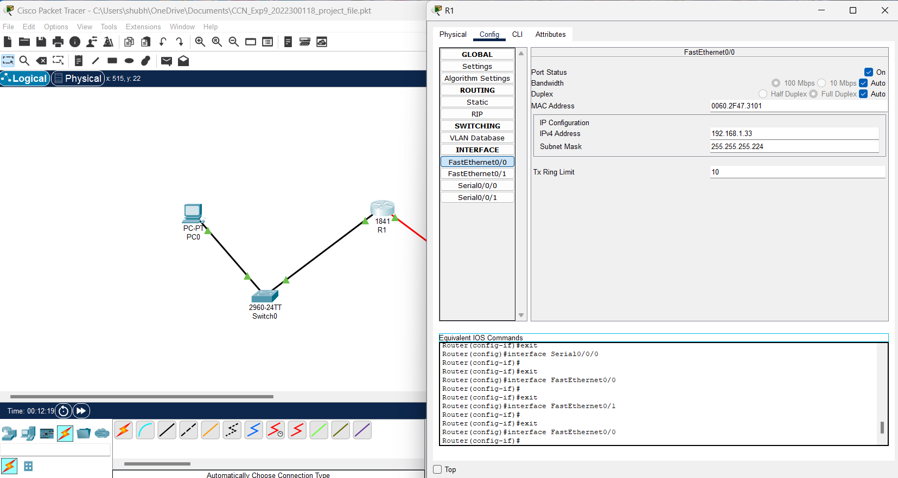

1. Assign the last valid host address in subnet 1 to PC1 i.e., 192.168.1.62

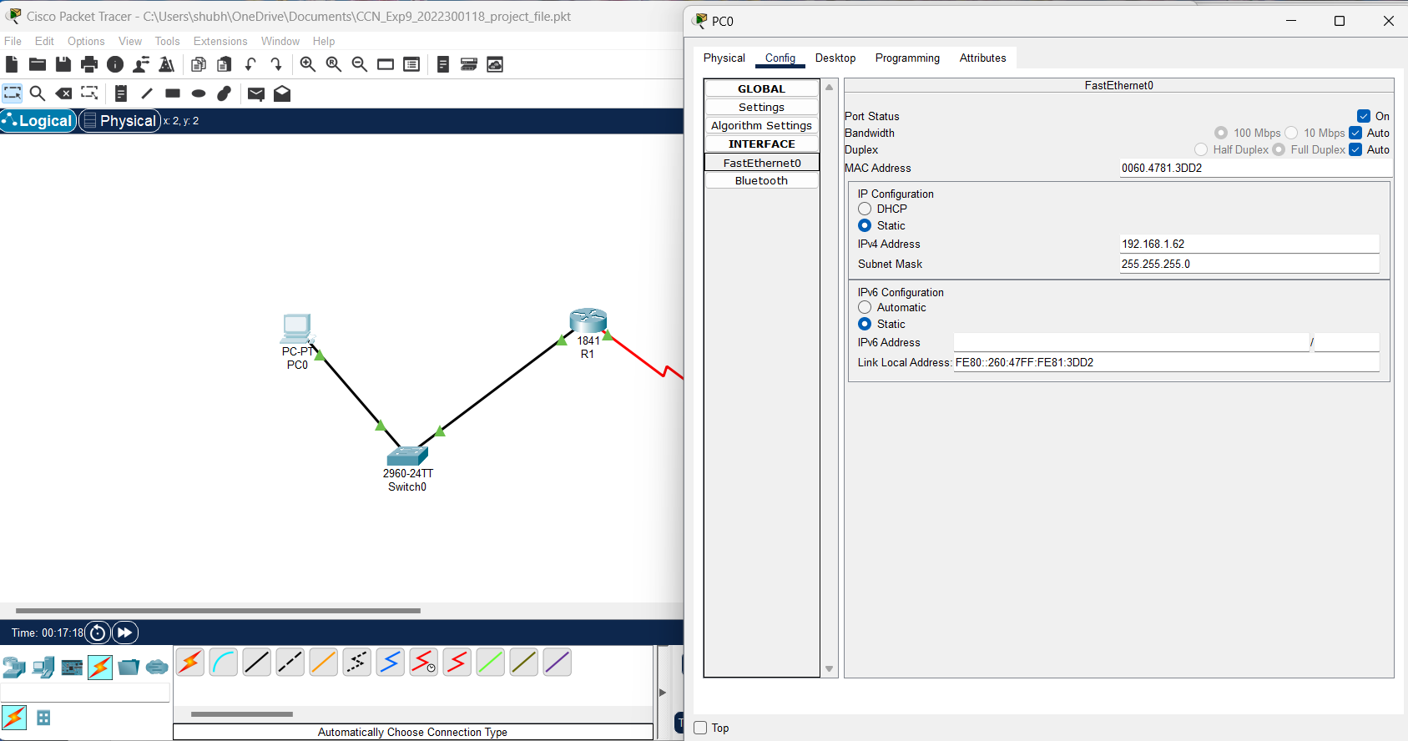

1. Assign the first valid host address in subnet 2 to the WAN interface on R1 i.e., 192.168.1.65

1. Assign the last valid host address in subnet 2 to the WAN interface on R2 i.e., 192.168.1.94

1. Assign the first valid host address in subnet 3 to the LAN interface of R2 i.e., 192.168.1.97

1. Assign the last valid host address in subnet 3 to PC2 i.e., 192.168.1.126

Step 2: Document the addresses to be used in the table provide under the Topology Diagram.

Addressing table :

**Task 4: Verify the Configurations.**

Answer the following questions to verify that the network is operating as expected.

1. From the host attached to R1, is it possible to ping the default gateway?

* Yes

1. From the host attached to R2, is it possible to ping the default gateway?

- Yes

**Task 5: Reflection**

1. Are there any devices on the network that cannot ping each other?

* Yes

We cannot ping the other default gateway from PC0 or PC1

1. What is missing from the network that is preventing communication between these devices?

* It is because the 2 devices belong to two different LANs, and the routing table does not have paths between them.

**Conclusion:**

Cisco Packet Tracer is an excellent tool for simulating and testing network configurations. It allows network engineers to experiment with various network topologies, protocols, and configurations without the need for expensive physical hardware.

Through this experiment, we learnt how to create a network topology, configure various devices, and test the connectivity between them, and also how to use network troubleshooting commands like ping using the console feature in the software.