**Shubhan Singh**

**2022300118**

**SE-Comps B/Batch C**

**18th April 2024**

**LA ISE-2**

**Program No.1** :- Solve the given system of equations in terms of x,y,z,w using Gauss Jacobi Method. Perform 11 iterations.

-14x+4y+2z+5w=33

5x+20y+4z+9w=57

2x+5y+12z+w=92

3x+2y+2z-8w=60

**Code :-**

clc;

A = [-14 2 4 5;5 20 4 9;2 5 12 1;3 2 2 -8]

B = [33;57;92;60]

x = 0

y = 0

z = 0

w = 0

n = 11

for i = 1:n

printf("\nFor iteration %d\n",i)

X = (B(1) - y*A(1,2) - z*A(1,3) - w*A(1,4))/A(1,1)

Y = (B(2) - x*A(2,1) - z*A(2,3) - w*A(2,4))/A(2,2)

Z = (B(3) - x*A(3,1) - y*A(3,2) - w*A(3,4))/A(3,3)

W = (B(4) - x*A(4,1) - y*A(4,2) - z*A(4,3))/A(4,4)

printf("X = %g\n",X)

printf("Y = %g\n",Y)

printf("Z = %g\n",Z)

printf("W = %g\n",W)

x = X

y = Y

z = Z

w = W

end

**Output :-**

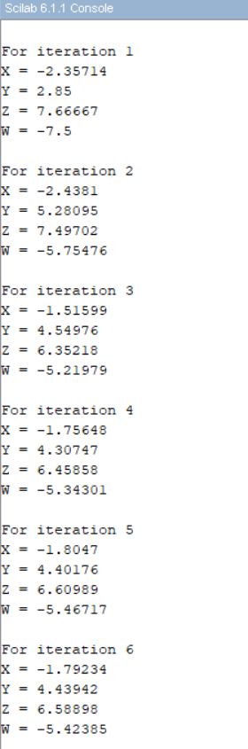

**Program No. 2:-** Solve the given system of equations in terms of x,y,z,w using Gauss Jordan Method.

x+2y+3z-w=10

2x+3y-3z-w=1

3x+2y-4z+3w=2

2x-y+2z+3w=7

**Code**:-

clc;

a = [1 2 3 -1;2 3 -3 -1;3 2 -4 3;2 -1 2 3]

printf("The matrix A is: ")

disp(a)

b = [10;1;2;7]

printf("The matrix B is: ")

disp(b)

c = [a b]

printf("The augmented matrix is: ")

disp(c)

n = 4

for i = 1:n

if c(i,i)==0

c(i,:) = c(i,:)

else

c(i,:) = c(i,:)/c(i,i)

end

for j = 1:n-1

if i+j<n+1

c(i+j,:) = c(i+j,:) - c(i+j,i)*c(i,:)

else

end

end

end

printf("The row echelon form is: ")

disp(c)

for j = n:-1:2

for i = 1:i-1

c(i,:) = c(i,:) - c(i,j)*c(j,:)

end

end

printf("The reduced row echelon form is: ")

disp(c)

printf("X = %g\n",c(1,5))

printf("Y = %g\n",c(2,5))

printf("Z = %g\n",c(3,5))

printf("W = %g\n",c(4,5))

**Output** :-

