**Shubhan Singh**

**SE-Comps B/Batch C**

**2022300118**

OS Experiment 2: Implementing static and dynamic linking

(All source code files are submitted on moodle)

**Aim:** Write a program for creating a static/dynamic link library for complex number operations and then test this library through linuxld linker.

Part 1:

LAB:

Files used:

mergesort.c

vol_cylinder.c

lib_mylib.h

exp2labdriver.c

Running static linking:

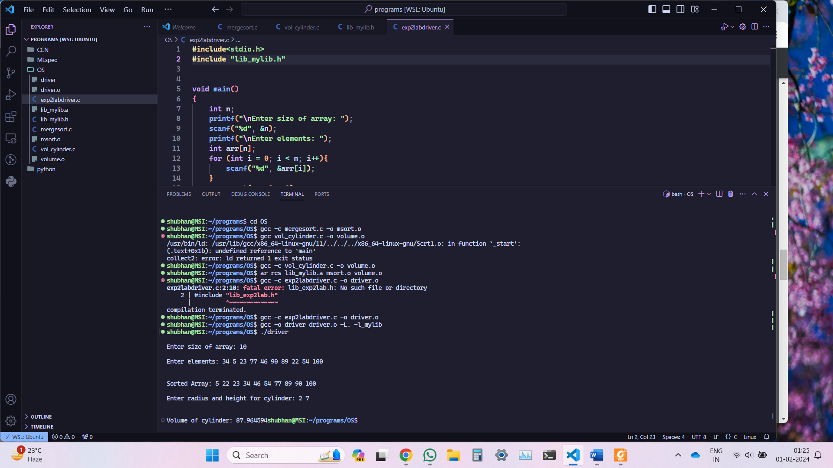

Running dynamic linking:

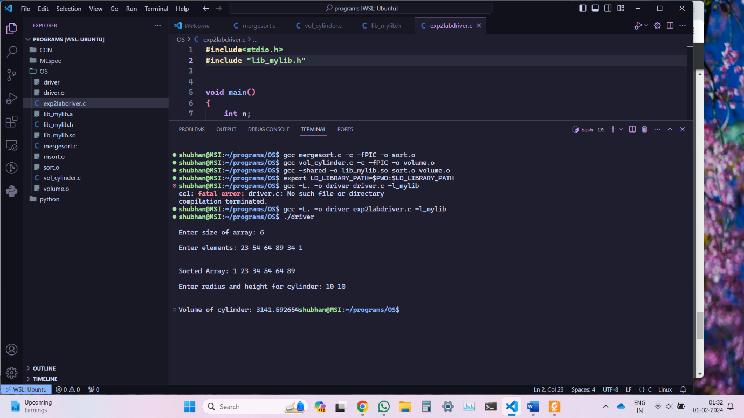

**Part 2:**

**Aim:** Write a program for creating a static/dynamic link library for complex number arithmetic.

Files used:

add_sub.c

mult_div.c

lib_mylib3.c

exp2lab2driver.c

Running static linking:

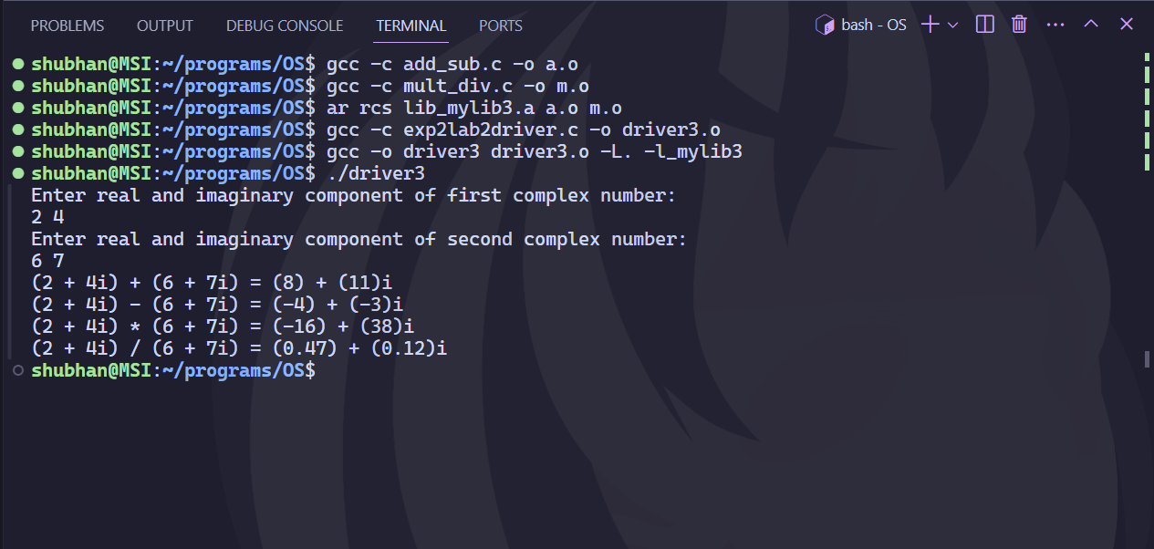

Running dynamic linking:

**Part 3:**

**Post lab question:** Create a scientific calculator program in C using static and dynamic linking. Create a separate file for each operation:

1. Basic arithmetic operations (addition, subtraction, multiplication, and division)

2. Trigonometric operations (sine, cosine, and tangent)

3. Logarithmic operations (natural logarithm and log base 10)

4. Exponential operations (e^x and x^y)

5. Factorial operation (n!)

Source Code:

arithmetic.c

logarithmic.c

exponential.c

trigonometric.c

factorial.c

lib_mylib2.h

exp2part2driver.c

Running static linking:

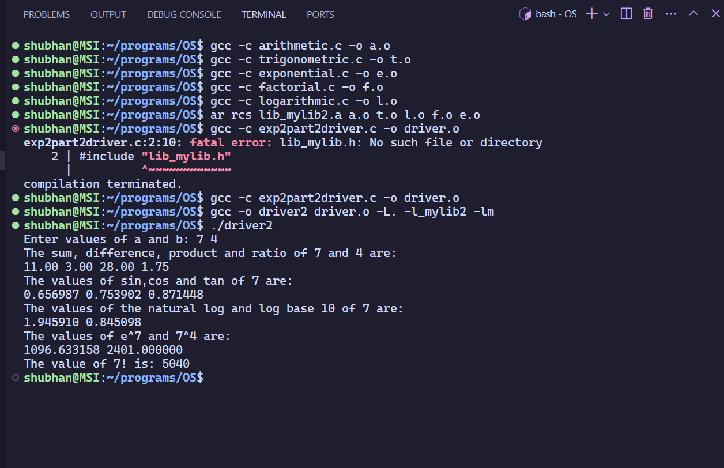

Running dynamic linking:

