**Shubhan Singh**

**SE-Comps B/Batch C**

**2022300118**

OS Experiment 4 : Multithreading

(All source code files are submitted on moodle)

**Part 1:**

**Problem statement**: Write a multithreaded program that calculates various statistical values for a list of numbers. This program will be passed a series of numbers on the command line and will then create three separate worker threads. One thread will determine the average of the numbers, the second will determine the maximum value, and the third will determine the median value.

Files used: *Exp4a.c*

Output:

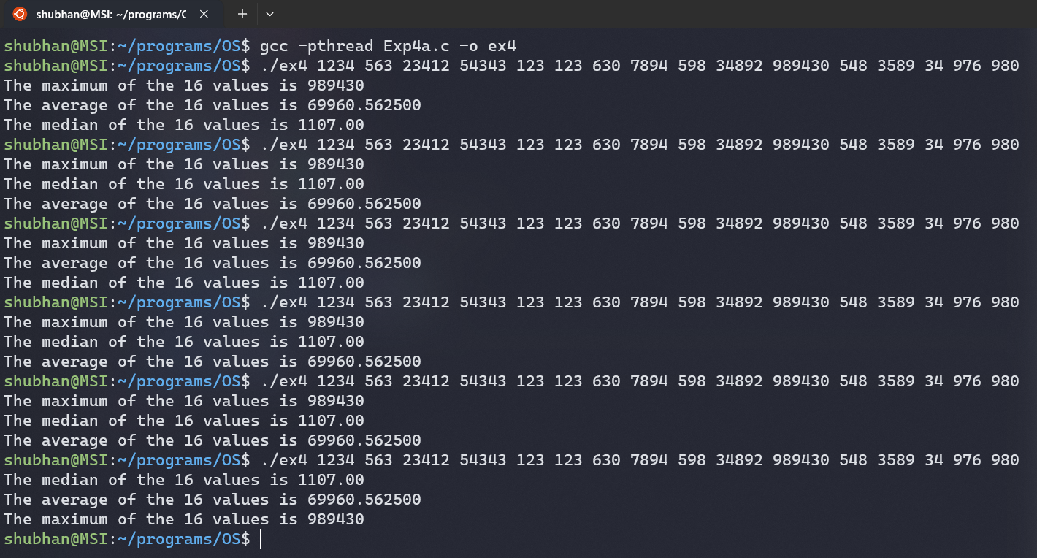

(The order of output changes for the same code)

**Part 2:**

**Aim:** Write a multithreaded program that creates two functions one for adding the element from array and other function to delete last two elements in array and print it. The code runs 5 times, addition of elements happens first and then the deletion. Check necessary conditions like minimum 2 elements remain in array.

Files used:

*Exp4b.c*

(Even though 3 threads are adding an element at once, use of mutex ensures that the control flow is stable)