**Shubhan Singh**

**SE-Comps B/Batch C**

**2022300118**

OS Experiment 5 : Scheduling

(All source code files are submitted on moodle)

**Problem statement**: Write a program to simulate the following Non-pre-emptive CPU scheduling algorithms to find turnaround time and waiting time. a) FCFS b) SJF c) Round Robin d) Priority

**Files used**: *Exp5.c*

**Output:**

1. FCFS

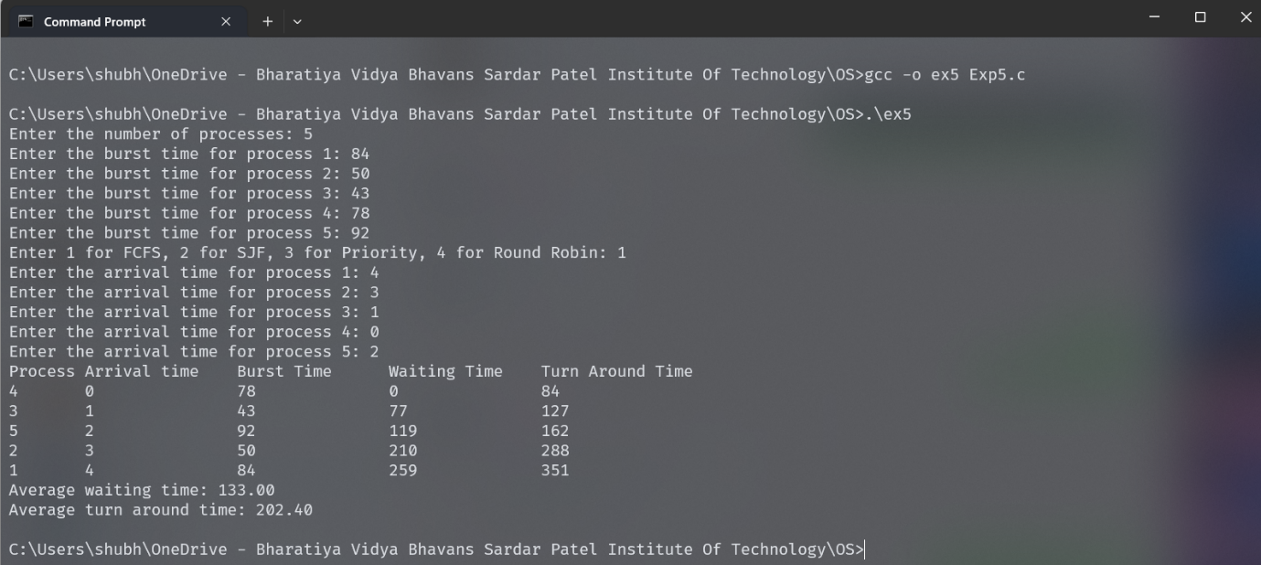

1. SJF

1. Priority Scheduling

1. Round Robin scheduling

