**Shubhan Singh**

**SE-Comps B/Batch C**

**2022300118**

OS Experiment 6: Pizza scheduling system

(All source code files are submitted on moodle)

**Problem statement**: Rominus pizza wants to implement a pizza scheduling system. Create individual systems implementing each of the following CPU scheduling algorithms as follows:

 ● FCFS: In a pizza delivery system, how does the First-Come-First-Served (FCFS) scheduling algorithm determine the order in which pizzas are delivered to customers?

● SJF: In a pizza delivery system, how does the Shortest Job First (SJF) scheduling algorithm prioritize which pizzas are delivered first based on their preparation time?

● Round Robin: In a pizza delivery system, how does the Round Robin scheduling algorithm ensure that each delivery driver gets a fair and equal chance to deliver pizzas?

● Priority: In a pizza delivery system, how does the Priority scheduling algorithm prioritize which pizzas are delivered first based on the urgency of the delivery (e.g. VIP customers, emergency deliveries)?

 Also, explain which algorithm will be best suited for the following scenario. Is it possible to combine the above algorithms to create an even more efficient algorithm? If yes, then explain how.

**Files used**: *Exp6.c*

**Output:**

1. FCFS

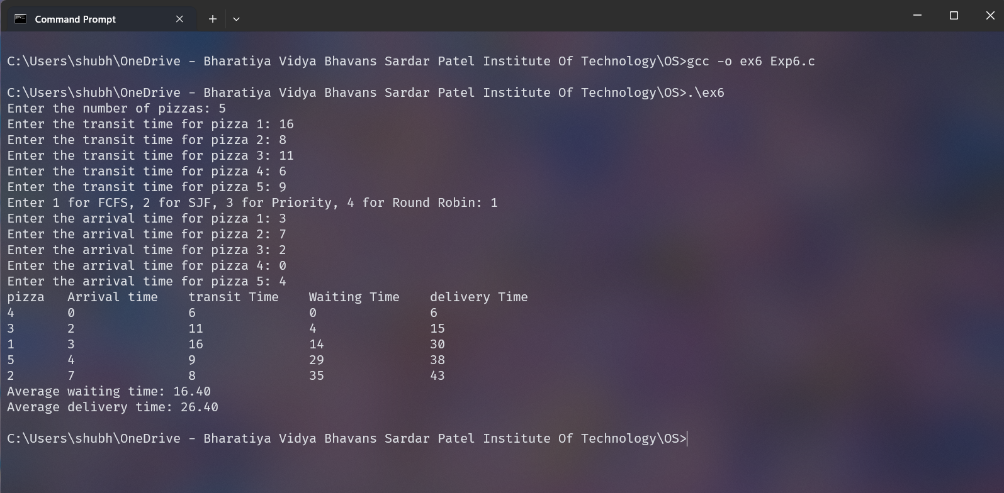

1. SJF

1. Priority Scheduling

1. Round Robin scheduling

Answers to additional questions are given in the handwritten report.