**Shubhan Singh**

**SE-Comps B/Batch C**

**2022300118**

OS Experiment 7 : Banker’s Algorithm

(All source code files are submitted on moodle)

**Problem statement**: Using the banker's algorithm for deadlock avoidance, when given data about resource constraints and their allocation, find whether a set of processes Is in deadlock or not, if not, find the order in which to give control to processes so as to avoid deadlock.

**Files used**: *bankers_algorithm.c*

**Output:**

(input file attached in submission)

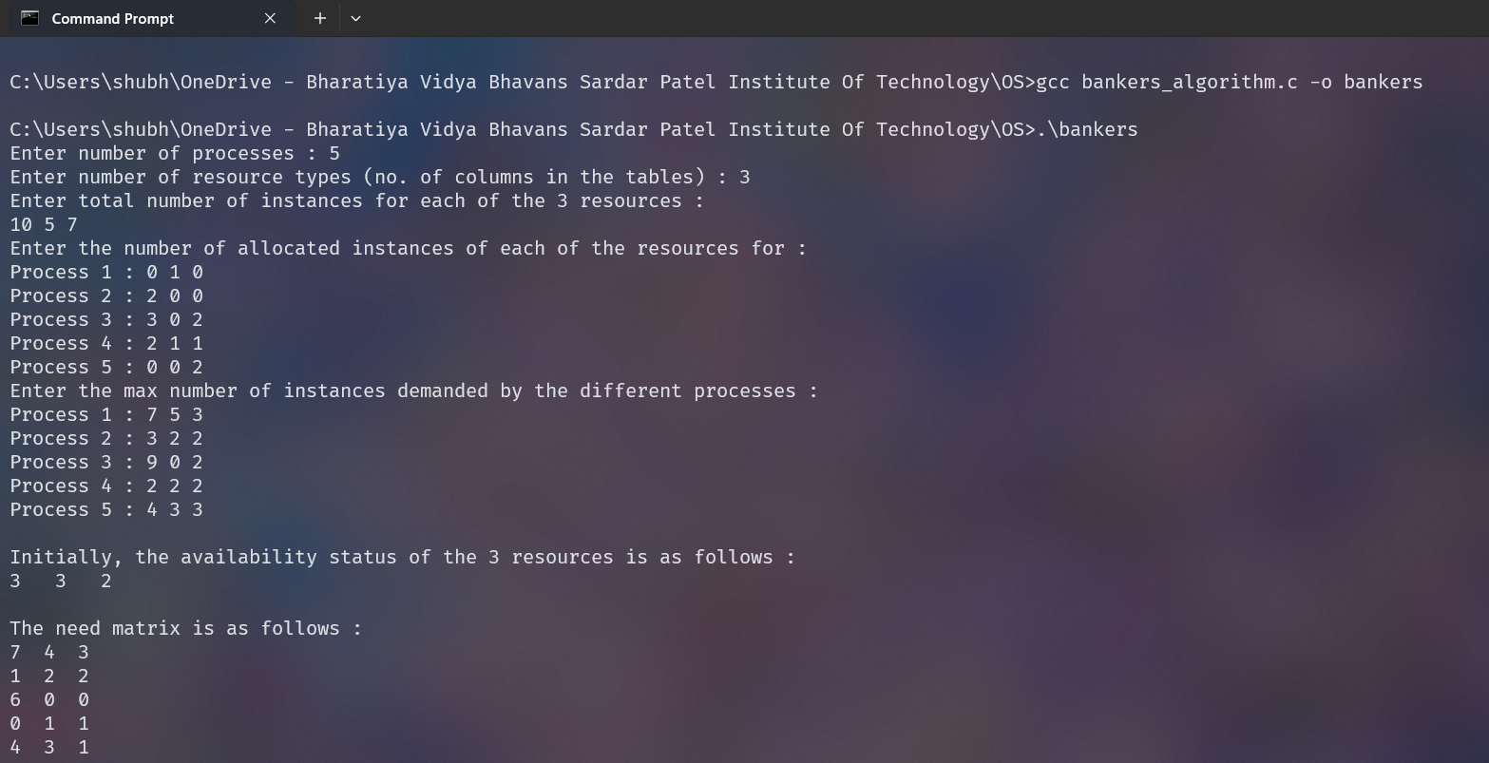

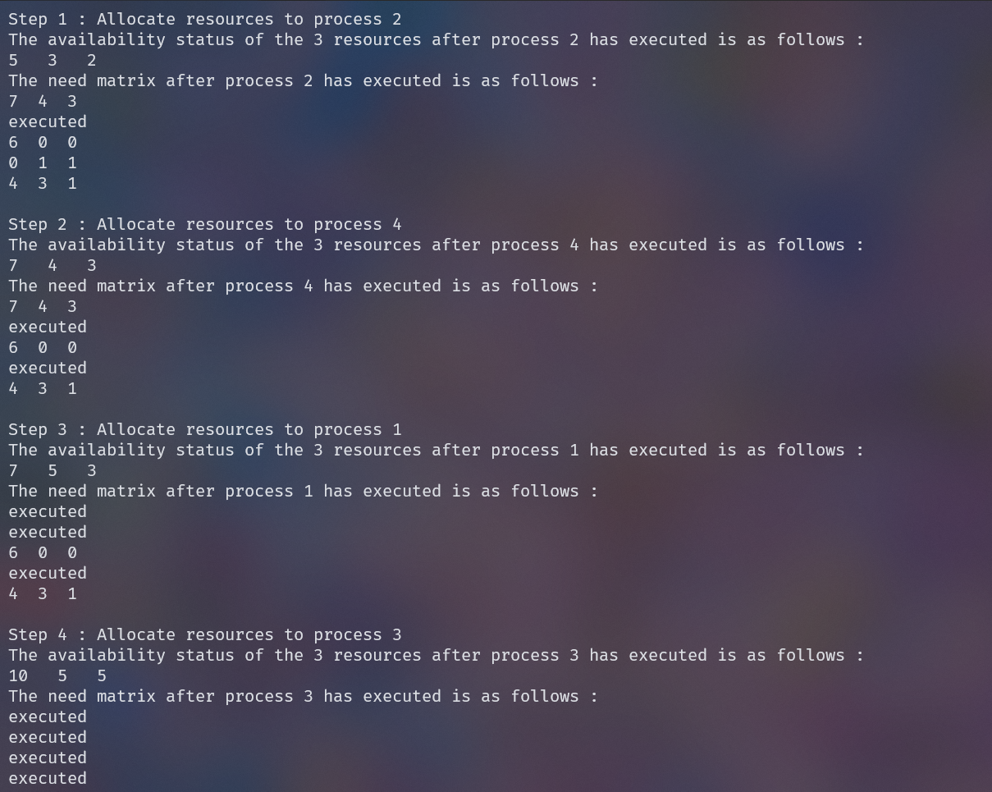

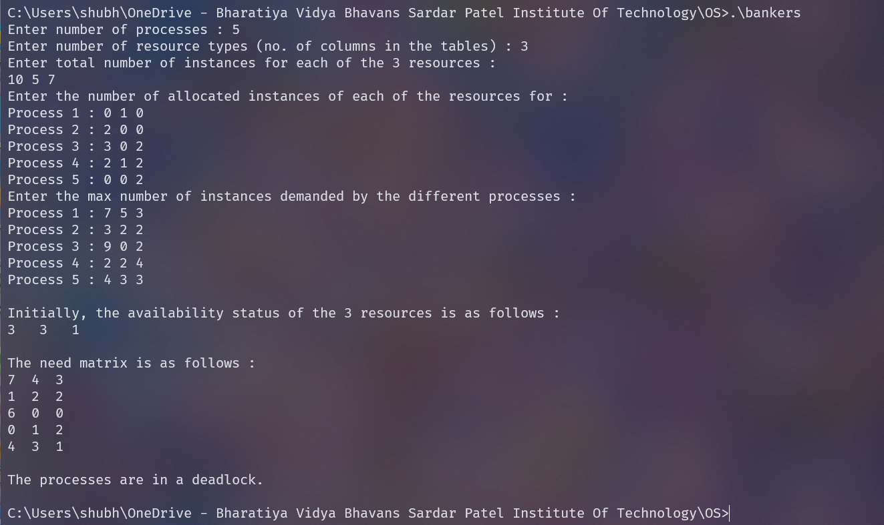

(Deadlock case)