Name: Shubhan Singh
Class: SE Comps B
Roll no.: 2022300118

CCN Experiment 10
Mininet

Objective: The objective of this lab exercise is to create a realistic virtual network using Mininet, a tool for emulating network environments. By the end of this exercise, students should be able to set up a virtual network, run real kernel, switch, and application code, and understand the basic workflow of Mininet.
Outcomes:
1. Understand the basics of Software Defined Networking (SDN).
2. Learn how to install and configure Mininet.
3. Create a virtual network with hosts, switches, and controllers.
4. Run real kernel, switch, and application code within the virtual network.
System Requirements:
1. A computer running a Unix-based operating system (e.g., Linux, macOS).
2. Python installed (recommended version 2.7.x or 3.x).
3. Superuser (root) privileges or sudo access.

Procedure:
Step 1: Installation and Setup
- Visit the Mininet website (mininet.org) and follow the instructions to download and install Mininet on your system. [1][2]
- Once installed, open a terminal and start Mininet by typing `sudo mn`.
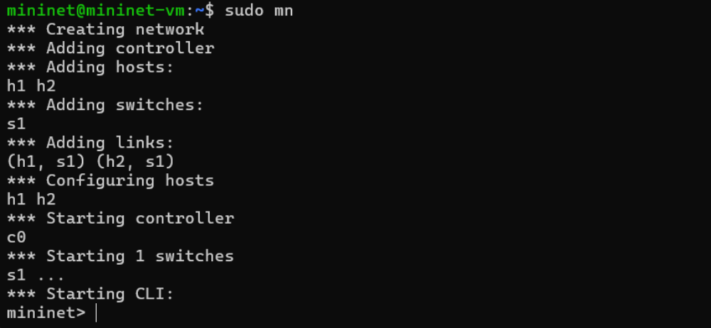
Step 2: Sample Workflow
- Create a simple network topology using the following command:
mininet> h1 = net.addHost('h1')
mininet> h2 = net.addHost('h2')
mininet> s1 = net.addSwitch('s1')
mininet> net.addLink(h1, s1)
mininet> net.addLink(h2, s1)
- Start the network:
mininet> net.start()

- Test connectivity between hosts:
mininet> h1 ping h2
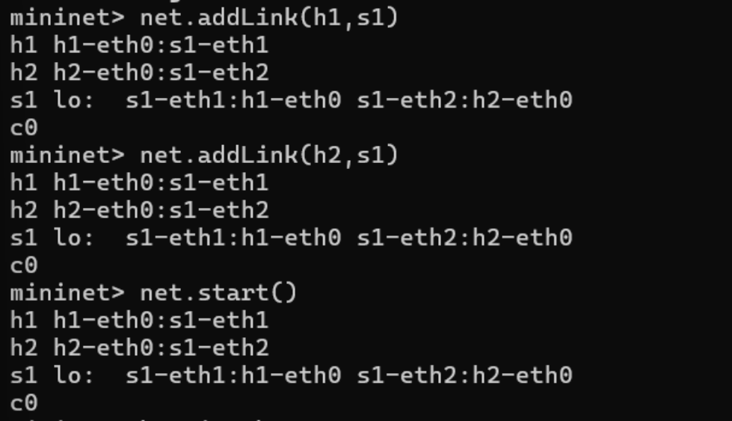

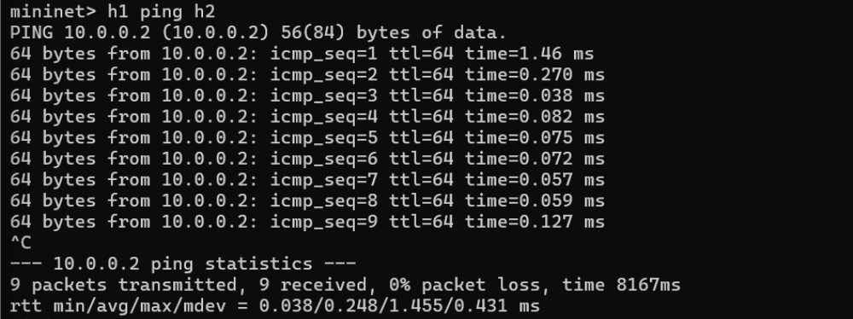

Step 3: Walkthrough
Part 1: Everyday Mininet Usage
1. Display Startup Options
Type the following command to display a help message describing Mininet’s startup options: Sudo mn -h
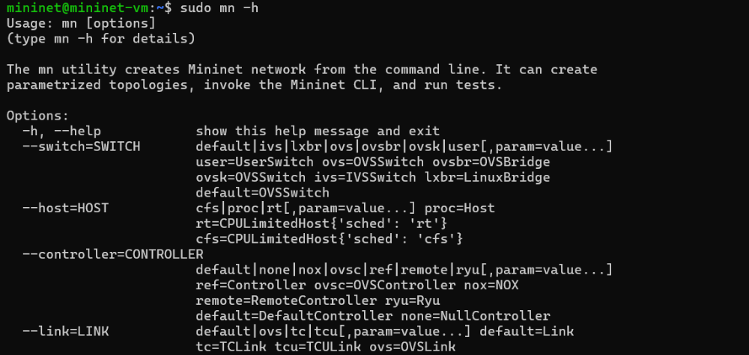
2. Installing wireshark
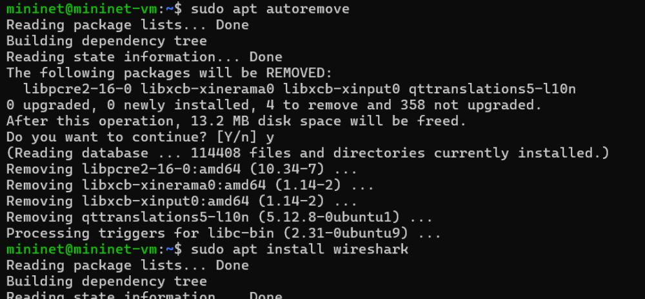

Interact with Hosts and Switches
Start a minimal topology and enter the CLI:
$ sudo mn
The default topology is the minimal topology, which includes one OpenFlow kernel switch connected to two hosts, plus the OpenFlow reference controller.
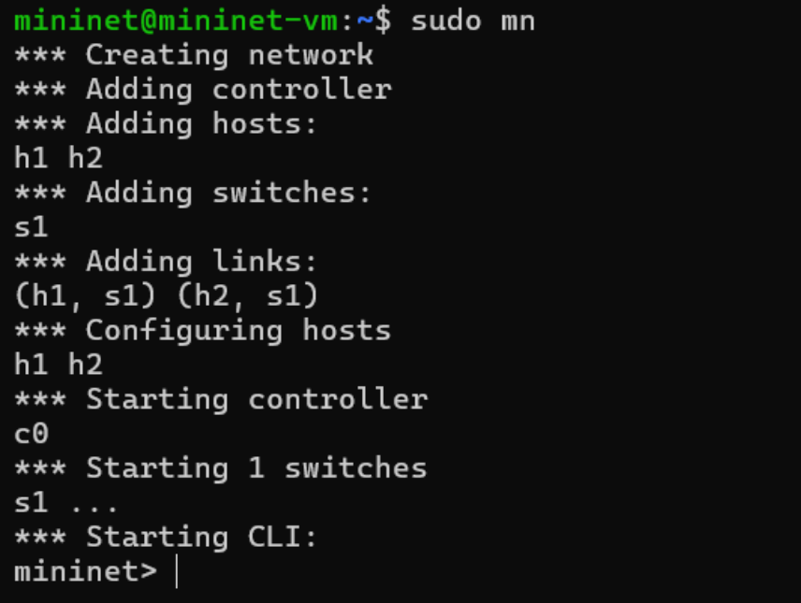
check the network configuration details (including IP addresses, interfaces, and other network-related information) of host h1 in the Mininet network.
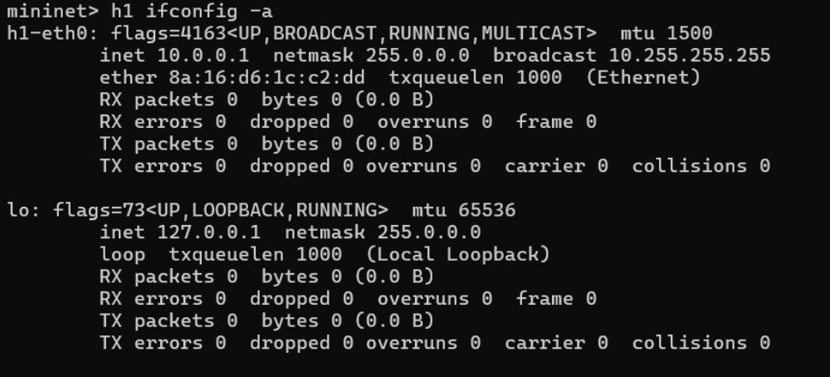

mininet> s1 ifconfig -a
This will show the switch interfaces, plus the VM’s connection out (eth0).
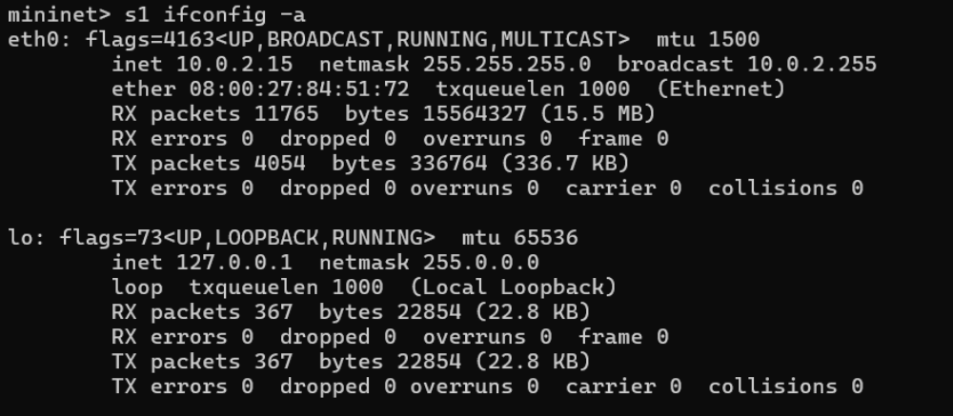
Note that only the network is virtualized; each host process sees the same set of processes and directories. For example, print the process list from a host process:
mininet> h1 ps -a
This should be the exact same as that seen by the root network namespace:
mininet> s1 ps -a
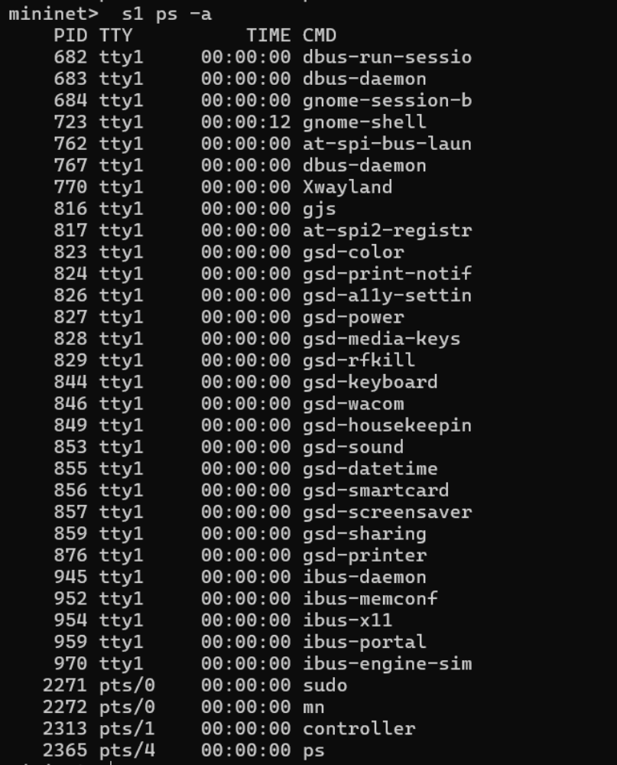
Test connectivity between hosts
Verifying that you can ping from host 0 to host 1:
mininet> h1 ping -c 1 h2
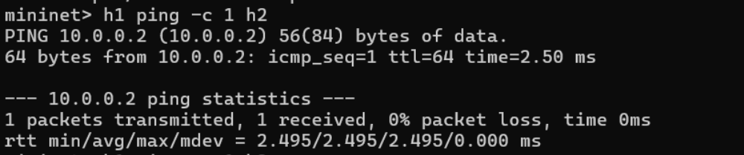
An easier way to run this test is to use the Mininet CLI built-in pingall command, which does an all-pairs ping:
mininet> pingall
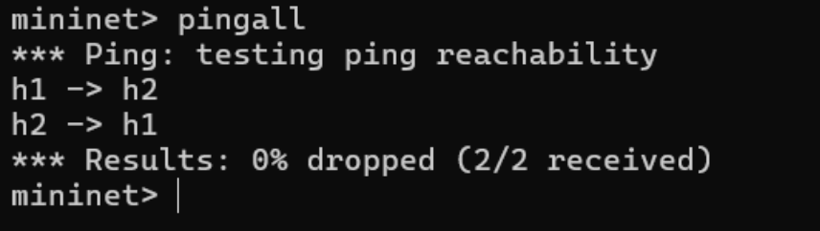
Run a simple web server and client
Mininet hosts can run any command or application that is available to the underlying Linux system (or VM) and its file system. You can also enter any bash command, including job control (&, jobs, kill, etc..) Here we are starting a simple HTTP server on h1, making a request from h2, then shutting down the web server:
mininet> h1 python -m http.server 80 &
mininet> h2 wget -O - h1
mininet> h1 kill %python
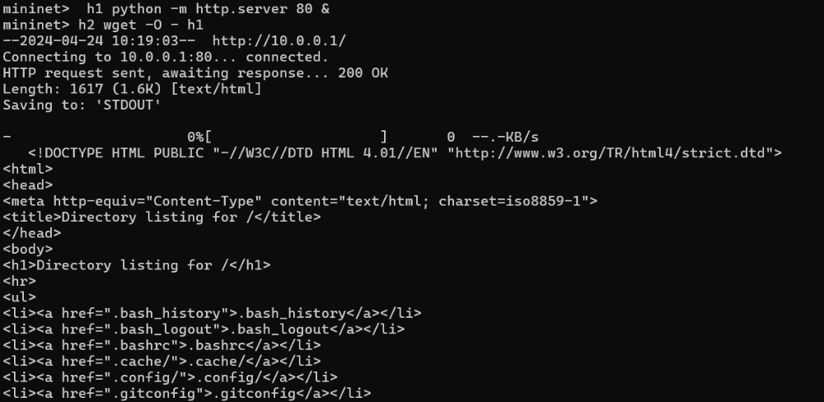
Part 2: Advanced Startup Options
Run a Regression Test
Mininet can also be used to run self-contained regression tests.
Run a regression test:
$ sudo mn --test pingpair
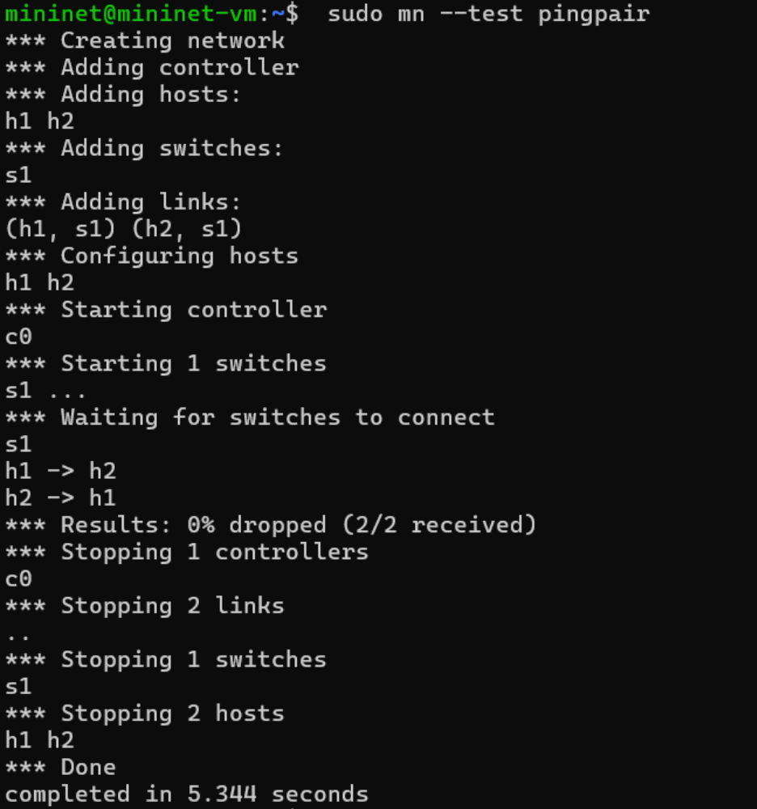
This command created a minimal topology, started up the OpenFlow reference controller, ran an all-pairs-ping test, and tore down both the topology and the controller.
Changing Topology Size and Type
The default topology is a single switch connected to two hosts. You could change this to a different topo with --topo, and pass parameters for that topology’s creation. For example, to verify all-pairs ping connectivity with one switch and three hosts:

Run a regression test :
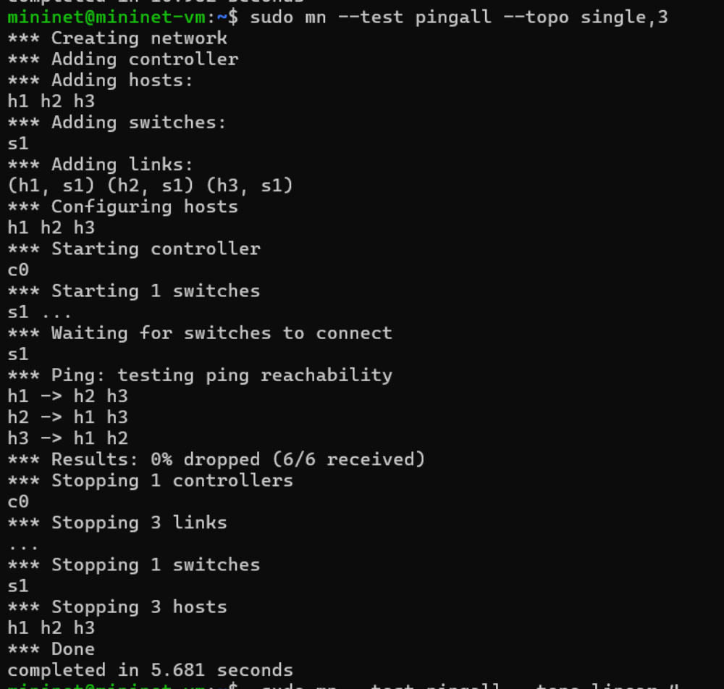
Link variations
Mininet 2.0 allows you to set link parameters, and these can even be set automatially from the command line:
$ sudo mn --link tc,bw=10,delay=10ms mininet> iperf
...
mininet> h1 ping -c10 h2
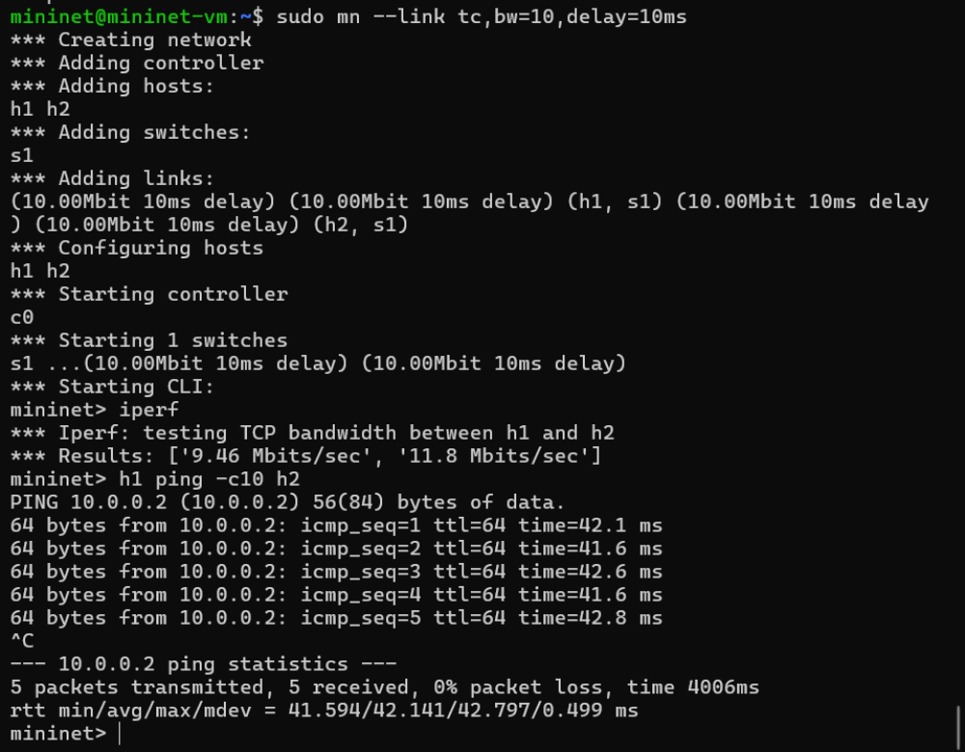
Adjustable Verbosity
The default verbosity level is info, which prints what Mininet is doing during startup and teardown. Compare this with the full debug output with the -v param:
$ sudo mn -v debug
...
mininet> exit
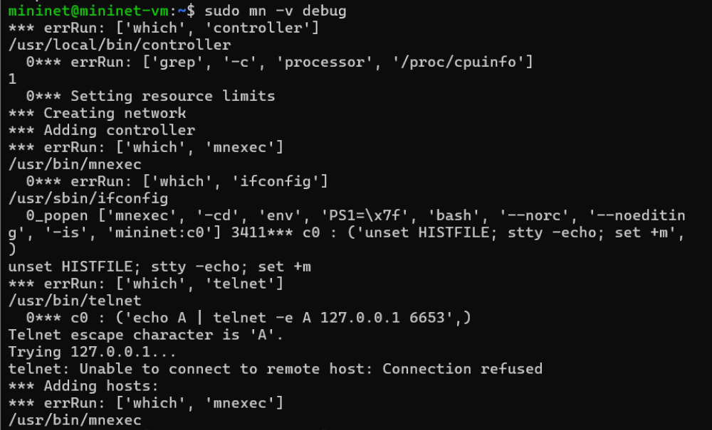
Custom Topologies
Custom topologies can be easily defined as well, using a simple Python API, and an example is provided in custom/topo-2sw-2host.py. This example connects two switches directly, with a single host off each switch:
simple topology example (topo-2sw-2host.py)
1 """Custom topology example
2
3 Two directly connected switches plus a host for each switch:
4
5 host --- switch --- switch --- host
6
- Adding the 'topos' dict with a key/value pair to generate our newly defined
- topology enables one to pass in '--topo=mytopo' from the command line.

9 """
10
11from mininet.topo import Topo
12
13class MyTopo( Topo ):
14 "Simple topology example."
15
16 def build( self ):
17 "Create custom topo."

18
19 # Add hosts and switches
20 leftHost = self.addHost( 'h1' )
21 rightHost = self.addHost( 'h2' )
22 leftSwitch = self.addSwitch( 's3' )
23 rightSwitch = self.addSwitch( 's4' )

24
25 # Add links
26 self.addLink( leftHost, leftSwitch )
27 self.addLink( leftSwitch, rightSwitch )
28 self.addLink( rightSwitch, rightHost )

29
30
31topos = { 'mytopo': ( lambda: MyTopo() ) }
When a custom mininet file is provided, it can add new topologies, switch types, and tests to the command-line. For example:
$ sudo mn --custom ~/mininet/custom/topo-2sw-2host.py --topo mytopo --test pingall
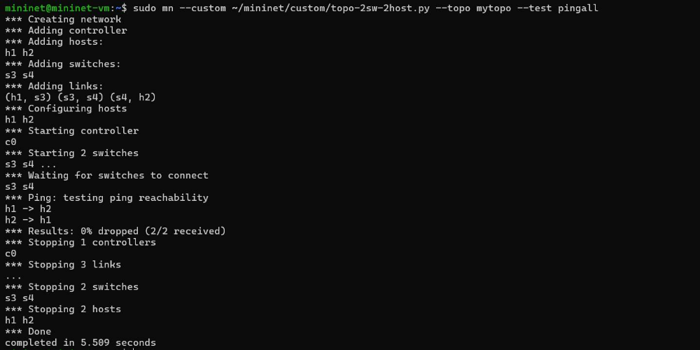
ID = MAC
By default, hosts start with randomly assigned MAC addresses. This can make debugging tough, because every time the Mininet is created, the MACs change, so correlating control traffic with specific hosts is tough.
The --mac option is super-useful, and sets the host MAC and IP addrs to small, unique, easy- to-read IDs.
Before:
$ sudo mn
...
mininet> h1 ifconfig
h1-eth0 Link encap:Ethernet HWaddr f6:9d:5a:7f:41:42
inet addr:10.0.0.1 Bcast:10.255.255.255 Mask:255.0.0.0
UP BROADCAST RUNNING MULTICAST MTU:1500 Metric:1
RX packets:6 errors:0 dropped:0 overruns:0 frame:0 TX packets:6 errors:0 dropped:0 overruns:0 carrier:0 collisions:0 txqueuelen:1000
RX bytes:392 (392.0 B) TX bytes:392 (392.0 B)
mininet> exit
After:
$ sudo mn --mac
...
mininet> h1 ifconfig
h1-eth0 Link encap:Ethernet HWaddr 00:00:00:00:00:01
inet addr:10.0.0.1 Bcast:10.255.255.255 Mask:255.0.0.0
UP BROADCAST RUNNING MULTICAST MTU:1500 Metric:1
RX packets:0 errors:0 dropped:0 overruns:0 frame:0 TX packets:0 errors:0 dropped:0 overruns:0 carrier:0 collisions:0 txqueuelen:1000
RX bytes:0 (0.0 B) TX bytes:0 (0.0 B)
mininet> exit
XTerm Display
For more complex debugging, you can start Mininet so that it spawns one or more xterms. To start an xterm for every host and switch, pass the -x option:
$ sudo mn -x
Other Switch Types
Other switch types can be used. For example, to run the user-space switch:
$ sudo mn --switch user --test iperf
Note the much lower TCP iperf-reported bandwidth compared to that seen earlier with the kernel switch.
If you do the ping test shown earlier, you should notice a much higher delay, since now packets must endure additional kernel-to-user-space transitions. The ping time will be more variable, as the user-space process representing the host may be scheduled in and out by the OS.
On the other hand, the user-space switch can be a great starting point for implementing new functionality, especially where software performance is not critical.
Another example switch type is Open vSwitch (OVS), which comes preinstalled on the Mininet VM. The iperf-reported TCP bandwidth should be similar to the OpenFlow kernel module, and possibly faster:
$ sudo mn --switch ovsk --test iperf
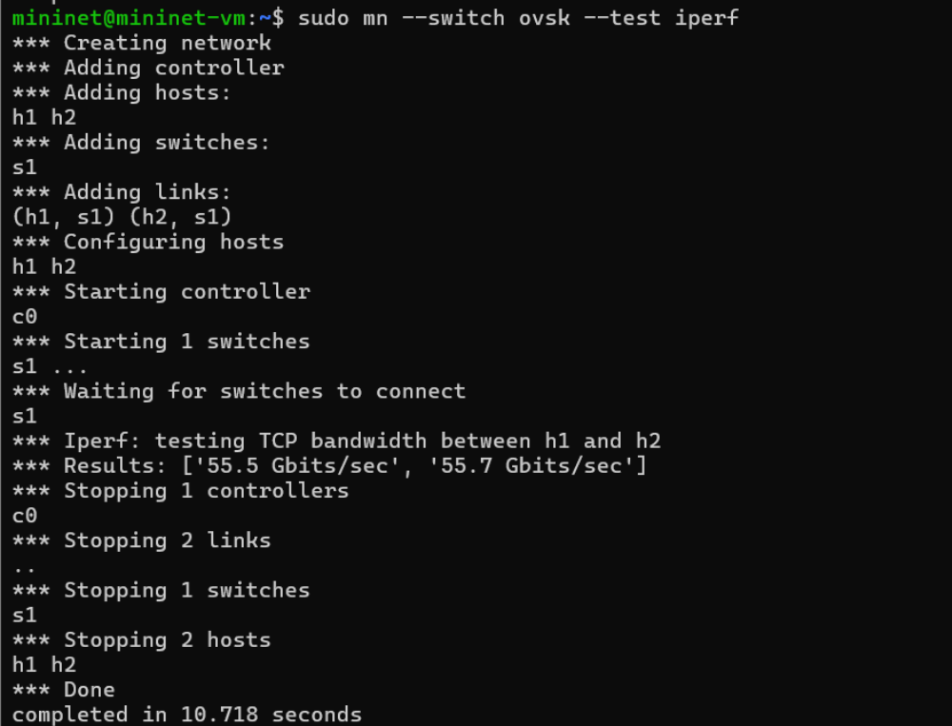

Part 3: Mininet Command-Line Interface (CLI) Commands Display Options
Python Interpreter
If the first phrase on the Mininiet command line is py, then that command is executed with Python. This might be useful for extending Mininet, as well as probing its inner workings. Each host, switch, and controller has an associated Node object.
At the Mininet CLI, run:
mininet> py 'hello ' + 'world'
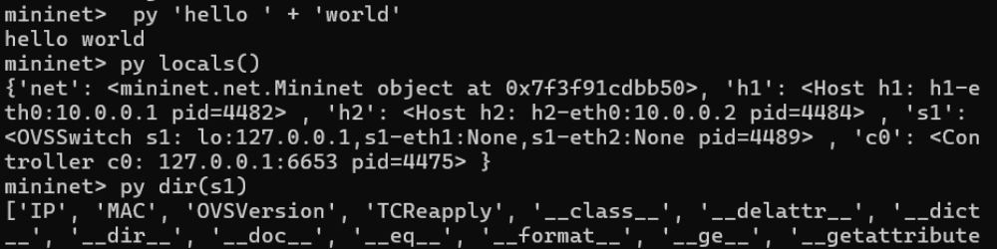
You can also evaluate methods of variables:
mininet> py h1.IP()
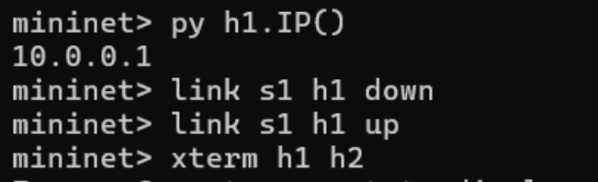
Part 4: Python API Examples
The examples directory in the Mininet source tree includes examples of how to use Mininet’s Python API, as well as potentially useful code that has not been integrated into the main code base.
SSH daemon per host
One example that may be particularly useful runs an SSH daemon on every host:
$ sudo ~/mininet/examples/sshd.py
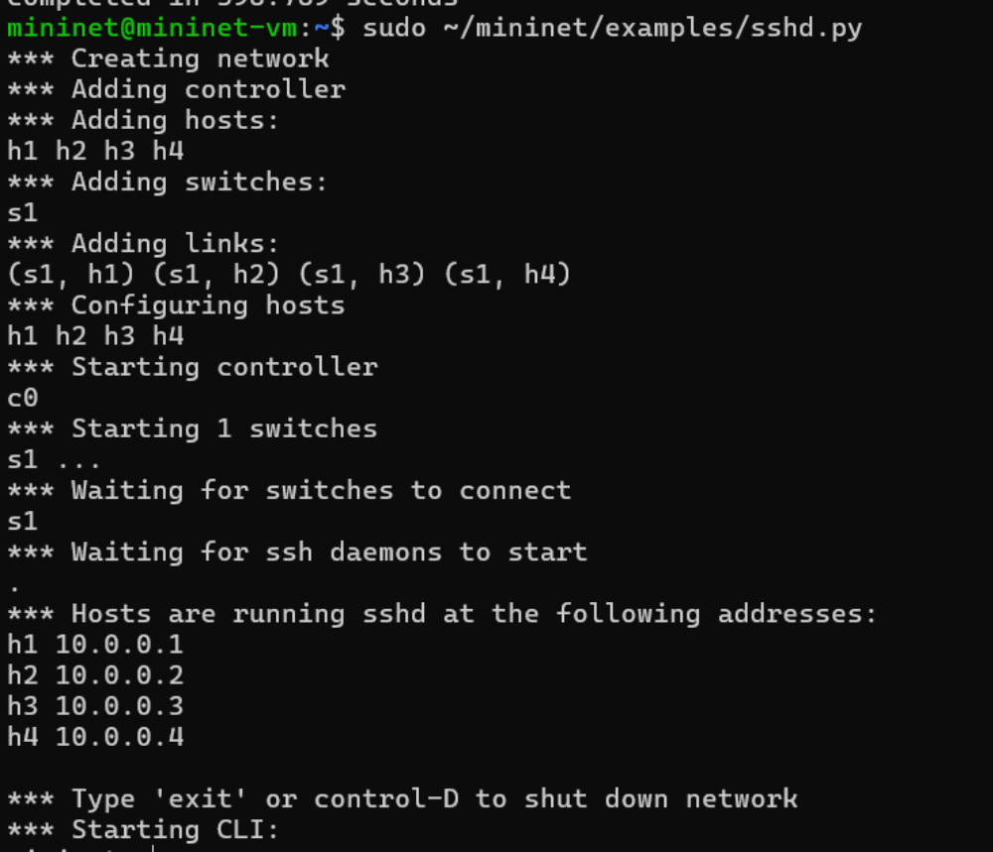
From another terminal, you can ssh into any host and run interactive commands:
$ ssh 10.0.0.1
$ ping 10.0.0.2
...
$ exit
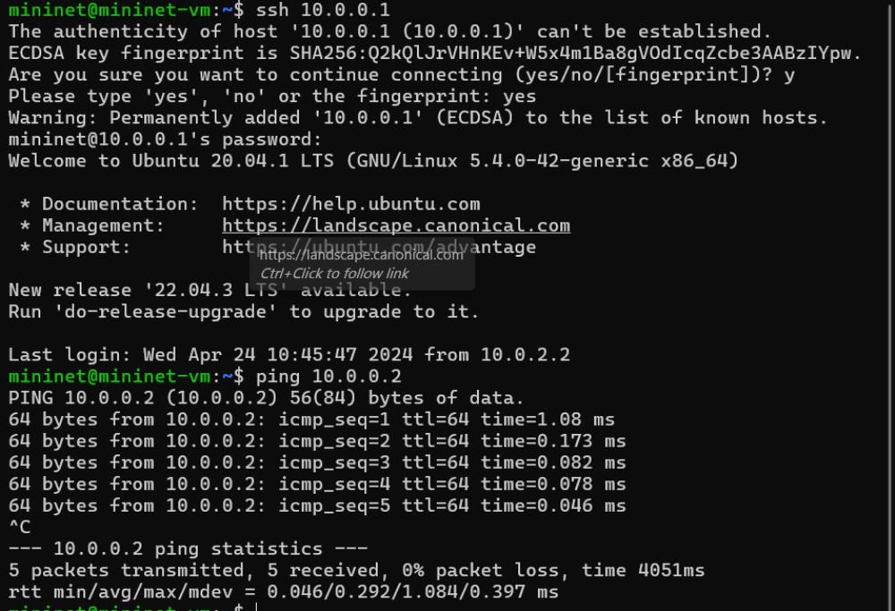
Mininet Walkthrough complete.
Conclusion:
In this experiment, we learnt how to set up a virtual network using mininet to implement Software Defined Networking (SDN), through the walkthrough tutorial on mininet’s website.
We installed mininet as a VM on our machine, which was preconfigured to contain all packages and permission required to use it. Using mininet,we made virtual networks with different topologies, ran python code inside of mininet and used the mininet python API, and learnt about many mininet features and commands.

