**CYCLE 6 – Forest Fire Detection Using Deep Learning**

**Week-1 Assignment**

**1)What is Deep Learning?**

Deep learning is a branch of machine learning which mimics the human brain and also that focuses on teaching computers to learn and make decisions like humans by using artificial neural networks. These networks are inspired by the way the human brain works and are made up of layers of interconnected nodes (also called neurons). The "deep" in deep learning refers to the use of many layers in these networks, which allows the model to learn complex patterns and features from large amounts of data.

Unlike traditional machine learning, which often needs a lot of manual feature extraction and domain knowledge, deep learning models can automatically learn the best features from raw data. This makes deep learning especially powerful for tasks like image recognition, speech processing, natural language understanding, and even playing games.

Some popular deep learning frameworks include TensorFlow, PyTorch, and Keras. These tools make it easier for developers and researchers to build, train, and test deep learning models.

In today’s world, deep learning is behind many technologies we use every day, such as voice assistants, facial recognition, self-driving cars, and recommendation systems on platforms like YouTube and Netflix. As the amount of data grows and computing power improves, deep learning continues to evolve and open up new possibilities in artificial intelligence.

**2)What is Neural Network and its Types?**

Neural Network consists of layers of interconnected nodes, or neurons, that collaborate to process input data. In a fully connected deep neural network, data flows through multiple layers, where each neuron performs nonlinear transformations, allowing the model to learn intricate representations of the data.

In a deep neural network, the input layer receives data, which passes through hidden layers that transform the data using nonlinear functions. The final output layer generates the model’s prediction.

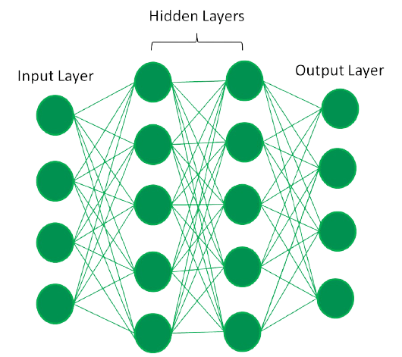

**Evolution of Neural Architectures**

The journey of deep learning began with the perceptron, a single-layer neural network introduced in the 1950s. While innovative, perceptrons could only solve linearly separable problems, failing at more complex tasks like the XOR problem.

This limitation led to the development of Multi-Layer Perceptrons(MLPs). It introduced hidden layers and non-linear activation functions. MLPs, trained using backpropogation, could model complex, non-linear relationships, marking a significant leap in neural network capabilities.

This evolution from perceptrons to MLPs laid the groundwork for advanced architectures like CNNs and RNNs, showcasing the power of layered structures in solving real-world problems.

**Types of neural networks**

**1.**[**Feedforward neural networks (FNNs)**](https://www.geeksforgeeks.org/understanding-multi-layer-feed-forward-networks/) are the simplest type of **ANN**, where data flows in one direction from input to output. It is used for basic tasks like classification.

**2.**[**Convolutional Neural Networks (CNNs)**](https://www.geeksforgeeks.org/introduction-convolution-neural-network/) are specialized for processing grid-like data, such as images. CNNs use convolutional layers to detect spatial hierarchies, making them ideal for computer vision tasks.

**3.**[**Recurrent Neural Networks (RNNs)**](https://www.geeksforgeeks.org/recurrent-neural-networks-explanation/)are able to process sequential data, such as time series and natural language. RNNs have loops to retain information over time, enabling applications like language modeling and speech recognition. Variants like LSTMs and GRUs address vanishing gradient issues.

**4.**[**Generative Adversarial Networks (GANs)**](https://www.geeksforgeeks.org/generative-adversarial-network-gan/) consist of two networks—a generator and a discriminator—that compete to create realistic data. GANs are widely used for image generation, style transfer, and data augmentation.

**5.**[**Autoencoders**](https://www.geeksforgeeks.org/auto-encoders/) are unsupervised networks that learn efficient data encodings. They compress input data into a latent representation and reconstruct it, useful for dimensionality reduction and anomaly detection.

**6.**[**Transformer Networks**](https://www.geeksforgeeks.org/getting-started-with-transformers/) has revolutionized NLP with self-attention mechanisms. Transformers excel at tasks like translation, text generation, and sentiment analysis, powering models like GPT and BERT.

**3)What is CNN in Simple words?**

A **Convolutional Neural Network (CNN)** is a type of deep learning model that is especially good at understanding images. It helps computers recognize patterns like edges, colors, shapes, or even faces in pictures.

Imagine how our eyes and brain work together to understand what we see — CNNs try to do something similar. They look at small parts of an image first (like a corner or a curve), and then combine that information to understand the whole picture.

CNNs are widely used in tasks like:

* Detecting objects in photos (e.g., finding a cat or car)
* Facial recognition
* Handwriting recognition
* Medical image analysis (like X-rays or MRI scans)

In simple terms, CNNs allow machines to “see” and make sense of images the way humans do, but using mathematics and layers of filters.

**4)Pipeline of the project?**

1. **Data Collection & Data Loading**

* The Data collection can be done from the Kaggle.com and there is no requirement of downloading the dataset we can use the api which acts between the server and client.
* The model has to be trained(helps for validation) with the dataset by using CNN if it is completed then it undergoes Testing for Evaluation.
* Our trained data has two classes that is, fire and nofire which comes under Binary image Classification where three or more classes comes under Multi image classification.
* Dataset should have trained data, test data, val which again divided in to cat1 & cat2.

1. **Image Processing & Image Augmentation**
2. **Build CNN🡪TensorFlow**
3. **Test Evvaluate.**