Dharshini V | PES1UG24AM428 | Lab 3
LAB 3 – COMPONENT MODELLING & ARCHITECTURE
Digital Campus Library Reservation Gateway
Student Name | Dharshini V | SRN | PES1UG24AM428

Component Diagram
Figure 1. Digital Campus Library Reservation Gateway – Layered Architecture UML Component Diagram
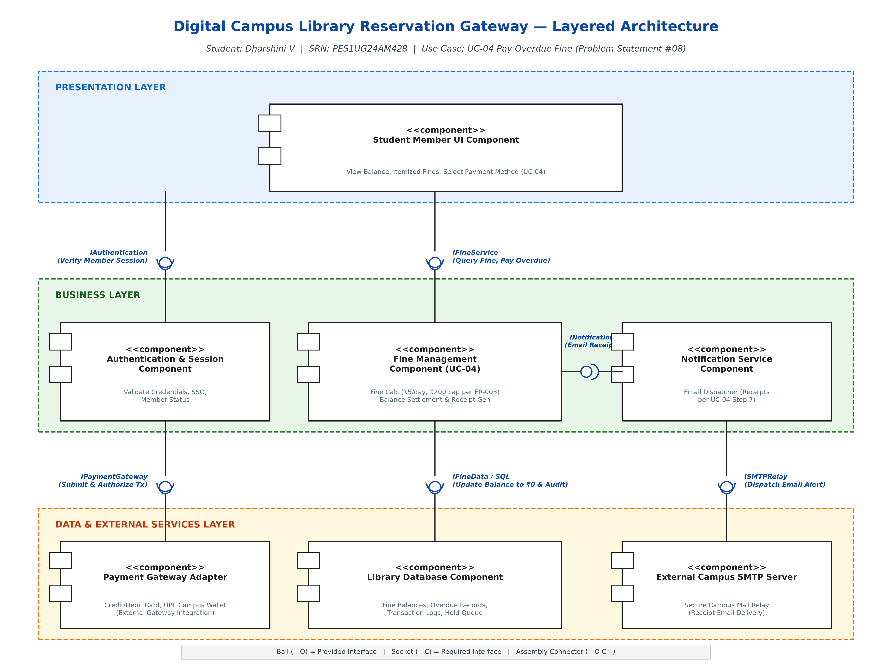

Architecture Selection
We chose Layered Architecture for the Digital Campus Library Reservation Gateway.
Architectural Choice:
A strict three-tier Layered Architecture organizing the system into Presentation, Business, and Data/External Services layers. The Student Member UI resides in the Presentation Layer; the Authentication & Session Component, Fine Management Component (UC-04), and Notification Service Component operate in the Business Layer; and the Payment Gateway Adapter, Library Database, and External Campus SMTP Server form the Data and External Services Layer. Each layer communicates strictly through well-defined provided (ball) and required (socket) interfaces.
Reason 1 (Separation of Concerns):
The workflow for UC-04 (Pay Overdue Fine) cleanly bifurcates into user interaction, business calculation rules, and payment/persistence mechanics. The Presentation layer handles member account navigation and payment selection without embedding fine calculation logic. The Fine Management Component strictly enforces the business rules (calculating ₹5/day overdue capped at ₹200 per FR-003, verifying authorization, zeroing balance). Separating these responsibilities ensures each component remains highly cohesive, testable, and maintainable.
Reason 2 (Modifiability & Service Independence):
The campus library system must interface with external financial systems (Credit Card, UPI, Campus Wallet) and email gateways. Isolating these integrations behind the IPaymentGateway and ISMTPRelay interfaces allows third-party payment vendor changes or email server updates to occur without modifying the core Fine Management business logic or the student user interface.
Security Advantage:
The Student Member UI never directly communicates with the Library Database or external financial payment gateways. All requests are mediated by the Business layer, where the Authentication component validates member credentials and session tokens before any financial action is initiated. Furthermore, payment secrets, API tokens, and database credentials remain confined within the server-side Data/External layer, mitigating SQL injection and transaction spoofing risks.
Performance Benefit:
Fine calculations (days overdue × rate, capped at ₹200) are evaluated in-memory with near-zero latency, and the database queries are optimized via indexed member and book IDs. In addition, receipt generation and dispatch are handled asynchronously through the Notification Service, preventing payment confirmation latency from blocking student UI interactions during peak campus hours.
Submission Package:
This submission package contains the complete architectural justification and final UML component diagram. The editable Draw.io model is provided as Digital_Campus_Library_Component_Diagram.drawio, along with high-resolution PNG and SVG diagram exports.

