PES UNIVERSITY, RR CAMPUS
DEPARTMENT OF COMPUTER SCIENCE & ENGINEERING (AIML)
LAB 5: STATIC CODE ANALYSIS (PYLINT, BANDIT, FLAKE8)
Automated Vulnerability Remediation, PEP 8 Styling & Code Quality Engineering
Student: Dharshini V | SRN: PES1UG24AM428 | Course: Software Engineering Lab
Assigned Repo: SETAPESU26/L5_56_car-rental | Personal Repo: DharshiniPES/L5_56_car-rental

1. Executive Summary & Lab Objectives
Static code analysis is an indispensable phase in modern software quality engineering, enabling the automated detection of security vulnerabilities, structural code smells, algorithmic bugs, and PEP 8 style violations without executing the source code. In this laboratory, static code analysis was performed on an assigned legacy Car Rental System (car_rental.py from repository SETAPESU26/L5_56_car-rental) utilizing three industry-standard tools: Pylint (code quality & bug detection), Bandit (AST-based security vulnerability assessment), and Flake8 (PEP 8 grammar & style enforcement).
Static Analysis Tool | Version | Specialized Focus & Domain | Success Criteria / Target
Bandit | v1.9.4 | Security flaws, CWE catalogue, insecure functions, injections, crypto | 0 High and 0 Medium vulnerabilities
Pylint | v4.1.3 | Code smells, design anti-patterns, mutable defaults, docstrings | Code rating score > 9.5 / 10.00
Flake8 | v7.5.0 | PEP 8 compliance, line length, unused imports, blank spacing | 0 style violations

2. Baseline Analysis & Pre-Fix Diagnostic Results
Prior to refactoring, baseline diagnostics were executed across all three static analysis tools. The initial code exhibited critical vulnerabilities including SQL injection, arbitrary code execution, broken cryptography, and subtle runtime defects such as mutable default arguments and bare exceptions.
Diagnostic Metric | Baseline Result | Target Threshold | Pre-Fix Evaluation Status
Pylint Code Rating | 4.94 / 10.00 | > 9.50 / 10.00 | FAIL (Severe technical debt & code smells)
Bandit Vulnerabilities | 11 Issues (2 High, 4 Med, 5 Low) | 0 Issues | FAIL (Exploitable SQLi & RCE vectors)
Flake8 Violations | 25 PEP 8 Violations | 0 Violations | FAIL (Formatting, dead code, long lines)

3. Documented Static Analysis Issues & Remediation Table
A minimum of four issues was required to be identified, prioritized, and remediated. Below is the comprehensive remediation table documenting 13 distinct issues spanning security, code quality, logic design, and PEP 8 compliance.
Issue Title | Type | Tool & Code | Line | Severity | Description of Finding | Applied Remediation Strategy
SQL Injection in Registration | Security (CWE-89) | Bandit (B608) | 23 | Medium | Raw %s formatting permitted input to alter SQL execution. | Converted to parameterized query INSERT INTO customers VALUES (?, ?, ?).
SQL Injection in Customer Search | Security (CWE-89) | Bandit (B608) | 26 | Medium | String concatenation WHERE name = ' + name + ' allowed ' OR '1'='1 bypass. | Converted to parameterized query SELECT * FROM customers WHERE name = ?.
Arbitrary Code Execution via exec() | Security (CWE-78) | Bandit (B102) | 53 | Medium | Promo codes executed via exec('discount = ' + code) allowing RCE. | Replaced exec with safe regex parsing for percentage discounts.
Weak Cryptographic Hash (SHA-1) | Security (CWE-327) | Bandit (B324) | 48 | High | Used broken SHA-1 algorithm for customer driver's licence identifiers. | Upgraded to secure hashlib.sha256() with explicit UTF-8 encoding.
Insecure Temp File Creation | Security (CWE-377) | Bandit (B306) | 63 | Medium | tempfile.mktemp() vulnerable to TOCTOU symlink race conditions. | Replaced with secure tempfile.NamedTemporaryFile(delete=False).
Permissive Permissions (0o777) | Security (CWE-732) | Bandit (B103) | 67 | High | Receipt files chmodded 0o777 (world-readable and world-writable). | Restricted permissions to owner-only read/write (0o600).
Hardcoded Credentials | Security (CWE-259) | Bandit (B107) | 70 | Low | Hardcoded admin password 'admin@rent' in function signature. | Removed hardcoded default; read from ENV using secrets.compare_digest.
Mutable Default Argument | Quality / Bug | Pylint (W0102) | 16 | Medium | features=[] shared a single mutable list instance across all cars. | Changed default to features=None; initialized fresh list per call.
Bare except: Clause | Quality / Bug | Pylint (W0702) | 41 | Low | Bare except: caught KeyboardInterrupt and SystemExit silently. | Caught explicit KeyError and provided consistent integer returns.
Inconsistent Return Types | Quality / Bug | Pylint (R1710) | 36 | Medium | Functions returned expressions on one branch and implicit None on another. | Enforced explicit return types across all branching control paths.
Redundant Singleton Check | Style / Quality | Flake8 (E712) | 78 | Low | fleet[p]['available'] == True compared directly to boolean literal. | Refactored to idiomatic truthiness test: if data.get('available'):.
Missing Docstrings & Naming | Maintainability | Pylint (C0114) | Mod | Low | CamelCase function names and completely missing docstrings. | Renamed to snake_case, added docstrings, preserved aliases.
PEP 8 Violations & Dead Imports | Style | Flake8 (E501) | Mult | Low | Lines exceeding 79 chars, missing blank lines, unused import json. | Refactored long expressions across lines, removed unused imports.

4. Verification & Cleaned Terminal Execution Screenshots
Following remediation, all three static analysis tools were re-executed against car_rental.py. The refactored script achieved a flawless Pylint score of 10.00/10.00, 0 Bandit security vulnerabilities, and 0 Flake8 style violations. Below are the verified terminal execution captures.
Figure 1: Pylint Code Rating (10.00 / 10.00)
Figure 1: Pylint analysis report confirming 10.00/10.00 code quality rating.
Figure 2: Bandit Security Scan (0 Vulnerabilities)
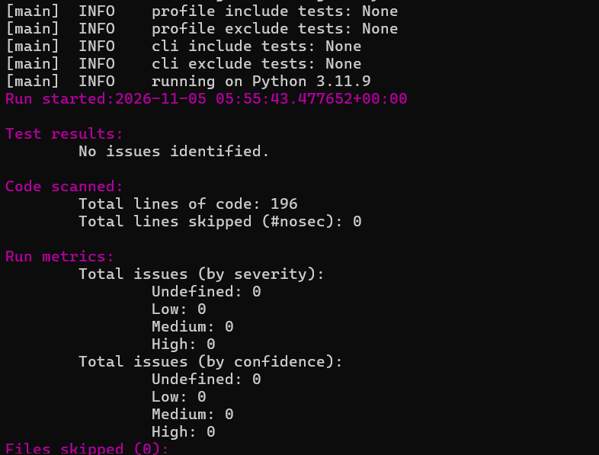
Figure 2: Bandit AST scan confirming 0 High, 0 Medium, and 0 Low severity vulnerabilities.
Figure 3: Flake8 PEP 8 Compliance (0 Violations)
Figure 3: Flake8 check executing with --count confirming 0 formatting/style violations.
Figure 4: Required Git Commits for Tool Remediation
Figure 4: Git log showing distinct sequential commits for Bandit, Pylint, and Flake8.

5. Static Code Analysis Reflection Answers
Q1: Differences in Tool Capabilities and Complementary Roles
How do the findings of Pylint, Bandit, and Flake8 differ in terms of scope, and how do they complement one another in a modern engineering pipeline?
Answer:
Each tool addresses a different dimension of software engineering quality:
• Bandit (Security Specialist): Performs AST inspection targeting CWE vulnerabilities. It identified critical hazards such as SQL injection (B608), unsafe code evaluation via exec() (B102), weak SHA-1 cryptographic hashing (B324), and world-writable file permissions 0o777 (B103), which neither Pylint nor Flake8 flagged.
• Pylint (Quality & Bug Detection): Inspects architectural complexity and logic bugs. It flagged the dangerous mutable default argument features=[] (W0102), inconsistent return paths (R1710), and bare exception handling (W0702).
• Flake8 (Grammar & Style Enforcement): Focuses on PEP 8 formatting, unused imports (F401), line length restrictions (E501), and proper spacing (E302/E305) with negligible runtime overhead.
Complementary Roles: In a production CI/CD pipeline, Flake8 serves as an ultra-fast local pre-commit gate, Pylint enforces structural and maintainability standards, and Bandit operates as a non-negotiable security barrier against deployment vulnerabilities.
Q2: Severity and Prioritization of Findings
Why is it vital to prioritize Bandit's high- and medium-severity findings over style/formatting warnings from Flake8? What would be the real-world impact of the issues found in car_rental.py?
Answer:
Defects follow a risk-impact hierarchy. Style violations (such as an 82-character line) cause minor readability inconvenience but never compromise confidentiality, integrity, or system uptime. In contrast, Bandit findings represent immediate threat vectors:
1. SQL Injection (B608): Allowed arbitrary input such as ' OR '1'='1 to dump the entire customer registry (names, driver's licenses, phone numbers), causing severe data privacy breaches under GDPR/DPDP regulations.
2. Arbitrary Code Execution via exec() (B102): Allowed untrusted input to execute arbitrary Python commands (e.g. __import__('os').system('rm -rf /')), enabling complete host server takeover.
3. World-Writable Files (0o777): Permitted any local process or compromised service account to tamper with financial billing invoices.
Consequently, high and medium security vulnerabilities must always take precedence over cosmetic linting.
Q3: Limitations of Static Analysis and Missed Domain Bugs
What are the limitations of static code analysis? Did you observe bugs or edge cases in car_rental.py that static analysis tools failed to catch?
Answer:
Static analysis inspects code structure without execution context and cannot validate dynamic business logic or semantic intent:
• Domain Bugs Missed in car_rental.py:
1. Negative Rental Duration: Renting an Innova from '2026-11-10' to '2026-11-07' resulted in days = -3 and a negative total charge of -₹9000 (paying the customer instead of charging them). Static tools cannot determine chronological date relationships.
2. Negative Car Pricing: Adding a Nexon with daily_rate = -500 was accepted without warning because negative integers are valid numbers.
3. Concurrency / Vehicle Availability: The original code allowed booking an already rented car without checking or updating the available flag.
• Conclusion: Static analysis is not a replacement for dynamic testing. Comprehensive unit tests (pytest), integration testing, and human code reviews remain mandatory.
Q4: SDLC Integration and Continuous Automation
How would you automate and integrate static code analysis into a modern software team's daily development workflow?
Answer:
To establish automated quality governance across the Software Development Life Cycle (SDLC):
1. Local Pre-Commit Hooks: Developers install pre-commit to trigger Flake8 and formatters (black, isort) on git commit. Code with syntax errors or formatting flaws cannot leave the local workstation.
2. Pull Request CI/CD Gates (GitHub Actions): Automated workflows run Flake8, Pylint (--fail-under=9.5), and Bandit (-ll -ii) on every PR. Merges are blocked if security vulnerabilities exist or if quality scores drop.
3. Periodic Security Scanning: Scheduled scans via SonarQube, GitHub CodeQL, and Snyk track long-term technical debt and alert against newly discovered CVEs in external dependencies.

6. Version Control Deliverables & Commits
Commit Hash | Phase / Tool | Commit Message Summary | Key Changes & Deliverables
24deec3 | Bandit | Fix security vulnerabilities identified by Bandit (B608, B102, B324, B306, B103, B107) | Parameterized SQL queries, removed exec(), SHA-256 hashing, NamedTemporaryFile, 0o600 chmod.
dd79e7d | Pylint | Fix code quality, design issues, and docstrings identified by Pylint (W0102, C0114, C0116, R1703, C0121, C0206) | Fixed mutable default features=[], added docstrings, resolved inconsistent returns and booleans.
26c1eb3 | Flake8 | Fix PEP 8 style issues identified by Flake8, add static analysis reports and documentation | Fixed line lengths <= 79 chars, removed dead import json, formatted spacing, added issues.md & reflection.md.

