Dhruv Talavat
PES1UG24AM087
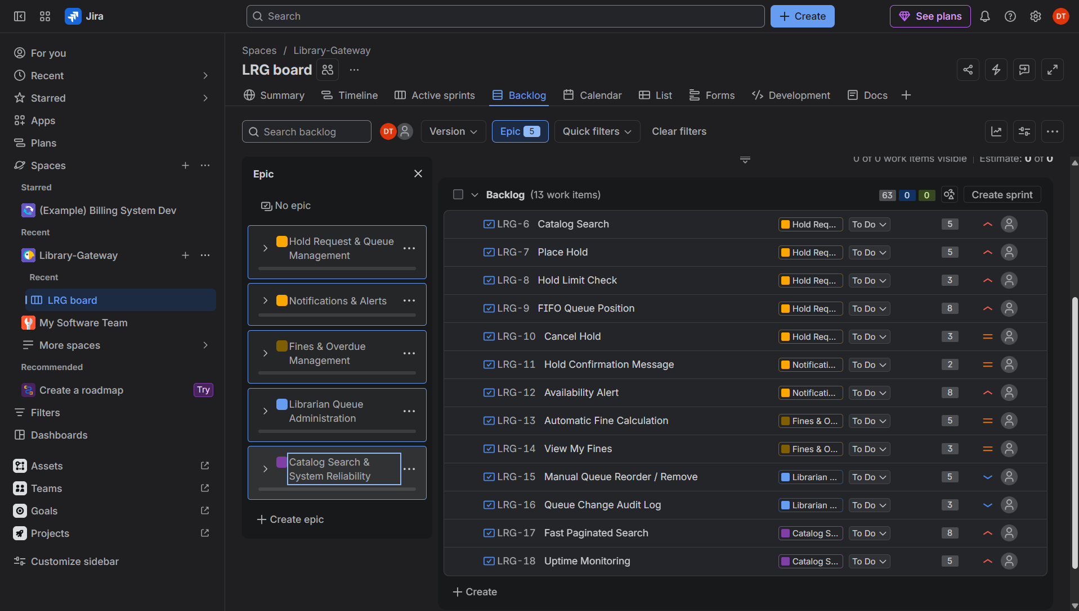

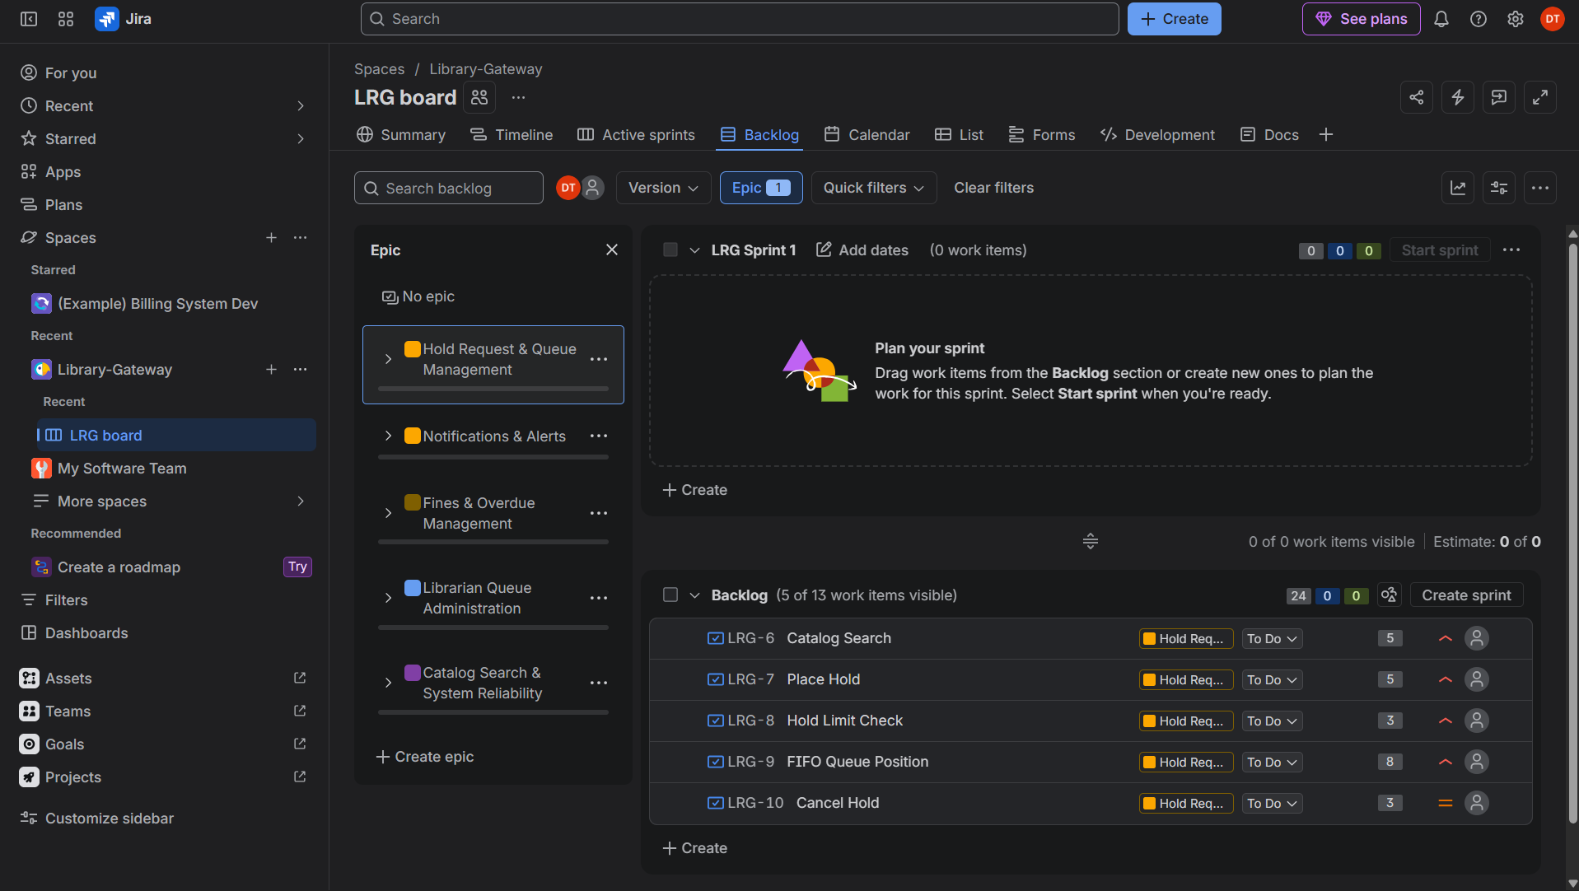

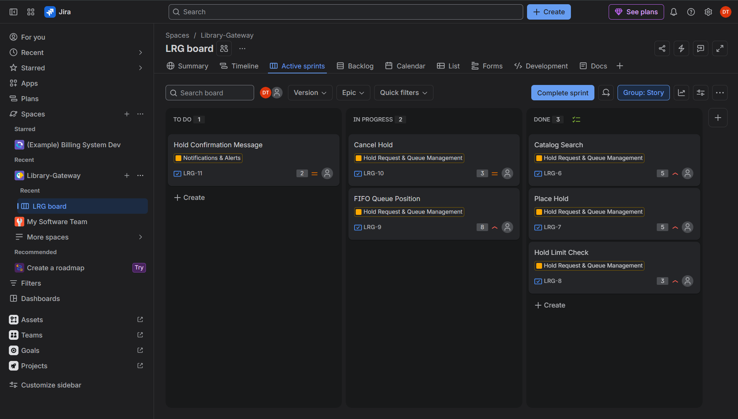

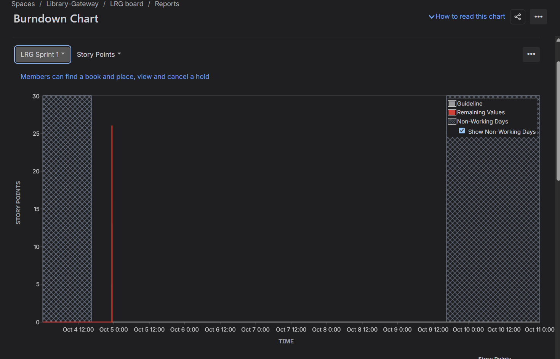

Reflection answers:
1. Did your estimations reflect the actual effort?
For the most part, yes. The small stories, such as Hold Confirmation Message (2 points) and Cancel Hold (3 points), were finished quickly and matched their estimates. The 8-point stories were the least predictable. FIFO Queue Position took the longest in Sprint 1 because of the queue ordering and wait-time logic. Fast Paginated Search was only completed on the last day of Sprint 2, so it was probably under-estimated, since performance targets carry more uncertainty than ordinary features. Next time I would split stories like these, for example into indexing and pagination in one story and benchmarking in another, so each piece can be estimated more accurately.
2. Was your backlog well-prioritized?
Yes, mostly. I put the High-priority stories that deliver the core purpose of the system (catalog search, place hold, hold limits and the FIFO queue) into Sprint 1, so a working end-to-end hold flow existed early. Notifications, fines and search performance depend on that foundation, so they followed in Sprint 2. The Low-priority librarian administration stories (manual queue reorder and the audit log) were kept for last because they only handle rare exceptions. One thing I would change is to move the Availability Alert story earlier, since it is closely tied to the hold queue and is one of the most important features for students.
3. How did your simulated sprint align with your plan?
Sprint 1 matched the plan closely. I committed 26 points across six stories, and all of them moved from To Do to In Progress to Done within the sprint. Sprint 2 was slightly over-committed. I planned 29 points but completed 24, about 83% of the commitment. Story 4.1 (Manual Queue Reorder / Remove, 5 points) was not finished and was returned to the backlog when I completed the sprint. Because it was the lowest-priority story in the sprint, the sprint goal of notifying members, calculating fines and speeding up search was still achieved.
4. What insights did the burndown chart give about your team's capacity?
The chart showed a realistic capacity of about 25 story points per one-week sprint, since I completed 26 in Sprint 1 and 24 in Sprint 2. In Sprint 1 the red line fell steadily toward zero by the end of the sprint. In Sprint 2 the line stayed flat for most of the sprint and dropped sharply near the end, which shows that one large story held up the progress and that 29 points was slightly more than the team could handle. The line finished above zero, which reflects the unfinished 5 points. For a third sprint I would commit to around 25 points, break stories larger than 5 points into smaller ones, and start the riskiest story first so the burndown follows the guideline more closely.

