LINEAR

<___question>

Type=1

<_block>

Two lines are perpendicular. If the gradient of one line is -3, what is the gradient of the other line ?

<_block>

[A] $3$

<_block>

[B] $\frac{1}{3}$

<_block>

[C] $- \frac{1}{3}$

<_block>

[D] $-3$

<_block>

[B]

<___question>

Type=1

<_block>

Which of these lines is perpendicular to *y = 3 – 2x* ?

<_block>

[A] $x+2y-1=0$

<_block>

[B] $2x+y-1=0$

<_block>

[C] $x-2y-1=0$

<_block>

[D] $2x-y-1=0$

<_block>

[C]

<___question>

Type=1

<_block>

If *P(-3, -1) and Q(0, -6),* what is the exact length of *PQ* ?

<_block>

[A] $\sqrt{8 }$ units

<_block>

[B] $\sqrt{17 }$ units

<_block>

[C] $\sqrt{34 }$ units

<_block>

[D] $\sqrt{58 }$ units

<_block>

[C]

<___question>

Type=1

<_block>

Which of these is the equation of the line of q ? 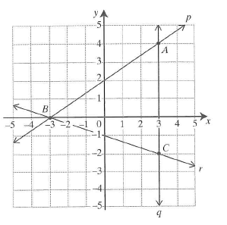

<_block>

[A] $x=3$

<_block>

[B] $y=3$

<_block>

[C] $y=x$

<_block>

[D] $x+y=3$

<_block>

[A]

<___question>

Type=1

<_block>

M(1, 4) is the midpoint of AB, where A(5, 2). What are the co-ordinates of B ?

<_block>

[A] (-4, 0)

<_block>

[B] $(-3, 0)$

<_block>

[C] $(-4, 6)$

<_block>

[D] $(-3, 6)$

<_block>

[D]

<___question>

Type=1

<_block>

Which of these is the area of triangle STV ?

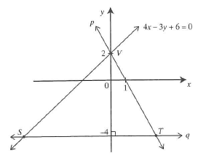

<_block>

[A] $22 \frac{1}{2}$ units²

<_block>

[B] $24 units²$

<_block>

[C] $38 units ²$

<_block>

[D] $30 units²$

<_block>

[A]

<___question>

Type=1

<_block>

Which of these lines has a gradient of 2 and a y-intercept of 3 ?

<_block>

[A] *y = 3x + 2*

<_block>

[B] $2x+y+3=0$

<_block>

[C] $3x+y+2=0$

<_block>

[D] $y=2x+3$

<_block>

[D]

<___question>

Type=1

<_block>

What is the equation of line *m* ?

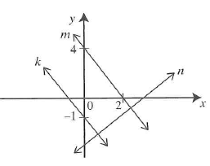

<_block>

[A] $y = -2x + 4$

<_block>

[B] $y = -4x + 2$

<_block>

[C] $y = -4x + 4$

<_block>

[D] $y=-2x-4$

<_block>

[A]

<___question>

Type=1

<_block>

What is the equation of the line passing through the origin with a gradient of -5 ?

<_block>

[A] *y = $-5x$*

<_block>

[B] $y= -5$

<_block>

[C] $x=-5y$

<_block>

[D] $x= -5$

<_block>

[A]

<___question>

Type=1

<_block>

Which of these is the gradient of the line parallel to

*ax + by + c =* *0 ?*

<_block>

[A] $\frac{a}{b}$

<_block>

[B] - $\frac{a}{b}$

<_block>

[C] $\frac{b}{a}$

<_block>

[D] $-\frac{b}{a}$

<_block>

[B]