POLYNOMINALS

<___question>

Type=1

<_block>

If *(x + 3)* is a factor of polynomial *P(x),* what must the value of *P(-3)* ?

<_block>

[A] $0$

<_block>

[B] $-3$

<_block>

[C] $3$

<_block>

[D] $-9$

<_block>

[A]

<___question>

Type=1

<_block>

*P(x)* has a double root at *x = 3* and a single root at *x = -1.* Which of these is a possible polynomial *P(x)* ?

<_block>

[A] $3(x+1)(x-3)$

<_block>

[B] $(x+1)(x-3)²$

<_block>

[C] $(x+1)²(x-3)$

<_block>

[D] $(x-1)(x+3)²$

<_block>

[B]

<___question>

Type=1

<_block>

A polynomial of degree 5 has a double root at *x = 1* and a triple root at *x = -2.* If *P(0)˂0,* which of these is the graph of *y = P(x)* ?

<_block>

[A]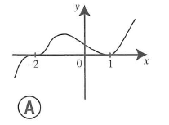

<_block>

[B]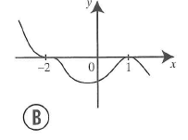

<_block>

[C]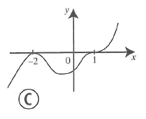

<_block>

[D]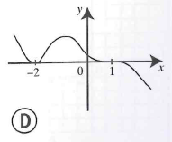

<_block>

[B]

<___question>

Type=1

<_block>

What is the constant term of *P(x)* x *Q(x)* ?

<_block>

[A] $-8$

<_block>

[B] $-2$

<_block>

[C] $2$

<_block>

[D] $5$

<_block>

[B]

<___question>

Type=1

<_block>

Which of these is **not** a factor of 210 ?

<_block>

[A] $3$

<_block>

[B] $4$

<_block>

[C] $5$

<_block>

[D] $7$

<_block>

[B]

<___question>

Type=1

<_block>

Which of these is the graph of *y = x² - 3x* ?

<_block>

[A]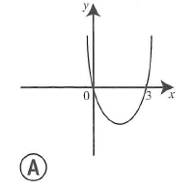

<_block>

[B]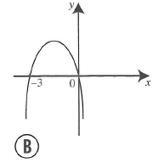

<_block>

[C]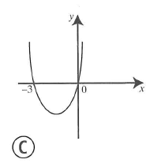

<_block>

[D]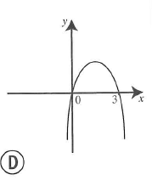

<_block>

[A]

<___question>

Type=1

<_block>

If *P(x) = (x – 3)(x + 2*), which of these is the graph of *y = P(x)* ?

<_block>

[A]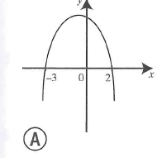

<_block>

[B]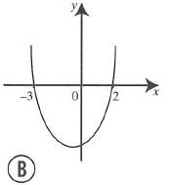

<_block>

[C]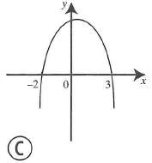

<_block>

[D]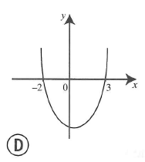

<_block>

[D]

<___question>

Type=1

<_block>

If *x² + x + 2 = (x + 3)(x – 2) + R(x),* which of these is the remainder of *R(x)* ?

<_block>

[A] $-3$

<_block>

[B] $2$

<_block>

[C] $8$

<_block>

[D] $10$

<_block>

[C]

<___question>

Type=1

<_block>

Which of these is the leading term of *3x² - 6x³ - 4x⁵ + 2* ?

<_block>

[A] *3x²*

<_block>

[B] *- 6x³*

<_block>

[C] $- 4x⁵$

<_block>

[D] $2$

<_block>

[C]

<___question>

Type=1

<_block>

Which of these is the remainder when 420 is divided by 19

<_block>

[A] $2$

<_block>

[B] $10$

<_block>

[C] $11$

<_block>

[D] $22$

<_block>

[A]