PROBABILITY

<___question>

Type=1

<_block>

Two balls are chosen from a bag containing four red balls, three green balls and a white ball. What is the probability of two red balls ?

<_block>

[A] $\frac{1}{16}$

<_block>

[B] $\frac{3}{14}$

<_block>

[C] $\frac{1}{4}$

<_block>

[D] $\frac{2}{7}$

<_block>

[B]

<___question>

Type=1

<_block>

Using the below figureif the lowest score is 14 and *Q is 19,* which of these is the value of *Q ?* 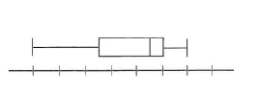

<_block>

[A] $24$

<_block>

[B] $26$

<_block>

[C] $28$

<_block>

[D] $30$

<_block>

[A]

<___question>

Type=1

<_block>

The probability of choosing a red ball from a bag containing red, blue and green balls is $\frac{5}{12}$. Which of these is the probability of the complementary event?

<_block>

[A] $\frac{1}{12}$

<_block>

[B] $\frac{1}{2}$

<_block>

[C] $\frac{7}{12}$

<_block>

[D] $\frac{11}{12}$

<_block>

[C]

<___question>

Type=1

<_block>

A bag containing 12 red cards, three blue cards and five green cards. Which of these is the probability of **not** choosing a blue card ?

<_block>

[A] $0.15$

<_block>

[B] $0.3$

<_block>

[C] $0.7$

<_block>

[D] $0.85$

<_block>

[D]

<___question>

Type=1

<_block>

If 4 red cards are removed from the bag,, what is the probability of selecting a blue or green card ?

<_block>

[A] $0.5$

<_block>

[B] $0.55$

<_block>

[C] $0.6$

<_block>

[D] $0.8$

<_block>

[A]

<___question>

Type=1

<_block>

Which figure represents two mutually exclusive events ?

<_block>

[A] 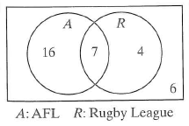

<_block>

[B] 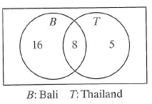

<_block>

[C] 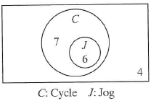

<_block>

[D] 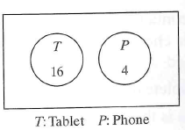

<_block>

[D]

<___question>

Type=1

<_block>

In a raffle, tickets numbered 1 to 100 are sold. What is the probability that the winning ticket is a number ending in *9* ?

<_block>

[A] $0.01$

<_block>

[B] $0.09$

<_block>

[C] $0.1$

<_block>

[D] $0.9$

<_block>

[C]

<___question>

Type=1

<_block>

The faces on an eight-sided die are numbered 1 to 8. What is the probability of **not** rolling a 4 ?

<_block>

[A] $0.4$

<_block>

[B] $0.5$

<_block>

[C] $0.6$

<_block>

[D] $0.875$

<_block>

[D]

<___question>

Type=1

<_block>

Using the below figure given a sport-playing student is chosen, what is the probability that they have a job ?

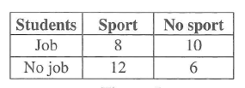

<_block>

[A] $\frac{1}{4}$

<_block>

[B] $\frac{2}{5}$

<_block>

[C] $\frac{4}{9}$

<_block>

[D] $\frac{2}{3}$

<_block>

[B]

<___question>

Type=1

<_block>

A die is rolled 30 times and the results are listed in the table below. Which of these is the number of times an odd number was rolled ?

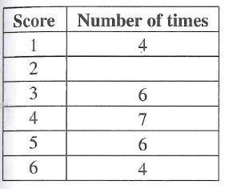

<_block>

[A] $3$

<_block>

[B] $15$

<_block>

[C] $16$

<_block>

[D] $17$

<_block>

[C]