SIMILAR AND CONGRUENT TRIANGLES, QUADRILATERALS AND POLYGONS

<___question>

Type=1

<_block>

The ratio of the sides of two squares is 2 : 3. Which of these is the ratio of the areas of the squares ?

<_block>

[A] 4 : 6

<_block>

[B] $8 :12$

<_block>

[C] $4 :9$

<_block>

[D] $3 :2$

<_block>

[C]

<___question>

Type=1

<_block>

What type of triangle is ▲*AEF* ?

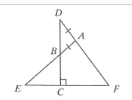

<_block>

[A] equilateral

<_block>

[B] $isosceles$

<_block>

[C] right-angled

<_block>

[D] scalene

<_block>

[B]

<___question>

Type=1

<_block>

Which of these is the value of *P* ? 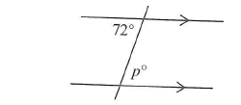

<_block>

[A] *p* = 72

<_block>

[B] $p = 108$

<_block>

[C] $p = 118$

<_block>

[D] $p = 128$

<_block>

[A]

<___question>

Type=1

<_block>

What test is used to prove the two triangles are congruent ? 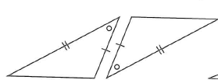

<_block>

[A] *SAS*

<_block>

[B] $RHS$

<_block>

[C] *AAS*

<_block>

[D] *SSS*

<_block>

[A]

<___question>

Type=1

<_block>

Using the formula *S = (n – 2)* x *180,* how many degrees are in a 20-sided polygon ?

<_block>

[A] *1620°*

<_block>

[B] $3080°$

<_block>

[C] *3240°*

<_block>

[D] *3600°*

<_block>

[C]

<___question>

Type=1

<_block>

Which of these is **not** a correct statement to prove

*▲ OXM ≡ ▲ OYM ?*

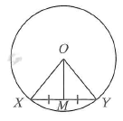

<_block>

[A] *OX = OY*

<_block>

[B] $∠XOM=∠YOM$

<_block>

[C] *XM = YM*

<_block>

[D] *OM* is common

<_block>

[B]

<___question>

Type=1

<_block>

Which of these is the angle sum of a pentagon ?

<_block>

[A] *500°*

<_block>

[B] $540°$

<_block>

[C] *720°*

<_block>

[D] *900°*

<_block>

[B]

<___question>

Type=1

<_block>

Which of these is a regular quadrilateral ?

<_block>

[A] rhombus

<_block>

[B] $rectangle$

<_block>

[C] kite

<_block>

[D] square

<_block>

[D]

<___question>

Type=1

<_block>

Which of these is the value for *x* when $\frac{x-2}{x}$ *= $\frac{3}{5}$*  ?

<_block>

[A] *x = -2*

<_block>

[B] $x=1$

<_block>

[C] *x = 2*

[D] *x = 5*

<_block>

<_block>

[D]

<___question>

Type=1

<_block>

Which of the following properties is **not** true for all kites ?

<_block>

[A] The angles add to 360°

<_block>

[B] $There is one axis of symmetry$

<_block>

[C] Two pairs of adjacent sides are equal

<_block>

[D] The diagonals bisect each other

<_block>

[D]