SINGLE AND BIVARIATE STATISTICS

<___question>

Type=1

<_block>

For the stem and leaf plot which of these is the range of scores?

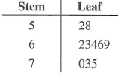

<_block>

[A] 3

<_block>

[B] $23$

<_block>

[C] $52$

<_block>

[D] $75$

<_block>

[B]

<___question>

Type=1

<_block>

The mean and standard deviation of the golf scores of 100 players were 82 and 3 respectively. There were 10 players who scored 82. If these results were removed, what effect would there be on the standard deviation ?

<_block>

[A] increase

<_block>

[B] $decrease$

<_block>

[C] unchanged

<_block>

[D] not enough information

<_block>

[A]

<___question>

Type=1

<_block>

Using the figure below which of these is the best description of the scores ?

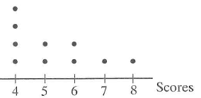

<_block>

[A] negatively skewed

<_block>

[B] $bimodal$

<_block>

[C] symmetrical

<_block>

[D] positively skewed

<_block>

[D]

<___question>

Type=1

<_block>

Using the figure below which of these is the best description of the scores ?

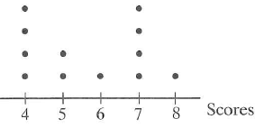

<_block>

[A] $bimodal$

<_block>

[B] $positively skewed$

<_block>

[C] negatively skewed

<_block>

[D] symmetrical

<_block>

[A]

<___question>

Type=1

<_block>

Using the figure below which of these is closest to the likely value of *b* if *a =* 1 ?

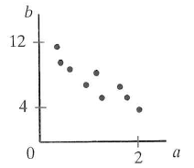

<_block>

[A] 4

<_block>

[B] $6$

<_block>

[C] 8

<_block>

[D] 10

<_block>

[C]

<___question>

Type=1

<_block>

Using the figure below which of these is the median ?

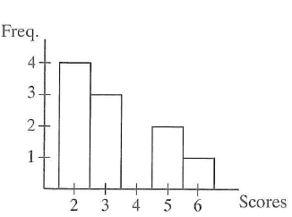

<_block>

[A] 2

<_block>

[B] $3$

<_block>

[C] 5.5

<_block>

[D] 6

<_block>

[B]

<___question>

Type=1

<_block>

Below is the grouped data frequency table. Which of these is the value of *q* ?

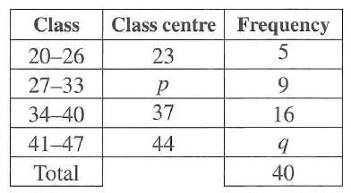

<_block>

[A] *q = 4*

<_block>

[B] $q = 5$

<_block>

[C] *q = 8*

<_block>

[D] *q = 10*

<_block>

[D]

<___question>

Type=1

<_block>

Using the below figure how many scores are less than 5 ?

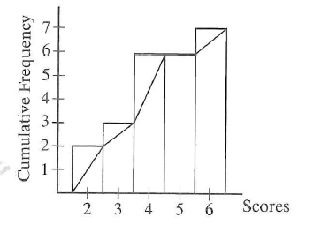

<_block>

[A] *2*

<_block>

[B] $4$

<_block>

[C] *6*

<_block>

[D] *11*

<_block>

[C]

<___question>

Type=1

<_block>

For the mean ( ***)* and the standard deviation ( *σ ),* which of these is the highest score ?**

<_block>

[A]

<_block>

[B]

<_block>

[C]

<_block>

[D] ***- 2σ***

<_block>

[B]

<___question>

Type=1

<_block>

The test results of 28 students ranged from 46 to 94 with a lower quartile of 63, a median of 84, and an interquartile range of 24. Which of these is the best description for the skewness of the data?

<_block>

[A] positively skewed

<_block>

[B] $symmetrical$

<_block>

[C] negatively skewed

<_block>

[D] not enough information

<_block>

[D]

<_block>

[C]