TRIGONOMETRY

<___question>

Type=1

<_block>

Which of these is the size of Ѳ in the below figure ?

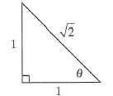

<_block>

[A] $45°$

<_block>

[B] $50°$

<_block>

[C] $55°$

<_block>

[D] $60°$

<_block>

[A]

<___question>

Type=1

<_block>

Which of these is the value of *a* in the below figure ?

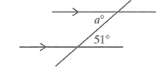

<_block>

[A] $39$

<_block>

[B] $49$

<_block>

[C] $51$

<_block>

[D] $129$

<_block>

[C]

<___question>

Type=1

<_block>

Which of these is the bearing of *A* from *B* in the below figure ? 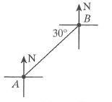

<_block>

[A] $030°$

<_block>

[B] $060°$

<_block>

[C] $210°$

<_block>

[D] $240°$

<_block>

[D]

<___question>

Type=1

<_block>

Which of these is the size of Ѳ, correct to the nearest minute in the below figure ?

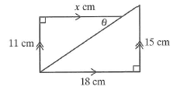

<_block>

[A] $39°8'$

<_block>

[B] $39°48'$

<_block>

[C] $50°12'$

<_block>

[D] $50°19'$

<_block>

[B]

<___question>

Type=1

<_block>

Which of these is negative ?

<_block>

[A] $\sin{120°}$

<_block>

[B] $\cos{330°}$

<_block>

[C] $\tan{300°}$

<_block>

[D] $\tan{200°}$

<_block>

[C]

<___question>

Type=1

<_block>

Boat *A* is 40 km south and 25 km west of Boat *B*. Which of these is closest to the bearing of Boat *A* from Boat *B* ?

<_block>

[A] $122°$

<_block>

[B] $212°$

<_block>

[C] $238°$

<_block>

[D] $328°$

<_block>

[B]

<___question>

Type=1

<_block>

Using the below figure how far east of S is T, correct to three significant figures *?*

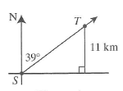

<_block>

[A] $8.91 km$

<_block>

[B] $8.92 km$

<_block>

[C] $13.5 km$

<_block>

[D] $13.6 km$

<_block>

[A]

<___question>

Type=1

<_block>

Using the below figure which of these is the size of the missing angle, to the nearest minute ?

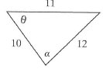

<_block>

[A] $67°19'$

<_block>

[B] $67°20'$

<_block>

[C] $107°15'$

<_block>

[D] $107°16'$

<_block>

[A]

<___question>

Type=1

<_block>

Using the below figure, if *q = 4*, which of these is the area of the triangle, correct to two decimal places ?

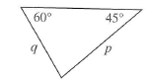

<_block>

[A] $6.31 units²$

<_block>

[B] $9.46 units²$

<_block>

[C] $14.85 units²$

<_block>

[D] $18.93 units²$

*

<_block>

[B]

<___question>

Type=1

<_block>

What is the value of 8 ÷ cos 68°, correct to two decimal places ?

<_block>

[A] $0.04$

<_block>

[B] $0.05$

<_block>

[C] $21.35$

<_block>

[D] $21.36$

<_block>

[D]