CSCE 2014 – Programming Project Report
Student Name: Grant Carmichael

Academic Integrity Statement: I pledge that I have neither given nor received unauthorized help on this programming assignment.

Problem Statement:
The primary goal of project five is to build a program that compares the lexical similarity between two e-Books stored in .txt files. The inputs used in this program are only in the goo-goo functionality when you input the names of the books you wish to compare. The outputs of the program are the amount of words in each book, the amount of unique words in each book, and the lexical similarity. Error handling was not specifically requested for this project but I built some basic error handling for if a file is input that cannot be read.

Design:
The primary design decisions I made for this project were how I wanted to handle user input/output data and the fastest way to handle data processing. The algorithms used in this program are binary and linear search algorithms, with the binary search being used in checking if the words are in the 100 most common English words, and the linear search finding the common words between two books. The pros of these choices is that the binary search algorithm for excluding the words while writing is extremely quick and runs well. The cons is that the linear search is a little bit slower, while the binary search algorithm is a little bit harder to implement.

Implementation:
The implementation was quite lengthy for this program. I started by first making my two files and making a simple main function, etc. The functionality of goo is required for goo-goo to work, so I began work on that file first. I didn’t have much code to start with, so I was starting from scratch. The first thing I implemented was reading the original file into another file that stripped all of the non-alphabetical text from it. After having that implemented and working, I slowly went about writing the function that determined the frequency of words in a file. After I had that fully working, I began finalizing the project through the goo-goo implementation. Goo-goo works by taking two of the frequency files and comparing each of the words to find what they have in common. It then divides by the average number of words to find a more fair number. Overall, the timeline for implementation was around a week and a half in total in the order that I described. It took around 12 hours total.

Testing:
Testing this program was quite simple. Testing for the goo portion of the program consisted of making sure that my program was writing to the output files correctly, and when it did it incorrectly I debugged the program to get it working again. For the goo-goo file, the primary feature being tested was the comparison process, which I tested by ensuring it could properly read the selected files and compare them. The normal inputs I used were the books to input, and there weren’t any special cases for this project because of how limited the user input is. Everything works as expected now.

No input for the goo file, this is the output
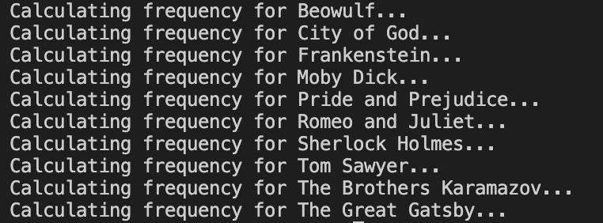

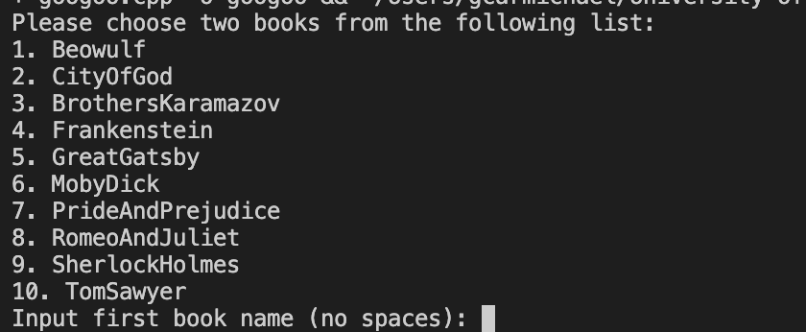

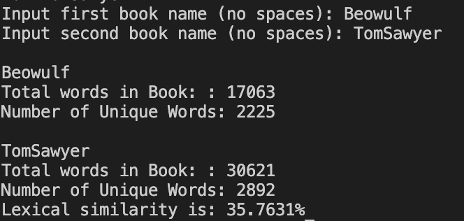

Book One | Book Two | Similarity Score
Beowulf | City Of God | 32.5074%
Beowulf | Brothers Karamazov | 29.1904%
Beowulf | Frankenstein | 37.3309%
Beowulf | Great Gatsby | 33.6088%
Beowulf | Moby Dick | 27.1193%
Beowulf | Pride and Prejudice | 33.75%
Beowulf | Romeo and Juliet | 34.9504%
Beowulf | Adventures of Sherlock Homes | 34.1266%
Beowulf | Adventures of Tom Sawyer | 35.7631%

Generative AI:
The only AI tool I used was chatGPT. I used it for re-explaining some of the instructions to make it clearer and to help write the function that read the data from the file, as allowed in the instructions. The prompts I used are found in my prompts.docx file but was only 2 prompts that were for getting the 100 most frequent English words and the function to read and clean the eBooks. The answers from this generative AI were helpful with the information it gave and its explanations, and it helped me understand what exactly was going on in the code that it gave me. I didn’t encounter any issues or problems when working with AI.

Conclusions:
The overall result of the assignment is definitely a large success. The project works as intended after the implementation process, and properly is able to read and write the frequency of files and process the lexical similarity. The way I approached this project is the way I would approach it if I were to do it again. I gave myself more than enough time to complete the project which relieved much of the stress, something that I would like to do again on next project. This project took around 10-12 hours of work from start to finish over a week and a half.

