Task 1

1. Demo that you are able to consume weather service API and display the weather details

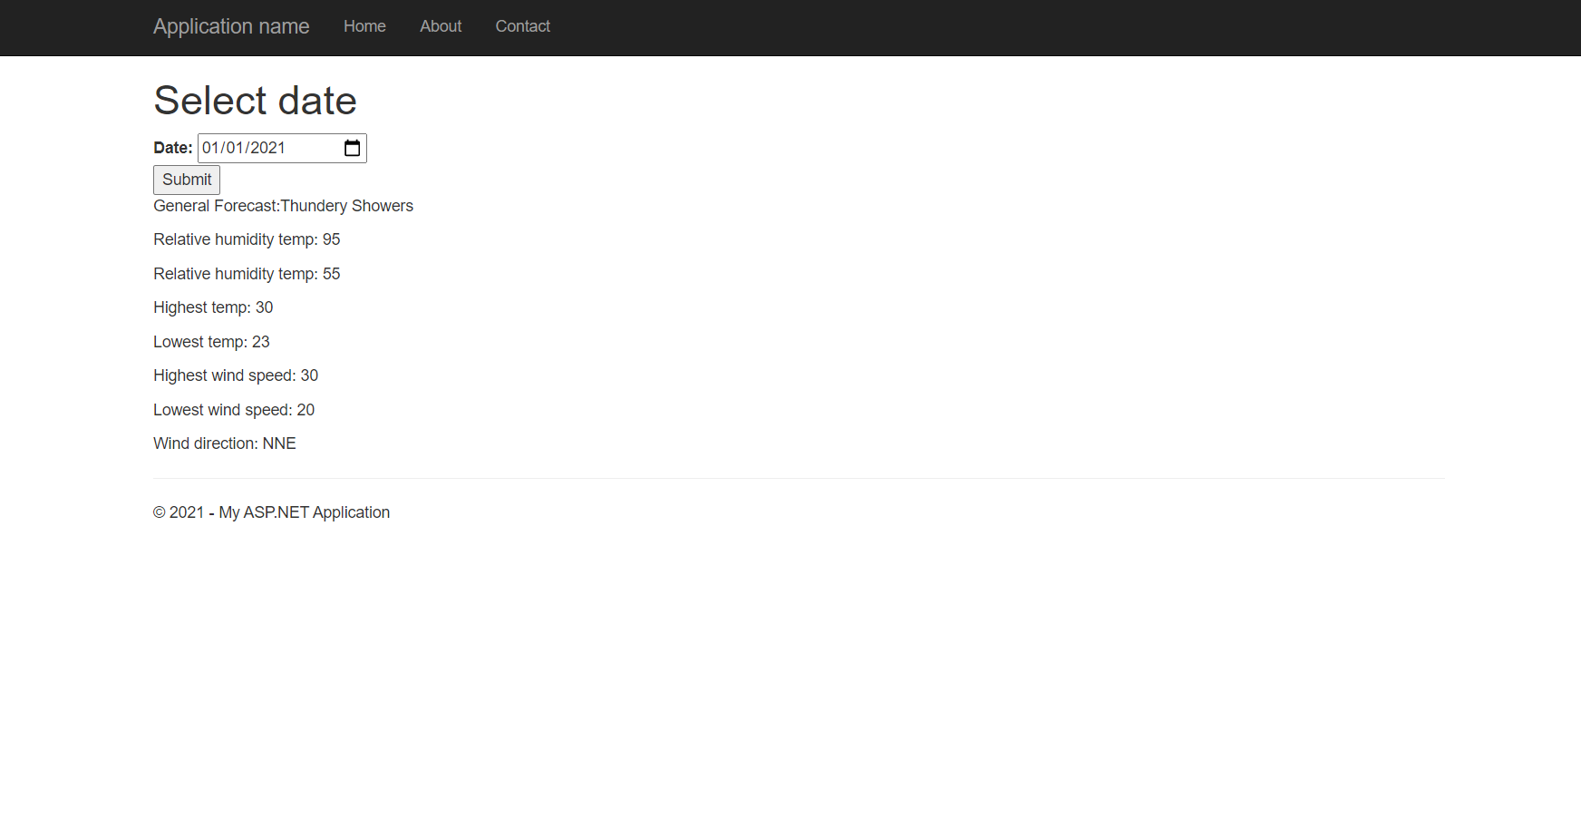

1. Draw a diagram to show the difference between invoking web service using C# and JQuery

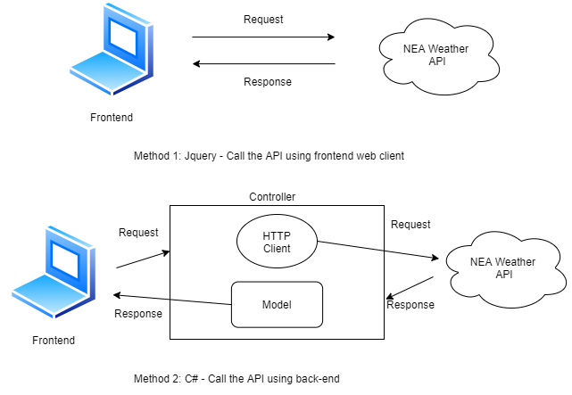

Task 3

1. Demo authentication and authorization

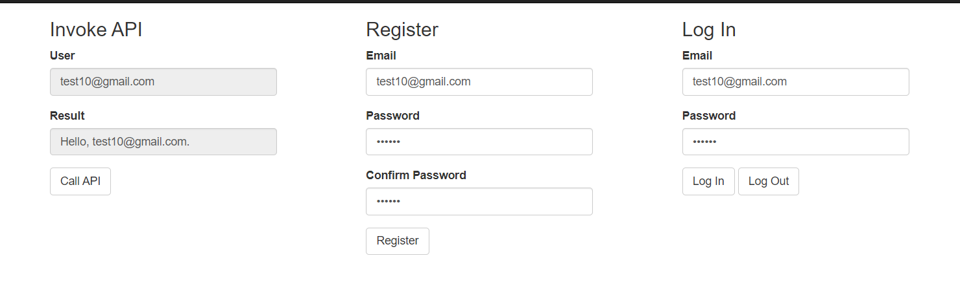

1. Add reCAPTCHA v3 to the registration part

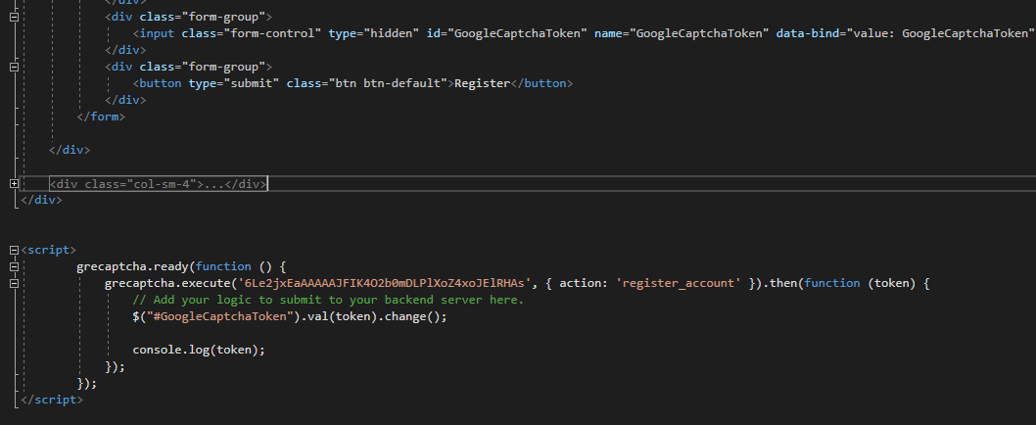

1. Postman testing result

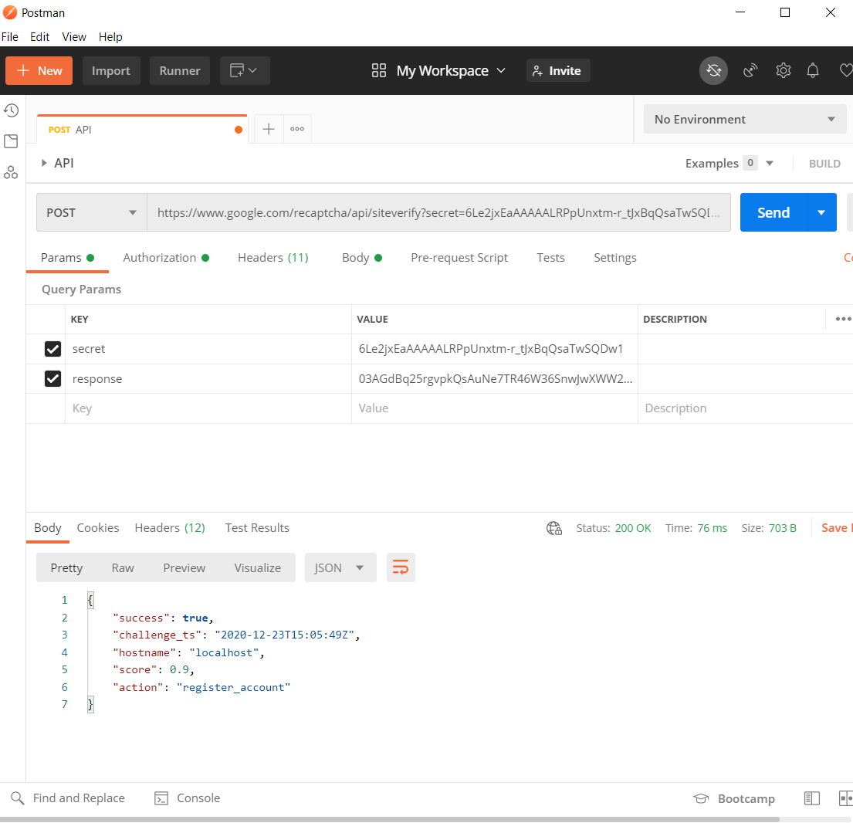

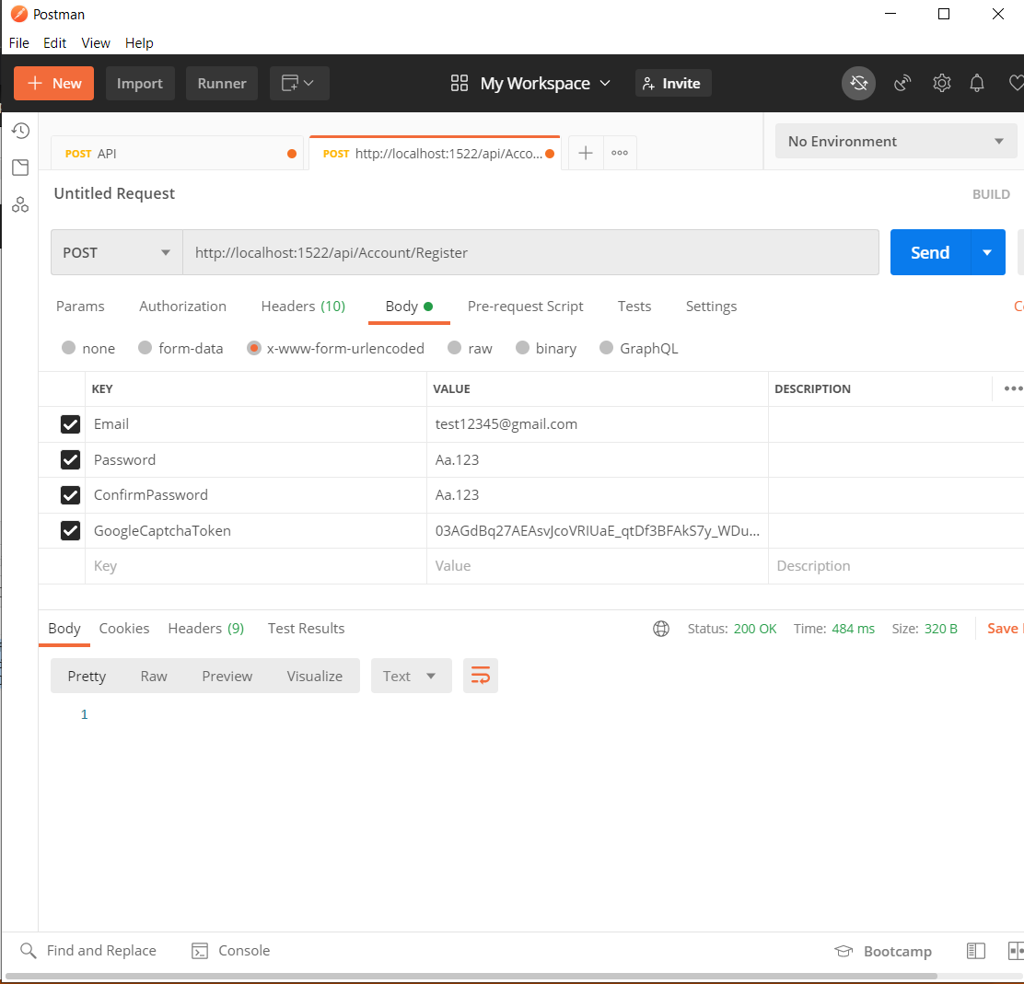

1. Draw a sequence diagram to explain your understanding

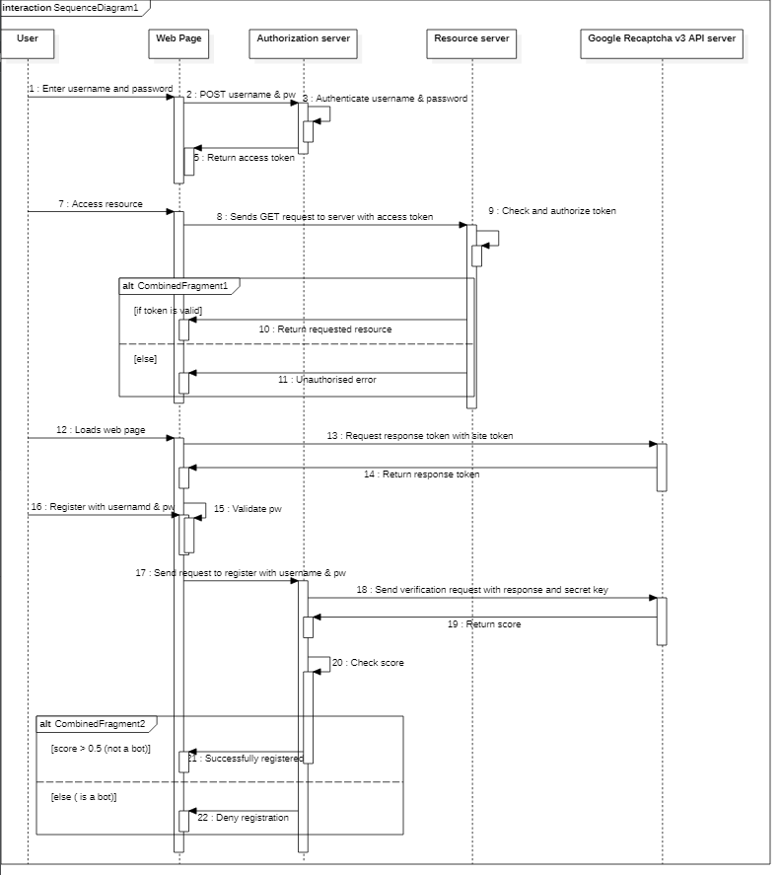

Task 6

1. Demo with a simple web page to show payment using Stripe billing subscription API and show successful payment for a daily subscription.

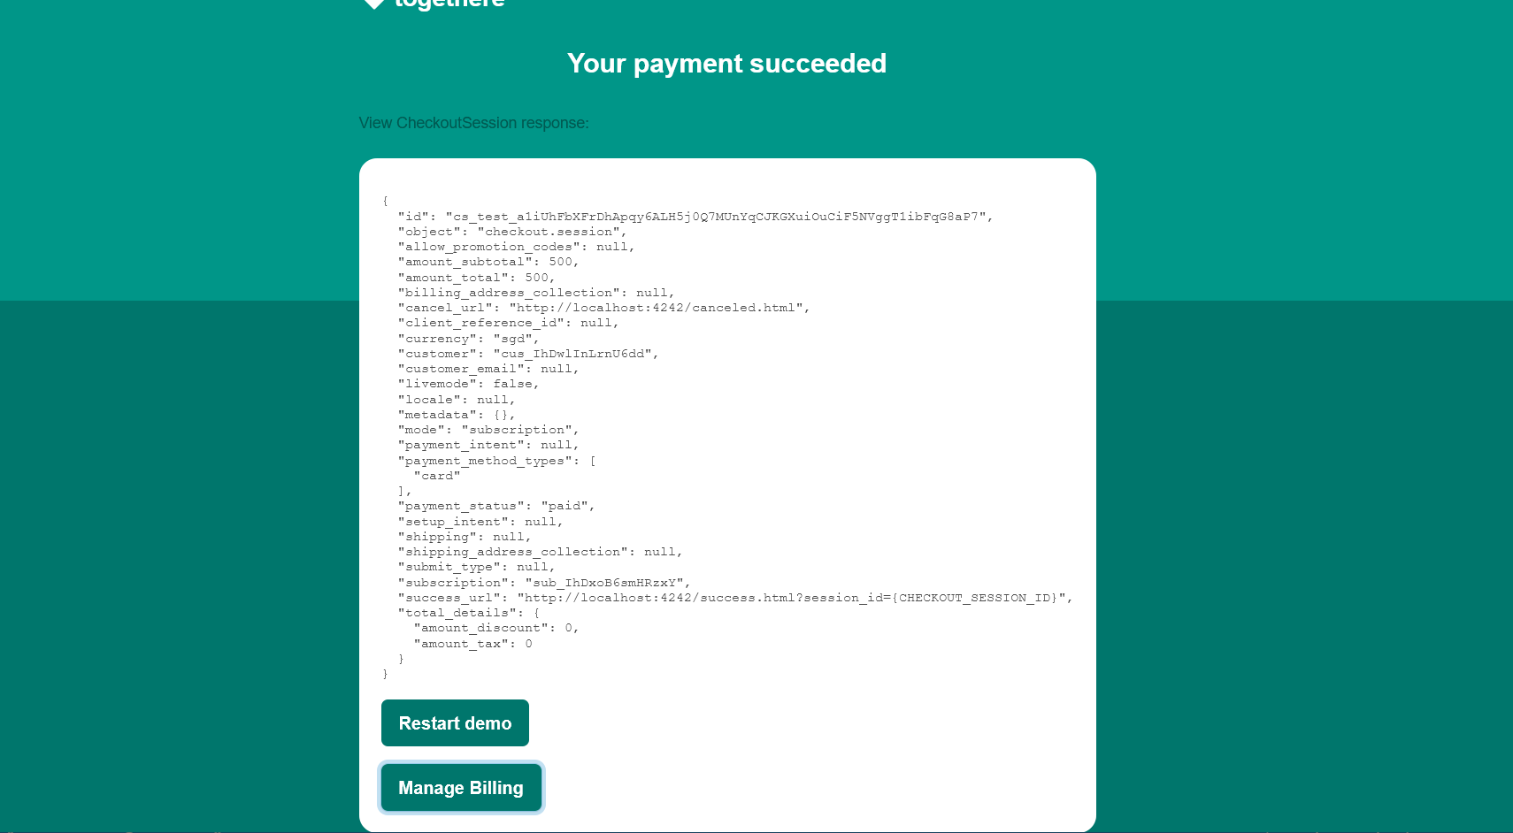

1. Demo at least 3 consecutive days of recurring subscription charges.

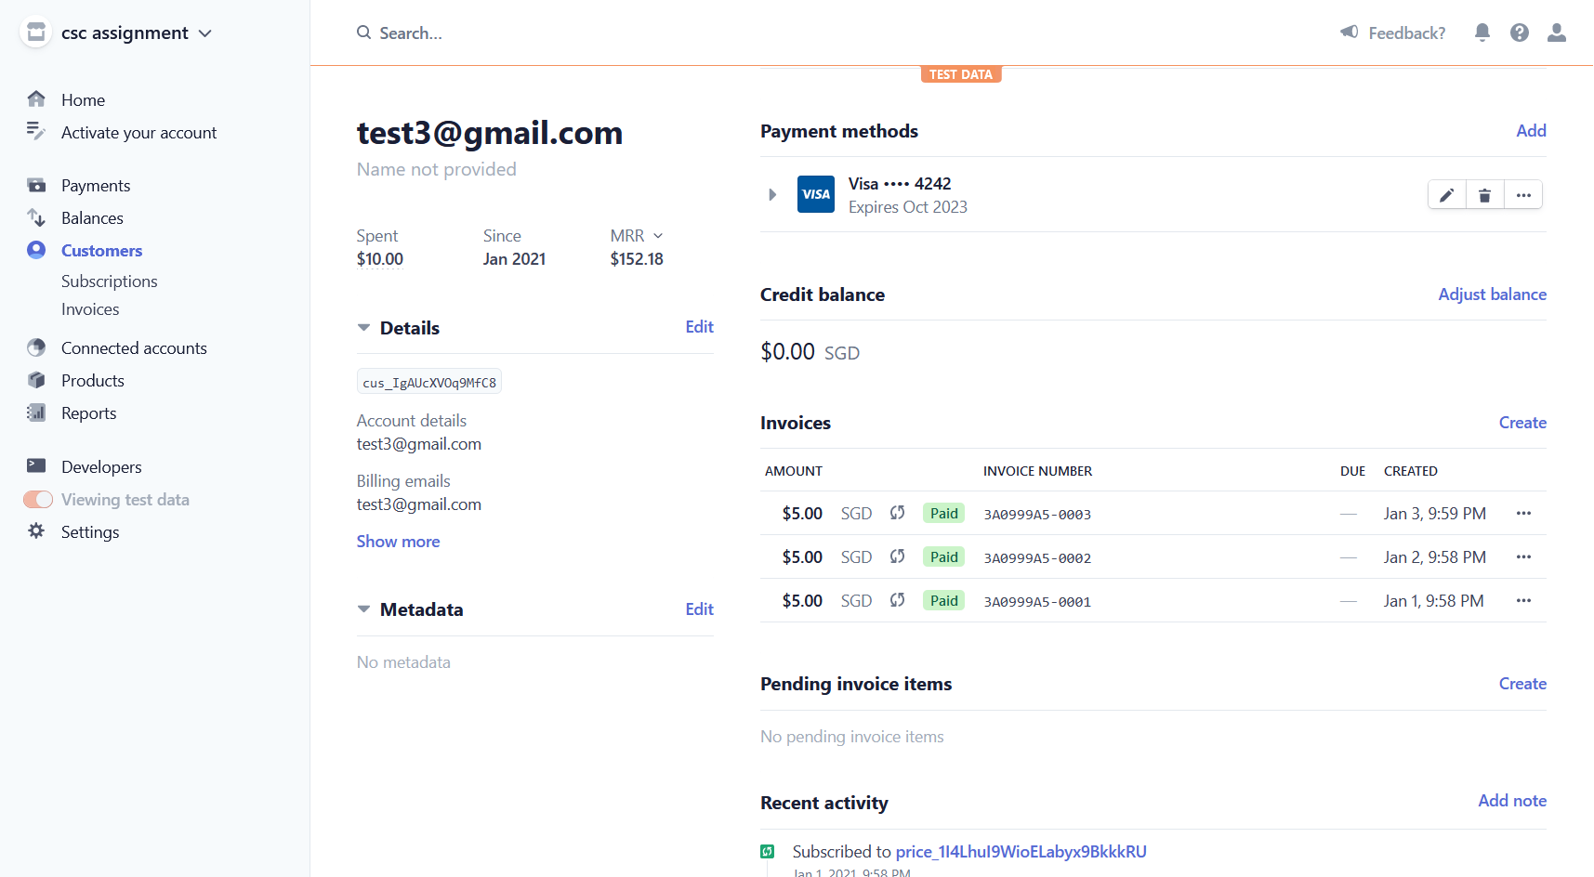

1. Demo Stripe subscription webhook to update database on success or failure to charge subscription

**stripe listen --forward-to localhost:4242/webhook**

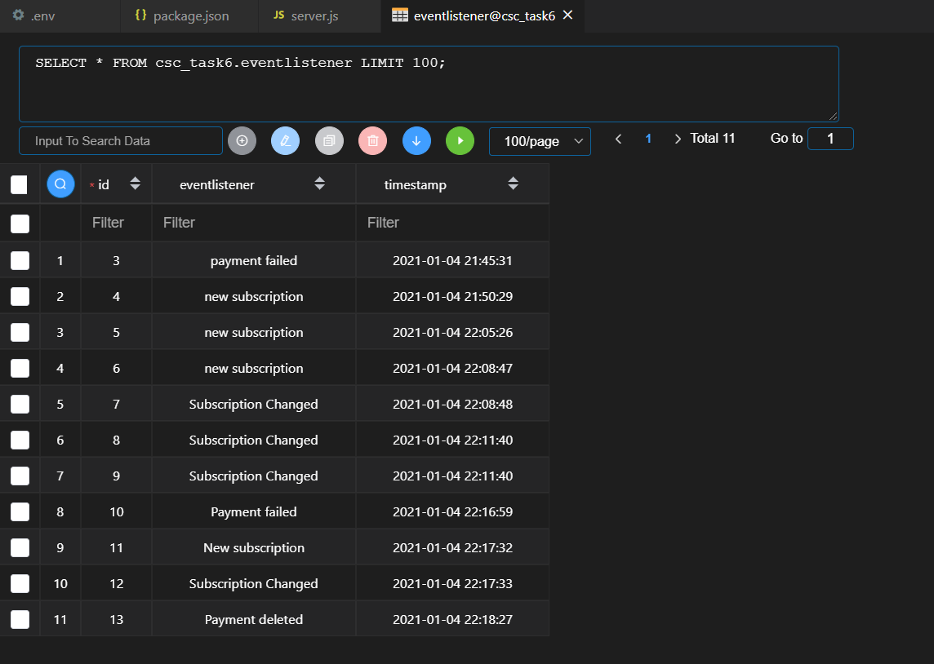

1. Demo using your web page to change Stripe subscription plan i.e. upgrade, downgrade, cancel, and next payment.

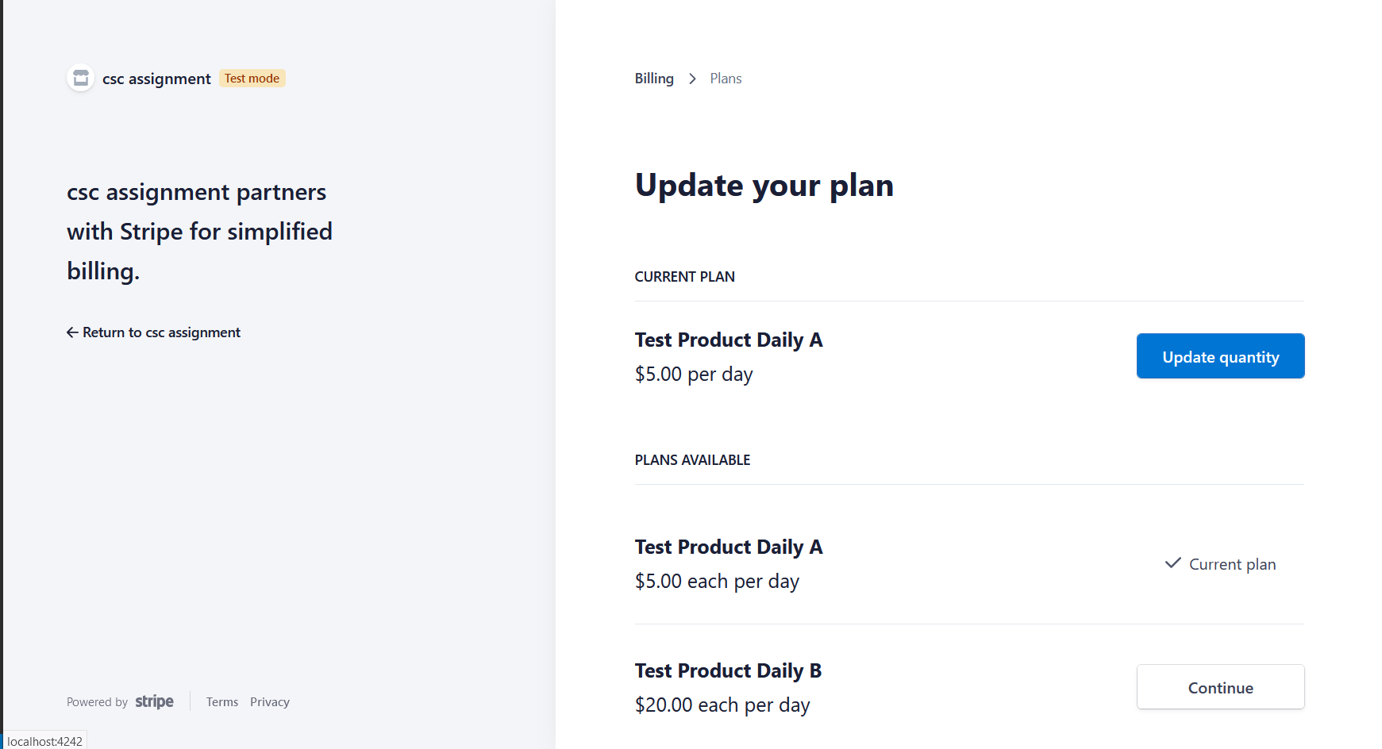

1. On changes to Stripe subscription such as successful charges, failure, and changes, use Stripe webhook to update your database. You can use Database-as-a-Service,



1. Draw a sequence diagram to explain your understanding of your project consuming Stripe API for subscription billing

