NAME: SAHIL BARNWAL REGNO: 24BDS0256

Subject: Computer Networks

Project Title: CONTENDER-ESTIMATION ADAPTIVE BACKOFF (CEAB): A COMPARATIVE STUDY OF WAITING STRATEGIES FOR

IEEE 802.11 CSMA/CA

Implementation Screenshots: Simulation OUTPUT:
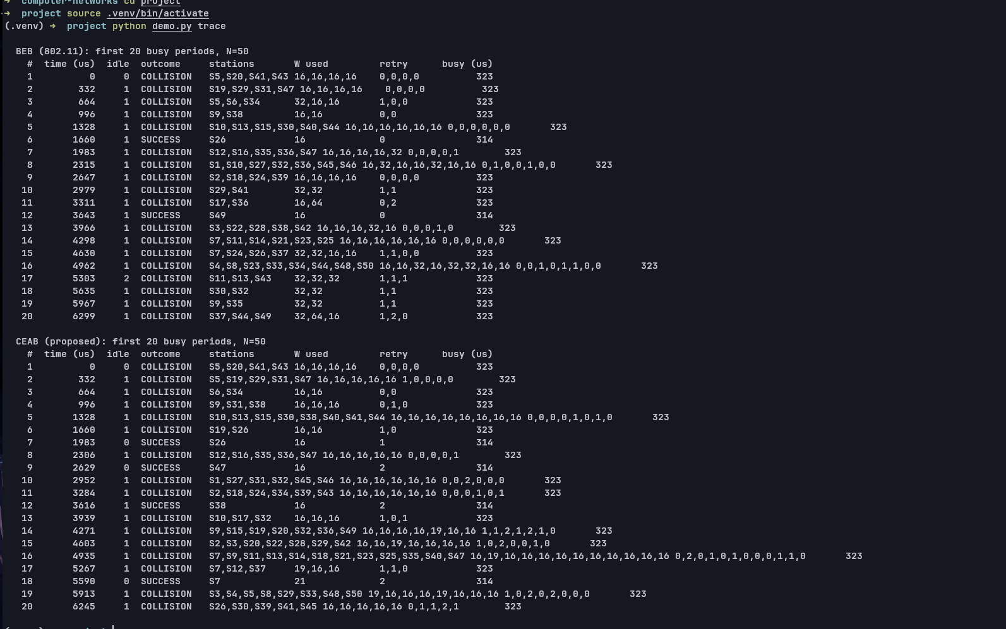

Simulation Graphs:

BEB VS CEAB
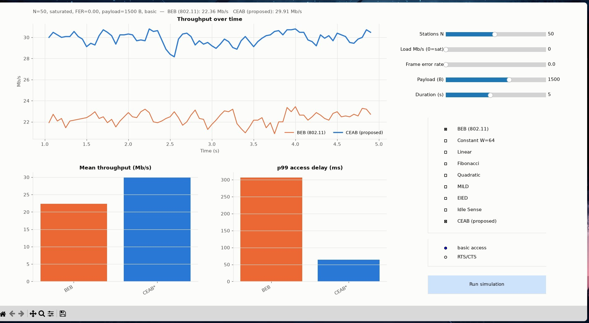

BEB VS CEAB VS Linear VS Quadratic
