What Does it Mean to be Wise?
James 3:13-18
The Worldly Life:

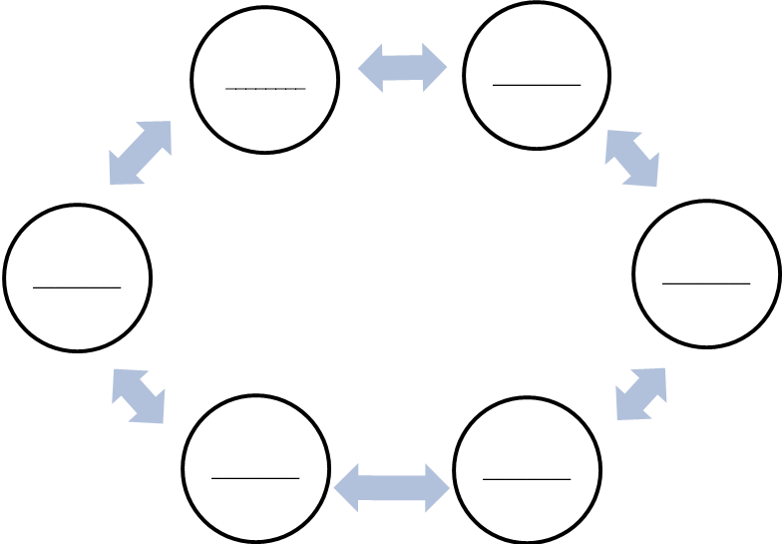
_______________________________
¹⁴ But if you have bitter jealousy and selfish ambition in your hearts, do not boast and be false to the truth. ¹⁵ This is not the wisdom that comes down from above, but is earthly, unspiritual, demonic. ¹⁶ For where jealousy and selfish ambition exist, there will be disorder and every vile practice. James 3:14-16
James 3:14-16
Outcomes:
- _______________
- _______________
- _______________
- _______________
- _______________
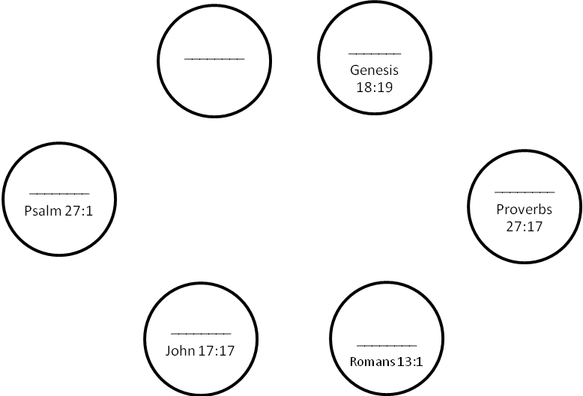
Three Chairs People Sit In:
_______________________________¹⁷ But the wisdom from above is first pure, then peaceable, gentle, open to reason, full of mercy and good fruits, impartial and sincere. ¹⁸ And a harvest of righteousness is sown in peace by those who make peace. James 3:17-18

James 3:17-18
The Spiritual Life:

- The Chair of _________________________________________________. Gal. 2:20, Phil. 3:13-14
- The Chair of _________________________________________________. 2 Tim. 3:5
- The Chair of __________________________ and ___________________. Prov. 15:28
Questions:
- _____________________________________________________________________________?
- _____________________________________________________________________________?

