

Project Report - 2

**BLACKBOARD CLONE**

**Submitted By: Submitted To:**

Name: Simarpreet Singh Mr. Ankush Kapoor

UID: 20MCA1137

Batch/Sec: MCA/1B

**UNIVERSITY INSTITUTE OF COMPUTING**

**TABLE OF INDEX**

**CONTENTS:**

1. Features of the project ……………………………………………………
2. Objectives of the project …………………………………………………
3. Scope of the project ………………………………………………………
4. Proposed Methodology …………………………………………………..
5. Hardware/ Software Requirement ……………………………………….
6. Data Flow Diagram ………………………………………………………
7. Work Progress …………………………………………………………....
8. Expected Outcome ………………………………………………………..
9. **FEATURES OF THE PROJECT**

A piece ofsoftwareis feature-rich when it has many options and functional capabilities available to the user. There are some of the features of the project are:

* 1. **Speed:** The loading speed of a web app is more important today. So I recreated blackboard learn with React JS as the front-end of my application and MongoDB for the database. The login and data fetching speed are increments.
  2. **URL Routing:** Routingis the process in which a user is directed to different pages on their actions and request. I used React Router to make routing even faster in my project and the reloading time of a web page is also decreased.

1. **OBJECTIVES OF PROJECT**

The objective is to design software for ELearning which contains all the information about the courses we choose. That should improve the efficiency and flexibility of the learning management system and provide a common platform for teachers and students. The students get the proper education and also get their details regarding the enrolled courses.

1. **SCOPE OF THE PROJECT**

Learning Management System is becoming a very essential component in education in this modern-day age. With the help of LMS, we can get an education online from our universities. In this pandemic, LMS becomes the only source of better education from our teachers also helps to get all the details regarding our enrolled courses and track our progress in it. We get multiple functionalities in a single platform for both teachers and students and can make video connections to make learning far better.

1. **PROPOSED METHODOLOGY**

LMS means the techniques and concepts for learning management of education as a whole, from the viewpoint of effective use of management resources to improve the efficiency and quality of education. A fully integrated Web Application-based LMS can access from any internet-enabled device.

It was made after extensive study of all the departments like a student, teachers, etc. of the universities and provided with the extract of everything an educational institute required for online learning.

1. **HARDWARE/SOFTWARE REQUIREMENT**

**Hardware Requirement:**

1. Processor: Atom, Celeron, Intel Dual Core
2. RAM: 2GB DDR3
3. Storage: 200Gb HDD
4. Graphics: 1GB UHD or NILL

**Software Requirement:**

1. OS: Any operating system
2. Web Browser: Any web browser with JavaScript enabled
3. **DATA FLOW DIAGRAM**

**USE CASE DIAGRAM**

A use case diagram at its simplest is a representation of a user’s interaction with the system that shows the relationship between the user and the different use cases in which the user is involved. A use case diagram can identify the different types of users of a system and the different use cases and will often be accompanied by other types of diagrams as well.

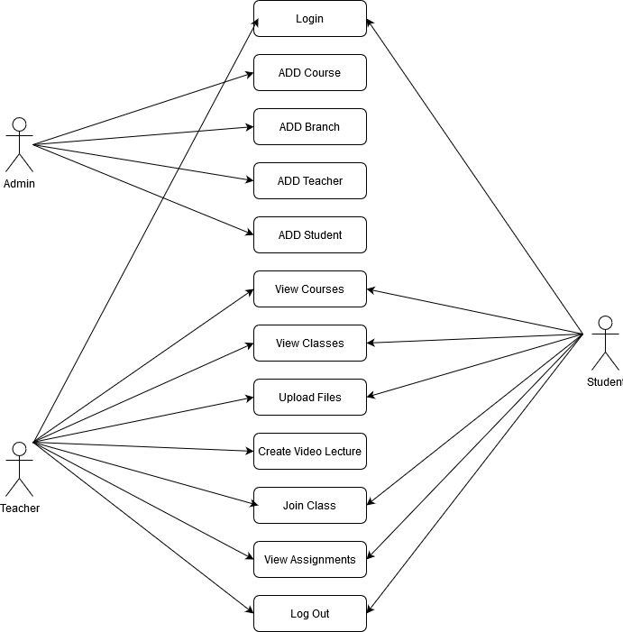

Figure 1: Use Case Diagram of LMS

**CLASS DIAGRAM**

The class diagram states the different classes involved in the software. For each class, a set of attributes and method are included. The relationship between the classes is also specified.

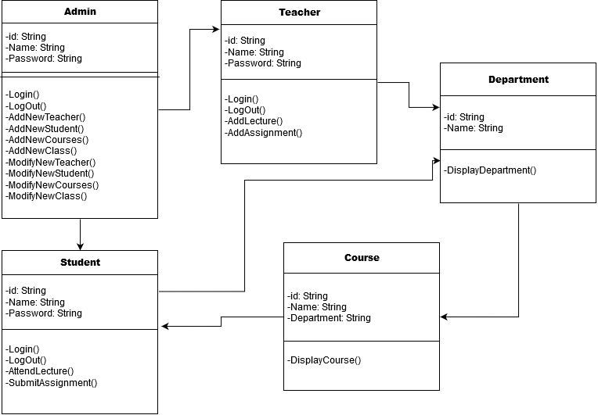

Figure 2: Class Diagram of LMS

**IMPLEMENTATION DETAILS**

The architecture comprises of various modules as given in the figure. There are 3 major categories in which the whole architecture in divided. These are administrator, teacher and student. The architecture is design such a way that is self-explanatory.

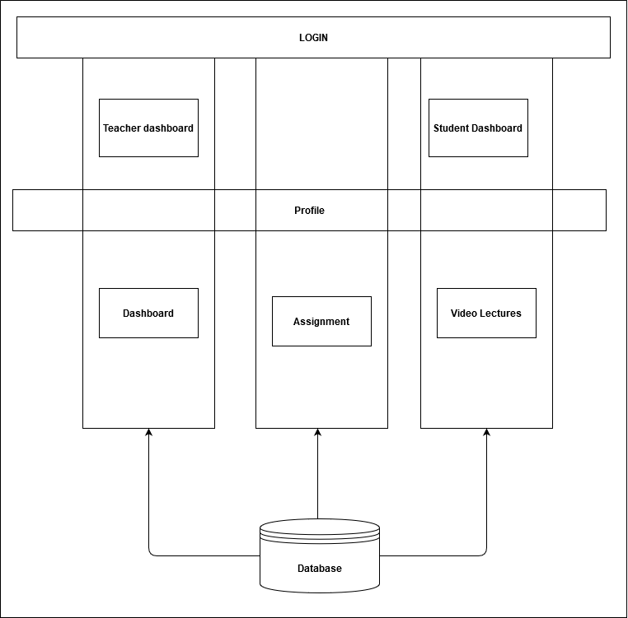

Figure 3: Architecture

1. **WORK PROGRESS**

Till now, I've implemented all the Databases using MongoDB and the front-end for the Log-In and COURSES section in my project Blackboard clone. Database User schema is also ready. Profile section and activity streams are almost completed. Sign-out functionality is completely done.

User Authentication section is completed and done by Jason web token.

**The various module in the project some of them are:**

1. Bcrypt JS: For converting string password into 12-digit hash form for more security.
2. React Router: To decrease the reload time of the web app.
3. Font awesome CDN: It is used to import icons used in the application.
4. Dotenv: It is used to hide secret keys and database login information.
5. Favicon: It used for all the icons included in my project.
6. React-Spinner: it used to make a beautiful loading screen meanwhile my data is fetching from database.
7. Next JS: It is a react js module use to create webapps.
8. WebRTC: It is used to make video calls over the network.
9. Tailwind CSS: It is use to make web app more attractive.
10. Express JS: It is used to do server-side coding.
11. **EXPECTED OUTCOME:**

The outcome I am getting while building this project is the same as I expected in the starting building a web app that is fast more user-friendly can contain a large amount of data and is also secure by hashing techniques.