RLIKE() Function in Hive

RLIKE stands for Right Like. RLIKE is special function in hive where if any sub-string of A matches with B then it evaluates to true

Hive has both LIKE and RLIKE, which uses regular expressions.

* Ex1:

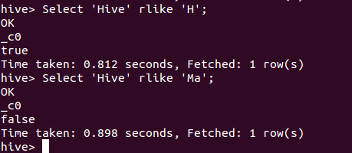

* RLIKE also obeys the Java regular expressions.

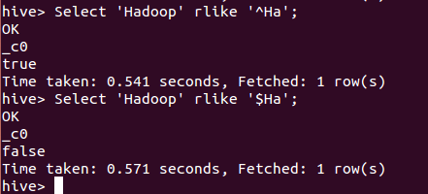

* RLIKE returns null, if any of the string or sub-string is null.

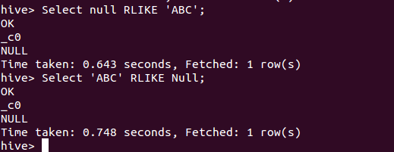

* In below example, we are searching for the EMP_NAME having sub-string ‘la’.

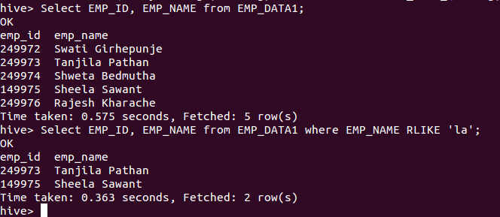

* And in below example, we are searching for the values in Designation column having numbers in it.

