RUN AudioCompresssion.m File. This is Method 1 using HAAR Wavelet.

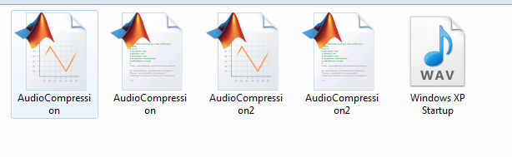

When you RUN in MATLAB, Following window will appear.

Select AUDIO and Then Press Compress Button. Observe difference between Size of Audio. It is compressed.

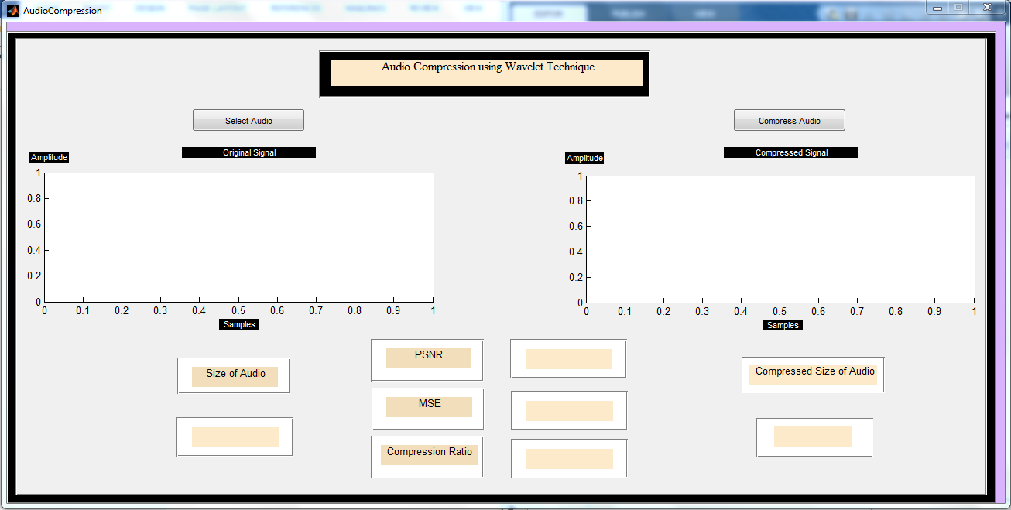

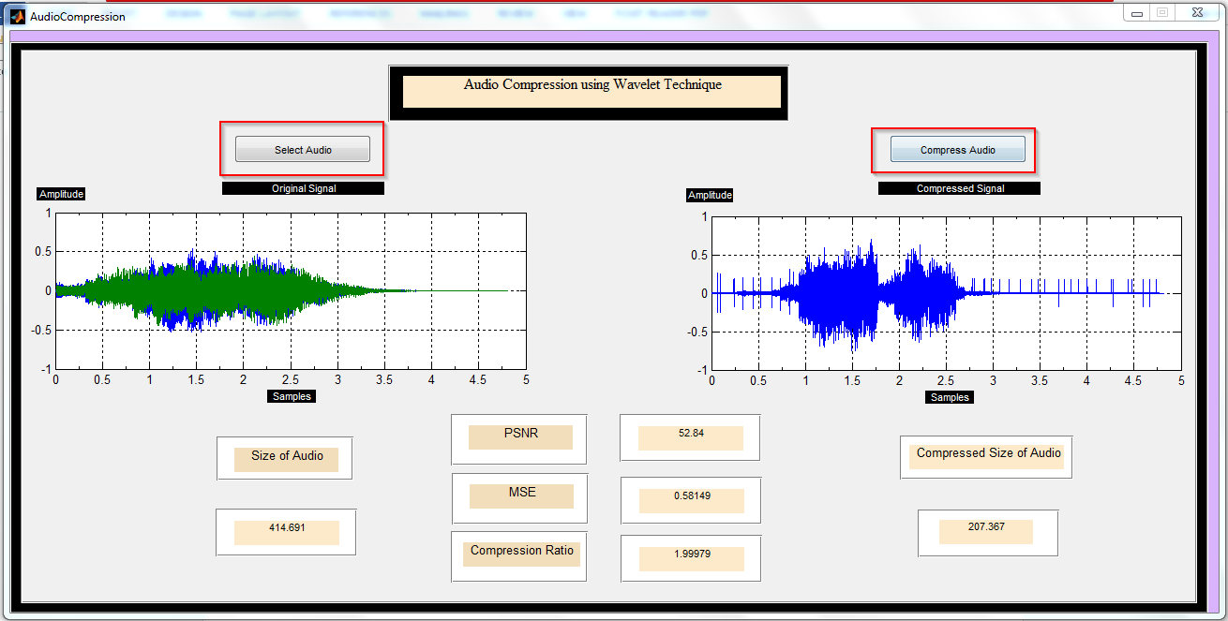

Compressed Audio file is generated as Output1 at the same path.

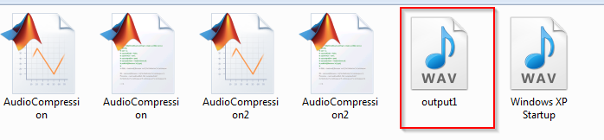

Now RUN AudioCompression2.m file

Select Audio and Press Compress Audio Button. And Observe the Size of Audio.

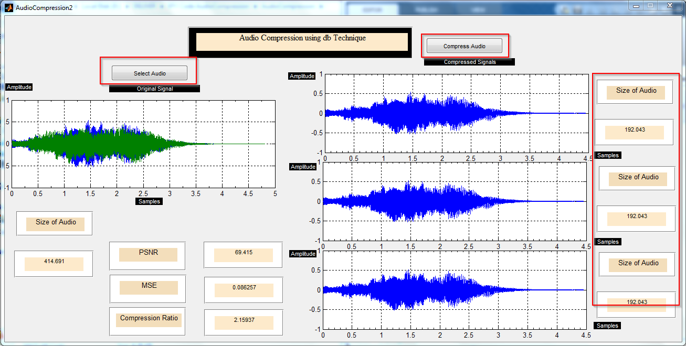

Compressed all the Three files are saved at the Same path.

