1. Peak Signal to Noise Ratio PSNR = 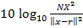
N is the length of the reconstructed signal, X is the maximum absolute square value of the
Signal x and is the energy of the difference between the original and reconstructed
Signals.
2. Mean Square Error MSE = 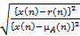
x (n) is the speech signal, r(n) is the reconstructed signal, and µx(n) is the mean of the speech
Signal.
3. Compression Ratio C = 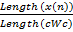
cWC is the length of the compressed wavelet transform vector.

4. HAAR Wavelet Algorithm

For a given signal x, the output of the µ-law compressor is,

y = 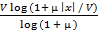sgn(x)

Where V is the maximum value of signal xµ is the µ-law parameter.

