ASSIGNMENT REPORT
ON
Analytical Report on Flipped Classroom Sessions: Conceptual and Practical Insights into MongoDB

Subject Name: Big Data Analytics
Subject Code: BDA601
Submitted By: Abhijit Kumar Singh Submitted To:
(1AY23CD001) Ms. Surbhi

TABLE OF CONTENTS

Sl. No. | Section Title | Page No.
1 | Introduction | 3
2 | Day 1 – Foundations of MongoDB | 3
2.1 | Conceptual Understanding of MongoDB | 3
2.2 | Interpretation of the Data Model | 4
2.3 | Analytical View of MongoDB Features | 5
2.4 | Replication and Sharding – System-Level Thinking | 5
2.5 | Learning Reflection from Day 1 | 6
3 | Day 2 – MongoDB Query Language | 6
3.1 | Practical Understanding of CRUD Operations | 6
3.2 | Query Optimization and Data Retrieval | 7
3.3 | Handling Complex Data Structures | 7
3.4 | Query Execution and Cursor Behavior | 8
3.5 | Learning Reflection from Day 2 | 8
4 | Day 3 – Advanced MongoDB Concepts | 9
4.1 | Aggregation as a Data Processing Tool | 9
4.2 | MapReduce – Conceptual Relevance | 9
4.3 | Indexing and Performance Optimization | 10
4.4 | Data Import and Export in Real Systems | 10
4.5 | Learning Reflection from Day 3 | 10
5 | Overall Learning Outcomes and Syllabus Implications | 11
6 | Challenges and Learning Gaps | 11
7 | Conclusion | 11

1. INTRODUCTION
The flipped classroom sessions held over three days gave a detailed understanding of MongoDB as a modern NoSQL database. Unlike traditional lectures, these sessions followed a student-focused approach where learners actively explained concepts. This helped improve both understanding and practical knowledge.
This method shifted learning from passive listening to active participation. Instead of just receiving information, students built their own understanding. The sessions focused not only on how MongoDB works but also on why it is useful in real-world, data-heavy applications. This helped connect theoretical concepts with their practical use in industry.
Across the three sessions, topics included basic concepts, query operations, and advanced data processing. Rather than just memorizing definitions or syntax, the sessions helped develop a deeper understanding of MongoDB’s design, how it differs from traditional relational databases, and its role in Big Data Analytics.
2. DAY 1 – FOUNDATIONS OF MONGODB
2.1 Conceptual Understanding of MongoDB
The first session introduced a shift from traditional relational database thinking to a document-based approach to data modeling. An important takeaway was understanding that MongoDB is not just another database, but a completely different way of organizing, storing, and retrieving data.
Instead of using fixed schemas and predefined tables, MongoDB allows a flexible structure where data can change over time. This flexibility matches the needs of modern applications, where data is often semi-structured or frequently updated. From a syllabus point of view, this highlights the importance of learning non-relational data models as an essential part of Big Data technologies.

2.2 Interpretation of the Data Model
The hierarchical structure of MongoDB—consisting of databases, collections, documents, and fields—was understood not just as a set of definitions, but as a design approach. It emphasizes keeping related data together and minimizing the need for joins.

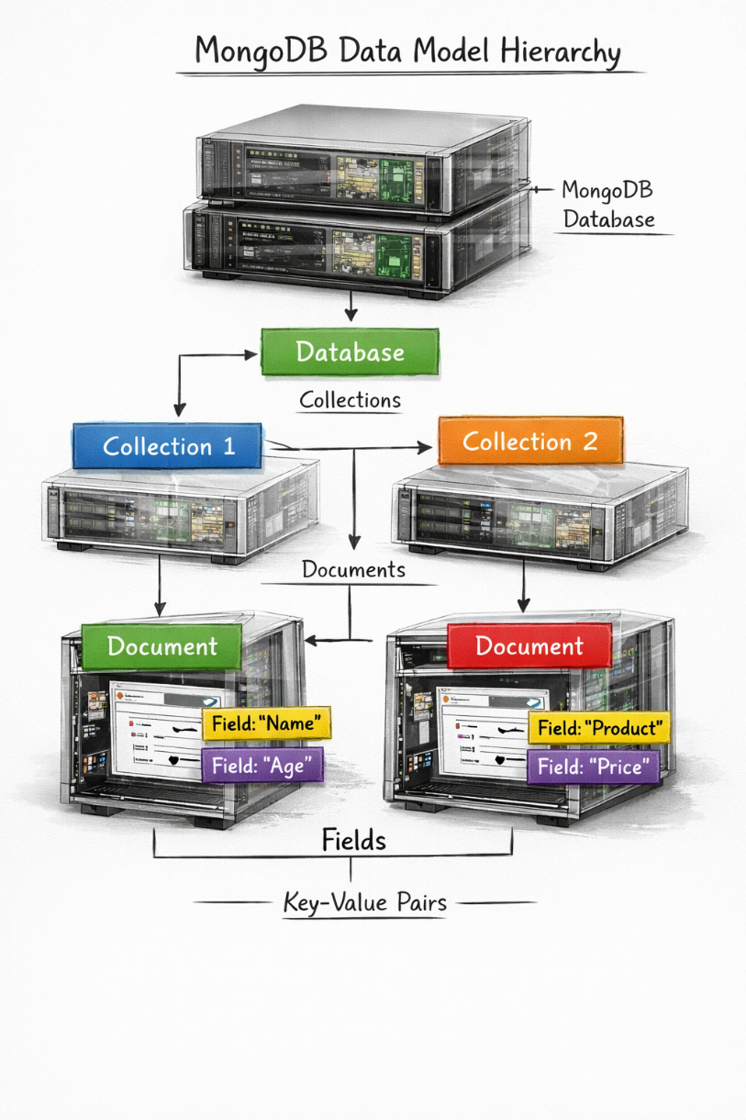
Title: MongoDB Data Model Hierarchy
From a learning standpoint, it became evident that embedding related data within documents reduces the need for complex join operations, thereby improving performance. This insight has direct implications on how database schemas should be designed in real-world applications, especially when dealing with large-scale distributed systems.

2.3 Analytical View of MongoDB Features
Instead of simply memorizing features like flexible schemas or dynamic queries, the session focused on understanding their practical value. For example, flexible schemas are not just convenient but essential in situations where data formats are unpredictable, such as in user-generated content platforms.
In the same way, the concept of a unique identifier (_id) was understood not just as a requirement, but as an important mechanism for maintaining data integrity and enabling efficient data retrieval. This also highlighted the continued importance of indexing and primary keys, even in non-relational databases.
2.4 Replication and Sharding – System-Level Thinking
The concepts of replication and sharding introduced a system-level perspective, highlighting how MongoDB handles scalability and fault tolerance.
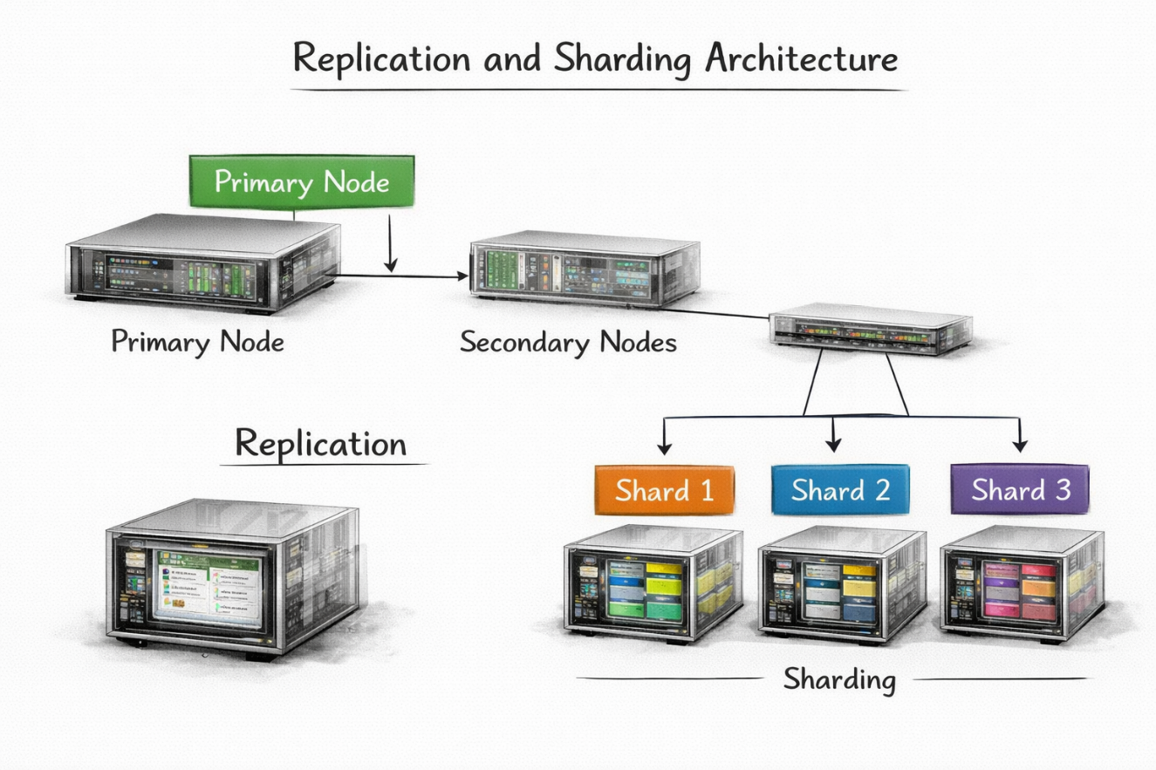
Title: Replication and Sharding Architecture
Description: Replication: One primary node with multiple secondary nodes Sharding: Data partitioned across multiple shards
From a deeper learning perspective, replication was understood as a method to ensure high availability, while sharding was seen as a solution for horizontal scalability. These concepts closely relate to distributed computing principles in the syllabus and are essential for building reliable and scalable systems.

2.5 Learning Reflection from Day 1
The first session significantly changed the approach to database design by focusing on flexibility, scalability, and performance. It also pointed out the limitations of traditional relational databases in handling modern data needs and presented MongoDB as a system better suited for big data environments.
3. DAY 2 – MONGODB QUERY LANGUAGE
3.1 Practical Understanding of CRUD Operations
The second session focused on query operations, but the main learning was not the syntax itself. Instead, it was about understanding how data is handled and accessed in a NoSQL environment.
CRUD operations were seen as the basic layer of database interaction, allowing applications to create, read, update, and delete data efficiently. The session showed how MongoDB makes these operations simpler through easy-to-use commands, reducing the complexity often found in SQL-based systems.

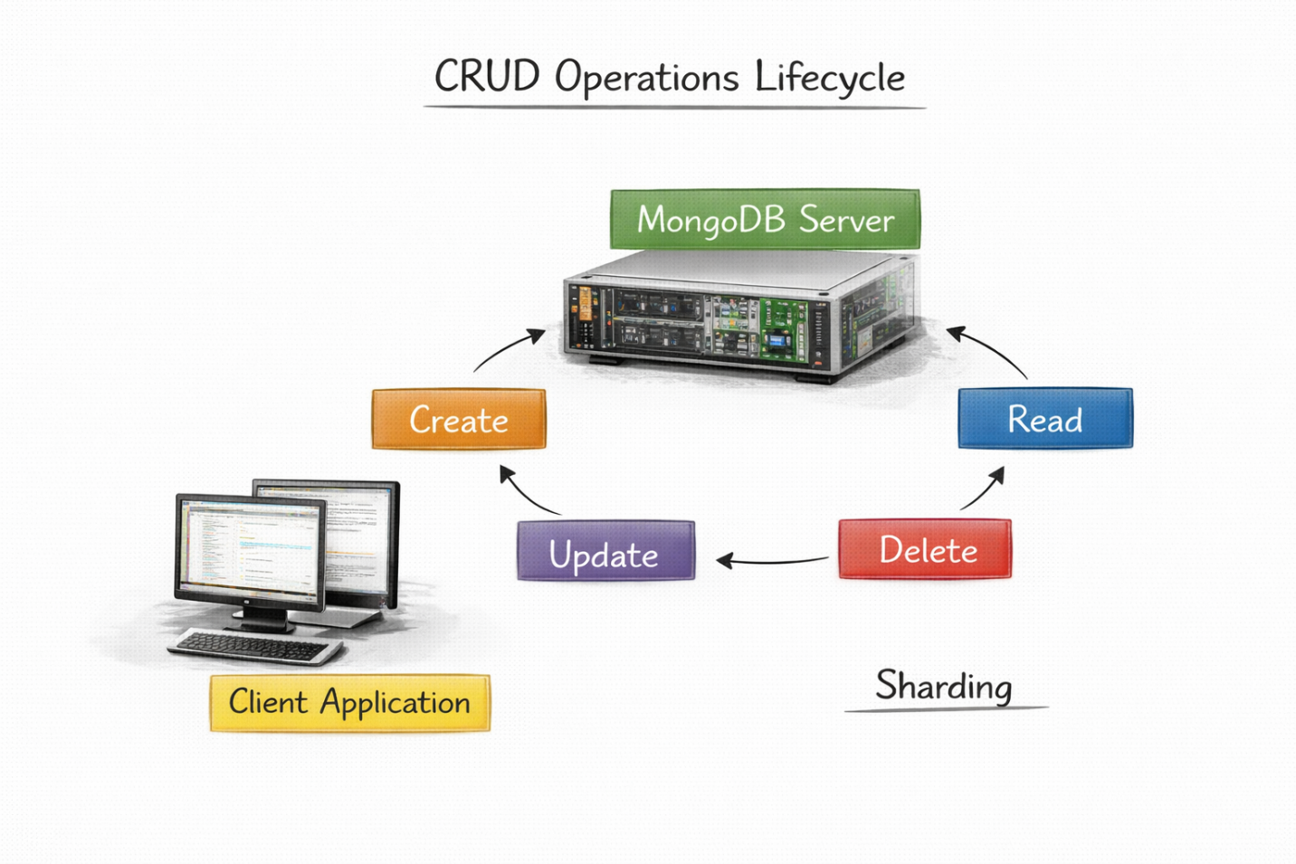
Title: CRUD Operations Lifecycle

3.2 Query Optimization and Data Retrieval
An important takeaway from this session was understanding the role of query modifiers such as limit, skip, and sort in improving data retrieval. These were not seen as just extra commands, but as tools to control data flow and enhance performance.
The idea of chaining queries showed how MongoDB can combine multiple operations, allowing more accurate and efficient data extraction. This is especially important in real-world applications where performance optimization is critical.

3.3 Handling Complex Data Structures
The ability to store arrays and nested objects showed MongoDB’s strength in handling complex data structures. This is especially useful in cases where relational databases would need multiple tables and joins to represent the same data.
From a learning perspective, this reinforced the idea that MongoDB is built to handle data in its natural form, instead of forcing it into strict table-based structures.

3.4 Query Execution and Cursor Behavior
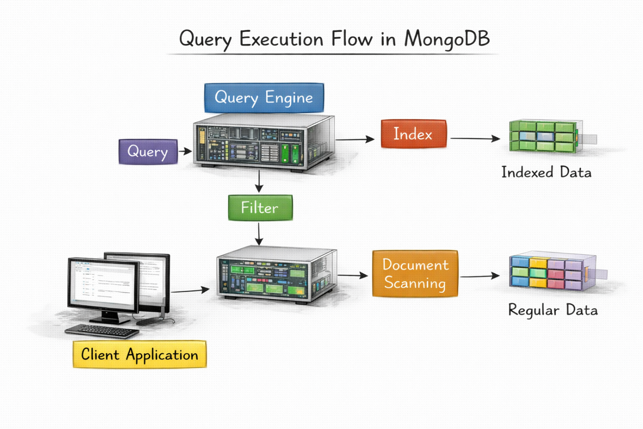
Title: Query Execution Flow in MongoDB
The concept of cursors introduced an important optimization technique where data is fetched in batches instead of all at once. This was understood as a key feature for efficiently handling large datasets and avoiding memory overload.
3.5 Learning Reflection from Day 2
The second session gave a deeper understanding of how MongoDB handles data at an operational level. It emphasized the importance of designing efficient queries and showed how MongoDB simplifies complex data operations while still maintaining high performance.

4. DAY 3 – ADVANCED MONGODB CONCEPTS
4.1 Aggregation as a Data Processing Tool
The aggregation framework was one of the most significant topics covered, as it demonstrated MongoDB’s capability to perform data analysis directly within the database.
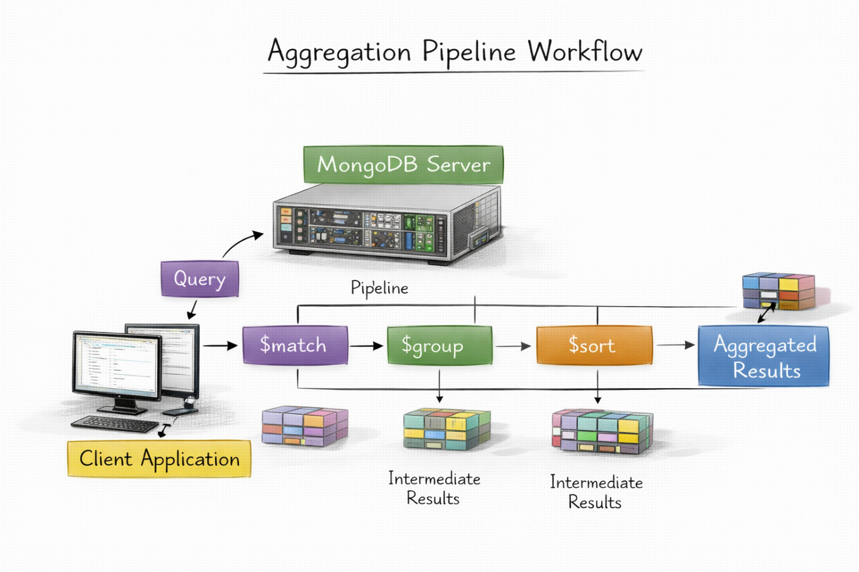
Title: Aggregation Pipeline Workflow
From a learning standpoint, aggregation was understood as a powerful alternative to processing data in external applications. This reduces data transfer overhead and improves overall system efficiency.

4.2 MapReduce – Conceptual Relevance
Although MapReduce is not widely used in modern MongoDB versions, learning about it helped in understanding distributed data processing. It showed how large datasets can be processed in parallel, which is a key concept in Big Data Analytics.

4.3 Indexing and Performance Optimization
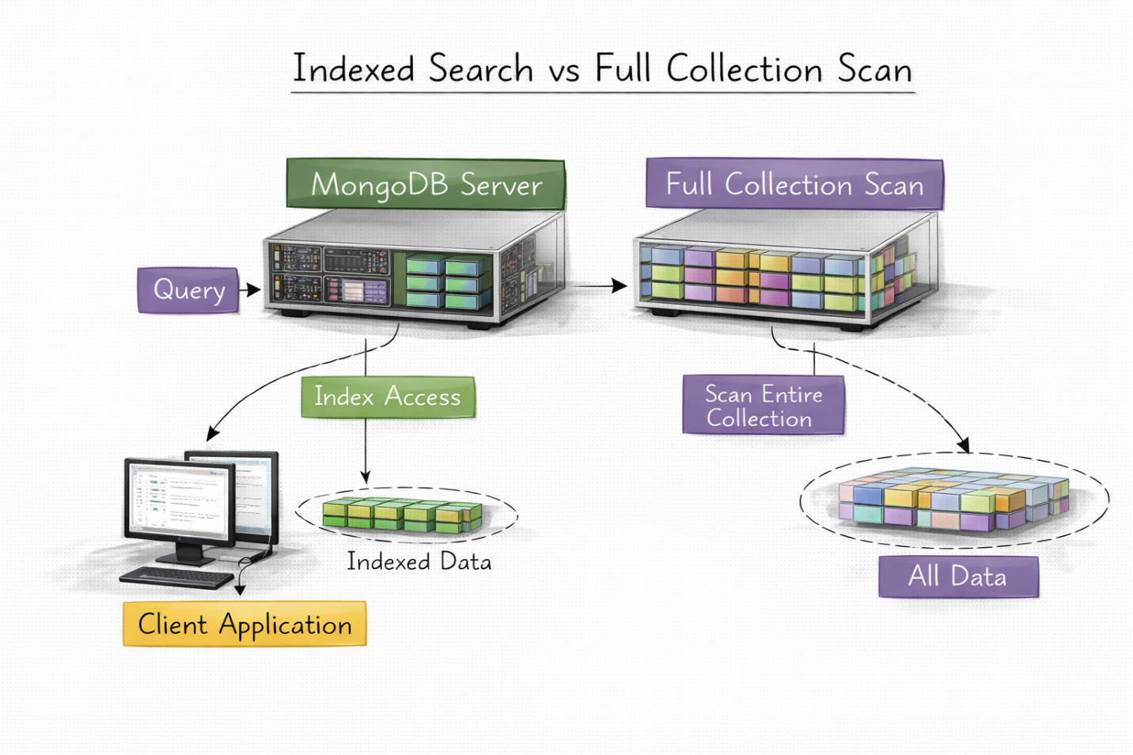
Title: Indexed Search vs Full Collection Scan
Indexing was understood as a critical factor in improving query performance. The session emphasized that while indexes speed up data retrieval, they also introduce overhead during write operations, thereby requiring careful implementation.

4.4 Data Import and Export in Real Systems
The MongoImport and MongoExport tools demonstrated how MongoDB integrates with external data sources. This highlighted its role in data pipelines and real-world analytics workflows.

4.5 Learning Reflection from Day 3
The third session extended the understanding of MongoDB beyond basic operations by introducing advanced methods for data processing and performance optimization. It highlighted the need to design efficient data workflows and to understand trade-offs at the system level.

5. OVERALL LEARNING OUTCOMES AND SYLLABUS IMPLICATIONS
The combined learning from all three sessions gave a complete understanding of MongoDB as an important part of Big Data technologies. From a syllabus point of view, the sessions reinforced key ideas such as distributed systems, data modeling, and performance optimization.
The flipped classroom approach improved analytical thinking and encouraged independent learning. It also showed the importance of practical understanding along with theory, which is necessary for real-world applications.

6. CHALLENGES AND LEARNING GAPS
Despite the wide coverage, some challenges were faced, especially in understanding advanced topics like aggregation pipelines and MapReduce. These concepts need more hands-on practice to become fully clear.
In addition, applying theoretical knowledge in practical situations is still an area that needs continuous improvement

7. CONCLUSION
The flipped classroom sessions offered a complete learning experience by combining theory with practical insights. This approach encouraged active participation, critical thinking, and a deeper understanding of MongoDB and its applications.
Overall, the sessions effectively bridged the gap between academic concepts and industry requirements, helping students prepare for real-world data challenges.

