PROJECT REPORT
ON
From BI to Big Data: Explain, Design & Defend

Subject Name: Big Data Analytics
Subject Code: BAD601
Submitted By: Abhijit Kumar Singh Submitted To:
USN: 1AY23CD001 Ms. Surbhi

SELECT YOUR DEPARTMENT NAME IN THE HEADER AND REMOVE OTHERS.

Table of Contents

Task No. | Task | Page No
1 | Big Data in Daily Life – Visual Storytelling
2 | BI vs Big Data Play
3 | Architecture Design Challenge
4 | Analytics & Tool Match

Task 1:
Big Data in Daily Life – Visual Storytelling

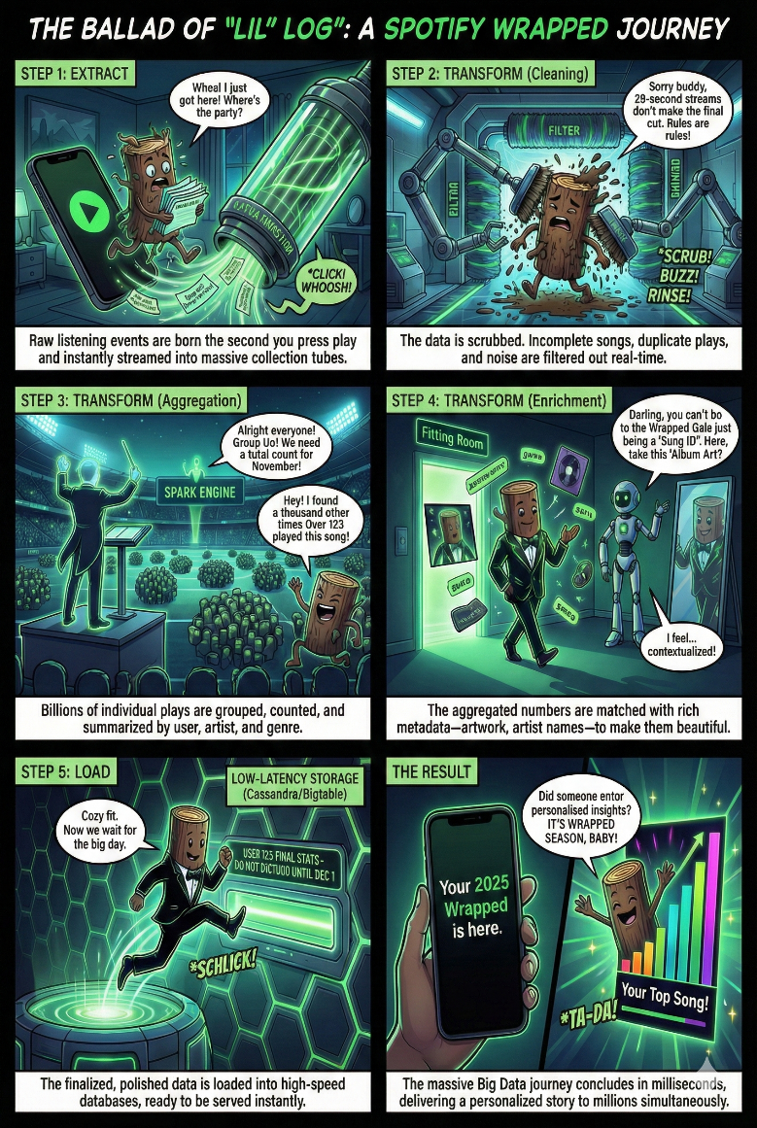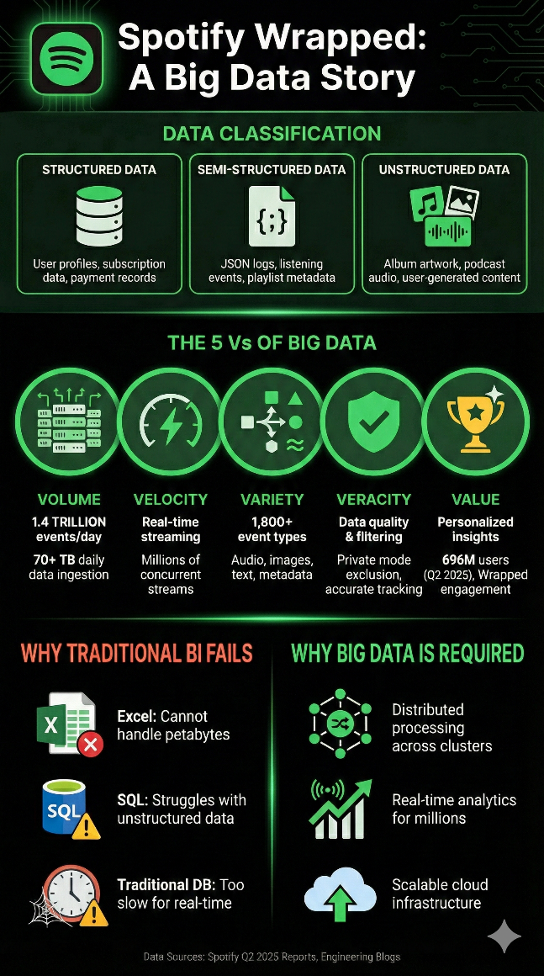

Journey of Data for Spotify Wrapped Spotify Wrapped Infographics

Task 2
BI vs Big Data Play
Setting: A café meeting between Data Consultant (YOU) and Business Manager (FRIEND)

Manager: Hey! So I've been thinking about our data analytics. We're using Excel and SQL databases right now. They work fine for our monthly reports. Why would we need anything more complicated?
Consultant: That's a great question! Let me ask you this - how long does it take to generate your monthly reports?
Manager: Usually about 2-3 days. We run queries overnight, export to Excel, clean the data, create pivot tables... it's our standard process.
Consultant: Right. Now imagine if Spotify tried doing that for Spotify Wrapped. They have 696 million users. If each user has just 1000 listening events per month, that's 696 BILLION records. Excel crashes at about 1 million rows.​
Manager: Okay, but we're not Spotify. We only have a few hundred thousand customers.
Consultant: True, but let's talk about real-time analytics. When a customer opens your app, how quickly can you personalize their experience based on their behavior?
Manager: Well... we can't really do that in real-time. We update recommendations weekly based on last week's data.
Consultant: Exactly! That's where traditional BI falls short. Spotify processes 1.4 TRILLION events DAILY. Every time someone plays a song, skips, likes, or creates a playlist, that data flows through Apache Kafka streams, gets processed in real-time, and updates recommendations within seconds.​
Manager: But why do they need that speed?
Consultant: Because user behavior changes moment-to-moment. If I'm listening to workout music at 6 AM, Spotify knows to recommend high-energy tracks. By 10 PM, it switches to chill vibes. Traditional BI with batch processing can't do that - you'd be showing yesterday's recommendations for today's mood.
Manager: I see. But can't we just upgrade our SQL database?
Consultant: Let's talk about data types. Your SQL database handles structured data beautifully - customer IDs, purchase amounts, dates. But what about images, audio files, social media posts, sensor data? That's unstructured data. Spotify stores album artwork, podcast audio, playlist cover images. Traditional relational databases aren't designed for that.​
Manager: So what's the alternative?
Consultant: Big Data technologies like Hadoop and NoSQL databases. Think of it this way: Traditional BI is like a single powerful truck carrying goods. It works great for regular loads. But Big Data is like a fleet of hundreds of smaller trucks working together in parallel. Spotify uses 690+ node clusters - each handling a piece of the work simultaneously.​
Manager: That sounds expensive and complex.
Consultant: Actually, cloud-based solutions make it affordable. Spotify migrated to Google Cloud Platform. You only pay for what you use, and it auto-scales. During Spotify Wrapped season in December, when traffic spikes 400%, their infrastructure automatically expands. Traditional systems would crash.​
Manager: What about NoSQL? We've always used SQL databases.
Consultant: SQL is fantastic for transactions and structured relationships. But NoSQL databases like Bigtable are designed for massive scale and flexible data. Spotify uses Bigtable to store 5 years of listening history per user, retrieving it in milliseconds. A traditional SQL database would take minutes to join all those tables.​
Manager: Can you give me a concrete business benefit?
Consultant: Spotify Wrapped. It's become a cultural phenomenon generating billions of social media impressions. But technically, it's an incredible feat: analyzing a full year of listening data for 696 million users, generating personalized insights, and delivering it all within seconds. With traditional BI doing batch processing, this would take weeks and cost millions in database processing.​
Manager: So the benefits are speed, scale, and variety of data?
Consultant: Exactly! Plus predictive analytics. Hadoop and Spark enable machine learning at scale. Spotify's recommendation algorithm processes all 1.4 trillion daily events to predict what you'll want to hear next. Traditional BI can tell you what happened last month. Big Data predicts what will happen tomorrow.
Manager: But we'd need to hire a whole team of data engineers, right?
Consultant: Not necessarily. Modern platforms like Google BigQuery and managed Hadoop services (Dataproc) handle the complexity. Your team writes SQL queries, the platform handles the distributed processing across thousands of machines. It's Big Data power with familiar tools.​
Manager: What about data quality? With so much data coming in, how do you ensure accuracy?
Consultant: Great question! That's where Apache Kafka and streaming pipelines shine. Data is validated in real-time as it arrives. Spotify filters out incomplete events, excludes private listening sessions from Wrapped, and catches errors immediately - not days later when you discover your batch job used bad data.​
Manager: I'm starting to see the picture. So when should a company make the jump from BI to Big Data?
Consultant: When you hit any of these walls: 1) Your data volume exceeds what traditional databases handle efficiently, 2) You need real-time insights not daily reports, 3) You're dealing with unstructured data like images, audio, logs, or 4) You want to do advanced machine learning at scale.
Manager: And the evolution path?
Consultant: Most companies don't abandon BI completely. They adopt a hybrid approach. Keep your SQL data warehouse for structured transactional data and compliance reports. Add Big Data infrastructure for real-time analytics, unstructured data, and machine learning. Spotify still uses both - BigQuery for structured analytics alongside Hadoop for massive-scale processing.​
Manager: This is making sense now. The business value is clear - better customer experiences through real-time personalization, the ability to analyze all types of data, and predictions that drive revenue. Traditional BI tells us where we've been. Big Data shows us where we're going.
Consultant: Exactly! And for Spotify, this translates directly to user engagement and retention. Spotify Wrapped alone drives massive re-engagement every December. That's the power of turning Big Data into business value.

Task 3
Architecture Design Challenge

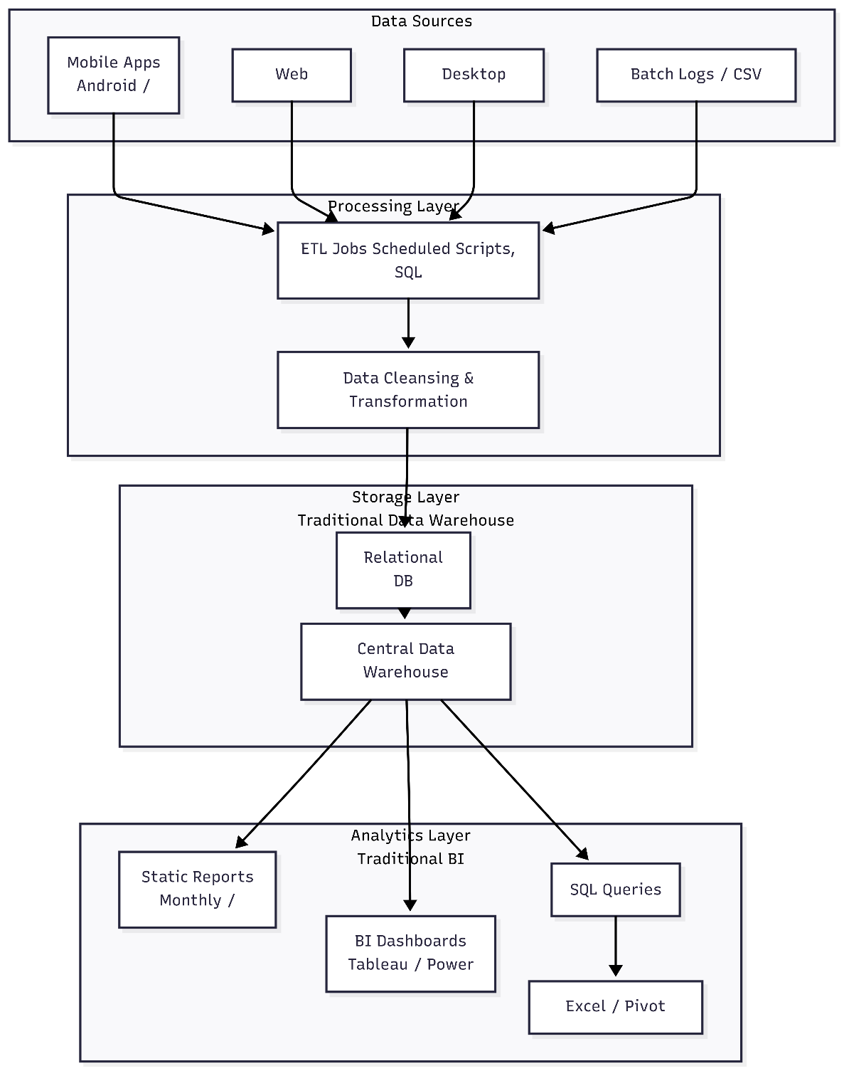
Traditional Data Warehouse Architecture
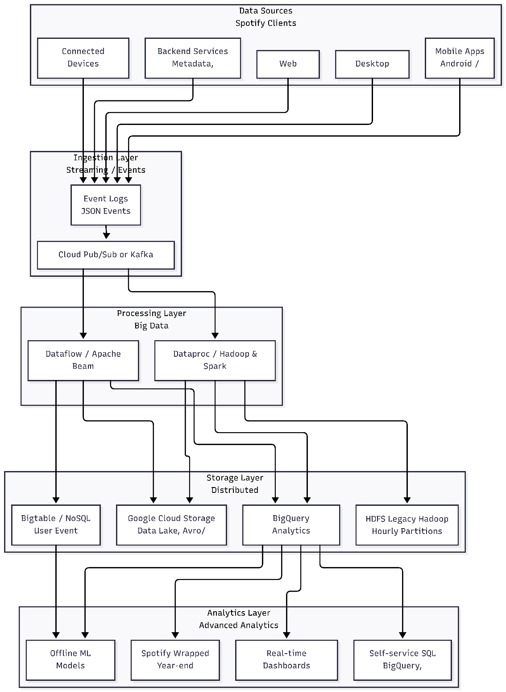
Hadoop / Big Data Architecture
TASK 4: Analytics & Tool Match

Business Question | Analytics Type | Big Data Tool | Spotify Wrapped Example
What happened? (Historical data) | DESCRIPTIVE Analytics | Hadoop + Hive  Batch processing of year's data  BigQuery for SQL analysis | "You listened to 45,000 minutes of music in 2025"  "Your top artist was Taylor Swift (328 plays)"
Why did it happen? (Pattern discovery) | DIAGNOSTIC Analytics | Apache Spark  Machine Learning for insights  Pattern recognition algorithms | "You discovered indie music through Discover Weekly"  "Your listening peaked during evening commutes"
What will happen next? (Future trends) | PREDICTIVE Analytics | ML Models + BigQuery  User behavior prediction  Trend forecasting | "Your top genre next year will likely be Electronic"  "You'll discover 150+ new artists next year"
What action should be taken? (Recommendations) | PRESCRIPTIVE Analytics | Real-time systems  Kafka + Bigtable  Personalization engine | "Try these new artists similar to your top 5"  "Here's your personalized 2026 playlist"

Task 5:
Bonus Challenge
How Spotify Wrapped Works - The LEGO Team Story
Imagine you have a giant pile of LEGO pieces and want to build an awesome Star Wars X-Wing. Doing it alone would take forever - you'd be sorting colors, finding the right shapes, and trying to figure out where everything goes.
Instead, you call all your friends to help. Here's how it works perfectly:
You divide up the pieces. One friend sorts all the red cockpit pieces. Another grabs just the wing parts. Someone else finds all the engine pieces. Each friend only handles one small job, so they finish super fast.
While one friend sorts red pieces, another sorts blue ones at the exact same time. No one waits around. Everyone works together, making the whole project lightning fast.
But you still need someone smart to check everyone's work. That's you - the team leader. You look at all the sorted piles and say, "Perfect! Red cockpit goes here, blue wings go there, now snap it all together!" Suddenly, you have a complete X-Wing.
This is exactly how Spotify builds your Wrapped.
Every song you play, skip, or save becomes one LEGO piece. Spotify's computers act like your friends - one computer sorts all your Minecraft music moments, another handles Among Us gaming tracks, another finds your superhero movie songs.
They all work at the same time, super fast. Then a master computer (that's you, the team leader) takes all their sorted piles and builds your personal music story: "Here's your gaming cockpit music, your squad wing tracks, your epic engine anthems!"
One computer alone would drown in everyone's music pieces. But hundreds of computers working as a team, plus one smart leader to put it all together? That's Big Data magic - turning chaos from millions of kids' music into your perfect personal Wrapped story, ready in seconds!

Add Table of Contents

- About the Project (2 pages)
- About the Tools and Technologies Used (5 Pages)
- Detailed description about your contribution (Explain what is done and how it is done (2 pages). Include the coding part that you have done(varies). Explain code in detail (2 pages).)
- Implementation Code (whole project code (varies))
- Results (Description with proper screenshots: 2-3 Pages)

Note0: Front page should be as in this report. Then Table of Contents with page number for each topic.
Note1: Use Times New Roman. Main heading 14, bold. Sub heading 12, bold. Content 12. Justified. Plagiarism free.
Note2: Tables or any diagrams must be named and size 10
Note3: Use Page Numbers as footer.

