dpnranker.com - Technical Reference Manual

1. Document Information
Property | Details
Product Name | dpnranker.com (Dentsu Podcast Network Ranker)
Version | 2.0
Document Date | July 21, 2026
Owner | Dentsu Podcast Network
Purpose | Official technical reference, architectural baseline, and security implementation guide.
Intended Audience | AI & InfoSec, Compliance, and Audit Stakeholders

Revision History
Version | Date | Author | Description
1.0 | 2026-06-25 | Dentsu Podcast Network | Initial baseline version representing the production deployment architecture.
2.0 | 2026-07-21 | Dentsu Podcast Network | Security improvements including rate limiting, strict HTTP headers, and IDOR prevention details.

2. Executive Summary
dpnranker.com is a proprietary web application developed for the Dentsu Podcast Network. It serves as a centralized creator marketplace and algorithmic podcast ranking index.

Business Purpose
The platform connects brands, agencies, and podcast creators by aggregating real-time analytics. It replaces fragmented data collection with a unified, transparent, and algorithmic "DPN Score" that normalizes audience penetration against engagement vectors. This empowers advertisers to make data-driven media investments while giving creators a platform to showcase their verified analytics.

Core Capabilities
- Algorithmic Ranking Engine: Synthesizes logarithmic scaling of 7-day cumulative YouTube audience penetration with relative engagement density vectors.
- Creator Management: Automated onboarding workflows allowing creators to securely claim their indexed podcasts via Magic Link verification.
- Agency Portal: Dedicated interfaces for media buyers and agency representatives to explore verified podcast inventory.
- Admin Orchestration: Centralized Super Admin controls to seed new podcasts, manage rankings, enforce data integrity, and dictate feature flags.

3. System Architecture
The application employs a decoupled, serverless-oriented architecture leveraging Next.js (App Router) backed by Supabase (PostgreSQL + Auth).
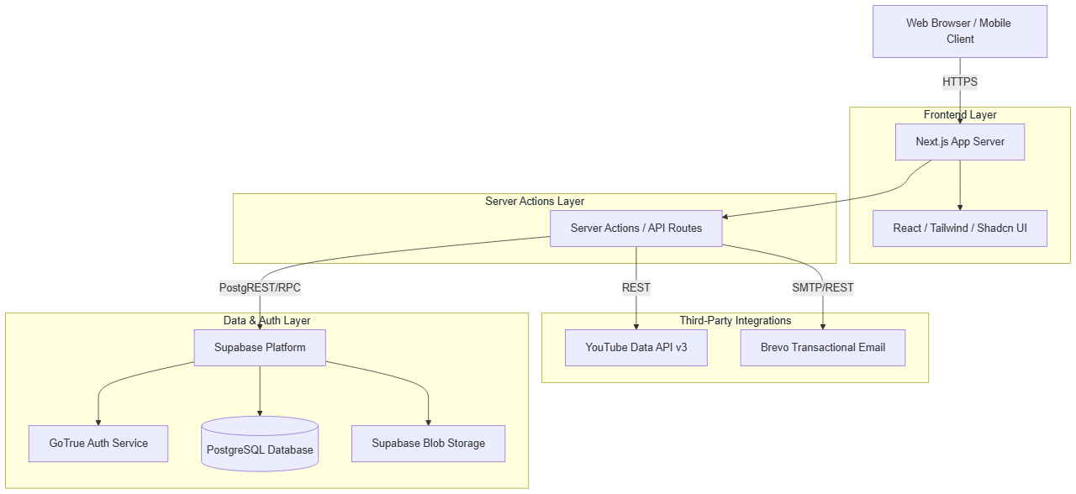

Deployment Architecture
The application is currently containerized and deployed via PM2 on a managed Ubuntu VPS (Hostinger), utilizing Nginx as a reverse proxy with SSL termination.

4. Technology Stack
Technology | Category | Purpose | Integration Profile
Next.js (v14+) | Framework | Full-stack React framework utilizing App Router. | Handles all routing, SSR/SSG rendering, and Server Actions for secure backend execution.
React | UI Library | Component-based UI rendering. | Powers the client-side interactivity and state management.
Tailwind CSS | Styling | Utility-first CSS framework. | Enables rapid, consistent, and responsive styling across the platform.
Shadcn UI | UI Components | Accessible, customizable component primitives. | Provides the baseline design system (buttons, modals, tooltips) ensuring UI consistency.
Supabase | Backend-as-a-Service | Database, Auth, and Storage. | Core data layer; utilizes PostgreSQL with Row Level Security (RLS) to enforce data boundaries.
YouTube API v3 | External API | Data ingestion and analytics tracking. | Fetches live subscriber counts, views, latest video URLs, and topic categories for algorithmic scoring.
Brevo | Email Service | Transactional email orchestration. | Delivers secure Magic Links and administrative invites.
PM2 | Process Manager | Production process orchestration. | Ensures the Next.js Node process runs continuously on the Hostinger VPS with automatic restarts.
[!NOTE]
Supabase is utilized as a hosted PaaS, offloading database maintenance, real-time socket management, and authentication infrastructure to a specialized provider.

5. Functional Modules

5.1. The Ranker Engine
- Purpose: Calculates and displays the proprietary DPN Score.
- Inputs: YouTube Subscriber Count, Total Views, Total Videos, Views (Last 7 Days).
- Business Logic: Applies a proprietary, non-linear algorithmic matrix to generate a normalized index.
- Dependencies: YouTube API, Postgres podcasts table, Postgres channel_stats_history table.

5.2. Identity & Access Management (IAM)
- Purpose: Manages user registration, role assignment, and access controls.
- Inputs: OAuth tokens, Email/Password, Magic Link tokens.
- Business Logic: Maps authenticated sessions to profiles.role (e.g., creator, agency_user, super_admin). Restricts UI elements and server actions based on these roles.
- Dependencies: Supabase GoTrue.

5.3. Admin Orchestration Console
- Purpose: Empowers administrators to manage the platform without direct database access.
- Business Logic: Allows admins to seed podcasts via YouTube URLs, manually override genres, revoke unauthorized claims, and manually trigger 7-day stat recalculations.
- Security: Protected by strict getAdminUser() server-side validations utilizing the SERVICE_ROLE_KEY to bypass standard RLS when performing global administrative tasks.

6. Process Flows

Creator Claim Workflow
This is a critical security workflow designed to prevent Insecure Direct Object Reference (IDOR) takeovers of podcast profiles.
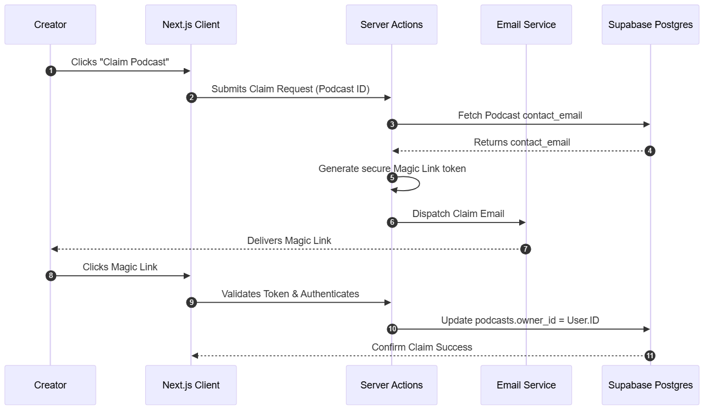

YouTube Data Synchronization
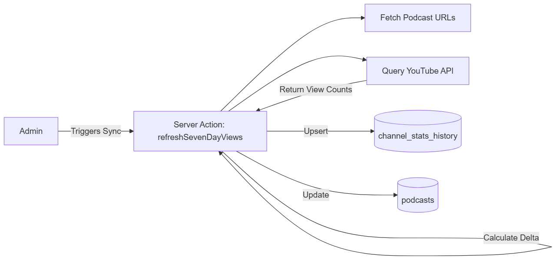

7. API Documentation

Internal Server Actions (Next.js)
The application relies heavily on Next.js Server Actions rather than traditional REST endpoints.
- adminSeedPodcast(youtubeUrl): Fetches YouTube channel statistics and inserts a new seeded record.
- refreshSevenDayViews(): Iterates over all approved podcasts to fetch current metrics and calculate the 7-day delta.
- updatePodcastGenre(id, newGenre): Updates the canonical genre using standardized dropdown values.

External API Usage: YouTube Data API v3
- Endpoints Used: /channels, /playlistItems, /videos
- Rate Limits: Bounded by Google Cloud Quotas (default 10,000 units/day).
- Error Handling: Graceful fallbacks implemented. If the API fails or rate limits are hit, the application retains the most recent valid snapshot.

8. Database Design
The database is built on PostgreSQL, hosted via Supabase.

Core Entity-Relationship Model
- profiles: Extends the auth.users table. Contains role, full_name, and company.
- podcasts: The primary entity. Contains statistics, URLs, metadata, and algorithmic inputs. Linked to profiles.id via owner_id.
- channel_stats_history: Time-series table logging daily snapshots of total_views and subscriber_count for trend analysis.
- agencies: Stores agency profiles and verification status.
[!TIP]
The channel_stats_history table utilizes a unique constraint on (podcast_id, recorded_date) to facilitate idempotency via upsert operations.

9. Security Architecture
The platform was engineered with a security-first posture, anticipating modern threat vectors.

9.1. Access Control & IAM
- Authentication: Managed entirely by Supabase Auth (GoTrue), ensuring industry-standard hashing, session management, and JWT signing.
- Row Level Security (RLS): Enabled on all Postgres tables. Database policies explicitly define read/write permissions based on auth.uid().
- Server-Side Authorization: Next.js Server Actions re-verify permissions utilizing a rigorous getAdminUser() utility before processing administrative state mutations.

9.2. Protection Against Common Threats
Threat Vector | Mitigation Strategy
SQL Injection | Nullified via Supabase ORM/PostgREST which natively parameterizes all database queries.
XSS (Cross-Site Scripting) | React inherently escapes dynamic content rendering. Unsafe raw HTML injection (dangerouslySetInnerHTML) is strictly prohibited.
CSRF (Cross-Site Request Forgery) | Next.js Server Actions implement native Origin validation and anti-CSRF tokens.
IDOR / Privilege Escalation | Ownership mutations (e.g., claiming a podcast) require out-of-band verification (Magic Link sent to the canonical channel email). Server actions explicitly validate the requesting user's owner_id.
Secrets Leakage | Critical tokens (SUPABASE_SERVICE_ROLE_KEY, YOUTUBE_API_KEY) are isolated to server-side environments and never exposed to the client bundle (NEXT_PUBLIC_ prefix is strictly avoided for sensitive keys).
DDoS & Spam (Feature Abuse) | In-memory IP-based rate limiting is enforced on sensitive forms (e.g., switchUserCategory for creator applications) to prevent automated spam and exhaustion.
Clickjacking & MIME-Sniffing | next.config.ts enforces X-Frame-Options: DENY, X-Content-Type-Options: nosniff, and Strict-Transport-Security headers on all responses.
[!CAUTION]
RLS Bypass Note: Administrative functions purposefully utilize the Supabase SERVICE_ROLE_KEY to bypass Row Level Security. This is a design requirement for global admin actions. The security of this bypass relies entirely on the integrity of the getAdminUser() check at the entry point of the server action.

10. Privacy & Compliance

DPDP Act (2023) Considerations
The platform adheres to the principles of India's Digital Personal Data Protection Act (2023):
- Data Minimization: We collect only essential personal data explicitly required to facilitate B2B portal functionality.
- Consent Management: Through our Creator and Agency signup forms, users are presented with clear opt-in requirements. Users provide express consent prior to sharing any personal or corporate information onto the platform.
- Purpose Limitation: Information collected through verified opt-ins is used strictly for platform services (such as matchmaking creators with agencies) and is not repurposed or sold to non-participating third parties.

11. Reliability & Operations
- Hosting Environment: Ubuntu VPS via Hostinger.
- Process Management: pm2 ensures process persistence and automatic restarts on crash.
- Data Backups: Handled natively by the Supabase platform (Point-in-Time Recovery enabled based on project tier).
- Graceful Degradation: If the YouTube API experiences an outage, the platform gracefully degrades by displaying the last known cached metrics rather than returning 500 errors to the client.

12. Deployment
Current Deployment Pipeline (Manual/Scripted):
- Code is versioned in GitHub.
- Administrator SSH access into the Hostinger VPS.
- Execution of the deployment script: cd /root/dpn-ranker git pull npm run build pm2 restart dpnranker ​
[!IMPORTANT]
This manual CI/CD pipeline is sufficient for v1.0 but may transition to automated GitHub Actions in future iterations to enforce testing gates before deployment.

13. Risks & Assumptions

Technical Assumptions
- YouTube API Stability: The algorithmic engine assumes the YouTube API schema and quota availability will remain consistent.
- Single Node Deployment: The Next.js application runs on a single VPS. It assumes traffic patterns will remain within the vertical scaling limits of the instance.

Potential Risks
- Rate Limiting Exposure: Server Actions currently lack strict IP-based rate limiting. Malicious actors could theoretically trigger API exhaustion if public endpoints (like adminSeedPodcast) are abused, though this is mitigated by admin auth gates.

14. Feature Update Log
Version: 1.0
Release Date: June 25, 2026
Summary: Baseline Production Release
New Features
- Initial deployment of algorithmic Ranker Engine.
- Secure Creator Claim workflow via Magic Link.
- Super Admin orchestration dashboard.
Enhancements
- Standardized canonical genre dropdowns across all creator, agency, and admin portals.
Security Improvements
- Implementation of out-of-band email verification to prevent IDOR attacks during podcast claiming.
- Strict Role-Based Access Control (RBAC) enforced on all server actions.
Infrastructure Changes
- PM2 production deployment on Hostinger VPS.
- Supabase integration configured for Auth and Database persistence.

