HKHT AI FOR SEVA
Master Consolidated Blueprint
HKHT AI for Seva — Enterprise Operating Platform
14 Workflows · 5 Journeys · One AI-First, 1000X-Optimized, End-to-End Automated Enterprise

Document | Master Consolidated Blueprint (the whole picture)
Covers | WF-001 to WF-014 + 5 end-to-end journeys + platform governance
Stack | Google-first: Gemini Enterprise · Vertex AI Agent Builder · BigQuery · Looker · AppSheet · Apps Script
Operating model | 30-Day Production Base + 60-Day Stabilization + 75-Day Enterprise Scale
North star | 1000X revenue & seva growth at minimum human intervention, maximum trust
Status | Consolidated blueprint v1.0

Hyderabad AI Revenue & Seva Growth Platform · Operating model: 30-Day Production Base + 60-Day Stabilization + 75-Day Enterprise Scale

1. Executive Overview
HKHT's Hyderabad operation is being rebuilt as one integrated, AI-first enterprise platform rather than a collection of isolated automations. Fourteen workflow modules share a single identity model, one approval discipline and one leadership command center. Together they form five end-to-end journeys that compound revenue and seva. This document is the whole picture: the architecture, the agentic operating mesh, the data spine, the journeys, the governance, the integration set, and the roadmap to a 1000X-scaled operation that runs at minimum human intervention while keeping every sensitive decision human-governed.
Core rule: Start small in execution. Start big in architecture. Start immediately in data discipline. Start revenue-first. Start human-governed. Start platform-compatible.

2. The Whole Picture — Platform Architecture
Seven layers bind every workflow into one operating model. Channels sit on top; a single command center gives leadership visibility; an agent-orchestration layer runs the work; deterministic automation and a shared data/identity spine sit beneath; knowledge & media and a governance/trust layer run through everything.
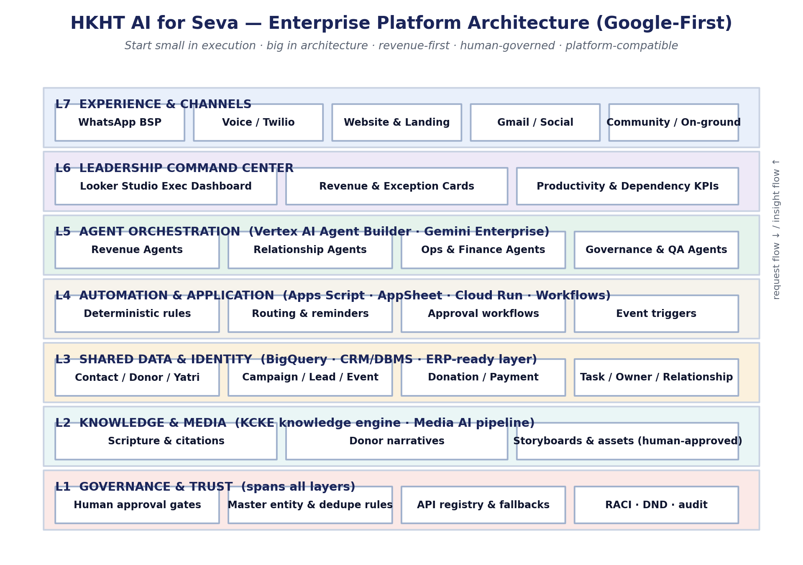
Figure 2.1 — The integrated, Google-first platform architecture.

Core architecture layers
Layer | Purpose | Primary Google-first technology
L7 Experience & Channels | Where devotees, donors and yatris interact | WhatsApp BSP · Twilio voice · Website · Gmail/Social
L6 Leadership Command Center | One daily executive view of the whole platform | Looker Studio (BigQuery)
L5 Agent Orchestration | ~130 specialist agents run the work | Vertex AI Agent Builder · Gemini Enterprise
L4 Automation & Application | Deterministic rules, routing, approvals, triggers | Apps Script · AppSheet · Cloud Run · Workflows
L3 Shared Data & Identity | One identity, source and relationship spine | BigQuery · CRM/DBMS · ERP-ready layer
L2 Knowledge & Media | Source-grounded content and approved media | KCKE engine · Media AI pipeline
L1 Governance & Trust | Approvals, dedupe, registry, RACI, audit | Spans all layers

3. AI-First Operating Model
- Treat current process as the problem record: not the target design.
- Deterministic automation: for validation, reminders, routing, status changes and dashboards.
- AI assistance: for classification, summarization, drafting, recommendation, anomaly detection and next-best-action.
- Agentic workflows: switched on only after data quality, approval routing and fallback paths are validated.
- Sensitive decisions stay human: with AI preparing decision-quality context.

4. The Agentic Operating Mesh
Each workflow is delivered by a team of narrow, cooperating agents. Around 130 specialist agents share one identity model, write to one warehouse, and surface on one command center. A platform orchestrator coordinates cross-workflow hand-offs.
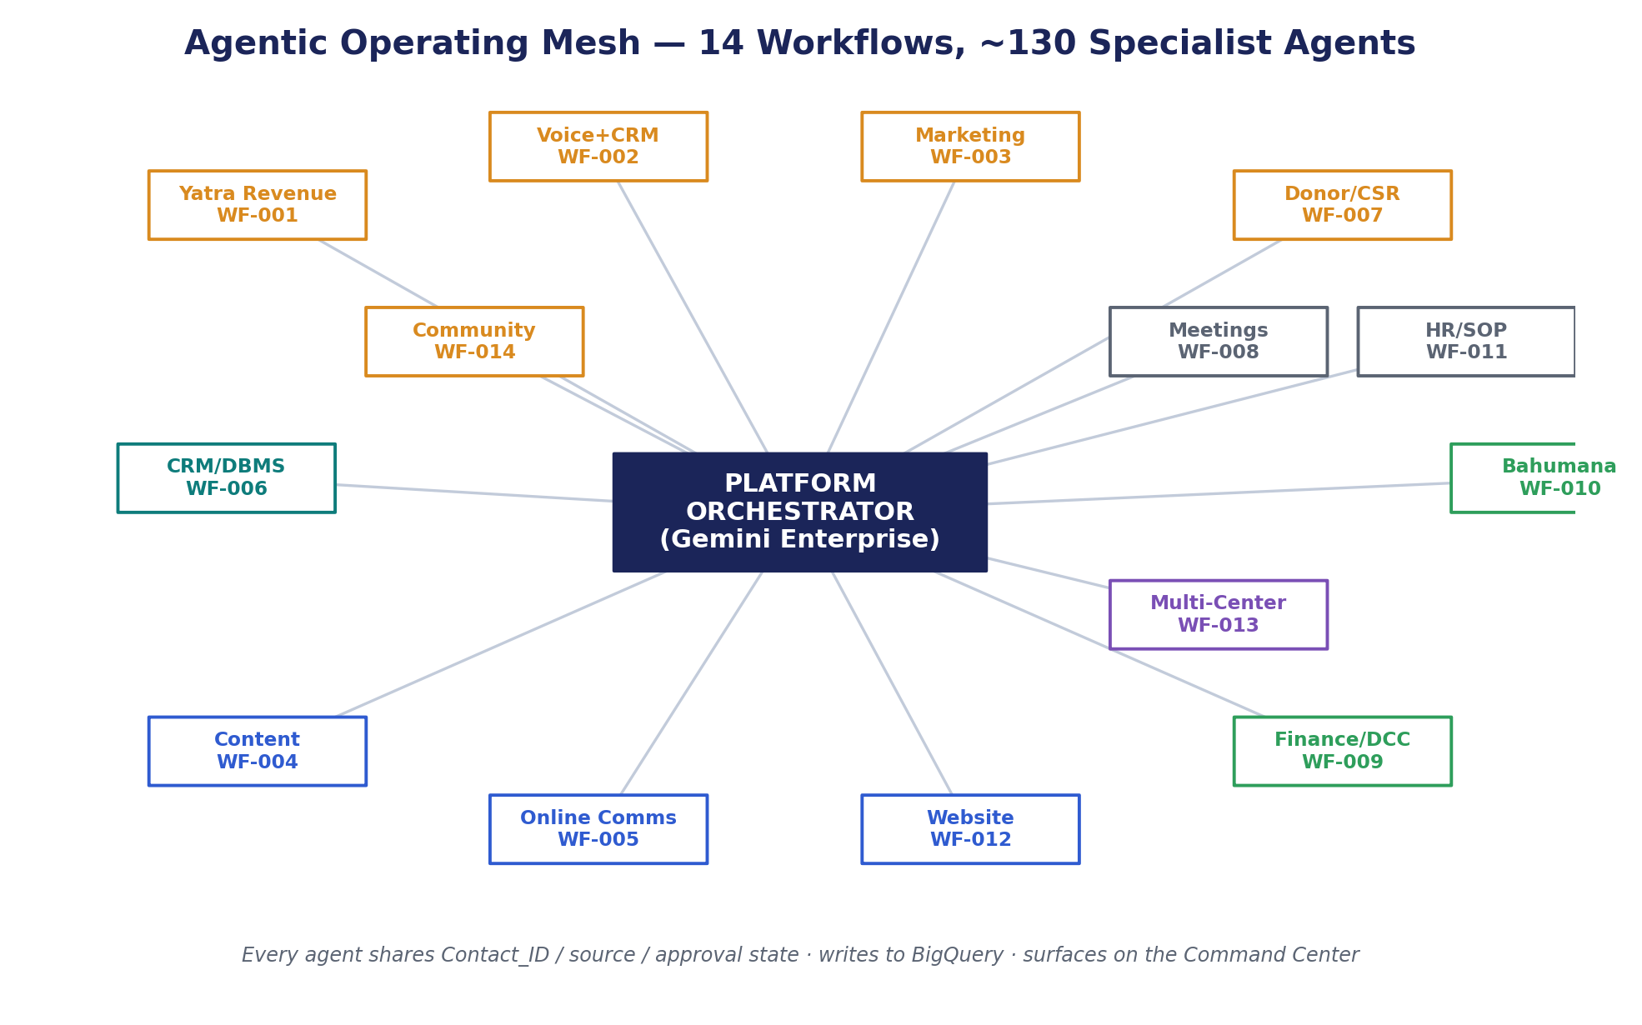
Figure 4.1 — The 14-workflow agentic operating mesh.
WF | Workflow | Agents
WF-001 | Yatra Lifecycle Automation | 10
WF-002 | Voice Agent Calling + CRM Follow-up | 6
WF-003 | Digital Marketing Campaign Automation | 12
WF-004 | Content Factory + Approval Workflow | 12
WF-005 | Online Communications / Digital Reception Desk | 9
WF-006 | CRM / DBMS / Data Governance | 12
WF-007 | Donor / LLP / CSR Cultivation | 8
WF-008 | Meeting Intelligence + Task Governance | 10
WF-009 | Finance / DCC / Payment / P&L Intelligence | 8
WF-010 | Bahumana / Prasadam / Inventory / Dispatch | 10
WF-011 | HR / SOP / KT / Team Management | 12
WF-012 | Website / Landing Page / Tech Support Automation | 11
WF-013 | Multi-Center Replication System | 8
WF-014 | Community Outreach System | 15
— | TOTAL specialist agents | 143

5. The Shared Data Spine (Master Entity Model)
Interoperability comes from one shared data contract owned by WF-006. Every workflow uses the same entities and IDs; nothing is created without a resolved Contact_ID, a source and an owner.
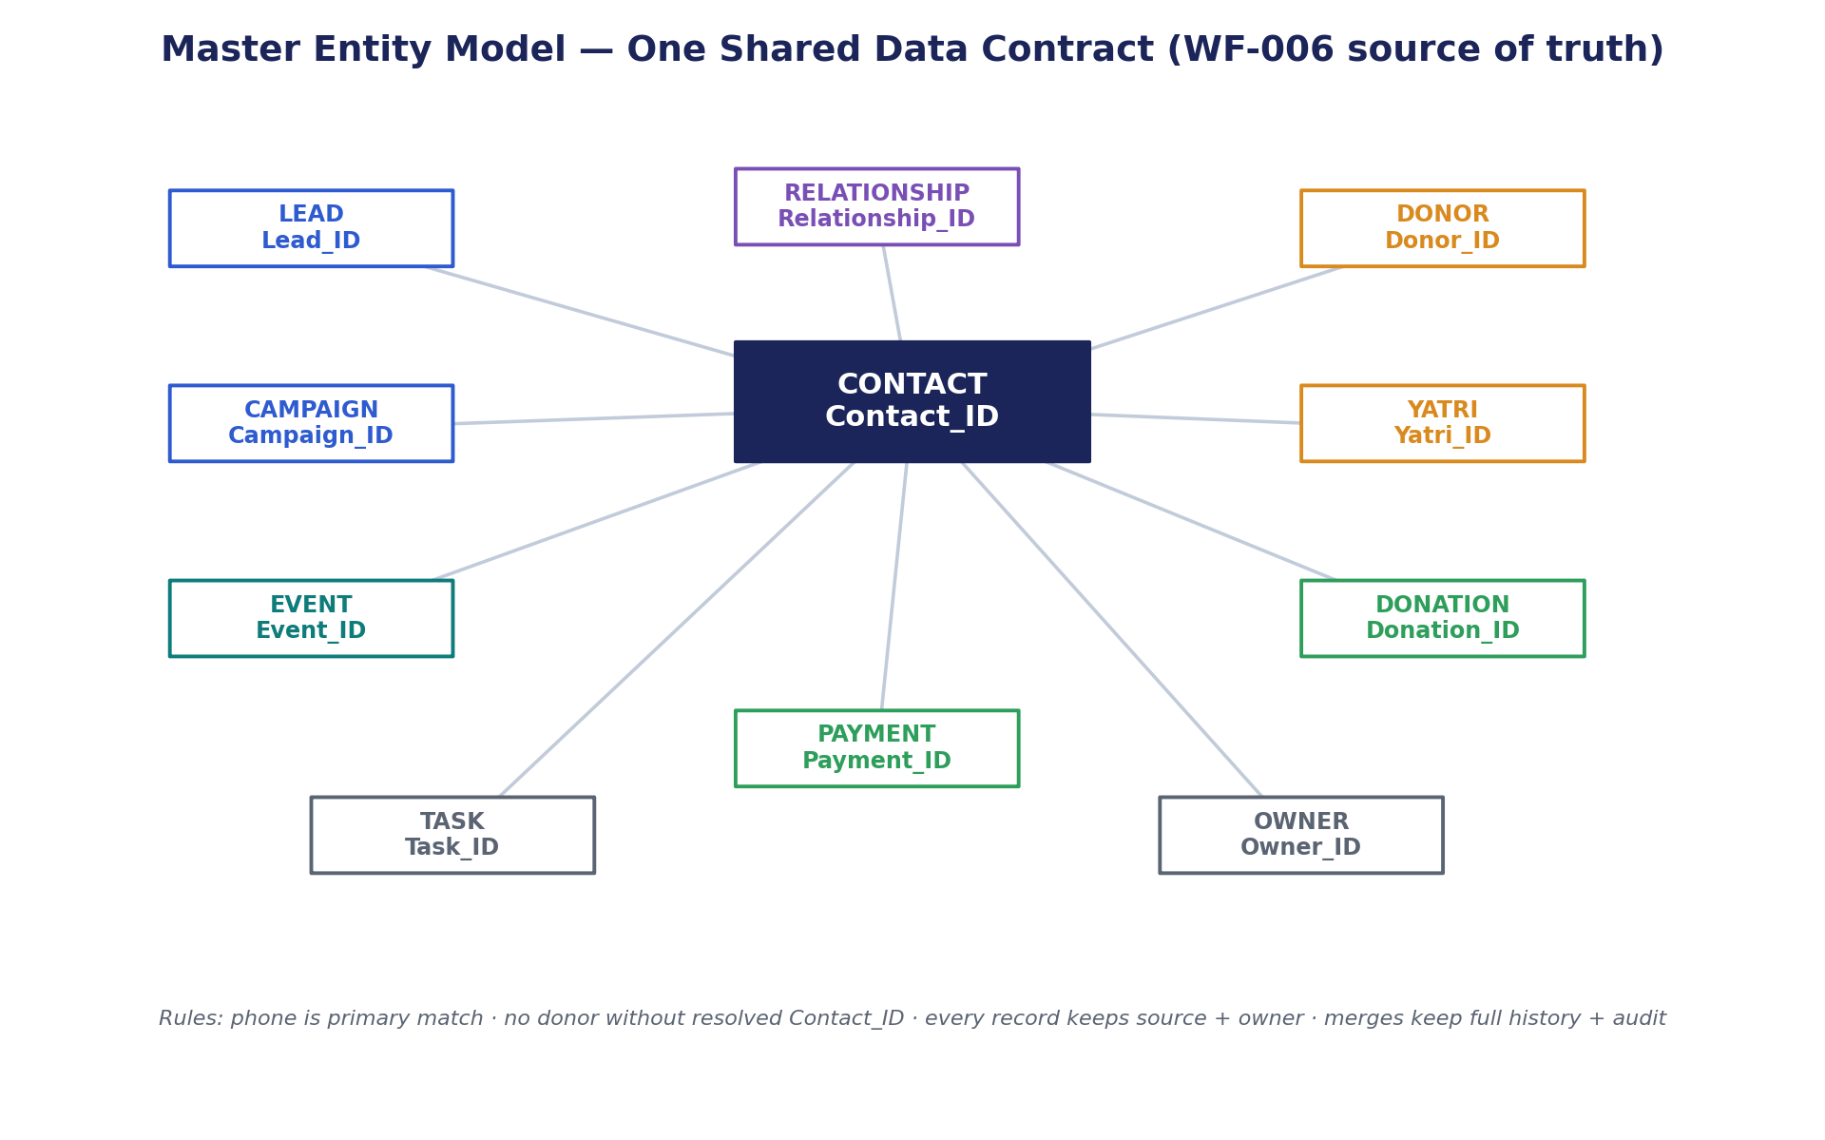
Figure 5.1 — Master entity model and relationships.
Entity | Primary ID | Source of truth
Contact | Contact_ID | CRM / DBMS
Donor | Donor_ID | CRM + finance/ERP layer
Yatri | Yatri_ID | Yatra module + CRM
Lead | Lead_ID | CRM / lead capture
Campaign | Campaign_ID | Campaign tracker / CRM
Event | Event_ID | Event/community tracker
Donation | Donation_ID | Finance / DCC / ERP layer
Payment | Payment_ID | Finance / DCC / ERP layer
Task | Task_ID | ClickUp / task layer
Owner | Owner_ID | HR / SOP / ClickUp
Relationship | Relationship_ID | CRM intelligence layer

Data rules: Phone is the primary match signal; high-value donors are never auto-merged; merges keep full history with an audit note; every record retains origin and last meaningful source.

6. The 14-Workflow Portfolio
Each workflow has its own detailed document. Summarised here with build sequence, accountable owner and platform role.
WF / Seq | Name | Owner | Platform role
WF-006  seq #1 | CRM / DBMS / Data Governance | Sachi Pr + Hemchand | The data backbone every other workflow stands on: one clean, deduplicated, source-tracked, consent-aware identity and re
WF-002  seq #2 | Voice Agent Calling + CRM Follow-up | Hemchand | The conversion accelerator: AI voice + disciplined CRM follow-up that turns lists and leads into qualified, booked and c
WF-001  seq #3 | Yatra Lifecycle Automation | Arjun Bandu Pr | The flagship revenue engine: turns pilgrimage demand into enrolled, paid, served and re-cultivated yatris while feeding
WF-003  seq #4 | Digital Marketing Campaign Automation | Hemchand | The demand factory: plans, launches and optimises paid + organic campaigns that feed qualified, attributed leads into ev
WF-007  seq #5 | Donor / LLP / CSR Cultivation | Shruta Deva Prabhu | The lifetime-value engine: cultivates donors, LLP relationships and CSR/HNI partners into recurring, growing, deeply-ser
WF-014  seq #6 | Community Outreach System | Maha Bhuja Prabhu | The grassroots pipeline: enters, nurtures and converts gated communities and cultural events into contacts, donors, yatr
WF-012  seq #7 | Website / Landing Page / Tech Support Automation | Hemchand | The conversion surface and digital reliability layer: ships fast, accurate, payment-ready pages and keeps everything onl
WF-009  seq #8 | Finance / DCC / Payment / P&L Intelligence | Shruta Deva Prabhu | The trust and truth layer: reconciles every rupee, validates receipts, resolves suspense, and gives leadership real-time
WF-008  seq #9 | Meeting Intelligence + Task Governance | Shravan | The execution backbone: converts every meeting decision into owned, tracked, closed tasks — so strategy actually ships.
WF-004  seq #10 | Content Factory + Approval Workflow | Satish | The source-grounded creative supply chain: produces approved, on-brand, scripturally accurate content and assets that fu
WF-005  seq #11 | Online Communications / Digital Reception Desk | Deepak | The always-on front door: unifies every inbound message across channels, replies fast and accurately, and routes intent
WF-010  seq #12 | Bahumana / Prasadam / Inventory / Dispatch | Sahoo | The gratitude-in-action engine: turns donations into well-chosen, in-stock, correctly-dispatched prasadam and gifts — an
WF-011  seq #13 | HR / SOP / KT / Team Management | Rajendra Prasad | The capacity and continuity layer: ensures every workflow has trained, role-clear, backed-up people — and that knowledge
WF-013  seq #14 | Multi-Center Replication System | Mukund Prabhu | The scale multiplier: packages the validated Hyderabad operating model into a replicable, standardised-yet-localisable b

7. Programme Sequencing & Go / No-Go Gates
Build order is deliberate: the data backbone first, then the revenue cluster, then execution, finance, content, operations and finally replication. Each step has a gate that must pass before scale.
Sequence | Workflows | Gate before scale
1 · Data Backbone | WF-006 | Contact_ID rules, duplicate policy, source fields approved
2 · P0 Revenue Cluster | WF-001/002/003/007/014/012 | CRM, owner, dashboard and fallback paths validated
3 · Execution Backbone | WF-008, WF-011 | ClickUp structure and RACI routing validated
4 · Financial Control | WF-009 | Payment & receipt exception visibility tested
5 · Content / Knowledge / Media | WF-004 + KCKE/Media AI | Source citation, review and approval path validated
6 · Operations Support | WF-010 | Inventory, courier and donor notification path validated
7 · Replication Package | WF-013 | Platform brief, data model, QA and governance pack accepted

Gate discipline: No scaled go-live without a CRM path, an owner path, dashboard visibility and a verified manual fallback. Use controlled / near-production dummy data when source, owner or approval path is unconfirmed.

8. The Five End-to-End Journeys
The workflows intermingle to form five revenue- and seva-compounding journeys. Each has its own detailed document; the golden journeys below are the platform's acceptance backbone.

J1 · Yatra & Pilgrimage Revenue
The pilgrimage journey is HKHT's highest-intent revenue path. Optimised end-to-end on shared data, it converts more leads at higher fill and margin, loses nothing to manual chasing, and turns every yatri into a cultivated lifetime donor.
Workflows: WF-003, WF-002, WF-001, WF-009, WF-010, WF-006, WF-007
Golden journey: Digital ad lead → CRM → voice follow-up → Yatra registration → payment → bahumana → donor follow-up

J2 · Donor / LLP / CSR Lifetime Value
Durable revenue comes from cultivated relationships, not one-off gifts. This journey systematises stewardship across channels so recurring giving, retention and major/CSR gifts compound — while keeping the personal, trust-based core human.
Workflows: WF-005, WF-003, WF-006, WF-007, WF-009, WF-010, WF-012
Golden journey: Donor inquiry / community contact → landing page → payment → receipt → donor cultivation → dashboard

J3 · Content, Brand & Communications
Content and communications are the demand and trust layer. Source-grounded, fast, on-brand content distributed across optimised channels and pages turns attention into attributed pipeline — safely and at scale.
Workflows: WF-004, WF-003, WF-005, WF-012, WF-006
Golden journey: Content request → KCKE grounding → Media AI / creative → approval → publishing → conversion

J4 · Internal Operations & Governance
Execution backbone. Decisions become accountable tasks, the right people are in place with captured knowledge, and data/finance governance keeps the platform trustworthy — collapsing managerial chasing and freeing leadership for revenue.
Workflows: WF-008, WF-011, WF-006, WF-009
Golden journey: Meeting decision → ClickUp task → owner follow-up → leadership dashboard

J5 · Scale & Replication
1000X is realised at the network level. Grassroots community outreach builds deep pipelines; the validated Hyderabad model is then packaged and replicated across centers, compounding revenue and seva far beyond one location.
Workflows: WF-014, WF-013, WF-006, WF-007
Golden journey: Community event → nurture → donation → donor cultivation → packaged module → new center

9. The 1000X Revenue & Seva Model
1000X is not one big bet; it is a ladder of compounding leverage. Control and visibility remove leakage (2X); agents remove manual chasing (10X); always-on conversion across channels (30X); all journeys compounding on shared data (100X); and a replicable model plus institutional memory across centers (1000X).
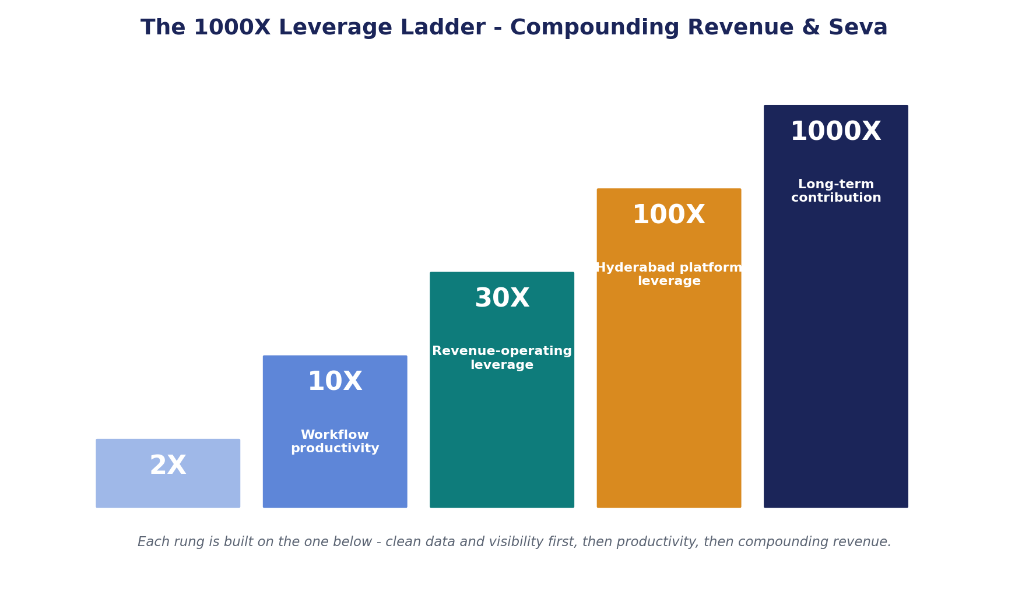
Figure 9.1 — The compounding leverage ladder.
Every workflow contributes specific, measurable levers (detailed in each workflow document). The platform-level outcomes are: zero revenue leakage, always-on conversion, lifetime relationship value, collapsed managerial dependency, and a network effect across replicated centers.

10. Consolidated Integration Registry (Essential Only)
Integrations are deliberately minimal — built only where essential, each with a confirmed/pending status and a manual fallback. The dialer is moved to Twilio in place of unsupported tools such as Hello Leads; this is a small, intentional swap, not a headline.
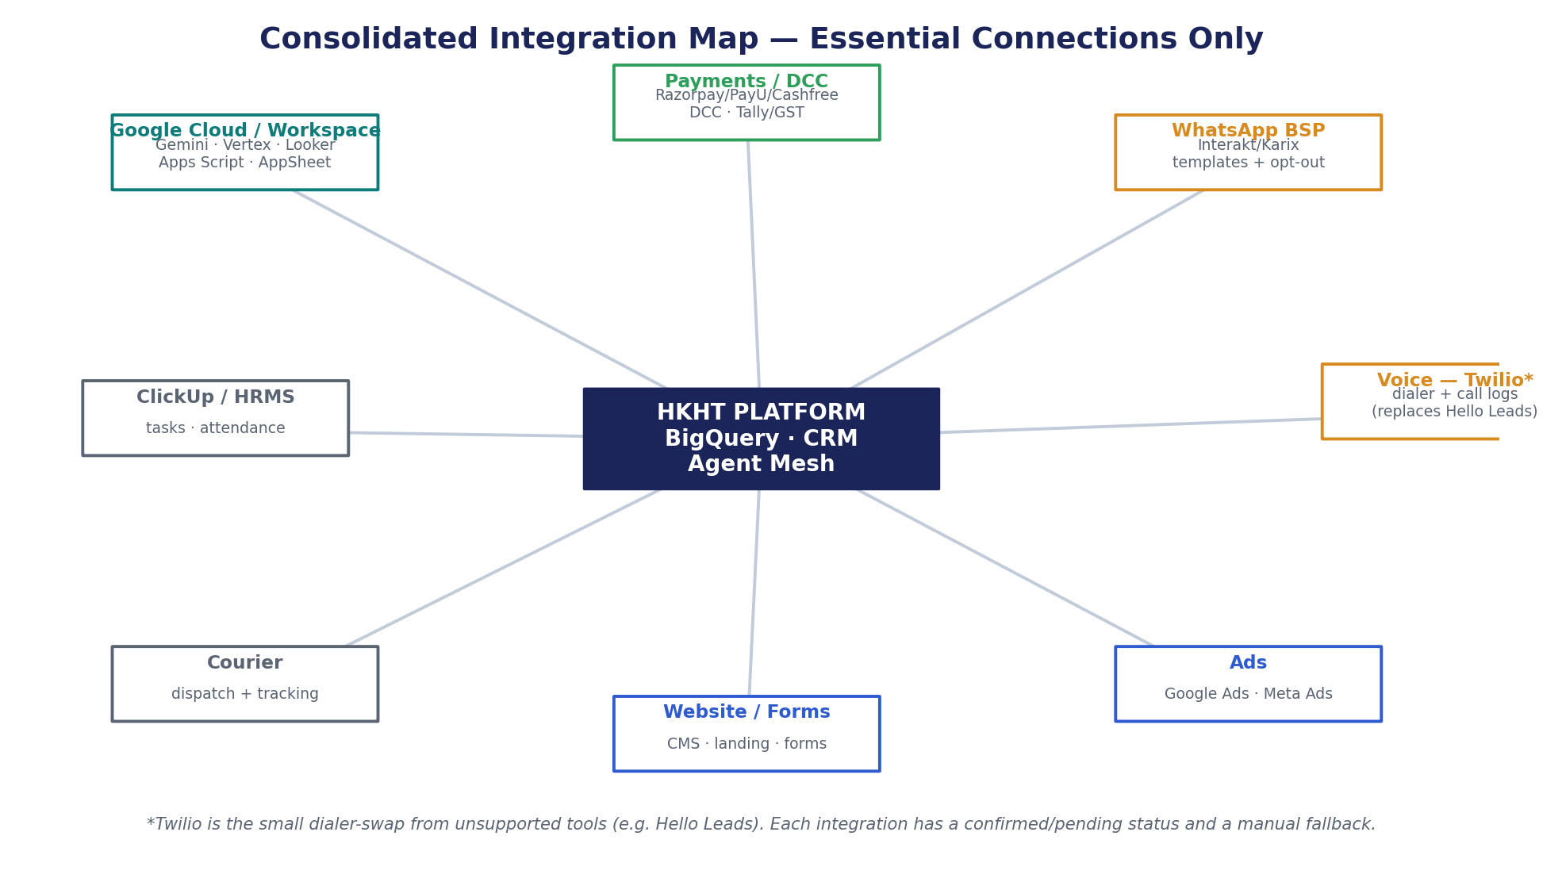
Figure 10.1 — Essential integration map.
Integration | Provider | Priority | Fallback
CRM / DBMS | CRM/DBMS platform | P0 | CSV + manual import
DCC / Dhananjaya | DCC | P0 | Export reconciliation
Payment gateways | Razorpay/PayU/Cashfree | P0 | Manual status upload
WhatsApp BSP | Interakt/Karix | P0 | Manual messaging queue
Voice — Twilio* | Twilio (replaces Hello Leads) | P0 | Manual call sheet
Google / Meta Ads | Google Ads · Meta | P0 | Manual report export
Website / landing | CMS / landing platform | P0 | Form + sheet capture
Looker / BigQuery | Google Cloud | P0/P1 | Sheets dashboard
Gemini / Vertex AI | Google AI stack | P1 | Human draft-only
ClickUp | ClickUp | P1 | Manual task upload
ERP | ERP platform | P1 | ERP-ready interim fields
Courier APIs | Courier providers | P2 | Manual courier sheet
HRMS | Keka/GreytHR | P2 | CSV export
Tally / GST | Tally / GST | P2 | Manual reconciliation

*Twilio replaces unsupported dialers (e.g. Hello Leads) — a minor component, intentionally not highlighted.

11. Leadership Command Center
One Looker Studio executive view aggregates the whole platform into a daily briefing. Every headline KPI drills into workflow, owner, record, source and next action; exceptions show severity, owner, due date and suggested step.
Dashboard block | Headline KPIs | Decision enabled
Revenue Health | Donations, Yatra & campaign revenue, pending payments, receipt exceptions | Where revenue is rising, stuck or at risk
Yatra Fill Rates | Capacity, registrations, paid status, waiting list, docs pending | Which Yatra needs follow-up or promotion
Donor Pipeline | Major-donor leads, meetings, proposals, follow-up due, aging | Which relationship needs action today
Campaign ROI | Spend, leads, CPL, conversion, revenue attribution | Which campaigns to scale, pause or adjust
Voice / Call Follow-up | Calls done, callbacks due, hot leads, handoffs | Which leads need human attention
Community Funnel | Communities, permissions, events, contacts, nurture | Which communities convert best
Website Conversion | Page health, forms, payment links, conversion | Which pages block conversion
Approvals & Delays | Pending approvals, overdue tasks, bottlenecks | What needs leadership decision
Productivity | Manual effort reduced, follow-up aging, task leakage | Whether managerial load is reducing

12. Governance, Trust & Human-in-the-Loop
AI prepares decision-quality context; humans decide on sensitive actions. Approvals are traceable via Task_ID, review status and decision-log entries. Every workflow validates owner, performer, approver, backup and escalation path before production routing.
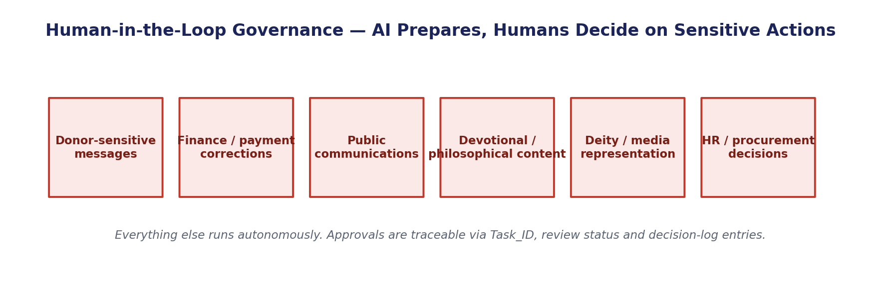
Figure 12.1 — The platform-wide human approval gates.

Approval routing
Decision type | Routing rule
Donor-sensitive communication | AI may draft; validated donor approver approves
Financial / payment correction | No automated correction without finance approval trail
Public communication | Publish only after review status is approved
Devotional / philosophical content | KCKE grounding + qualified content approver
Deity / media representation | Approved asset + media/content approver
HR / procurement decision | AI prepares context; human decides

13. Service Continuity & Fallback
If automation, an API or a dashboard is unavailable, each workflow degrades to a defined manual path with daily reconciliation. Donor-facing continuity (payment, receipt, sensitive messages) has priority; no manually captured record bypasses later reconciliation; fallback status is shown on dashboards. A five-step post-incident review (capture, contain, reconcile, correct, verify) closes every event.

14. Knowledge (KCKE) & Media AI Boundaries
Spiritual knowledge, media generation, CRM and ERP data are kept separate with defined interfaces. KCKE supplies scriptural references, citations and donor narratives with source IDs and approval status; the Media AI pipeline produces scene-level storyboards and assets that always require human approval before public use. CRM/ERP never store raw spiritual content beyond approved links and metadata.

15. Institutional Memory, Voice Readiness & Productivity Baseline
- Institutional memory: Capture Mukund Prabhu's judgment (donor, Yatra pricing, escalation, vendor, content, CSR, community, campaign) as decision trees and guardrails exposed through copilots — not uncontrolled AI output.
- Voice & calling readiness: Scaled calling launches only after source verification, DND/suppression checks, dedupe, approved scripts (with version control) and mapped outcome codes — Green/Amber/Red risk gating.
- Productivity baseline: Measure manual chasing, approval aging, manual reports, follow-up delay, task leakage and revenue leakage; target reductions at Day 30/60/75 and track Mukund Prabhu dependency on operational items downward.

16. Delivery Roadmap
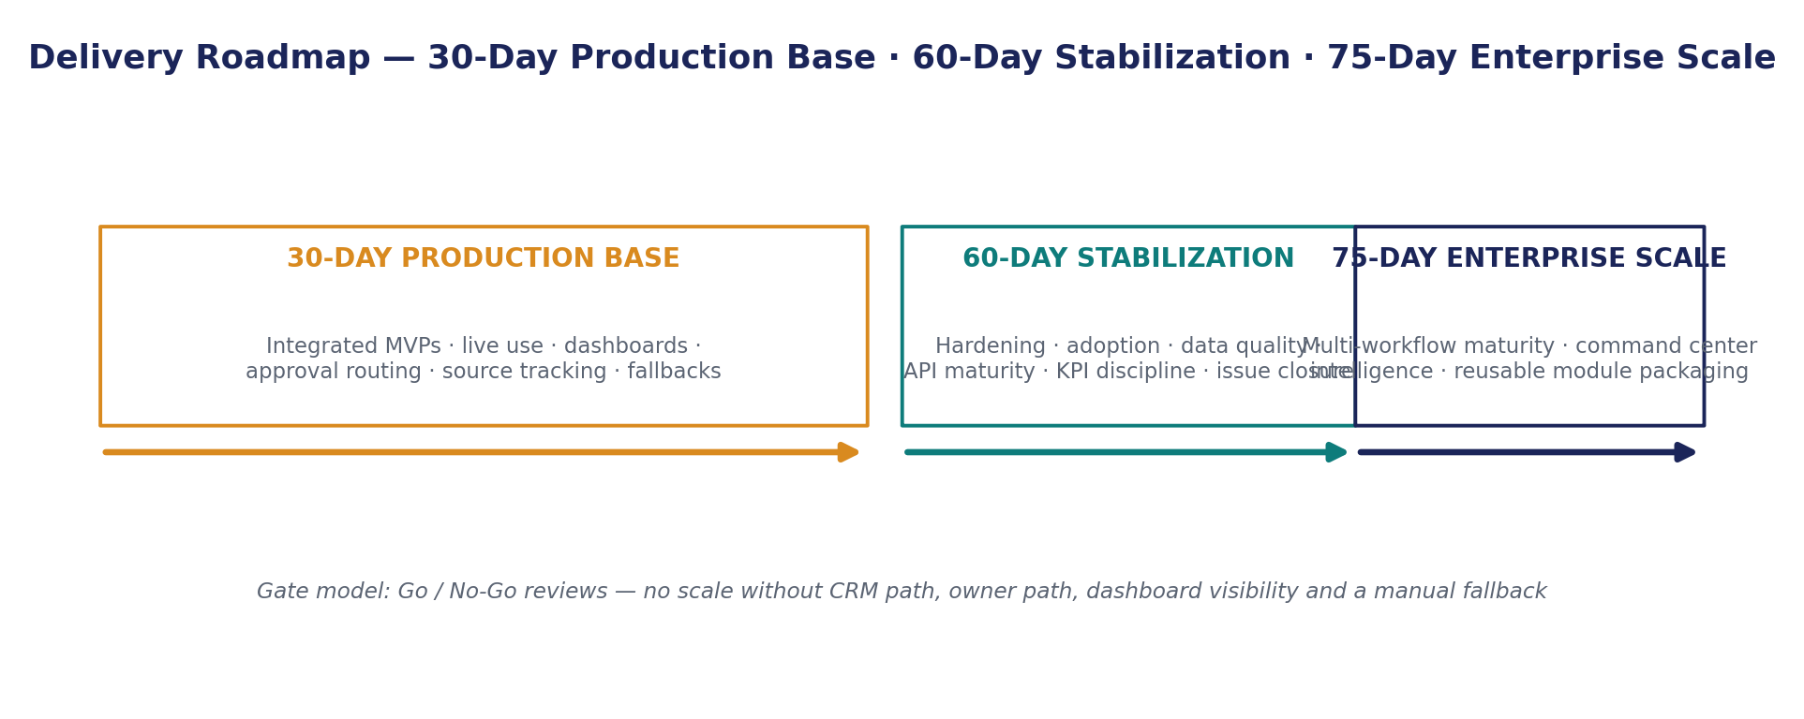
Figure 16.1 — 30 / 60 / 75-day operating model.
Phase | Operating focus
30-Day Production Base | Integrated MVPs, live use, dashboards, approval routing, source tracking, exception flow, production-readiness review.
60-Day Stabilization | Hardening, adoption, data-quality lift, workflow tuning, API maturity, KPI discipline, issue closure.
75-Day Enterprise Scale | Enterprise-scale readiness, advanced integration, multi-workflow maturity, command-center intelligence, reusable module packaging.

17. Key Risks & Open Validations
Risk | Control
CRM data quality incomplete | Run WF-006 first; CSV fallback only with shared IDs
WhatsApp template/provider readiness unknown | Use WhatsApp Governance Register; approve templates early
API access not confirmed | Use API registry with confirmed/pending/fallback status
Payment/receipt exceptions affect donor trust | Separate financial exception visibility + manual correction path
Role ownership outdated/unclear | RACI verification; route only to validated owners
Cold calling-list quality / DND | TRAI/DND audit, dedupe and Green/Amber/Red gating before scale

18. Document Package Index
This blueprint is accompanied by 14 workflow documents and 5 journey documents:
- Workflow documents: WF-001 … WF-014 — one detailed, build-ready, 1000X-optimized document each (folder 01_Workflows).
- Journey documents: J1 Yatra Revenue · J2 Donor/LLP/CSR LTV · J3 Content/Brand/Comms · J4 Internal Ops & Governance · J5 Scale & Replication (folder 02_Journeys).
- This document: Master Consolidated Blueprint — the whole picture.
Source basis: the 14 workflow Document-B briefs, the 13 platform-governance documents, the automation master register and the platform architecture brief.

