**Easy RPA Connector**

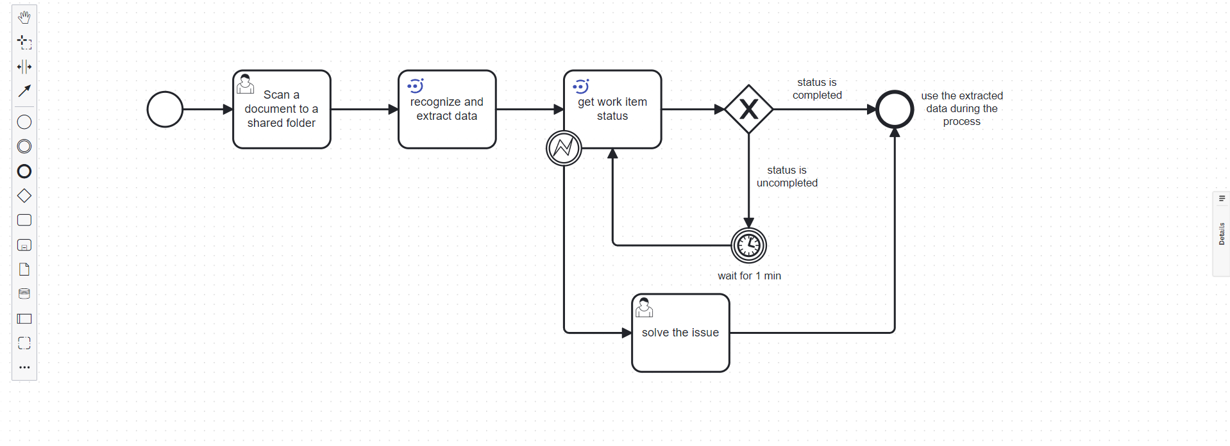   
Expanding Camunda Processes with Easy RPA

Integrate the capabilities of Robotic Process Automation (RPA) seamlessly into your Camunda processes through the Easy RPA Connector. Add work items to Easy RPA and receive real-time updates on their status. Streamline repetitive tasks and enable end-to-end automation by harnessing the combined strengths of Camunda and Easy RPA.

# **Features and Benefits** Start process

With this function, you can generate items in the robot's task queue. Upon initiation of the process by the robot, it communicates back the Camunda process ID and its current status.

# Get process status

Monitor the automated tasks you've scheduled in Easy RPA seamlessly from within your Camunda workflows. This functionality offers immediate insight into the progress of each task, enabling informed decision-making and ensuring seamless operations. Leverage this information for logging purposes, managing errors, or initiating follow-up actions in your business processes.

# Get item from Data Store Using this feature, users are provided with a link to access stored data from the process.

# Search item in Data Store

This operation allows you to find specific robot-recognized data in order to further use them as process variables in Camunda.

# Search item in Document Set

This operation looks for the elements of the necessary information with the data extracted from the process. And as a result of Camunda operation json returns with all data of the process.  
  
Elevate your automation capabilities, reduce manual efforts, and enhance the efficiency of your Camunda processes with the Easy RPA Connector.  
Read documentation.