Instructions

T-V

# Welcome to the lab

Welcome to the lab, and thank you for participating in today’s experiment.

Please place all your personal belongings away and switch off your phones and other mobile devices so we can have your complete attention. DO NOT socialize or talk during the experiment.

It is very important that you do not touch the computer until you are instructed to do so. When you are told to use the computer, please use it only as instructed. In particular, do not attempt to browse the web or use programs unrelated to the experiment.

# The Experiment

The experiment you participate in today is an experiment in spatial planning, where you and other participants determine whether a Project gets developed or not. At the end of the experiment, you are paid for your participation in cash. Each of you may earn different amounts. The amount you earn depends on your decisions, chance, and others’ decisions.

You will be using the computer for the entire experiment, and all interaction between you and others will be through computer terminals. You will interact anonymously and your decisions will only be stored together with your random ID number. Your name will not be made public, neither today nor in the future.

# Computer Instruction

We will go through these instructions very slowly and it is important that you follow them. If you have any questions, raise your hand and your question will be answered so everyone can hear.

# Overview of the experiment

At the start of the experiment, each of you will be randomly assigned a role, you will be a developer or a land owner. All roles remain the same throughout today’s experiment; so if you are an owner in round 1, you remain an owner throughout the experiment. In this experiment, you will play 6 rounds; the first round is a practice round. Your performance in the remaining 5 rounds will determine your pay. One of those rounds will be picked at random to determine your payment.

In every round, all players will decide on the development of a plot of land owned by the developer via a set procedure. The players either implement a Project, or no Project is implemented. The project decreases the value of all the land owners by different values, as well as increases the value of the developer. Both the value of the land with a Project and the value of the land with No Project are randomly drawn for each owner and the developer in each round.

The experiment simulates a democratic situation where the owners are voters. If the majority votes for the project to be developed, the project gets developed. However, since the development decreases the value of the properties of the adjacent owners, the owners can request compensation from the developer for the development of the project before the vote.

**Below, we explain the phases of the experiment in detail.**

## Phase: “Presentation”

All computer screens have some common elements that we will briefly explain here. The blue bar (see item 1) at the top shows your role in the experiment -at the far left- and some information about the current state of the round. At the far right, you can see the round and phase of the experiment. Every phase has a time limit, a clock is shown next to the round and phase indication.

Area 2 shows the layout of the land. Your role and plot of land are highlighted in blue in this area. All owners and the developer have a value for their plot of land that depends on whether or not the project is developed. These property values are randomly drawn from a uniform distribution in every round. Area 3, shows the value ranges from which the actual values for all players are drawn, for each role the minimum and maximum values are indicated. Note that the values can vary from session to session, but the value range will remain the same during the session today.

You can see the values used in your session on your computer screen throughout the experiment. Note that in each round, the project is either developed or not. If the project is developed, each player receives the value of their land with the Project at the end of the round. If the group decides not to develop the land, each player receives the value of their land under the No Project condition at the end of the round.

**1**

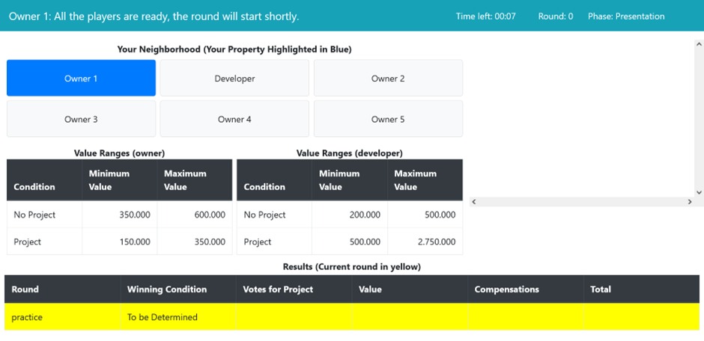In some phases, you can chat with other participants. In that case, a chat box will become available in Area 4.

**33**

**2**

**4**

## Phase: “Deliberation”

In the “deliberation” phase, every player is informed about their valuation for this round, both with Project and with No Project (see area 5). Note again, these valuations are drawn randomly for each player in each round from the same uniform distribution. The specific values drawn for you in a given round do not provide any information about the values drawn for other players, or about values that will be drawn in later rounds. The number between brackets shows the difference in value of your property *if* the project gets developed.

In the “deliberation phase,” the chat box is active (area 6). The chat box on the right allows you to chat with everyone, or you can select a specific group of participants or just chat with one individual. If you chat with a subset of the group, the others (not included) will not be able to see what is being communicated. You can select the participants you want to chat with by clicking the tick boxes or using the blue buttons.

The message can be entered in the text field that will also show the messages received. Sending a message is done by pressing the blue “send” button. Note that in the blue bar, at the top-right, the timer is now active. This phase lasts for 180 seconds. When the timer reaches 0 the entire group moves to the next phase.

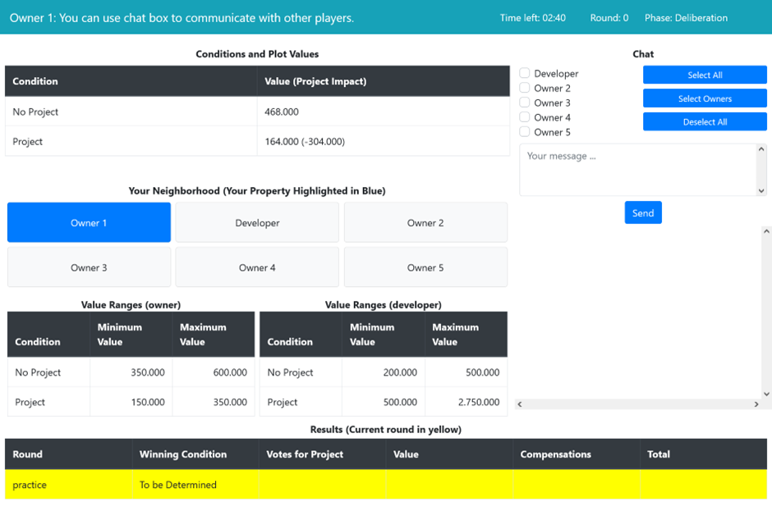

**5**

**61**

## Phase: “Request”

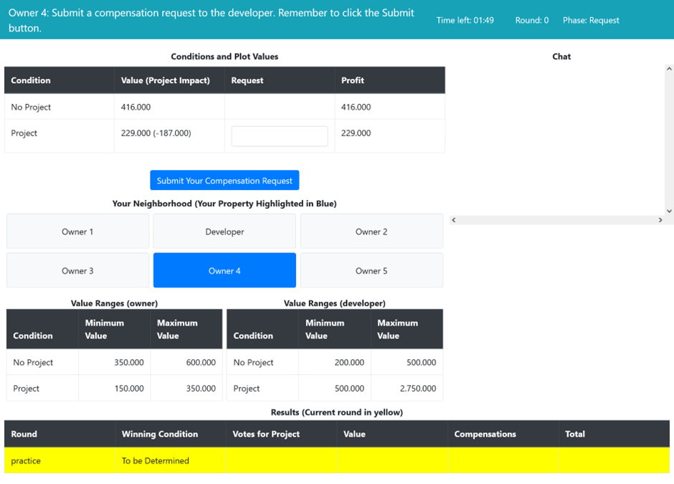

**71**

In the “request” phase the developer is inactive and waits. The owners make compensation requests. The owners individually decide on the amount of compensation they request from the developer for the development of the Project by entering a number in the Request field and pressing the blue button (area 7). Requests are only recorded once you press the blue button and confirm your choice. Left of the input field, owners are reminded of the valuation of their land with Project and with No Project. If the Project is developed, owners receive their value for the plot of land with the Project plus the compensation that is determined by the developer in the next stage. If the group decides on No Project, owners receive their valuation for the land with No Project.

Note that, if you as an owner do not indicate your “request” for compensation, a default compensation request of “0” will be recorded for you. All recorded requests are shown to the developer in the next phase, requests are not shown to other voters.

The “request” phase moves on to the next phase when (1) the timer runs out or (2) all owners have submitted their “request”. During the request phase, the developer will not be able to see your “request” yet.

## Phase: “offer”

**81**

**10**

**9**

**111**

After all owners have submitted their requests (or the time has passed), the developer sees the requested amounts, of the owners, in area 8. The “requests” for compensation are ordered from high to low. As a Reminder: in area 9 the developer can see the distributions from which the individual values are drawn.

In area 10, the developer can set the *offer* amount. This is the compensation they offer to each owner if the Project is implemented. The offer is only submitted after the developer presses the blue button and confirms their choice.

Next to the input field, the developer can see their profit if the offer is accepted. Just above, the developer sees his profit if No Project is selected by the owners. If the developer fails to “offer” an amount within the time limit for this phase, a default offer of “0” will be made.

In area 11, the developer can see individual requests per owner, as well as the *median* request made. The median request is the request in the middle of the list pf all requests made by the owners.

The “offer” phase moves on to the next phase when (1) the timer runs out or (2) the developer has submitted the “offer”. The owners will see the “offer” in the next phase.

## Phase: “deliberation”

**12**

The game moves on to the second “deliberation” phase. The amount of compensation offered by the developer is shown in area 12. The compensation amount that the developer pays if the offer is accepted is the **same** for every owner.

The chat box is active again. Just like in the first deliberation phase, you can select the participants you want to chat with by clicking the tick boxes or using the blue buttons. There will be 120 seconds to chat.

## Phase: “Voting”

In the voting phase, the developer is inactive and the owners vote on the development of the Project. Voting is done by selecting one of the options in the tick boxes in area 13 and pressing the blue ‘vote’ button. Your vote is only registered after you click the blue button and confirm your choice. If you do not submit a vote, you are assumed to abstain from voting. The profit of the round for each of the two options is shown directly left of the tick boxes.

If at least as many voters vote in favor as against (excluding abstaining voters) the Project is implemented. For instance, if 1 voter abstains, 2 voters vote in favor, and 2 voters vote against, then the project is implemented. When the Project is implemented, all 5 voters, regardless of their vote, receive the offered compensation.

When every voter has submitted their vote or the time runs out, the game moves on to the next phase. Again, you can see the remaining time at the top-right part of the screen.

**13**

## Phase “Results”

The “Result” phase shows the results of the round. All players see the outcome of the vote and their individual payoffs of their land and the compensation if any occurred in Area 14.

After the “results” phase the game moves on to the next round. In total, there are 6 rounds, including the first practice round which does not count toward your final payment. From the last 5 rounds that are eligible for payment, one will be chosen at random.

**14**

## Phase “Final Results”

**15**

**16**

On the final results page (after the experiment is done), the amount you earned in “points”, as well as the “final Euro Amount” (Area 15) will be shown. The final Euro amount is calculated by taking the points earned + the base points that depend on your role and dividing this by a fixed exchange rate that depends on your role. The show-up fee is added to this total to make your payment. The experimenters will call the payment token (Area 16), and you will receive your payment.

Please fill out the survey questions before collecting your payment.

Make sure that you fill out the payment token and final amount, as well as all other information on the payment receipt before collecting your payment.

Base points and exchange rates used in this session are the following:

1) owners get ‘0’ basepoints with an exchange rate of 20.000,

2) the developer gets ‘500.000’ basepoints with an exchange rate of 50.000.

## Login Instructions

You will now be asked to pick an envelope in which you will find the number of the computer where you will sit.

Once seated, log in with your student account, open the **edge browser** and type in the following: <https://yary.eu>

There you should see two games:

Voting IBEX – 1

Voting IBEX – 2

* If the number in your envelope is 1-6 , you should *join* game ’IBEX Voting -1’
* If the number in your envelope is 7-12, you should *join* game ‘ IBEX Voting -2’