CanFlood User’s Manual

# Introduction

CanFlood is a flood risk modelling toolbox built for Canada. CanFlood facilitates flood risk calculations with three basic steps:

1. Building the model 
2. Running the model 
3. Visualizing/Analyzing the results 

Each of these steps has a suite of tools designed to aide the flood risk modeller in a wide range of flood risk modelling tasks.

CanFlood models are designed to write and read from small ‘Control Files’. These make it easy to build and share a specific model or scenario, and to keep a record of how a results set were generated. These also facilitate making a small change to a common input file (e.g. inventory), and having this change replicated across all scenario runs. Control Files don’t contain any (large) data, only parameter values and pointers to the datasets required by a CanFlood model. All CanFlood filepaths are absolute, so moving or renaming files/folders will break a control file. Diligent and consistent file storage and naming conventions are essential for a pleasant modelling experience.

# Installation

All installation instructions can be found on GitHub:

<https://github.com/IBIGroupCanWest/CanFlood>

Once installed, you should see three CanFlood buttons on the toolbar (and in the menu Plugins > CanFlood):



# Tutorial 1: Risk (L1)

## Load data to the project

Load all the data for Tutorial 2: CanFlood\tutorials\2\data\

It should look something like this:

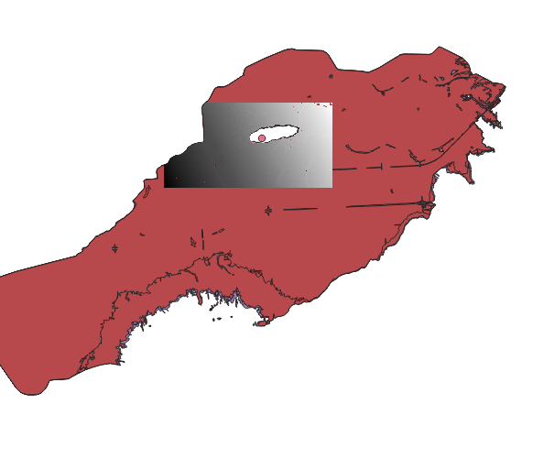

## Build the Model

Press the ProjectDataPrep button 

### Setup

On the ‘Setup’ tab, fill out the information as shown (selecting your own directories):

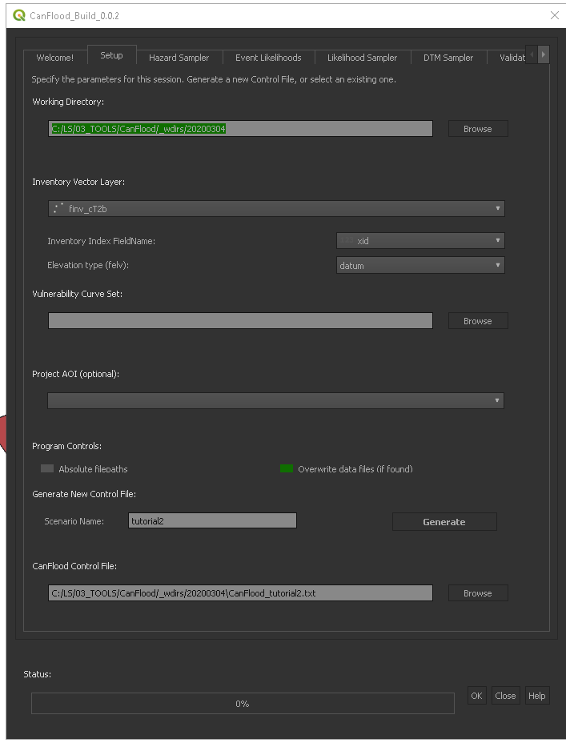

Click ‘Generate’. In the selected working directory, you should see the following:

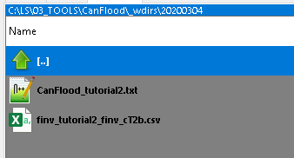

### Hazard Sampler

Move to the ‘Hazard Sampler’ tab, and click ‘Add All Visible’:

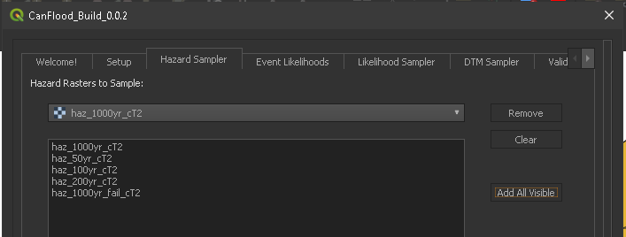

Click ‘Generate’.

### Event Likelihoods

Move to the ‘Event Likelihoods’ tab. Specify the correct values for each likelihood (from the event names) as shown:

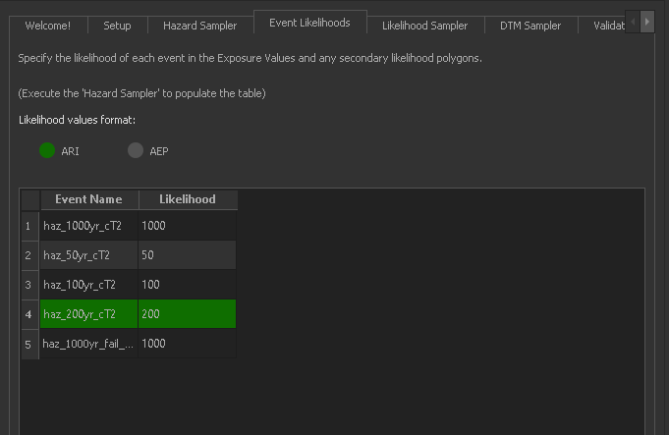

Press ‘Store Event Likelihoods’

### Likelihood Sampler

Move to the Likelihood Sampler tab. Select the corresponding secondary exposure likelihoods layer for the 1000yr failure event as shown:

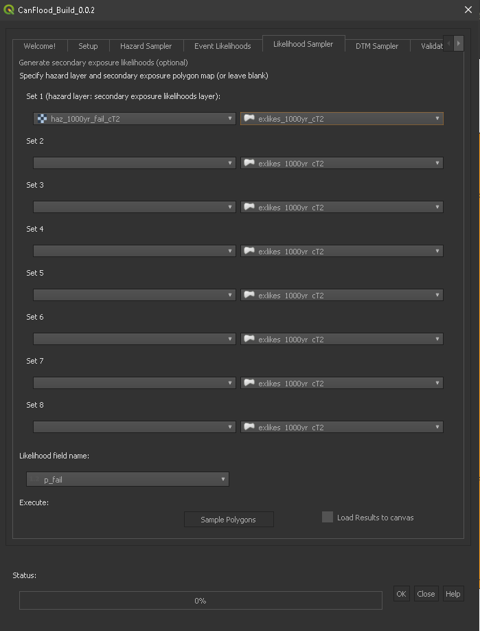

Ensure ‘p_fail’ has been selected as the likelihood field name. Click ‘Sample Polygons’

### Validation

Move to the ‘Validation’ tab, check ‘Risk (L1)’, click ‘Validate’.

The model control file should now be constructed. Navigate to the control file (shown on ‘Setup’ tab), open and inspect the file. It should look similar to:

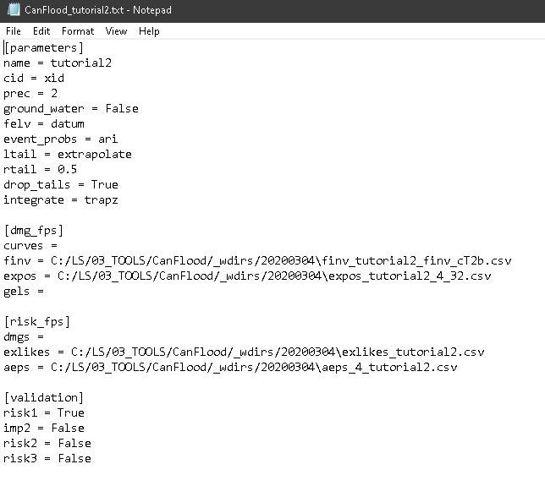

## Run the Model

Select the ‘Model’ button 

### Setup

On the ‘setup’ tab, select a working directory (does not have to match that from the previous step) where all your results should be stored. Also select the control file created in the previous section. It should look similar to this:

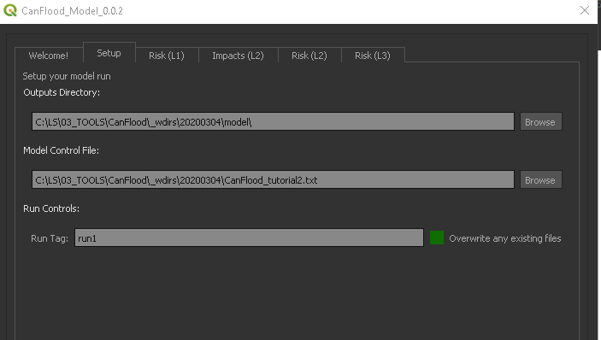

### Execute

Navigate to the ‘Risk (L1)’ tab. Check the first 2 boxes and press ‘Run Risk1’.

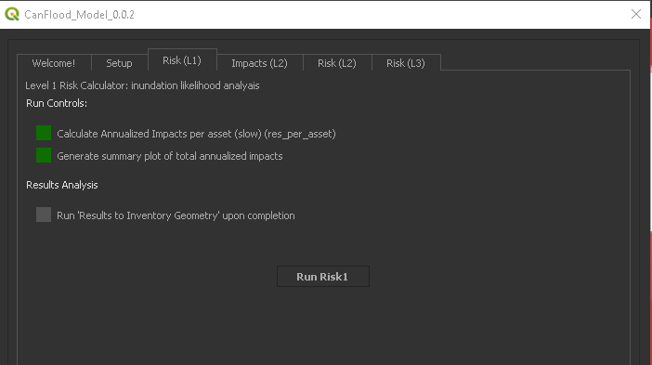

### View Results

Navigate to the selected working directory. You should see 3 files created:

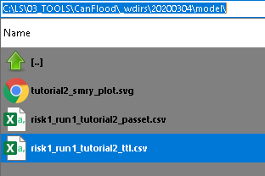

The svg is a plot of the total results (risk1_run1_tutorial2_ttl.csv):

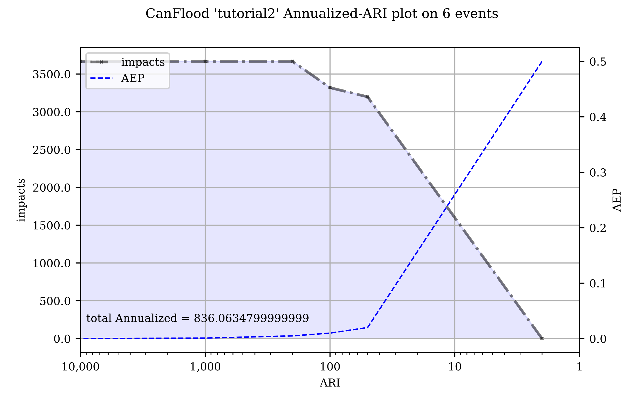

# Tutorial 2: Risk (L2)

CanFlood 0.0.1 comes packaged with an example data set to facilitate learning the platform through this tutorial. These files can be found in the Tutorials/2 folder and are described below:

* *finv_cT2.gpkg:* This is an example asset inventory in CanFlood format.
* *CanFlood_curves_rfda_20200218.xls:* This is an example vulnerability curve set. Each tab corresponds to one depth-damage curve.
* *dtm_cT1.tif*: This is an example DTM raster
* 4 water surface level (WSL) hazard rasters corresponding to 4 different flood events (haz_1000yr_cT2.tif, haz_100yr_cT2.tif, haz_200yr_cT2.tif, haz_50yr_cT2.tif)

Ensure you have all of these files before continuing with the tutorial.

## Load data to project

Start by loading all of the tutotial data into Qgis, it should look something like this:

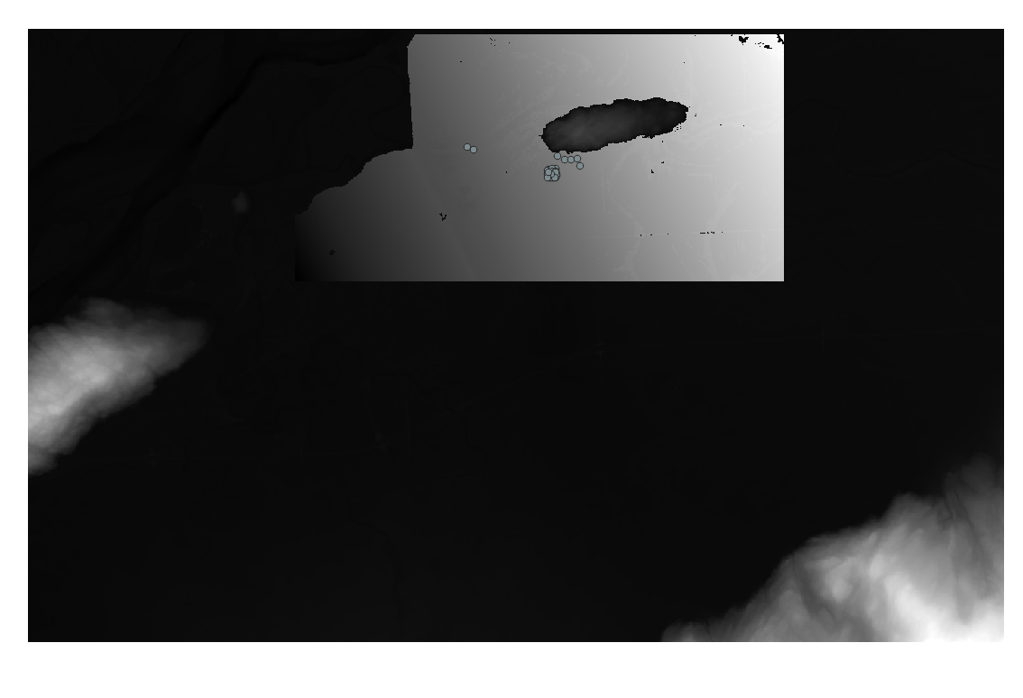

You can ignore the DTM for now, as it won’t be used for this tutorial.

## Build the Model

Click the first button ‘ProjectDataPrep’ . You should see this welcome screen:

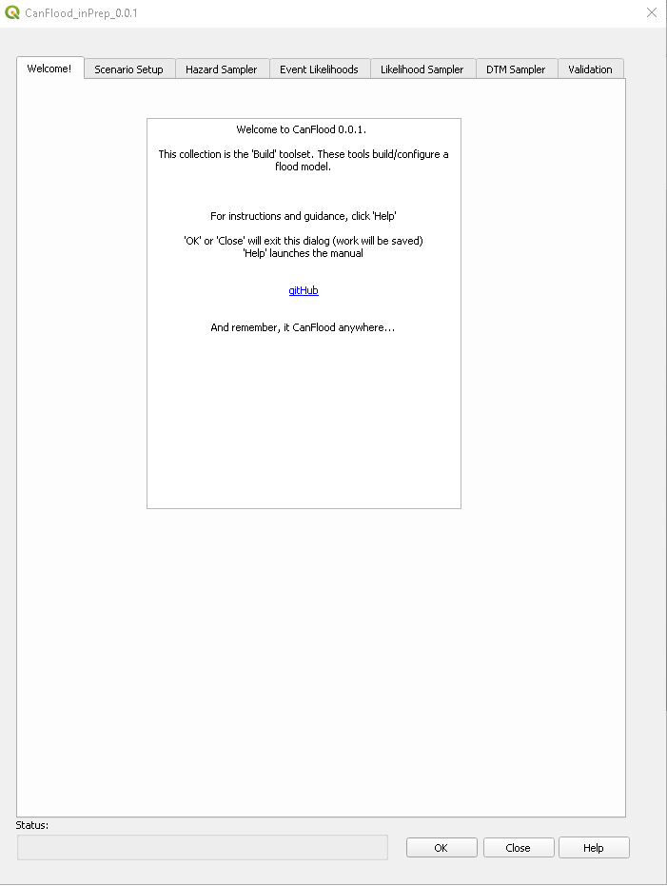

Notice the 7 tabs. Each of these correspond to a tool that helps build different CanFlood models:

* *Scenario Setup*: This is a mandatory tab for starting the control file (and converting the inventory to csv format)
* *Hazard Sampler*: This tab facilitates sampling the different flood event WSL rasters with the inventory geometry. This results in an exposure table of WSL per event per asset.
* *Event Likelihoods*: This tab is used to assign event probabilities to the different events sampled by the Hazard Sampler.
* *Likelihood Sampler:* This tab is used to assign secondary event polygons to the events (not implemented in 0.0.1)
* *DTM Sampler:* Like the Hazard Sampler, this is used for sampling a DTM raster with the inventory geometry. This tool is only required if the elevations provided in the inventory are relative to ground.
* *Validation:* This should always be the last Build tool executed. Validated should also be executed before any Control File is loaded into a model (and after any subsequent changes). This tab ensures all of the inputs are in the proper format for the Level 1 and Level 2 models.

### Setup your scenario

1. Set a convenient working directory (this is where all the files generated by Build tools will be stored)
2. Ensure the ‘finv’ vector layer is selected in the ‘Inventory Vector Layer’ drop down. Set the Index FieldName and Elevation type as shown below.
3. Navigate ‘Vulnerability Curve Set’ to the location of the provided CanFlood_curves_rfda_20200218.xls
4. Add a scenario name to distinguish this model build from any others.
5. Click ‘Generate the Control File’.

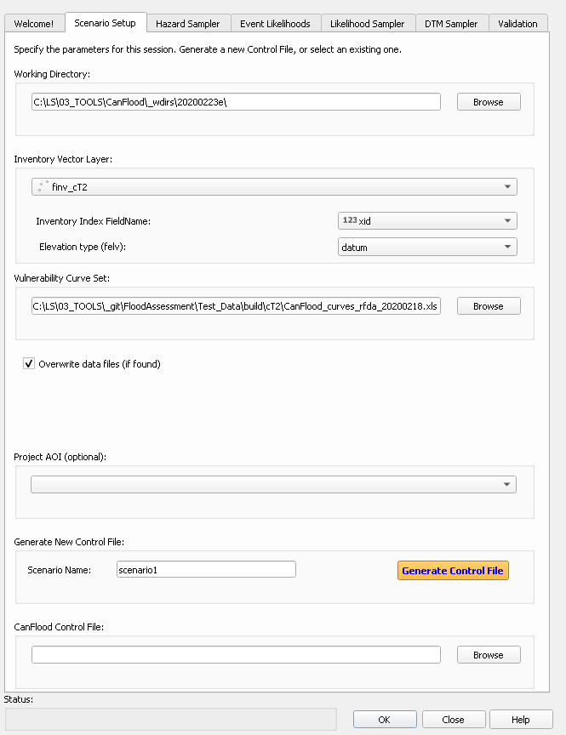

There should be a message on the Qgis Toolbar indicating the process ran successfully.

If you close the CanFlood dialog, and view the ‘CanFlood’ Log Messages Tab (View > Panels > Log Messages), you can see the detailed log messages for the process you just completed. It should look something like this:

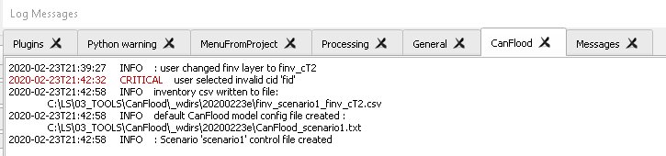

Navigate to the directory where the inventory csv was written (this should be the working directory you selected) and open the control file. It should begin with ‘CanFlood’ and look something like this:

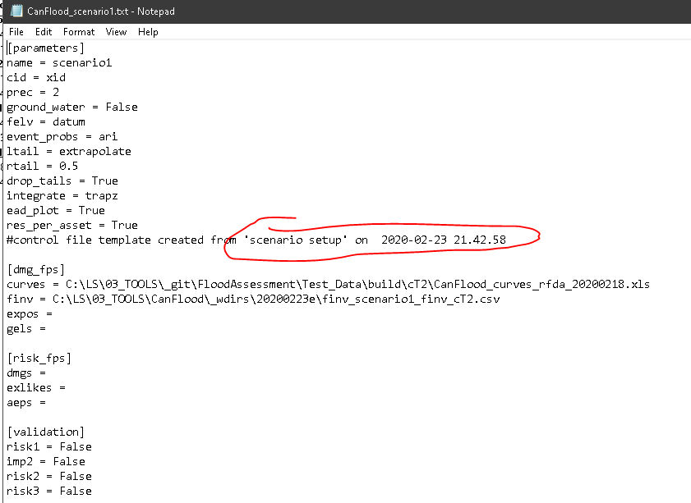

Notice the ‘#’ comment letting you know how and when this control file was created (#comment lines are ignored by the program). Also notice that ‘curves’ has been populated with the directory you provided for ‘Vulnerability Curve Set’, while ‘finv’ has been populated with a csv version of the inventory layer you specified.

### Hazard Sampler

On CanFlood.Build’s ‘Hazard Sampler’ tab, add the 4 hazard rasters to the window, and click ‘Generate Exposure Tables’.

Navigate back to the Control File, and you should now see a file path specified for ‘expos’. Navigate to the file path shown for ‘expos’. It should look something like this:

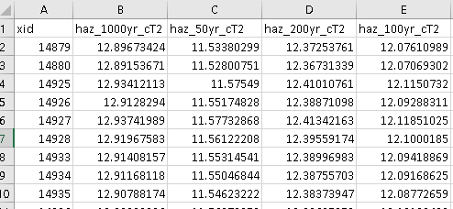

This is the exposure values table. Each row corresponds to an asset, and each column to a flood event, and each value to a WSL.

### Event Likelihoods

On CanFlood.Build’s ‘Event Likelihoods’ tab, you should now see the 4 hazard events populating the table:

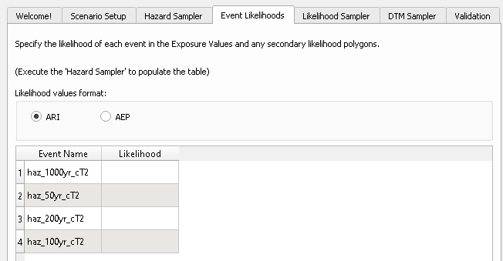

Enter in the corresponding ARI values for each event (1000, 50, 200, 100). Click ‘Store Event Likelihoods’.

On the control file, you should now see a file path for ‘aeps’.

### Validation

On CanFlood.Build’s Validation tab, ensure the level 2 models are selected, then click ‘Validate’. Resolve any errors and repeat. Once validated successfully, the last section of the Control File should now look like this:

[validation]

risk1 = False

imp2 = True

risk2 = True

risk3 = False

This indicates that the control file has been validated for both level 2 models. Your control file is now ready to be executed. Close the dialog.

## Run the Model

In Qgis, click CanFlood’s Model button . You should see the modelling welcome screen:

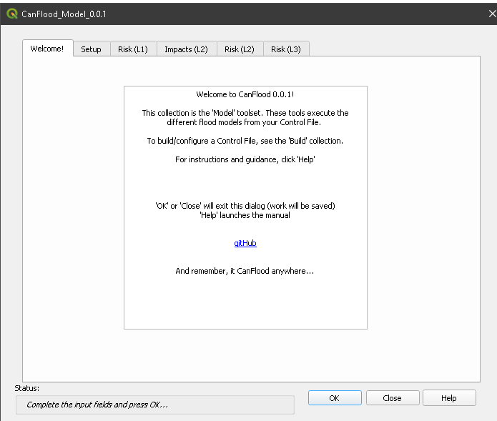

### Setup

Select CanFlood.Model’s Setup tab, and select a working directory (where you’d like your outputs to be placed) and the model control file generated in the previous steps. Specify a second tag for labelling this run. The level 1 and 2 models all share these parameters.

### Impact (L2)

Select CanFlood.Model’s Impacts (L2) tab. Uncheck the ‘Run Risk Model’ box (we’ll do that in the next step). Click ‘Run Impacts2’. The CanFlood log tab should look something like this:

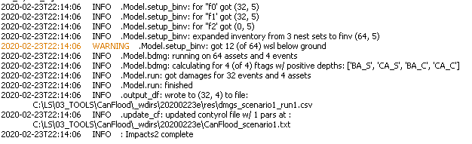

On the Control File, a filepath for ‘dmgs’ should now be shown. Navigate to this csv. It should look something like this:

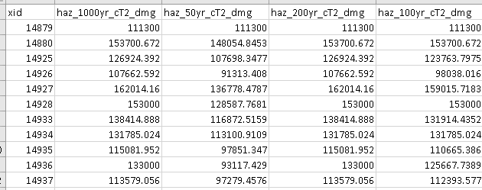

These are the damages per event per asset. Now you’re ready to calculate flood risk!

### Risk (L2)

Select CanFlood.Model’s ‘Risk (L2)’ tab. Check the first two boxes:

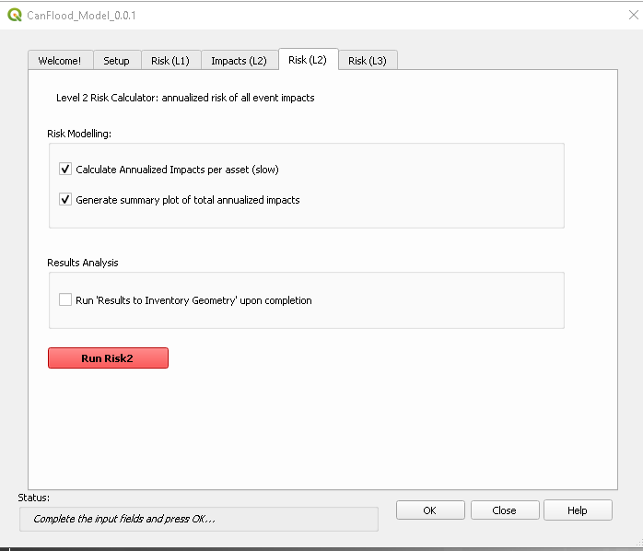

Click ‘Run Risk2’. The log panel should look like:

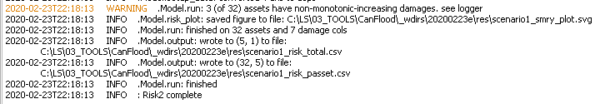

Notice the warning, this means that 3 of the assets damages do not increase with more extreme floods. This is probably a result of localized bad raster values.

Navigate to the file shown on the ‘Model.risk_plot’ line. This should be a SVG file that looks like this:

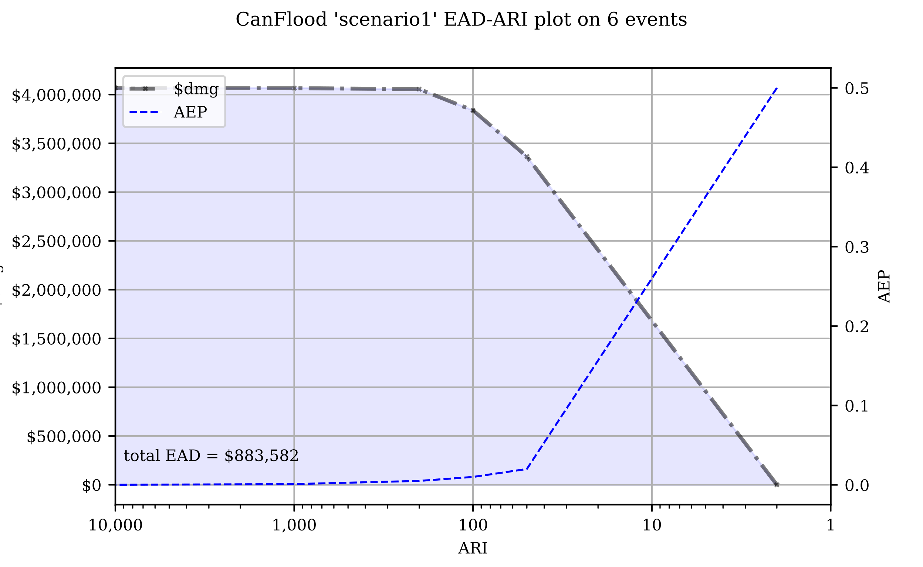

This is a graphical summary of the total risk of this inventory to these hazard rasters. These should be the same values shown in the ‘risk_total.csv’ file in the same directory.

Open the ‘risk_passet.csv’ file in the same directory. It should look something like this:

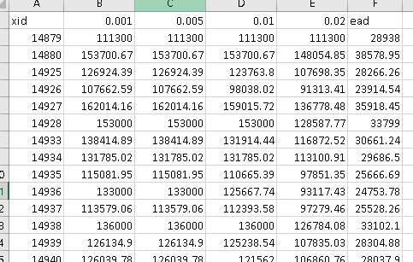

These are the estimated damages per event (should be the same as what is shown in the ‘dmgs.csv’) and the annualized damages per event, calculated with the annual exceedance probabilities (AEPs) shown in the first row.

Congratulations! You’ve run your first CanFlood model!

# Data Requirements

CanFlood models are only as robust as the data sets they are built with. Below is a summary of the main datasets the user must collect and compile prior to building a CanFlood model.

## Asset Inventory (finv)

The asset inventory is a comprehensive list of the objects or assets who’s impacts will be evaluated by the CanFlood model. The asset inventory is a spatial data set with these attributes:

* fX_tag: value telling the model which vulnerability function to assign to this asset
* fX_scale: value to scale the vulnerability function by (e.g. floor area)
* fX_cap : value to cap vulnerability prediction by (e.g. improvement value)
* fX_elv: elevation to anchor the vulnerability function (e.g. first floor height + DTM)
* geometry: geospatial data telling the model where to sample the hazard rasters..
* inventory indexer: unique integer used by the model to link together datasets.

To facilitate complex assets (e.g. a house vulnerable to structural and contents damages), CanFlood asset inventories support nesting of the 4 key attributes (tag, scale, cap, elv) (using the X in fX). In this way, a single asset can sample up to 10 different vulnerability functions. An example entry for a single family dwelling may look like:

|  |  |  |  |  |  |  |  |  |
| --- | --- | --- | --- | --- | --- | --- | --- | --- |
| xid | f0_tag | f0_scale | f0_cap | f0_elv | f1_cap | f1_elv | f1_scale | f1_tag |
| 14879 | BA_S | 117.99 | 91300 | 11.11 | 20000 | 11.11 | 117.99 | BA_C |

Where BA_S corresponds to a vulnerability function for estimating structural damages, and BA_C estimates contents damages. Additional fX columns could be added to nest vulnerability functions for basements, garages, and so on.

# Build Toolset

The build toolset contains a suite of tools intended to aide the flood risk modeller in their construction of CanFlood L1 and L2 models.

## Converting from Other Platforms

On the ‘other’ tab some tools are provided to aide in conversion from common data formats to that of CanFlood.

### RFDA conversion

RFDA was developed by the Province of Alberta in 2014 as a Qgis 2 plugin. RFDA did not include any spatial analysis or annualization functions. RFDA inventories are in spreadsheet format (.xls) indexed by column location (not labels). Curves are tagged to assets using a concatenation of columns 11 and 12. Many columns in the inventory are ignored in rfda. These are the functional columns:

* 0:'id1',
* 10:'class',
* 11:'struct_type',
* 13:'area',
* 18:'bsmt_f',
* 19:'ff_height',
* 20:'lon',*
* 21:'lat', *
* 25:'gel'

*not used by rfda, but necessary for spatial analysis.

RFDA uses a legacy format for reading damage functions based on alternating column locations.

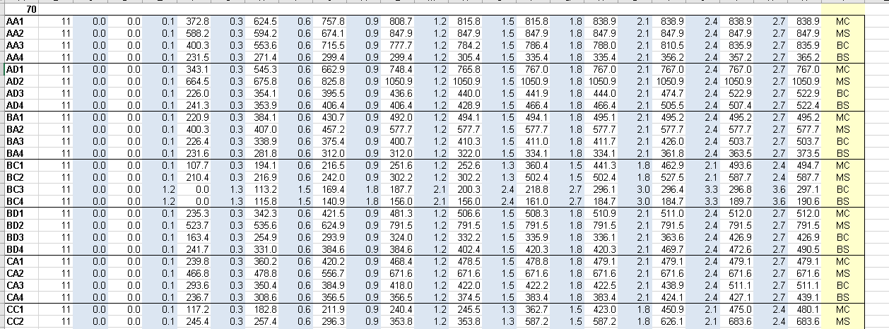

RFDA was developed in tandem with a set of 1D damage functions from building surveys of structures in Edmonton and Calgary, AB in 2014. Curves for building replacement/repair and contents damage were developed separately. Residential curves for main floor and basement were developed separately.

During a model run, RFDA applies a contents and structural curve to each asset, and the corresponding basement pair to those with ‘bsmt_f’=True.

To facilitate converting from rfda inventories to CanFlood format, two tools are provided:

1. Inventory converter; and
2. Damage Curve converter.

#### Inventory Conversion

The RFDA Inventory Conversion requires a point vectorlayer as an input (this can easily be built from .xls by exporting to csv then creating a csv layer in Qgis from the lat/long values). Based on the concatenated ‘class’ and ‘struct_type’ values in the inventory, each asset is assigned a f0_tag with a ‘_M’ suffix to denote this as a main floor curve (e.g. BD_M). Based on the ‘bsmt_f’ value, the f1_tag is also assigned with a ‘_B’ suffix. These suffixes correspond to the curve naming of the DamageCurves tool (described below). The f1_elv is assigned from: f0_elv – bsmt_ht. Once converted, the user can start the CanFlood model building process.

#### DamageCurves Converter

This tool converts the tabular location based RFDA curves into a CanFlood curve set (one curve per tab). The following combinations of RFDA curves are constructed:

* Individual (e.g. main floor contents)
* Floor combined (e.g. main floor structural and contents)
* Type combined (e.g. structural basement and mainfloor)
* All combined

This allows the user to customize which curves are applied how using CanFlood’s nested curve capabilities. By default, the Inventory Conversion tool assins the ‘Floor combined’ curves using the ‘bmst_f’.

# Model Toolset

## Risk (L2)

CanFlood’s Level 2 Risk tool is designed to perform a ‘classic’ object-based deterministic flood risk assessment using depth-damage curves, asset heights, and WSL values to estimate annualized damages. Beyond this classical risk model, Risk (L2) also facilitates risk estimates that incorporate conditional hazard events, like levee failure during a 100-yr flood.