IBM/Lexmark Wheelwriter 1000 Teleprinter Adaptation
https://github.com/IBM-1620/Junior/raw/master/docs/wheelwriter-adaptation-instructions.pdf

The IBM 1620 Jr. project sponsored by the Computer History Museum is recreating the experience of running historic software on a 1960s-era computer by bringing a real IBM 1620 console to life with a cycle-accurate simulation running on a modern microcomputer. An integral part of the IBM 1620 console is the attached typewriter used to enter booting instructions and interact with programs. The typewriters used on the original machines were the IBM Executive Model B and the IBM Selectric, neither of which is practical to use for the recreation. Instead, a more recent IBM/Lexmark Wheelwriter 1000 typewriter has been adapted by interposing a microcontroller between the typewriter’s keyboard and logic board. This allows keys typed on the keyboard to be captured and sent to the simulator over a USB serial link and, conversely, for the simulator to send characters that are printed by injecting virtual keypresses to the logic board.

Other historical computer projects may have a similar need for a computer-interfaced typewriter or teletype and could use the same approach with a variation of the microcontroller firmware. This document provides instructions for modifying an IBM/Lexmark Wheelwriter 1000 typewriter as was done for the IBM 1620 Jr. project. These instructions may work with other model Wheelwriters, but that has not been verified. The tasks include drilling holes in the typewriter case to mount the added USB Interface Board and USB-B cable; unsoldering two keyboard cable connectors from the typewriter’s logic board to reuse on the interface board and be replaced by more readily available connectors; building the USB Interface Board; and installing the interface board and cables connecting it to the logic board. The following block diagram shows the adaptation.

Wheelwriter Case Modifications
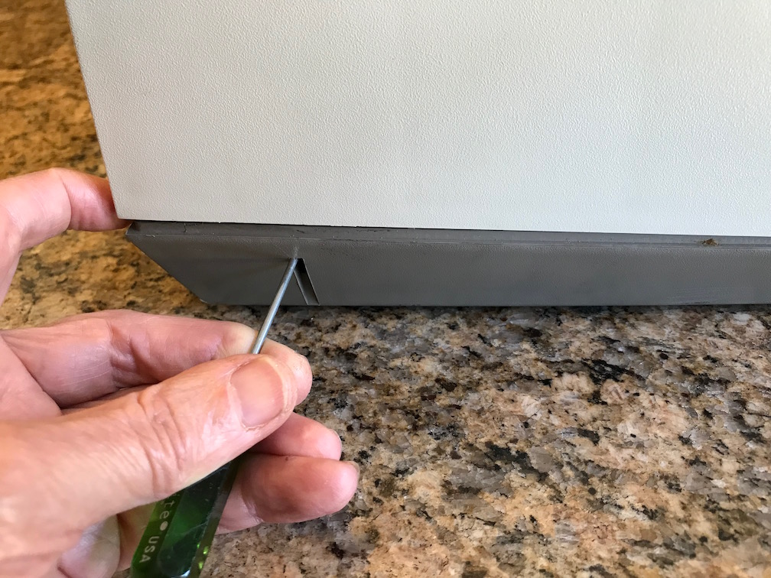
- Pull the paper release and paper bail load levers forward.
- Remove the top half of the Wheelwriter case by inserting a thin screwdriver into the slots in the lower half of the case on each side near the back and pushing in on the latches to release the top half, then rotate the top half upwards from the rear. The top will still be tethered by a cable to the LED display panel.
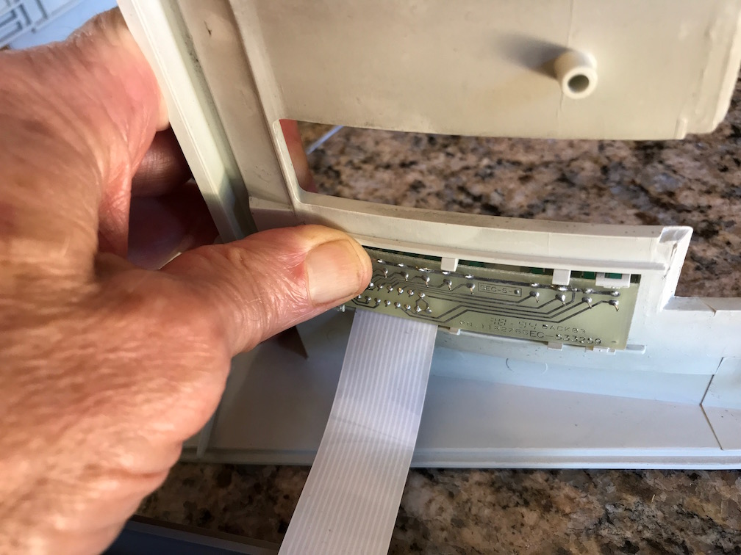
- Gently push on the back side of the LED panel to disengage it from the top half of the case, then feed it back through the hole so the top half is completely free.
- Remove the ribbon cartridge by pushing on the blue lever and then lifting up and out, then manually push the carriage all the way to the right so it is out of the way.
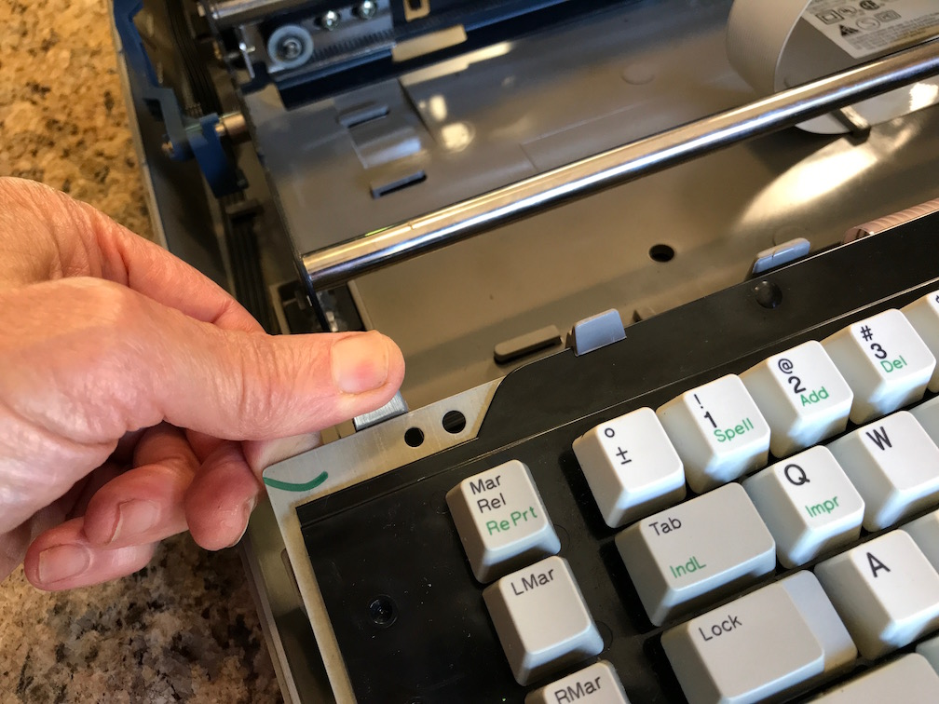
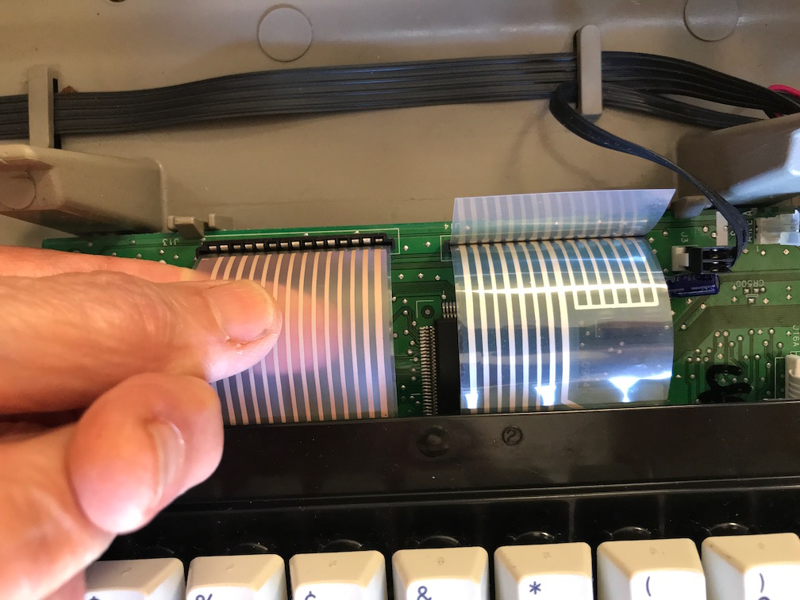
- Remove the keyboard from its mounting by releasing four latches along the back edge of the keyboard and then rotating upward slightly and pulling the keyboard out from the catches at the front. Then you can set the keyboard down and pull the FFC (flat flex cable) cables out of the logic board connectors.

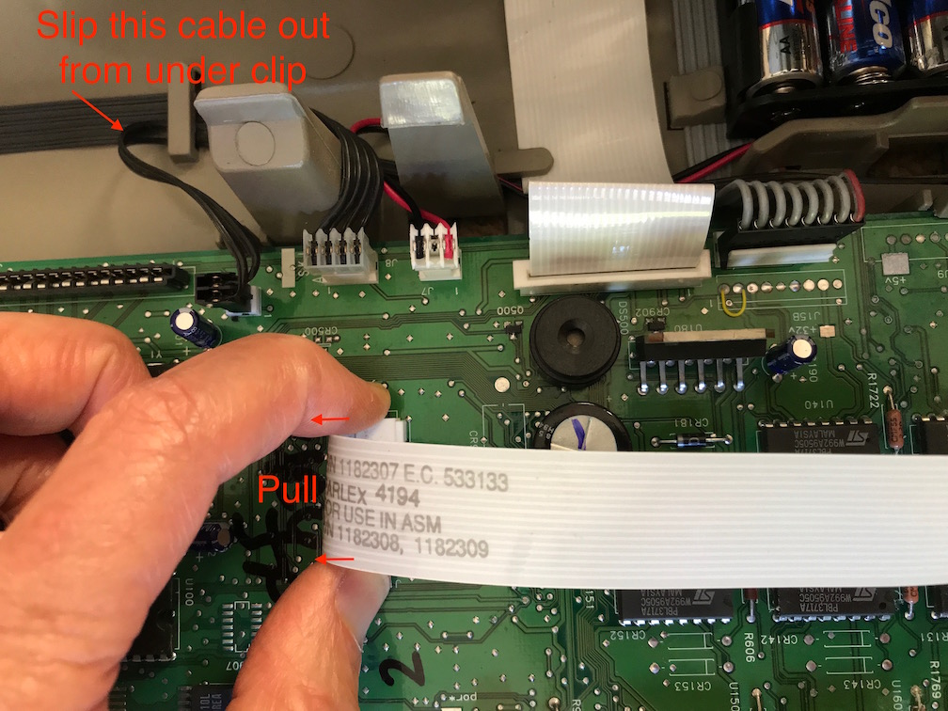
- Unplug all the cables connected to the logic board. The connectors for the two white FFC cables are zero-insertion-force connectors where you pull on the clamp tabs to release the cable. All the other connectors lift straight up, but the 8-wire cable J15A is quite stiff and requires some force to lift. The black two-wire cable going to J3 needs to be slipped out from under the clip in the base and rerouted since the USB Interface Board will cover that clip.
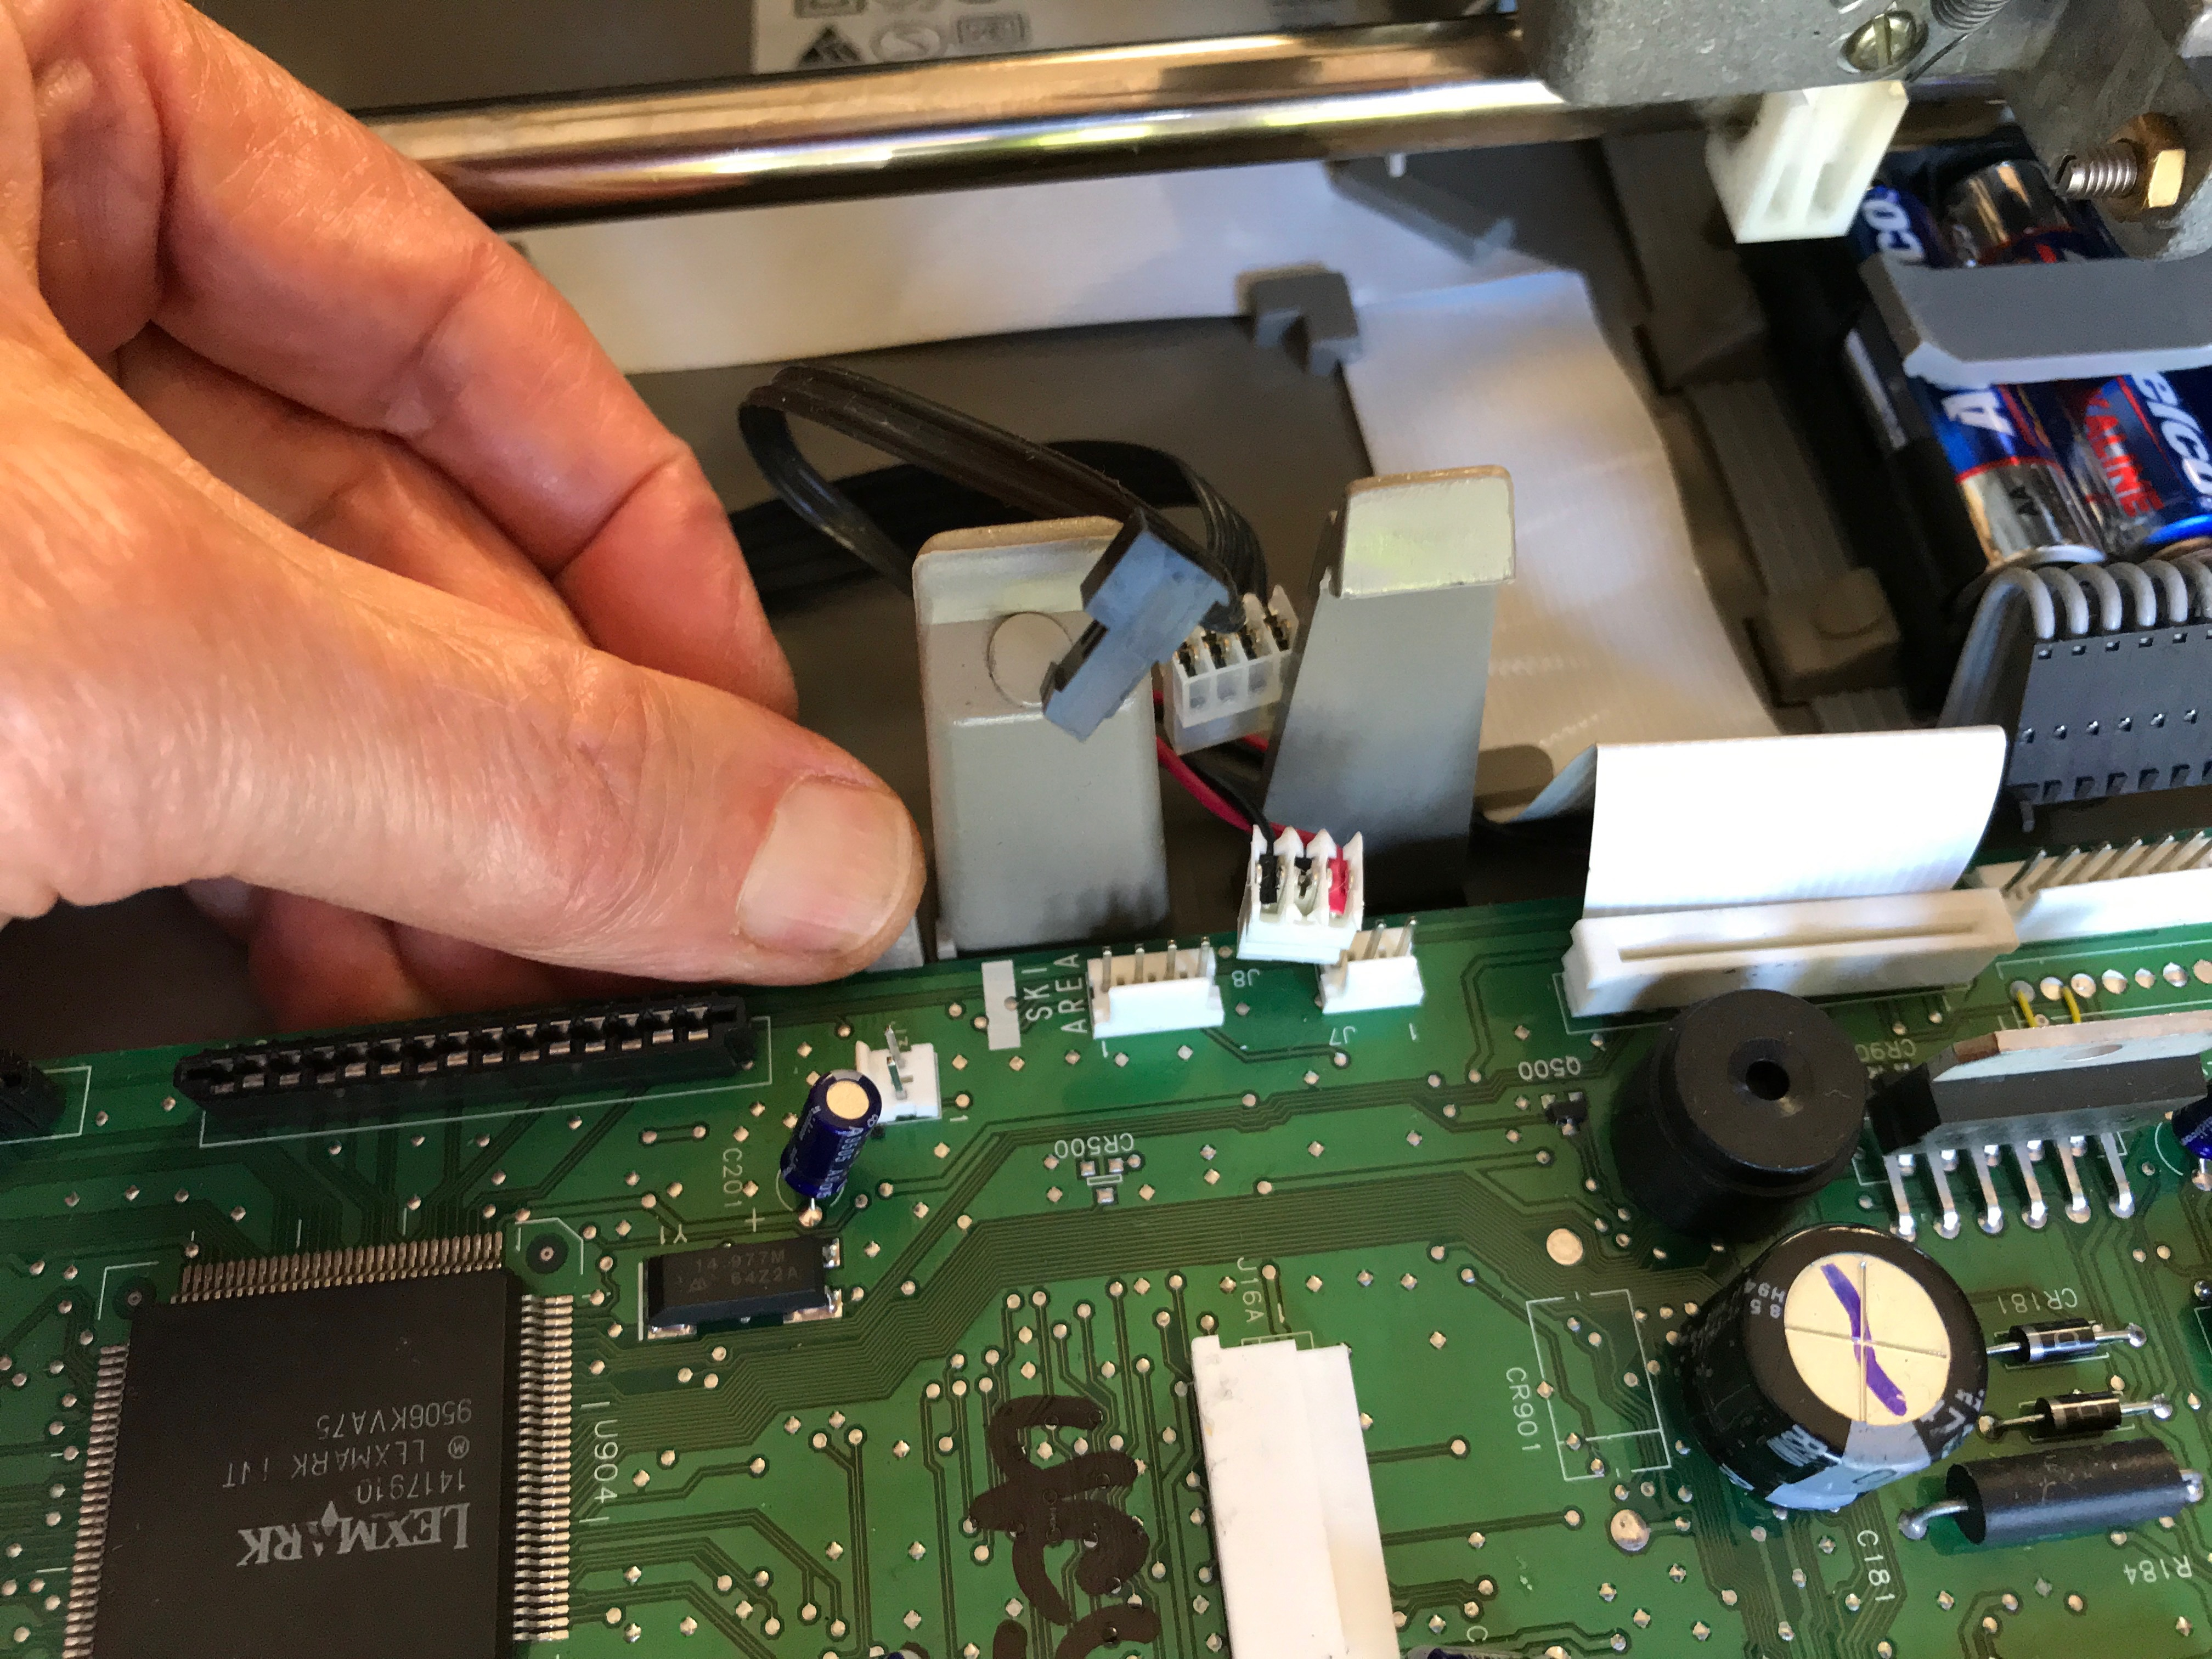
- Remove the logic board by releasing three latches along the back edge and lifting it out of the catches at the front.

- Unplug the connectors from the two servo motors at the back of the case (for platen rotation and carriage motion).
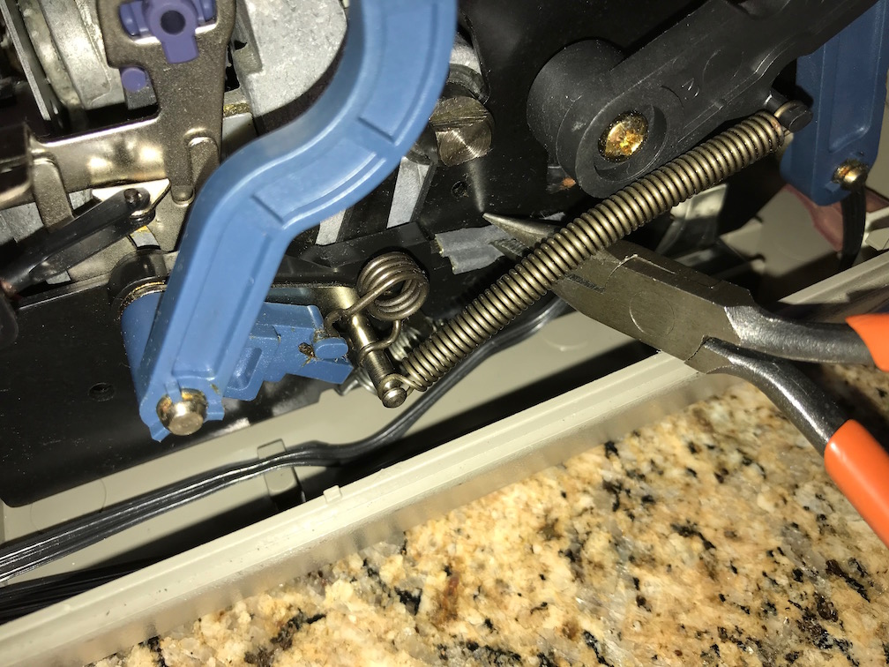
- Unplug the two wires from tabs on the switch at the bottom of the paper bail load lever. It is not necessary to keep track of which wire was connected to which tab.
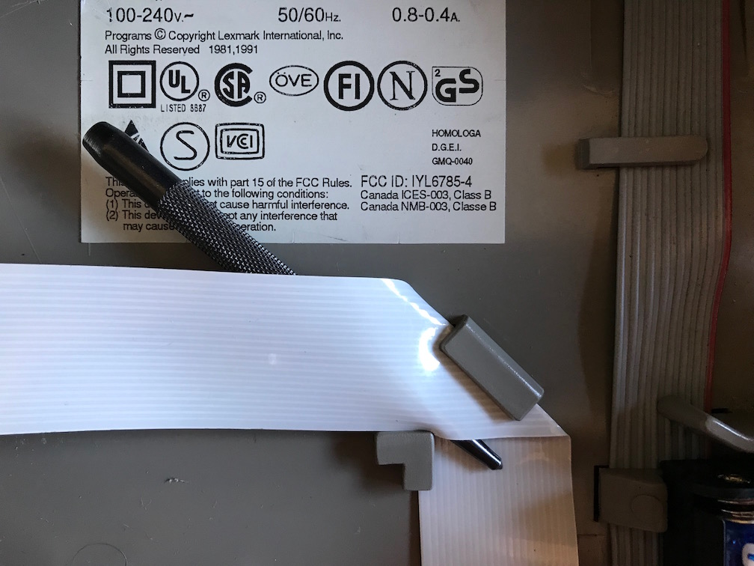
- Push the carriage back to the left and slip the carriage FFC cable out from under the clip in the center of the case bottom. Insert a round object such as a center punch or pencil between the two layers of the carriage FFC cable where it makes a 90° bend in order to slip the cable out from under the inner clip at that corner, then slide the cable out from under the outer clip.
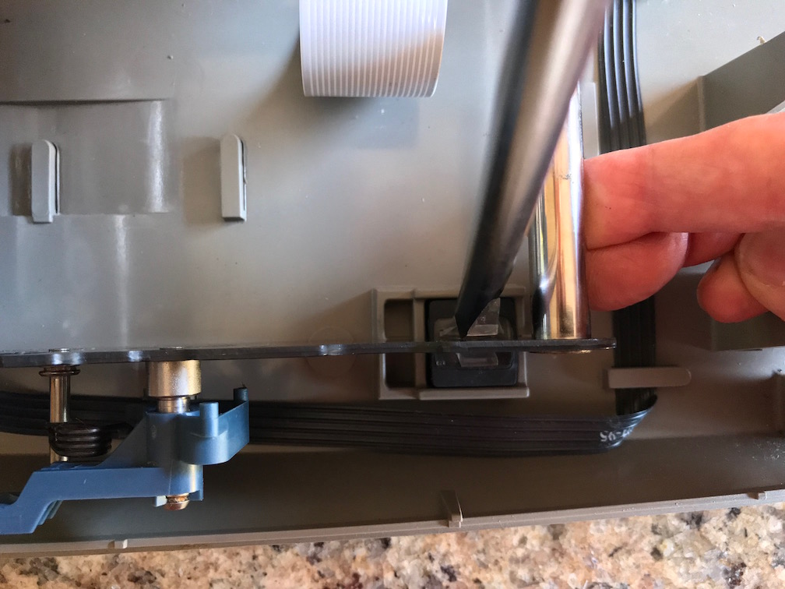
- Remove the whole frame assembly by releasing the four clips at the corners of the frame assembly. Use a twisting motion with a large screwdriver on the inside of the sheet metal frame members (except the right rear which is outside) to pry the latches free from the slots in the frame while lifting the frame to completely remove it. The latch has to bend back more than 1/8” before it is free of the frame.
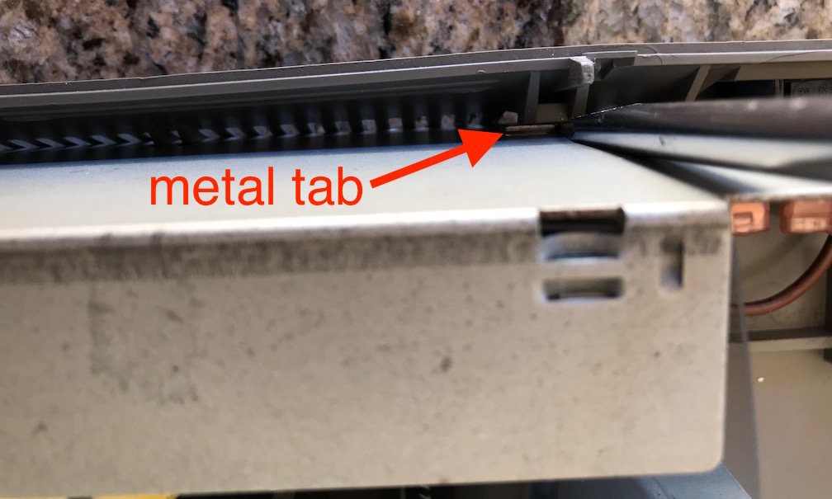
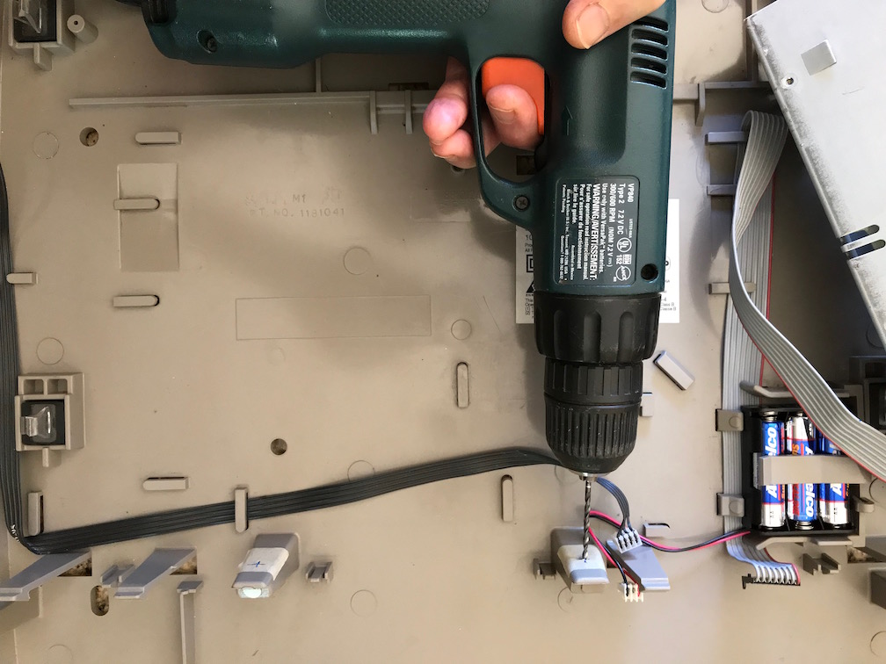
- Move the power supply out of the way by prying two catches in the back side of the plastic base away from tabs on back side of the power supply’s metal case and rotating it out of the way (no need to unplug the AC connectors). Drill 3/32" holes in the two keyboard support posts adjacent on both sides of where the USB Interface Board will go, located 1.35" from the floor of the Wheelwriter case and centered in the width of each post. Marking the location on a piece of masking tape and center-punching with an awl may help. Drill only through the near surface of the post which is less than 1/8” thick. Snap the power supply back into place and slip its cable back under the clips in the base.
- Slip the platen motor cable that runs along the left side of the base out from under its clips where it crosses the location where the USB Interface Board will go in the middle of the base, and fold it back out of the way.
- Print and cut out the two templates provided on a later page of this document. Verify that the printer scaling is accurate by measuring the dimensions as shown on the Wheelwriter USB Interface Template, and reprint with adjusted scaling if necessary.
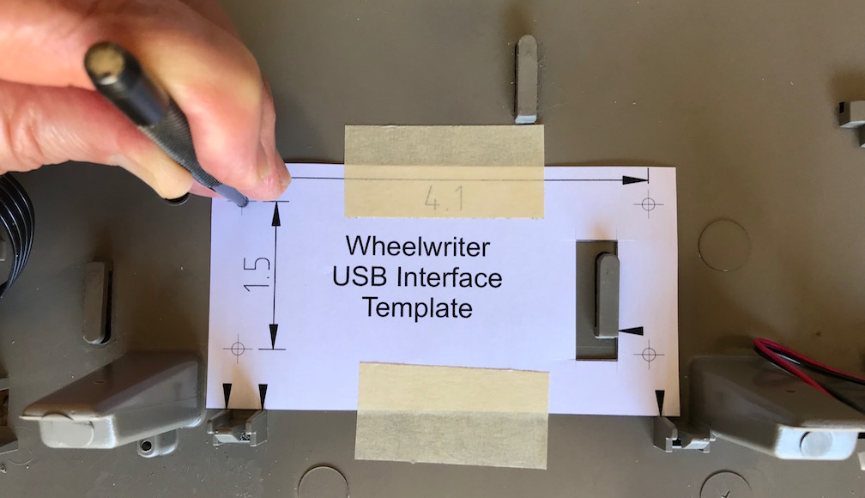
- Place a scrap piece of 3/16” plywood or other material underneath the middle of the base to support it where holes to mount the USB Interface Board will be drilled. Position the Wheelwriter USB Interface Template against the reference points indicated by arrows, and tape in place. Center-punch for the four USB Interface Board mounting holes indicated on the template. Some generations of the Wheelwriter 1000 have a thin aluminum static shield covering the base which is not present on the unit in these photographs, but the procedure is the same. Drill 1/8" mounting holes from the top.
- From the underside of the case, countersink the four mounting holes for the USB Interface Board standoffs so the flat-head screws will be below the surface.
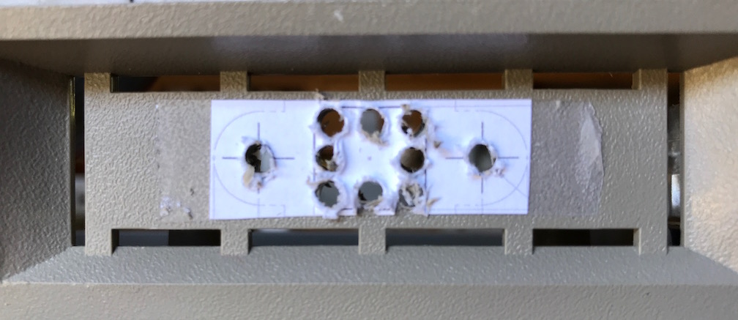
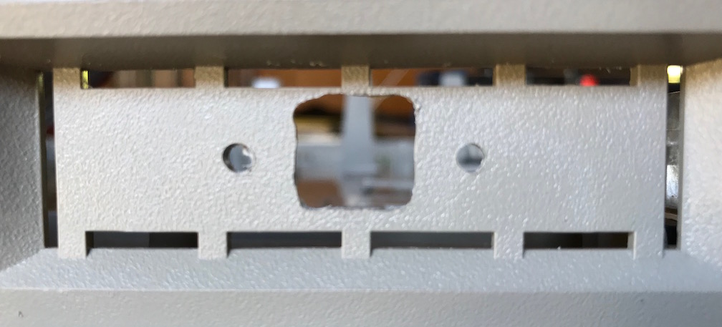
- The second template shows the cutout pattern for the USB-B connector. Use double-sided tape to attach it centered on the knockout panel in the rear of the lower case (on the right as viewed from the rear). Use an awl to center-punch for the mounting screw holes and holes at the corners and midpoints of the center cutout area, then drill 1/8" holes for the mounting screws, corners and midpoints. Clear out the cutout with snips, saw, file, razor knife and/or Dremel tool.
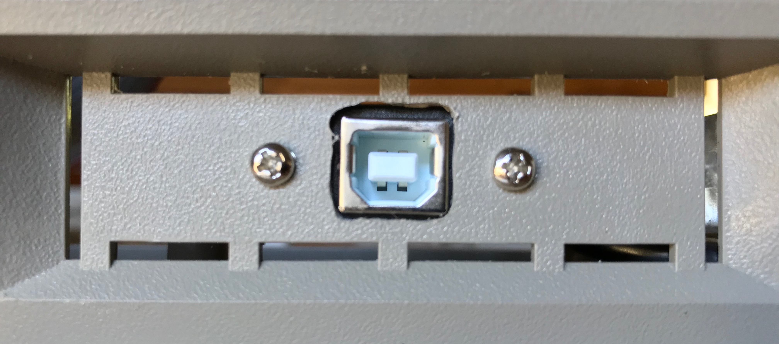
- Install the USB panel-mount connector using the provided screws.
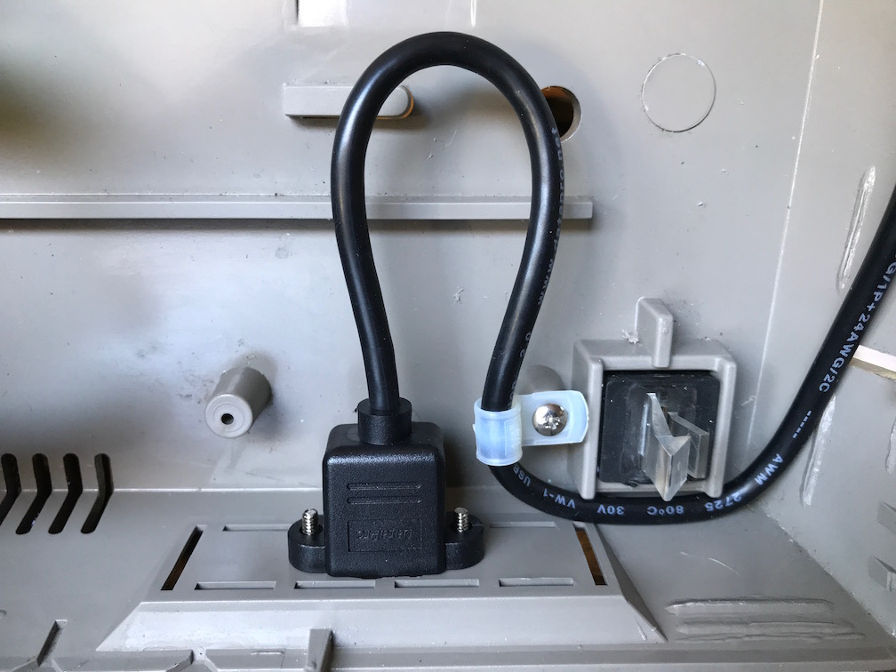
- Restrain the USB cable with a cable clamp screwed to the left post inside the knockout panel area using one of the #4 truss head sheet metal screws.
- Set the frame assembly loosely back in position making sure not to pinch any cables.
- Connect the two wires to the tabs on the switch at the bottom of the paper bail load lever. It does not matter which wire goes to which tab.
- Slide the carriage FFC cable back into the corner clips so the bottom layer is under the inner corner clip and then the fold slides into the outer corner clip. Then insert the round object to bow up the upper layer to get it uder the inner corner clip. Also slide the cable back under the clip in the center of its track.
- Push the frame assembly back down into its four corner latches.
- Plug in the cables for the two servo motors at the back.
- Slip the platen motor cable back under its clips where it will cross under the USB Interface Board.

Logic Board Modifications
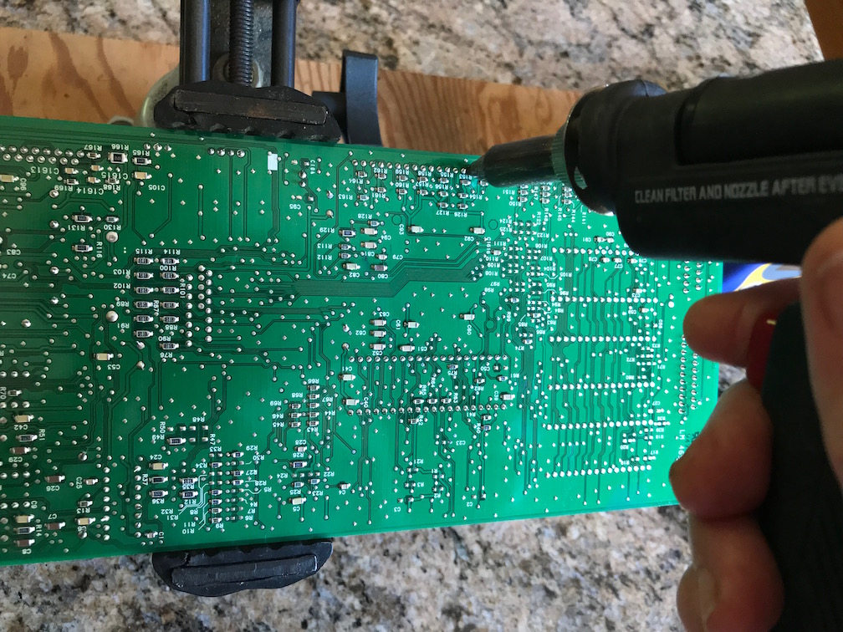
- Unsolder the keyboard FFC connectors (TE/AMP part 6-520315-5) from logic board to reuse on the USB Interface Board. This is most easily done with a vacuum desoldering tool, but may also be possible with a hand solder-sucker or solder wick. Another approach is to solder a piece of 10-14AWG solid wire across all the pins of the connector, then heat that wire with enough power so that all the pins are melted at once to pull out the connector.
- Remove solder from the leftmost 3 holes of unpopulated J9 on the logic board (in the right rear corner).

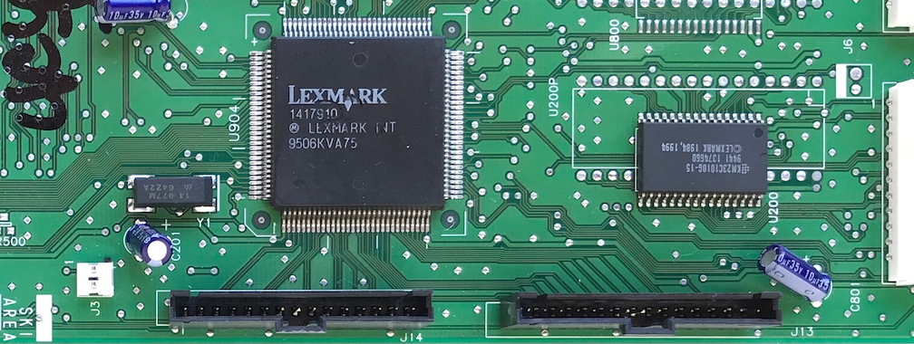
- Install new 6-103908-4 FFC connectors on the logic board in J13 and J14 with latches toward the edge of the board.
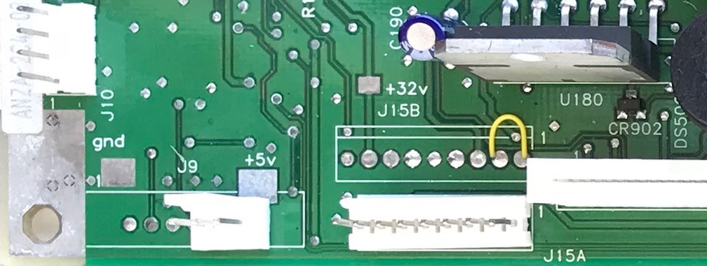
- Install a 22-27-2031 3-pin Molex connector in J9 on logic board, with the latch away from the edge of the board.
- (optional) Clean soldered areas with solvent to remove flux.

USB Interface Printed Circuit Board Assembly
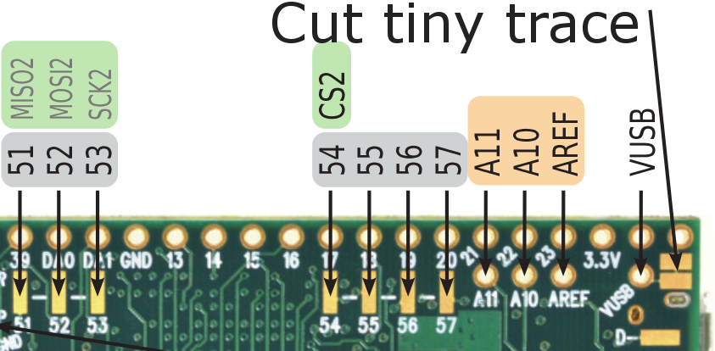
- Cut the VIN - VUSB trace on the underside of the Teensy board.
- Insert SIL header pins into the 48-pin socket, then set the Teensy board over the pins to solder.
- Insert and solder two new 6-103635-4 FFC connectors and the two 6-520315-5 FFC connectors harvested from the logic board.
- Insert and solder a 22-27-2021 2-pin power connector with the latch side toward the edge of the board.
- Insert and solder the discrete components (capacitors, resistor, LED).
- Insert the three DIPs (two 7404 ICs and the resistor array) using a pin-squeezing tool, then solder them.
- Insert and solder the two 2-pin headers J6 and J7.
- Insert and solder the Teensy socket (possibly with the Teensy in place).
- Clip all component leads on the back side of the board to avoid damaging FFC cables.
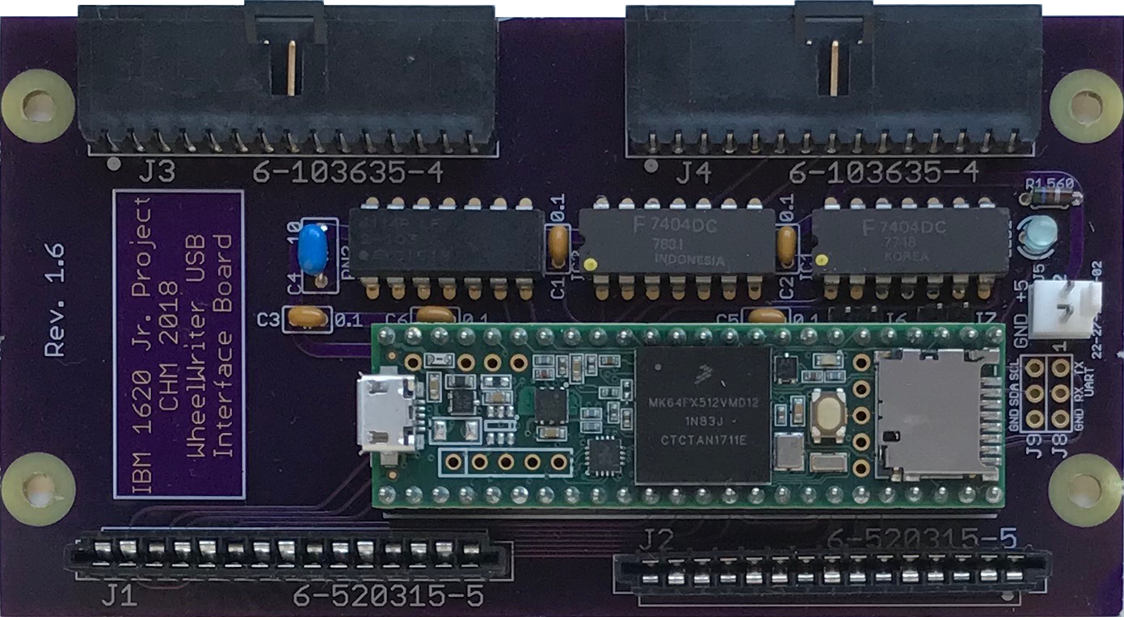
- (optional) Clean with solvent to remove flux.

Install the USB Interface Board and Cables
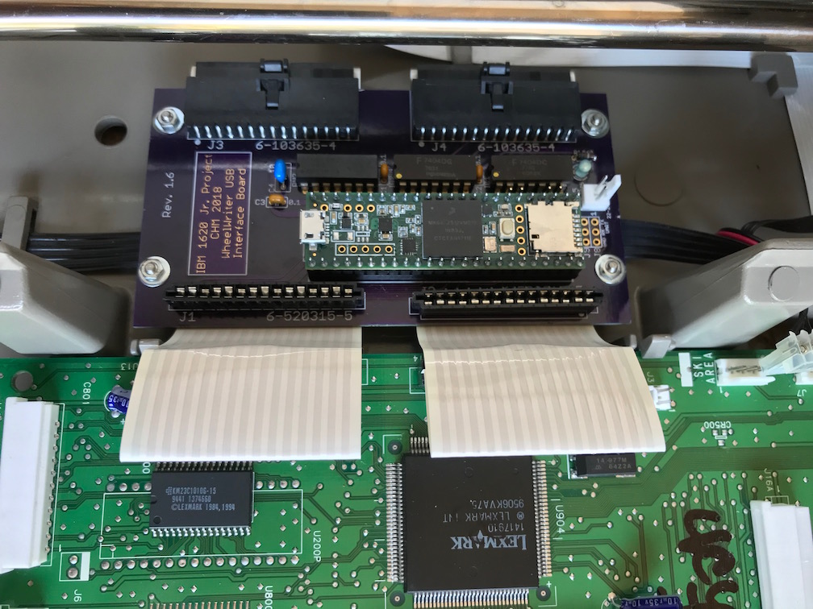
- Attach four standoffs for mounting the USB Interface Board using flat-head screws from the underside, but don't tighten them.
- Reinstall the logic board but do not attach any cables yet.
- Plug FFC interconnect cables into USB Interface Board and fold them back under the board right at the connectors. Plug the other end of the FFC interconnect cables into the logic board.
- Install the USB Interface Board onto standoffs with washers and nuts. Finish tightening using a wrench or nutdriver on the nuts and tighten the screws from underneath.
- Where the FFC interconnect cables come up from under the USB Interface Board by the logic board, pull the cables taut and fold them away from the USB Interface Board right at the connectors on the logic board, then crease the excess so they will stay under the keyboard.
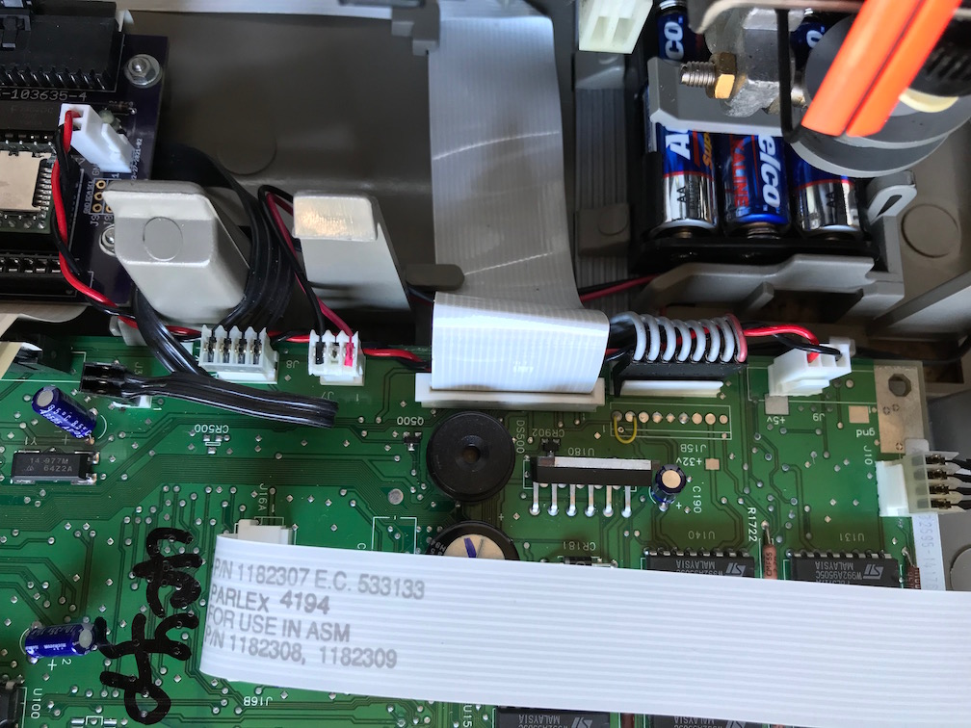
- Install the new power cable from the logic board to the USB Interface Board, routing it underneath all the other cables along the back edge of the logic board. Bend the wires down sharply at the connector on the USB Interface Board to avoid interference with the carriage. Now reconnect all the existing cables. To insert the FFC cables for the carriage and the LED panel, first pull the connector clamp open, then insert the cable, then push the clamp closed. The black 2-wire ribbon cable to J3 has excess length now because it no longer hooks through the clip that is now under the USB Interface Board, so bend that excess over the logic board.
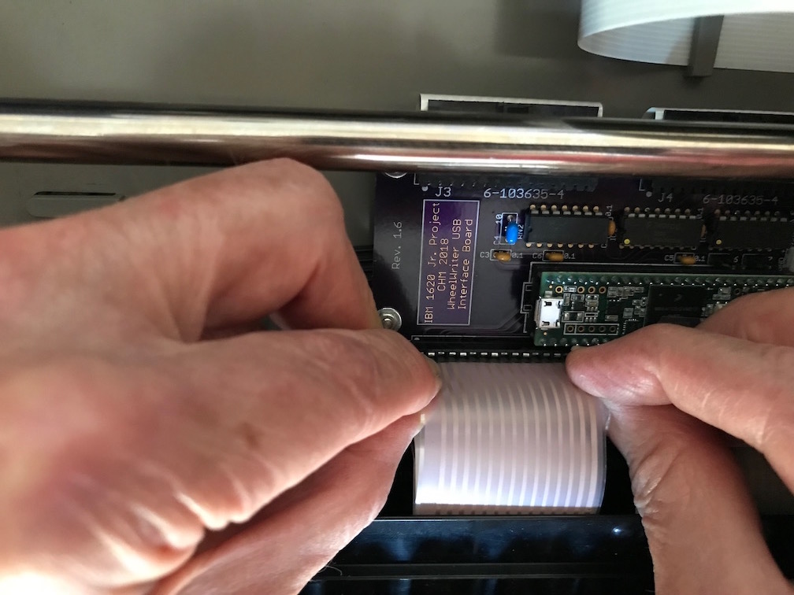
- Lay the keyboard loosely over its position and insert the FFC cables from the keyboard into the connectors on the USB Interface Board (this is not easy – it may require padded forceps).
- Make a bracket to depress the keyboard FFC cables by manually bending steel coat-hanger wire using needle-nose pliers according to the dimensions shown in the CAD diagram below.
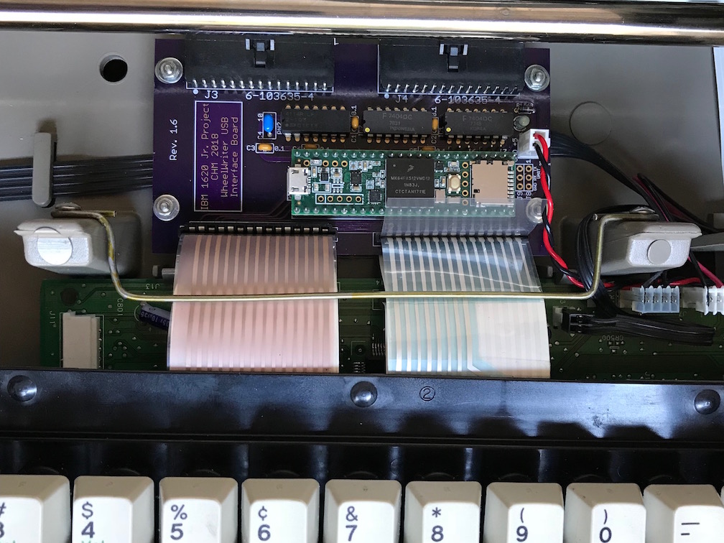
- Install the bracket to hold back the keyboard FFC cables using two #4 truss head screws into the holes drilled into the keyboard support posts.
- Install the keyboard into its front catches and then rear clips.
- Plug in the micro-USB connector into the Teensy.

- Adjust the position of the USB cable, wedging it down behind the left rear foot and restraining it with a cable tie to the existing clip for the platen motor ribbon cable at its front corner.
- Plug in and power on the Wheelwriter. Plug a USB-B into the cable into the new panel connector at the back of the Wheelwriter and connect it to the host computer, then download appropriate firmware into the Teensy. It will be necessary to cycle power on the Wheelwriter after the download before the logic board will be properly operating with the firmware on the USB Interface Board.
- Verify operation with appropriate test programs.
- Reinstall the top half of the Wheelwriter case: pull the paper release and paper bale levers forward; thread the LED panel through its hole in the case top; hook in the catches at the front of the machine and then tilt down the back until the latches meet and catch; and finally snap the LED panel back into place.

Parts List

Modified Wheelwriter CAD Diagram
To see details more clearly, try viewing the PDF file for this document online and zoom in. Better yet, view the original PDF of this diagram with black background that is downloadable from:
https://github.com/IBM-1620/Junior/raw/master/docs/wheelwriter-adaptation-CAD.pdf
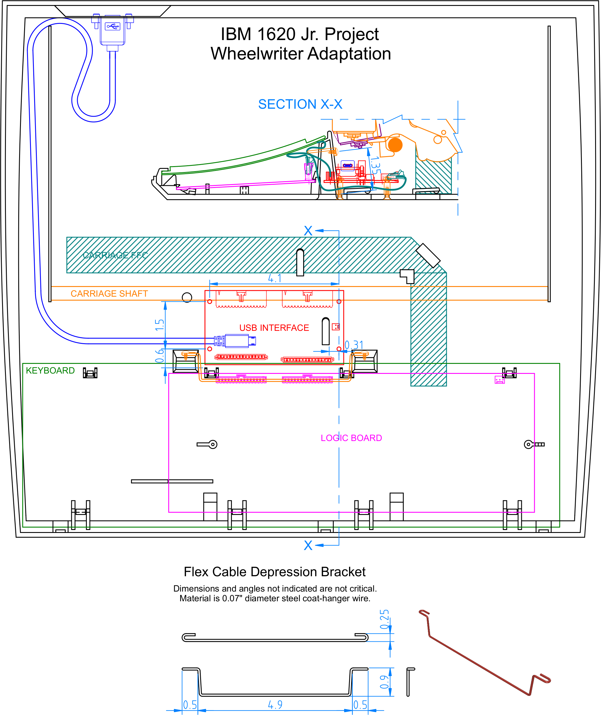

Templates
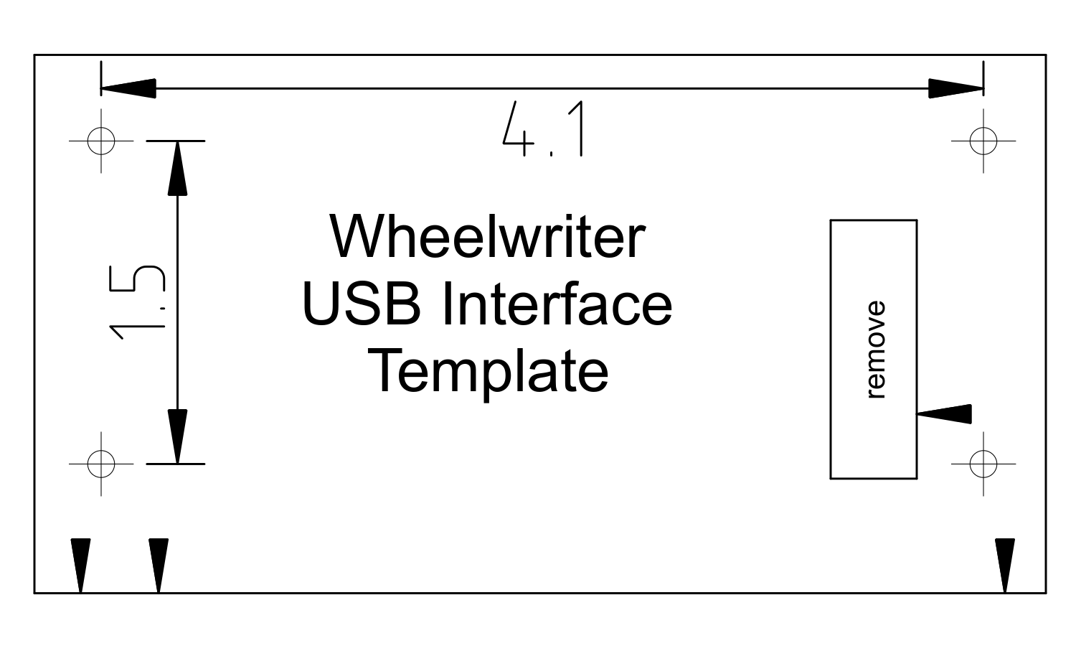
Print and cut out these templates for use during the Wheelwriter modification procedures. Verify that the printer scaling is accurate by measuring the dimensions (in inches) as shown on the Wheelwriter USB Interface Template.
This second template is for drilling and cutting holes in the knockout panel at the rear of the Wheelwriter base for mounting the USB-B cable. The dimensions are in millimeters, so the 26 mm distance between the two mounting holes is 1.024 inches.



