# **Watsonx Orchestrate x Salesforce integration**

# 1. Salesforce setup

## **Generate Keys**

### Enable Connected Apps

1. **Go to Apps**→ External Client App→ Settings
2. Enable Connected App

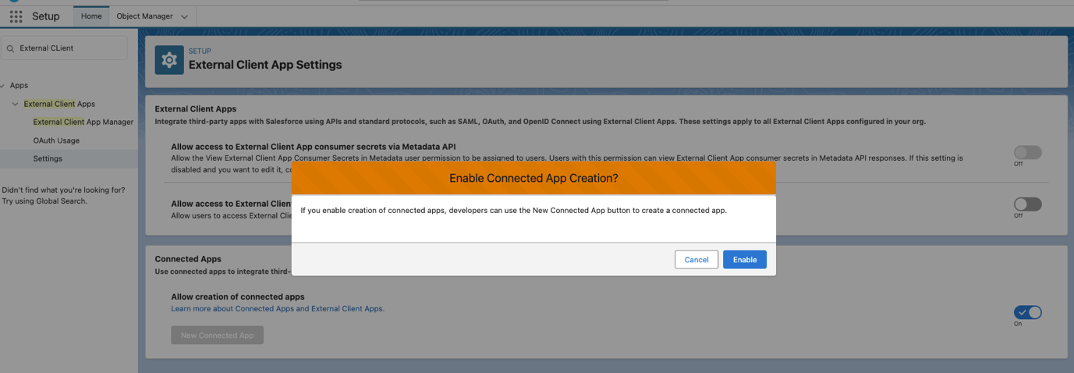

1. Click new connected App

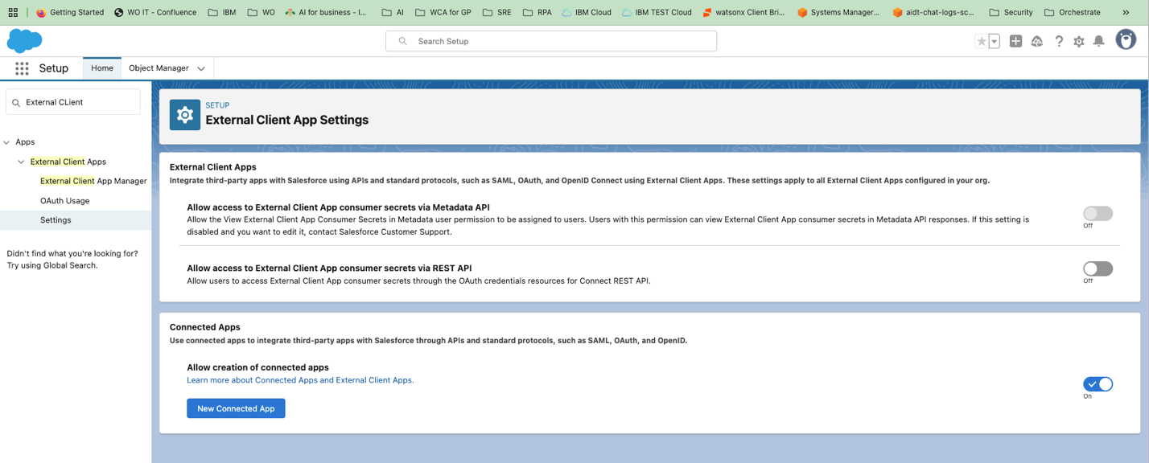

1. Fill required fields
   1. Connected App Name
   2. Api Name
   3. Contact Email

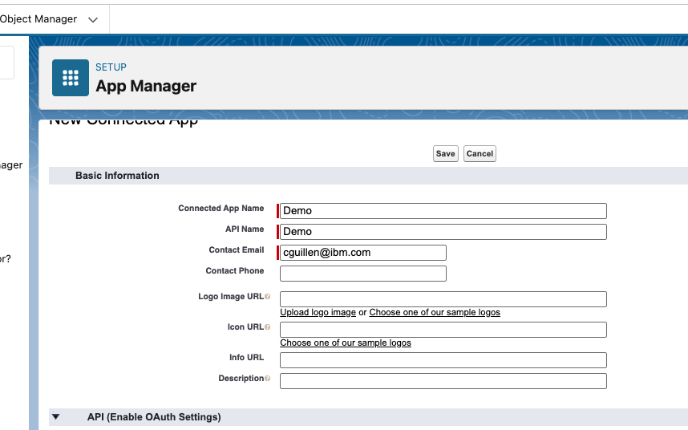

1. Enable "Enable OAuth Settings"
   1. Use “https://login.salesforce.com” in the callback url
   2. Available OAuth Scopes
      1. Chatbot_api
      2. Sfap_api
      3. Api
      4. Refresh_token
   3. Disable
      1. Require Proof Key for Code Exchange (PKCE) Extension for Supported Authorization Flows
      2. Require Secret for Web Server Flow
      3. Require Secret for Web Server Flow
      4. Require Secret for Refresh Token Flow
   4. Enable
      1. Enable Client Credentials Flow
   5. Issue JSON Web Token (JWT)-based access tokens for named users

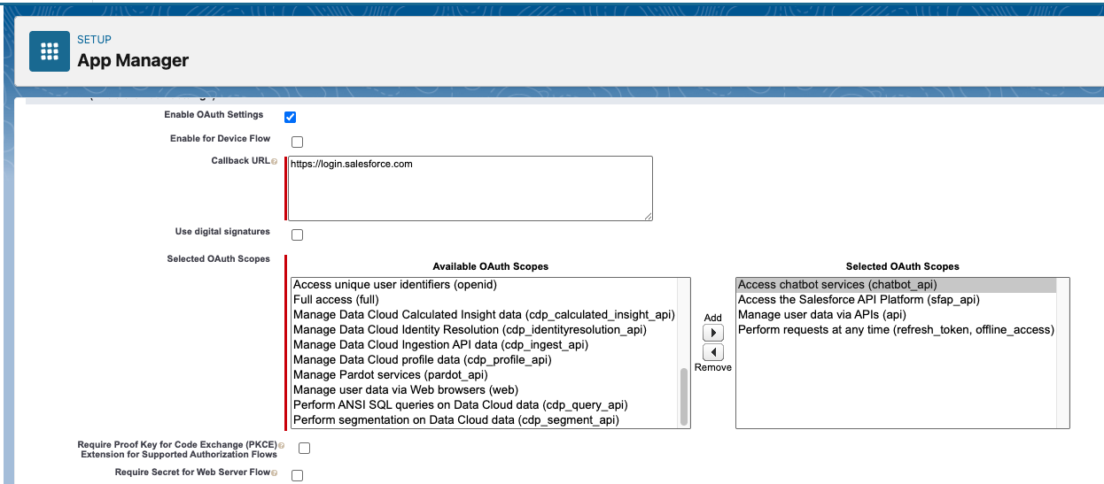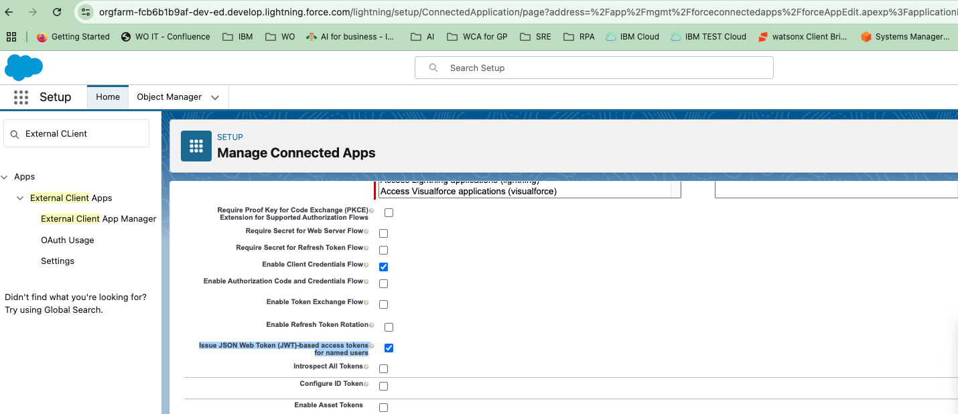

* 1. Then Save

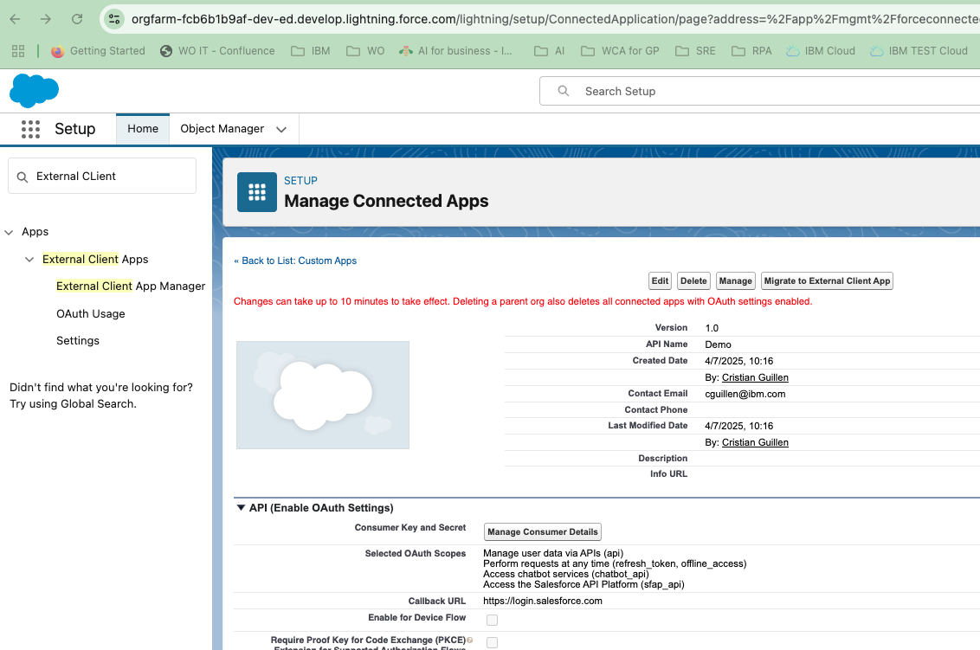

* 1. Then click Manage, then Edit policies
  2. Setup the user in **Client Credentials Flow**

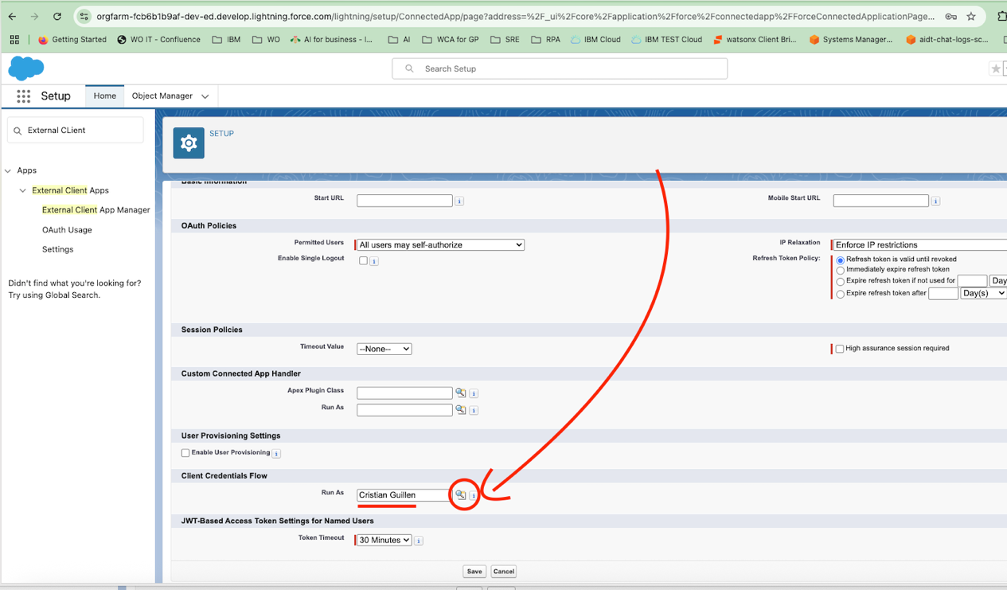

* 1. Then come back to app manager
  2. Look for Demo app and click **view**

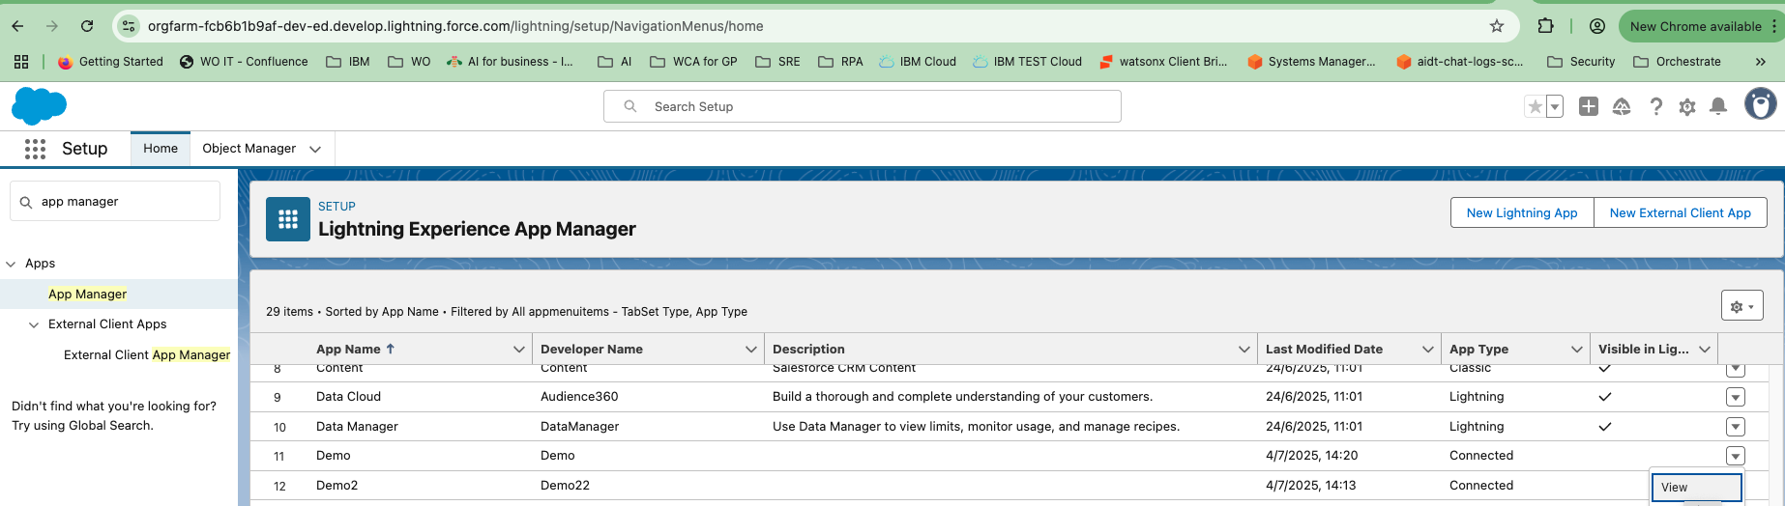

* 1. Click manage Consumer Details

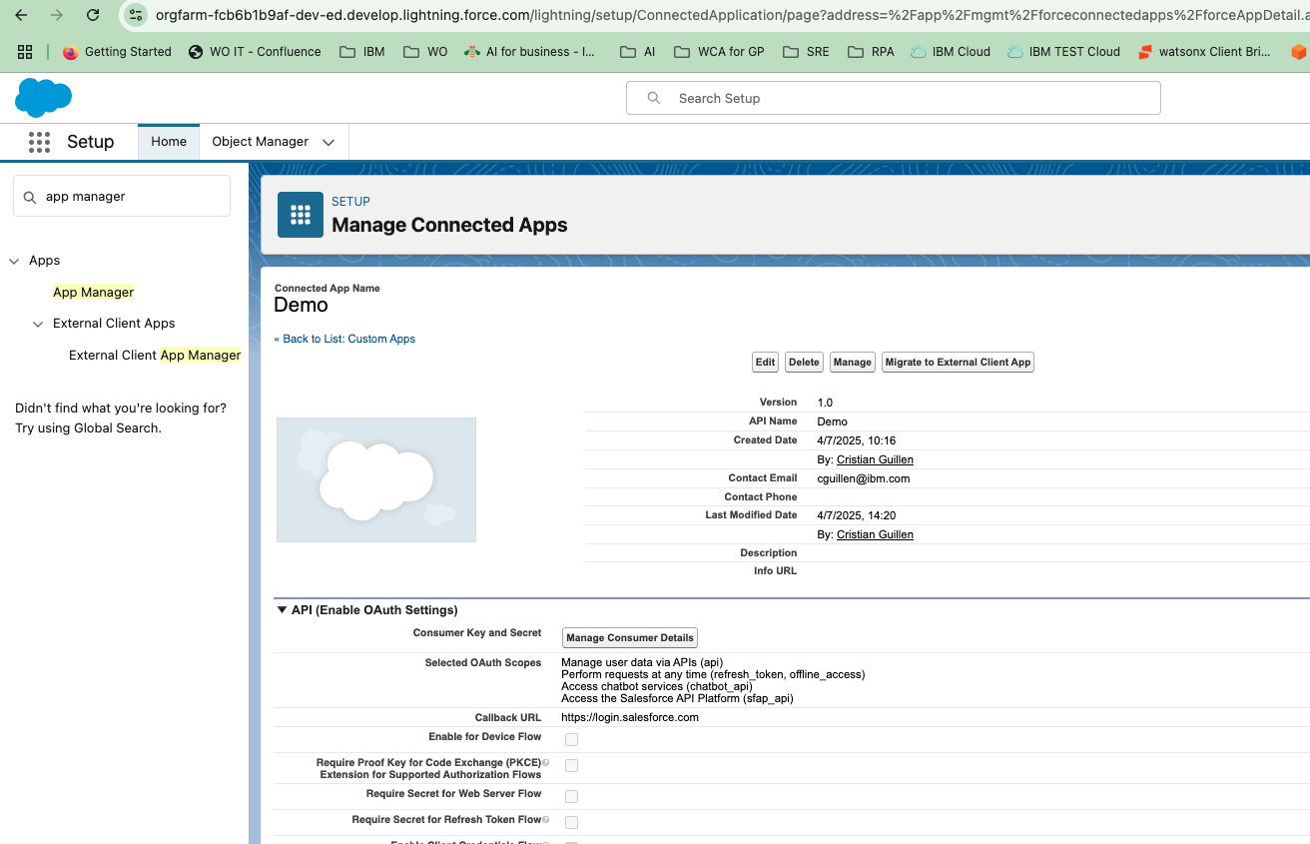

* 1. Copy the two keys provided and saved in a secure location

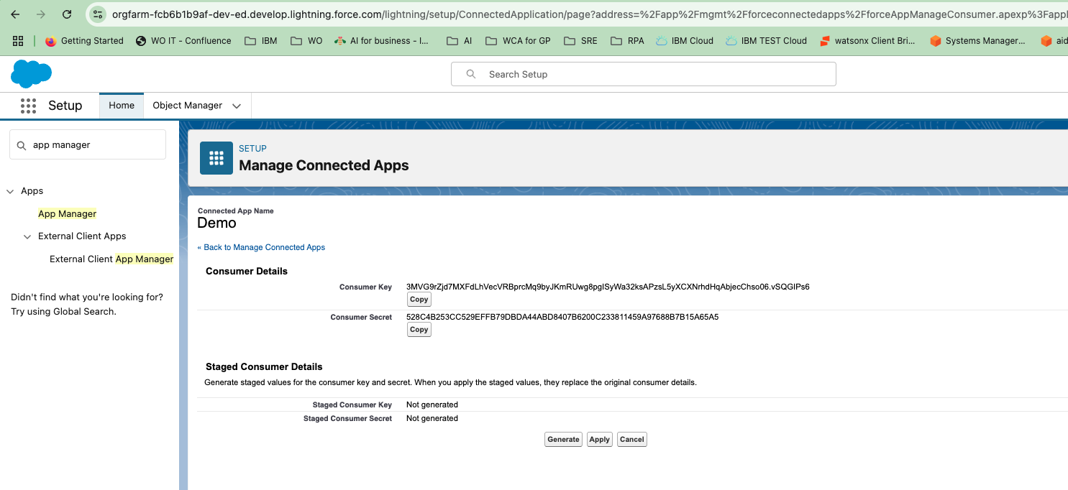

## **Look for the domains**

Look for “my domain” save the “**Current My Domain URL**” in the same pace than the keys above

|  |  |
| --- | --- |
| **Current My Domain URL** | **orgfarm-fcb6b1b9af-dev-ed.develop.my.salesforce.com** |

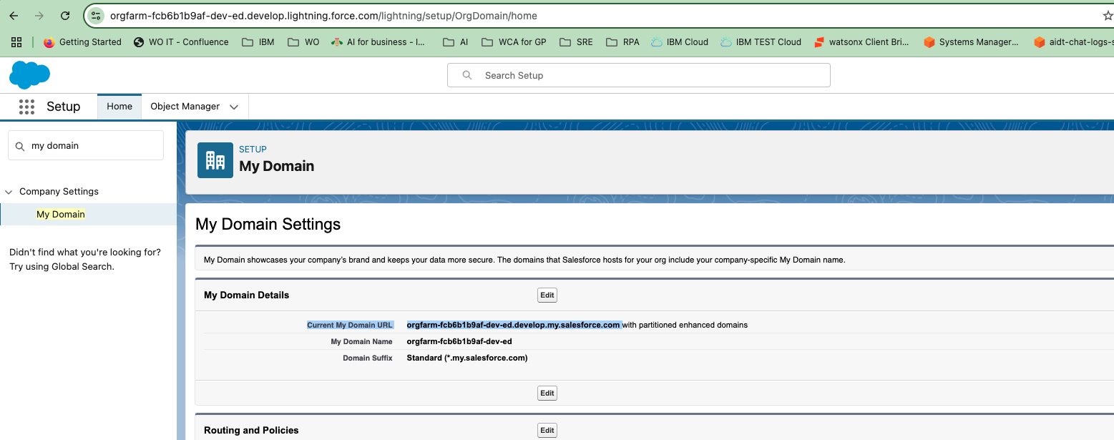

## **Connections**

Then create the following keys in the draft/live setting of watson orchestrate:

* **base_url**, use the domain above with the https:// prefix
* **token_url**, use the domain above with this path /services/oauth2/token
* **client_id**, use the consumer key
* **client_secret**, use the consumer secret
* **domain**, use the domain above **without** salesforce.com suffix

### Example

"base_url": "<https://orgfarm-fcb6b1b9af-dev-ed.develop.my.salesforce.com>",

"token_url": "<https://orgfarm-fcb6b1b9af-dev-ed.develop.my.salesforce.com/services/oauth2/token>",

"client_id": "xxx",

"client_secret": "xxxx",

"domain": "orgfarm-fcb6b1b9af-dev-ed.develop.my"

# 2. watsonx Orchestrate integration

## **Create connection**

To connect watsonx Orchestrate to Salesforce:

1. From the main menu, select **Manage** > **Connections**.
2. Search for **Salesforce**.
3. Find the connection ID with the followiing structure: **salesforce_key_value_ibm_184bdbd3**.
4. For the matched connection ID, click **Edit**.
5. Choose the environment to create the connection: draft or live.
6. Select the **Authentication Type** as **Key Value Pair**.
7. Provide the following **Keys**, click **Add new field** to add additional key-value pairs:
   * base_url
   * token_url
   * client_id
   * client_secret
   * domain

For all **Value** fields insert the value corresponding to the key.

1. Select the [credential type](https://www.ibm.com/docs/en/SSAVQO/manage/connections.html#credential-types).
2. Click **Save**.

*Source*: <https://www.ibm.com/docs/en/watsonx/watson-orchestrate/base?topic=agents-salesforce>

## **Create Salesforce agent**

To import prebuilt Salesforce agent:

1. From the main menu, select **Manage** > **Connections**.
2. Search for **CRM Management**.
3. Click **Use as template**.
4. (optional) Update agent’s parameters
5. Test your agent in Preview window

*Example: list 5 opportunities*