**Lab 1005: Transformation Advisor**



**Last updated:** March 2023

**Duration:** 45 minutes

Need support? Contact **Kevin Postreich, Yi Tang**

## **Introduction**

**IBM Cloud Transformation Advisor** (Transformation Advisor) is an application modernization tool that is entitled through IBM WebSphere Hybrid Edition.

Transformation Advisor is used to help modernize your Java applications and move them to Liberty on VMs and optionally to Liberty on Kubernetes-based platforms.

Transformation Advisor determines the complexity of your applications, identifies needed application changes, estimates the development cost for a move to Liberty, and generates reports and deployment artifacts that can help you update applications and move them to the target environment.

The Transformation Advisor tool provides the following value:

* identify the Java EE programming models in the app.
* determine the complexity of apps by listing a high-level inventory of the content and structure of each app.
* highlight Java EE programming model and WebSphere API differences between the WebSphere profile types
* identify Java EE specification implementation differences that might affect the app
* generate accelerators for deploying the application to Liberty and containers in a target environment.

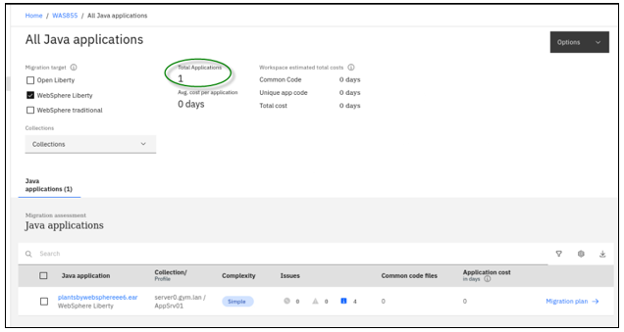

## **Accessing the environment**

If you are doing this lab as part of an instructor led workshop (virtual or face to face), an environment has already been provisioned for you. The instructor will provide the details for accessing the lab environment.

Otherwise, you will need to reserve an environment for the lab. You can obtain one here. Follow the on-screen instructions for the “**Reserve now**” option.

KLP: TBD LINK TO ENV RESERVATION

The lab environment contains two (2) Linux VMs.

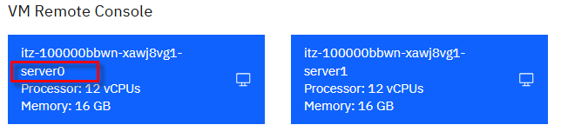

A Published Service is configured to provide access to the **server0** VM through the noVNC interface for the lab environment.

1. Access the lab environment from your web browser.

a. When the environment is provisioned, right-mouse click on the **Published Service** link/ Then select “**Open link in New Tab**” from the context menu.

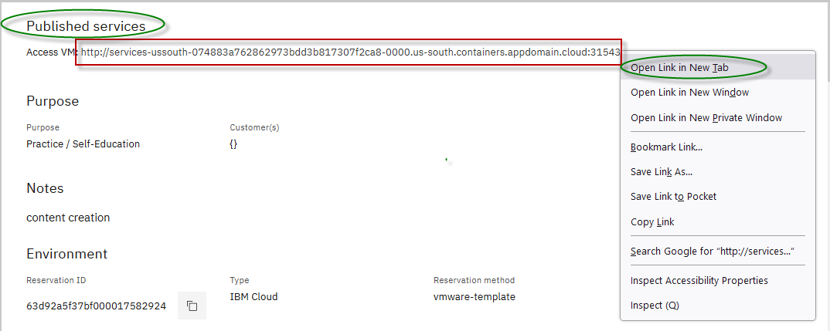

b. Click on the **"vnc.html"** link to open the lab environment through the **noVNC** interface.

[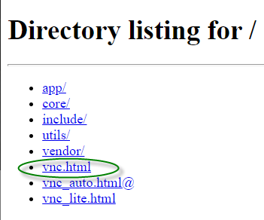](https://github.com/IBMTechSales/klp-workshop-labs/blob/master/1161-RuntimeModernization/extras/images/vnc-link.png)

c. Click the **Connect** button

[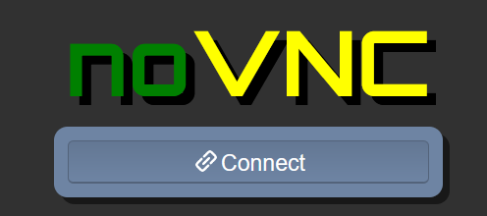](https://github.com/IBMTechSales/klp-workshop-labs/blob/master/1161-RuntimeModernization/extras/images/vnc-connect.png)

d. Enter the password as: **passw0rd**. Then click the **Send Credentials** button to access the lab environment.

**Note:** That is a numeric zero in passw0rd

[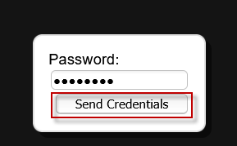](https://github.com/IBMTechSales/klp-workshop-labs/blob/master/1161-RuntimeModernization/extras/images/vnc-password.png)

1. Login to the **server0** VM using the credentials below:
   * User ID: **techzone**
   * Password: **IBMDem0s!**

## **Tips for working in the lab environment**

1. You can use your Browsers **zoom in** and **zoom out** options to resize the virtual desktop to fit your screen.

The examples below are using Firefox and Chrome browsers.

* + Firefox example:

[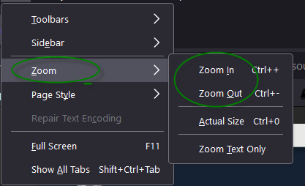](https://github.com/IBMTechSales/klp-workshop-labs/blob/master/1161-RuntimeModernization/extras/images/zoom.png)

* + Chrome example:

[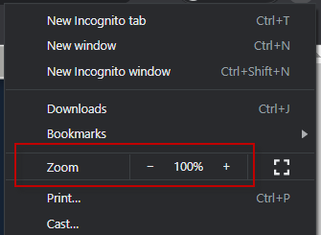](https://github.com/IBMTechSales/klp-workshop-labs/blob/master/1161-RuntimeModernization/extras/images/zoom-chrome.png)

1. You can copy / paste text from the lab guide into the lab environment using the clipboard in the noVNC viewer.

a. Copy the text from the lab guide that you want to paste into the lab environment

b. Click the **Clipboard** icon and **paste** the text into the noVNC clipboard

[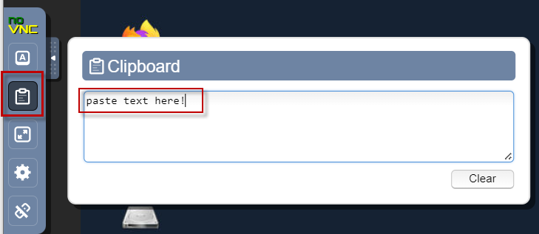](https://github.com/IBMTechSales/klp-workshop-labs/blob/master/1161-RuntimeModernization/extras/images/paste.png)

c. Paste the text into the VM, such as to a terminal window, browser window, etc.

d. Click on the **clipboard** icon again to close the clipboard

**NOTE:** Sometimes pasting into a Terminal window in the VM does not work consistently. In this case you might try again or paste the text into a **Text Editor** in the VM, and then paste it into the Terminal window in the VM.

1. An alternative to using the noVNC Copy / Paste option, you may consider opening the lab guide in a web browser inside of the VM. Using this method, you can easily copy / paste text from the lab guide without having to use the noVNC clipboard.

## **Lab: Transformation Advisor**

This lab demonstrates using Transformation Advisor for **runtime modernization to Liberty**. It uses the PlantsByWebSphere application, which originates from WebSphere ND V8.5.5.

It shows the value of using Transformation Advisor (TA) to evaluate on-premises Java applications and identify the effort required for migrating the application to Liberty.

You will also explore the deployment accelerators that TA generates to help deploy and run Java applications on Liberty on VMs and Kubernetes-based platforms.

**This lab contains the following activities:**

* Clone the git repository to the VM, which contains artifacts required for the lab
* Review the existing WebSphere application used in the scenario
* Use Transformation Advisor to collect data about the WebSphere application and server configuration, under assessment.
* Use Transformation Advisor to assess the application for suitability for Liberty
* Explore the deployment accelerator artifacts generated by Transformation Advisor that streamlines the configuration and deployment of the application to WebSphere Liberty

## **Clone the GitHub repo for this workshop**

This lab requires artifacts that are stored in a GitHub repository. Run the command below to clone the repository to the local VM used for the lab.

1. Clone the GitHub repo that contains lab artifacts needed for the lab.
2. Open a new terminal window on the “**server0.gym.lan**” VM

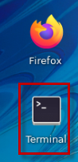

1. Clone the GitHub repository required for the lab

|  |
| --- |
| git clone <https://github.com/IBMTechSales/liberty_admin_pot.git> |

## **Part 1: Review the on-prem WebSphere “PlantsByWebSphere” app that is used for the Liberty Runtime Modernization scenario**

In this section, you take a quick look at the current WebSphere Application Server environment and the PlantsByWebSphere application deployed to the local WebSphere Application Server (WAS) environment on the VM.

1. Start the PlantsByWebSphere application DB2 database, which runs in a local docker container

To start the DB2 database in the container:

* 1. Open a new terminal window



b. In the terminal window, issue the command below to start the DB2 database. Then use the “**docker ps**” command to verify the database container is running

|  |
| --- |
| docker start db2_demo_data  docker ps |

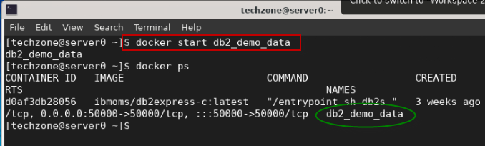

1. Start WebSphere Application Server

In the desktop VM, you have a local WebSphere Application Server (WAS) which hosts the PlantsByWebSphere application. To start the WAS server:

From the terminal window, issue the command below to start the WAS server.

|  |
| --- |
| /opt/IBM/WebSphere/AppServer85515/bin/startServer.sh tWAS_85515_server |

The WebSphere Application Server is ready when you see the message stating the server is “**open for e-business”**, as illustrated below:

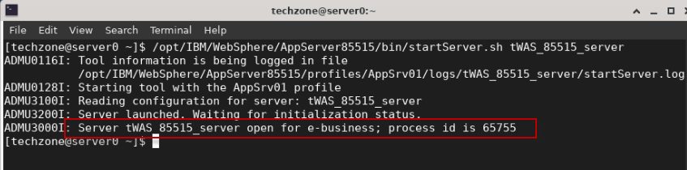

1. Access the WebSphere Administration Console to view the application deployed.
   1. Open the **Firefox** Browser on the VM.

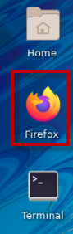

* 1. From the Firefox browser, click **WebSphere Integrated Solution Console** bookmark to launch the WAS console. Or launch the WAS admin console using the URL:

|  |
| --- |
| https://localhost:9043/ibm/console/ |

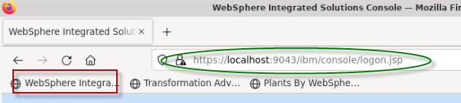

c. If you see the **Warning: Potential Security Risk Ahead** message, click **Advanced**>**Accept the Risk and continue**.

d. In the WAS Admin Console login page, enter the WebSphere Admin User ID and Password as: **wsadmin** / **wsadmin** and click **Login**.

[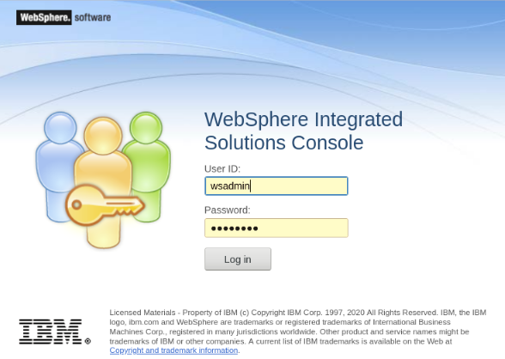](https://github.com/IBMTechSales/klp-workshop-labs/blob/master/1153-TechJam-Evaluate-App-TransformationAdvisor/images/media/image12.png)

e. On the WAS Console page, click **Applications** -> **Application > Types** -> **WebSphere enterprise applications** to view the deployed applications.

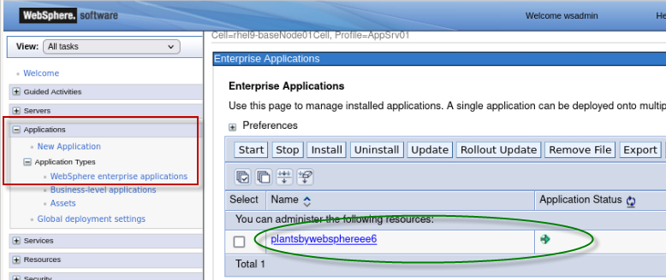

In the Enterprise Applications list, you can see the PlantsByWebSphere application is deployed and in the “**running**” status, as indicated by the GREEN Started icon.

Next, you will quickly run the PlantsByWebSphere application from the Firefox browser to ensure it works as expected.

1. Launch and test the PlantsByWebSphere application
   1. From the Firefox Browser, open a **new** browser tab.
   2. Click on the “**Plants By WebSphere**” bookmark, or enter the following URL in the browser:

|  |
| --- |
| http://server0.gym.lan:9080/PlantsByWebSphere |

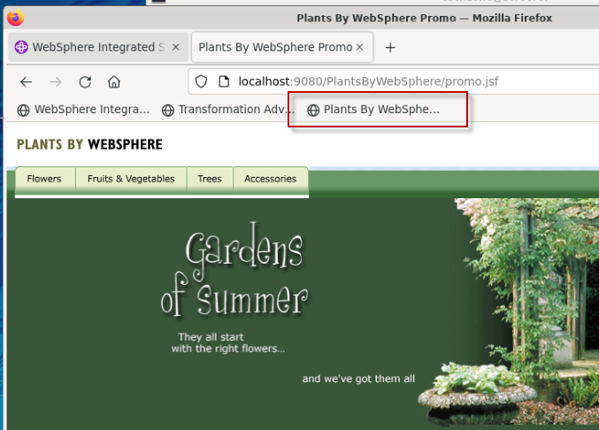

* 1. Click on the “**Flowers**” tab, which will retrieve the catalog of flowers from the DB2 Database.

If the list of Flowers is displayed, then the application is functioning as expected in the WebSphere Application Server environment.

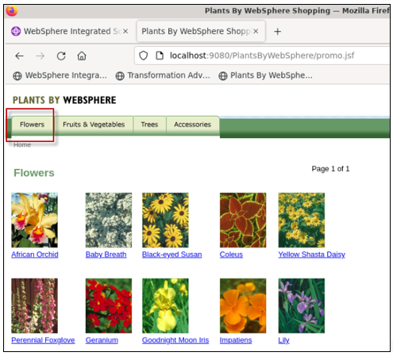

1. **Close** the Browser

In the next section of the lab, you will leverage Transformation Advisor to accelerate the “Runtime Modernization” from the traditional WebSphere Application Server to the cloud-enabled, right-sized, cost effective, and modern Liberty Application Server.

Transformation Advisor is entitled for use through the IBM WebSphere Hybrid Edition product, as is all editions of WebSphere Liberty.

## **Part 2: Transformation Advisor data collector and migration bundle**

In this section of the lab, you will:

* Use Transformation Advisor data collector utility to collect application and configuration data from the WebSphere Application Server that is currently running the PlantsByWebSphere application
* Use Transformation Advisor to do a quick analysis to gain valuable insights to determine the feasibility and effort required to migrate the PlantsByWebSphere application to the modern Liberty runtime.
  + In this lab, no application code changes are required to run PlantsByWebSphere application on WebSphere liberty.
* Download the Liberty deployment artifacts generated by Transformation Advisor to facilitate a quick configuration and deployment of the PlantsByWebSphere application to WebSphere Liberty running on the VM.

### **Access Transformation Advisor using the local installation**

Transformation Advisor can be installed into an existing RedHat OpenShift Cluster or locally on a VM into docker containers.

You can try Transformation Advisor – Local for yourself by registering for a 90-day free trial: <http://ibm.biz/cloudta-trial>

In this lab environment, we have pre-installed Transformation Advisor – Local which runs in docker containers.

1. Launch the **Transformation Advisor** using the following commands:

|  |
| --- |
| cd /home/techzone/transformation-advisor-local-3.4.0  ./launchTransformationAdvisor.sh |

Wait for Transformation Advisor to initialize and display the action menu list.

1. Type **5** and press **Enter** to start the **Transformation Advisor**.

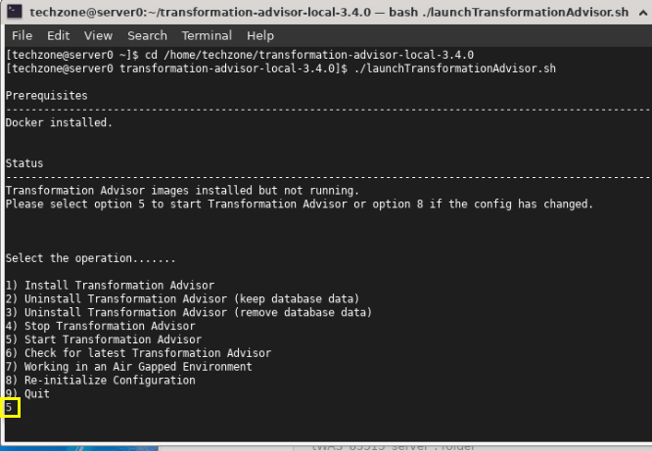

1. After a few moments, the **Transformation Advisor** application is started. Right-click the application URL link and select **Open Link** to launch it in a web browser window.

The URL is displayed in the output from the TA command: <http://server0.gym.lan:3000>

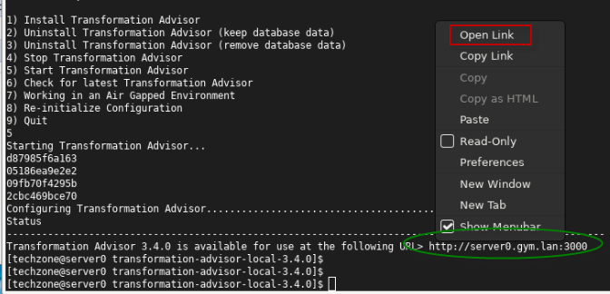

This **Transformation Advisor** Home page is displayed in the Web Browser.

[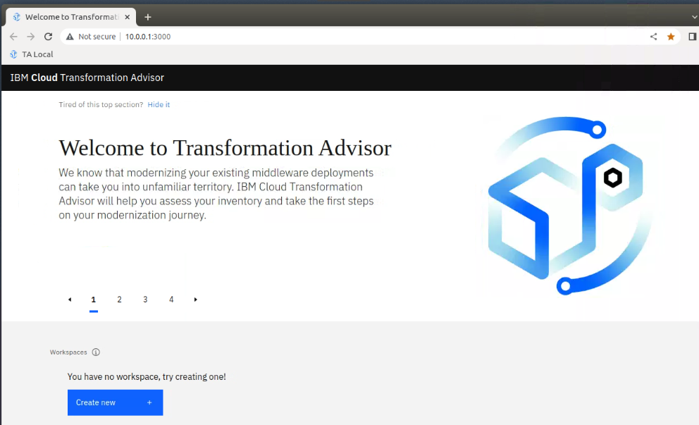](https://github.com/IBMTechSales/klp-workshop-labs/blob/master/1153-Evaluate-App-TransformationAdvisor/images/media/image11.png)

In the next section, you will use the Transformation Advisor UI to download the **data collector utility** for the WebSphere Application Server environment. For this lab WebSphere is running on the Linux VM.

### **Download Transformation Advisor Data Collector utility**

Now the Transformation Advisor is running, you will download its Data Collector utility that will run against the WebSphere Application Server to gather application and server configuration data for analysis and an assessment for modernizing the runtime to Liberty.

To evaluate on-premises Java applications, you need to run **Transformation Advisor Data Collector utility** against the Application server environment. It will extract application and configuration from the environment.

Use the following steps to download the data collection utility from the Transformation Advisor

1. From the Transformation Advisor Home page, create a **new workspace**

a. Click the **Create New** button

b. Enter the workspace name as **WAS855, then** click the **Create** button

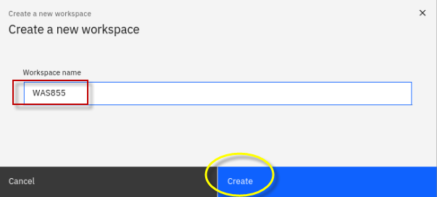

|  |  |
| --- | --- |
| [sign-info](https://github.com/IBMTechSales/klp-workshop-labs/blob/master/1153-Evaluate-App-TransformationAdvisor/images/media/image13.png) | A workspace is a designated area that will house the migration recommendations provided by **Transformation Advisor** from your application server environment. You can name and organize these however you want, whether it’s by business application, location, or teams |

Once the Workspace is created, you will have options to either **download** the Data Collector utility or **upload** existing data file into TA for analysis.

[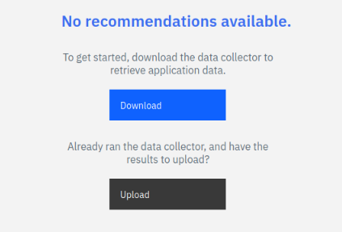](https://github.com/IBMTechSales/klp-workshop-labs/blob/master/1153-Evaluate-App-TransformationAdvisor/images/media/image14.png)

1. Click the **Download** button to download the data collector for Linux

[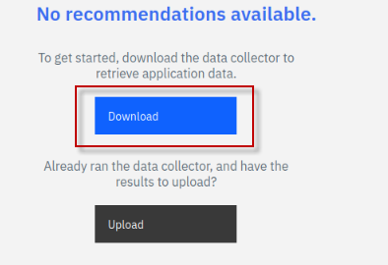](https://github.com/IBMTechSales/klp-workshop-labs/blob/master/1153-Evaluate-App-TransformationAdvisor/images/media/image15.png)

1. In the Download page, you can download data collector utility based on your source operating system for your WebSphere environment. It also shows how to use the command line utility to collect application and configuration data from WebSphere, WebLogic, and Tomcat servers.

a. Since WebSphere is running on the lab VM, which is Linux OS, click **Download Linux** to get the utility.

[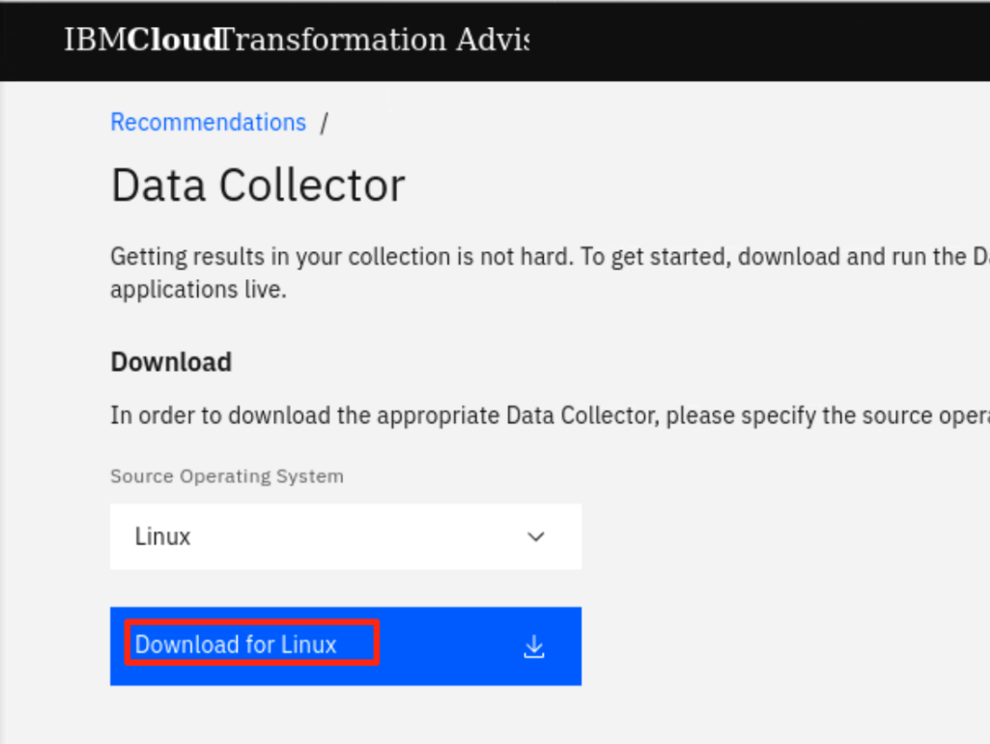](https://github.com/IBMTechSales/klp-workshop-labs/blob/master/1153-Evaluate-App-TransformationAdvisor/images/media/image16.png)

b. In the Firefox browser, when the download is complete, you will see the file shown in the “**Downloads**” folder.

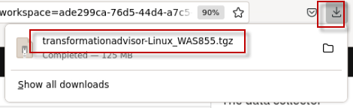

**Note:** The zipped Data Collector utility file will be saved as:

/**home/techzone/Downloads/transformationadvisor-Linux_WAS855.tgz**

### **Run the Transformation Advisor Data Collector utility**

After downloading the zipped Data Collector utility, it needs to be unpacked and run against a WebSphere Application server (WAS) to collect all the data of deployed applications and their configuration from the WAS server.

Now, let’s run the data collector.

1. Go back to the terminal window and navigate the **/home/techzone/Downloads** directory and view its contents with commands:

|  |
| --- |
| cd /home/techzone/Downloads/  ls -l | grep transformationadvisor |

You can see the downloaded data collector utility file named “**transformationadvisor-Linux_WAS855.tgz**”

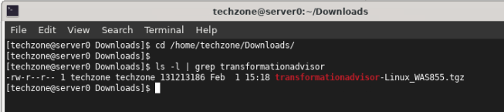

1. Create a new directory and extract the data collector utility to the new directory, using the following commands:

|  |
| --- |
| mkdir ~/Student/lab_1005    tar xvfz transformationadvisor-Linux_WAS855.tgz –directory ~/Student/lab_1005 |

The data collector utility will be extracted to:

/home/techzone/Student/lab_1005***/*transformationadvisor-3.4.0**

1. Verify the data collector was extracted to the target directory:

|  |
| --- |
| ls -l /home/techzone/Student/lab_1005***/*transformationadvisor-3.4.0** |

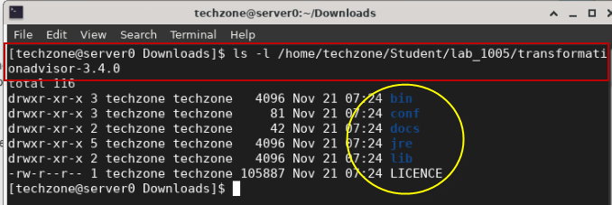

**Note:** At this point, the data collector is ready to execute against a WebSphere environment.

1. Return to the Transformation Advisor UI in the Web browser to view the section on “**Run the Tool**”, which shows the command to run on the WebSphere environment.

a. From the **Data Collector** page, scroll down to the “**Run Tool**” section.

The data collector command to be executed is based on the **domain** and **analysis type** selections you make in this section.

[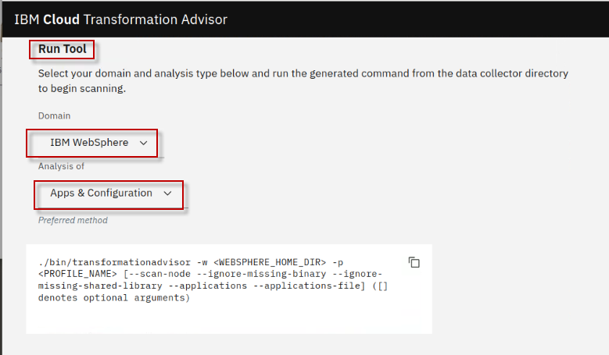](https://github.com/IBMTechSales/klp-workshop-labs/blob/master/1153-Evaluate-App-TransformationAdvisor/images/media/image19.png)

1. Choose the **IBM WebSphere** Domain.

**Note:** The data collector tool command changes based on this selection.

[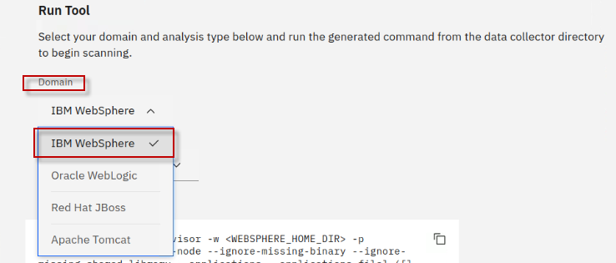](https://github.com/IBMTechSales/klp-workshop-labs/blob/master/1153-Evaluate-App-TransformationAdvisor/images/media/image20.png)

1. Select the Analysis type of “**Apps and Configuration**”

Selecting **Apps & Configuration** ensures that the application data and server configuration data is collected.

The server configuration data is extremely helpful in Transformation Advisor to generate deployment artifacts in the migration bundle, which we will explore later in the lab.

[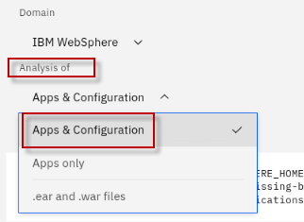](https://github.com/IBMTechSales/klp-workshop-labs/blob/master/1153-Evaluate-App-TransformationAdvisor/images/media/image21.png)

1. Run the data collector command shown below, which is based on the selected options.

|  |
| --- |
| cd /home/techzone/Student/lab_1005/transformationadvisor-3.4.0/  bin/transformationadvisor -w /opt/IBM/WebSphere/AppServer85515 -p AppSrv01 |

**Tip:**

**-w** option is the installation directory for WebSphere Application Server

**-p** option is the name of the WebSphere “profile” to collect the data from

1. Type the number “**1”** to accept the license agreement and press **Enter**, as illustrated below.

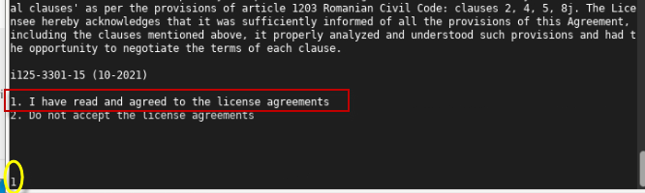

This process takes time to complete, depending on how many applications are deployed on the WebSphere Application server.

When the data collector completes, it will indicate the following:

* Status: **Finished**
* Configuration analysis: **Completed**
* Profile name: **AppSrv01**
* Applications Competed: **1**
* Progress: **100%**

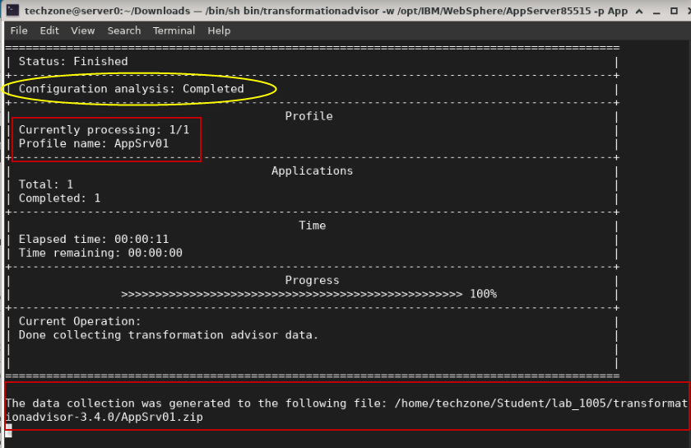

When the collection utility completes, the following messages is displayed.

**“The data collection was generated to the following file: /home/techzone/Student/lab_1005/transformationadvisor-3.4.0/AppSrv01.zip”**

“**Thank you for uploading your data. You can proceed to the application UI for doing further analysis.”**

Your application data is collected and is saved to the “**AppSrv01.zip**” file.

In general, if your application server and the **Transformation Advisor** are in the same network infrastructure, the collected data will be automatically uploaded to **Transformation Advisor** for you to view the analysis results.

Otherwise, you must manually upload the data to **Transformation Advisor** before you can view the results.

### **Upload the data collection into Transformation Advisor**

In this section, you will upload the data collection zip file “**AppSrv01.zip**” from the WebSphere environment for analysis.

1. Go back to the Transformation Advisor page in the web browser, click the “**Workload type**”

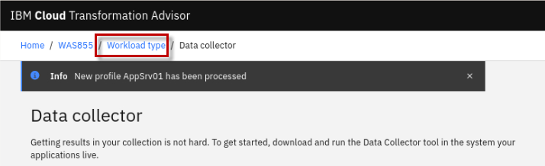

Once the data collection has been uploaded to Transformation Advisor, you are redirected back to the Transformation Advisor “**All Java applications” view**.

1. Optionally, resize the Firefox browser window and reduce the size of the text, to be able to provide an optimal view of the Transformation Advisor Analysis results.

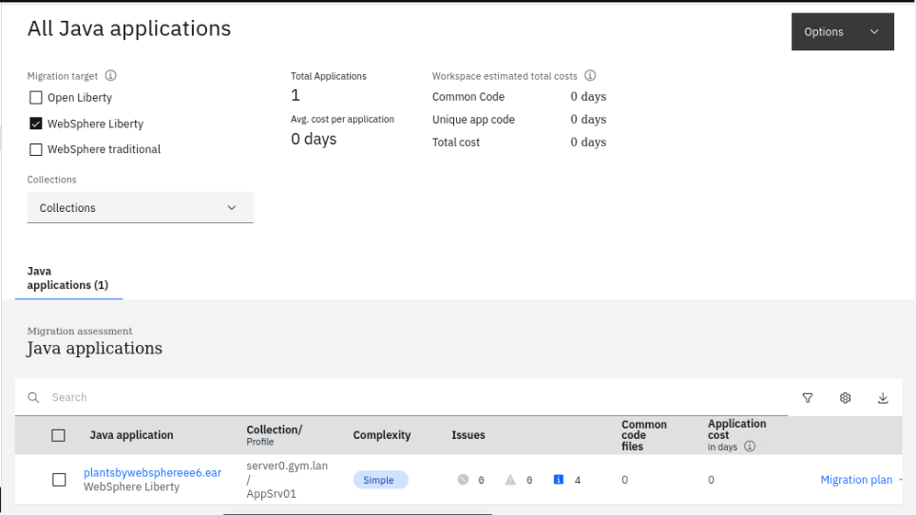

1. Review the workspace summary information at the top of the page.

Notice that the page shows “**All Java applications**” from the WebSphere Application Server profile named **AppSrv01**. In this case, only one application is shown, “**plantsbywebsphereee6.ear**”

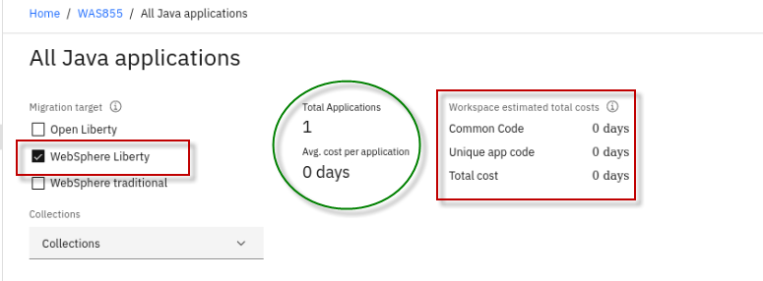

The following details are included in the “**workspace summary**” located at the top of the page.

* + **Migration Target: The default selection is “WebSphere Liberty” as the most optimal migration target. However, you may also display analysis details for Open Liberty and WebSphere traditional**
  + **Total Applications**: The total number of applications in the workspace.
  + **Avg. cost per application**: The average number of days of development effort required to migrate an application to WebSphere Liberty target.
  + **Common Code**: The total cost to migrate all the common code in the workspace to the target platform.
  + **Unique app code**: The total cost to migrate all the unique app code (code that is not shared between applications) in the workspace to the target platform.
  + **Total cost**: The total cost to migrate all the applications and common code in the workspace to the target platform.

In the next section, you will use Transformation Advisor and do a quick review of the application data analysis that was collected for the “**PlantsByWebSphere**” application.

## **Part 3: Quick evaluation of the PlantsByWebSphere application**

**The goal of runtime modernization for the PlantsByWebSphere application is to be able to deploy and run the application on WebSphere Liberty to leverage the many benefits of the modern Liberty Application Server runtime.**

**The first insight you will gain from Transformation Advisor is the overall complexity required to modernize to the Liberty runtime for the specific application being assessed.**

In this section you will do a quick review the analysis results for the **plantsbywebsphereee6.ear** application to get a clear understanding of the development effort to modernize the runtime to WebSphere Liberty for the PlantsByWebSphere application.

1. Ensure you are at the “**All Java Applications**” page in Transformation Advisor.

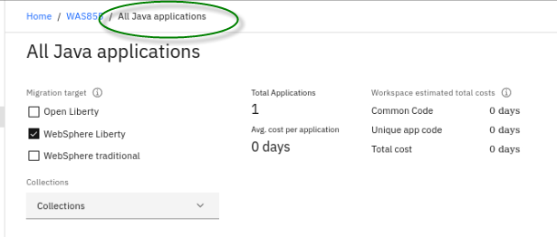

1. Ensure “**WebSphere Liberty**” is the only selected migration target

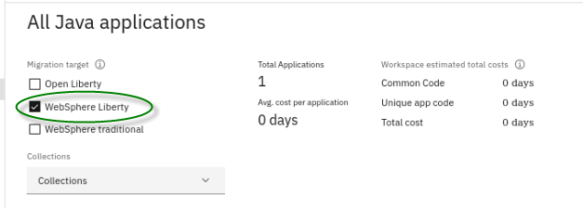

1. In the **"Java applications"** section, locate **plantsbywebsphereee6.ear** which is the only application that was analyzed by the data collector.

Let’s breakdown the summary analysis for the application with an explanation of the data columns based on the illustration for **plantsbywebsphereee6.ear** below:

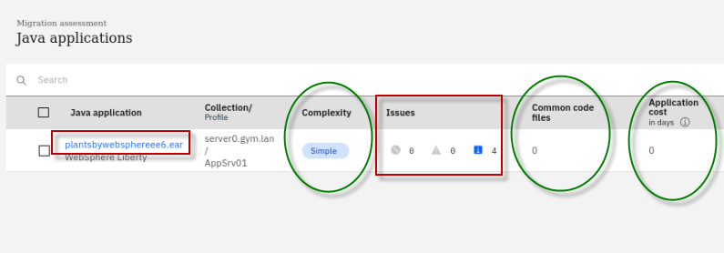

* Complexity: **Simple**

Complexity indicates how complex Transformation Advisor considers this application to be if you were to migrate it to WebSphere Liberty.

The complexity can be “Simple”, “Moderate”, or “Complex”.

**Simple** means there will not be any code changes to modernize to the WebSphere Liberty runtime.

**Moderate** means there could be some application code changes required, but the changes are well known and easily managed.

**Complex** means that application code must change, most often due to the fact that the application uses APIS that are not available in Liberty, and therefore the application code must be refactored using different APIs that are supported in Liberty.

* **Issues**: 4 Informational issues

The number and severity of potential issues with the migration of the application.

The PlantsByWebSphere application has 4 “Informational” issues discovered. Informational issues often flag external dependencies and configuration that need to be considered, such as security, databases, and considerations if moving the application to containers.

* **Common code files**: 0 common code files discovered among the applications in the workspace

The number of common code files this application uses. A file is considered common if it is from a Shared Library or is used by at least one other application.

* **Application cost in days**: 0 days of development effort (**No application code changes required**)

Provides an estimate in days for the development effort to perform the migration for just this application.

In this example, if you want to modernize the Java runtime to WebSphere Liberty for the plantsbywebsphereee6.ear application, the complexity level is **Simple**, which indicates that the application code does not need to be changed before it can be moved to WebSphere Liberty.

The application has no dependency, does not contain any know common code or shared library files. It has four minor (informational level) issues.

**Note:** The estimated development effort is zero day because no code change is required.



1. Click the **plantsbywebsphereee6.ear** link to expand its analysis results to access various assessment reports.

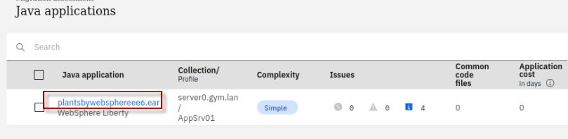

1. Scroll down to bottom of the page and click the **Technology report** link, this opens a new browser window and displays the Technology report.

[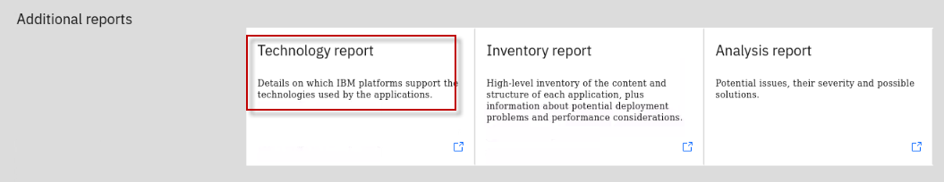](https://github.com/IBMTechSales/klp-workshop-labs/blob/master/1153-Evaluate-App-TransformationAdvisor/images/media/image44.png)

The **Technology report** lists all java technologies the application used and whether these technologies are supported by a specific WebSphere platform from Liberty for Java on IBM Cloud to WebSphere traditional for z/OS.

It is used to determine whether a particular WebSphere edition is suitable for an application in the various target runtime environments.

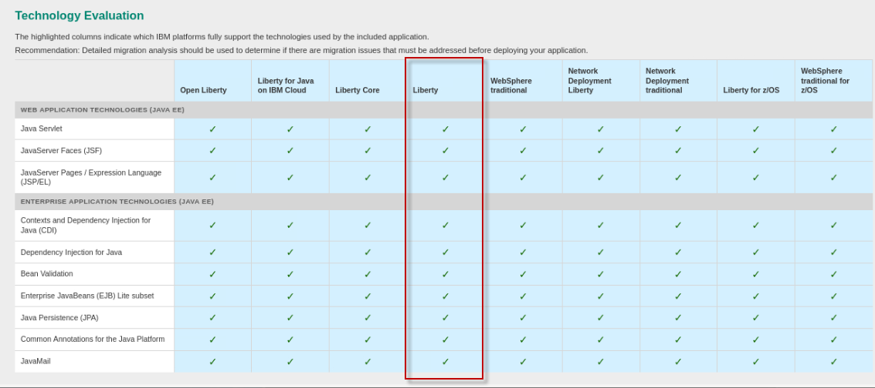

|  |  |
| --- | --- |
| [sign-info](https://github.com/IBMTechSales/klp-workshop-labs/blob/master/1153-Evaluate-App-TransformationAdvisor/images/media/image13.png) | **Tip:**  Notice that the APIs used in the PlantsByWebSphere application are 100% available in WebSphere Liberty, further evidence that the application is a suitable candidate for runtime modernization to WebSphere Liberty |

1. **Close** the Application Technology Report tab in the Firefox browser.
2. Return to the “**All Java Applications**” view in Transformation Advisor

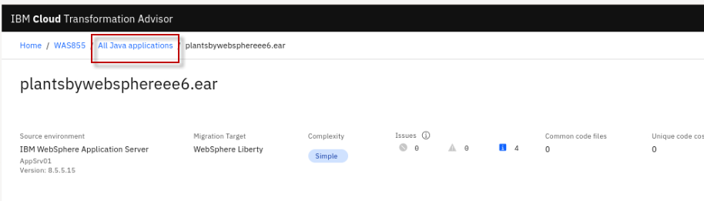

From this quick analysis you reviewed above, you learned that PlantsByWebSphere application is suitable for runtime modernization to WebSphere Liberty.

In the next section, you will explore and download the deployment artifacts that Transformation Advisor generated to facilitate the deployment of the PlantsByWebSphere application to WebSphere Liberty.

Then, in a separate lab, you will leverage these deployment artifacts while you deploy the PlantsByWebSphere application to WebSphere Liberty that you will install on the VM.

## **Part 4: Explore and download the migration bundle for the PlantsByWebSphere application**

Transformation Advisor displays details about the **migration plan** that it generated to accelerate the migration from WebSphere traditional to WebSphere Liberty.

The migration plan includes a **bundle** of diverse artifacts, depending on the needs of the application to accelerate the build, configuration, and deployment of an application to VMs or to containers.

Now, let’s quickly explore the **Migration Plan** for the PlantsByWebSphere application to see the artifacts that Transformation Advisor created to expedite the application deployment to the WebSphere Liberty target runtime.

1. Ensure you are at the “**All Java applications**” view in Transformation Advisor which displays the Java application summary list

[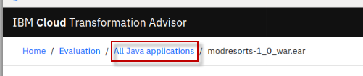](https://github.com/IBMTechSales/klp-workshop-labs/blob/master/1153-Evaluate-App-TransformationAdvisor/images/media/image59.png)

1. Ensure only the **WebSphere Liberty** migration target is selected

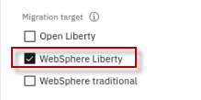

1. Click on the **Migration plan** link located next to the **plantsbywebsphereee6.ear** application which will display its **migration plan** for the WebSphere Liberty target runtime.

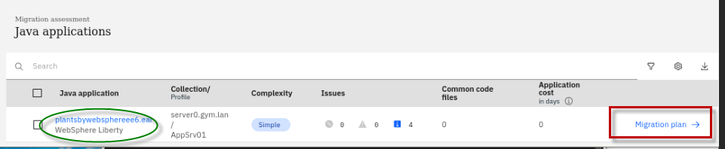

1. The Migration Plan page is displayed

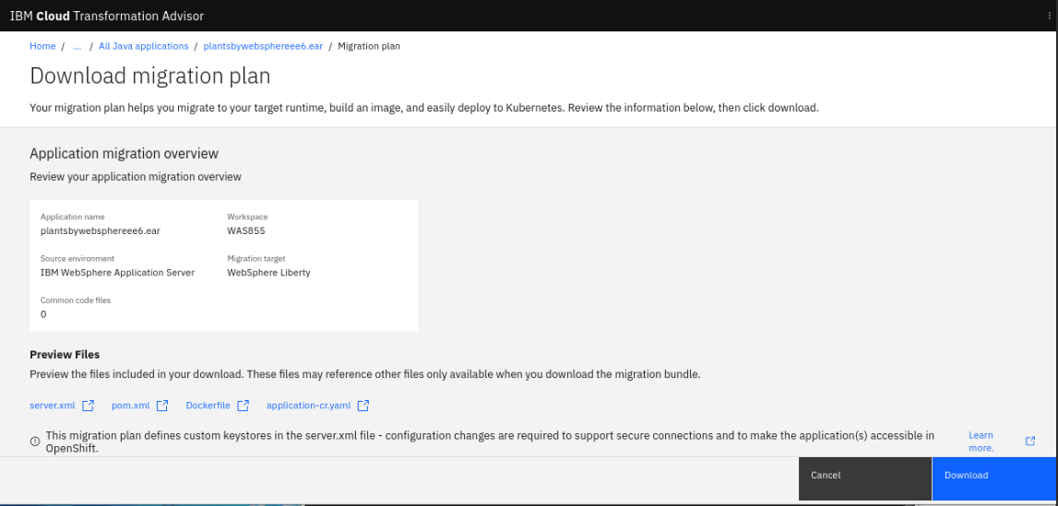

1. Scroll down to the **Preview Files** section of the migration plan. Notice the files that were generated by Transformation Advisor to accelerate build and deployment of the application to Liberty.

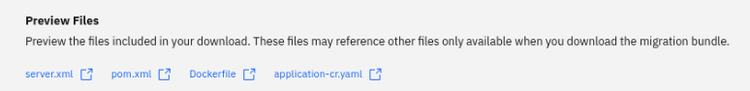

To accelerate the application modernization, the artifacts produced by Transformation Advisor include:

* + **server.xml**: the configuration for the Liberty server
  + **pom.xml**: Build the application using Maven
  + **Application CR**: Custom Resource for the application to be deployed to OpenShift via the Open Liberty Operator
  + **Dockerfile**: Create the Docker image for the application

The user can choose to **download** the artifacts as a migration bundle.

1. Scroll down and review the “**Application Dependencies**” of the application. Then, expand the **plantsbywebsphereee6.ear** application.

Transformation Advisor detected two DB2 database libraries as required dependencies for the PlantsByWebSphere application. During your migration project, you will need to gather the required libraries and place in the Liberty library path.

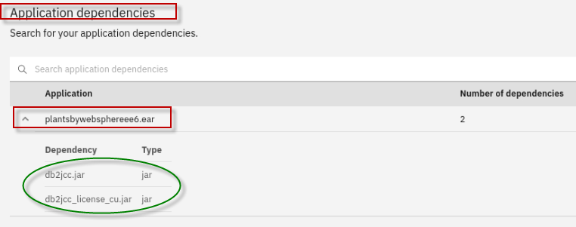

1. Click the **Download button** to download the bundle of artifacts to the local filesystem on the server0.gym.lan VM.

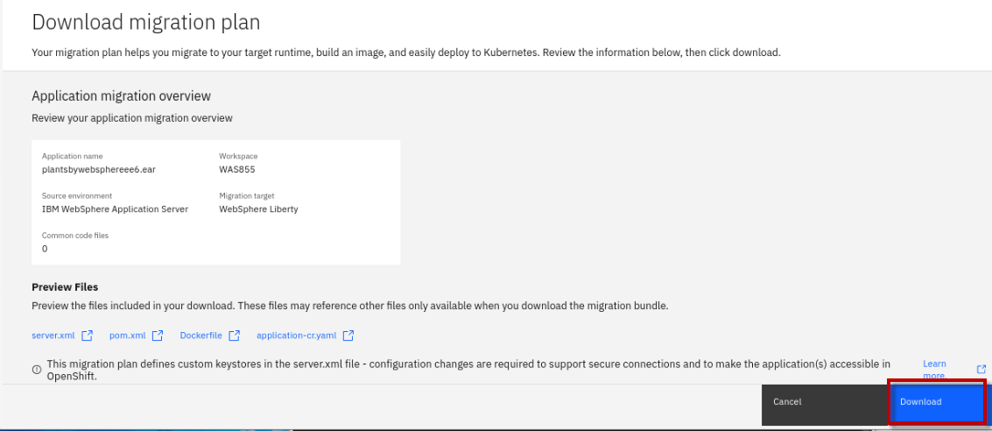

The migration bundle named “**plantsbywebsphereee6.ear_migrationBundle .zip”** file will be downloaded to the **/home/techzone/Downloads** directory

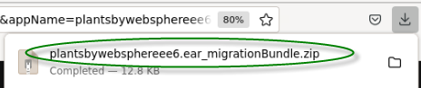

1. Unzip the migration bundle artifacts to a new folder on the server0.gym.lan VM

a. From a terminal window, run the following commands to unzip the migration bundle to a new directory named "**pbw-bundle**":

|  |
| --- |
| mkdir /home/techzone/Student/lab_1005/pbw-bundle  cd /home/techzone/Student/lab_1005/pbw-bundle  unzip ~/Downloads/plantsbywebsphereee6.ear_migrationBundle.zip -d ~/Student/lab_1005/pbw-bundle  ls -l |

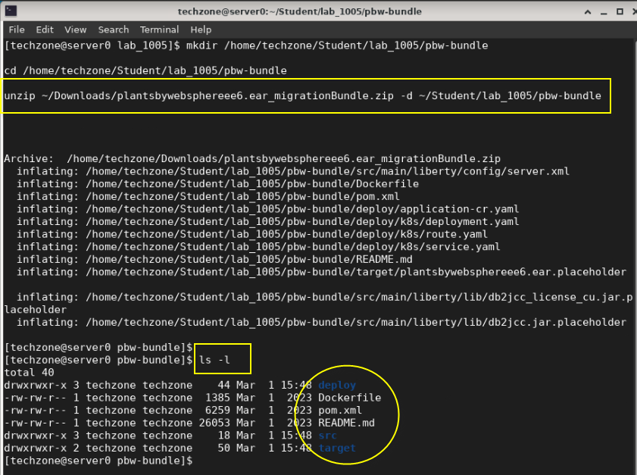

**Congratulations!** You have successfully assessed the PlantsByWebSphere application, found that it is suitable to be deployed on a modern WebSphere Liberty Server runtime.

You have downloaded the deployment accelerator artifacts generated by Transformation Advisor, which will accelerate the configuration and deployment of PlantsByWebSphere to Liberty.

The next steps, which are detailed in the next lab; “**Lab_1010-Runtime Modernization**” are:

* Install WebSphere Liberty using the archive installation method
* Create a new WebSphere Liberty Server
* Configure the WebSphere Liberty server using the deployment accelerators generated by Transformation Adviser, namely the “**server.xml**”
* Deploy the PlantsByWebSphere application to WebSphere Liberty

## **Summary**

In this lab, you learned how to evaluate the existing Java application using Transformation Advisor.

You downloaded Transformation Advisors generated deployment accelerators from the migration bundle that accelerate the build, configuration, and deployment of an application to Liberty.

Transformation Advisor accelerates application migration to Liberty and helps minimize errors and risks, while speeding time to value.

**Congratulations!**

**You have successfully completed the lab “Transformation Advisor”**