**1. INTRODUCTION**

**a. Project Overview**

Good health can be achieved by maintaining good behaviors such as a good night sleep, enough exercise and good nutrition. However, the competitive environment nowadays prevents such good behaviors.

Thus, this project is to develop an application that is able to record the nutrition, sleep and exercise information, analyze the collected information in order to provide a notification or an alarm, and present the analyzed results in a simple and easy to understand format

**b. purpose**

* Remote access to the users to track their nutrition ,sleep and exercise information
* User can edit their nutrition intakes plans
* Provide a option for user to edit their exercise routine as per their requirements.

**2. LITERATURE SURVEY**

1. **Exisiting problem**

* Lack sources of information for nutrition information
* Lack of Nutritional knowledge
* Awareness of the need for healthy eating habits and understanding the foods to eat are very less in previous days.
* Difficult to get appointment from the nutritionist to get the knowledge about the healthy food.
* People hesitate to go and get health related information in person.
* Due to their busy schedule it is difficult to spend time for following the healthy habits.
* Difficult to know about the diet choices

1. **references**

1. Balintfy JL. Menu planning by computer. Communications of the ACM. 1964;7(4):255–259. doi: 10.1145/364005.364087.

2. Chen, Y. , Hsu, C. Y. , Liu, . L and Yang, S. (2012), 'Constructing a nutrition diagnosis expert system,' Expert System with Application, 39(2) , 2132–2156

3. Dr.A.V.Senthil Kumar, Mr.siva., “ Nutrition Informatics App”, International Journal of Creative Research Thoughts, Vol.10, Issue 5, May 2022, ISSN:2320-2882

4. Jen-Hao and Henry Chang (2010). SmartDiet: A Personal Diet Consultant for Healthy Meal Planning.

5. DV Chandran, Sayali Adarkar, Apoorva Joshi, Preeti Kajbajd,, “Digital Medicine: An android based application for health care system”, IRJET, Volume-4, 04Apr-2017.

6.Garvita Gehlot, “ DIETEXPERT – ANDROID APPLICATION FOR PERSONAL DIET CONSULTANT, International Journal of Engineering Applied Sciences and Technology, 2021 Vol. 5, Issue 12, ISSN No. 2455-2143, Pages 202-205

7.Hong, S. M. and Kim, G. (2005). 'Web Expert System for Nutrition Counseling and Menu Management,' J Community Nutrition, 72 ,107 -113.

8. Jeong Sun Ahn1, Dong Woo Kim2, Jiae Kim3, Haemin Park3 and Jung Eun Lee1,4, “Development of a Smartphone Application for Dietary Self-Monitoring”, Frontiers in Nutrition, ORIGINAL RESEARCH published: 23 September 2019, doi: 10.3389/fnut.2019.00149  
9. Katerina Giazitzi, Vaios T. Karathanos, “Nutritional application software for restaurants: The tool of customer satisfaction and behaviour”, International Journal of Electronic Customer Relationship Management · January 2016, DOI: 10.1504/IJECRM.2016.082197

10. MariaUlfa ,WinnySetyonugroho ,Tri Lestari, Esti Widiasih,and AnhNguyenQuoc, “Nutrition-Related Mobile Application for Daily Dietary Self-Monitoring”, Hindawi, Journal of Nutrition and Metabolism, Volume 2022, Article ID 2476367, 11 pages, https://doi.org/10.1155/2022/2476367

11. Mustafa Mamat, Siti Kamila Deraman, Noor Maizura Mohamad Noor and Nor Fadzilah Zulkifli (2013). Relationship between Body Mass Index and Healthy Food with a Balanced Diet. Applied Mathematical Sciences, Vol. 7, 2013, no. 4, 153-159.

12. Promoting Fruit and Vegetable Consumption around the World. WHO. http://www.who.int/dietphysicalactivity/fruit/en/

1. **Problem statement definition**

To achieve a balanced and healthy life is difficult to this busy environment. Consuming unhealthy fast food due to their busy schedule leading to heavy risk factors like heart disease, diabetes and obesity. Healthy eating and nutritious food have become an essential part of everyone’s life. To achieve a balanced and healthy life is difficult to this busy environment. Smartphone’s are capable solving different problems in numerous areas of day to day life. Health and Nutrition System solve this problem and makes everyone live a healthy life.

**3. IDEATION & PROPOSED SOLUTION**

**a. Empathy Map Canvas**

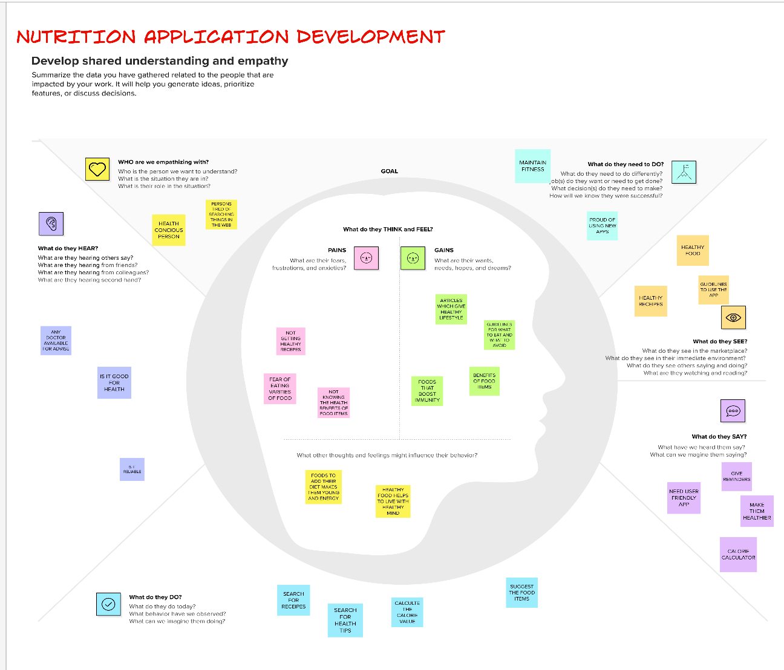

**b. Ideation & Brainstorming**

Brainstorming provides a free and open environment that encourages everyone within a team to participate in the creative thinking process that leads to problem solving. Prioritizing volume over value, out-of-the-box ideas are welcome and built upon, and all participants are encouraged to collaborate, helping each other develop a rich amount of creative solutions.Use this template in your own brainstorming sessions so your team can unleash their imagination and start shaping concepts even if you're not sitting in the same room. Reference: <https://www.mural.co/templates/empathy-map-canvas\>

Step-1: Team Gathering, Collaboration and Select the Problem Statement

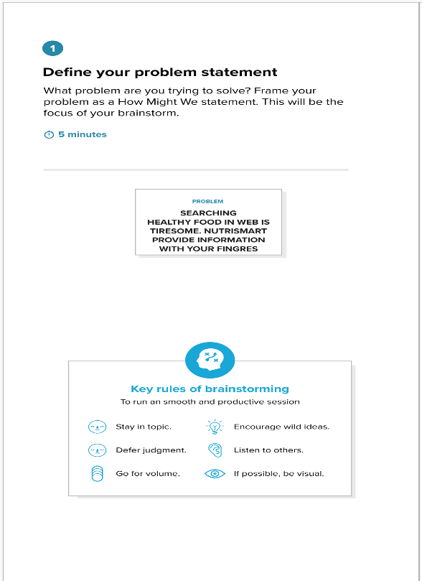

Step-2: Brainstorm, Idea Listing and Grouping

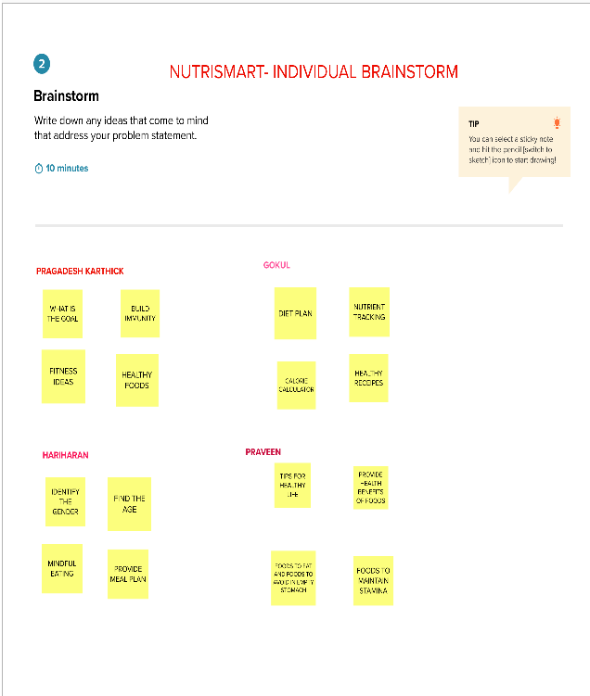

Step-3: Idea Prioritization

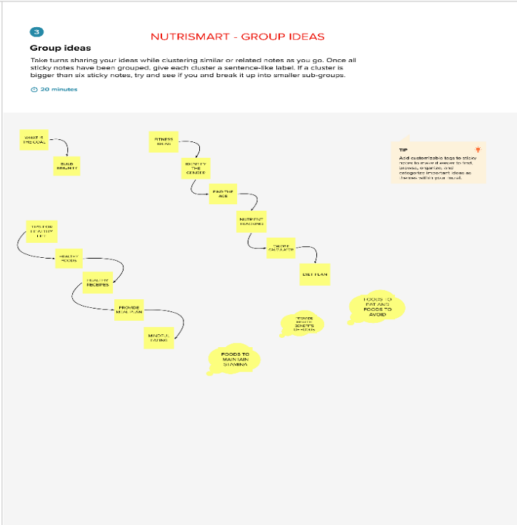

c. Proposed Solution

Project team shall fill the following information in proposed solution template.

|  |  |  |
| --- | --- | --- |
| **S.No.** | **Parameter** | **Description** |
|  | Problem Statement (Problem to be solved) | * Healthy eating and nutritious food have become an essential part of everyone’s life. * To achieve a balanced and healthy life is difficult to this busy environment. * Smartphone’s are capable solving different problems in numerous areas of day to day life. * NUTRISMART solve this problem and makes customer live a healthy life. |
|  | Idea / Solution description | * Suggest healthy food to maintain healthy body * Maintain the log of daily calorie * Suggestion for correct intake of food * Provide healthy recipes * Suggest some tips for healthy life * Provide health benefits of food |
|  | Novelty / Uniqueness | * Calorie calculator – based on the age and gender * Provide the user a nutrition guide to their doorstep * Provide Notifications to their day-to-day life |
|  | Social Impact / Customer Satisfaction | * Getting Nutritious tips from various sources. * Customer can get enough knowledge of what to eat and what not to eat. * Maintain their fitness by following the health tips and achieve the fitness goal |
|  | Business Model (Revenue Model) | * Mobile Apps plays a vital role in the day-to-day life. * They are Very easy and Time consuming * Economically they are very feasible |
|  | Scalability of the Solution | * In a family there may be infants, young children, adolescent, adults, and elderly all living under one roof. * It is always a big challenge to provide a good nutritious diet for each of the member, particularly when their needs, preferences vary. * Diet and nutrition app can help the entire family in adopting a fit and healthy lifestyle. * The user will keep track of their current exercise, food, and water statistics through continuous usage of the app. |

1. **Problem solution fit**

**5. AVAILABLE SOLUTIONS**

**1. CUSTOMER SEGMENT(S)**

**C**

**6. CUSTOMER CONSTRAINTS**

**A**

**S**

* The user will keep track of their current exercise, food, and water statistics through continuous usage of the NUTRISMART App
* Suggest tips for healthy life
* Provide the user a reliable and time saving nutrition guide to their doorstep
* Smartphone’s are capable solving their different problems

Everyone craves for healthy and nutritious food on their plates. Healthy eating and nutritious food have become an essential part of everyone’s life. NUTRISMART app can help the individual in adopting a fit and healthy lifestyle. Customers between the age group of 17-60.

**CC**

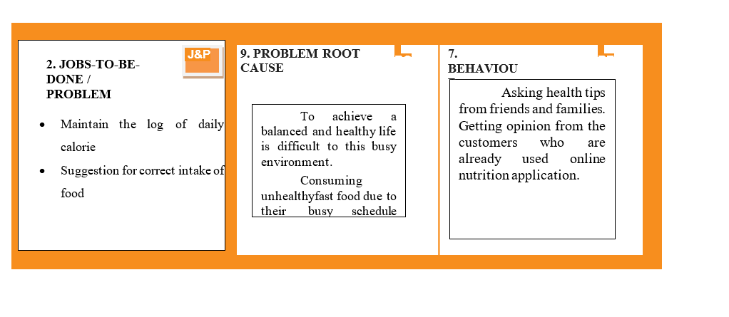

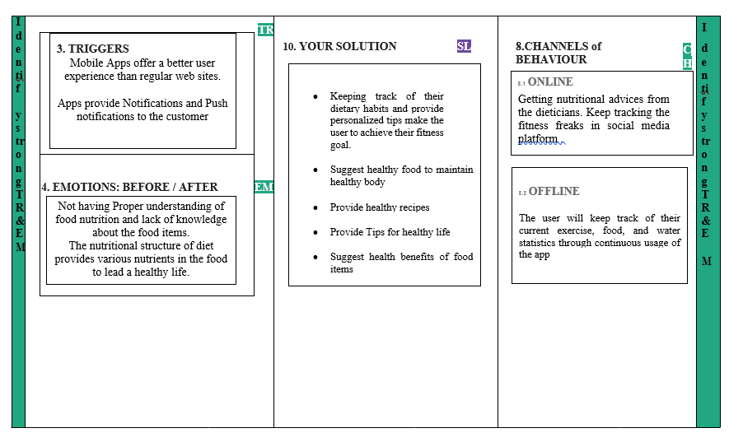

4. REQUIREMENT ANALYSIS

1. **Functional Requirements: Nutrition Assistant Application**

Following are the functional requirements of the proposed solution.

|  |  |  |
| --- | --- | --- |
| **FR No.** | **Functional Requirement (Epic)** | **Sub Requirement (Story / Sub-Task)** |
| FR-1 | User Registration | Registration through Form |
| FR-2 | User Confirmation | Confirmation via Email |
| FR-3 | User Login | Login through Email & Password |
| FR-4 | Dashboard | View the name of the user and see the dashboard menu |
| FR-5 | Food Log | By clicking the mouse, able to see the Food details |
| FR-6 | Calorie Calculator | Input the age, gender, weight for viewing the food to eat |
| FR-7 | Diet Plan | By clicking the mouse, able to see the diet plan |
| FR-8 | Alerts & Notifications | During login, able to see the push notifications and alerts |
| FR-9 | Admin Login | Login through Email and Password |
| FR-9 | Manage Databases | Able to create Database  Able to update Database  Able to Add Database  Able to delete Database |
| FR-10 | Manage Reports | Able to view the reports |

1. **Non-functional Requirements: NUTRITION ASSISTANT APPLICATION**

Following are the non-functional requirements of the proposed solution.

|  |  |  |
| --- | --- | --- |
| **FR No.** | **Non-Functional Requirement** | **Description** |
| NFR-1 | **Usability** | By a single click, user can able to view the contents. It is user friendly. |
| NFR-2 | **Security** | Login and password provide security to the customer |
| NFR-3 | **Reliability** | The system can perform without failure in 90 percent of the use cases |
| NFR-4 | **Performance** | The page can be loaded with minimum 20 seconds |
| NFR-5 | **Availability** | The App dashboard must be available only to the registered users |
| NFR-6 | **Scalability** | The must be scalable to support 10 visits at the time |

**5. PROJECT DESIGN**

**Data Flow Diagrams :** **Nutrition Assistant Application**

A Data Flow Diagram (DFD) is a traditional visual representation of the information flows within a system. A neat and clear DFD can depict the right amount of the system requirement graphically. It shows how data enters and leaves the system, what changes the information, and where data is stored.

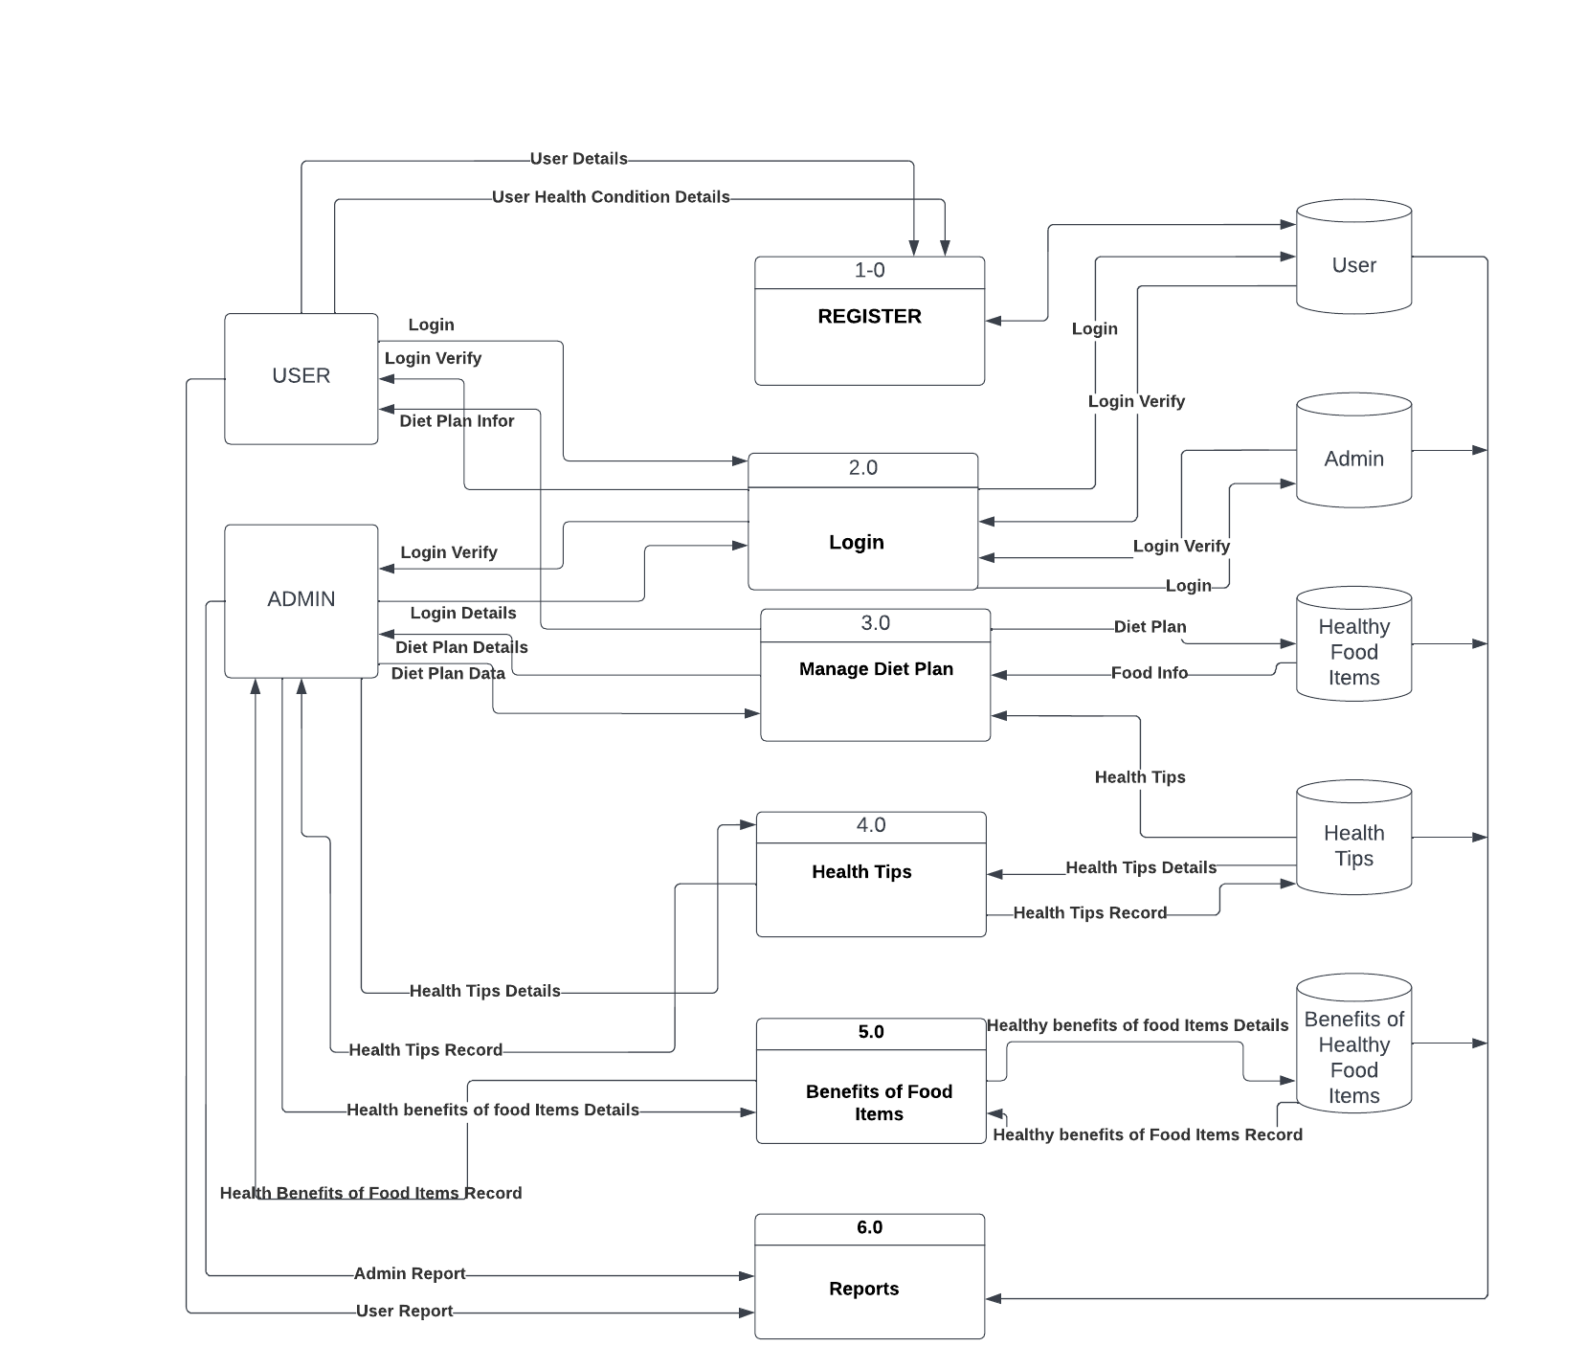

**b. Solution & Technical Architecture**

**Technical Architecture: Nutrition Assistant Application**

The Deliverable shall include the architectural diagram as below and the information as per the table1 & table 2

USER

FRONT END

BACK END

DATABASE

JAVA

ANDRIOD STUDIO

HTML

JAVA SCRIPT

SQLITE

**Table-1 : Components & Technologies:**

|  |  |  |  |
| --- | --- | --- | --- |
| **S.No** | **Component** | **Description** | **Technology** |
|  | User Interface | How user interacts with application e.g.  Web UI, Mobile App, Chatbot etc. | HTML, CSS, JavaScript |
|  | Application Logic-1 | Logic for a process in the application | Java / Python |
| 3. | Database | Data Type, Configurations etc. | MySQL |
| 4. | Cloud Database | Database Service on Cloud | IBM DB2 |
| 5. | File Storage | File storage requirements | IBM Block Storage |
| 6. | Infrastructure (Server / Cloud) | Application Deployment on Local System / Cloud  Local Server Configuration:  Cloud Server Configuration : | Local, Cloud Foundry |

**Table-2: Application Characteristics:**

| **S.No** | **Characteristics** | **Description** | **Technology** |
| --- | --- | --- | --- |
|  | Open-Source Frameworks | List the open-source frameworks used | Android Studio 4.1 |
|  | Security Implementations | List all the security / access controls implemented, use of firewalls etc. | NIL |
|  | Scalable Architecture | Justify the scalability of architecture (3 – tier, Micro-services) | 3-tier |
|  | Availability | Justify the availability of application (e.g. use of load balancers, distributed servers etc.) | Local Server |
|  | Performance | Design consideration for the performance of the application (number of requests per sec, use of Cache, use of CDN’s) etc. | 10 request per second |

**References:**

[**https://c4model.com/**](https://c4model.com/)

[**https://developer.ibm.com/patterns/online-order-processing-system-during-pandemic/**](https://developer.ibm.com/patterns/online-order-processing-system-during-pandemic/)

[**https://www.ibm.com/cloud/architecture**](https://www.ibm.com/cloud/architecture)

[**https://aws.amazon.com/architecture**](https://aws.amazon.com/architecture)

[**https://medium.com/the-internal-startup/how-to-draw-useful-technical-architecture-diagrams-2d20c9fda90d**](https://medium.com/the-internal-startup/how-to-draw-useful-technical-architecture-diagrams-2d20c9fda90d)

**c. User Stories**

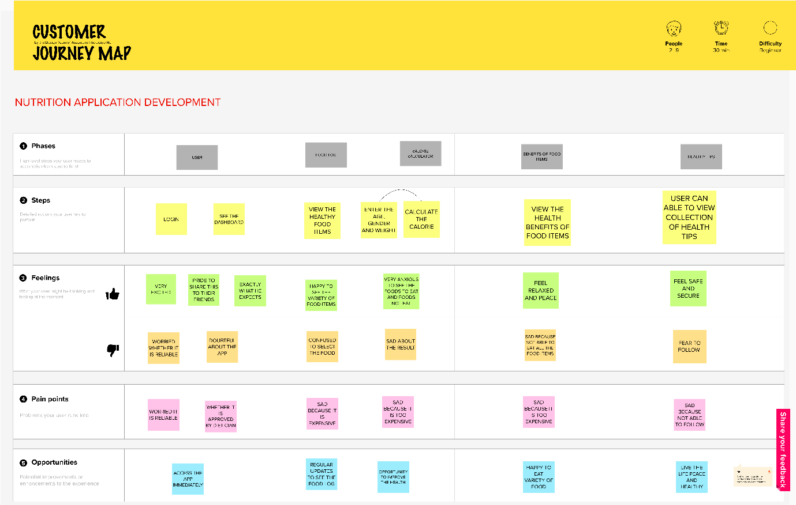

**6. PROJECT PLANNING & SCHEDULING**

1. **Sprint Planning & Estimation**

| **Sprint** | **Functional Requirement (Epic)** | **User Story Number** | **User Story / Task** | **Story Points** | **Priority** | **Team Members** |
| --- | --- | --- | --- | --- | --- | --- |
| Sprint-1 | Registration | USN-1 | As a user, I can register for the application by entering my email, password, and confirming my password. | 5 | High | Gokul .S  Hariharan.J  Pragadesh Karthick.S  Praveen.K.S |
| Sprint-1 |  | USN-2 | As a user, I will receive confirmation email once I have registered for the application | 5 | High | Gokul .S  Hariharan.J  Pragadesh Karthick.S  Praveen.K.S |
| Sprint-1 | Login | USN-3 | As a user, I can register for the application through Facebook | 5 | High | Gokul .S  Hariharan.J  Pragadesh Karthick.S  Praveen.K.S |
| Sprint-2 | Dashboard | USN-4 | As a user, I can register for the application through Gmail | 10 | Medium | Gokul .S  Hariharan.J  Pragadesh Karthick.S  Praveen.K.S |
| Sprint-2 | Food Log | USN-5 | As a user, I can log into the application by entering email & password | 10 | High | Gokul .S  Hariharan.J  Pragadesh Karthick.S  Praveen.K.S |
| Sprint-3 | Calorie Calculator | USN-6 | As a user, I can enter the details of age, weight, gender details of the user | 5 | High | Gokul .S  Hariharan.J  Pragadesh Karthick.S  Praveen.K.S |
| Sprint-3 | Diet Plan | USN-7 | As, a user I can view the diet plan by clicking menu using the mouse | 10 | High | Gokul .S  Hariharan.J  Pragadesh Karthick.S  Praveen.K.S |
| Sprint-3 | Alerts & Notifications | USN-8 | As a user, I can receive the alerts and notifications as soon as enter into the App | 5 | Medium | Gokul .S  Hariharan.J  Pragadesh Karthick.S  Praveen.K.S |
| Sprint-1 | Login | ADMN-1 | As a admin, I can login into the application by providing mail id and password | 5 | High | Gokul .S  Hariharan.J  Pragadesh Karthick.S  Praveen.K.S |
| Sprint-4 | Manage Databases | ADMN-2 | As a admin, I can able to create databases | 5 | High | Gokul .S  Hariharan.J  Pragadesh Karthick.S  Praveen.K.S |
| Sprint-4 |  | ADMN-3 | As a admin, I can able to update the database | 3 | High | Gokul .S  Hariharan.J  Pragadesh Karthick.S  Praveen.K.S |
| Sprint-4 |  | ADMN-4 | As a admin, I can able add the contents to the database | 2 | High | Gokul .S  Hariharan.J  Pragadesh Karthick.S  Praveen.K.S |
| Sprint-4 |  | ADMN-5 | As a admin, I can able to remove the contents of the databases | 5 | High | Gokul .S  Hariharan.J  Pragadesh Karthick.S  Praveen.K.S |
| Sprint-4 | Manage Reports | ADMN-6 | As a admin, I can generate reports | 5 | High | Gokul .S  Hariharan.J  Pragadesh Karthick.S  Praveen.K.S |

**b. Sprint Delivery Schedule**

| **Sprint** | **Total Story Points** | **Duration** | **Sprint Start Date** | **Sprint End Date (Planned)** | **Story Points Completed (as on Planned End Date)** | **Sprint Release Date (Actual)** |
| --- | --- | --- | --- | --- | --- | --- |
| Sprint-1 | 20 | 6 Days | 24 Oct 2022 | 29 Oct 2022 | 20 | 29 Oct 2022 |
| Sprint-2 | 20 | 6 Days | 31 Oct 2022 | 05 Nov 2022 | 20 | 05 Nov 2022 |
| Sprint-3 | 20 | 6 Days | 07 Nov 2022 | 12 Nov 2022 | 20 | 12 Nov 2022 |
| Sprint-4 | 20 | 6 Days | 14 Nov 2022 | 19 Nov 2022 | 20 | 19 Nov 2022 |
|  |  |  |  |  |  |  |
|  |  |  |  |  |  |  |
|  |  |  |  |  |  |  |
|  |  |  |  |  |  |  |

**c. Reports from JIRA**

**Velocity:**

Imagine we have a 10-day sprint duration, and the velocity of the team is 20 (points per sprint). Let’s calculate the team’s average velocity (AV) per iteration unit (story points per day)



**AV = 20/14 = 1.4**

**Average Velocity is 2 points per Sprint**

**Burndown Chart:**

A burn down chart is a graphical representation of work left to do versus time. It is often used in agile[software development](https://www.visual-paradigm.com/scrum/what-is-agile-software-development/) methodologies such as [Scrum](https://www.visual-paradigm.com/scrum/scrum-in-3-minutes/). However, burn down charts can be applied to any project containing measurable progress over time.

|  |  |  |  |  |  |  |  |
| --- | --- | --- | --- | --- | --- | --- | --- |
|  | Intial Estimate | 24-10-22 | 25-10-22 | 26-10-22 | 27-10-22 | 28-10-22 | 29-10-22 |
| Sprint Number | day 0 | day 1 | day 2 | day 3 | day 4 | day 5 | day 6 |
| sprint 1 | 20 | 0 | 10 | 5 | 3 | 1 | 1 |
| sprint 2 | 20 | 3 | 8 | 4 | 2 | 1 | 2 |
| sprint 3 | 20 | 5 | 4 | 4 | 5 | 2 | 0 |
| sprint 4 | 20 | 8 | 3 | 3 | 3 | 2 | 1 |
|  |  |  |  |  |  |  |  |
| Remaining Effort | 80 | 64 | 39 | 23 | 10 | 4 | 0 |
| ideal Effort | 80 | 58 | 40 | 30 | 9 | 8 | 0 |
|  |  |  |  |  |  |  |  |

[**https://www.atlassian.com/agile/tutorials/burndown-charts**](https://www.atlassian.com/agile/tutorials/burndown-charts)

**Reference:**

[**https://www.atlassian.com/agile/project-management**](https://www.atlassian.com/agile/project-management)

[**https://www.atlassian.com/agile/tutorials/how-to-do-scrum-with-jira-software**](https://www.atlassian.com/agile/tutorials/how-to-do-scrum-with-jira-software)

[**https://www.atlassian.com/agile/tutorials/epics**](https://www.atlassian.com/agile/tutorials/epics)

[**https://www.atlassian.com/agile/tutorials/sprints**](https://www.atlassian.com/agile/tutorials/sprints)

[**https://www.atlassian.com/agile/project-management/estimation**](https://www.atlassian.com/agile/project-management/estimation)

[**https://www.atlassian.com/agile/tutorials/burndown-charts**](https://www.atlassian.com/agile/tutorials/burndown-charts)

# CODING & SOLUTIONING

* 1. Feature 1

**Admin Panel – Website**

***Admin App (portal):***

1. They can login to the site and update the nutrition details in the portal.

2.Based on the bmi a diet plan will be created.

3.They can be able to see how many people are on weight gain or weight loss journey.

* 1. Feature 2

**User App – Mobile App**

***User App (Mobile App):***

1. The app will have a user registration and login.

1. After the user logged into and enter the app it will create a diet plan according to the user's bmi value.

User

* 1. **Database Schema**
     1. email
     2. password

Admins

1. email
2. password

Nutritions

1. fruits
2. vegetables

# 8.TESTING

* 1. Test Cases

|  |  |  |  |  |
| --- | --- | --- | --- | --- |
| **Section** | **Total**  **Cases** | **Not**  **Tested** | **Fail** | **Pass** |
| Print Engine | 7 | 0 | 0 | 7 |
| Client Application | 51 | 1 | 0 | 50 |
| Security | 2 | 0 | 0 | 2 |
| OutsourceShipping | 3 | 0 | 0 | 3 |
| ExceptionReporting | 9 | 0 | 0 | 9 |
| Final Report Output | 4 | 0 | 0 | 4 |
| VersionControl | 2 | 0 | 0 | 2 |

* 1. User Acceptance Testing

1. Defect Analysis

This report showsthe number of resolved or closed bugs at each severity level, and how they were resolved

|  |  |  |  |  |  |
| --- | --- | --- | --- | --- | --- |
| **Resolution** | **Severit**  **y1** | **Severity2** | **Severity3** | **Severity4** | **Subtotal** |
| By Design | 10 | 4 | 2 | 3 | 20 |
| Duplicate | 1 | 0 | 3 | 0 | 4 |
| External | 2 | 3 | 0 | 1 | 6 |
| Fixed | 11 | 2 | 4 | 20 | 37 |
| Not Reproduced | 0 | 0 | 1 | 0 | 1 |

|  |  |  |  |  |  |
| --- | --- | --- | --- | --- | --- |
| Skipped | 0 | 0 | 1 | 1 | 2 |
| Won't Fix | 0 | 5 | 2 | 1 | 8 |
| Totals | 24 | 14 | 13 | 26 | 7  7 |

1. Test Case Analysis

This reportshows the numberof test cases that have passed, failed,and untested

|  |  |  |  |  |
| --- | --- | --- | --- | --- |
| **Section** | **Total Cases** | **Not Tested** | **Fail** | **Pass** |
| Print Engine | 7 | 0 | 0 | 7 |
| Client Application | 51 | 1 | 0 | 50 |
| Security | 2 | 0 | 0 | 2 |
| OutsourceShipping | 3 | 0 | 0 | 3 |
| ExceptionReporting | 9 | 0 | 0 | 9 |
| Final Report Output | 4 | 0 | 0 | 4 |
| VersionControl | 2 | 0 | 0 | 2 |

# 9.RESULTS

a. Performance Metrics

1. In Admin Panel they can login to the site and update the food nutrition details
2. Based on the bmi value a diet plan will be created.
3. In User App(Mobile App) will have a user registration and login.
4. After the user logged into and enter the app it will create a diet plan according to the user's bmi value.

# 10. ADVANTAGES & DISADVANTAGES

**Advantages**

1. **It can cause you to think about and consider a food choice before you take a bite.**
2. **It allows you to analyze your own food choices to assess and tweak your eating plan and patterns.**
3. **It provides general awareness of nutrients in food.**
4. **It is a targeted way to focus on your health.**

**Disadvantages**

1. The risk of data breach
2. It may cause human error Network unstability lead to huge cause

# 11.CONCLUSION

Most countries in the region implement school health and nutrition programmes, including

school feeding, deworming, vitamin and mineral supplementation, etc. Innovative, creative and

effective school nutrition education programmes exist in some countries in the region. However,

these are often small-scale and implemented as pilot projects, focus on children with special

needs and prioritize the transfer of knowledge over the promotion of active learning and the

creation of appropriate attitudes, life skills and behaviors. Generally, nutrition education is not

systematically integrated into school curricula in the region. So developing a nutrition assistant

application will help people to stay healthy.

# 12.FUTURE SCOPE

The application provides an efficient way of showing the identified nutrition intakes to the users

Diet and nutrition apps market is expected to grow in the forecast period of 2021 to 2028. Data Bridge Market Research analyses that the market is growing with a CAGR of 30.4% in the forecast period of 2021 to 2028 and is expected to reach USD 17,450.56 million by 2028.Nutrition assistant application will be developed with exercise ,sleep and calories tracking modules so that it help people to stay fit and healthy

**13.APPENDIX:**

**Source code:**

**Index.html:**

<!DOCTYPE html>

<html lang="en">

<head>

<meta charset="UTF-8">

<meta http-equiv="X-UA-Compatible" content="IE=edge">

<meta name="viewport" content="width=device-width, initial-scale=1.0">

<link href="https://cdn.jsdelivr.net/npm/bootstrap@5.2.2/dist/css/bootstrap.min.css" rel="stylesheet" integrity="sha384-Zenh87qX5JnK2Jl0vWa8Ck2rdkQ2Bzep5IDxbcnCeuOxjzrPF/et3URy9Bv1WTRi" crossorigin="anonymous">

<script src="https://cdn.jsdelivr.net/npm/bootstrap@5.2.2/dist/js/bootstrap.bundle.min.js" integrity="sha384-OERcA2EqjJCMA+/3y+gxIOqMEjwtxJY7qPCqsdltbNJuaOe923+mo//f6V8Qbsw3" crossorigin="anonymous"></script>

<title>Nutrition Assistant</title>

<link rel="icon" href="{{ url_for( 'static', filename = 'src/cardiogram.jpg')}}">

<link rel="stylesheet" href="{{ url_for( 'static', filename = 'css/index.css')}}">

<style>

</style>

</head>

<body>

{% if error %}

<p style="font-size:20px;padding:20px;background-color:red;border-radius:20px;margin: 10px 40px">{{error}}</p>

{% endif %}

<div class="container-fluid">

<div class="row">

<div class="col-lg-5 colh heading">

<p class="display-3">Nutrition Assistant</p>

</div>

<div class="col-lg-7 colh">

<div>

<ul class="lists">

<li> <a id="c1" href="#cont_1">Home</a></li>

<li onmouseover = "signinOne(this)" onmouseout="unsignin(this)"> <a id="c2" href="#logins">SignIn</a></li>

<li onmouseover = "signinTwo(this)" onmouseout="unsignin(this)"> <a id="c3" href="#logins">SignUp</a></li>

<li onmouseover = "visible(this)" onmouseout="unsignin(this)"> <a id="c4" href="#abouts">About</a></li>

</ul>

</div>

</div>

</div>

</div>

<div class="container-fluid content">

<div class="row">

<div class="col-lg info">

<p>

Nutritional support is the provision of adequate nutrients to maintain a

healthy body weight and avoid malnutrition. The continuous delivery of

high-quality and cost-effective nutritional care to patients has been

shown to be an increasingly difficult task. It is observed that dieticians

are requested to carry out the nutritional assessment, to manually

calculate the nutritional needs and to design the everyday meal plan for

each patient. In most cases, these time-consuming tasks are not completed

due to lack of time or inadequate number of personnel. Development of a

cloud based system would have the ability to calculate the nutritional requirements and to

guide first line nutritional management to patients and clients automatically.

The nutrient content calculation was planned to undertake with commonly consumed traditional

as well as junk foods

</p>

</div>

<div class="col-lg info" id="infos">

<div class="cont_1 pb-0">

<div onclick="ont()" id="l1" class="options">

<p><img src="{{ url_for( 'static', filename = 'src/home.jpg')}}" width="60" height="60" alt=""><p class="list">Home</p>

</div>

<div id="l2" class="options">

<p><img src="{{ url_for( 'static', filename = 'src/login.jpg')}}" width="60" height="60" alt=""><p class="list">Sign In</p>

</div>

<div id="l3" class="options">

<p><img src="{{ url_for( 'static', filename = 'src/sign-up.jpg')}}" width="60" height="60" alt=""><p class="list">Sign Up</p>

</div>

<div id="l4" class="options">

<p><img src="{{ url_for( 'static', filename = 'src/info.jpg')}}" width="60" height="60" alt=""><p class="list">about</p>

</div>

<div id="logins" class="login">

<div class="container" id="container">

<div class="form-container sign-up-container">

<form action="{{ url_for('register') }}" method="post" enctype="multipart/form-data">

<h1>Create Account</h1>

<input type="text" name="name" placeholder="Name" required />

<input type="email" name="email" placeholder="Email" required />

<input type="password" name="pass" placeholder="Password" required />

<button>Sign Up</button>

</form>

</div>

<div class="form-container sign-in-container">

<form action="{{ url_for('homepage') }}" method="post" enctype="multipart/form-data">

<h1>Sign in</h1>

<input STYLE="display:none" type="text" name="name" placeholder="Name"/>

<input type="email" name="email" placeholder="Email" required />

<input type="password" name="pass" placeholder="Password" required />

<a href="#">Forgot your password?</a>

<button>Sign In</button>

</form>

</div>

<div class="overlay-container">

<div class="overlay">

<div class="overlay-panel overlay-left">

<h1>Welcome Back!</h1>

<p>To keep connected with us please login with your personal info</p>

<button class="ghost" id="signIn">Sign In</button>

</div>

<div class="overlay-panel overlay-right">

<h1>Hello, Friend!</h1>

<p>Enter your personal details and start journey with us</p>

<button class="ghost" id="signUp">Sign Up</button>

</div>

</div>

</div>

</div>

</div>

<div class="about" id="abouts">

<p>

A web based tool is being planned for therapeutic nutrition prescriptions in clinical settings.

The cloud based system would have the ability to calculate the nutritional requirements and to

guide first line nutritional management to patients and clients automatically.

</p>

</div>

</div>

</div>

</div>

</div>

</body>

<script src="{{ url_for('static', filename='js/index.js') }}">

</script>

</html>

Forgot_password.html:

<!DOCTYPE html>

<html lang="en">

<head>

<meta charset="UTF-8">

<meta http-equiv="X-UA-Compatible" content="IE=edge">

<meta name="viewport" content="width=device-width, initial-scale=1.0">

<title>Forgot Passwordt</title>

<link href="https://cdn.jsdelivr.net/npm/bootstrap@5.2.2/dist/css/bootstrap.min.css" rel="stylesheet" integrity="sha384-Zenh87qX5JnK2Jl0vWa8Ck2rdkQ2Bzep5IDxbcnCeuOxjzrPF/et3URy9Bv1WTRi" crossorigin="anonymous">

<script src="https://cdn.jsdelivr.net/npm/bootstrap@5.2.2/dist/js/bootstrap.bundle.min.js" integrity="sha384-OERcA2EqjJCMA+/3y+gxIOqMEjwtxJY7qPCqsdltbNJuaOe923+mo//f6V8Qbsw3" crossorigin="anonymous"></script>

<link rel="icon" href="{{ url_for( 'static', filename = 'src/cardiogram.png')}}">

<link rel="stylesheet" href="{{ url_for( 'static', filename = 'css/forgot.css')}}">

<link rel="stylesheet" href="{{ url_for( 'static', filename = 'css/dashboard.css')}}">

</head>

<body>

{% if error %}

<p style="font-size:20px;padding:20px;background-color:red;border-radius:20px;margin: 10px 40px">{{error}}</p>

{% endif %}

<div class="container-fluid float">

<div class="containers floatcontainers">

<div class="row maxhight displaytype p-3">

<div class="col-lg-6 maincontainers">

<div class="boxfor">

<form action="{{url_for('forgot')}}" method="post">

<input type="email" required name="f_emil" value="" placeholder="abc@mail.com">

<input type="submit" value="Send OTP">

</form>

</div>

</div>

<div class="col-lg-6 maincontainers">

<div class="boxfor">

<form action="{{url_for('forgot')}}" method="post">

<input type="OTP" required name="f_otp" placeholder="OTP">

<input type="password" required name="f_psw" placeholder="new password">

<input type="password" required name="f_psws" placeholder="confirm password ">

<input type="submit" value="Submit">

</form>

</div>

</div>

</div>

</div>

</div>

</body>

</html>

<!--<div class="col-lg-6 box1 maxhight displaytype">

<div class="displaytype bg-danger ">

<form action="" method="post">

<input type="email" required name="f_emil" placeholder="abc@mail.com">

<input type="submit" value="Send OTP">

</form>

</div>

</div>

<div class="col-lg-6 box1 maxhight displaytype">

<form action="" method="post">

<input type="email" required name="f_emil" placeholder="abc@mail.com">

<input type="submit" value="Send OTP">

</form>

</div> -->

Dashboard.html:

<!DOCTYPE html>

<html lang="en">

<head>

<meta charset="UTF-8">

<meta http-equiv="X-UA-Compatible" content="IE=edge">

<meta name="viewport" content="width=device-width, initial-scale=1.0">

<link href="https://cdn.jsdelivr.net/npm/bootstrap@5.2.2/dist/css/bootstrap.min.css" rel="stylesheet" integrity="sha384-Zenh87qX5JnK2Jl0vWa8Ck2rdkQ2Bzep5IDxbcnCeuOxjzrPF/et3URy9Bv1WTRi" crossorigin="anonymous">

<script src="https://cdn.jsdelivr.net/npm/bootstrap@5.2.2/dist/js/bootstrap.bundle.min.js" integrity="sha384-OERcA2EqjJCMA+/3y+gxIOqMEjwtxJY7qPCqsdltbNJuaOe923+mo//f6V8Qbsw3" crossorigin="anonymous"></script>

<link rel="stylesheet" href="{{url_for('static', filename='css/dashboard.css')}}">

<link rel="icon" href="{{ url_for( 'static', filename = 'src/cardiogram.png')}}">

<title>Welcome {{user}}</title>

</head>

<body>

{% if msg %}

<div class="msg bg-info" style="padding: 0px 0 0px 50px;margin: 20px 20px 0 20px;border-radius: 20px;">

<h4>{{msg}}</h4>

</div>

{% endif %}

<div class="container-fluid dash">

<div class="header p-3">

<h3><img src="{{url_for('static', filename='src/user.jpg')}}" alt="ico" width="50px" height="50px">&nbsp;&nbsp;Dashboard</h3>

<div style="display:flex; justify-content: right;align-items: center;">Welcome {{user}},&nbsp;&nbsp;<form action="" method="post" enctype="multipart/form-data"><button type="submit" name="logout" class="combutton btns">Log Out</button></form></div>

</div>

</div>

<div class="container-fluid">

<div class="row rowh">

<div class="col-lg-4 colh">

<div class="maincon comcolor">

<h4>Control panal</h4>

<h5><form action="" name="deleteHistory" method="post" enctype="multipart/form-data"><input style="width: 200px;border:0px;padding:10px 40px;border-radius:20px;" type="submit" name="deleteHistory" value="Delete All History"></form></h5>

<table>

<tr>

<th>History</th>

</tr>

{% for row in history %}

<tr>

<td>{{ row['TIME'] }}</td>

<td><form method="post" action="{{url_for('homepage')}}" class="inline">

<input type="hidden" name="extra_submit_param_view" value="{{row['NUTRITION']}}">

<button type="submit" name="submit_param" value="submit_value" class="link-button">

View

</button>

</form>

</td>

<td><form method="post" action="{{url_for('homepage')}}" class="inline">

<input type="hidden" name="extra_submit_param_delete" value="{{row['TIME']}}">

<button type="submit" name="submit_param" value="submit_value" class="link-button">

Delete

</button>

</form>

</td>

</tr>

{% endfor %}

</table>

</div>

</div>

<div class="col-lg-8 row colh">

<div class="row normsize">

<div class="col-lg normsize roudcorner comcolor">

<div class="comflex-col">

<img id="myImage" class="normsize" style="border: 5px solid rgb(25, 25, 25);;" src="{{url_for('static', filename='src/food.jpg')}}" alt="food" width="300" height="300">

<button class="combutton btns" onclick="setImage()" >Clear Image</button>

</div>

</div>

<div class="col-lg normsize roudcorner comcolor">

<div class="comflex lesssize normpadding">

<div>

<h1>Upload Image</h1>

<form action="{{url_for('upload_file')}}" method="post" enctype="multipart/form-data">

<input type=file onchange="readURL(this);" name="file">

<input style="margin: 10px 0px;" onclick="setImage()" type=submit value=Upload name="upload">

</form>

</div>

</div>

</div>

</div>

</div>

</div>

</div>

{% if data %}

<dic class="container-fluid float">

<div class="containers floatcontainer ">

<div class="box1">

<div class="close">

<a href="{{url_for('upload_file',methods='POST')}}" class="closes"></a>

</div>

</div>

<div style="background-color: rgb(105, 102, 102);margin-top: 25px;font-size: 30px;font-weight: bold;padding-left: 15px;"><p>Nutrition Facts</p></div>

<div class="box2">

<div class="bcol">

<table style="width:100%;">

<tr>

<th>Calories</th>

<th>{{data[0]}}{{unit[0]}}</th>

</tr>

<tr>

<th></th>

<th>Daily Value</th>

</tr>

<tr>

<th>Total Fat</th>

<th>{{data[1]}}{{unit[1]}}</th>

</tr>

<tr>

<td>Saturated Fat</td>

<td>{{data[2]}}{{unit[2]}}</td>

</tr>

<tr>

<td>Polyunsaturated Fat</td>

<td>{{data[3]}}{{unit[3]}}</td>

</tr>

<tr>

<td>Monounsaturated Fat</td>

<td>{{data[4]}}{{unit[4]}}</td>

</tr>

<tr>

<th>Cholesterol</th>

<th>{{data[5]}}{{unit[5]}}</th>

</tr>

<tr>

<th>Sodium</th>

<th>{{data[6]}}{{unit[6]}}</th>

</tr>

<tr>

<th>Potassium</th>

<th>{{data[7]}}{{unit[7]}}</th>

</tr>

<tr>

<th>Sugar</th>

<th>{{data[8]}}{{unit[8]}}</th>

</tr>

<tr>

<th>Protein</th>

<th>{{data[9]}}{{unit[9]}}</th>

</tr>

<tr>

<th>Carbohydrates</th>

<th>{{data[10]}}{{unit[10]}}</th>

</tr>

<tr>

<th>Vitamin A</th>

<th>{{data[11]}}{{unit[11]}}</th>

</tr>

<tr>

<th>Vitamin C</th>

<th>{{data[12]}}{{unit[12]}}</th>

</tr>

<tr>

<th>Vitamin D</th>

<th>{{data[13]}}{{unit[13]}}</th>

</tr>

<tr>

<th>Vitamin B5</th>

<th>{{data[14]}}{{unit[14]}}</th>

</tr>

<tr>

<th>Calcium</th>

<th>{{data[15]}}{{unit[15]}}</th>

</tr>

</table>

</div>

</div>

</div>

</dic>

{% endif %}

<script>

//image = document.getElementById('myImage');

function clearImage() {

image.src = "{{url_for('static',filename='src/user.jpg')}}"; //onclick="document.getElementById('myImage').src='src/omplate.png'"

}

function setImage() {

image.src = "{{url_for('static',filename='src/food.jpg')}}";

}

</script>

<script src="{{url_for('static', filename='js/dashboard.js')}}">

</script>

</body>

</html>

GitHub & Project Demo Link:

Github link:

https://github.com/IBM-EPBL/IBM-Project-10108-1659095780