# A NEW HINT TO TRANSPORTATION - ANALYSIS OF THE NYC BIKE

**SHARE SYSTEM**

|  |  |
| --- | --- |
| Assignment Date | 5th October 2022 |
| Student Name | Mr. Kishore M |
| Student Roll Number | 19F127 |

## TASK:

Upload the dataset to Cognos Analytics, Explore and Visualize the 50-startups dataset.

## DATASET USED:

This particular dataset holds data from 50 startups in New York, California, and Florida. The

features in this dataset are **R&D spending**, **Administration Spending**, **Marketing Spending**, and **Location features**, while the target variable is: **Profit**.

1. **R&D spending**: The amount which startups are spending on Research and development.
2. **Administration spending**: The amount which startups are spending on the Admin panel.
3. **Marketing spending**: The amount which startups are spending on marketing strategies.
4. **State**: To which state that particular startup belongs.
5. **Profit**: How much profit that particular startup is making.

## SOLUTION:

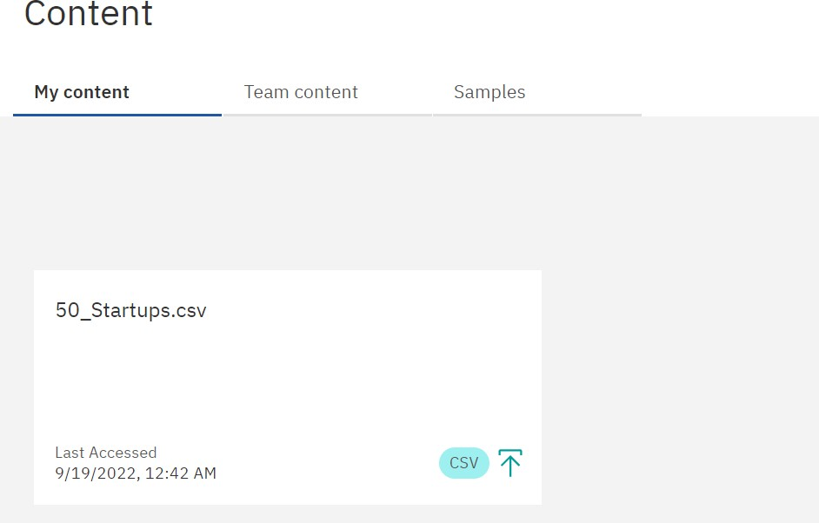

As highlighted by the red box, the dataset *50_Startups.csv* was successfully

**uploaded** onto the IBM Cognos platform.

## EXPLORATION AND VISUALIZATION OF THE DATASET:

**Visualization #1:**

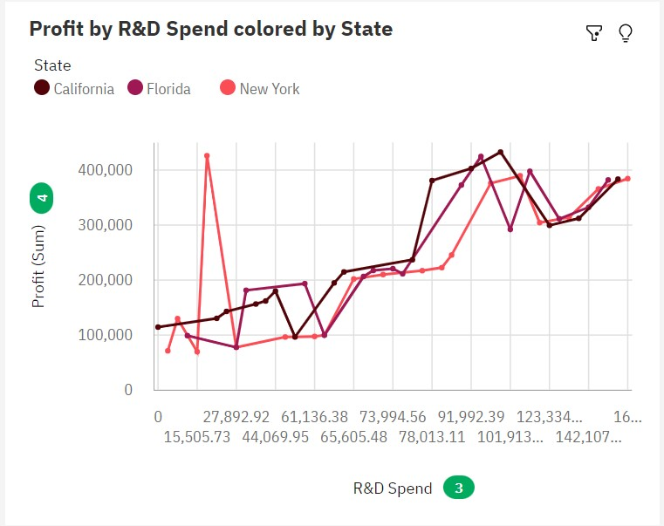

This chart plots the correlation between R&D expenditure and Profit in each state. It is observed that in general the profit increases with increase in R&D expenditure

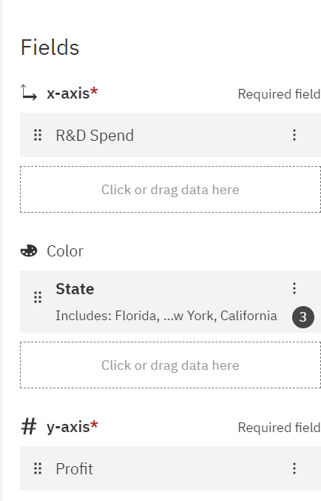

## Visualization #2:

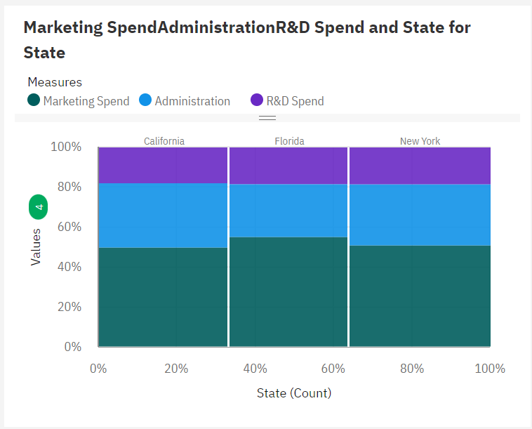

This Marimekko shows the percentage of money that was spent in Marketing, R&D and Administration in each state. The width of each bar is decided by the number of startups in each state

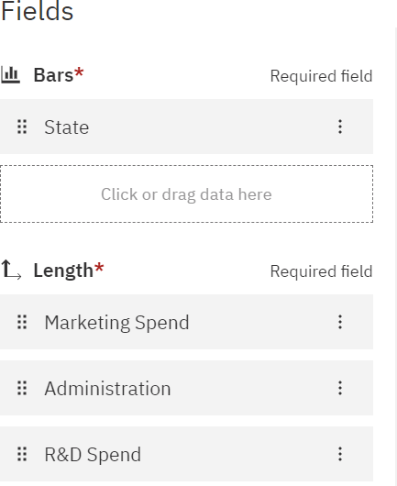

## Visualization #3:

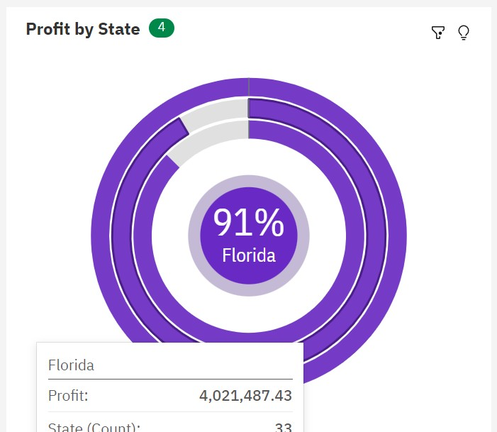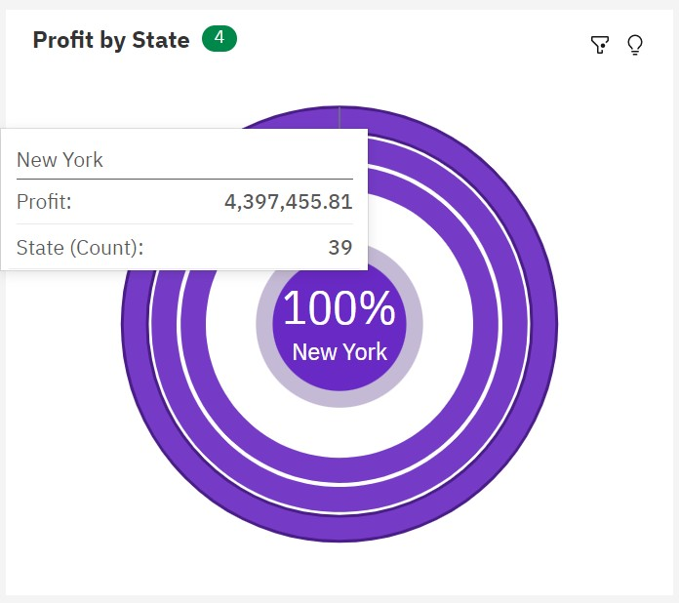

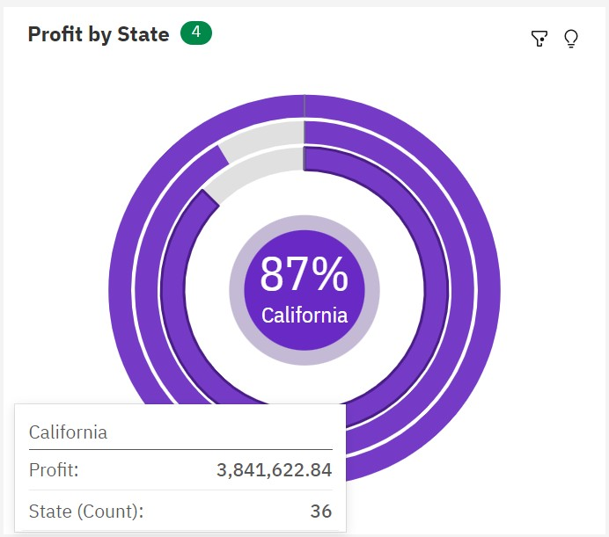

This Radial graph compares the net profit amount generated in each state. Since

New York generated the highest profit, comparisons are done keeping New York as a base. California and Florida generated 91% and 87% of the profit that New York Generated.

## Visualization #4:

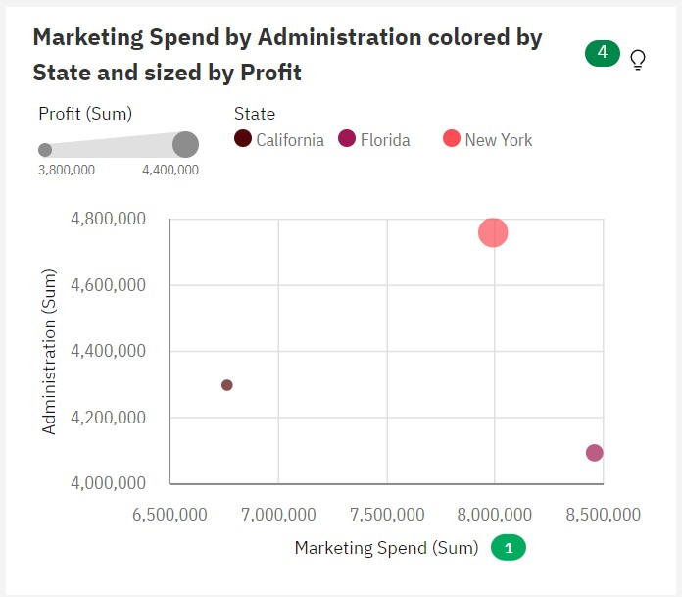

This bubble plot gives us the combination of Marketing Spend and Administration Spend and the profit for each combination. The size of the bubbles indicate the amount of profit. Bigger sphere - bigger profit.

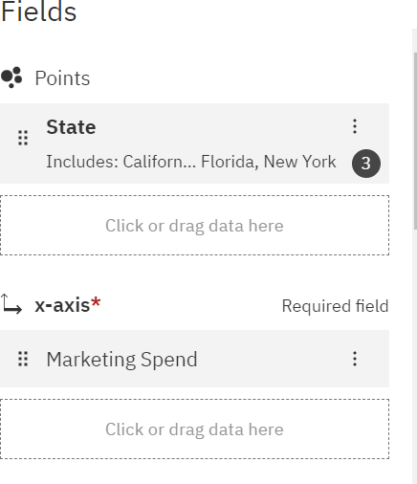

## Visualization #5:

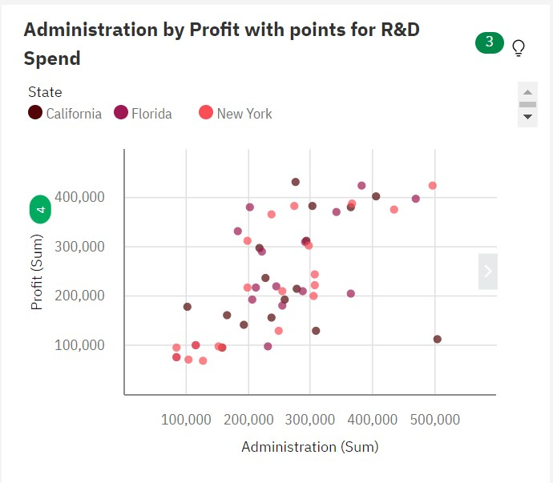

This scatter plot shows the relation between Administration spend and profit and the startups of the different states are differentiated by colour.

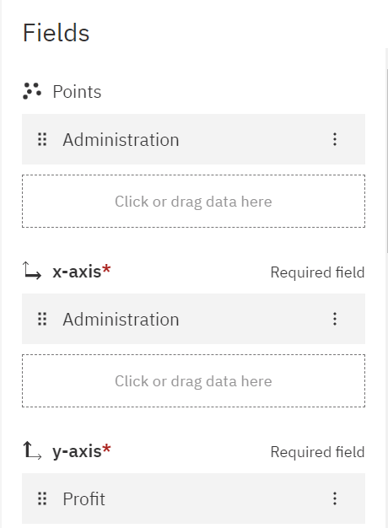

## Visualization #6:

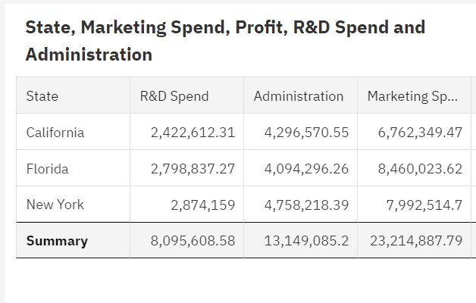

The above table aggregates data from all rows and gets the count of net spend for each column for each state and generates a total summary

