## Tab 1



Pharmaceutical Sales Dashboard

Analyze the pharma sales statistics using interactive visualizations

Tab 2

Sales by Customers

Tot...

No image selected

Image URL

Enter image URL here

Paste the URL and press Enter to save it.

CBN | 24

Nes...

# Sales by Location

Location

~~LUTH | 54 National Hospital | 52~~

Abeokuta Abuja Calabar

Ibadan Ilorin Kaduna

Kano Lagos Port Harcourt

Un...

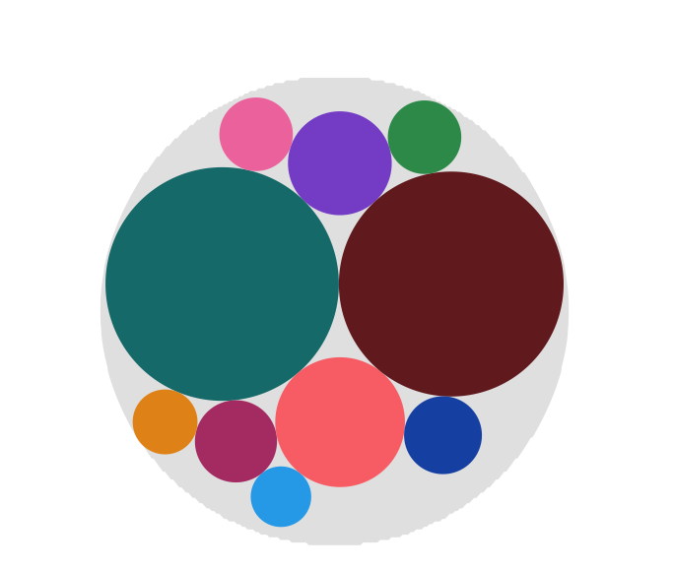

NNPC | 30

Mobi...

C...

Shel...

Abeokuta

Abuja Calabar Ibadan Ilorin Kaduna Kano Lagos

Location

Port Harcourt

Warri

0 50 100 150 200 250

L.Sales (Sum)

## Tab 4

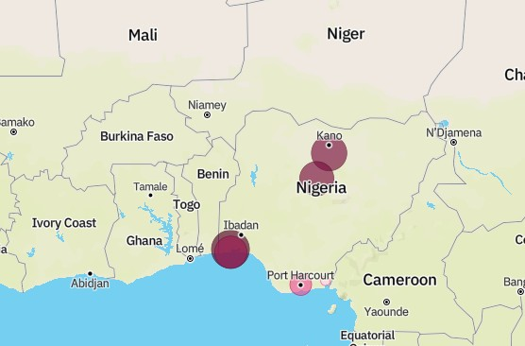

Inventory Stock for Warehouse Locations

[© Mapbox](https://www.mapbox.com/about/maps/) [© OpenStreetMap](https://www.openstreetmap.org/about/)

Tab 5

Received Inventory from Supllier

Supplier

Astra Zeneca Novartis Pﬁzer Sanoﬁ

Astra Zeneca

Novartis

Pﬁzer

Sanoﬁ

# Sales by Sales Representative

Sales Rep

M. Sule P. Michaels S. Sunday

A. Chukwu A. Oni

657.8

429



629.2

572

572

## Tab 3

Sales Trend

Measures

C.Sales L.Sales M.Sales

200

100

Values

0

April

December

January

June

May

October

August

February

July

March

November

Se...



Month

## Tab 6

Monthly Sales

Month

March January February August September May June April November October December July

### 817.9



817.9

817.9

591.65

681.58

681.58

Tab 7

Actual and Received Inventory by Month

Measures

Received Inventory Inventory Stock

### 250,000

|  |  |  |  |  |  |  |  |  |  |  |  |  |
| --- | --- | --- | --- | --- | --- | --- | --- | --- | --- | --- | --- | --- |
|  |  |  |  |  |  |  |  |  |  |  |  |  |
|  |  |  |  |  |  |  |  |  |  |  |  |  |
|  |  |  |  |  |  |  |  |  |  |  |  |  |
|  |  |  |  |  |  |  |  |  |  |  |  |  |
|  |  |  |  |  |  |  |  |  |  |  |  |  |
|  |  |  |  |  |  |  |  |  |  |  |  |  |

200,000

150,000

Values

100,000

50,000

0

April

December

January

June

May

October

August

February

July

March

November

Se...



Month